Appendix

Suppressing COVID-19 transmission in Hong Kong: an observational study of the first four months

Case definitions of COVID-19

COVID-19 has been classified as a notifiable disease in Hong Kong. The case definitions of COVID-19 have been updated multiple times in response to the improved understanding about the disease and the changes in the epidemic locally and globally. The changes of the case definitions over time are summarized in the table blow.
Version (issue date) | Criteria: | Case classifications | Differences
V1  (Jan 7) | Reporting criteria:  An individual fulfilling the following:  • Presented with fever and acute respiratory illness, or with pneumonia; AND  • With travel history to Wuhan within 14 days before onset of symptom  (irrespective of any exposure to wet market or seafood market).  Laboratory criteria:  Not applicable. | Suspected case:  A case that fulfils the reporting criteria.  Probable case:  A case that:  • fulfils the reporting criteria, AND  • has pneumonia confirmed by chest X-ray; AND  • has either (i) exposure to the Huanan Seafood Market in Wuhan, or (ii) close contact with a pneumonia case with unknown aetiology epidemiologically linked to the above market in Wuhan within 14 days before onset of symptoms.  Confirmed case:  Not applicable. | /
V2  (Jan 16) | Reporting criteria:  An individual fulfilling the following:  • Presented with fever and acute respiratory illness, or with pneumonia; AND  • met one of the following criteria within 14 days before onset of symptom:  1. With travel history to Wuhan (irrespective of any exposure to wet market or seafood market); OR  2. Visited a medical hospital in Mainland China; OR  3. Had close contact with a symptomatic case with confirmed infection of the novel coronavirus.  Laboratory criteria:  Detection of nucleic acid of the novel coronavirus in a clinical specimen. | Suspected case:  A case that fulfils the reporting criteria.  Probable case:  A case that:  • fulfils the reporting criteria; AND  • has pneumonia confirmed by chest X-ray; AND  • has either one of the following: (i) exposure to wet market in Wuhan, or (ii) visited a medical hospital in Wuhan; or (iii) had close contact with a confirmed case of the novel coronavirus.  Confirmed case:  A patient presenting with compatible clinical features fulfils the laboratory criteria. | -Added exposure to medical hospitals in Mainland China as one condition for travel history;  -Clarified laboratory criteria;  -Clarified the definition of confirmed cases.
V3  (Jan 20) | Reporting Criteria:  An individual fulfilling the following:  • Presented with fever and acute respiratory illness, or with pneumonia; AND  • Met one of the following criteria within 14 days before onset of symptom:  1. With travel history to Hubei Province (irrespective of any exposure to a wet market or seafood market); OR  2. Visited a medical hospital in Mainland China; OR  3. Had close contact with a symptomatic case with confirmed infection of the novel coronavirus.  Laboratory criteria:  Detection of nucleic acid of the novel coronavirus in a clinical specimen. | Suspected case:  A case that fulfils the reporting criteria.  Probable case:  A case that:  • fulfils the reporting criteria; AND  • has pneumonia confirmed by chest X-ray; AND  • has either one of the following: (i) exposure to a wet market in Wuhan, or (ii) visited a medical hospital in Wuhan; or (iii) had close contact with a confirmed case of novel coronavirus infection.  Confirmed case:  A patient presenting with compatible clinical features fulfils the laboratory criteria. | -Expanded the exposure history from Wuhan to Hubei Province as one condition for travel history in the reporting criteria.
V4  (Jan 23) | Reporting Criteria:  An individual fulfilling the following:  • Presented with fever OR acute respiratory illness OR pneumonia; AND  • met one of the following criteria within 14 days before onset of symptom:  1. With travel history to Hubei Province (irrespective of any exposure to a wet market or seafood market); OR  2. Visited a medical hospital in Mainland China; OR  3. Had close contact with a symptomatic case with confirmed infection of the novel coronavirus.  Laboratory Criteria:  Any one of the following:  1. Detection of nucleic acid of the novel coronavirus in a clinical specimen; OR  2. Isolation of the novel coronavirus from a clinical specimen; OR  3. Seroconversion or four-fold or greater increase in antibody titre to the novel coronavirus in paired serum specimens. | Suspected case:  A case that fulfils the reporting criteria.  Probable case:  A case that:  • fulfils the reporting criteria; AND  • has pneumonia confirmed by chest X-ray; AND  • has either one of the following: (i) exposure to a wet market in Wuhan, or (ii) visited a medical hospital in Wuhan; or (iii) had close contact with a confirmed case of novel coronavirus infection.  Confirmed case:  A patient presenting with compatible clinical features fulfils the laboratory criteria. | -Changed and loosened the symptom description for reporting criteria (from “AND” to “OR”);  -Added virus isolation and serological tests as laboratory confirmation tests.
V5  (Feb 24) | Reporting criteria:  An individual fulfilling the following:  • Presented with fever OR acute respiratory illness OR pneumonia; AND  • Met one of the following criteria within 14 days before onset of symptom:  1. With travel history to mainland China or South Korea; OR  2. Had close contact with a confirmed case of COVID-19.  Laboratory Criteria:  Any one of the following:  1. Detection of nucleic acid of the novel coronavirus in a clinical specimen; OR  2. Isolation of the novel coronavirus from a clinical specimen; OR  3. Seroconversion or four-fold or greater increase in antibody titre to the novel coronavirus in paired serum specimens. | Suspected case:  A case that fulfils the reporting criteria.  Probable case:  A case that:  • fulfils the reporting criteria; AND  • has pneumonia confirmed by chest X-ray; AND  • has either one of the following: (i) exposure to a wet market in Wuhan, or (ii) visited a hospital in Wuhan; or (iii) had close contact with a confirmed case of novel coronavirus infection.  Confirmed case:  A patient presenting with compatible clinical features fulfils the laboratory criteria. | -Expanded potential exposure areas from Hubei to mainland China or South Korea in the reporting criteria;  -Deleted the emphasis on “symptomatic” in the description of exposure history to confirmed cases in the reporting criteria.
V6  (Feb 28) | Reporting criteria:  An individual fulfilling the following:  • Presented with fever* OR acute respiratory illness OR pneumonia; AND  • Met one of the following criteria within 14 days before onset of symptom:  1. With travel history to a place with active community transmission of COVID-19; OR  2. Had close contact with a confirmed case of COVID-19.  (*Except fever due to a known etiology not related to respiratory infections)  Laboratory Criteria:  Any one of the following:  1. Detection of the nucleic acid of the novel coronavirus in a clinical specimen; OR  2. Isolation of the novel coronavirus from a clinical specimen; OR  3. Seroconversion or four-fold or greater increase in antibody titre to the novel coronavirus in paired serum specimens. | Suspected case:  A case meets the reporting criteria.  Probable case:  • A case meets the reporting criteria AND has pneumonia confirmed by chest X-ray, AND has one of the following:  (i) exposure to a wet market in Wuhan,  (ii) visited a medical hospital in Wuhan;  (iii) had close contact with a confirmed case of SARS-CoV-2 infection.  Confirmed case:  A patient presenting with compatible clinical features fulfils the laboratory criteria. | -Further described the symptoms to exclude fever due to other respiratory infections;  -Expanded the exposure area to any active community transmission of COVID-19 in the reporting criteria.
V7  (Mar 4) | Reporting Criteria:  An individual fulfilling the following:  • Presented with fever* OR acute respiratory illness OR pneumonia; AND  • Met one of the following criteria within 14 days before onset of symptom:  1. With travel history to a place with active community transmission of  COVID-19; OR  2. Had close contact with a confirmed case of COVID-19.  (*Except fever due to a known etiology not related to respiratory infections)  Laboratory criteria:  Anyone of the following:  1. Detection of nucleic acid of SARS-CoV-2 in a clinical specimen; OR  2. Isolation of SARS-CoV-2 from a clinical specimen; OR  3. Seroconversion or four-fold or greater increase in antibody titre to SARS-CoV-2 in paired serum specimens. | Suspected case:  A case that fulfils the reporting criteria.  Probable case (either of the following):  • A case having radiological evidence of pneumonia (by chest X-ray or computed tomography scan) AND epidemiological linkage to a confirmed case of COVID-19;  • A case having epidemiological linkage to a confirmed case of COVID-19 or an outbreak of COVID-19 but with an inconclusive laboratory test result for SARS-CoV-2 (irrespective of any symptom).  Confirmed case:  A case fulfils the laboratory criteria (including asymptomatic cases). | -Included computed tomography scan as the radiographic evidence of pneumonia for probable cases;  -Included patients with no clear symptom but linked to cases or an outbreak of COVID-19 and with inconclusive test results as probable cases;  -Emphasized the possibility of having confirmed asymptomatic cases.

Countries with active community transmission of COVID-19

The case definitions for COVID-19 surveillance include a component of travel history of suspected patients to areas with a potentially high risk of transmission of COVID-19. These areas were defined by the Department of Health in Hong Kong as countries with active community transmission of COVID-19. The list of countries has been updated with the evolution of epidemics globally. The table below shows the changes in countries/areas/territories determined to have an active community transmission of COVID-19 over time announced by the Department of Health.

Issuing date | List of countries
Feb 29 | Mainland China, Korea, Italy (Lombardia, Veneto, Emilia-Romagna), Iran
Mar 13 | Mainland China, Korea, Italy, Iran, France (Bourgogne-Franche-Comté and Grand Est), Germany (Nordrhein-Westfalen), Spain (Madrid, La Rioja and País Vasco), Japan (Hokkaido)
Mar 14 | -Western Pacific Region:  Mainland China, Japan (Hokkaido), Korea  -Eastern Mediterranean Region:  Egypt, Iran  -European Region:  Austria, Belgium, Czech Republic, Denmark, Estonia, Finland, France, Germany, Greece, Hungary, Iceland, Italy, Latvia, Liechtenstein, Lithuania, Luxembourg, Malta, Netherlands, Norway, Poland, Portugal, Slovakia, Slovenia, Spain, Sweden, and Switzerland
Mar 16 | -Western Pacific Region:  Mainland China, Japan (Hokkaido), Korea  -Eastern Mediterranean Region:  Egypt, Iran  -Americas Region:  United States of America  -European Region:  Austria, Belgium, Czech Republic, Denmark, Estonia, Finland, France, Germany, Greece, Hungary, Iceland, Ireland, Italy, Latvia, Liechtenstein, Lithuania, Luxembourg, Malta, Netherlands, Norway, Poland, Portugal, Slovakia, Slovenia, Spain, Sweden, Switzerland, United Kingdom
Mar 21 | Mainland China, all overseas countries/territories (not including Macao SAR and Taiwan)
Mar 25 | Mainland China, Macao SAR and Taiwan, all overseas countries/ territories
Note:
1. Travel history mentioned in the reporting criteria in case definitions changed to “a place with active community transmission of COVID-19” since the version issued on Feb 28.
2. Areas in bold in the table show the changes compared to the previous version.

Categorisation of COVID-19 cases in this study

All probable and confirmed COVID-19 cases identified in Hong Kong were originally reported by the Department of Health as imported cases, close contacts of imported cases, unlinked local cases, close contacts of local cases, possibly local cases or close contacts of possibly local cases.
Imported case refers to COVID-19 cases infected outside of Hong Kong, and close contact of imported case is a confirmed COVID-19 case infected locally but identified as a close contact of an imported case. Unlinked local case is a case who had no travel history outside Hong Kong within 14 days before onset of symptoms or confirmation of infection and the infection of whom could not be attributed to any other confirmed case(s). Close contact of local case is a case identified in a cluster and linked to a case infected in Hong Kong. A small proportion of COVID-19 cases in Hong Kong were classified as “possibly local cases” who were patients who had a travel history to places outside Hong Kong during the incubation period whereas the epidemiologic investigation suggested the infection of the case might occurred locally. Close contacts of possibly local cases refer to confirmed cases linked to a possibly local case.
In the current study, we reclassified all the COVID-19 cases confirmed in Hong Kong into six categories: sporadic imported cases, imported index cases, linked-imported cases, sporadic local cases, local index cases and linked-local cases, considering their potential contributions to local transmission of COVID-19 and the possible impact on them of different interventions implemented in Hong Kong.
Clusters were defined in this study if one or more cases were linked to another confirmed case (N ≥ 2). An index case refers to the case first identified in a cluster. Details in case classifications see below.
- Sporadic imported case is a case which was not linked with other local cases and acquired infections outside Hong Kong, i.e. visited overseas areas during the incubation period (14 days before onset of symptoms).
- Locally infected index case linked with imported case (Imported index case) is a case which was first confirmed in a cluster of COVID-19 cases directly linked to an imported case (imported cluster).
- Locally infected case linked with imported case (Linked-imported case) refers to the case identified in a cluster linked to an imported case and confirmed later than the index case of the cluster.
- Sporadic local case is a case which acquired infection in Hong Kong (locally) without identifiable contact to other confirmed local cases.
- Locally infected index case linked with local case (Local index case) is a case which was first identified in a cluster linked to an local case.
- Locally infected case linked with local case (Linked-local case) is a locally-infected case which was identified in a cluster linked to a local case and confirmed later than the index case of the cluster.

Interventions implemented in Hong Kong in response to COVID-19

Date | Interventions
Travel-related measures
Feb 8 | All persons entering Hong Kong from the Mainland or having stayed in the Mainland in the past 14 days before arrival in Hong Kong are subject to compulsory quarantine for 14 days.
Mar 8 | Health declaration extended from travellers from mainland China to all inbound travellers arriving at the Hong Kong International Airport (paper or electronic)
Mar 25 | - All non-Hong Kong residents arriving by air from any location other than mainland China, Macau, or Taiwan will be denied entry (extended on April 6).  - Non-Hong Kong residents arriving from mainland China, Macau, or Taiwan will be denied entry if they have been to any overseas countries and regions in the past 14 days (extended on April 6).  - Hong Kong residents and non-Hong Kong residents arriving from mainland China, Macau, or Taiwan with no travel to any overseas countries and regions in the past 14 days will be subject to a 14-day compulsory quarantine (extended on April 6, extending expiry date on April 28 till June 7 but with broadened exemptions for cross-boundary students and those traveling for purpose of manufacturing operations, business activities or the provision of professional services in the interest of Hong Kong's economic development).  - The Hong Kong International Airport will suspend all transit services (extended on April 6).
Mar 4 | First batch of chartered flights from Wuhan, Hubei, with 244 HK residents, were under quarantine at in Chun Yeung Estate.
Mar 25-26 | Second batch of evacuation with two chartered flights from Hubei
April 5 | Chartered flight from Peru with 65 HK residents, tested in temporary test centres, have quarantine at home or a designated place if with negative results.
Community measures
Jan 22 | School holiday for Chinese New Year; Feb 3 Postponement of school opening until May 27
Jan 29-Mar 1 & Mar 21-May 3 | Civil servants flexible working hours and work from home arrangements
Jan 25 | Postponement and cancellation of major social and sporting events
Jan 25 | Closure of theme parks
Mar 7 | The Leisure and Cultural Services Department announced that some indoor leisure venues and cultural facilities will be reopened on Mar 11
Mar 28-Apr 21 | Restaurant capacity restriction to limit the number of customers in catering business premises at any one time not exceeding 50 per cent of the normal seating capacity of the premises
Mar 28-May 7 | Closures of leisure venues including amusement game centres, bathhouses, fitness centres, places of amusement, places of public entertainment, party rooms
Mar 29-May 7 | Ban on group gathering of >4 people in public places
Apr 1-May 7 | Closures of karaoke, mahjong-tin kau and nightclub establishments and suspension of karaoke and mahjong-tin kau activities in catering premises and clubhouses
Apr 3-May 7 | Closures of bars and premises selling liquor
Apr 10-May 7 | Closures of beauty parlours and massage establishments
May 8-21 | Ban on group gathering of 4 people relaxed to 8 people
May 6 | Reopen public outdoor leisure facilities
May 8-21 | Reopen bars and premises selling liquor subject to restriction on capacity and headcount per table, suspension of live performance and dancing
May 8-21 | Karaoke establishments, clubs or nightclubs, party rooms and bathhouses remain closed; Reopen amusement game centre, fitness centre, place of amusement, place of public entertainment, beauty parlour, massage establishment and mahjong-tin kau premises subject to conditions
Case-based measures
Jan 17 | Temperature check of all inbound travellers at all borders
Jan 20 | Reporting system in operation for medical practitioners to report patients meeting the reporting criteria of COVID-19
Jan 23 | Testing and isolation for all suspected and confirmed cases, quarantine and testing for close contacts
Feb 18 | Testing patients at general outpatient clinics and A&Es for COVID-19
Mar 9 | Free COVID-19 test covering all private clinics and hospitals under the Enhanced Laboratory Surveillance Programme, for patients with fever or respiratory symptoms, especially those with a travel history outside HK within 14 days before onset (The specimens could be sent to an accredited private microbiology laboratory for transport to the Public Health Laboratory Service Branch on the day of collection. This service is provided on Monday to Friday (except public holidays))
Mar 19 | People with upper respiratory symptoms arriving Hong Kong via the airport will be sent to the test centres at the Asia World-Expo or the North Lantau Hospital for the viral test and to wait for the laboratory results. For those who have negative test results, they can return to their residence and continue their home quarantine for 14 days.
Mar 20 | Testing inbound travellers who are aged ≥65 and those residing with seniors aged ≥65 (self-specimen collection and submission)
Mar 25 | Testing asymptomatic inbound travellers arriving from the UK, Europe and US (self-specimen collection and submission)
Mar 27 | Testing asymptomatic inbound travellers expanding to those arriving from the Philippines and Indonesia
Mar 28 | Testing asymptomatic inbound travellers expanding to those arriving from Japan
Mar 29 | Testing asymptomatic inbound travellers expanding to those arrive from all places specified under Cap. 599E (Compulsory Quarantine of Persons Arriving at Hong Kong from Foreign Places Regulation), i.e. all places outside China.
Apr 2 | Door-to-door self-paid service of specimen collection for inbound travellers under mandatory home quarantine; Apr 14 Extend to those ordered by private medical practitioners
Apr 8 | - Testing all asymptomatic inbound travellers arriving at the Hong Kong International Airport (all specimen collection at the temporary COVID-19 test centre), those with specimens collected need to go back for home quarantine by their own means;  - Testing inbound travellers who have been to Hubei Province in the past 14 days arriving through Shenzhen Bay Port and Hong Kong-Zhuhai-Macao Bridge Hong Kong Port (self-specimen collection and submission)
Apr 9 | Asymptomatic inbound travellers arriving on flights from the UK are required to proceed to the DH's Temporary Specimen Collection Centre to collect their deep throat saliva samples and wait for the test results
Apr 20 | Distribute second specimen containers to inbound travellers for testing on day 12, and the test of the second specimens began on 29 Apr.
Apr 22 | All inbound travellers arriving at Hong Kong International Airport who have submitted specimens for COVID-19 testing must wait for test results at a designated location.
Other measures
Jan 25 | Activation of the “Emergency Response Level” of the Preparedness and Response Plan against infectious disease outbreak; Suspension of all hospital visits
Jan 27 | Barred entry of non-Hong Kong residents who have visited the Hubei Province; Flight suspension between Hong Kong and Wuhan; Quarantine people with travel history to Hubei Province in the past 14 days
Jan 30 | Closure of 6 border control points; Reduction of mainland flights by half; Reduction of cross-border bus services
Feb 4 | Further closure of 4 control points
Feb 15 | Adjustment of non-emergency services at hospitals
Mar 20 | Temporary COVID-19 test centres in operation
Mar 25 | Set up COVID-19 triage and virus test centres in some A&E departments in hospitals
Mar 31 | Addition of 400 second-tier isolation beds

Estimation of the effective reproductive number (R_{t})
Since travel-based measures would directly impact on infections identified from inbound travellers through medical observation or quarantine while community-based measures were assumed to affect occurrence of local infections, the infectiousness of imported cases and local cases were unlikely to be equal. Therefore, we extended the approach described by Cori et al.¹ to estimate the effective reproductive number for imported and local cases as follows:
Transmission is modeled by using a Poisson process. If $w_{s}$ is a probability distribution (sum equal to 1) of the infectiousness profile after infection, then the rate for infection at time step t-s generates new infections in time step t is equal to $R_{t}w_{s}$, where $R_{t}$ is the reproduction number at t. Therefore, the reproductive number for imported cases was the ratio of number of new local cases infected by imported cases at time t and the total infectiousness of imported case at time t, given by $\sum_{s=1}^{t-1}{I_{t-s}^{Imported}w_{s}}$. The reproductive number for local cases wat the ratio of number of new local cases infected by other local cases at time t and the total infectiousness of local case at time t, given by $\sum_{s=1}^{t-1}{I_{t-s}^{Local}w_{s}}$, where $I_{t}^{Local}$ and $I_{t}^{Imported}$ was the number of local cases and imported cases at time t.
Estimating effective reproductive number needs time series of cases by infection time but we only observed the time series by infection. Therefore, we used the deconvolution in Goldstein et al.² to obtain the four time series by infection time, with incubation period distribution, with mean 5.2 days (SD 3.9) estimated from Li et al.³ Hence, we can reconstruct the four epidemic curves (imported cases, unlinked local cases, local cases linked with other local cases, local cases linked with reported cases) by infection time.
To compute the infectiousness since infection $w_{t}$, we use the convolution of above incubation period and the infectiousness relative to onset (allowed to be pre-symptomatic) based on viral shedding data, with a shifted gamma distribution:
$$f_{c}\left(x\right)=f(x+c)$$
with shift and scale parameter 2.12 and 0.69, and c equal to 2.3. To account for the fact that imported cases did not contribute their entire infectiousness in Hong Kong, we assumed they started to contribute their infectiousness at onset in Hong Kong (the median of the difference between arrival date and onset date is 0 based on the “eCOVID-19” data). Hence, the infectiousness profile of local cases, $w_{L}\left(t\right)=w(t)$. For the infectiousness profile of imported cases, we assumed that it started at 5 days after infection since the mean incubation period is 5 days. Therefore, the infectiousness profile of imported cases is:
$$w_{I}\left(t\right)=I\left(t≥5\right)*\frac{w\left(t\right)}{\sum{I(t≥5)w(t)}}$$

Denote $Y_{j}(k)$ the number of cases with infection at day k for type j (1: imported, 2: local case linked with imported cases, 3: local case linked with other local cases), with using Poisson model, we have:
$$Y_{2}\left(t\right)\sim Poisson\{R_{I}\left(t\right)\sum_{k=1}^{t-1}{Y_{1}\left(k\right)w_{I}\left(t-k\right)}\}$$
$$Y_{3}\left(t\right)\sim Poisson\{R_{L}\left(t\right)\sum_{k=1}^{t-1}{{\{Y}_{2}\left(k\right)+Y_{3}(k)\}w_{L}\left(t-k\right)}$$
where $R_{I}\left(t\right)$ and $R_{L}\left(t\right)$ the reproductive number of imported cases and local cases respectively.

We used the 7-day smoothing as in Cori et al., meaning that the transmissibility is assumed constant over a time period $[t-τ+1,t]$ with $τ=7$. Denote the reproductive number for this time period $R_{v}^{τ}(t)$ (v=L for local cases, v=I for imported case)
Hence the full data likelihood at a time period t is
$$P\left(Y_{2}\left(t\right),…,Y_{2}\left(t-τ+1\right),Y_{3}\left(t\right),…,Y_{3}\left(t-τ+1\right) | Y_{2}\left(1\right),…Y_{2}\left(t-τ\right),Y_{3}\left(1\right),…Y_{3}\left(t-τ\right)\right)=\prod_{s=t-τ+1}^{t}{\frac{{\left(R_{L}^{τ}\left(t\right)Φ_{L}\left(s\right)\right)}^{Y_{3}\left(s\right)}e^{-R_{L}^{τ}\left(t\right)Φ_{L}\left(s\right)}}{Y_{3}\left(s\right)!}}*\frac{{\left(R_{I}^{τ}\left(t\right)Φ_{I}\left(s\right)\right)}^{Y_{2}\left(s\right)}e^{-R_{I}^{τ}\left(t\right)Φ_{I}\left(s\right)}}{Y_{2}\left(s\right)!}$$

where $Φ_{L}\left(t\right)=\sum_{k=1}^{t-1}{{\{Y}_{2}\left(k\right)+Y_{3}(k)\}w_{L}\left(t-k\right)}$ and $Φ_{I}\left(t\right)=\sum_{k=1}^{t-1}{Y_{1}\left(k\right)w_{I}\left(t-k\right)}$. The total likelihood is the product of time period in the observed data, excluding for the first 6 days due to 7-day smoothing.
Since the source of infection for sporadic local cases or local index cases were missing (could be from imported cases or other local cases), we developed a data-augmented Markov chain Monte Carlo algorithm to jointly estimate the time-varying reproductive numbers for local and imported cases, and the source of infection for local cases:
In each MCMC step, we first updated the model parameters by standard Metropolis-Hasting algorithm. Then, we sample the number of unlinked local cases for each time step that were infected from imported cases by using Metropolis-Hasting algorithm as follows:
For each time u with unlinked local cases v, we get a proposal of number of unlinked local cases that are linked with imported cases $δ$ with equal probability from 0 to v, and hence the number of unlinked local cases that are linked with other local cases was $v-δ$. Hence we can get $Y_{j}(k)$ and compute the full data likelihood.
To obtain the final estimates of R_{t} that accounted for the uncertainty for deconvolution since the incubation period is estimated, in addition to model parameter uncertainty, we followed the approach in Salje et al.⁴. We reconstructed 1000 epidemic curves as follows:
For each curve, we first sample the parameters for the incubation period distribution, based on the estimation in Li et al.³. Then we used the deconvolution with that incubation period distribution and estimate R_{t}. Then we presented the mean, 2.5% and 97.5% quantiles for those 1000 R_{t} estimates for each time point.
Estimation of potential effectiveness of public health interventions
To estimate the effect of interventions on the time varying reproductive number, we assumed R_{t} was log-linearly associated with the implementations of interventions in the above framework:
$$\log\left(R_{I}\left(t\right)\right)=β_{0}+β_{1}*X_{1}(t)$$
$$\log\left(R_{L}\left(t\right)\right)=β_{2}+β_{3}*X_{2}\left(t\right)+β_{4}*X_{3}(t)$$
Where $X_{1}(t)$, $X_{2}\left(t\right)$ and $X_{3}(t)$ is indicator function (equal to one when the intervention is implemented and 0 otherwise) for mandatory quarantine of inbound travellers, civil servants working from home (that was widely mirrored in other sectors of the economy), and additional physical distancing measures including closure of high-risk places/facilities respectively.
Hence, effectiveness for intervention for mandatory quarantine of inbound travellers, civil servants working from home (that was widely mirrored in other sectors of the economy), and additional physical distancing measures including closure of high-risk places/facilities were defined as $1-exp⁡(β_{1})$, $1-exp⁡(β_{3})$ and $1-exp⁡(β_{4})$ respectively. We used the abovementioned method to account for the uncertainty of incubation period for each individual.

Figure S1. Countries of origin of imported COVID-19 cases identified from inbound travellers to Hong Kong. Only countries with 2 or more cases reported were shown in the figure. Countries with one confirmed imported case during the reporting period were not included in the figure, including Belgium, Bhutan, Bulgaria, Finland, Israel, Italy, Laos, Luxembourg, Mexico, New Zealand, Nigeria, Norway, Russia, Sri Lanka while one case reported travel origin being Europe.
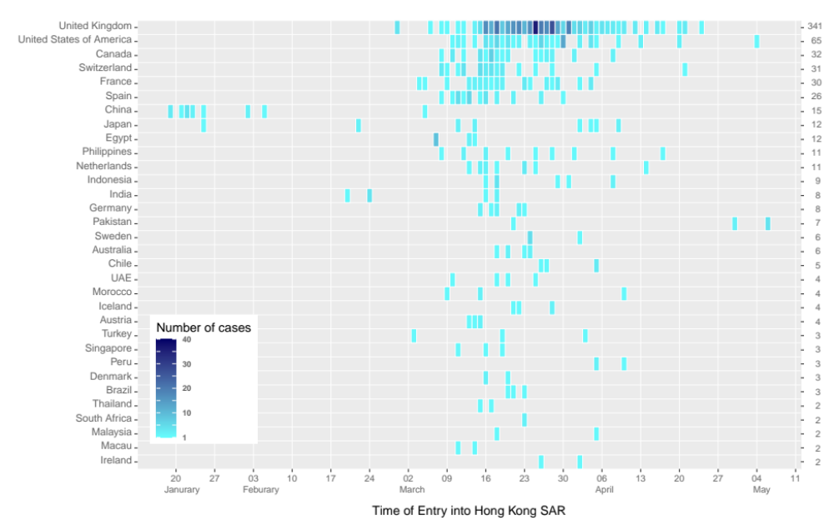
Figure S2. Posterior distribution of reproductive number of local cases from January 27 to February 7, 2020 (Available upon request for February 8 to April 18, 2020)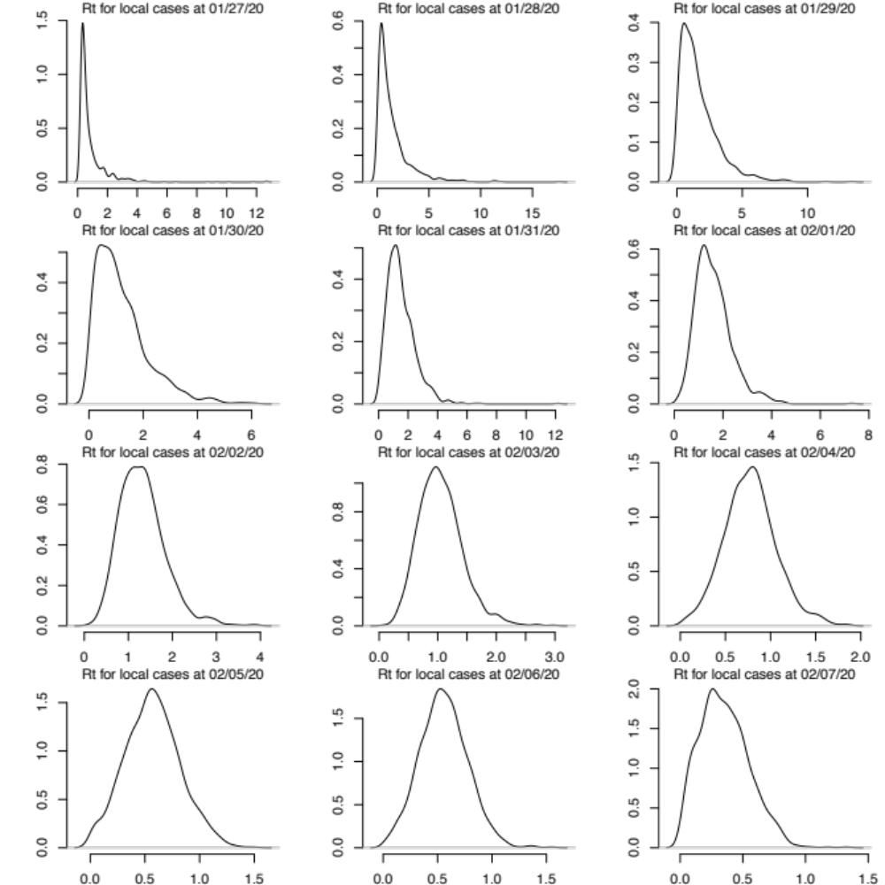

Figure S3. Traceplots of reproductive number of local cases from January 27 to February 7, 2020 (Available upon request for February 8 to April 18, 2020)
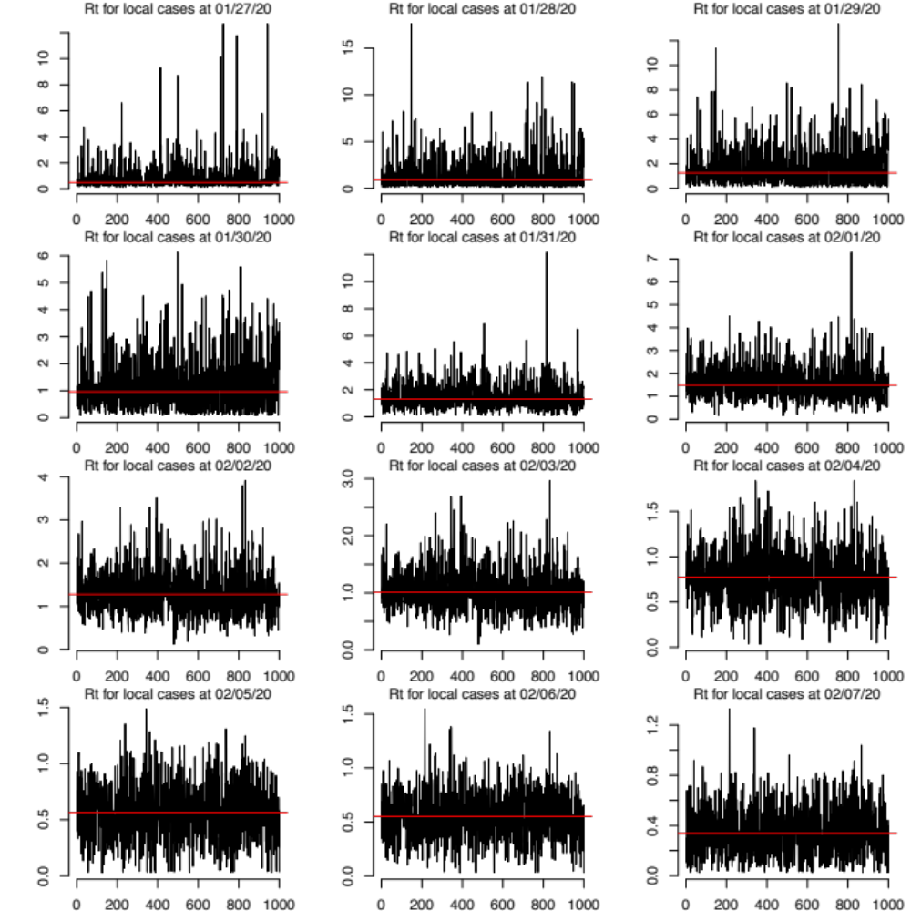

Figure S4. Posterior distribution of reproductive number of imported cases from January 27 to February 7, 2020 (Available upon request for February 8 to April 19, 2020)
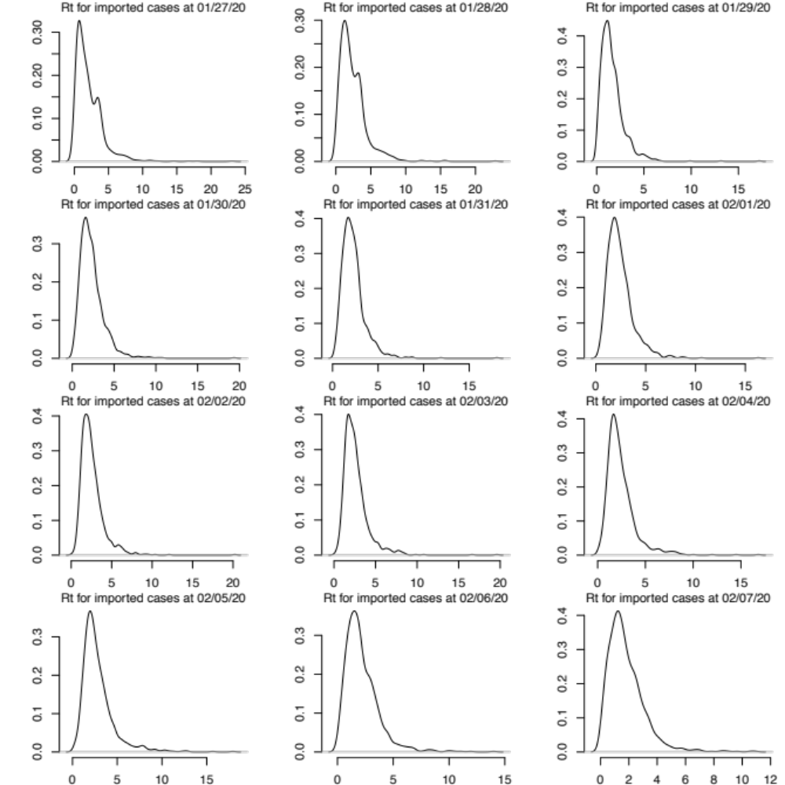

Figure S5. Traceplots of reproductive number of lmported cases from January 27 to February 7, 2020 (Available upon request for February 8 to April 29, 2020)
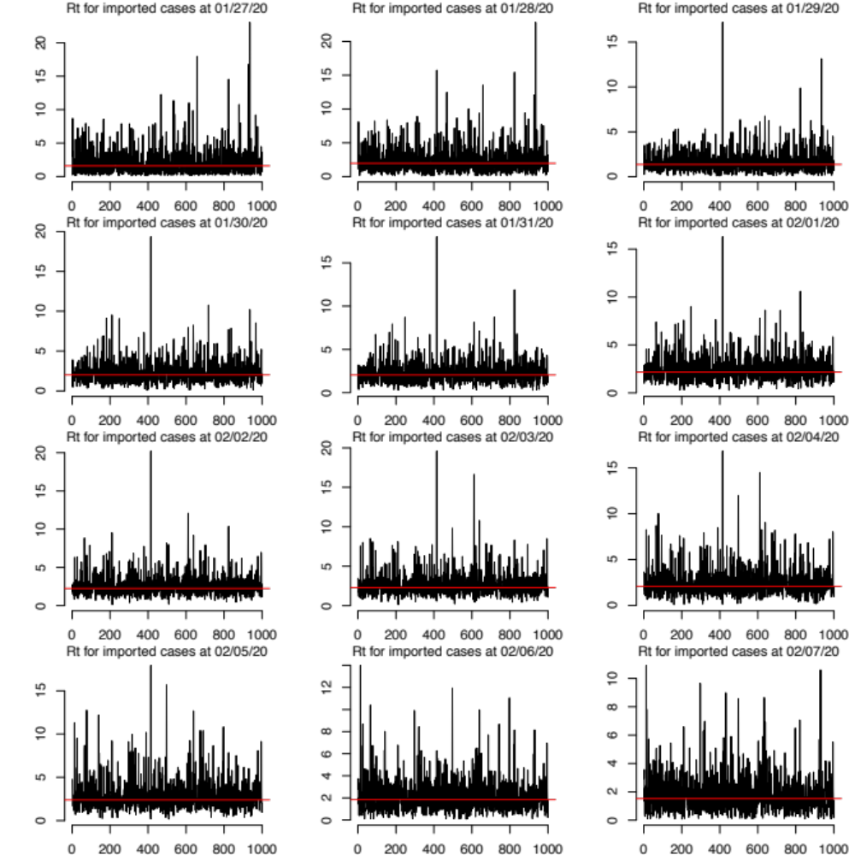
Table S1. Mean estimates of the effective reproductive number (R_{t}) for the time periods when different interventions were implemented in Hong Kong and the estimated effectiveness of each intervention measured by the reduction in Rt from a regression model.
Intervention | Intervention status | Mean R_{t} | Effectiveness*
Mandatory quarantine of travellers
Before Feb 8 | No | 2.00 (0.98, 4.42)
At or After Feb 8 | Yes | 0.40 (0.24, 0.74) | 95% (88%, 98%)
Civil servants working from home
Before Jan 29 | No | 1.10 (0.25, 4.02)
Jan 29 to Mar 1 | Yes | 0.66 (0.48, 0.88)
Mar 2 to Mar 20 | No | 1.19 (0.77, 1.97)
Mar 21 to May 8 | Yes | 0.48 (0.33, 0.60) | 67% (36%, 90%)
Additional physical distancing measures
(including closure of high-risk places/facilities)
Before Mar 28 | No | 0.94 (0.74, 1.32)
After Mar 28 | Yes | 0.21 (0.06, 0.39) | 58% (15%, 99%)
*effectiveness was defined in above section, which compares the incidence of COVID-19 during the specified study periods with and without the interventions.

REFERENCES
1. Cori A, Ferguson NM, Fraser C, Cauchemez S. A new framework and software to estimate time-varying reproduction numbers during epidemics. Am J Epidemiol 2013; 178(9): 1505-12.
2. Goldstein E, Dushoff J, Ma J, Plotkin JB, Earn DJ, Lipsitch M. Reconstructing influenza incidence by deconvolution of daily mortality time series. Proc Natl Acad Sci U S A 2009; 106(51): 21825-9.
3. Li Q, Guan X, Wu P, et al. Early Transmission Dynamics in Wuhan, China, of Novel Coronavirus-Infected Pneumonia. N Engl J Med 2020; 382(13): 1199-207.
4. Salje H, Cummings DAT, Rodriguez-Barraquer I, et al. Reconstruction of antibody dynamics and infection histories to evaluate dengue risk. Nature 2018; 557(7707): 719-23.

