Figure S1
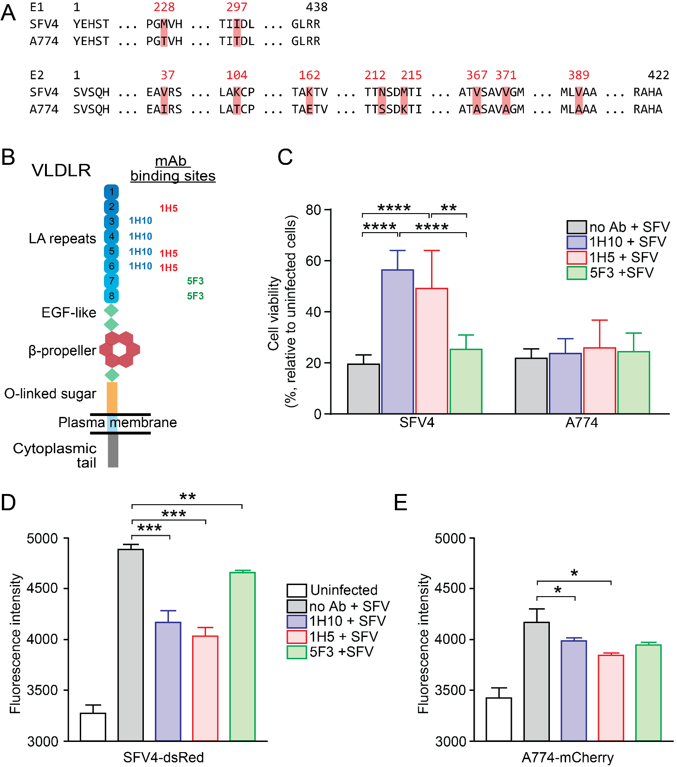

Figure S1. VLDLR LA-binding antibodies block infectivity of SFV4 but not A774. A, Alignment indicating differences (in red) in SFV4 and A774 structural E1 and E2 protein sequences. Residue numbers are indicated above the sequence. B, Schematic presentation of VLDLR and binding sites for the blocking monoclonal antibodies (mAb) 1H10, 1H5 and 5F3 in the VLDLR ligand-binding domain. C, Incubating HOS cells with VLDLR blocking antibodies reduces SFV4 (but not A774) infection. Cell viability of SFV4 or A774-infected (MOI=0.1) HOS cells pre-incubated with the LDLR class A specific mAbs 1H10, 1H5 or 5F3 in an attempt to block SFV entry. Cell viability was measured by MTT-assay 48h after infection. Means ± standard deviations from two experiments are shown (n=7). Statistical analysis is done using One-way ANOVA with Tukey’s multiple comparisons test. ****P<0.0001, **P<0.01. D and E, HOS cells were pretreated with monoclonal VLDLR blocking antibodies (1H10, 1H5 or 5F3) followed by infection with SFV4-dsRed or A774-mCherry using MOI 0.1 (n=3). Fluorescence intensity of viral expressed fluorophores (dsRed or mCherry) was measured with CLARIOstar plate reader 24h after infection. Statistical analysis is done using unpaired, two-tailed t-test as comparison to no Ab control. ***P<0.001, **P<0.01, *P<0.05.

Figure S2
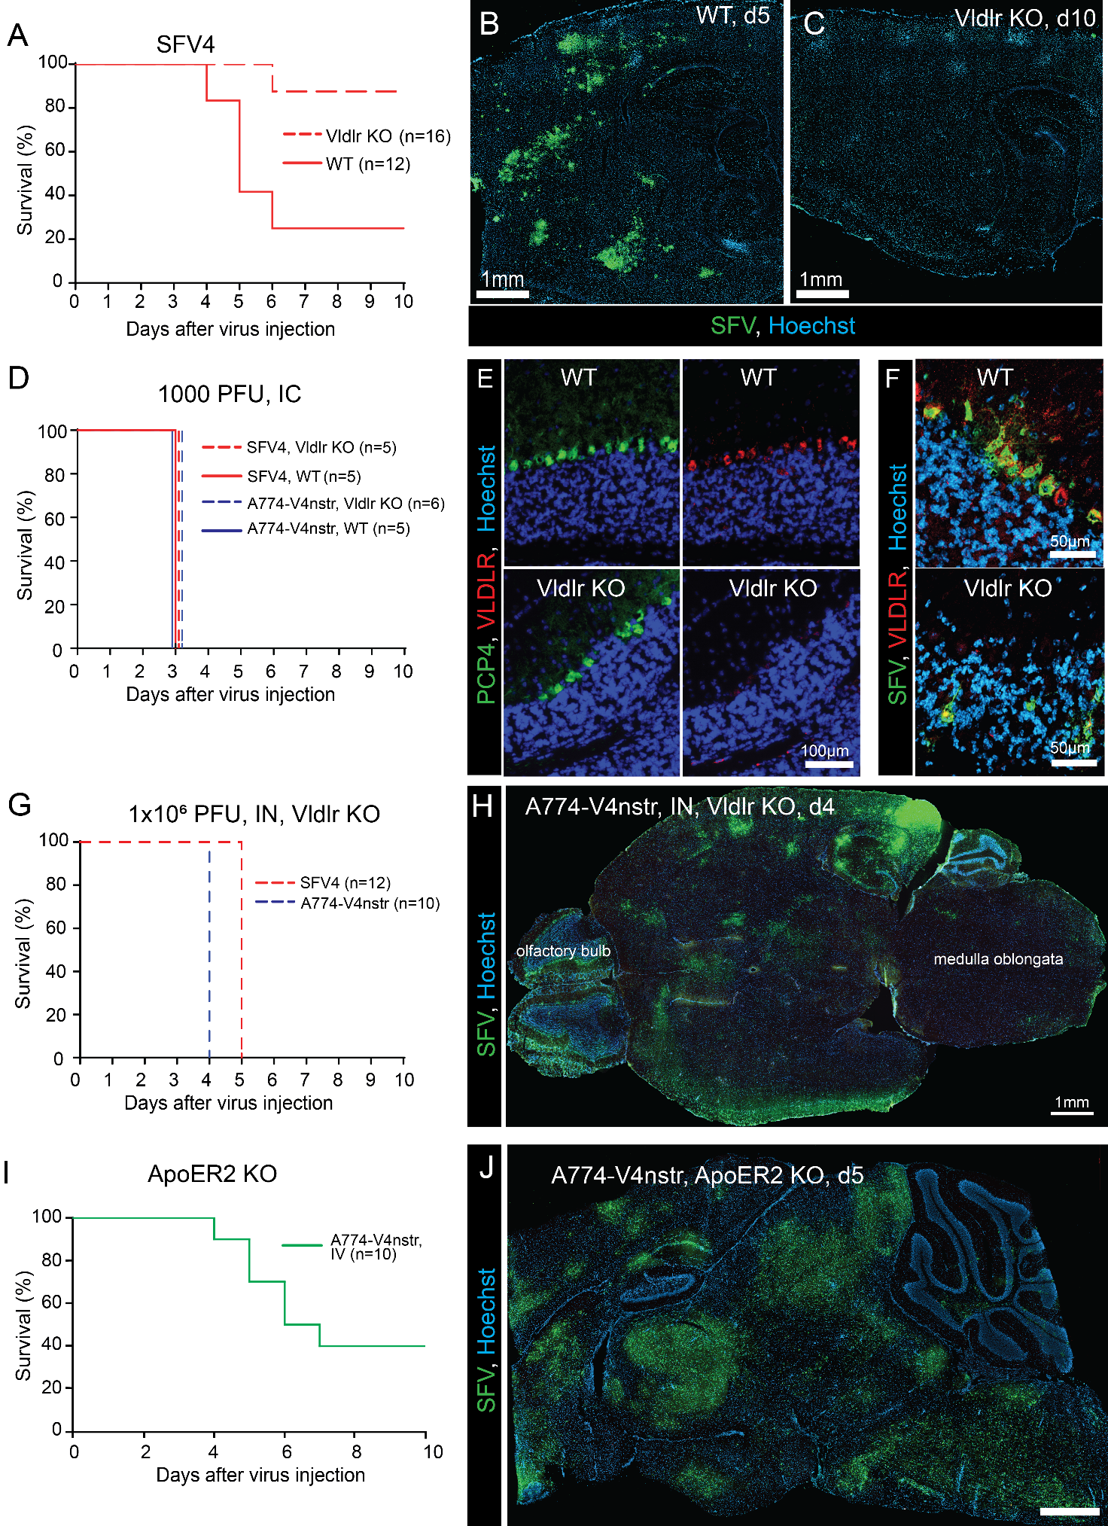
Figure S2: VLDLR^{-/-} mice are not protected against intracranial or intranasal SFV infections. A, Kaplan-Meier analysis of wild-type (WT) and Vldlr KO mice infected intravenously (IV) with SFV4 shows clear survival benefit in Vldlr KO mice. B-C, Representative immunostaining for SFV proteins in mouse brain at end point after IV SFV4 injection show expression of SFV proteins in WT (B) but not in Vldlr KO (C) mice. D, Kaplan-Meier survival analysis of WT and Vldlr KO mice intracranially (IC) injected with SFV4 or A774-V4nstr. All mice succumb to neurological symptoms. E-F, VLDLR expression correlates with SFV infectivity in Purkinje neurons in mice after IC SFV injection. Representative immunostainings of mouse cerebellum. Staining of Purkinje neurons with Purkinje Cell Protein 4 (PCP4) in WT and Vldlr KO mice. VLDLR expression of Purkinje neurons in WT but not in Vldlr KO mice. F, Representative immunostaining show SFV4 replication 3 days after intracranial injection in Purkinje neurons of WT mice but not in Vldlr KO mice. G, Kaplan-Meier survival analysis of Vldlr KO mice infected intranasally (IN) with SFV4 or A774-V4nstr. All mice succumb to neuropathogenicity. H, Representative immunostaining of Vldlr KO mouse brain (transverse plane) 4 days after IN A774-V4nstr injection. SFV staining can be seen in olfactory bulb but also in deeper in the brain tissues. I, Kaplan-Meier analysis of ApoER2 KO mice infected intravenously (IV) with A774-V4nstr. J, Representative immunostaining for SFV proteins in ApoER2 mouse brain at end point after IV A774-V4nstr injection.

Figure S3
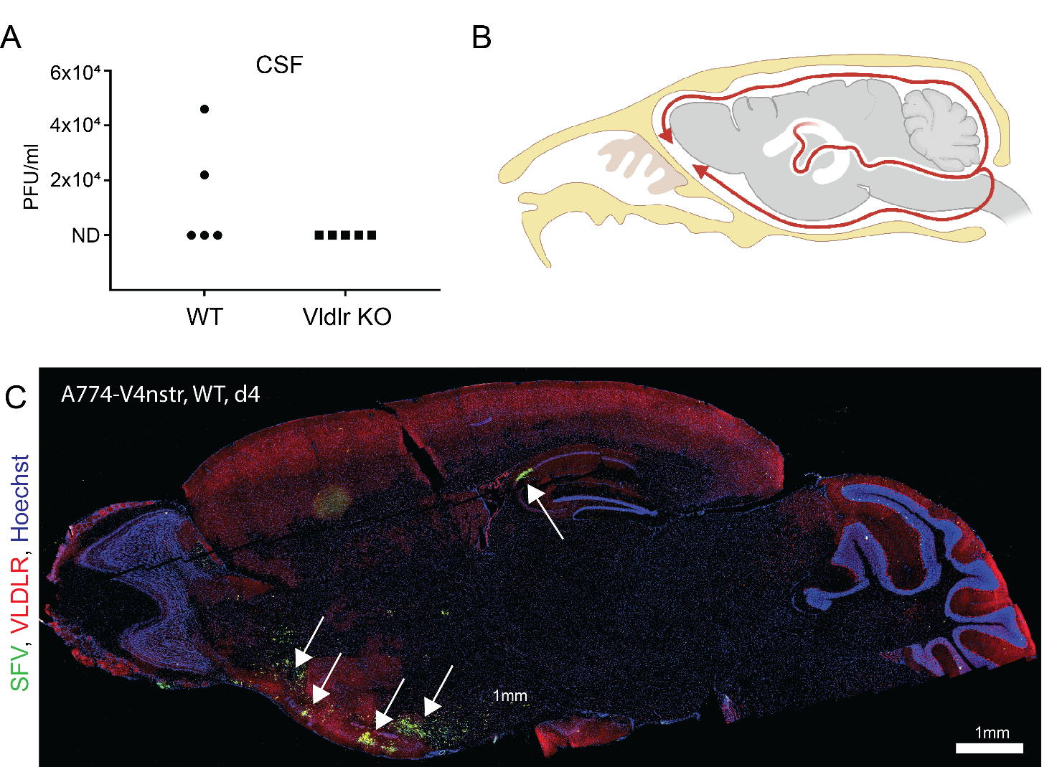
Figure S3. SFV invades the brain through the CSF. A, Plaque titration result from CSF samples collected 3 days after IV A774-V4nstr injection (1x10⁷ PFU) into WT and VLDLR^{-/-} mice (n=5). Virus can be detected in 2/5 WT samples but in none of the Vldlr KO samples. B, Schematic picture of CSF fluid flow in the mouse brain. C, Representative immunostaining for SFV proteins (green) in WT mouse brain at day 4 after IV A774-V4nstr injection show expression of SFV proteins in high VLDLR expressing ventral regions.

Figure S4
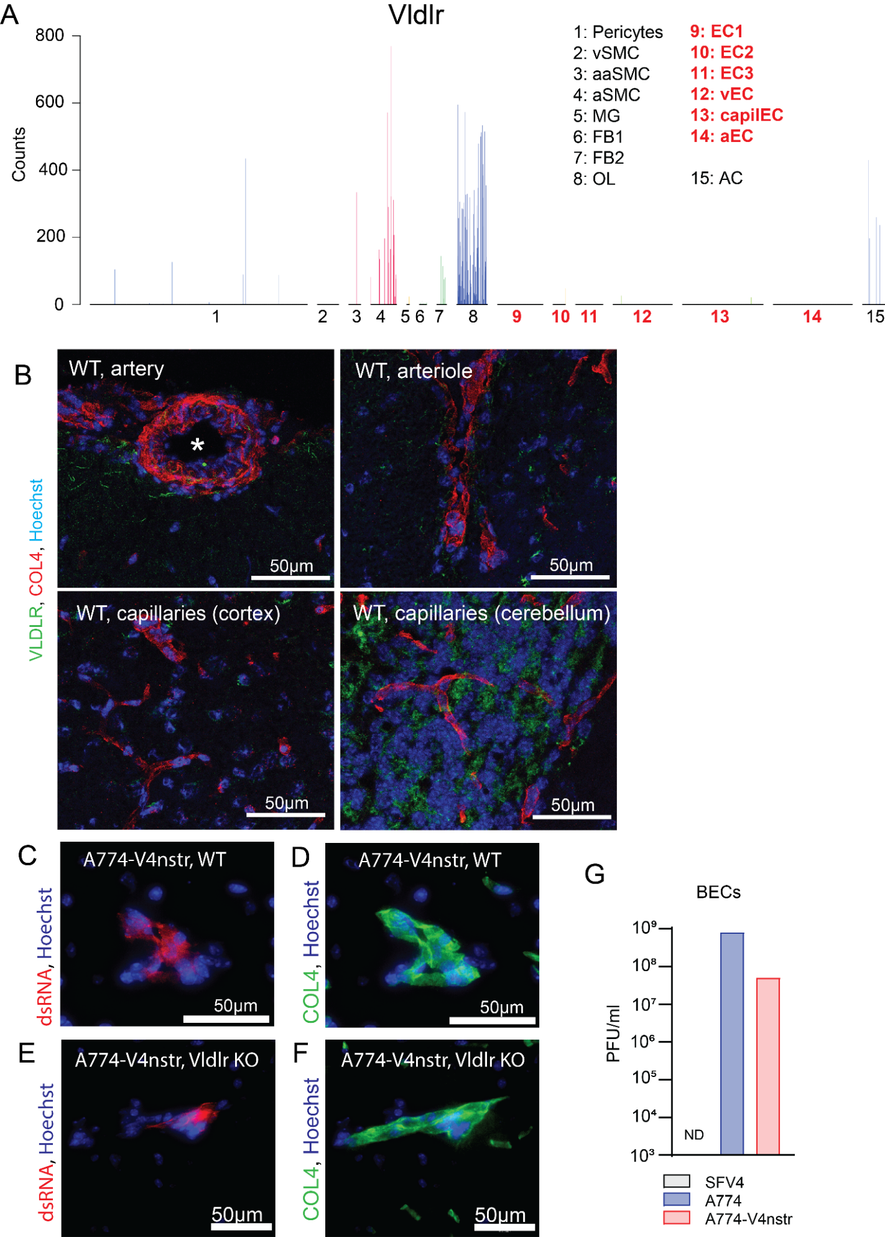
Figure S4. Mouse brain endothelial cells lack VLDLR expression. A, single cell RNAseq data reproduced from “Database of gene expression in adult mouse brain and lung vascular and perivascular cells” (http://betsholtzlab.org/VascularSingleCells/database.html.) ^{14, 15}. VLDLR is clearly absent in all endothelial cell populations (9-14, indicated with red numbers). B, Representative immunostainings for VLDLR in artery (lumen indicated with star), arteriole and smaller capillaries in WT mouse brain. VLDLR-expressing cells can be seen close to type IV collagen (COL4)-coated vessels but not inside the vessels. C-F, Representative immunostainings showing A774-V4nstr infection (dsRNA staining) in basement membrane (collagen IV) surrounding BBB cells (consisting of endothelial cells, pericytes and astrocyte endfeets) 2 days after IV injection in WT (C and D) and Vldlr KO mouse (E and F). G, Analysis of SFV infectivity in isolated mouse brain endothelial cells. Plaque titration of supernatant collected 48 hours after MOI = 0.01 infection with SFV4, A774 or A774-V4nstr. No virus can be detected after SFV4 infection. ND: not detected. Abbreviations: PC - Pericytes; SMC - Smooth muscle cells; MG - Microglia; FB - Vascular fibroblast-like cells; OL - Oligodendrocytes; EC - Endothelial cells; AC - Astrocytes; v - venous; capil - capillary; a - arterial; aa - arteriolar; 1,2,3- subtypes.

Figure S5
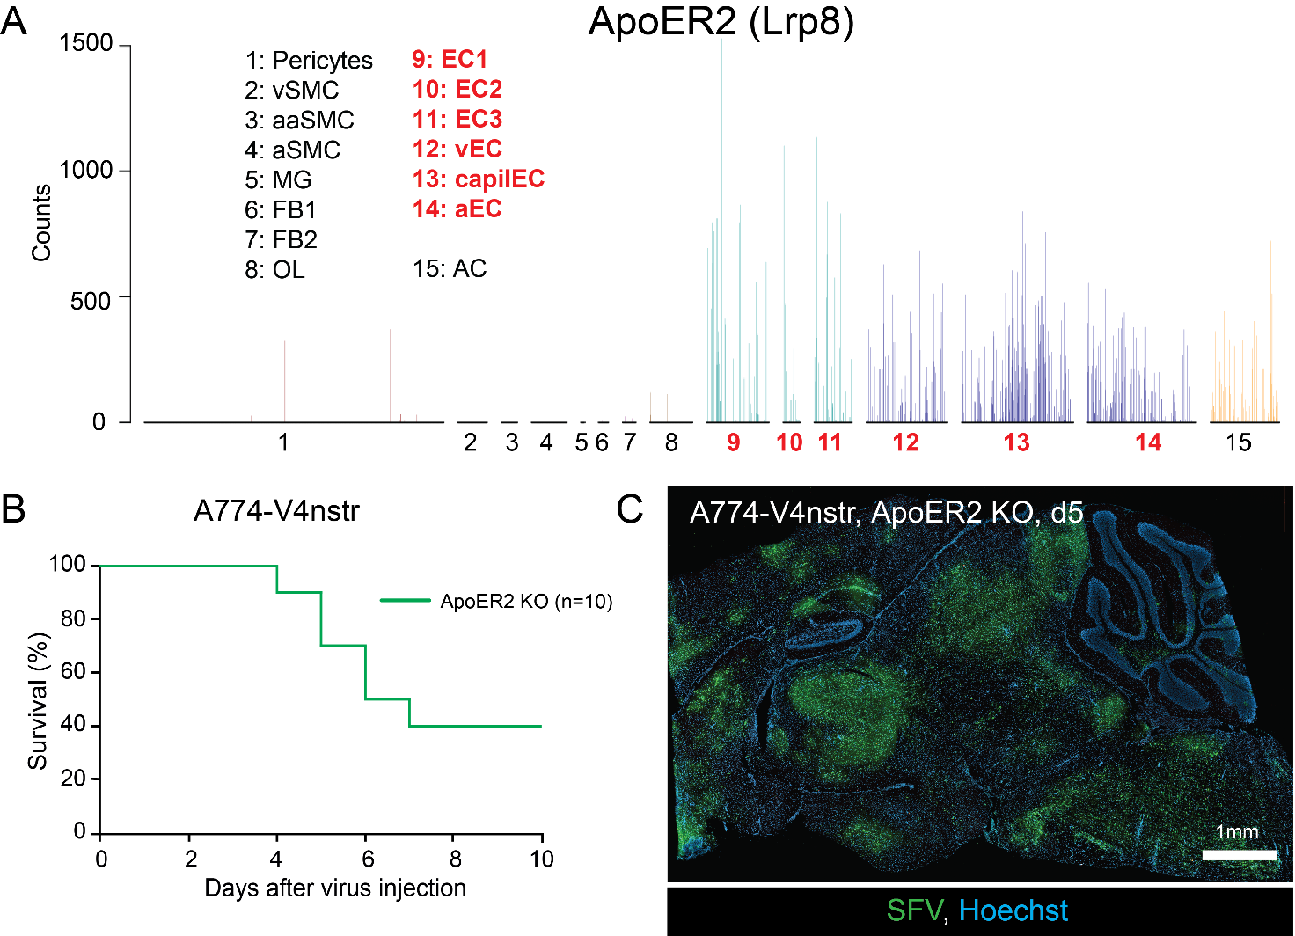
Figure S5. ApoER2-/- mice are not completely protected against intravenous SFV infection. A, single cell RNAseq data reproduced from “Database of gene expression in adult mouse brain and lung vascular and perivascular cells” (http://betsholtzlab.org/VascularSingleCells/database.html.) ^{14, 15}. ApoER2 is clearly expressed in all endothelial cell populations (9-14, indicated with red numbers). B, Kaplan-Meier analysis of ApoER2 KO mice infected intravenously with A774-V4nstr (1x10⁶ PFU). C, Representative immunostaining for SFV proteins in mouse brain at end point (day 5) after IV A774-V4nstr injection in ApoER2 KO mouse, shows presence of virus throughout the brain. Abbreviations: PC - Pericytes; SMC - Smooth muscle cells; MG - Microglia; FB - Vascular fibroblast-like cells; OL - Oligodendrocytes; EC - Endothelial cells; AC - Astrocytes; v - venous; capil - capillary; a - arterial; aa - arteriolar; 1,2,3- subtypes.

Figure S6
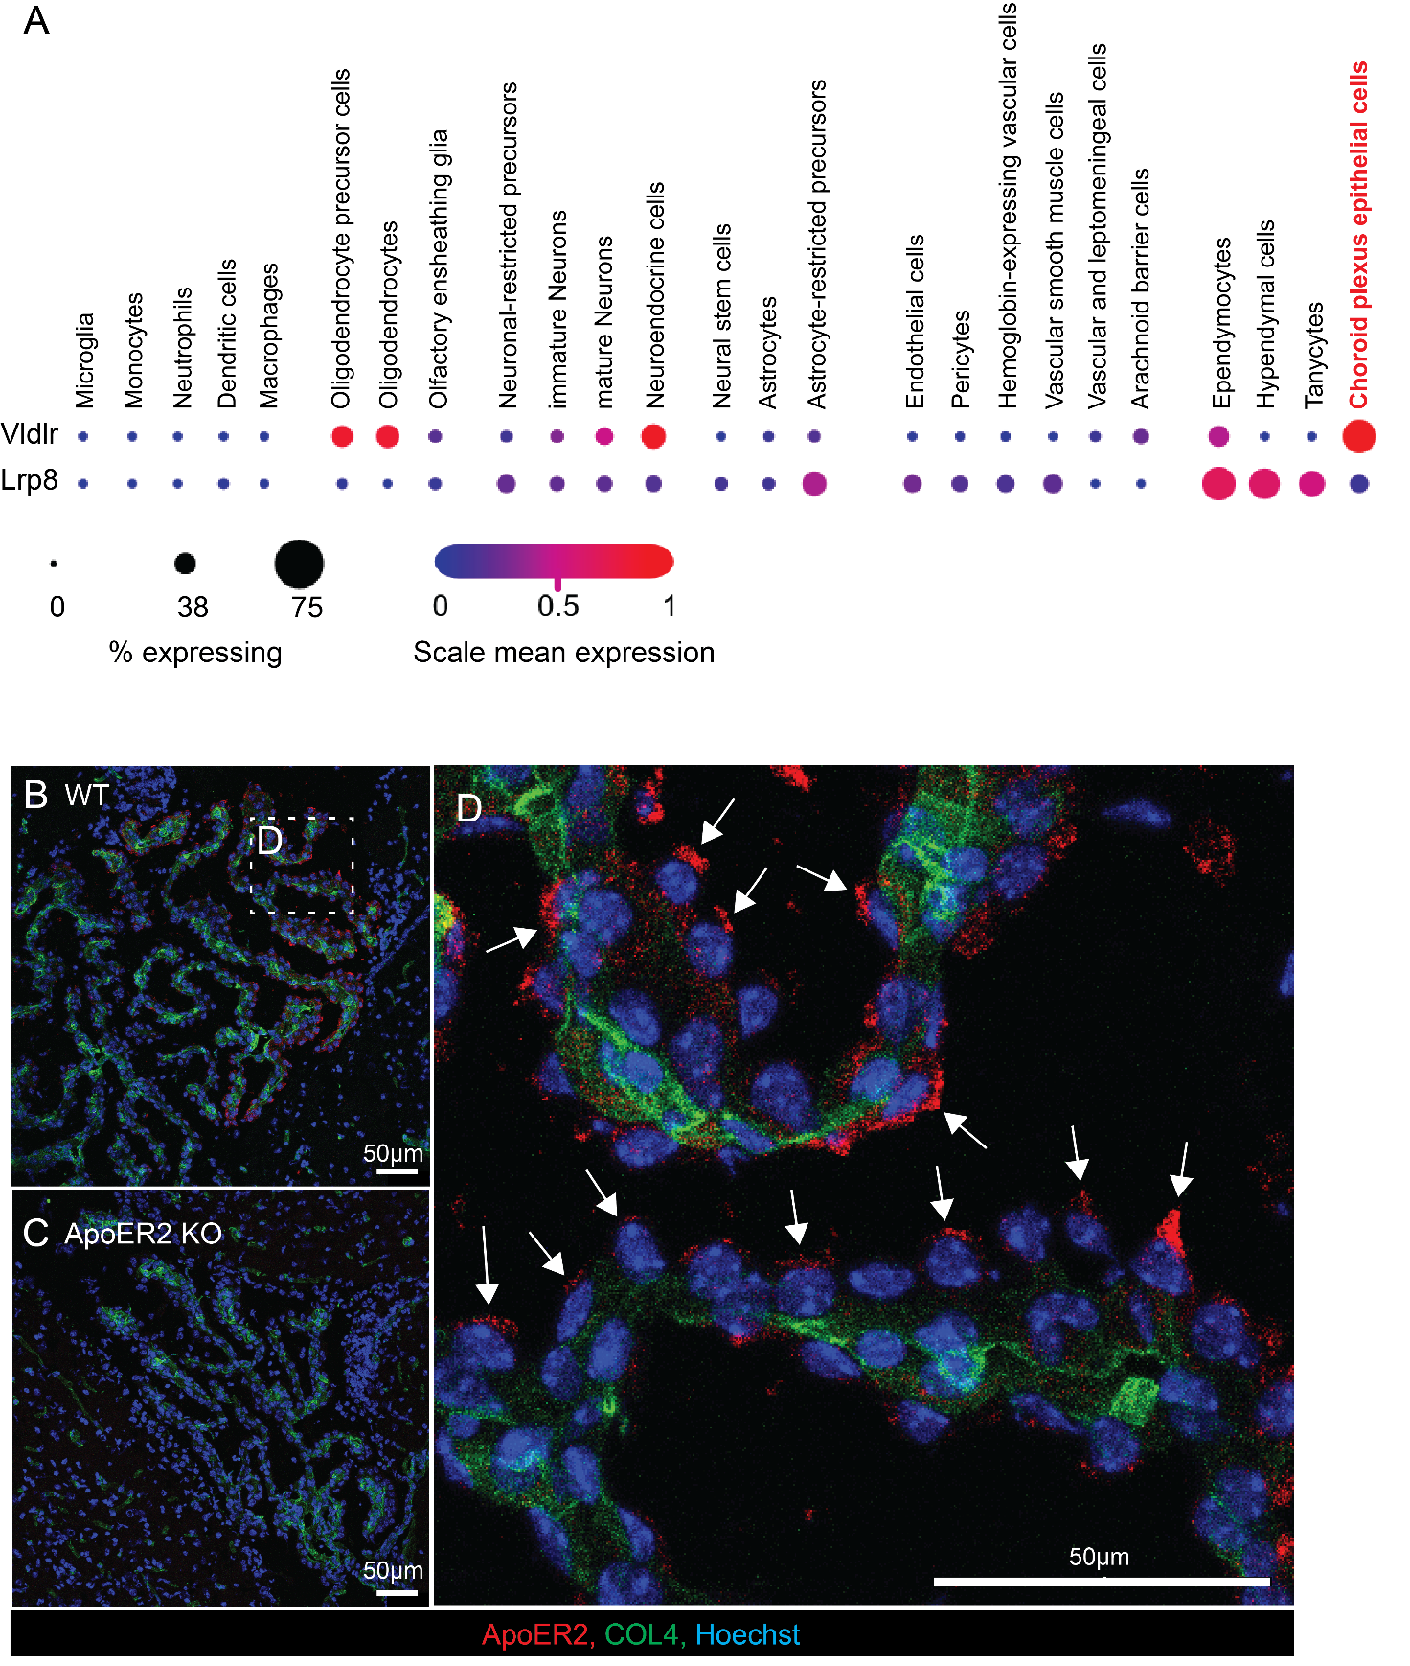
Figure S6. ApoER2 expression in choroid plexus epithelial cells has apical polarity. A, single cell RNAseq dot plot data (reproduced from “A single-cell transcriptomic atlas of the aging mouse brain” https://singlecell.broadinstitute.org/single_cell/study/SCP263/aging-mouse-brain ²²) showing expression of Vldlr and Lrp8 in different cell types in mouse brain (2-3 month old WT mouse). Choroid plexus epithelial cells (red) show notable Vldlr^{high}/Lrp8^{low} expression profile. B-D, Representative immunostaining of mouse choroid plexus. ApoER2 seen on epithelial cells in WT (B) but not ApoER2 KO (C) sample. D, Magnified insert from B (indicated with box), show apical ApoER2 polarization in epithelial cells (indicated with arrows).

