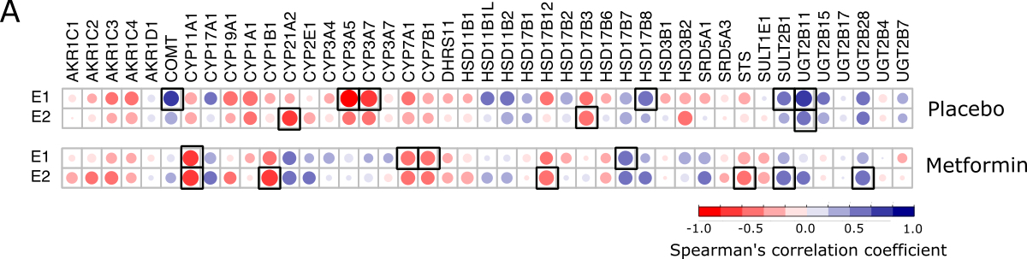
Figure S4. A. The heat map showing Spearman’s rank correlation between breast tissue expression of the genes involved in the steroid biosynthesis and metabolism and serum levels of E1 and E2 in the postmenopausal placebo- and metformin-treated participants. The circles sizes and colors represent the correlation coefficients. Significant correlated genes are marked with squares. The genes with standard deviation equal to zero were excluded in this analysis.

