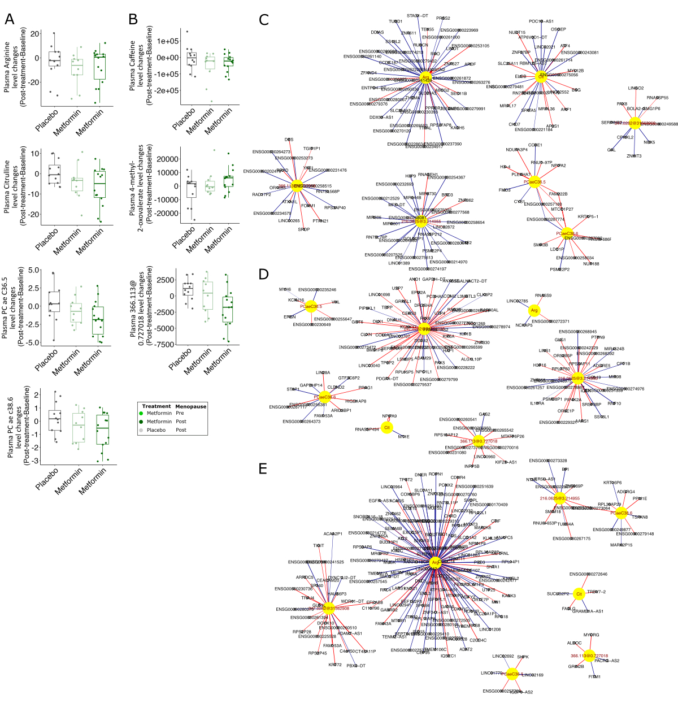

Figure S2. A-B. The box plots showing significantly modified metabolites comparing metformin- vs. placebo-treated groups (p <0.05) that were also found in the pooled RFH + MetBreCS study using targeted (A) and untargeted (B) metabolomics approaches. The multivariable linear model fit test (Metformin vs Placebo) results are presented in Table S2.

C-E. Highly correlated (Spearman´s correlation coefficient >0.8, p-value <0.05) breast tissue gene expression with the metformin-associated plasma metabolites shown in A-B. C, D and E show the highly correlated gene transcripts in the placebo-treated, pre- and postmenopausal metformin-treated groups, respectively. Positively and negatively correlated genes are shown in blue and red lines, respectively. The thickness of the lines represents the correlation coefficient values.

