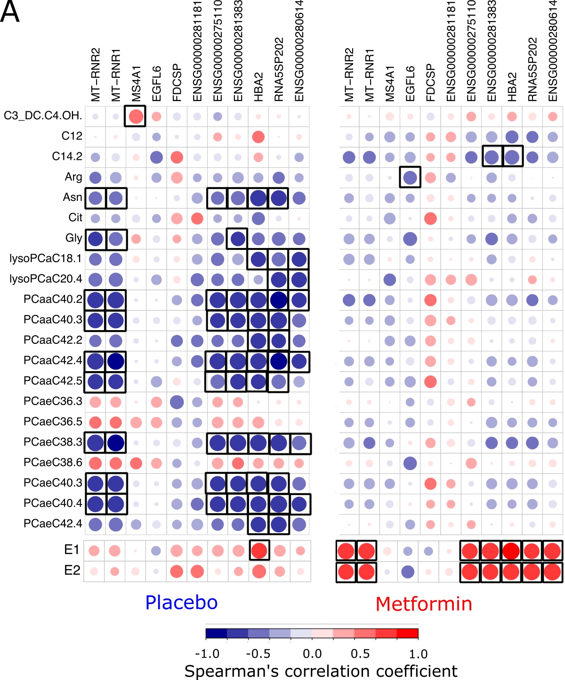
Figure S3. A. The heat map showing Spearman´s correlation between the differentially expressed breast tissue genes and the circulating levels of significantly altered metabolites (p <0.05), E1 and E2 in the postmenopausal metformin- vs. placebo-treated groups. The circle size and color represent the correlation coefficient as shown in the color bar. Significant correlated genes (p <0.05) are marked with squares.

