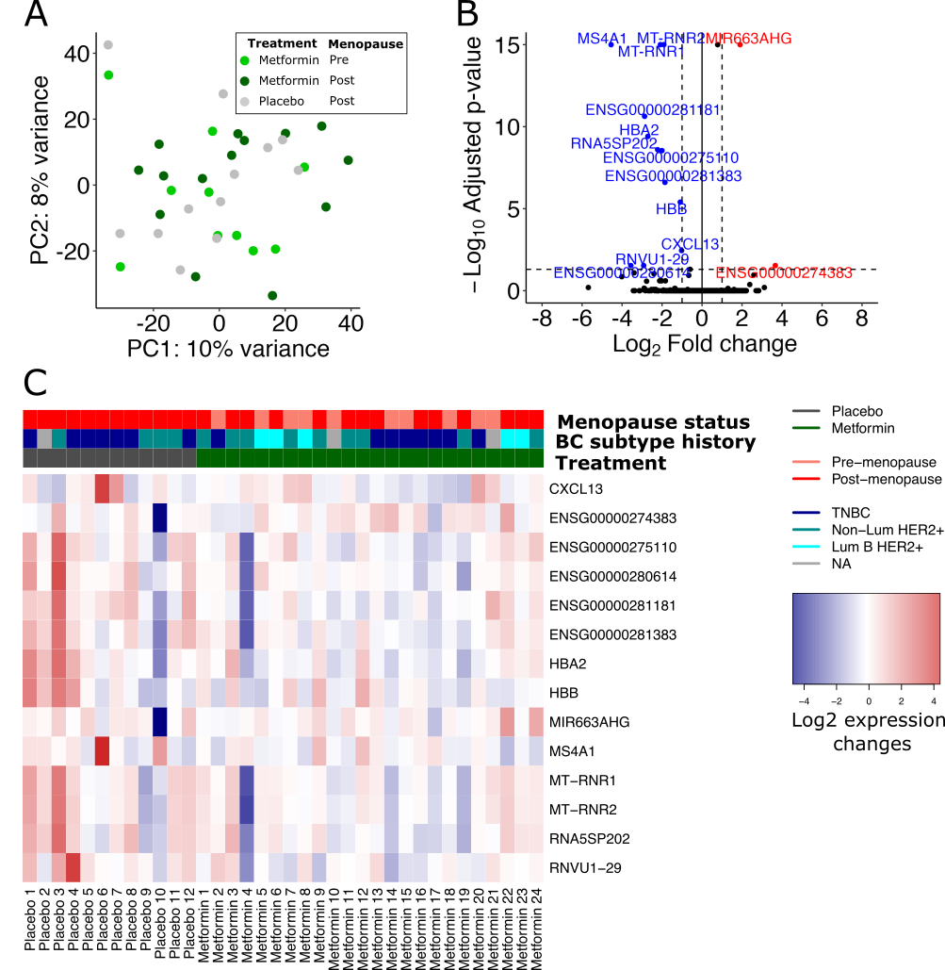

Figure S1. A. Principal component analysis of the normalized gene expression profiles of the pre- and postmenopausal participants in the MetBreCS trial. The transcriptomics profile changes (post-treatment – baseline) are shown in two representative principal components (PC1 and 2). Each color shows the treatment groups (placebo and pre- and postmenopausal metformin).
B. Volcano plot showing differentially expressed genes comparing the transcriptomic profile of pre- (n=10) and postmenopausal (n=14) metformin- vs. postmenopausal placebo-treated (n=12) groups using time course likelihood ratio test. The significant (adjusted p-value <0.01) over-expressed genes (red) are represented as log2 fold changes comparing metformin vs. placebo >1.0 and down-regulated (blue) as log2 gene expression changes <1.0.
C. Heatmap presenting the log2 gene expression change (post-treatment – baseline) of the differentially expressed genes in panel B. The values are centered on the median of each gene expression changes.

