Hanging glacier avalanche (Raunthi gad-Rishiganga) and Debris flow disaster of 7th February 2021, Uttarakhand, India, A Preliminary assessment
Renoj J. Thayyen^{1*}, P.K Mishra¹, Sanjay K. Jain¹, John Mohd Wani¹, Hemant Singh¹, Mritunjay K. Singh^{1,2} and Bankim Yadav³
Correspondence to: renojthayyen@gmail.com
Supplementary material

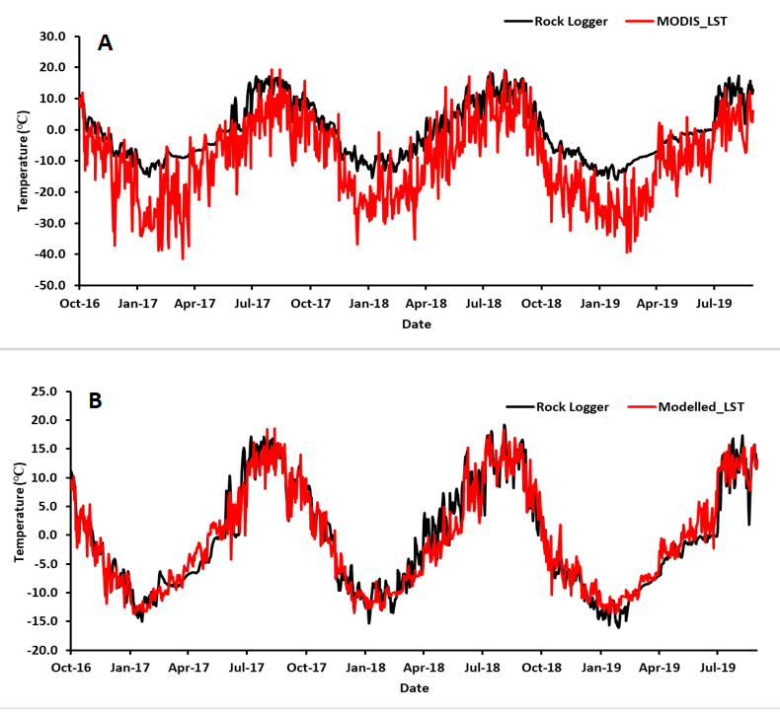

Figure S1: a) Comparison of MODIS LST (MODIS_LST) and ground temperature measured on a bed rock (Rock logger) in Leh, Ladakh by a GeoPrecission M-Log5W-CABLE logger. (b) comparison of modelled LST (Modelled_LST) and ground temperature measured on a bed rock (Rock Logger) in Leh, Ladakh by a GeoPrecission M-Log5W-CABLE logger.

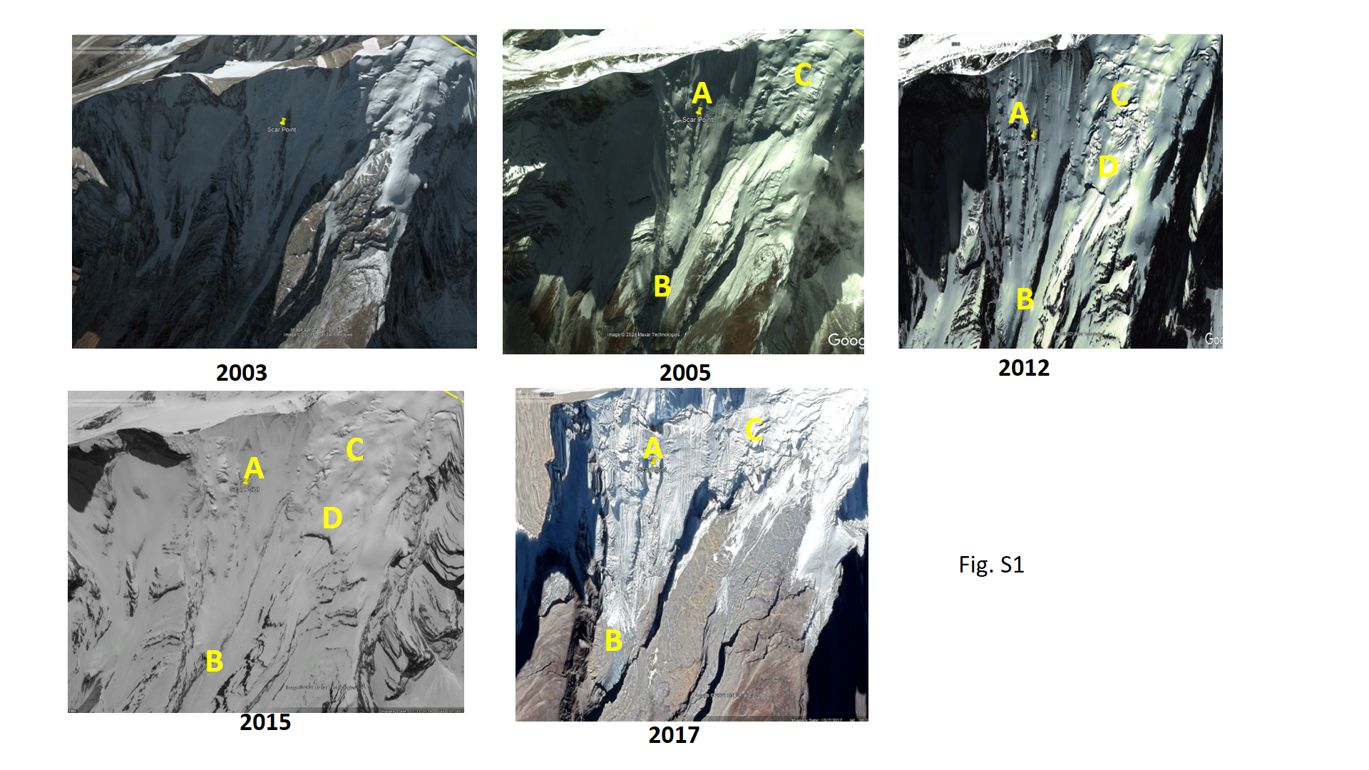
Figure S2: Images of hanging glacier from 2003 to 2017 showing the shrinkage mostly on the left and frontal margins with a steady right lobe. A) accumulation zone B) tongue of the glacier which progressively detached from the bed by warming of the surrounding rock mass C) left flank of the glacier which showed surge type advancement during 2012-2015, D) area detached during 2015-17 period.
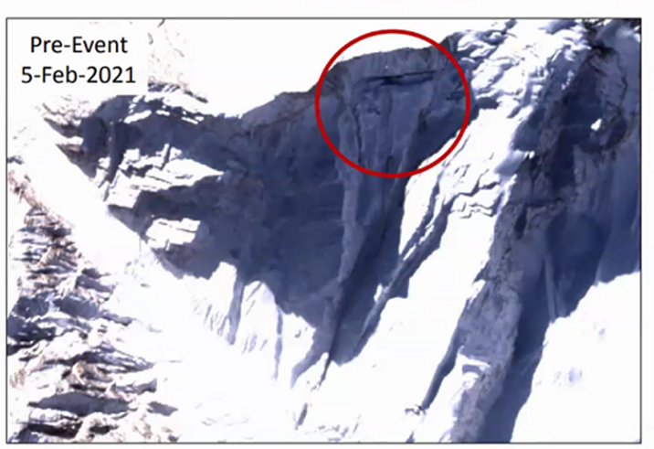
Figure S3: Satellite image showing the snow accumulation over the hanging glacier on 5th February 2021. A well-developed crevasse along the beschurund is also visible.
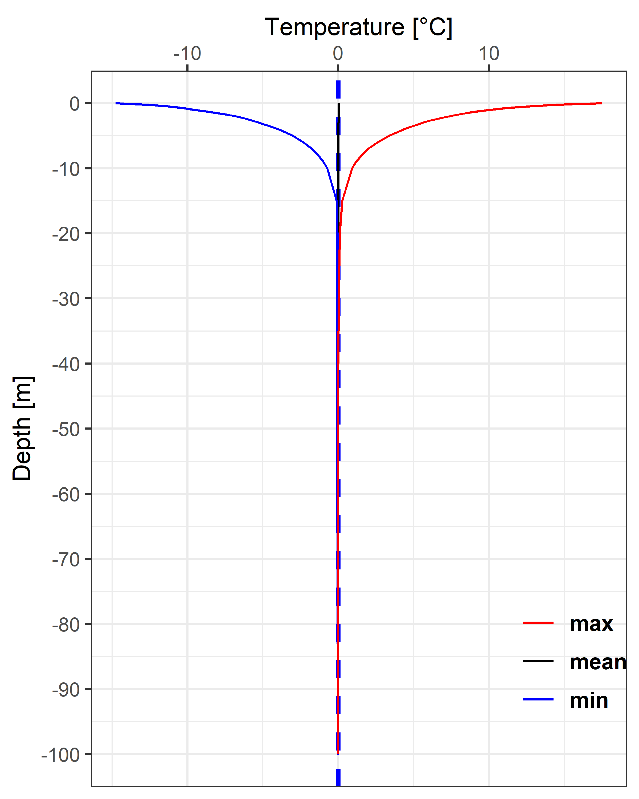
Figure S4: Thermal envelop curve for study site showing warm permafrost below 50 m depth

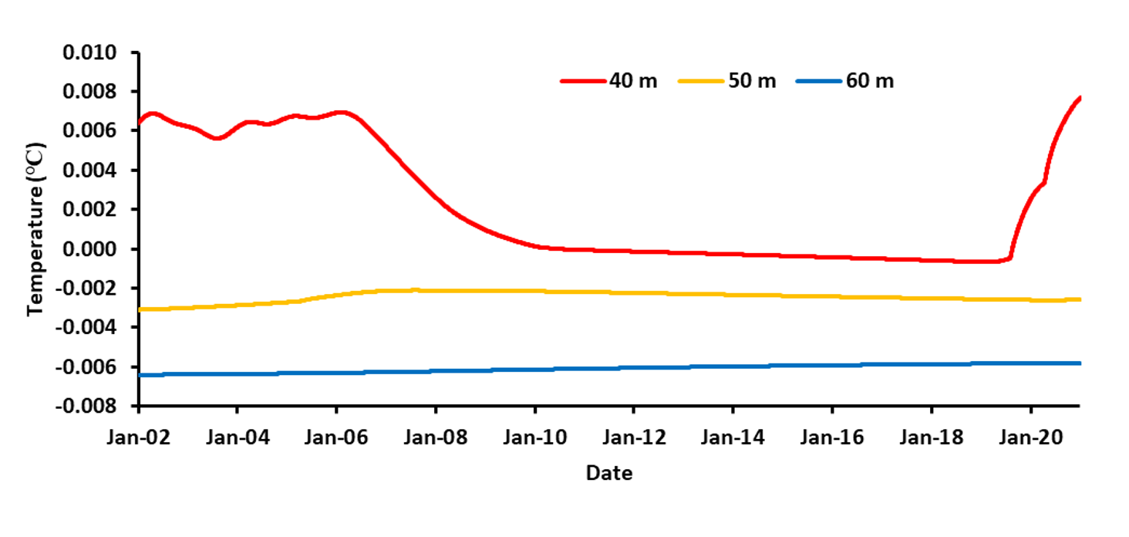
Figure S5: Modelling show the permafrost conditions below 50 m and alternating regime at 40 m. Recent warming at 40 m which peaked in December-February is clearly illustrated.

Figure S6: Hydrograph generated using SCS Dimensionless UH approach

Table S1: Initial MODIS SCPs (MOD10A1 and MYD10A1) classes reclassified in to new classes
Initial Class | Initial Class Value | Re-Classified into | Re-Class Value
No-snow | 0 | No-Snow | 1
Snow | 0-100 | Snow | 2
Missing data | 200 | Cloud | 0
No decision | 201 | Cloud | 0
Night | 2011 | Cloud | 0
Inland Water | 237 | No-Snow | 1
Ocean | 239 | No-Snow | 1
Cloud | 250 | Cloud | 0
Detector Saturated | 254 | Cloud | 0
Fill | 255 | Cloud | 0

