A Potent Athero-protective Nanovaccine Cocktail by Two-Pronged Intracellular Delivery of Antigen and Adjuvant for Dendritic Cell Activation

Keywords: Nanovaccine, atherosclerosis, p210, cellular delivery, iron oxide

Materials and Methods
Materials. Polyethylene glycol 2000 (OH-PEG₂₀₀₀-OH), potassium bromide (KBr, ≥99.0%), 2,2,6,6-tetramethyl-1-piperidinyloxy (TEMPO, 98%), iron (III) acetylacetonate [Fe(acac)₃, ≥99.0%], and oleylamine (technical grade, 70%) were purchased from Sigma-Aldrich (US). Sodium hypochlorite solution (HClO, ~8%), diphenyl ether (≥99.9%), N-hydroxysuccinimide (NHS), 1-Ethyl-3-(3-dimethylaminopropyl) carbodiimide (EDC), and N,N’-dicyclohexylcarbodiimide (DCC) were purchased from Aladdin Chemicals Co., Ltd (China). All the organic solution including diethyl ether, N,N-Dimethylformamide (DMF) and ethanol (EtOH) were purchased from Macklin Chemicals Co., Ltd (China). All the chemicals were used without purification if no further specification was given.
Synthesis of PEG-SP. SPIONs coated with carboxyl-terminated PEG (Mw=2000) were prepared by thermal decomposition method according to previous study.¹ Typically, 525 mg of ferric acetylacetonate [Fe(acac)₃], 6.0 g of dicarboxyl-terminated PEG (HOOC-PEG₂₀₀₀-COOH) (prepared by oxidation of HO-PEG₂₀₀₀-OH with TEMPO following previous protocol²), and 2.0 mL of oleylamine were added in 25.0 mL of diphenyl ether. After aging the mixture at 80 °C under nitrogen for 4 h, the reaction was heated to 260 °C at a rate of 10 °C/min and kept at reflux for 30 min. By redispersing the product in ethanol and precipitating with chilled diethyl ether (RCI Labscan) for three cycles, the PEG-SPs were purified, dialyzed against deionized water (D.I. water) for 48 h, filtered a via 0.22 μm syringe filter, and freeze-dried. The lyophilized particles were tightly sealed and stored at -80°C until used.
Preparation of SPION-based nanovaccines. Typically, 10 mg of PEG-SPIONs were dissolved in 1 mL of anhydrous DMSO, activated with 40 μmol of DCC and 60 μmol of NHS for 2 h before 6 nmol of CpG-ODN (thiol-modified oligodeoxynucleotide CpG 1826, 5’-tcc atgacgttcctgacgtt), 6 nmol of p210 (KTTKQ SFDLS VKAQY KKNKH), or mixture of CpG-ODN and p210 were added (total 12 nmol), which yield to SP-D, SP-P, and SP-DxPy, respectively. The mixture was sonicated for 30 mins and left on an orbital shaker for 8 h. After dialyzing against distilled water for 48 h, the nanoparticles were filtered with 0.22 μm syringe filter and freeze-dried. SP-Dx+Py was prepared as physical mixture of SP-D and SP-P at a molar ration of x to y.
Characterizations of PEG-SP and SPION-based nanovaccines. The size and morphology of the PEG-SPs were determined by TECNAI G2 20 transmission electron microscope (TEM) (LaB6, FEI Netherlands). The hydrodynamic sizes and zeta potentials of the nanoparticles were tested in both water and complete cell culture medium using Zetasizer Nano ZS90 (Malvern, UK). The magnetic property of the lyophilized PEG-SPs was measured by using a vibrating sample magnetometer (VSM, HH-15).Magnetization was measured over a range of applied field from -6,000 Oe to 6,000 Oe at 300 K. The thermogravimetric analyses (TGA) of the dried samples were performed using a thermo-gravimetric analyzer (SDTA 851e, Mettler Toledo, Switzerland) at a heating rate of 10 °C/min from room temperature to 600 °C under nitrogen flow. The surface coating of the nanoparticles was recognized by Fourier transform infrared spectroscopy (Nicolet iS20, ThermoFisher, USA) ranging from 500 cm⁻¹ to 4000 cm^{–1} with a step size of 4 cm⁻¹. The gel electrophoresis of nanoparticles was performed in 0.5% agarose gel soaked in 1% TAE buffer at 120V for 20 mins.
Culture of bone morrow-derived dendritic cells (BMDCs). Monocytes were isolated from the femurs and tibias of C57BL/6 mice at age of 4-6 weeks and differentiated to BMDCs according to previous protocol.³ Cells were cultured at a density of 10⁶/mL in RPMI medium (Thermo Fisher Scientific) supplemented with 10% FBS (Gibco), 10 units/mL penicillin, 10 μg/mL streptomycin, 50 μM β-mercaptoethanol (β-ME) (Gibco), 2 mM L-glutamine (Gibco) and 20 ng/mL murine GM-CSF and 10 ng/mL murine IL-4 (Novoprotein Technology, China) at 37°C and 5% CO₂. Fresh medium containing the same concentration of growth factors was added to cells on Day 3 and Day 7. On Day 8, the cells were ready to use.
Cell proliferation study. BMDCs were seeded in a 96-well plate at a density of 5.0×10⁵ cells per well in 200 μL complete RPMI medium for 24 h at 37 °C. The SPION-based vaccines were added at different concentrations (0-1000 μg/mL) to the BMDCs and incubated for 24 h before the Cell Counting Kit-8 (CCK-8) (Apexbio, USA) was performed according to the manufacturer’s protocol.
BMDCs in vitro activation. BMDCs were seeded in a 24-well plate at a density of 1.0×10⁵ cells per well in 1 mL complete RPMI medium for 24 h at 37 °C. Next, the cells were treated with various SPION-based vaccines (200 μg/mL) or the counterparts without nanoparticle conjugation (500 nM for CpG-ODN and p210; 1μg/mL for LPS) for 24 h or 72 h. The cells were then collected with cold PBS treatment for flow cytometric analysis or quantification of Fe content by inductively coupled plasma mass spectrometry (ICP-MS).
To check the surface expression of different markers, the collected cells were stained with Fc blocker (anti-mouse CD16/32, BioLegend; 101302) together with APC anti-mouse CD11c (BioLegend; 117310), FITC anti-mouse CD40 (BioLegend; 124607), FITC CD80 (B7-1) monoclonal antibody (16-10A1) (Invitrogen, ThermoFisher; 11-0801-82), PE anti-mouse CD86 (BioLegend; 105105), PE MHC Class I (H-2Kb) monoclonal antibody (AF6-88.5.5.3) (Invitrogen, ThermoFisher; 12-5958-82), or FITC MHC Class I (I-A/I-E) monoclonal antibody (M5/114.15.3) (Cell Signaling Technology; 42594S) before staining with Zombie Aqua fixable viability dye (BioLegend; 423101). Finally, the cells were resuspended in 200 μL FACS buffer for flow cytometry analysis. To quantify the cellular uptake of Fe in each treatment, the cells from each well were digested with distilled nitric acid for 12 h, diluted with deionized water to 2% HNO₃ solution, and analyzed with ICP-MS (i CAP Q, ThermoFisher, USA).
For cytokine expression, the cells were incubated with SPION-based vaccines (200 μg/mL) or the counterparts without nanoparticle conjugation (500 nM for CpG-ODN and p210; 1μg/mL for LPS) for 24 h. The supernatants were collected and the cytokine levels (TNF-α, IL-6, and IL-12p70) were tested with individual enzyme-linked immunoassay (ELISA) kits according to the manufacturer’s protocol (Multisciences Biotech, China).
Cell uptake, pharmacological inhibition, and intracellular trafficking. The nanvaccines made from Quasar 670-labeled CpG-ODN and FITC-tagged p210 were added to the BMDCs pre-seeded on coverslips in 24-well plates and incubated for different durations of time. The cells were then fixed with 4% paraformaldehyde (PFA), washed with PBS three times, stained with Hoechst 33342 (Beyotime, China) and mounted with Fluoromount-G mounting medium (Absin, China).
For pharmacological inhibition study, BMDCs were pre-treated with cell culture medium containing different concentrations of chemical blockers or blocking antibodies for 1 h. These blockers include fucoidan (50 μg/mL, Yuanye Bio-Technology, China), mannan (1 mg/mL, Yuanye Bio-Technology, China), amiloride (500 μg/mL, Glpbio, USA), antibody against CD16/32 (10 μg/mL, BioLegend; 101302). After removing the inhibitor-containing medium, 0.3 mL of serum-containing cell culture medium that contains the same inhibitor at the original concentration and 200 μg/mL of SP-P, SP-D, SP-D1P1, and SP-D1+P1 were subsequently added to the cells. After 4 h of incubation, the medium was removed, and the cells were rinsed with PBS. The cells were then fixed with 4% paraformaldehyde (PFA), washed with PBS three times, stained with Hoechst 33342 (Beyotime, China) and mounted with Fluoromount-G mounting medium (Absin, China).
In the intracellular trafficking of nanovaccines, the cells were incubated with fluorescently tagged nanovaccines for different durations of time. The cells were washed with PBS and stained with Lyso-Tracker Red (Beyotime, China) alive according to the manufacturer’s protocol.
In the three studies above, the cells were prepared to be visualized by using an Olympus confocal microscope (FV3000). The excitation wavelength for DAPI was 405 nm, and the corresponding emission filter was 440-500 nm. The excitation wavelength for the FITC-labeled nanovaccines was 488 nm, and the corresponding emission filter was 500-530 nm. The excitation wavelength for Quasar 670-labeled nanovaccines was 640 nm, and the corresponding emission filter was 650-750 nm. ImageJ (Fiji contributors) with a JACoP plugin was used to quantify the colocalization of the two fluorescence signals in the images required, and the Pearson’s colocalization coefficient was calculated. The average fluorescence intensities of the nanovaccines before and after pharmacological treatments were also measured by Fiji.
Immunization protocol. Male ApoE-/- (4-5 weeks) mice were purchased from Gem Pharmatech Company, China, and housed in a pathogen-free animal facility accredited by Nanjing First Hospital, Jiangsu, China. The mice were kept on a 12 hour day/night cycle with unrestricted access to water and food. All animal procedures followed the guidelines stipulated by the Animal Experimentation Ethics Committee (AEEC) at Nanjing First Hospital, Jiangsu, China (DWSY-1901323). The mice were first maintained on normal chow diet, each received subcutaneous primary immunization of PBS, mixture of 20 nmol of CpG-ODN and 20 nmol of p210 (D+P), 2.5 mg of SP-D1P1(containing ~3.0 nmol of CpG-ODN and 3.2 nmol of p210), or 2.5 mg of SP-D1+P1 (containing ~2.2 nmol of CpG-ODN and ~3.7 nmol of p210) in the dorsal area between scapulas at 7 weeks of age, followed by a booster at 9 and 12 weeks of age. One week after the last booster, the diet was switched to high cholesterol chow (Trophic Animal Feed High-Tech company, LAD0011) and continued until euthanasia at the age of 26 weeks. Other mice under the same immunization protocol (both male ApoE-/- and age-matched C57BL/6 mice) were sacrificed one week after the primary booster injection to access immune responses by flow cytometry.
Tissue harvesting, preparation and staining. ApoE-/- mice were euthanized and the whole aortas were harvested, washed with PBS and stained with Oil Red O (ORO) staining solution (Sigma-Aldrich) to assess the development of atherosclerosis en face. The samples were imaged, and the percentage of ORO-positive area was calculated by ImageJ software. The hearts were harvested and embedded in OCT compound (Sakura Finetek, USA), froze at −80 °C, and serially sectioned into 10 μm-thick slices. After fixation, cryosections were blocked with 2% bovine serum albumin (BSA) for 1 h, and stained with PBS containing 2% BSA and primary antibodies for 1 h at room temperature. The primary antibodies include rabbit polyclonal primary antibody against CD68 (1:2000 dilution, Proteintech, 25747-1-AP), rabbit polyclonal primary antibody against ICAM-1 (1:50 dilution, Proteintech, 10020-1-AP), and rabbit polyclonal primary antibody against CD11c (1:100 dilution, Proteintech, 17342-1-AP). The aortic sections were further stained with CoraLite594 -conjugated goat anti-rabbit IgG(H+L) (1:1000 dilution, Proteintech, SA00013-4), washed, stained with Hoechst 33342 and mounted with Fluoromount-G mounting medium. The excitation wavelengths for CoraLite594 are 405 nm and 561 nm, and the corresponding emission wavelength ranges are 415–500 nm and 542–650 nm, 570–590 nm, respectively. Images were taken at the same laser settings for each fluorophore type.
Serum ELISA. ELISA basic kit (Multisciences; 70-EK0011) was used to prepare the p210 pre-coated 96 well plates for detection of anti-p210 IgM and IgG in the mice serum. Specifically, 20 μg/mL of p210 was added to the plates and incubated at 4 °C overnight to assess antibody levels according to the manufacturer’s protocol. HRP-conjugated goat anti-mouse IgG Fc (Abcam; ab97265) or IgM μ chain specific (Proteintech, SA00012-6) was used as detecting antibodies, which was further detected by developing in TMB as substrate. The optical density values were recorded at 450 nm, using 570 nm as the reference by a Tecan multimode microplate reader (Infinite F50, Tecan group Ltd., Switzerland). The other cytokine levels in the serum including IFN-γ and IL-10 were tested with ELISA kits according to the manufacturer’s protocol (Multisciences Biotech, China).
Flow cytometry. At 10 weeks and 26 weeks of age, the immunized ApoE^{-/-} mice were euthanized. The spleens and dLNs were excised, minced, and filtered (70 μm; BD Biosciences) to generate a single-cell suspension and centrifuged at 4 °C at 1800 rpm for 10 min. After lysis of red blood cells, the pelleted splenocytes were resuspended in FACS buffer (5 mM EDTA and 1% FBS in PBS), stained with Fc blocker (anti-mouse CD16/32, BioLegend; 101302) together with APC anti-mouse CD11c antibody (BioLegend; 117310), PE CD4 monoclonal antibody (RM4-5) (Invitrogen; 12-0042-81), PE CD8a monoclonal antibody (53-6.7) (Invitrogen; 12-0081-82), APC anti-mouse CD25 antibody (PC61) (BioLegend; 102012), FITC L-10 monoclonal antibody (JES5-16E3) (Invitrogen; 11-7101-81), APC anti-mouse CD62L antibody (MEL-14) (BioLegend; 104411), and FITC anti-mouse/human CD44 antibody (IM-7) (BioLegend; 103005). The dLNs were extracted and passed through a 70 μm cell strainer, stained with Fc blocker (anti-mouse CD16/32, BioLegend; 101302) together with APC anti-mouse CD11c antibody (BioLegend; 117310) and PE anti-mouse CD86 (BioLegend; 105105). The cells were then stained with Zombie Aqua Fixable Viability Kit (BioLegend; 423101) and resuspended in 200 μL of FACS buffer for flow cytometry analysis by a flow cytometer (BD FACSCantoII). Data were analyzed by the FlowJo software (Tree Star).
CD8⁺ T cell isolation and co-culture with BMDCs. Immunized ApoE^{-/-} mice at the age of 13 weeks were euthanized and the splenocytes were collected as above. The CD8⁺ T cells were then isolated using BD IMag cell separation kit (anti-mouse CD8a particles-DM 53-6.7, BD Pharmagin; 551516) per manufacturer’s protocol, and co-cultured with BMDCs (see Supporting Information for detailed procedures) in a CD8:DC ratio of 3:1. After co-culture for 4 h, the cells were collected and processed for flow cytometric determination of CD11c and live/dead staining.
T cell proliferation assay. Male wild type mice (C57BL/6) were fed on regular chow diet and immunized at the same timepoints as the ApoE^{-/-} mice above. At 15 weeks of age (3 weeks after the second booster), the mice were euthanized and the splenocytes were collected with the same procedure for flow cytometry. The splenocytes from each mouse in the treatment group (n≥3) were labeled with 2 μM of CSFE at 37 °C (ThermoFisher Scientific; C34554) for 10 min. Equal number of cells were seeded into the 6-well plates and stimulated with p210 at 20 μg/mL in complete RPMI medium supplemented with IL-2 at 20 ng/mL (Novoprotein, China). Cells were harvested after 5 days and stained with fluorescent anti-CD4 or CD8a antibody and subjected to flow cytometry.
Histological staining for in vivo toxicity. The lower heart, brian, liver, spleen, lung, kidney and skin around the injection sites were fixed in neutral buffered Formalin fixative (Solarbio Life Sciences, China) overnight, embedded in paraffin, and cut into sections of 5 μm thick. Paraffin-sections were deparaffinized in xylene, rehydrated through a series of ethanol (100%, 90%, 70%) and deionized water, and stained by hematoxylin and eosin solutions (H&E; Sigma). The stained sections were dehydrated in ethanol, cleared in xylene, mounted with Canada balsam mountant (Solarbio Life Sciences, China), and imaged with an inverted fluorescence microscope (Optika, Italy) in bright-field mode. To examine the residual SPIONs in the mouse tissues, the collected organs were also stained with freshly made Prussian blue staining solutions (mixture of 20% hydrochloride and 10% potassium ferrocyanide), counter-stained with Nuclear Fast Red staining solution (Beyoetime Biotechnology, China).
Data processing and statistical analysis. The GraphPad Prism software was used for data analysis and graph construction. To determine the statistical significance in the comparison of two groups, an unpaired two-tail t test was performed. To determine the statistical significance in the comparison of multiple groups, an unpaired one-way analysis of variance (ANOVA) was performed with Tukey’s test for post hoc analysis. Results are considered significant at p < 0.05.

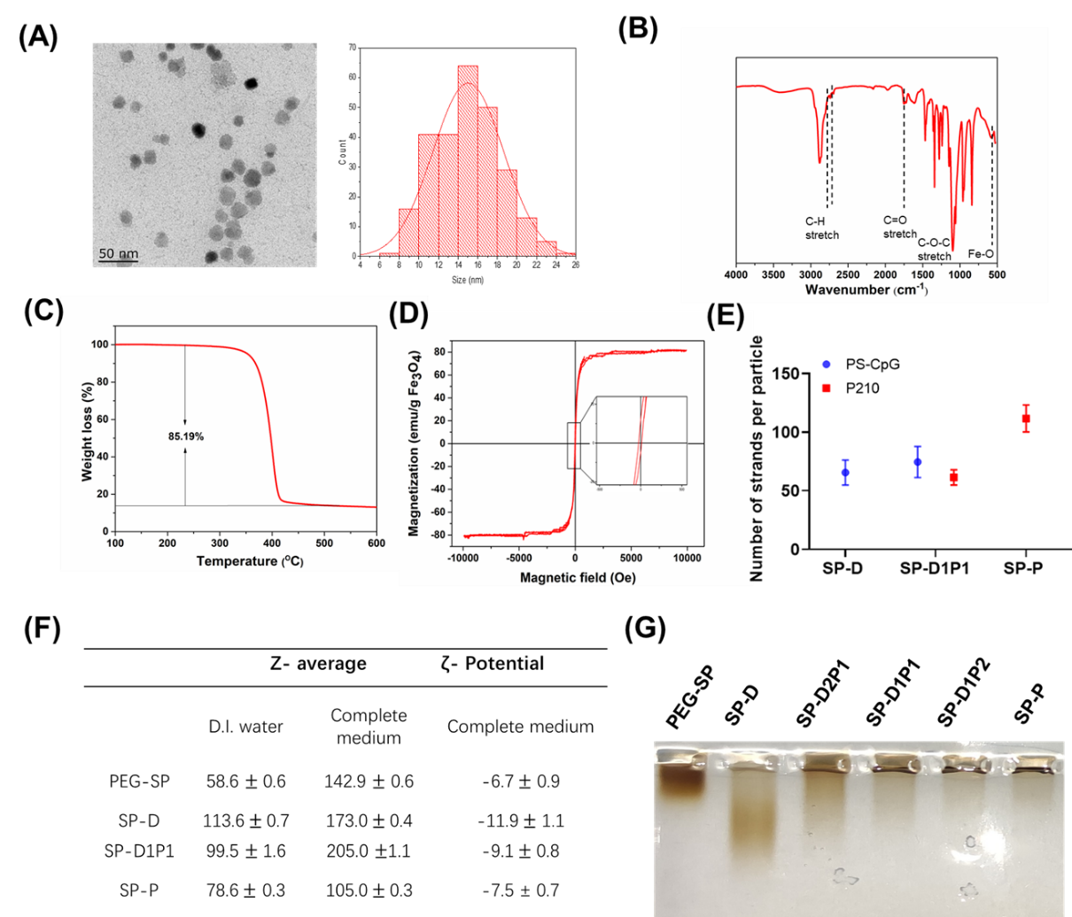
Figure S1. Physicaochemical characterizations of PEG-SPs and the loading density of ligands on nanovaccines. (A) TEM image of PEG-SP and the size distribution. (B) The FTIR spectrum of PEG-SPs, showing the characteristic peaks for Fe-O and COOH bonds. (C) The TGA curve for PEG-SPIONs, suggesting the weight percentage of PEG in PEG-SP is around 85%. (D) The magnetization curve of PEG-SPs suggests that the SPION cores are superparamagnetic, as it has a high saturation magnetization and nearly-zero remanence. (E) Quantification of DNA strands and peptides on the nanoparticles. (F) The increased hydrodynamic diameters of PEG-SP, SP-D, SP-D1P1 and SP-P in complete cell culture medium compared to deionized water suggests the adsorption of serum without obvious aggregation. The more negative surface charge after conjugation of CpG-ODN confirms the chemical structures. (G) Corresponding with the zeta potentials, nanoparticles with more DNA content migrate faster to the positive electrode in agarose gel electrophoresis.

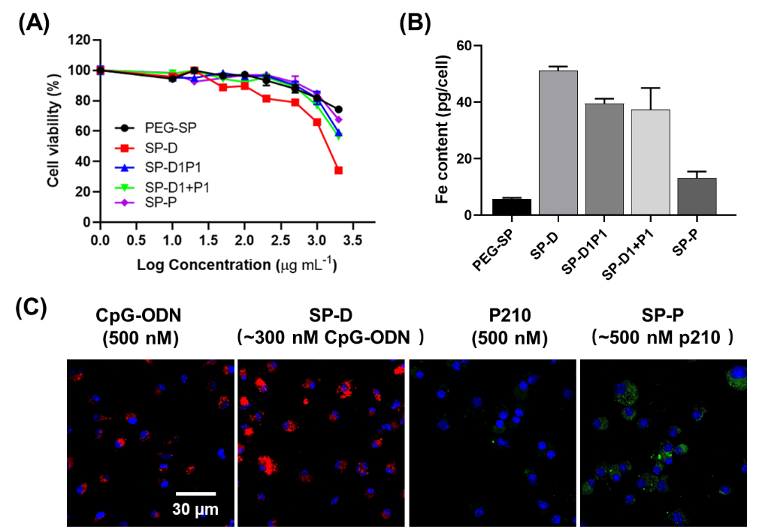
Figure S2. Cytotoxicity and cellular uptake of nanovaccines in BMDCs. (A) The cytotoxicity of BMDCs after incubation with PEG-SP, SP-D, SP-D1P1, SP-D1+P1, and SP-P, as tested by the CCK-8 assay, showing that PEG-SP as the least toxic while SP-D as the most toxic nanoparticles. (B) By ICP-MS measurement of the Fe content in BMDCs incubated with nanovaccines for 24 h, both DNA and peptide coating could promote cellular uptake of SPIONs. (C) Compared to the CpG-ODN and p210 counterparts not tethered to SPIONs, the nanoassembly promoted intracellular delivery of both adjuvant and antigens, showing potentials in better activation of dendritic cells.

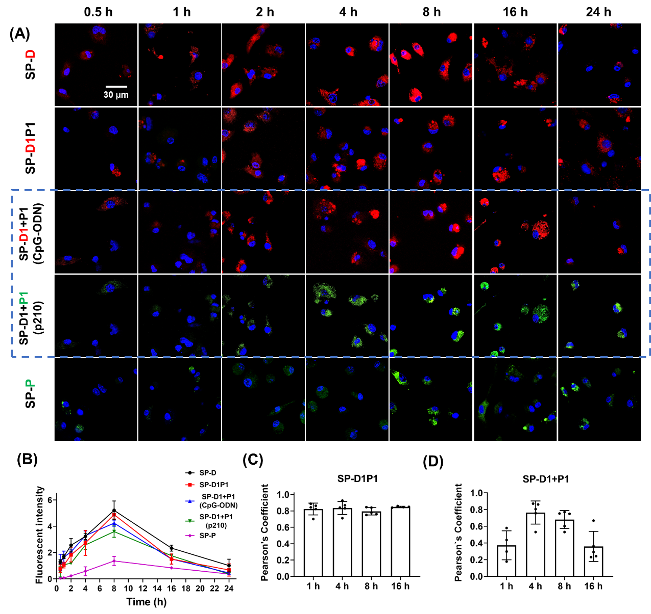
Figure S3. Uptake kinetics and intracellular stabilities of SP-D, SP-D1P1, SP-D1+P1 and SP-P in BMDCs. (A) Confocal microscopic images of the BMDCs after incubation with the nanoparticles for different durations of time. SP-D and SP-D1P1 were conjugated with CpG-ODN fluorescently modified with Quasar 670 (red), SP-P was conjugated with FITC-tagged p210 (green), while SP-D1P1 and SP-D1+P1 were modified with both ligands (red and green). Due to the lack of colocalization, the signals from both channels (CpG-ODN and p210) of SP-D1+P1 were shown. (B) By analyzing the fluorescence intensities of BMDCs at different time points, all nanoparticles are found to enter the cells in a time-dependent manner from 0-8 h, but the intensities decreased after 8 h. (C) The intracellular stability of SP-D1P1 is demonstrated by the high-colocalization of CpG-ODN and p210 signals on the particles, while (D) in SP-D1+P1, the two components do no colocalize with each other, suggesting different pathways of SP-D and SP-P in entering the cells.

Figure S4. Intracellular trafficking of nanoparticles by comparing with Lysotracker. (A) Confocal microscopic images of BMDCs after incubation of SP-D (green), SP-D1P1 (green), and SP-P (red) for different durations of time. Cells were counter-stained with Lysotracker, the biomarker for lysosomes of incubation, which was shown in either red (for SP-D and SP-D1P1 groups) or green (for SP-P group). (B) Both SP-D and SP-D1P1 started to localize to lysosomes at 4 h, peaked at 8 h. Differently, SP-P mostly localized at lysosomes at 16 h post incubation. Pearson’s colocalization coefficient of 0.7 or above indicates substantial colocalization. (C) At 4 h post incubation with the nanovaccine cocktail, SP-D1+P1, SP-D and SP-P localize with lysosomes to different extents as reflected by yellow color, where more SP-D resides in lysosomes than SP-P.

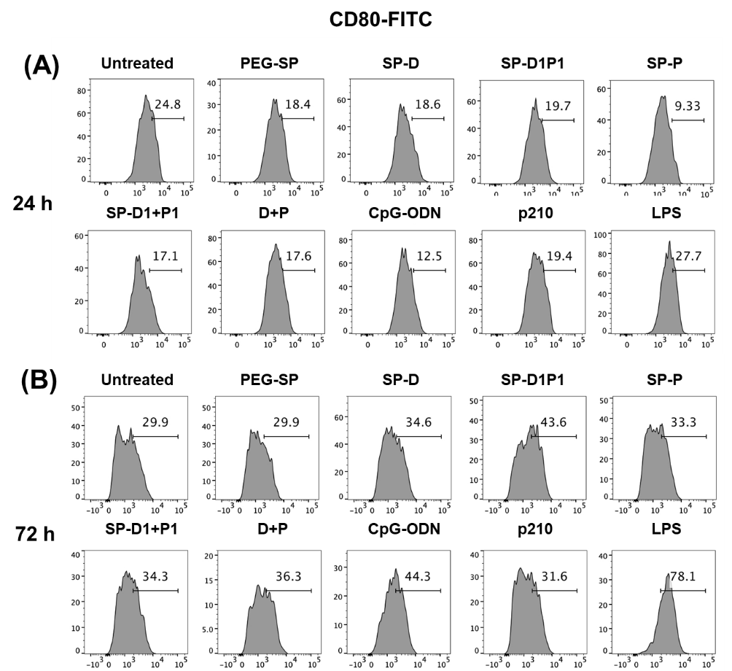
Figure S5. Screening of the formulation of vaccines for optimized BMDC activation by CD80 expression. Antibody staining for CD80 expression after incubation of vaccines for (A) 24 h and (B) 72 h. The positive population was gated by appropriate isotype controls and the figures shown were the representative of three separate experiments.

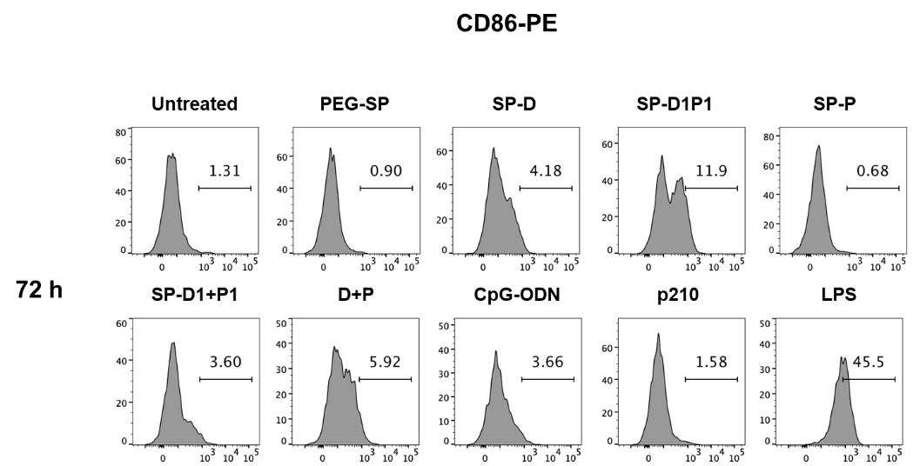
Figure S6. Antibody staining of BMDCs for CD86 expression after incubation of vaccines for 72 h. The positive population was gated by appropriate isotype controls and the figures shown were the representative of three separate experiments.

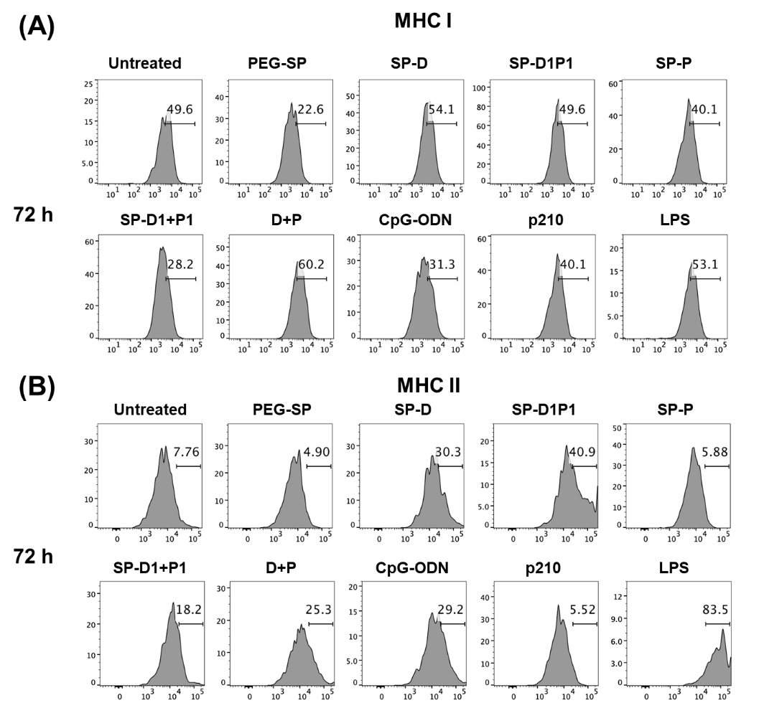
Figure S7. Screening of the formulation of vaccines for optimized BMDC activation by MHC I and MHC II expression. Antibody staining of BMDCs for (A) MHC I and (B) MHC II expression after incubation of vaccines for 72 h. The positive population was gated by appropriate isotype controls and the figures shown were the representative of three separate experiments.

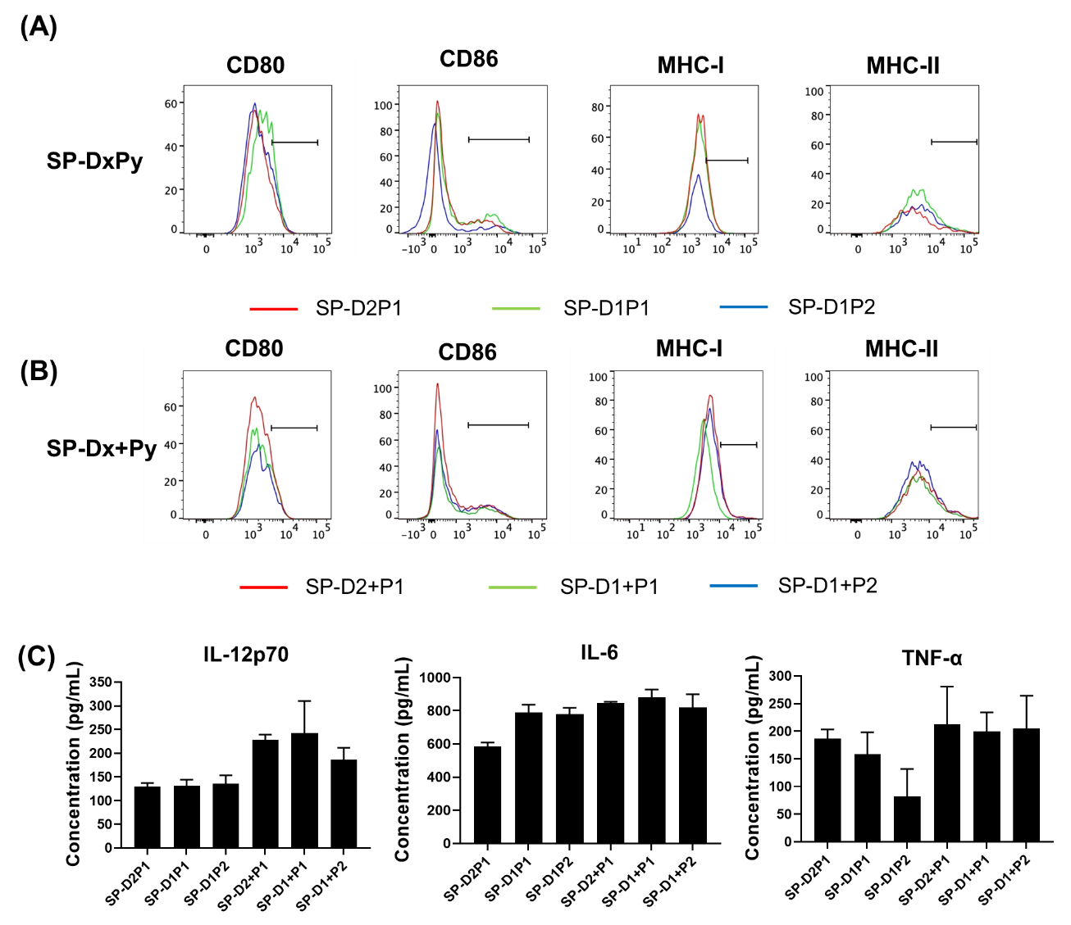
Figure S8. Screening for optimal SP-DxPy and SP-Dx+Py formulation by BMDC activation and cytokine secretion. (A) SP-DxPy and (B) SP-Dx+Py with different x/y ratios (2:1, 1:1, and 1:2) were added to the BMDCs for 24 h before flow cytometric analysis. The expressions of CD86, CD80, MHC I and MHC II on BMDCs were compared but not significantly different. The positive population was gated by appropriate isotype controls and the figures shown were the representative of three separate experiments. (B) Supernatants from BMDCs after treatment above were collected to measure the IL-12p70, IL-6, and TNF-α secretion with ELISA kits. In general，SP-Dx+Py showed higher cytokine levels than SP-DxPy, but the difference of x/y ratio was not significant. The data are presented as the mean ± SD (n=3).

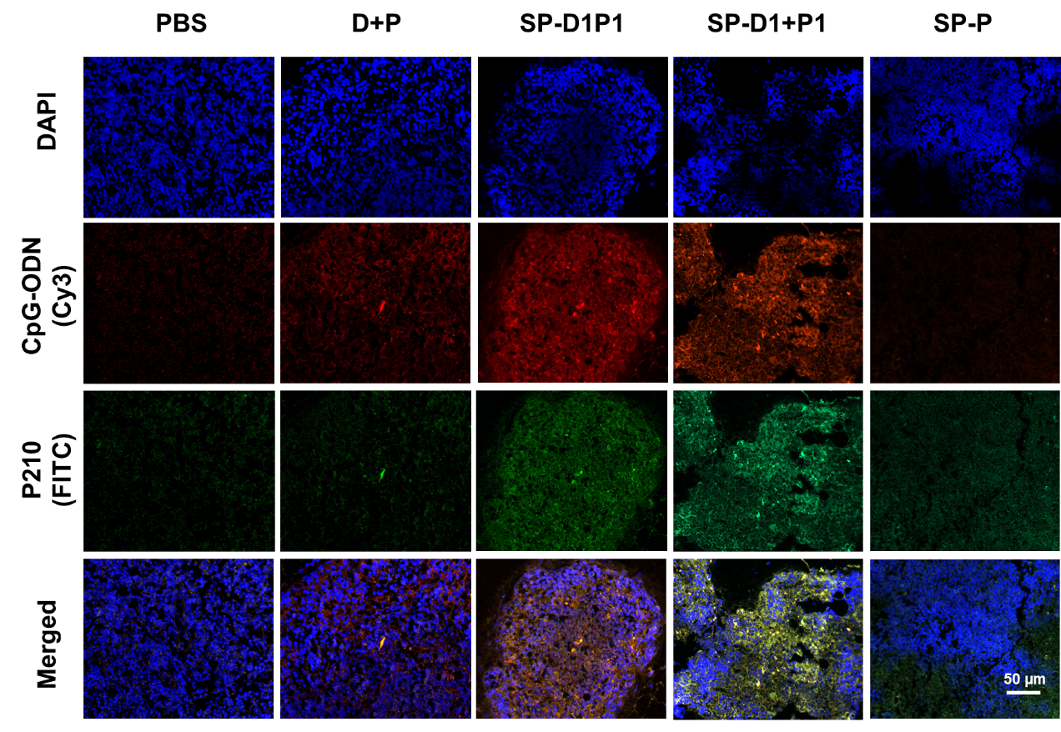
Figure S9. Confocal microscopic images of the draining lymph nodes of C57BL/6 mice showing the retention of fluorescently tagged vaccines at 16 h after subcatanous injection . In the formulation, CpG-ODNswas Cy3-labeled and p210 was FITC-labeled. The cells were stained with DAPI and shown in blue. Compared to physical mixture, both SP-D1P1 and SP-D1+P1 promote their retentions judged by the intensities.

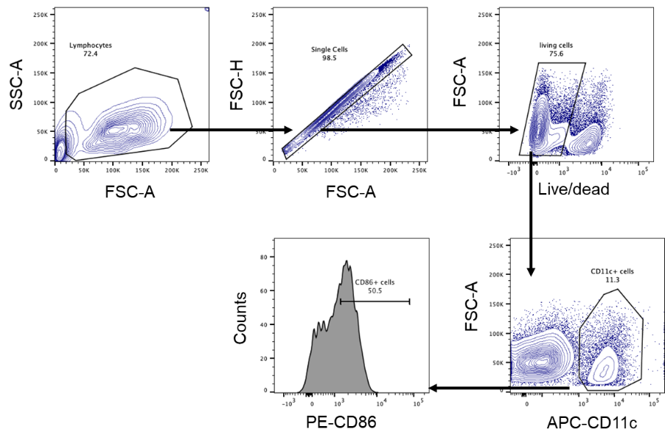
Figure S10. Flow cytometry gating strategy for analyzing the dendritic cells in the draining lymph nodes. Single cell suspension from lymph nodes was gated on FSC-A and SSC-A to exclude cell debris, followed by exclusion of doublets on FSC-H. Singlets were then gated on Live/Dead staining for viable cells. Dendritic cells were considered as CD11c⁺ cells and CD86 was used as a marker of DC stimulation.

Figure S11. SP-P does not show significant effect in reducing the plaque progression. (A) Optical images of Oil Red O-stained aortas after full vaccination as stated in the experimental section. (B) By analyzing the percentage of Oil Red O-stained area, no significant differences were observed among PBS and SP-P group (n = 3 or 4 mice per group).

Figure S12. Antibody responses to nanovaccine immunizations in C57BL/6 mice and the bodyweight of ApoE^{-/-} mice after full vaccination. (A) P210 IgM and (B) IgG antibody levels were low before immunization and remained low in PBS group, but significantly enhanced after primary booster (10 weeks) and second booster (15 weeks). (C) Immunization with D+P or nanovaccines did not cause significant difference in the bodyweight of ApoE^{-/-} mice at euthanasia (26 weeks).

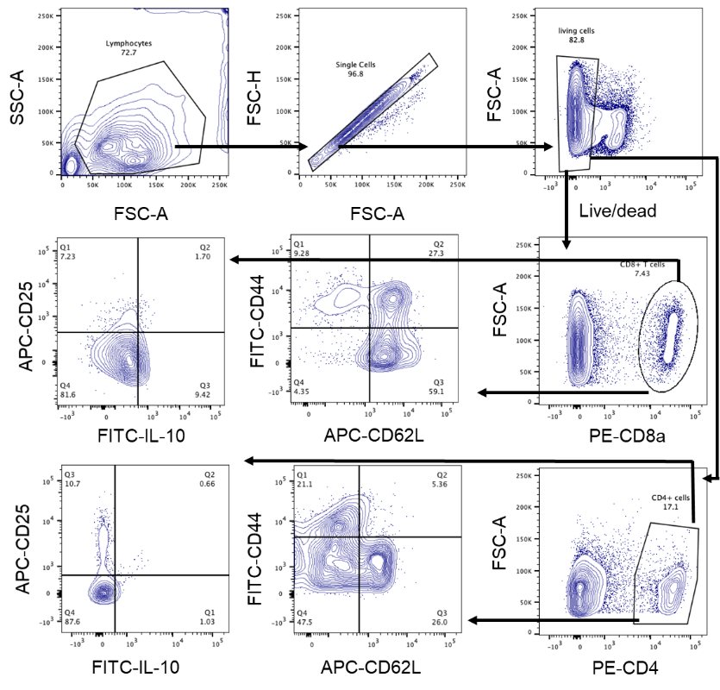
Figure S13. Flow cytometry gating strategy for analyzing the spleen CD4⁺ and CD8⁺ T cells. Single cell suspension from the spleen was gated on FSC-A and SSC-A to exclude cell debris, followed by exclusion of doublets on FSC-H. Singlets were then gated on Live/Dead staining for viable cells. Cells were then further separated in different staining panels by CD62L, CD44, CD25 and IL-10.

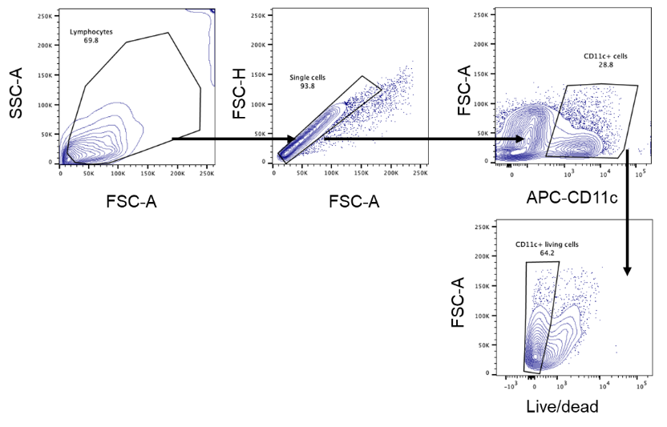
Figure S14. Flow cytometry gating strategy for analyzing the viability of dendritic cells after co-culture of CD8⁺ T cells. Single cell suspension was gated on FSC-A and SSC-A to exclude cell debris, followed by exclusion of doublets on FSC-H. Dendritic cells were considered as CD11c⁺ cells and the viable cells were gated based on Live/Dead staining.

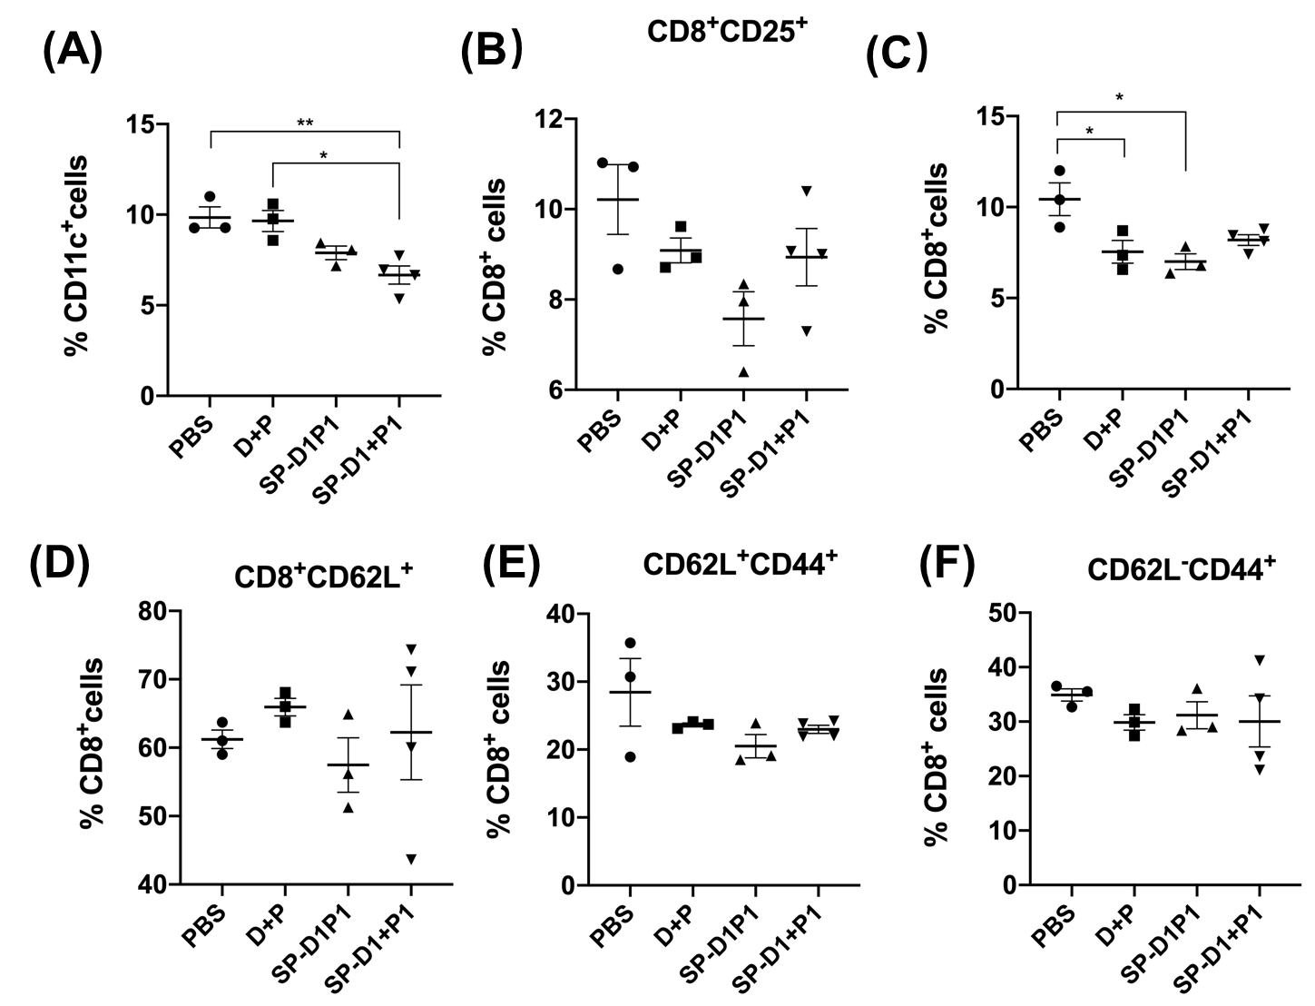
Figure S15. Responses of DCs at draining lymph nodes and spleen CD8⁺ T lymphocytes of ApoE^{-/-} mice to nanovaccine immunization at week 26. Cells in the draining lymph nodes and spleen T lymphocytes were separately collected and subjected to flow cytometric analysis. (A) The bar graphs showed reduced number of DCs in the draining lymph nodes of ApoE^{-/-} mice after nanovaccine immunization. No significant difference was observed in the splenic (B) CD8⁺CD25⁺ T cells, but (C) reduced CD8⁺ T cells was noticed. Meanwhile, analysis of memory T cells in each group showed no differences in (D) CD8⁺CD62L⁺ T cells, (E) CD8⁺ central memory T cells (CD8⁺CD62L⁺CD44⁺), or (F) CD8⁺ effector memory T cells (CD8⁺CD62L⁻CD44⁺).

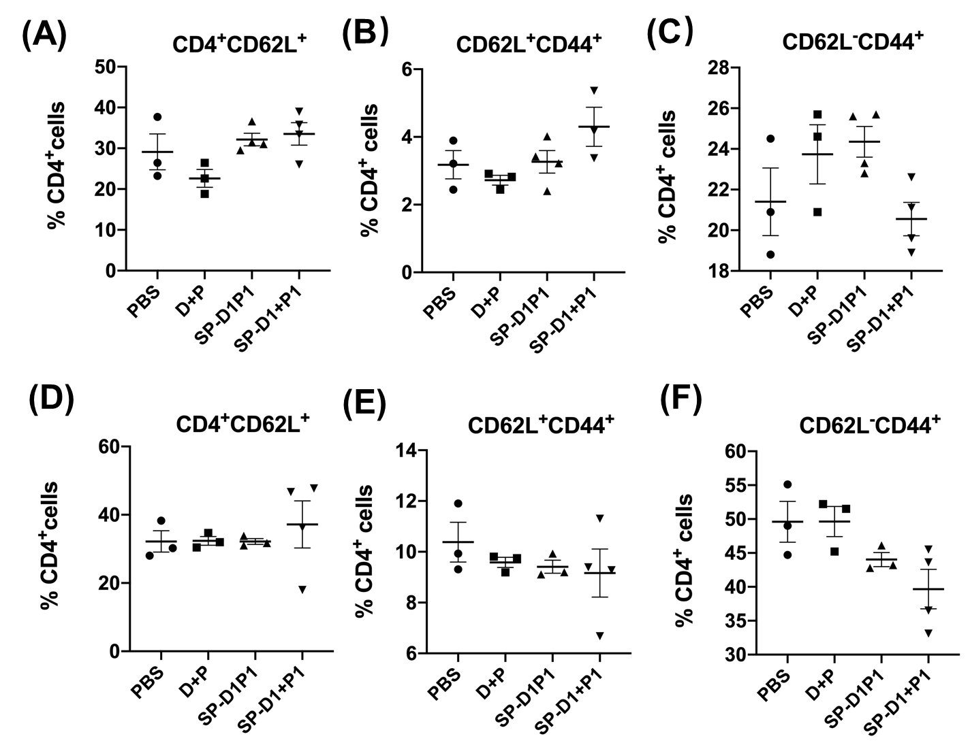
Figure S16. Spleen CD4⁺ T lymphocytes responses of ApoE^{-/-} mice to nanovaccine immunization at week 10 and week 26. Spleen T lymphocytes were collected and subjected to flow cytometric analysis. The bar graphs did not show significant difference between each group in the percentage of (A) CD4⁺CD62L⁺ T cells, (B) CD4⁺ central memory T cells (CD4⁺CD62L⁺CD44⁺), or (C) CD4⁺ effector memory T cells (CD4⁺CD62L⁻CD44⁺) at week 10, nor in (D) CD4⁺CD62L⁺ T cells, (E) CD4⁺ central memory T cells (CD4⁺CD62L⁺CD44⁺), or (F) CD4⁺ effector memory T cells (CD4⁺CD62L⁻CD44⁺) at week 26.

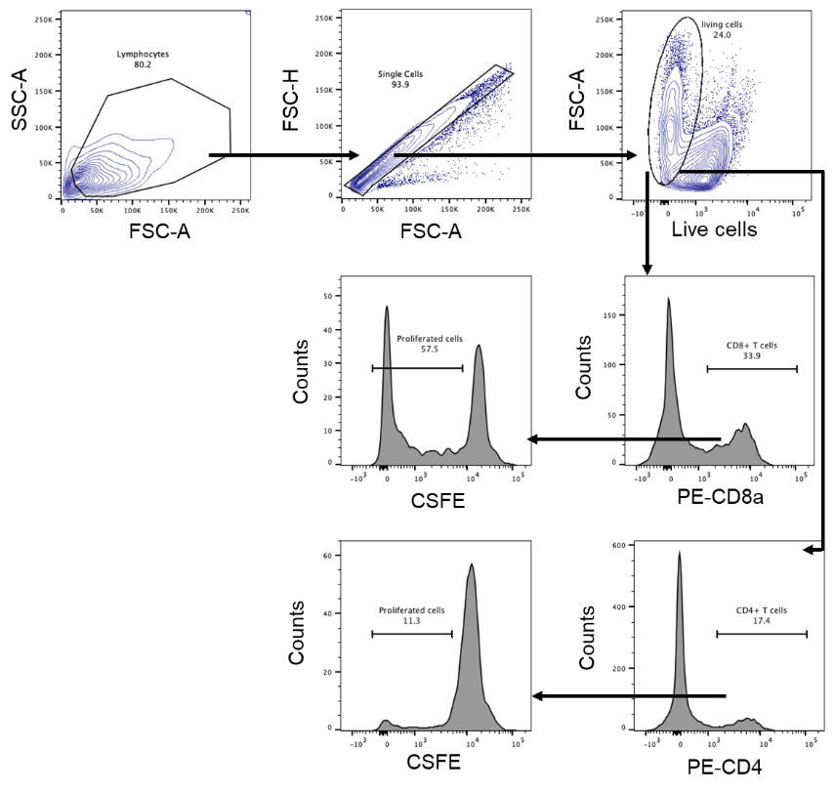
Figure S17. Flow cytometry gating strategy for analyzing the proliferation of CD4⁺ and CD8⁺ T cells after p210 stimulation. Single cell suspension was gated on FSC-A and SSC-A to exclude cell debris, followed by exclusion of doublets on FSC-H. Singlets were then gated on Live/Dead staining for viable cells. Cells were then further separated into CD4⁺ and CD8⁺ T cells, of which the cell population with decreased CSFE intensities were gated as proliferated cells.

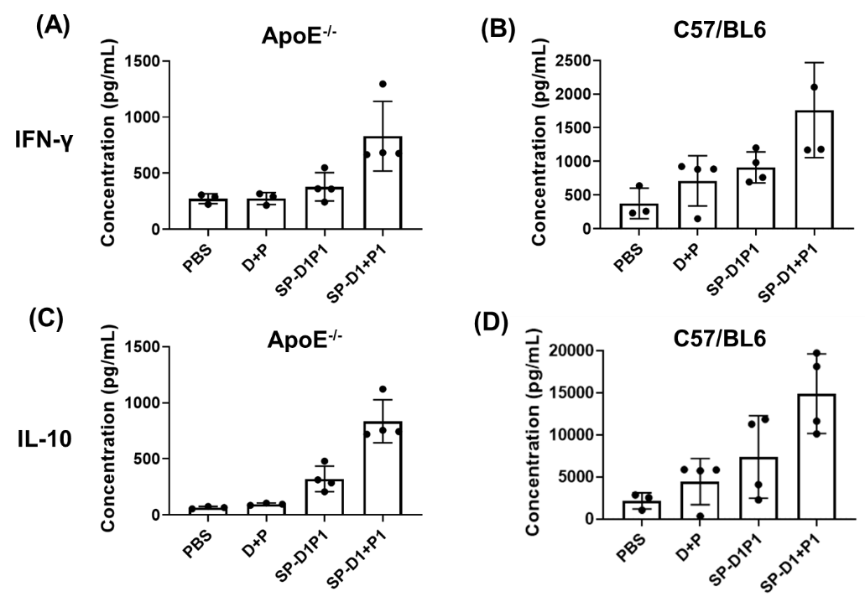
Figure 18. Serum cytokine levels of immunized ApoE^{-/-} mice and C57BL/6 mice after the primary booster (week 10). (A) (B) IFN-γ and (C) (D)IL-10 levels in the serum were measured by ELISA, which showed that SPION-based vaccinations enhanced the IFN-γ and IL-10 levels and SP-D1+P1 was even more potent than SP-D1P1.

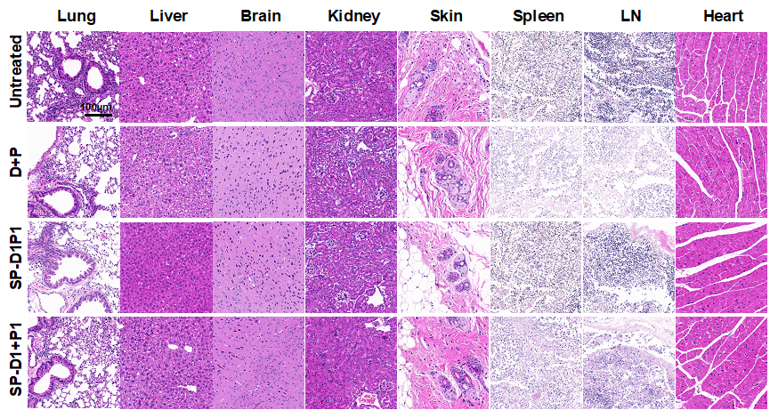
Figure 19. H&E staining of major organs in different treatment groups. Histological examinations of the lung, liver, brain, kidney, skin, spleen, lymph node and heart harvested from ApoE^{-/-} mice at the age of 26 weeks after full vaccinations of different treatments shows no appreciable change in tissue morphology. Representative images were chosen from n=6-8 mice per group.

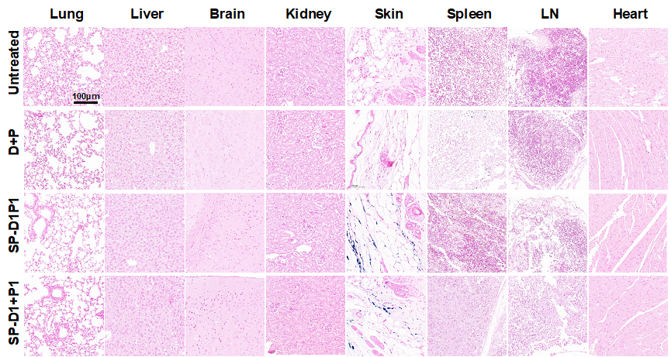
Figure 20. Prussian blue staining of major organs in different treatment groups. Lung, liver, brain, kidney, skin, spleen, lymph node and heart were harvested from ApoE^{-/-} mice at the age of 26 weeks after full vaccinations of different treatments, and stained to visualize the residual SPIONs, which only existed in the skin tissue in SP-D1P1 and SP-D1+P1 groups. Representative images were chosen from n=6-8 mice per group.

References
1. Jia, Q.; Zeng, J.; Qiao, R.; Jing, L.; Peng, L.; Gu, F.; Gao, M., Gelification: An Effective Measure for Achieving Differently Sized Biocompatible Fe3O4 Nanocrystals through a Single Preparation Recipe. Journal of the American Chemical Society 2011, 133 (48), 19512-19523.
2. Li, X.-Q.; Meng, F.-T.; Ma, G.-H.; Su, Z.-G., A Simple and Efficient Method for Synthesis of Carboxymethylated Polyethyleneglycol. Journal of Chemical Research 2005, 2005 (5), 280-281.
3. Lutz, M. B.; Kukutsch, N.; Ogilvie, A. L. J.; Rößner, S.; Koch, F.; Romani, N.; Schuler, G., An advanced culture method for generating large quantities of highly pure dendritic cells from mouse bone marrow. Journal of Immunological Methods 1999, 223 (1), 77-92.

