Supplemental Figure and Tables

Chen H, et al., Circulating metabolomic profile links the MIND diet to cognitive function in middle-aged and older adults

Figure S1. Metabolic signature of the MIND diet and its correlation with the MIND diet score in the Whitehall II study constructed using all 152 metabolites
Table S1. Adjusted beta coefficients for the associations between the metabolite z-scores and the MIND diet score
Table S2. Coefficients for the metabolite z-scores in the calculation of the metabolomic signature score of the MIND diet
Table S3. Association of the MIND diet and its metabolic signature (per standard deviation) with cognitive function in the Whitehall II (1997-2013) in study subgroups
Table S4. Association of the MIND diet and its metabolic signature (per standard deviation) with cognitive function in the Whitehall II (1997-2013) in sensitivity analyses
Table S5. Association of the MIND diet and its metabolic signature (per standard deviation) with annual changes (z-score/year) in cognitive function from Phase 5 (1997-1999) to Phase 11 (2012-2013) in the Whitehall II

Figure S1. Metabolic signature of the MIND diet and its correlation with the MIND diet score in the Whitehall II study constructed using all 152 metabolites
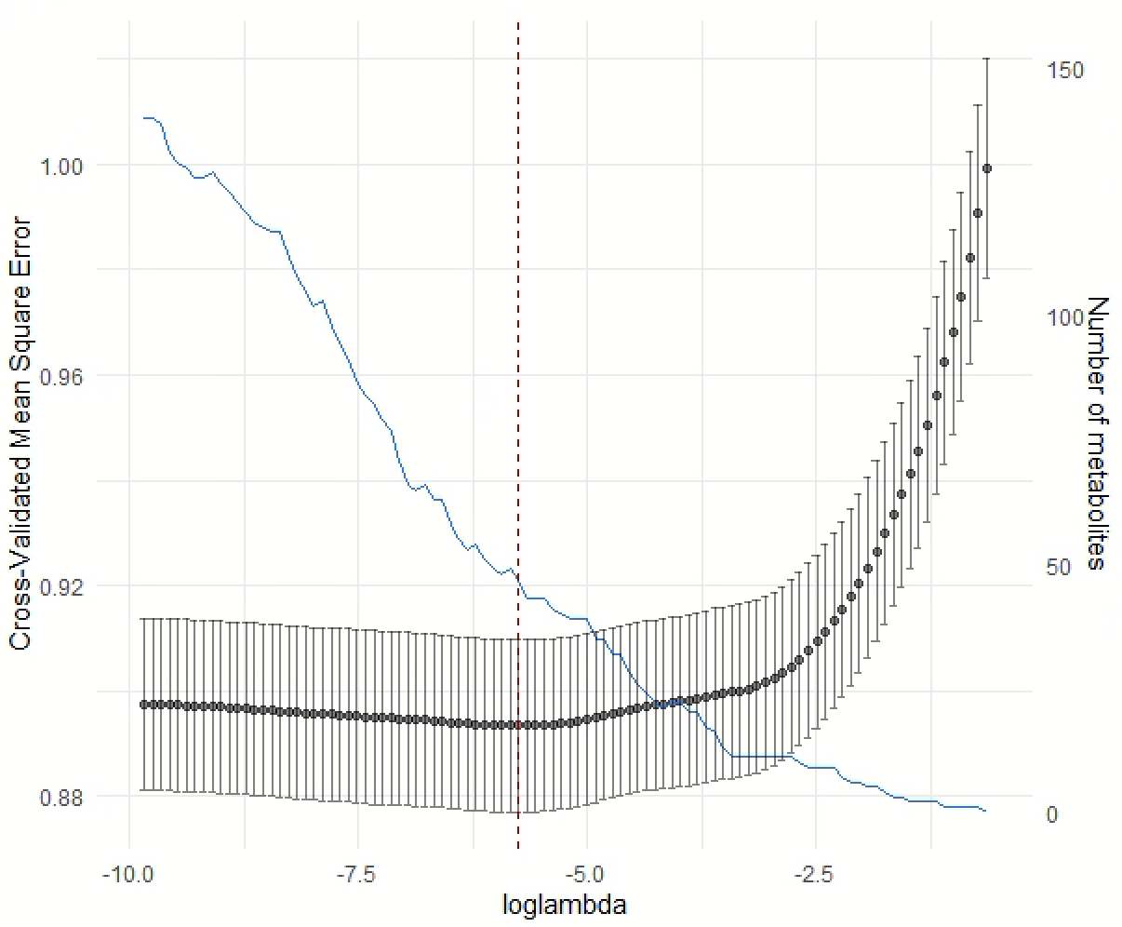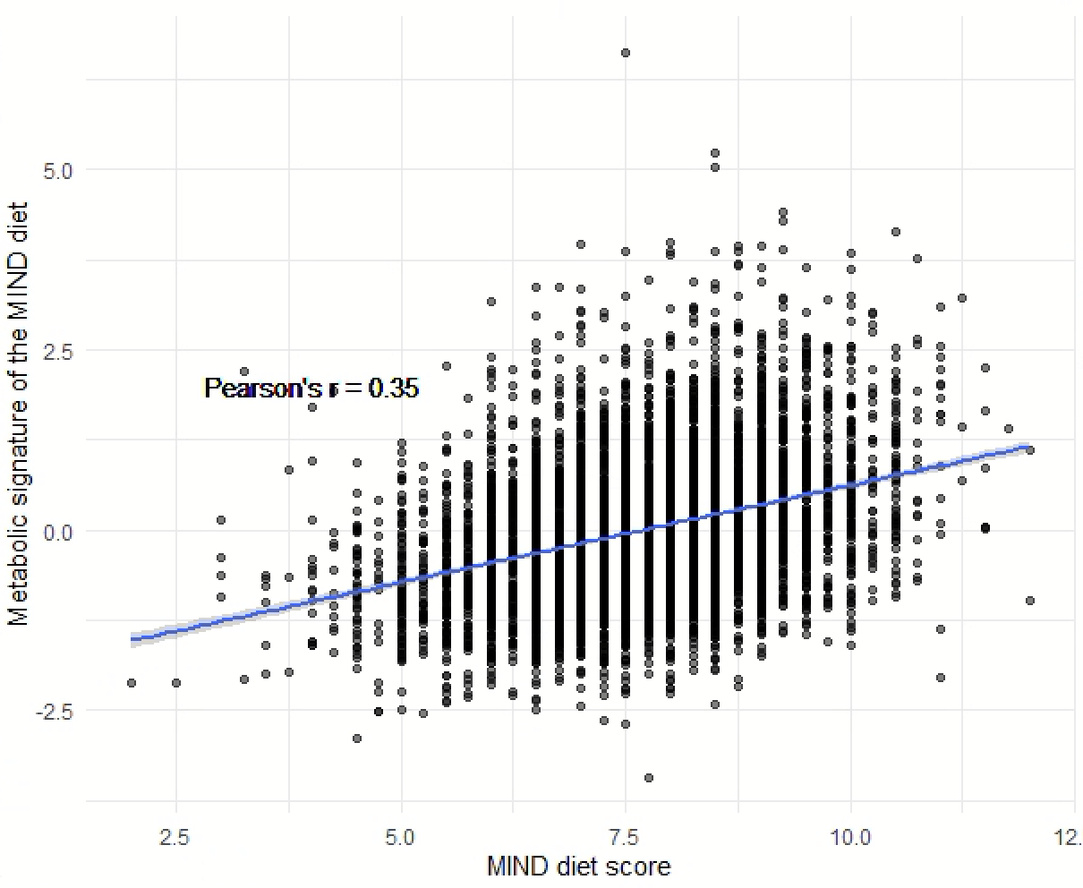

Table S1. Adjusted beta coefficients for the associations between the metabolite z-scores and the MIND diet score
Metabolite | Whitehall II |  | UK Biobank
Metabolite | Beta | P-value* | Beta | P-value*
Docosahexaenoic Acid | 0.51 | 3.70E-67 | 0.31 | 7.65E-17
Omega-3 Fatty Acids | 0.44 | 2.10E-51 | 0.25 | 5.61E-11
Degree of Unsaturation | 0.34 | 8.70E-29 | 0.35 | 3.58E-22
Average Diameter for HDL Particles | 0.16 | 6.18E-08 | 0.07 | 3.08E-02
Triglycerides in Large HDL | 0.15 | 2.59E-06 | -0.05 | 2.45E-01
Cholesteryl Esters in Large HDL | 0.15 | 1.95E-06 | 0.09 | 1.19E-02
Cholesterol in Large HDL | 0.14 | 2.00E-06 | 0.09 | 1.37E-02
Concentration of Large HDL Particles | 0.14 | 3.62E-06 | 0.08 | 2.31E-02
Total Lipids in Large HDL | 0.14 | 3.62E-06 | 0.08 | 2.31E-02
Phospholipids in Very Large HDL | 0.14 | 2.00E-06 | 0.08 | 3.52E-02
Free Cholesterol in Large HDL | 0.14 | 3.78E-06 | 0.08 | 2.46E-02
Concentration of Very Large HDL Particles | 0.14 | 4.67E-06 | 0.07 | 8.06E-02
Total Lipids in Very Large HDL | 0.13 | 6.21E-06 | 0.08 | 3.52E-02
Phospholipids in Large HDL | 0.13 | 1.89E-05 | 0.08 | 2.60E-02
Cholesteryl Esters in Very Large HDL | 0.12 | 9.45E-05 | 0.09 | 1.50E-02
Cholesterol in Very Large HDL | 0.12 | 9.65E-05 | 0.08 | 2.56E-02
Polyunsaturated Fatty Acids | 0.12 | 5.55E-05 | 0.07 | 8.58E-02
Total cholesterol in HDL3 | 0.12 | 3.81E-04 | . | .
Total cholesterol in HDL | 0.12 | 1.94E-04 | . | .
Total cholesterol in HDL2 | 0.11 | 2.97E-04 | . | .
Estimated description of fatty acid chain length, not actual carbon number | 0.11 | 1.60E-03 | . | .
Apolipoprotein A1 | 0.11 | 3.49E-04 | 0.03 | 5.28E-01
Free Cholesterol in Very Large HDL | 0.11 | 1.94E-04 | 0.06 | 1.84E-01
Phosphatidylcholines | 0.10 | 8.73E-04 | 0.01 | 9.34E-01
Total Choline | 0.09 | 2.41E-03 | 0.00 | 9.47E-01
Phosphoglycerides | 0.09 | 4.84E-03 | 0.00 | 9.54E-01
Triglycerides in Very Large HDL | 0.08 | 1.19E-02 | -0.06 | 1.74E-01
Average Diameter for LDL Particles | 0.08 | 1.79E-02 | 0.16 | 2.30E-04
Total Esterified Cholesterol | 0.07 | 9.65E-03 | 0.01 | 9.25E-01
Total Cholesterol | 0.06 | 2.61E-02 | 0.00 | 9.65E-01
Free Cholesterol in IDL | 0.06 | 3.29E-02 | 0.01 | 9.34E-01
Free Cholesterol in Very Small VLDL | 0.06 | 3.58E-02 | -0.03 | 4.76E-01
Triglycerides in Medium LDL | 0.06 | 7.67E-02 | -0.10 | 2.63E-02
Triglycerides in LDL | 0.05 | 1.25E-01 | -0.09 | 3.52E-02
Triglycerides in HDL | 0.03 | 3.26E-01 | -0.12 | 7.38E-03
Monounsaturated Fatty Acids | 0.02 | 6.05E-01 | -0.13 | 2.19E-03
Creatinine | 0.01 | 7.98E-01 | -0.12 | 1.05E-03
Triglycerides in Small LDL | 0.01 | 8.29E-01 | -0.11 | 1.14E-02
Acetate | -0.01 | 8.45E-01 | 0.11 | 1.37E-02
Lactate | -0.01 | 7.26E-01 | -0.12 | 4.84E-03
Triglycerides in Medium HDL | -0.02 | 5.94E-01 | -0.12 | 4.73E-03
Pyruvate | -0.02 | 5.92E-01 | -0.10 | 1.84E-02
Saturated Fatty Acids | -0.03 | 3.83E-01 | -0.12 | 3.83E-03
Total Triglycerides | -0.05 | 1.47E-01 | -0.12 | 3.83E-03
Leucine | -0.07 | 2.77E-02 | -0.10 | 1.50E-02
Phospholipids in Medium VLDL | -0.07 | 3.11E-02 | -0.06 | 2.24E-01
Cholesteryl Esters in Chylomicrons and Extremely Large VLDL | -0.07 | 3.35E-02 | -0.14 | 7.75E-04
Cholesterol in Chylomicrons and Extremely Large VLDL | -0.07 | 3.26E-02 | -0.14 | 8.75E-04
Free Cholesterol in Chylomicrons and Extremely Large VLDL | -0.07 | 3.26E-02 | -0.14 | 1.01E-03
Total Lipids in Medium VLDL | -0.07 | 2.43E-02 | -0.07 | 1.30E-01
Triglycerides in VLDL | -0.07 | 2.46E-02 | -0.12 | 3.75E-03
Concentration of Medium VLDL Particles | -0.07 | 2.04E-02 | -0.06 | 1.84E-01
Free Cholesterol in Very Large VLDL | -0.08 | 1.63E-02 | -0.13 | 2.19E-03
Free Cholesterol in Large VLDL | -0.08 | 1.63E-02 | -0.12 | 4.73E-03
Phospholipids in Chylomicrons and Extremely Large VLDL | -0.08 | 1.46E-02 | -0.14 | 8.75E-04
Triglycerides in Medium VLDL | -0.08 | 1.27E-02 | -0.09 | 2.60E-02
Triglycerides in Small HDL | -0.08 | 1.23E-02 | -0.13 | 2.19E-03
Glycine | -0.08 | 1.63E-02 | -0.03 | 4.65E-01
Phospholipids in Very Large VLDL | -0.08 | 8.21E-03 | -0.14 | 1.12E-03
Phospholipids in Large VLDL | -0.09 | 7.25E-03 | -0.12 | 3.50E-03
Cholesterol in Very Large VLDL | -0.09 | 7.74E-03 | -0.12 | 4.42E-03
Total Lipids in Chylomicrons and Extremely Large VLDL | -0.09 | 7.25E-03 | -0.15 | 5.24E-04
Concentration of Chylomicrons and Extremely Large VLDL Particles | -0.09 | 6.35E-03 | -0.14 | 7.75E-04
Triglycerides in Large VLDL | -0.09 | 6.35E-03 | -0.12 | 4.50E-03
Total Lipids in Very Large VLDL | -0.09 | 6.46E-03 | -0.14 | 1.01E-03
Total Lipids in Large VLDL | -0.09 | 6.35E-03 | -0.12 | 4.73E-03
Concentration of Large VLDL Particles | -0.09 | 6.35E-03 | -0.12 | 3.75E-03
Concentration of Very Large VLDL Particles | -0.09 | 6.35E-03 | -0.14 | 1.05E-03
Triglycerides in Very Large VLDL | -0.09 | 6.35E-03 | -0.14 | 8.75E-04
Cholesterol in Large VLDL | -0.09 | 6.35E-03 | -0.10 | 1.45E-02
Alanine | -0.09 | 7.96E-03 | -0.06 | 2.24E-01
Isoleucine | -0.09 | 3.46E-03 | -0.10 | 2.28E-02
Triglycerides in Chylomicrons and Extremely Large VLDL | -0.09 | 4.82E-03 | -0.15 | 4.56E-04
Cholesteryl Esters in Very Large VLDL | -0.09 | 4.82E-03 | -0.11 | 1.14E-02
Cholesteryl Esters in Large VLDL | -0.10 | 2.19E-03 | -0.09 | 4.61E-02
Phenylalanine | -0.11 | 8.99E-04 | -0.11 | 1.23E-02
Citrate | -0.11 | 1.58E-03 | -0.04 | 4.09E-01
Glycoprotein acetyls, mainly a1-acid glycoprotein | -0.12 | 9.30E-05 | . | .
Glutamine | -0.13 | 1.20E-04 | -0.02 | 7.64E-01
Glycoprotein Acetyls | -0.14 | 3.85E-05 | -0.10 | 2.05E-02
Average Diameter for VLDL Particles | -0.14 | 4.22E-06 | -0.14 | 8.75E-04
Conjugated linoleic acid | -0.16 | 1.95E-06 | . | .
Free Cholesterol in VLDL | . | . | -0.09 | 3.76E-02
Phospholipids in VLDL | . | . | -0.10 | 2.28E-02
Total Lipids in VLDL | . | . | -0.11 | 1.04E-02
* P-values were adjusted using Benjamini-Hochberg methods to account for false discovery rate.

Table S2. Coefficients for the metabolite z-scores in the calculation of the metabolomic signature score of the MIND diet
Metabolite | Coefficient in Whitehall II | Coefficient in UK Biobank
Glycoprotein acetyls, mainly a1-acid glycoprotein | -0.128 | .
Cholesteryl Esters in Very Large HDL | -0.128 | 0.157
Free Cholesterol in Very Small VLDL | -0.073 | .
Average Diameter for VLDL Particles | -0.069 | -0.025
Isoleucine | -0.066 | 0.015
Conjugated linoleic acid | -0.060 | .
Total Choline | -0.058 | .
Omega-3 Fatty Acids | -0.050 | .
Glutamine | -0.044 | .
Citrate | -0.008 | .
Glycoprotein Acetyls | -0.004 | -0.021
Total Esterified Cholesterol | 0.002 | .
Concentration of Large VLDL Particles | 0.004 | -0.038
Free Cholesterol in Very Large HDL | 0.004 | .
Phospholipids in Large VLDL | 0.005 | -0.509
Phenylalanine | 0.005 | .
Estimated description of fatty acid chain length, not actual carbon number | 0.010 | .
Alanine | 0.012 | .
Phospholipids in Large HDL | 0.013 | 0.241
Phospholipids in Very Large HDL | 0.020 | -0.015
Triglycerides in Small HDL | 0.029 | .
Degree of Unsaturation | 0.033 | .
Average Diameter for LDL Particles | 0.035 | 0.011
Triglycerides in Large VLDL | 0.060 | -0.114
Polyunsaturated Fatty Acids | 0.078 | .
Triglycerides in Very Large VLDL | 0.085 | -0.207
Average Diameter for HDL Particles | 0.125 | 0.001
Docosahexaenoic Acid | 0.327 | .
Triglycerides in Medium HDL | . | -0.283
Triglycerides in Chylomicrons and Extremely Large VLDL | . | -0.203
Total Lipids in Very Large VLDL | . | -0.197
Cholesteryl Esters in Large HDL | . | -0.179
Triglycerides in Medium VLDL | . | -0.172
Total Lipids in Very Large HDL | . | -0.138
Cholesterol in Large HDL | . | -0.116
Triglycerides in Medium LDL | . | -0.113
Concentration of Large HDL Particles | . | -0.102
Cholesteryl Esters in Very Large VLDL | . | -0.099
Total Lipids in Chylomicrons and Extremely Large VLDL | . | -0.095
Phospholipids in VLDL | . | -0.047
Cholesterol in Very Large HDL | . | -0.047
Cholesterol in Chylomicrons and Extremely Large VLDL | . | -0.047
Leucine | . | -0.034
Free Cholesterol in VLDL | . | -0.029
Phospholipids in Very Large VLDL | . | -0.015
Triglycerides in LDL | . | -0.006
Total Lipids in Large VLDL | . | 0.002
Triglycerides in Small LDL | . | 0.003
Cholesterol in Very Large VLDL | . | 0.009
Cholesteryl Esters in Chylomicrons and Extremely Large VLDL | . | 0.010
Concentration of Chylomicrons and Extremely Large VLDL Particles | . | 0.012
Phospholipids in Chylomicrons and Extremely Large VLDL | . | 0.025
Concentration of Very Large VLDL Particles | . | 0.025
Cholesteryl Esters in Large VLDL | . | 0.052
Total Lipids in Large HDL | . | 0.059
Cholesterol in Large VLDL | . | 0.065
Free Cholesterol in Large HDL | . | 0.119
Free Cholesterol in Very Large VLDL | . | 0.120
Free Cholesterol in Chylomicrons and Extremely Large VLDL | . | 0.138
Triglycerides in HDL | . | 0.161
Free Cholesterol in Large VLDL | . | 0.199
Total Lipids in VLDL | . | 0.213
Total Triglycerides | . | 0.503
Triglycerides in VLDL | . | 0.544

Table S3. Association of the MIND diet and its metabolic signature (per standard deviation) with cognitive function in the Whitehall II (1997-2013) in study subgroups
 | MIND diet score  (Per standard deviation) | Metabolomic signature score  (Per standard deviation)
Age
<=60 years | 0.09 (-0.00, 0.18) | 0.08 (-0.01, 0.17)
>=60 years | 0.11 (0.05, 0.16) | 0.15 (0.10, 0.21)
P-interaction | 0.453 | 0.043
Sex
Female | 0.10 (0.04, 0.15) | 0.10 (0.04, 0.16)
Male | 0.11 (0.01, 0.20) | 0.18 (0.10, 0.27)
P-interaction | 0.775 | 0.032
Education level
College/university degree | 0.10 (0.06, 0.14) | 0.12 (0.06, 0.19)
High school or below | 0.08 (0.02, 0.15) | 0.13 (0.05, 0.20)
P-interaction | 0.650 | 0.054
Linear mixed effect models were adjusted for age, sex, total energy intake, ethnicity, marriage and partnership status, years of formal education, physical activity, smoking, hypertension, diabetes, and cardiovascular diseases.

Table S4. Association of the MIND diet and its metabolic signature (per standard deviation) with cognitive function in the Whitehall II (1997-2013) in sensitivity analyses
 | MIND diet score  (Per standard deviation) | P-value | Metabolomic signature score  (Per standard deviation) | P-value
Global cognitive function
Sensitivity analysis 1 | 0.08 [0.05, 0.11] | <0.001 | 0.15 [0.11, 0.18] | <0.001
Sensitivity analysis 2 | 0.06 (0.03, 0.08] | <0.001 | 0.06 [0.03, 0.08] | <0.001
Memory
Sensitivity analysis 1 | 0.02 [0.00, 0.03] | 0.025 | 0.04 [0.02, 0.05] | <0.001
Sensitivity analysis 2 | 0.02 [0.00, 0.03] | 0.009 | 0.03 [0.01, 0.04] | <0.001
Verbal fluency
Sensitivity analysis 1 | 0.04 [0.02, 0.05] | <0.001 | 0.05 [0.03, 0.06] | <0.001
Sensitivity analysis 2 | 0.03 [0.02, 0.04] | <0.001 | 0.02 [0.01, 0.03] | <0.001
Reasoning
Sensitivity analysis 1 | 0.03 [0.02, 0.04] | <0.001 | 0.06 (0.05, 0.07] | <0.001
Sensitivity analysis 2 | 0.02 [0.01, 0.03] | <0.001 | 0.02 [0.01, 0.03] | <0.001
Sensitivity analysis 1 is restricted to participants without diabetes or cardiovascular diseases; sensitivity analysis 2 is restricted to participants cognitive function scores above the lowest sex-specific quintiles.

Table S5. Association of the MIND diet and its metabolic signature (per standard deviation) with annual changes (z-score/year) in cognitive function from Phase 5 (1997-1999) to Phase 11 (2012-2013) in the Whitehall II

 | MIND diet score | MIND metabolic score
Global Cognitive Function | 0.0018 [-0.0016, 0.0051] | 0.0039 [0.0004, 0.0075]
Memory | 0.0012 [-0.0010, 0.0035] | 0.0027 [0.0003, 0.0051]
Verbal Fluency | 0.0007 [-0.0011, 0.0025] | 0.0008 [-0.0012, 0.0027]
Reasoning | -0.0004 [-0.0015, 0.0008] | 0.0007 [-0.0005, 0.0019]
Models were adjusted for age, sex, total energy intake, ethnicity, marriage and partnership status, years of formal education, physical activity, smoking, hypertension, diabetes, and cardiovascular diseases.

