SUPPLIMENTRY FILE:

A procedure for temperature-sensitive, fluorescence-active carrageenan nanogel using disoriented conformation of carrageenan with de-solvating agent.
Akanksha Bhatt, Priyank Purohit* Shashank Kailkhura ,
Department of Pharmacy, Graphic Era Hill University Dehradun, Dehradun, 28008, India

Fig A: Diagrammatic presentation of preparation carrageenan based nano and simple gel
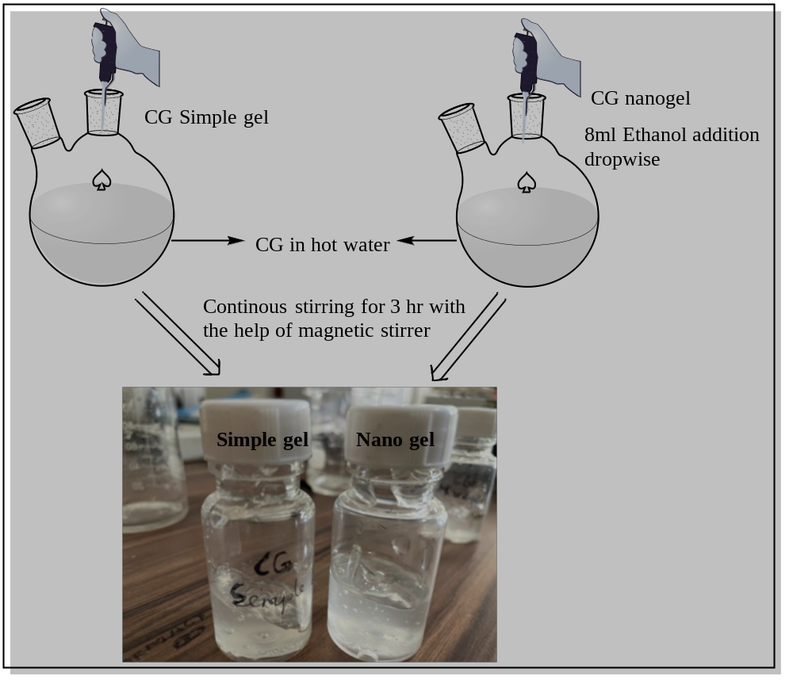

Figure B : Evaluation of spreadability for nanogel and simple gel
