Supplementary:
Eco-friendly and cost-effective adsorbent derived from blast furnace slag with black liquor waste for hazardous remediation
Ahmed H. Naggar^{1*}, Abdelghaffar Dhmees², Tarek A. Seaf-Elnasr³, Kwok F. Chong⁴,
Gomaa A.M. Ali⁵, Hazim M. Ali³, Rasmih M. Kh. Alshamery³, Lubna H. M. AlNahwa³,
Al-Sayed A. Bakr^{2**}

¹ Department of Chemistry, College of Science and Arts, Jouf University, Al-Qurayyat, Saudi Arabia
² Department of Analysis and Evaluation, Egyptian Petroleum Research Institute (EPRI), Nasr city, Cairo 11727, Egypt
³ Department of Chemistry, College of Science, Jouf University, Sakaka, Saudi Arabia
⁴ Faculty of Industrial Sciences and Technology, Universiti Malaysia Pahang, Gambang, 26300 Kuantan, Malaysia
⁵ Department of Chemistry, Faculty of Science, Al-Azhar University, Assiut 71524, Egypt
* Corresponding author email: ahayoub@ju.edu.sa
** Corresponding author email: als_water@yahoo.com

Table S1: Chemical composition of BFS
Composition | SiO₂ | CaO | Al₂O₃ | MgO | MnO₂ | SO₃ | Fe-oxides
Wt. (%) | 33.35 | 40.54 | 11.51 | 5.05 | 6.30 | 2.75 | 0.5

Table S2: The XPS analysis of SBL and Th/SBL
Name |  | SBL |  |  |  | Th/SBL
Name |  | Peak BE | Atomic % |  |  | Peak BE | Atomic %
C 1s |  | 287.22 | 5.43 |  |  | 290.35 | 13.20
O 1s |  | 534.20 | 59.78 |  |  | 536.68 | 59.45
Si 2p |  | 105.13 | 27.98 |  |  | 109.14 | 18.38
Na 1a |  | 1073.32 | 5.84 |  |  | 1075.17 | 4.40
Cl 2p |  | 200.45 | 0.97 |  |  | 200.45 | 0.51
Th 4f |  | ……… | ……… |  |  | 339.86 | 4.06

Table S3: Sorption modeling of kinetics sorption
Model | Equation | Parameters
sPFOLE | $$log\left(q_{e}-q_{t}\right)=logq_{e}-\frac{k_{1}t}{2.303}$$ | q_{e} = the amount of Th(IV) ions adsorbed at equilibrium (mg/g),  q_{t} = the amount of Th(IV) ions adsorbed at time t, (mg/g),  t = contact time (min),  k₁ = kinetic rate constants for pseudo-first-order (min^{–1}),  k₂ = kinetic rate constants for pseudo-second-order (L/mg min),  k_{int} = rate constants for intra-particle diffusion kinetic (mg/g min^{0.5}),  C = the intercept, which indicates the thickness of the boundary layer
sPSOLE | $$\frac{t}{q_{t}}=\frac{1}{k_{2}q_{e}^{2}}+\frac{t}{q_{e}}$$
sIPDE  (Weber & Morris) | $$q_{t}=k_{int}t^{0.5}+C$$

Table S4: Linearized sorption isotherms modeling
Model | Equation | Parameters
Langmuir | $$\frac{C_{e}}{q_{e}}=\frac{q_{e}}{q_{max}}+\frac{1}{bq_{max}}$$ | q_{e} = amount of Th(IV) ions adsorbed at equilibrium (mg/g),  C_{e} = equilibrium concentration of Th(IV) (mg/L),  q_{max} = saturated monolayer adsorption (mg/g),  b = the Langmuir constant (mL/mg),  k_{F} = the adsorption capacity (mg/g),  n = Freundlich constant indicating adsorption intensity,  K_{T} = Temkin isotherm equilibrium binding constant (L/g),  R = gas constant (8.314 J/mol K),  b_{T} = Temkin isotherm constant,  A_{T} = constant related to the sorption binding heat (J/mol)  T = temperature (K)
Freundlish | $$\log{q_{e}}=\log{k_{F}+\frac{1}{n}\log{C_{e}}}$$
Temkin | $$q_{e}=\frac{RT}{b_{T}}lnC_{e}+\frac{RT}{b_{T}}lnK_{T}$$  $$A_{T}=\frac{RT}{b_{T}}$$

Table S5: Th(IV) desorption and sorption relative efficiencies for reusability and recycling
Cycle no. |  | Desorption, (%) |  | Reusability, (%)
1 |  | 96.04 |  | 100*
2 |  | 93.14 |  | 94.68
3 |  | 91.57 |  | 92.86
4 |  | 87.34 |  | 88.13
5 |  | 81.43 |  | 82.46
* Reference value for Th(IV) sorption efficiency (at 1st cycle).

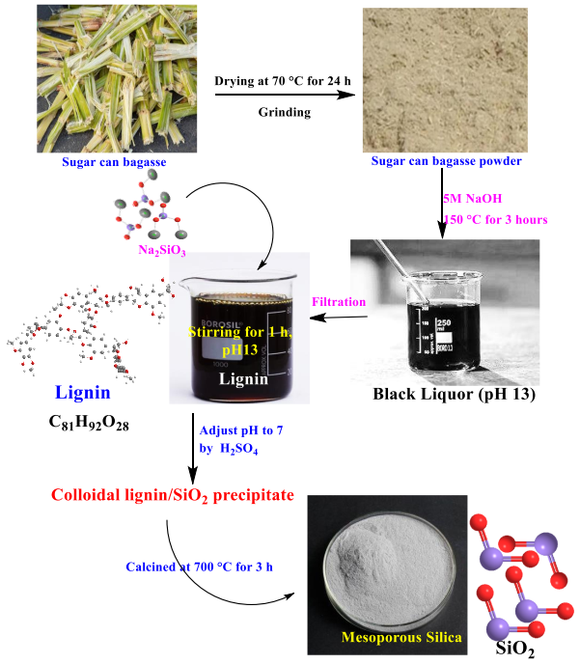
Fig. S1: Mes-Si-NP manufacturing from sugarcane bagasse

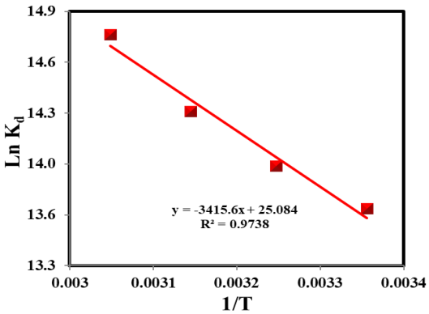
Fig. S2: Thermodynamics of Th(IV) sorption using lnK_{d} vs. 1/T relation

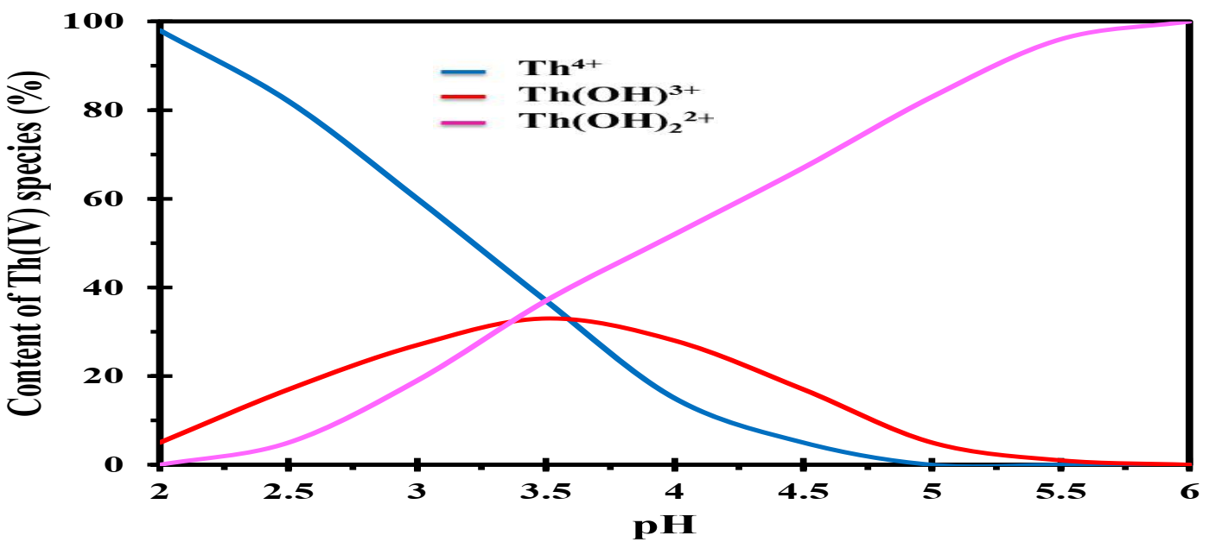
Fig. S3: The relative proportion of Th(IV) at different pH values

