Supplementary Material

Experimental Investigation of Microparticle Focusing in SiO₂ Nanofluids Inside Curvilinear Microchannels
Arsalan Nikdoost and Pouya Rezai*

Department of Mechanical Engineering, York University, Toronto, ON, Canada
*Corresponding author: BRG 433B, 4700 Keele St, Toronto, ON, M3J 1P3, Canada; Tel: +1-4167362100-44703; Email: prezai@yorku.ca

Rheological Characteristics of SiO₂ nanofluid Solutions
Rheological characteristics of these metallic nanofluids have been previously reported^{1,2}. Moldoveanu et al.² reported the viscosity of SiO₂ nanofluids over a wide range of shear rates ($\dot{γ}$=1.5V_{x}/D_{h} by ³). Viscosity variation of these nanofluids in Fig. S1 shows a non-Newtonian (shear-thickening) behavior. In our study, the viscosities for different SiO₂ concentration were estimated using a power function of the shear rate ($\dot{γ}>100 [\frac{1}{s}]$) as shown below.
$φ=1\% v/v: μ=\left(8.77×{10}^{-5}\right)×{\dot{γ}}^{0.80} [Pa.s]$ (S1)
$φ=2\% v/v: μ=\left(1.06×{10}^{-4}\right)×{\dot{γ}}^{0.79} [Pa.s]$ (S2)
$φ=3\% v/v: μ=\left(1.24×{10}^{-4}\right)×{\dot{γ}}^{0.77} [Pa.s]$ (S3)

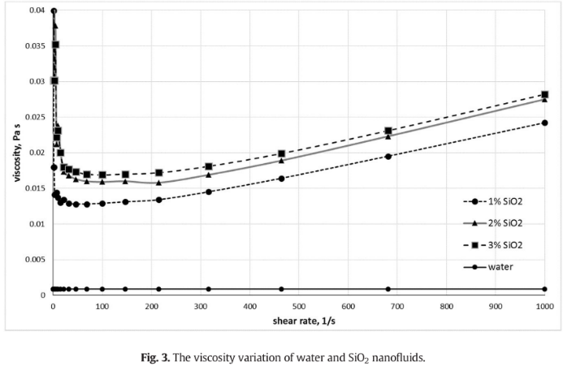
Fig. S1 Viscosity variation of water and SiO₂ nanofluids over a an expanded range of shear rate as reported by Moldoveanu et al.² Reprinted with permission from Journal of Molecular Liquids.
References:
¹ N.M. Bahari, S.N. Che Mohamed Hussein, and N.H. Othman, Part. Sci. Technol. 0, 1 (2020).
² G.M. Moldoveanu, C. Ibanescu, M. Danu, and A.A. Minea, J. Mol. Liq. 253, 188 (2018).
³ G. D’Avino and P.L. Maffettone, J. Nonnewton. Fluid Mech. 215, 80 (2015).

