Additional File 3
Supplementary material
Table S1. STEM analysis of GSE41655 and GSE115513.

Table S2. STEM analysis of GSE41657 and GSE37364.

Figure S1. A UMAP plots of cells from three tissue. Each dot represents a cell, and colors correspond to cell origins. B Log-normalized expression levels of canonical marker genes for the above cell types. C UMAP plots of epithelial cells from three tissue. Each dot represents a cell, and colors correspond to cell origins. D Log-normalized expression levels of canonical marker genes for the epithelial cell types.
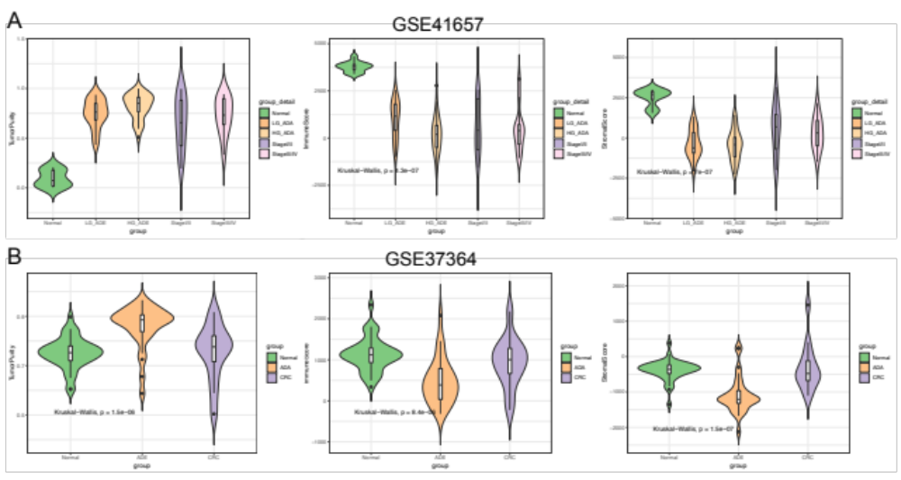
Figure S2
Boxplot plots of tumor purity, immune score, and stromal score in GSE41657(A) and GSE37364(B) via ESTIMATE analysis, split by stages of CRC initiation.

