Psychedelic 5-HT_{2A} receptor agonism: neuronal signatures and altered neurovascular coupling.

Jonah A. Padawer-Curry^{1,2}, Abraham Z. Snyder^{2,3}, Annie R. Bice², Xiaodan Wang^{2,4}, Ginger E. Nicol³, Jordan G. McCall^{5*}, Joshua S. Siegel^{3*}, Adam Q. Bauer^{1, 2,4*}

Imaging Science Program¹, Department of Radiology², Department of Psychiatry³, Department of Biomedical Engineering⁴, Department of Anesthesiology⁵, Washington University in St. Louis, St. Louis, MO.

*These principal investigators contributed equally

1.) Supplemental Analysis
1.1) Cross-covariance analysis
For each cortical region, cross-covariance functions of calcium and HbT signals were calculated. To obtain global estimates, regional functions were averaged. Using these results, peak and TTP were calculated. The frequency-dependent content of cross-covariance functions were estimated by as the cross-spectral density, quantified as magnitude-squared coherence (MSC):

$MSC=\frac{P_{xy}^{2}}{P_{xx}P_{yy}}$ , (1)

where $P_{xy}$, $P_{xx}$ , and $P_{yy}$ are the cross-spectrum power density and $x$- and $y$- PSDs, respectively.

Phase information between calcium and hemodynamics were investigated through the angle between the real and imaginary parts of the cross-spectrum power density, $P_{xy}$. Phase averaging was performed in the complex plain to avoid issues with phase unwrapping. Owing to the features observed in the MSC plots (see Results), power was integrated over two frequency bands: between 0.5 Hz and 2 Hz and below 0.5 Hz.

2.) Supplemental Results
2.1) Regional resting-state activity power
Supplemental Figure 4 reflects the same data shown in Figure 4c, reformatted to emphasize topography. DOI-induced alterations in power often revealed a spatial structure with increasing power in the anterior-to-posterior and in the lateral-to-medial directions. For instance, under DOI, large increases in ISA power were found in cingulate, frontal, and secondary motor networks while much smaller changes were found in somatosensory and visual networks. These alterations were attenuated under DOI+MDL, for instance, in cingulate and frontal networks. Additionally, the DOI-induced spatial structure of increasing power in the anterior-to-posterior and in the lateral-to-medial directions, was effectively eliminated with DOI+MDL. Calcium intermediate band power maps revealed similar structure as ISA band but were significantly smaller in magnitude. For instance, DOI and DOI+MDL minimally increased cingulate, frontal, and secondary motor networks. Lastly, in the delta-band, DOI increased medial networks, with the largest increases in the cingulate and secondary motor networks, while DOI+MDL largely reversed these changes.

Hemodynamics reveal differential alterations when compared to calcium. Under DOI, ISA band activity massively increased over the somatosensory networks which was attenuated with DOI+MDL. Under both DOI and DOI+MDL, intermediate band activity largely reflected ISA topography but was decreased by a factor of approximately three. Interestingly, delta-band activity was present in hemodynamic signaling under the DOI condition, with large increase in the whisker-barrel cortex. These findings in the context of interwoven task and resting-state imaging, suggest a slower degree of recovery to baseline hemodynamic levels after stimulus conditions as well as increased delta-band transduction.

2.2) Regional resting-state neurovascular coupling
Prior to administration of drugs, HRFs varied across the cortex (Fig. S5a, left). Strong calcium-to-hemodynamic coupling (reflected in higher peaks in the HRF) was observed in somatosensory and parietal regions; weaker coupling was observed in frontal, cingulate, and retrosplenial regions. After administering DOI, HRFs and TFs differed across the cortex (Fig. S5). As reflected in global HRF measures (main text Fig. 5a), DOI caused HRFs to deviate from canonical form ubiquitously across the cortex (Fig. S5a, middle). Moreover, following administration of DOI, HRFs were narrower (i.e., more prompt) and calcium-to-hemodynamics coupling was stronger in somatosensory and parietal regions. Furthermore, after DOI, all networks exhibited a broadening of spectral content in frequencies approaching 1 Hz (Fig. S5b, middle). As reflected in other measures (main text Figs. 2-5), DOI+MDL HRFs and TFs closely resembled characteristics following saline.

2.3) Lagged cross-covariance analysis
Global (Fig. S6) and regional (Fig. S7) lagged cross-covariance functions (CCF) and coherence were calculated to better understand the observed resting-state changes in the relationship between calcium and total hemoglobin.

2.3.1) Global lagged cross-covariance analysis
Cortical averaged CCFs were compared before and after injection of all drugs (Fig. S6a). Before injection of any drug (“Pre”), global CCFs reflected a simple, causal (i.e., calcium leading hemodynamics) relation. Injection of saline and DOI+MDL (“Post”) minimally altered this relation. DOI decreased calcium-to-hemodynamic lagged synchrony, as reflected in a decreased CCF peak value. Moreover, the DOI global CCF decayed faster, indicating a dampening of low-frequency coupling. The CCF observed in the DOI condition included a notch at zero lag (Fig. S6a, middle, black arrow). The significance of this feature is uncertain; a hypothetical account of this feature is discussed in main text, section 5.3.1.

Magnitude squared coherence functions (MSC) were calculated to assess the frequency content present in global CCFs (Fig. S6b). Before injection of drugs, the global MSC exhibited a peak at 0.2 Hz, indicating the band-limited nature of NVC. After injection of DOI, a 0.8 Hz coherence peak (~0.5 Hz half-bandwidth) emerged and the 0.2 Hz peak largely diminished, as reflected in the time domain DOI results (i.e., CCFs, Fig. S6a). This phenomenon signifies a DOI-induced shift in the NVC frequency band. As demonstrated in other analytical measures, the addition of MDL largely reversed the effects of DOI.

To quantitate the above observations, coherence was integrated from (1) 0.5 Hz to 2.0 Hz and (2) below 0.5 Hz for all drugs. Saline did not alter coherence. There was a decrease in low frequency (<0.5 Hz) coherence after injection of DOI and DOI+MDL. Furthermore, injection of DOI increased 0.5 Hz - 2.0 Hz global coherence.

Across all drug conditions, phase exhibited a calcium lag-lead relation, reflected in the positive slope at frequencies below ~1 Hz (Fig. S6c). Notably, uncertainty in the phase measure remained low at frequencies up to 5 Hz. The significance of this observation speaks to the fidelity and temporal-resolution of high-frequency hemodynamics in optical imaging relative to BOLD fMRI.

2.3.2) Regional cross-covariance analysis
Regional CCF and MSC were calculated to assess the topography of drug-induced effects (Fig. S7). Before drugs (“Pre”), coupling was strongest in somatosensory and parietal regions and weakest in frontal, cingulate, retrosplenial, and motor regions (Fig. S7a, left).

As evident in post-injection DOI regional HRFs (Fig. S5a), DOI decreased coupling strength across the cortex. Moreover, as observed in the DOI global CCFs (Fig. S6a), all DOI regional CCFs exhibited a sharp notch at zero lag. Notably, the deepest notches were in secondary motor, retrosplenial, and visual regions. Moreover, DOI CCFs decayed faster in all critical regions, with stronger decreases in the cingulate and retrosplenial areas. DOI+MDL predominantly reflected pre-injection CCFs, except for negative-lagged decreases in somatosensory and parietal regions.

Regional contributions to global MSC were evaluated (Fig. S7b). As reported in global measures, before administration of drugs, strong coherence was restricted to low frequencies (<0.5 Hz) and was strongest in somatosensory and parietal regions. Coherence was weakest in frontal, cingulate, motor, and retrosplenial regions.

After injection of DOI, low-frequency coherence decreased and MSCs exhibited prominent regionally specific changes. In this view, it is evident that the emergent 0.8 Hz global MSC peak arose primarily from increased coherence in higher association regions such as cingulate, secondary motor, and retrosplenial cortices. Notably, before injection of DOI, these regions showed low, broad-band coherence. Following injection of DOI+MDL, regional coherence primarily reflected pre-injection characteristics.

Before injection of drugs, regional phase relations did not show topographic specificity (Fig. S6c). After injection of DOI and DOI+MDL, most regions matched their pre-injection characteristics, except for frontal, cingulate, and retrosplenial regions.

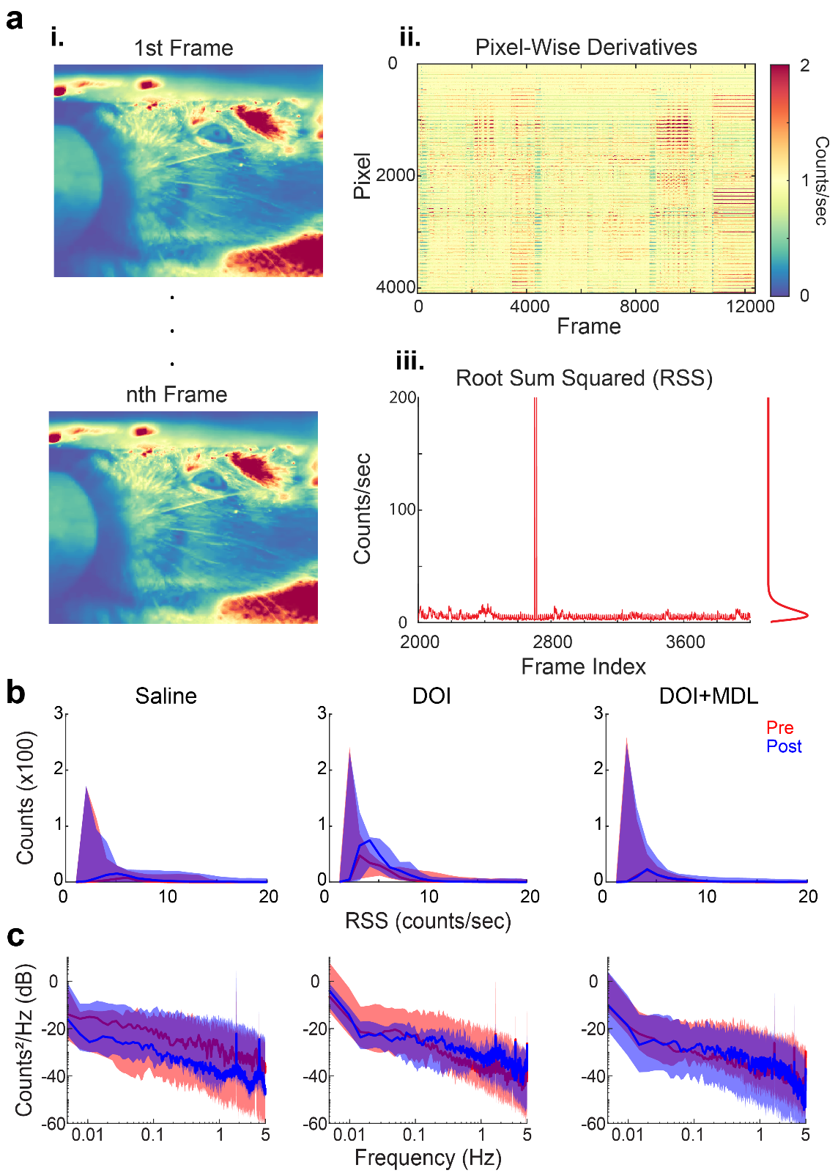
Supplemental Figure 1. DOI does not increase motion during WFOI. A CMOS camera (frame rate: 20 Hz, field-of-view ~7cm-by-7cm), was placed in of the mouse to monitor movement. Frontal illumination was delivered through a 750 nm, near infrared (NIR), LED, and NIR polarizers were used to minimize specular reflection. Movies were recorded and time locked to WFOI. a) Analysis pipeline of movement quantification. Movies were binned by a factor of two to allow for quicker processing time and each pixel was normalized to their mean average intensity over the duration of acquisition. Each pixel was differentiated across time, rectified through squaring, added across all pixels, and then square-rooted to get a single root-sum squared (RSS) trace of movement for a given scan. Scan RSS traces were put into a histogram and averaged across all scans for a given mouse and drug group. Movement’s spectral content was calculated using a smoothed estimate of power spectrum densities (i.e., pwelch). b) Histograms of movement traces. RSS time traces were put into a histogram for each drug, mouse, and scan. Averages across pre- and post-injection were created for each drug condition. No significant differences were found between pre- and post- distributions or across drugs. No significant differences (Kruskal- Wallis: p=0.681), were observed across drugs. c) Power spectral density estimates of movement traces. The spectral content of RSS traces was examined using a smoothing estimator and band-limited integrated power was compared over the infraslow (ISA, 0.01-0.08 Hz), intermediate (0.08-0.50 Hz) and delta-bands (0.5-4.0 Hz). No significant differences were found between pre- and post- distributions or across drugs (Kruskal-Wallis: ISA: p=0.514; intermediate: p=0.6189; delta: p=0.6407). The number of censored runs per 30-minute session were not significantly different between drugs (Kruskal-Wallis: p=0.431).

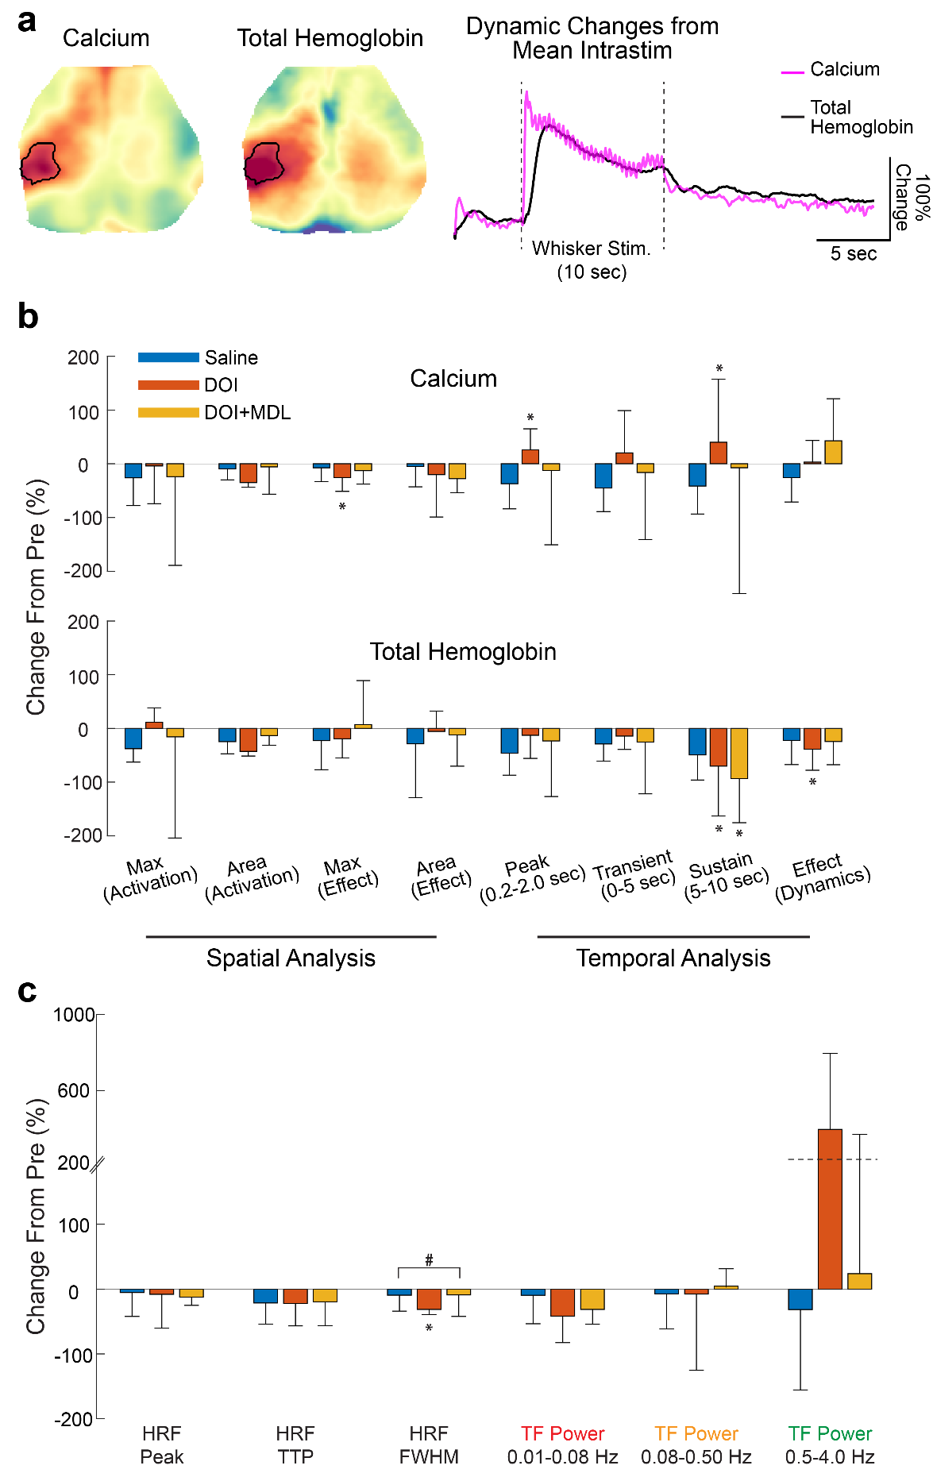
Supplemental Figure 2) Quantification of task-based calcium and hemodynamic, and neurovascular changes induced by 5-HT_{2a} receptor agonism. For all data presented in Figures 2 and 3, parameters were extracted and compared across drugs. a.) Pre-injection stimulus. Pre-injection effect maps from all experimental conditions (n=24; 8 mice $∙$3 drug conditions) were combined and averaged to create a single, high-signal-to-noise ratio (SNR) response effect map. To establish a response criterion applicable to all mice and drug conditions, this effect map was then thresholded at 75% of the maximum value to create a shared region of interest (ROI) for further analysis across all mice. Time traces within this ROI were averaged together and normalized by their intra-stimulus average. Medians and interquarile ranges (IQR) were calculated across mice. Significance of time (i.e., pre- versus post-) was assessed through Wilcoxin’s sign-rank tests (*<0.05, **<0.01, ***<0.001). Effect of drug was tested using an one-way Kruskal-Wallis and post-Hoc Wilcoxon’s sign-rank tests (#<0.05, ##<0.01, ###<0.001). Multiple comparisons was corrected using the Bonferonni method. b) Quantification of calcium and hemodynamic response dynamics. Parameters for calcium and hemodynamic response maps and dynamics were extracted and compared across drugs. Within the ROI, response amplitude, area (i.e., number of pixels over 75% of the maximum), and Cohen D’s effect size were tabulated and visualized. Temporal dynamics were parameterized by extracting the maximum value over the inter-stimulus period, the AUC during the transient response (0-5 seconds) and the sustained response (5-10 seconds), and Cohen’s D effect. c) Parameter quantification of stimulus evoked neurovascular coupling. For task-based hemodynamic response functions (HRF), peak values (peak), time to peaks (TTP), and full-width-at-half maximums (FWHM) were calculated. For transfer functions (TF), band-limited frequency transduction was parameterized in three frequency bands: infraslow activity (ISA, 0.03 Hz -0.08 Hz), intermediate band (0.08-0.50 Hz), and delta-band (0.5 Hz-4.0 Hz).
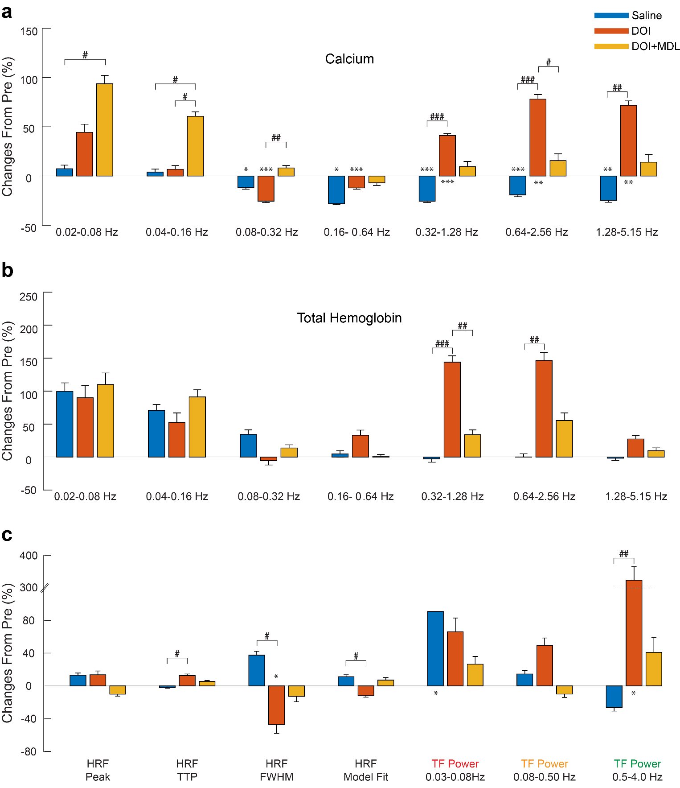
Supplemental Figure 3) 5-HT_{2a} receptor agonism changes resting-state power and neurovascular coupling. A-b) Band-limited power of the cortical average resting-state. Power spectral density estimates were parameterized and compared across drugs. To calculate band-limited power, power spectral density estimates were integrated over triple-octave bins and compared between drugs for both calcium (a) and hemodynamic (b) activity. The lowest frequency bin was limited by the lower limit of 0.02 Hz due to the tapering window length. All parameters were averaged over the cortex and comparisons were made between pre- and post-injection (i.e., effect of time) and across drugs using t-tests (*<0.05, **<0.01, and ***<0.001) and one-way ANOVAs with t-test post-hoc tests (#<0.05, ##<0.05, ###<0.001), respectively. Multiple comparisons were corrected for using the Bonferroni method. c.) Neurovascular coupling quantification. Hemodynamic response functions (HRFs) were calculated at the regional level and peak value (peak), time to peak amplitude (TTP), and full width at half maximum (FWHM) were extracted and averaged across regions. Predicted hemodynamic activity at each region was calculated by convolving each region’s HRF with the measured calcium activity in that region. Predicted and measured hemodynamic activity were compared via Pearson correlation coefficient, to get a measure of model fit. Band-limited frequency transduction was calculated over three frequency bands: infraslow activity band (ISA, 0.03-0.08Hz), intermediate activity band (0.08 Hz-0.50 Hz), and delta activity band (0.5 Hz-4.0 Hz). The lowest frequency bin was limited by the lower limit of 0.03 Hz due to the tapering window length.

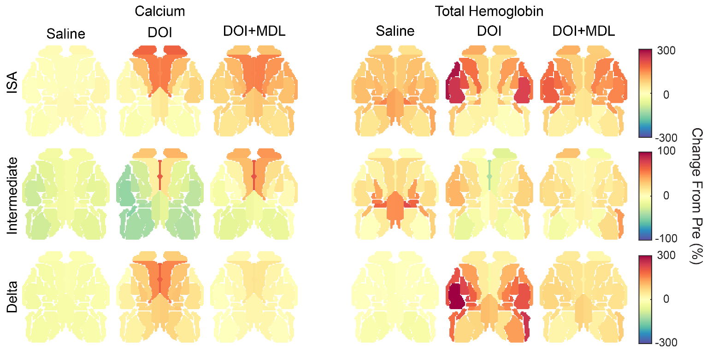
Supplemental Figure 4) Regional changes in calcium and hemodynamic activity attributed to 5-HT_{2a} receptor activity. Power spectral densities for each functional region (displayed in Fig. 4c), were integrated over standard functional bands: (1) infraslow (ISA, 0.02 Hz-0.08 Hz), (2) intermediate (0.08 Hz- 0.50 Hz) and, (3) delta bands (0.5 Hz-4.0 Hz). Integrated power was displayed on the cortex and maps are displayed as percent changes from baseline (i.e., pre injection) for each region and contrast. This process was performed on both calcium (left) and hemodynamic (right) activity. a) Integrated calcium power. DOI gave rise to a spatial structure, with increasing power in the anterior-to-posterior and in the lateral-to-medial directions: DOI increased ISA power in cingulate, frontal, and secondary motor networks (164% [156%, 186%]) but only slightly increased ISA power in somatosensory and visual networks (26% [17%, 57%] and -13% [-17%, -10%], respectively). This feature was attenuated under DOI+MDL, for instance, in cingulate and frontal networks (124% [94%, 157%]). Power maps of intermediate frequencies revealed similar structure as ISA but were significantly smaller in magnitude. For instance, DOI and DOI+MDL minimally increased cingulate (68% and 69%), frontal (33% and 42%), and secondary motor networks (14% and 38%). DOI increased delta-band power in medial networks such as cingulate (197%) and secondary motor networks (153%). DOI+MDL largely reversed these changes (maximum of 49%). b) Integrated hemodynamic power. Hemodynamics reveal differential alterations compared to calcium. Under DOI, ISA activity massively increased over the somatosensory networks (212% [127%, 237%]), which was attenuated with DOI+MDL (162% [154%, 178%]). Under both DOI and DOI+MDL, intermediate activity reflected ISA topography but was approximately three times smaller. Notably, delta-band activity was present in hemodynamic signaling under the DOI condition, with a 314% increase in the whisker-barrel cortex. These findings in the context of interwoven task and resting-state imaging, suggest a slower degree of recovery to baseline hemodynamic levels after stimulus conditions as well as increased delta-band transduction.
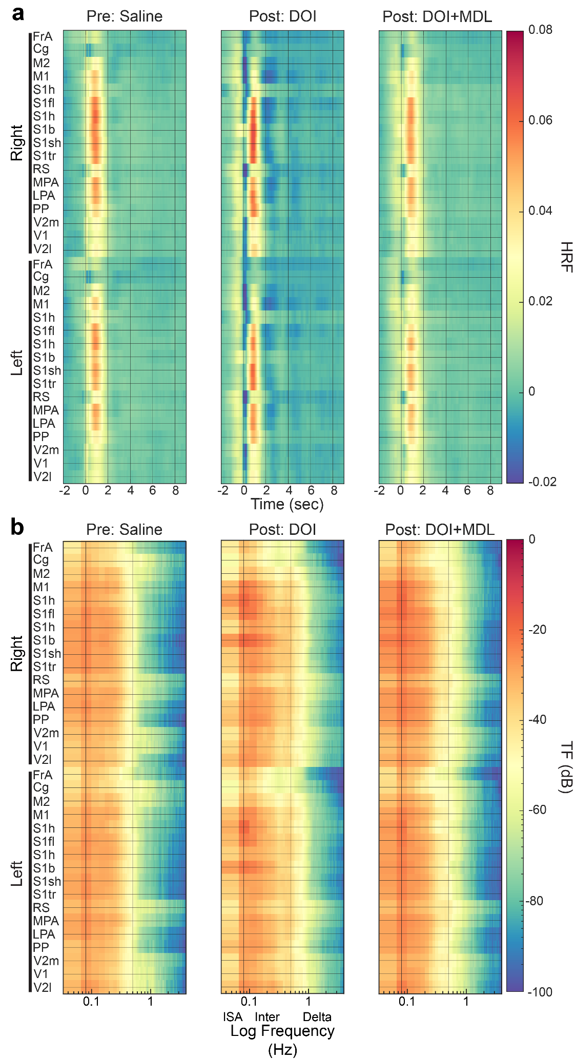
Supplemental Figure 5) DOI induces regionally specific alterations in NVC. a) Estimated HRFs for each region were averaged across mice for each drug condition. Prior to drug administration, NVC differed across the cortex. For instance, somatosensory and parietal regions exhibited the largest degree of coupling, while frontal and cingulate regions exhibited more modest coupling. DOI caused a zero-lag notch across the cortex, strongest in secondary motor, retrosplenial, and visual regions. Additionally, DOI increased coupling in the somatosensory and parietal regions. These effects were dampened when DOI was administered with DOI. The color axis has units of $μ$Mol/($Δ$F/F%). b) Group averaged, regional transfer functions of each HRF reported in panel a. Regions are organized from posterior-to-anterior and from right-to-left. As seen with HRFs, before drugs, frequency dependent calcium-to-hemodynamic transduction differed across the cortex. For instance, cingulate and retrosplenial regions exhibited broad-band transduction compared to the rest of the cortex. DOI increased transduction in frequencies above 0.1 Hz, for instance, in somatosensory regions. Additionally, DOI gave rise to broader band (power above 0.5 Hz, with a ~1 Hz peak) transduction across the cortex. These effects were largely reversed with MDL. The color axis has units dB.

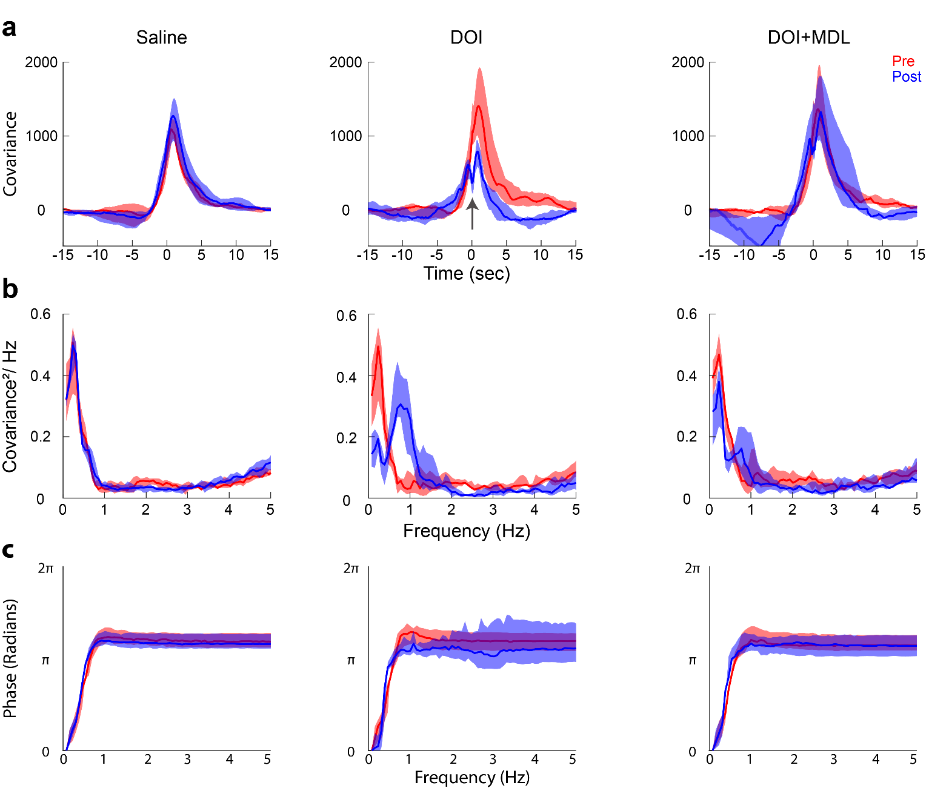
Supplemental Figure 6) Lagged cross-covariance and coherence recapitulate DOI-induced changes in neurovascular coupling and reveal increased lower delta band coherence. a) Cross-covariance between calcium and total hemoglobin. The lagged cross-covariance function (CCF) between calcium and hemodynamic activity at each pixel was calculated for each time window (i.e., data split into 30 second windows) and averaged across time and across the cortex for each mouse. Plots represent means and standard deviations. Before drugs, CCFs reflected a simple, causal (i.e., calcium leading hemodynamics) relation. Saline and DOI+MDL minimally altered this relation. DOI decreased synchrony (decreased peak value, -51% [-66%, -13%] pre-versus post-injection: p=0.039; Kruskal-Wallis: p=0.040; saline versus DOI: p=0.040). As observed in global HRFs (Fig. 3a), the DOI CCF included a zero-lag notch (discussed in 5.3.1). We note that covariance here has units of $μ$Mol$∙$($Δ$F/F%). b) Coherence between calcium and hemodynamics. To better understand the frequency content in the cross-covariance functions, cross-spectral power density estimates between calcium dynamics and hemodynamics were calculated for each region and window (i.e., data split into 30 second windows). From this, magnitude-squared coherence (MSC) was calculated as $MSC={{\left|P_{xy}\right|}^{2}}/{{(P}_{xx}P_{yy})}$, such that,${ P}_{xy}$, $P_{xx}$, and $P_{yy}$ are the complex-valued cross-spectrum power density estimates and power spectral density estimates, respectively. Cortical averages were calculated by averaging across all regions and are displayed as means and standard deviations. Coherence was integrated from (1) 0.5 Hz to 2.0 Hz and (2) below 0.5 Hz. Before drugs, MSC exhibited a peak at 0.2 Hz, indicating the band-limited nature of NVC. Saline did not alter coherence. After injection of DOI, a 0.8 Hz coherence peak (~0.5 Hz half-bandwidth) emerged (0.5 Hz - 2.0 Hz: +170% [110% 230%]; pre- versus post-injection: p=0.008; Kruskal-Wallis: p=0.002; saline versus DOI: p=0.013) and the 0.2 Hz peak largely diminished (<0.5 Hz: -47% [-53%, 49%], pre- versus post-injection: p=0.008; Kruskal-Wallis: p=0.027, saline versus DOI: p=0.027).This phenomenon signifies a DOI-induced shift in the NVC frequency band. As demonstrated in other analytical measures, the addition of MDL largely reversed the effects of DOI. b) Phase relation between calcium and hemodynamics. Across all drug conditions, phase exhibited a calcium lag-lead relation, reflected in the positive slope at frequencies below ~1 Hz.

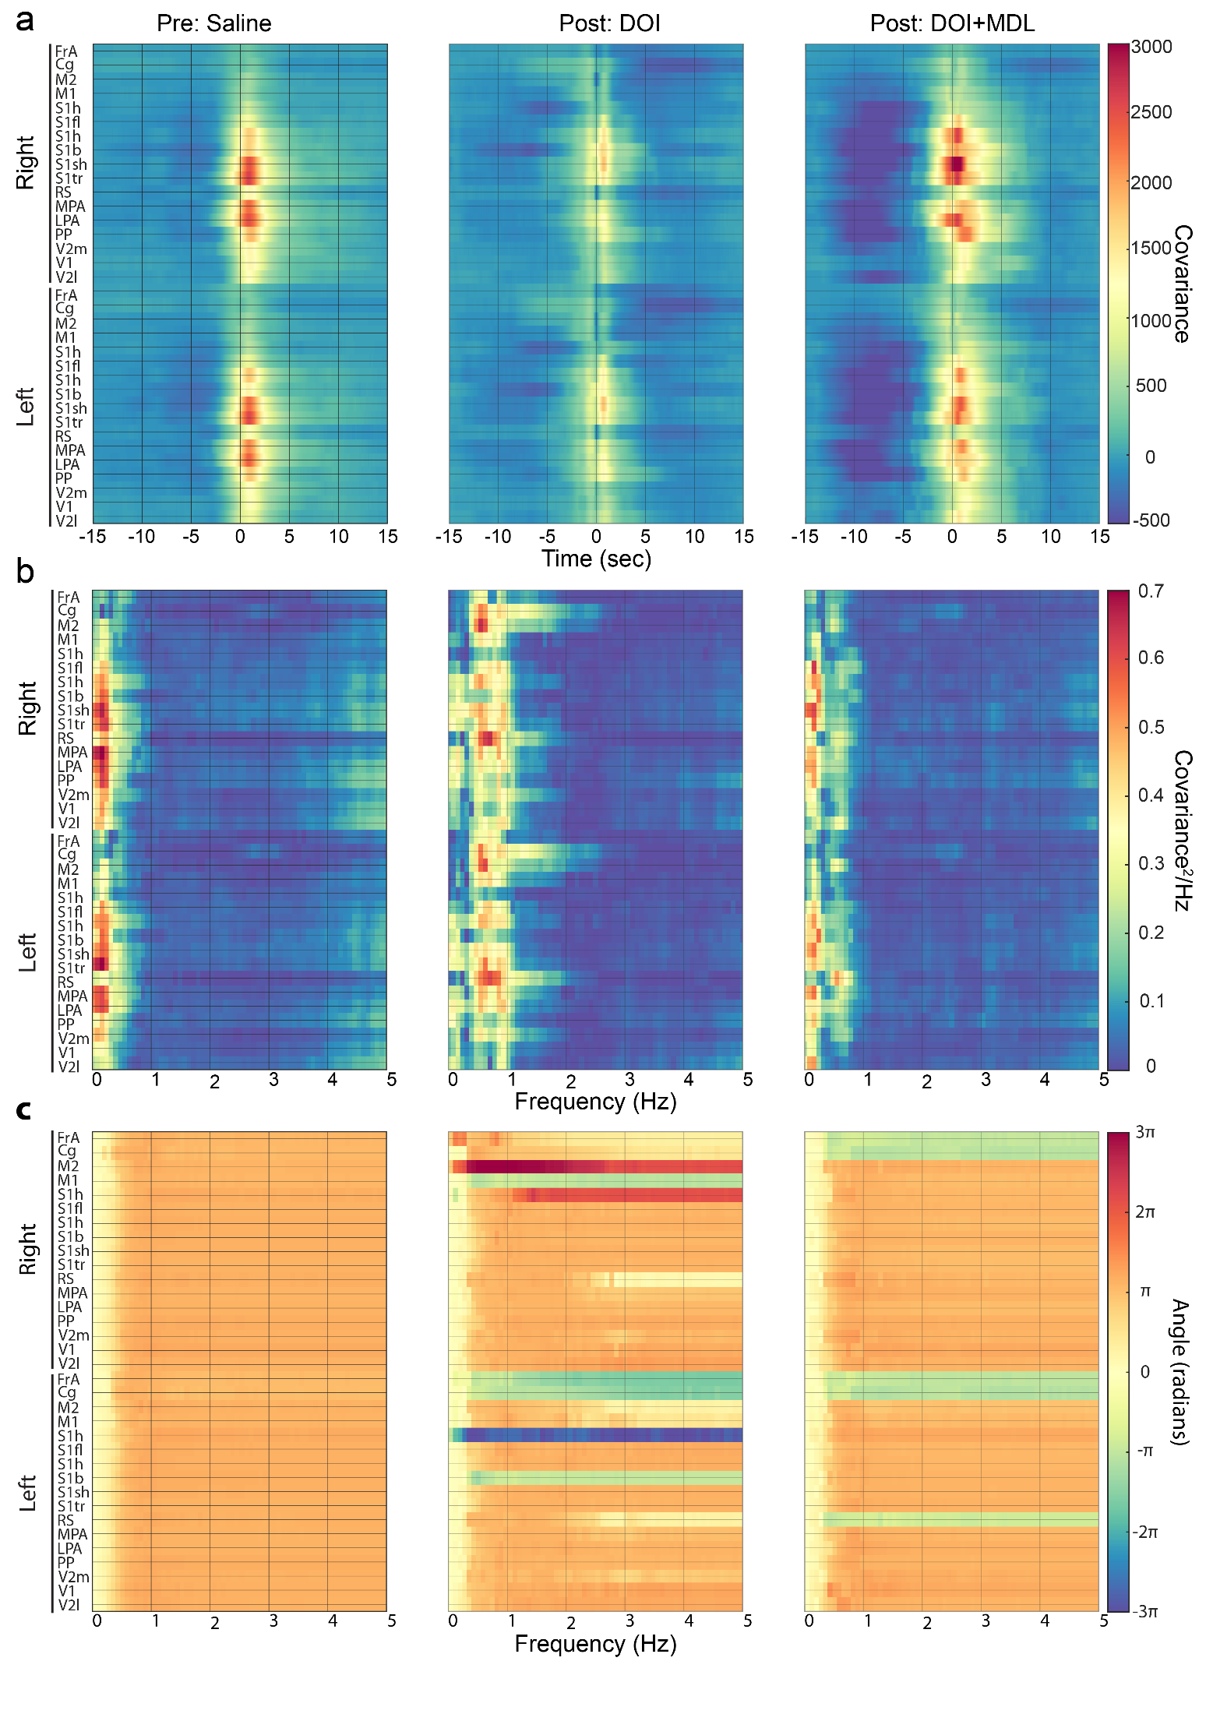
Supplemental Figure 7) Regional lagged cross-covariance and coherence. a) Lagged cross-covariance between calcium and hemodynamics reveal regional-specific contribution to global cross analysis. Lagged cross-covariance between calcium and hemodynamics was calculated for each region and time window. Windows were averaged through medians. Before drugs (left), coupling was strongest in somatosensory and parietal regions and weakest in frontal, cingulate, retrosplenial, and motor regions. As evident in regional HRFs (Fig. S5a), DOI decreased cortical-wide coupling strength and gave rise to a sharp notch at zero lag. Notably, the deepest notches were in secondary motor, retrosplenial, and visual regions. DOI CCFs also decayed faster in all critical regions, with stronger decreases in the cingulate and retrosplenial regions. DOI+MDL predominantly reflected pre-injection CCFs, except for negative-lagged decreases in somatosensory and parietal regions. We note that covariance here has units of $μ$Mol$∙$($Δ$F/F%). b) Coherence between calcium and hemodynamics. To better understand the frequency content in the cross-covariance functions, cross-spectral density estimates were calculated for each region using a smoothed estimator. From this, magnitude-squared coherence (MSC) was calculated as $MSC={{\left|P_{xy}\right|}^{2}}/{{(P}_{xx}P_{yy})}$, such that,${ P}_{xy}$, $P_{xx}$, and $P_{yy}$ are the complex-valued cross-spectrum power density estimates and power spectral density estimates, respectively. As observed in global measures before drugs, there was strong coherence in lower frequencies (<0.5 Hz) and was strongest in somatosensory and parietal regions. Coherence was weakest in frontal, cingulate, motor, and retrosplenial regions. DOI decreased low-frequency coherence and changes were regionally specific. The emergent 0.8 Hz global MSC peak (Fig. S 6b) was primarily in higher association regions such as cingulate, secondary motor, and retrosplenial cortices. Notably, before injection of DOI, these regions showed low, broad-band coherence. DOI+MDL regional coherence reflected pre-injection characteristics. c) Phase relation between calcium and hemodynamics. Before drugs, phase relations did not show regional variation (left). After injection of DOI and DOI+MDL, most regions matched their pre-injection characteristics, except for frontal, cingulate, and retrosplenial regions, where phase slopes reversed. DOI and DOI+MDL caused phase slopes to become negative in some regions (i.e., start yellow, become green), revealing that hemodynamics lead calcium in this band (i.e., vasculo-neural coupling, see section 5.3.1). MDL did not fully reverse this phenomenon.

