Supplementary Material

COVID-19-like symptoms and their relation to SARS-CoV-2 epidemic in children and adults of an Italian birth cohort
Maja Popovic, Chiara Moccia, Elena Isaevska, Giovenale Moirano, Costanza Pizzi, Daniela Zugna, Franca Rusconi, Franco Merletti, Milena Maule, Lorenzo Richiardi

Figure S1. Weighted prevalence of COVID-19-like symptoms in adults between February 21st 2020 (date of the first COVID-19 case reported in Italy) and the date of completion of the questionnaire, and in the last week before the completion of the questionnaire, by sex
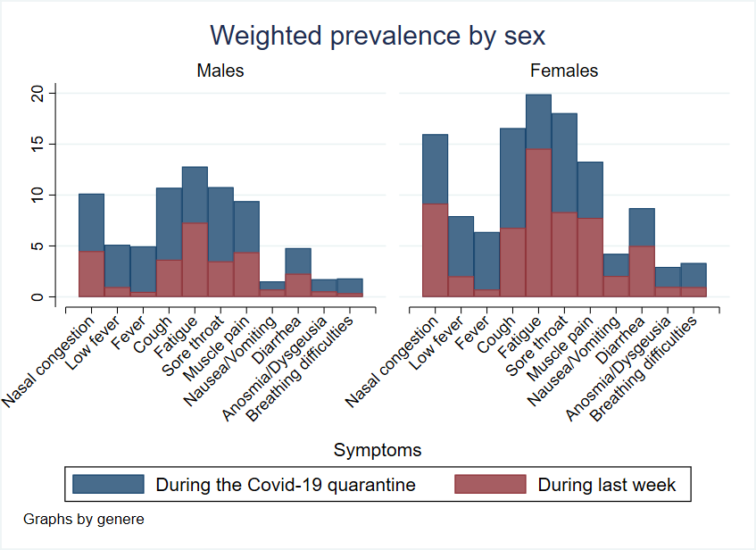

Figure S2. Scatter plots of cumulative incidence of COVID-19 by province and the prevalence of testing for SARS-CoV-2 and COVID-19 diagnosis in adults from the NINFEA cohort. Data points represent provinces with at least 50 participants who responded to the NINFEA questionnaire on COVID-19: Alessandria, Asti, Arezzo, Cuneo, Florence, Lucca, Milan, Rome, and Turin.

Figure S3. Scatter plots of cumulative incidence of COVID-19 by province and the prevalence of COVID-19-like symptoms in adults from the NINFEA cohort. Data points represent provinces with at least 50 participants who responded to the NINFEA questionnaire on COVID-19: Alessandria, Asti, Arezzo, Cuneo, Florence, Lucca, Milan, Rome, and Turin.

Figure S4. Scatter plots of cumulative incidence of COVID-19 by province and the prevalence of COVID-19 symptoms and testing for SARS-CoV-2 in children aged ≥6 years from the NINFEA cohort. Data points represent provinces with at least 50 participants who responded to the NINFEA questionnaire on COVID-19: Alessandria, Asti, Arezzo, Cuneo, Florence, Lucca, Milan, Rome, and Turin.

Table S1. Geographical correlation coefficients between the population cumulative incidence of COVID-19 as reported by the Surveillance System and the prevalence of COVID-19-like symptoms, testing for SARS-CoV-2 and COVID-19 diagnosis in adults from the NINFEA cohort, by sex.
Symptoms and SARS-CoV-2 testing and  COVID-19 diagnosis | Females |  | Males
Symptoms and SARS-CoV-2 testing and  COVID-19 diagnosis | Spearman’s rho | p-value |  | Spearman’s rho | p-value
Nasal congestion | 0.20 | 0.61 |  | 0.45 | 0.22
Fever 37.0-37.5ºC | 0.00 | 1.00 |  | 0.95 | 0.0003
Fever >37.5ºC | 0.50 | 0.17 |  | 0.17 | 0.67
Sore throat | 0.62 | 0.08 |  | 0.35 | 0.36
Cough | 0.08 | 0.83 |  | 0.52 | 0.15
Muscle pain | 0.88 | 0.002 |  | 0.93 | 0.0002
Fatigue | 0.62 | 0.08 |  | 0.87 | 0.003
Nausea/Vomiting | -0.27 | 0.49 |  | 0.39 | 0.38
Diarrhoea | 0.50 | 0.17 |  | 0.35 | 0.36
Anosmia/Dysgeusia | 0.62 | 0.10 |  | 0.40 | 0.50
Breathing difficulties | 0.60 | 0.12 |  | 1.00 | 0.00
At least one symptom¹ | 0.27 | 0.49 |  | 0.57 | 0.11
SARS-CoV-2 test² | -0.45 | 0.26 |  | 0.33 | 0.42
COVID-19 diagnosis | 0.80 | 0.20 |  | 0.50 | 0.67
Provinces with at least 50 participants who responded to the NINFEA questionnaire on COVID-19 were considered: Alessandria, Asti, Arezzo, Cuneo, Florence, Lucca, Milan, Rome, and Turin.
Correlation coefficients of at least 0.70 are reported in bold.
¹ Excluding anosmia/dysgeusia and breathing difficulties
² Nasopharyngeal swab for SARS-CoV-2 testing

