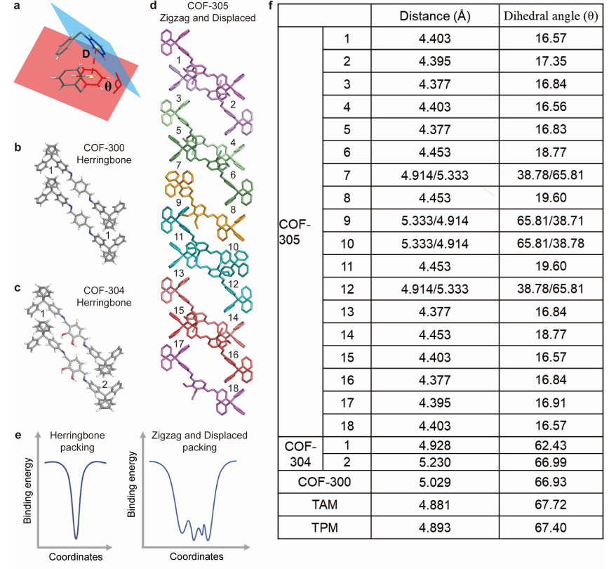
Extended Data Fig. 1. The diverse packing geometry in COF-305. a, Inter-molecular interaction of TAM motif relies on two diphenylmethyl moisties and is characterized by the distance (D) and dihydral angle (θ). b-d, The number represent the inter-molecular interaction sites in these three COFs. e, The energy landscapes of TAM in crystalline state are speculated to provide rationalization for COF-305. Herringbone packing would represent one energy minimum and a high-energy barrier, so that slight deviation from the packing would result in a very unfavorable structure. When herringbone packing is not feasible for COF, the TAM go for the zigzag and displaced packing modes, which could possess multiple local energy minima with low-energy barriers, resulting in a complex structure for COF-305. f, Table showing the distances and dihedral angles between the interacting phenyl rings of two adjacent tetraphenyl methane in COF-305, COF-304, COF-300, TAM and TPM. Numbers in the table represent inter-molecular interaction shown in the figure in the left column.

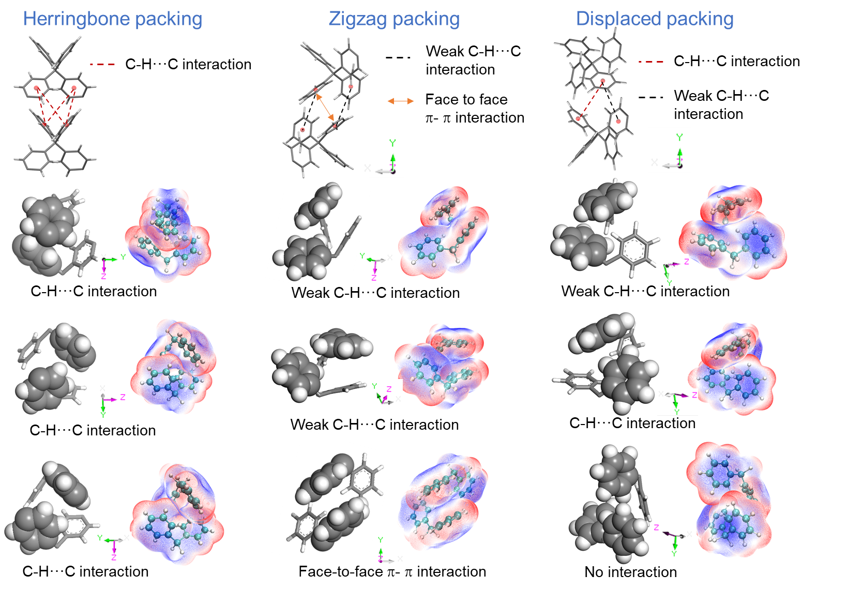
Extended Data Fig. 2. Inter-molecular interaction of TAM motif in the three packing modes. Electrostatic potential coloured van der Waals surface maps of inter-molecular interaction of TAM motif were created and the analyzed phenyls pairs are in CPK mode. The TAM molecules crystallized in a highly symmetric space group, thus resulting in the four identical CH···C interactions between adjacent phenyls groups (herringbone packing). In zigzag packing mode, there exists a pair of face-to-face π-π interaction and two pairs of weak CH···C interaction. In displaced packing mode, there exists a pair of CH···C interaction and a pair of weak CH···C interaction.

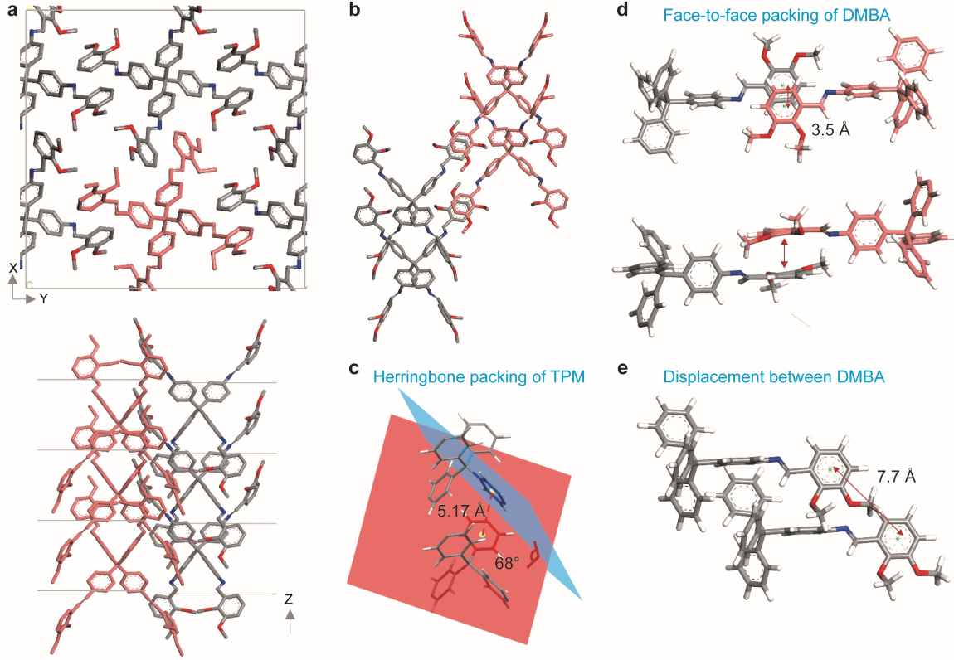
Extended Data Fig. 3. Single-crystal structure of M-305-2. a, Packing of M-305-2 viewed from c-axis (top) and viewed along c-axis (down). b, The presentation will feature two columns of M-305-2 molecules, with one column highlighted in red. c, The TAM motifs in M-305-2 are arranged in herringbone packing mode, with dihedral angle of 68º and distance of 5.17 Å between the interacted phenyl rings. Adjacent DMBA motifs from two column exhibit face-to-face packing (d), while in the same column, they adopt displaced packing (e).

