Supplementary Information (59 pages)

Encoding Ordered Complexity to Covalent Organic Frameworks

Lei Wei^{1,#} Xinyue Hai^{1,#} Tongtong Xu¹, Zidi Wang¹, Wentao Jiang¹, Shan Jiang¹, Qisheng Wang², Yue-Biao Zhang^{1,3}*, Yingbo Zhao^{1,3}*
¹School of Physical Science and Technology, ShanghaiTech University, Shanghai, 201210, P. R. China.
²Shanghai Key Laboratory of High-Resolution Electron Microscopy, ShanghaiTech University, Shanghai 201210, China.
³Shanghai Synchrotron Radiation Facility, Shanghai Advanced Research Institute, Chinese Academic of Sciences, Shanghai 201210, China.

*To whom correspondence should be addressed: ybzhang@shanghaitech.edu.cn; zhaoyb2@shanghaitech.edu.cn
#These authors contributed equally.

Table of contents
Section S1. Materials and Instrumentation 3
Section S2. Synthesis of COFs and their structural analogues. 5
Section S3. The characterization of the crystalline structures of COF-305 and COF-304 8
Section S4. Structural analysis of COF-304 and COF-305 23
Section S5. Structure analysis of model molecules of analogue of COFs 36
Section S6. Computational simulation 56

Section S1. Materials and Instrumentation
Materials
2,3-dihydroxyterephthalaldehyde (DHPA, purity ≥ 98%), 2,3-dimethoxyterephthalaldehyde (DMPA, purity ≥ 98%), 4'',4'''-methanetetrayltetraaniline (TAM, purity ≥ 99%) were purchased from Jilin Chinese Academy of Sciences-Yanshen Technology Co., Ltd. Terephthalaldehyde (TPA, purity ≥ 98%) was purchased from Shanghai Aladdin Biochemical Technology Co. Super dry 1,4-dioxane (purity ≥ 99.5%) and aniline (purity ≥ 99.5%) were purchased from J&K Scientific Ltd. 1,4-dioxane (AR, purity ≥ 99.5%) and n-butanol (AR) were purchased from General-reagent Co., Ltd. Purification of TAM is needed prior to COF synthesis.
Instrumentation
Single-crystal x-ray diffraction (SXRD) data of COF-304 and TPM was collected at Shanghai Synchrotron Radiation Facility (SSRF) Beamline BL17B1 station (λ = 0.71073 Å) equipped with a marXperts MX300 CCD detector. SXRD of COF-305 was collected at SSRF Beamline BL10U2 station (λ = 0.6887 Å) equipped with a marXperts MX300 CCD detector. All the datasets of single-crystal were collected at 100 K, and the data were accordingly processed with CrysAlisPro (version.171.37.35), HKL2000¹, and APEXII² software packages, depending on the instrument setup. SXRD data of TAM, DMPA, M-300, M-304, M-305, and M-305-2 was collected on a Bruker D8 Venture Photon III diffractometer using Ga Kα (λ = 1.34138 Å) X-ray source. The specimen was cooled to 150 K using a cryo-stream 800 plus chilled by liquid nitrogen. SXRD data of DHPA was collected on a Bruker D8 Venture diffractometer equipped with a fine-focus Cu target X-ray tube operated at 40 W power (50 kV, 1 mA) with radiation of λ = 1.5418 Å. The specimen was cooled to 150 K using a cryo-stream 800 plus chilled by liquid nitrogen.
The structure analysis and refinement were carried out using the SHELX algorithms in Olex2^{3, 4}. Solvent masking was applied during structure refinement⁵. All the non-hydrogen atoms were refined anisotropically, all the hydrogen atoms were added geometrically and refined in the riding model. Crystal data and details of the structure refinement for single crystals are given in Supplementary Tables 1-11 and the attached CIFs. Mercury⁶ and Diamond⁷ software were used for structural visualization.
Powder x-ray diffraction (PXRD) patterns of COF samples were collected on a Rigaku D8 Advance diffractometer equipped with a Cu target X-ray tube operated at 1600 W power (40 kV, 40 mA). The samples were measured with a step size of 0.02º and a scan time of 0.2 s per step.
The Fourier-transform infrared (FT-IR) COF samples were recorded on neat samples in the range of 500–4000 cm⁻¹ on a PerkinElmer FT-IR spectrometer equipped with single reflection diamond ATR module.
The solid-state ¹³C nuclear magnetic resonance (¹³C SSNMR) of COF samples were recorded on a Bruker ADVANCE 400 MHz Solid NMR spectrometer with cross-polarization magic angle-spinning (CP/MAS) and 4.0-mm double-resonance MAS probe. The samples were loaded in the zirconia rotor with a sample spinning rate of 13.0 kHz.
The thermal gravimetric analyses (TGA) were carried out using a TAQ50 TGA analyzer from 25 to 800 °C under N₂ atmosphere with a temperature ramping rate of 5 °C/min.
Low-pressure gas adsorption isotherm was measured volumetrically using a Quantachrome iQ (N₂, CO₂). Liquid nitrogen and dry ice-methanol bath was used for temperature-control at 77K and 195 K, respectively.

Section S2. Synthesis of COFs and their structural analogues.
Synthesis of single-crystalline COF-304. DHPA (15 mg, 0.090 mmol) was dissolved in 0.5 mL of 1,4-dioxane and 60 μL of aniline was added. The mixture was transferred to an NMR tube and then 0.2 mL of aqueous acetic acid (15 M) was added. After homogenously mixed, red-crystalline precipitate was observed, and the solution of TAM (20 mg, 0.0528 mmol) dissolved in 0.75 mL 1,4-dioxane was added carefully. The reaction was placed at room temperature stand still for three weeks, the dark red-coloured crystals slowly crystallized out. The as-synthesized single crystals were isolated and then exchanged by n-butanol three times for SXRD measurement. A rod-shaped crystal (10 × 10 × 60 μm³) of COF-304 was selected for SXRD measurement.
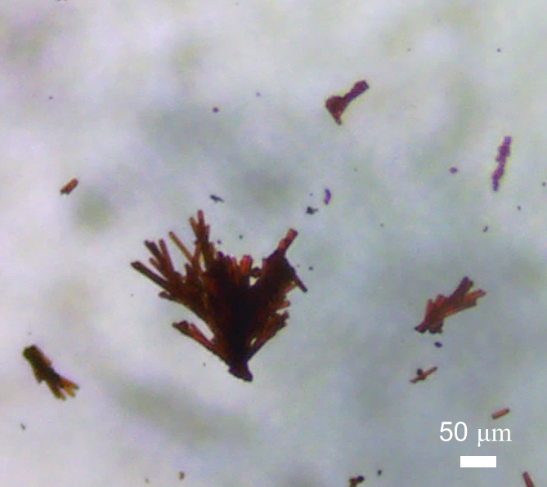
Supplementary Fig. 1. Optical microscopic image of rod-like COF-304.

Synthesis of single-crystalline COF-305. DMPA (17 mg, 0.088 mmol) was dissolved in 0,5 mL of 1,4-dioxane, and then 40 μL of aniline and 200 μL aqueous acetic acid (15M) were added to a 5 mL vial. After homogenously mixing the solution, the solution of TAM (20 mg, 0.0528 mmol) dissolved in 0.75 mL 1,4-dioxane was added carefully. The reaction was placed standstill at room temperature. The yellow-coloured crystals of about 30 μm was crystallized out after two days, and the crystal size could reach about 40 μm in four days. The as-synthesized single crystals were isolated and then exchanged by n-butanol for three times for SXRD measurement.
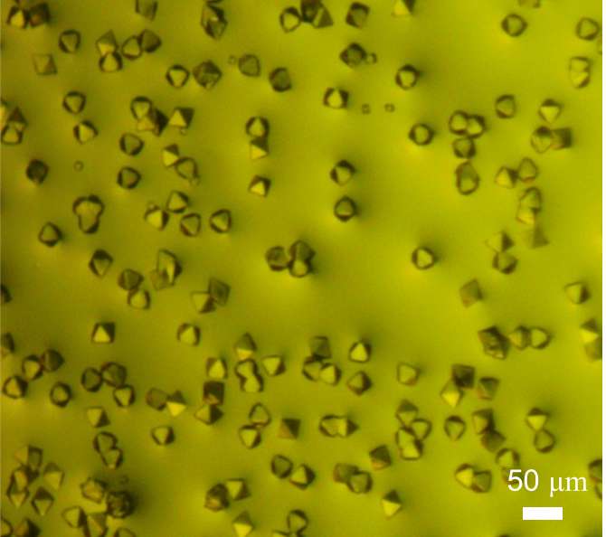
Supplementary Fig. 2. Optical microscopic image of as-synthesized COF-305 crystal with average sizes of 40 μm.

Synthesis of molecular model compound M-300 (1,1'-(1,4-phenylene)bis(N-phenylmethanimine))
TPA (20 mg, 0.149 mmol) was dissolved in 1 mL of 1,4-dioxane, and then 100 μL of aniline and 200 μL aqueous acetic acid (6 M) were added to a 5 mL vial. The reaction was placed standstill at room temperature for half an hour, and a colourless crystal was observed. The as-synthesized single crystals were isolated for SXRD measurement.
Synthesis of molecular model compound M-304 (3,6-bis(-(phenylimino)methyl)benzene-1,2-diol).
DHPA (20 mg, 0.12 mmol) was dissolved in 1 mL of 1,4-dioxane, and then 100 μL of aniline and 200 μL aqueous acetic acid (6 M) were added to a 5 mL vial. The reaction was heated at 80 ºC for one day, then placed at room temperature for one day, and dark red-color crystals were observed. The as-synthesized single crystals were isolated for SXRD measurement.
Synthesis of molecular model compound M-305 (-1,1'-(2,3-dimethoxy-1,4-phenylene)bis(N-phenylmethanimine)).
A mixture of DMPA (23 mg, 0.119 mmol) was dissolved in 0.5 mL of 1,4-dioxane, and then 30 μL of aniline was added to the 5 mL vial. The reaction was placed at room temperature while volatilizing the organic solvent slowly and a yellowish single crystal was obtained. The single crystals were picked up directly for SXRD measurements.
Synthesis of molecular model compound M-305-2 ((1E,1'E,1''E,1'''E)-N,N',N'',N'''-(methanetetrayltetrakis(benzene-4,1-diyl))tetrakis(1-(2,3-dimethoxyphenyl)methanimine)).
A mixture of DMPA (21 mg, 0.119 mmol) was dissolved in 0.5 mL of 1,4-dioxane, and then 10 mg of TAM was added to the 5 mL vial. The reaction was placed at room temperature while volatilizing the organic solvent slowly and a yellowish single crystal was obtained. The single crystals were picked up directly for SXRD measurements.

Section S3. The characterization of the crystalline structures of COF-305 and COF-304
Supplementary Table 1. Crystallographic data and structural determination for COF-305.
Name | COF-305
Formula sum | C₁₁₂₅H₉₀₆N₁₀₀O₁₀₀
Formula Weight | 17425
Crystal system | Orthorhombic
Space group | Fdd2 (No.43)
a (Å) | 47.077(9)
b (Å) | 67.629(14)
c (Å) | 42.547(9)
V (Å³) | 135460 (48)
Z | 288
Temperature (K) | 100
Density(g/cm³) | 0.615
Measured reflections | 38304
unique reflections | 38304
Θ range (º) | 1.021- 20.841
R₁ | 0.0744
wR₂ | 0.2488
S(GOF) | 1.004
Parameters | 2141
Restraints | 190
Max/min res. Dens., (e Å⁻³) | 0.220 / -0.171
Crystal size, mm³ | 0.06×0.04×0.04
Radiation, Å | 0.6887
CCDC number | 2292629
^{𝑎}𝑅₁ = ∑||𝐹𝑜| − |𝐹𝑐||/ ∑|𝐹_{𝑜}|; ^{𝑏}𝑤𝑅₂ = [∑ 𝑤 ($F_{0}^{2}$ − $F_{C}^{2}$)²/ ∑ 𝑤 ($F_{0}^{2}$)²]^{1/2}; ^{𝑐}𝑆 = [∑ 𝑤($F_{0}^{2}$ − $F_{C}^{2}$)² /(𝑁_{𝑟𝑒𝑓} - 𝑁_{𝑝𝑎𝑟})]^{1/2}.

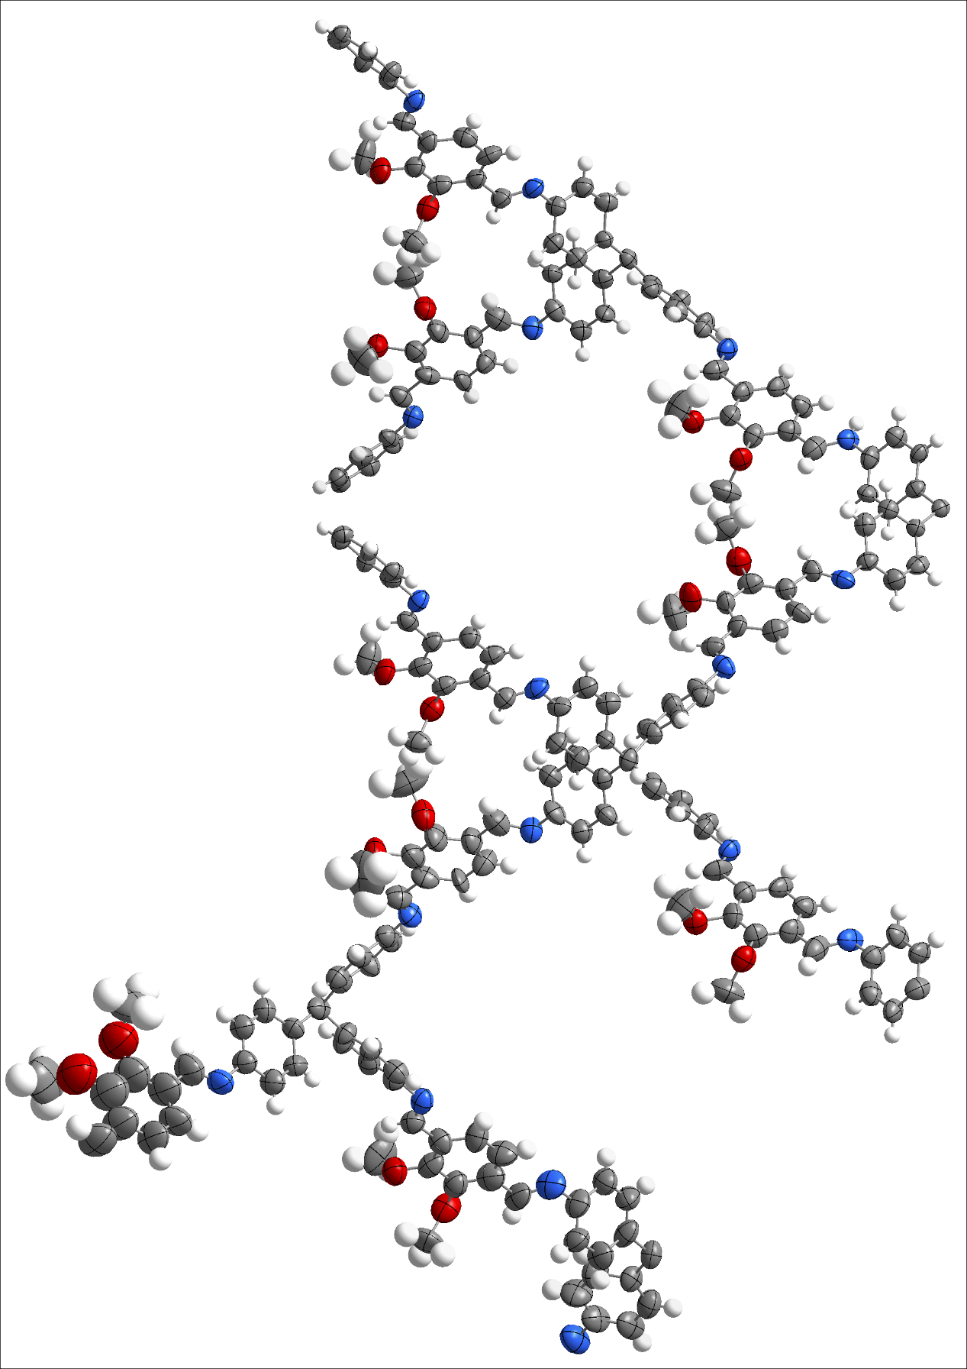
Supplementary Fig. 3. Asymmetric unit in the single-crystal structure of COF-305. Thermal ellipsoids are drawn with a 50% probability. Colour code: N, blue; O, red; C, grey; H, white.
Supplementary Table 2. Unit cell parameters of COF-305 measured under different solvents.
Solvent | Crystal system | a (Å) | b (Å) | c (Å) | V (Å³)
n-butane | Fdd2 | 47.08 | 67.63 | 42.55 | 135460
1,4-dioxane | Fdd2 | 46.52 | 66.11 | 41.82 | 128590
DMF | Fdd2 | 47.23 | 67.02 | 42.50 | 134548
Mesitylene | Fdd2 | 47.35 | 67.42 | 42.16 | 134590

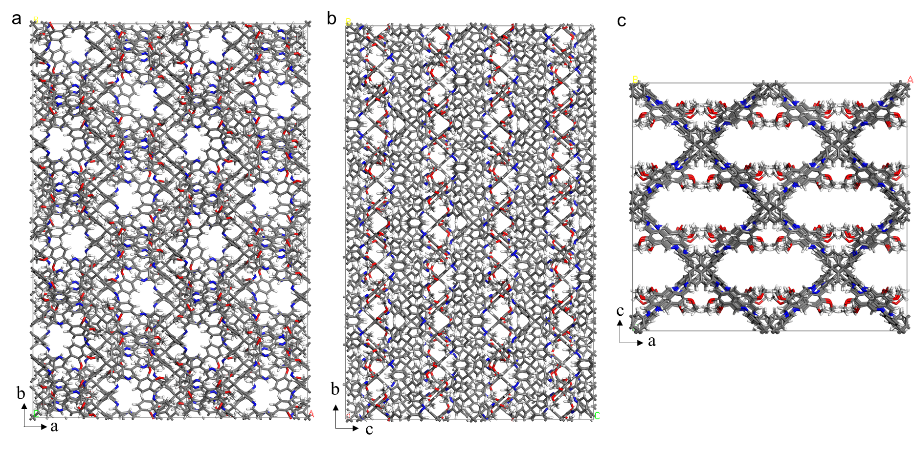
Supplementary Fig. 4. Single-crystal structure of COF-305 viewed from c-axis (a), a-axis (b), and b-axis (c). Colour code: N, blue; O, red; C, grey; H, white.

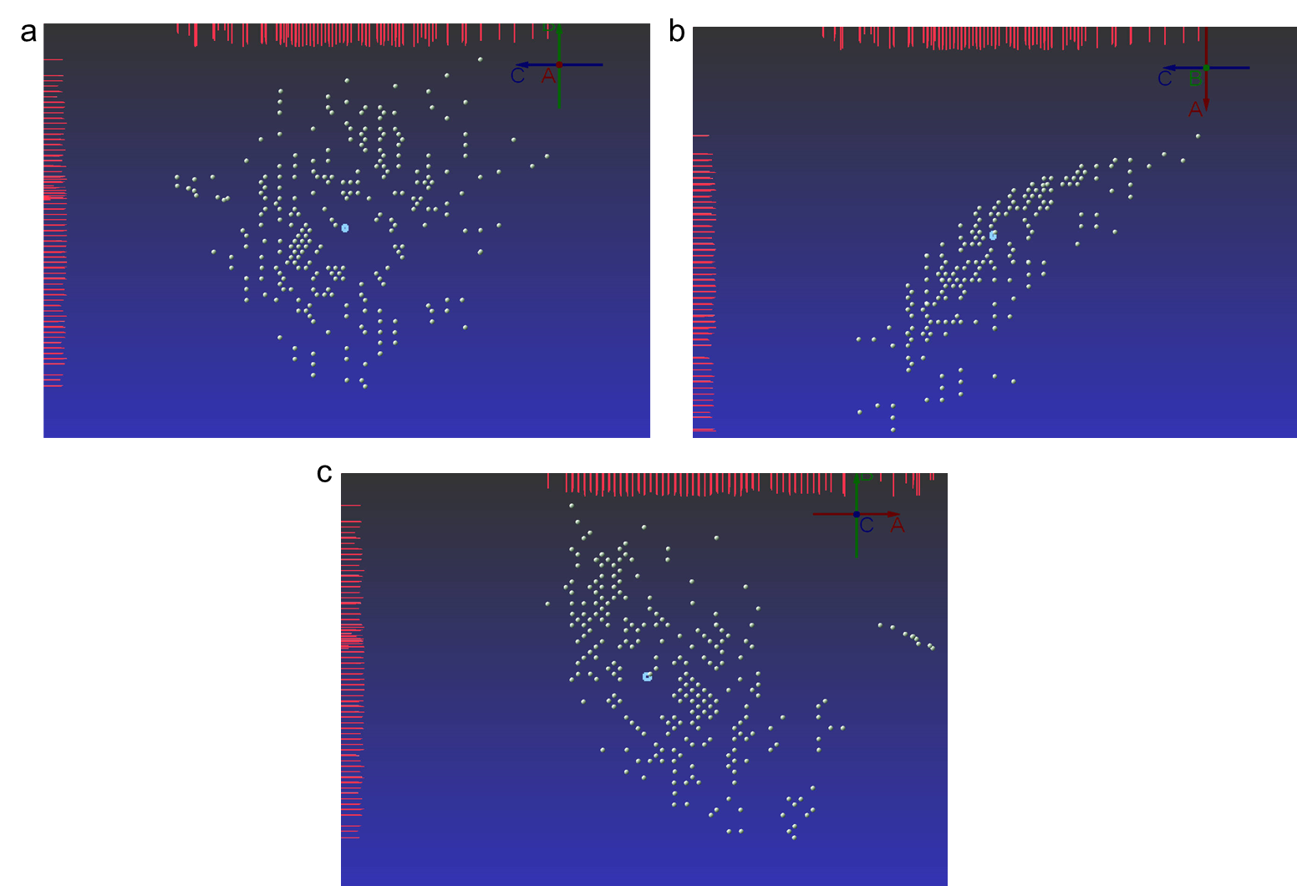
Supplementary Fig. 5. The oriented lattice views. The 2D profiles on the top and the left are counting intensity. Figure a) viewed from the a-axis, (b) from the b-axis, and (c) from c-axis.

Supplementary Fig. 6. PXRD patterns of COF-305 collected in n-butanol vapor atmosphere (red). The experimental pattern is compared to the simulated pattern based on the refined single crystal structure (green). The difference in intensity between experimental pattern and simulated one is due to the calculated PXRD pattern according to the “solvent-masked” structure of COF-305.

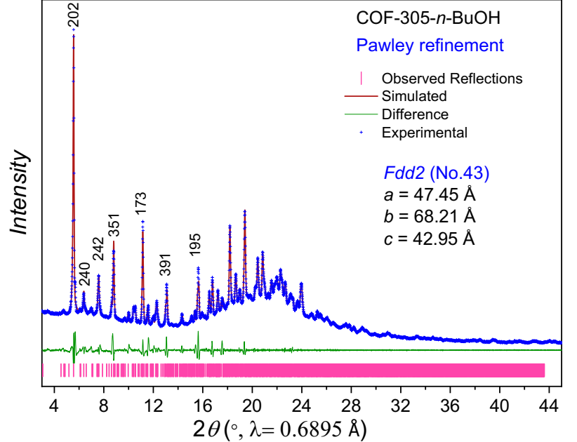
Supplementary Fig. 7. Pawley refinement of refined single crystal structure of COF-305 (red) against the PXRD pattern of the n-butanol adsorbed sample (blue). The experimental PXRD pattern was collected with the crystal size of ca. 40 μm.

Supplementary Fig. 8. FTIR spectra of starting material (TAM, DMPA) and COF-305. IR peak at 3397 cm⁻¹ for TAM (assigned to the N-H stretching mode of amino group) and 1684 cm⁻¹ for DMPA (assigned to the C=O stretching mode of aldehyde) disappeared. Newly emerged IR peak at 1623 cm⁻¹ for COF-305 confirms the formation of imine linkage in COF-305.

Supplementary Fig. 9. The ¹³C SSNMR spectra of COF-305 under n-butanol vapor atmosphere showing the successful formation of imine linkage. The signal at 155.23 and 154.63 ppm were assigned to the carbon atom of imine bond for COF-305. The characteristic chemical shift at 61.53 ppm should be assigned to the carbon atom of the methoxy group of DMPA, and chemical shift at 63.82 ppm is assigned to the quaternary carbon atom in TAM segment. Chemical shifts at 61.569, 34.80, 19.07, and 13.90 ppm are assigned to the carbon atoms of n-butanol.

Supplementary Fig. 10. The TGA traces of activated COF-305 with thermal stability up to 390 °C.

Supplementary Fig. 11. N₂ adsorption isotherm of COF-305 measured at 77 K.

Supplementary Fig. 12. CO₂ adsorption isotherm of COF-305 measured at 195 K. CO₂ uptake shows stepwise adsorption and hysteresis between adsorption and desorption, which means the structure changes during CO₂ go through the channels.

Supplementary Table 3. Crystallographic data and structural determination for COF-304.
Name | COF-304
Formula sum | C₁₆₄H₁₁₂N₁₆O₁₆
Formula Weight | 2562.7427
Crystal system | Tetragonal
Space group | I-4 (No.82)
a (Å) | 26.210(6)
b (Å) | 26.210(6)
c (Å) | 7.582(3)
V (Å³) | 5209 (3)
Z | 16
Density(g/cm³) | 0.817
Measured reflections | 5222
unique reflections | 1879
Θ range (º) | 2.38-18.19
R₁ | 0.1805
wR₂ | 0.4147
S(GOF) | 1.094
Parameters | 55
Restraints | 204
Max/min res. Dens., (e Å⁻³) | 0.331 / -0.716
Crystal size, mm³ | 0.01×0.01×0.06
Radiation, Å | 0.71073
Temperature (K) | 100
CCDC number | 2292628
^{𝑎}𝑅₁ = ∑||𝐹𝑜| − |𝐹𝑐||/ ∑|𝐹_{𝑜}|; ^{𝑏}𝑤𝑅₂ = [∑ 𝑤 ($F_{0}^{2}$ − $F_{C}^{2}$)²/ ∑ 𝑤 ($F_{0}^{2}$)²]^{1/2}; ^{𝑐}𝑆 = [∑ 𝑤($F_{0}^{2}$ − $F_{C}^{2}$)² /(𝑁_{𝑟𝑒𝑓} - 𝑁_{𝑝𝑎𝑟})]^{1/2}.

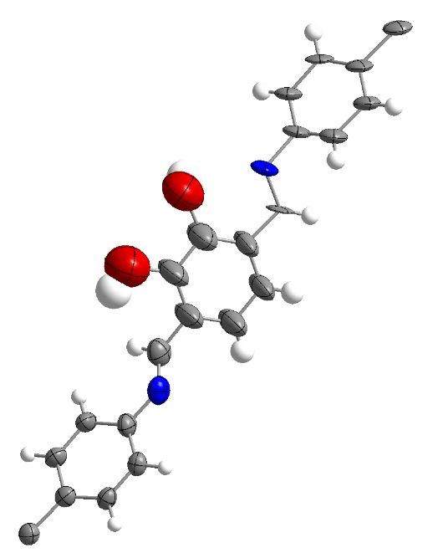
Supplementary Fig. 13. Asymmetric unit in the single-crystal structure of COF-304. Thermal ellipsoids are drawn with a 50% probability. Colour code: N, blue; O, red; C, grey; H, white.

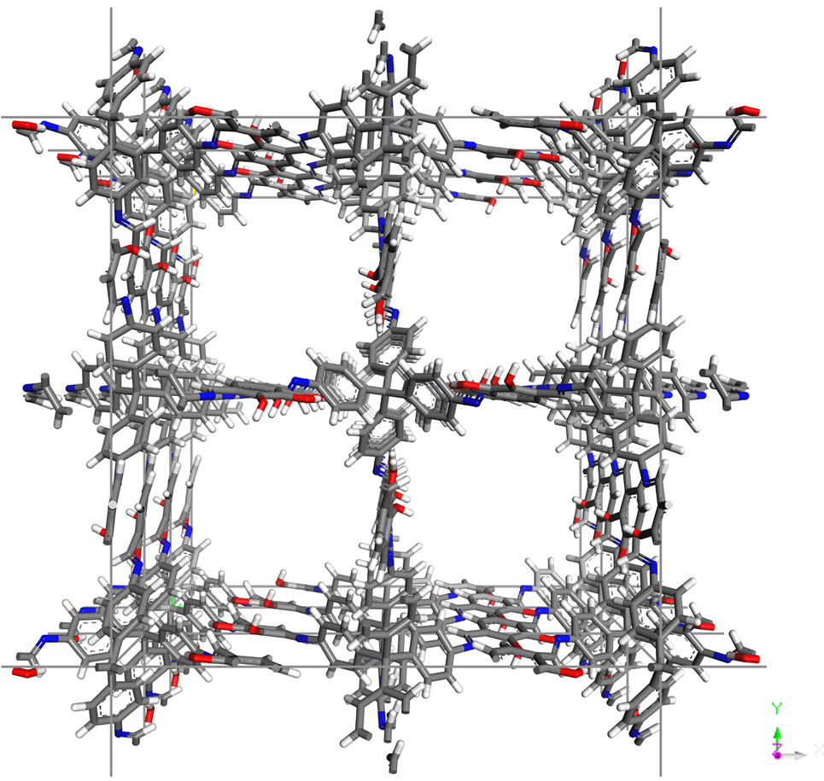
Supplementary Fig. 14. Single-crystal structure of COF-304 viewed along c-axis. Colour code: N, blue; O, red; C, grey; H, white.

Section S4. Structural analysis of COF-304 and COF-305
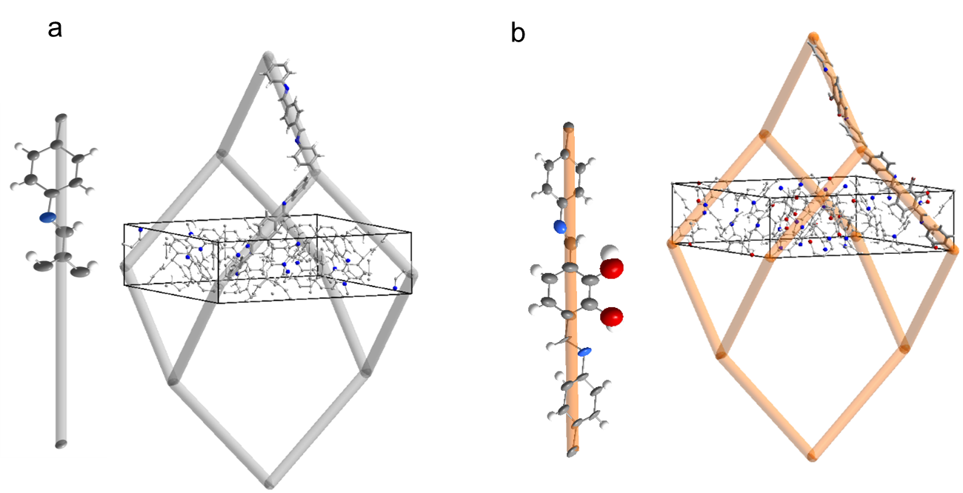
Supplementary Fig. 15. Primitive interpenetration cell (PIC) of COF-300 (a) and COF-304 (b).

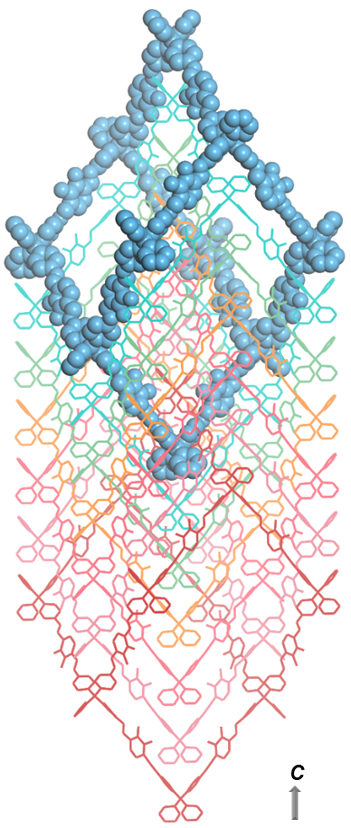
Supplementary Fig. 16. The 7-fold catenation of the diamondoid networks of COF-304.

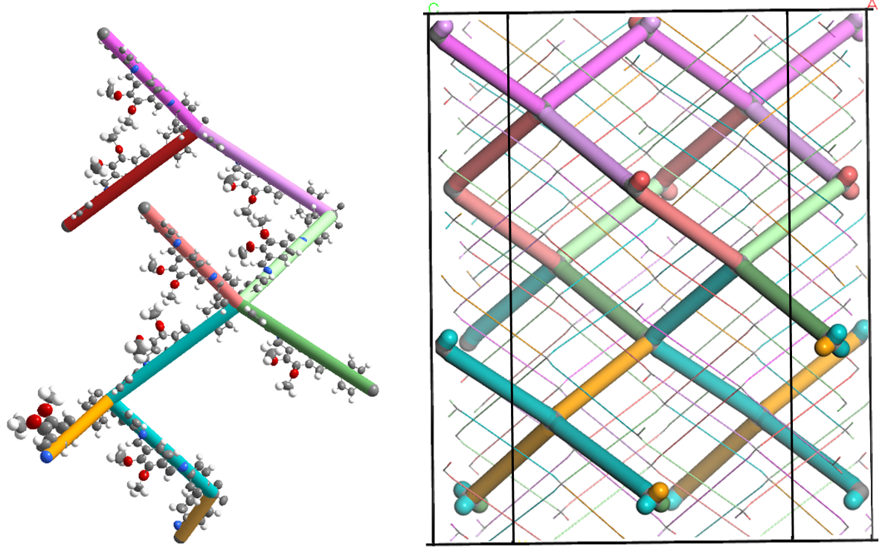
Supplementary Fig. 17. Asymmetric unit in the single-crystal structure of COF-305 and the struts are replaced by coloured sticks (left). The distribution of these sticks in the unit cell of COF-305 and we bolded one set of them (right).

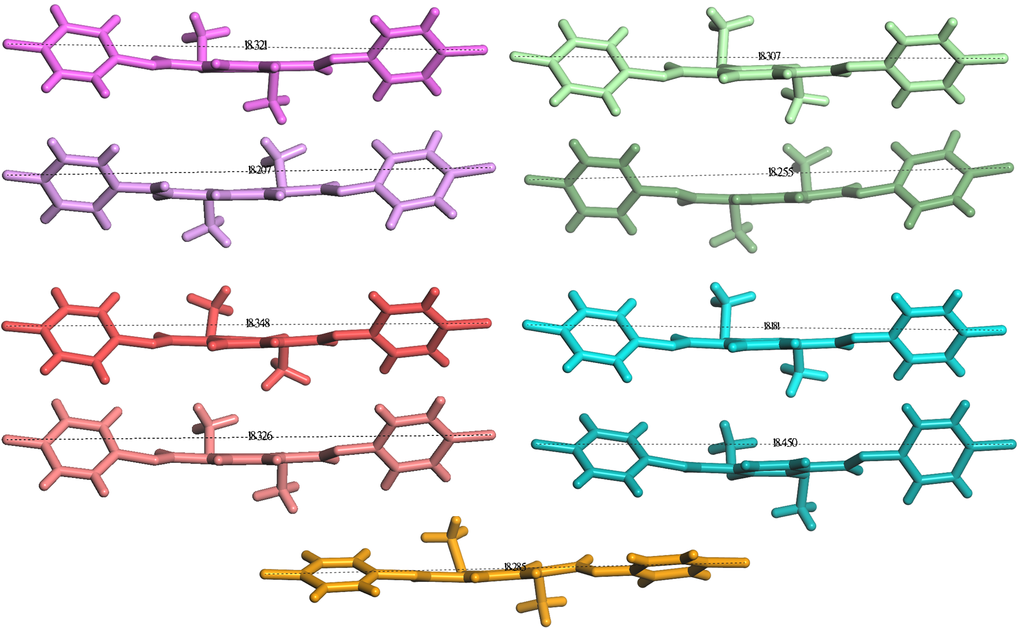
Supplementary Fig. 18. COF-305 contains 9 types of struts with varying lengths, which are measured from one carbon node to another.

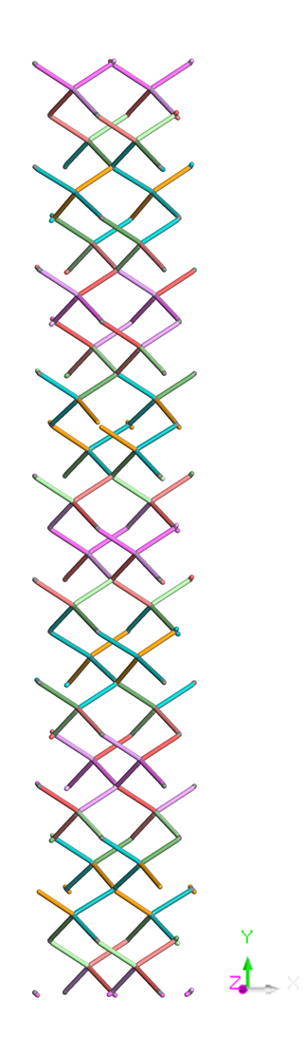
Supplementary Fig. 19. Primitive interpenetration cell (PIC) of COF-305. In one diamondoid network, the PIC is the minimum repeating unit.

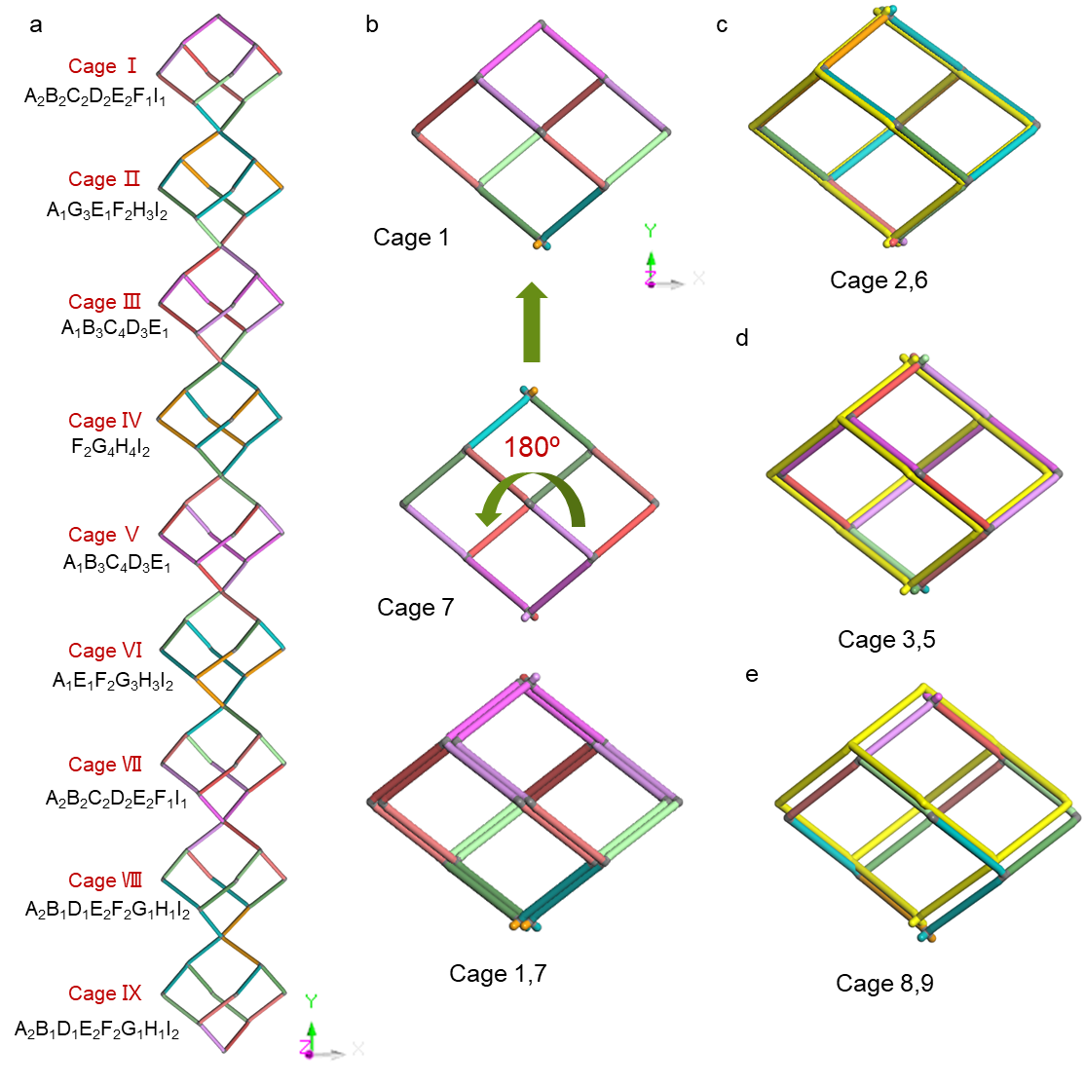
Supplementary Fig. 20. Primitive interpenetration cell (PIC) of COF-305 contains 9 kinds of cages meet at each vertex along the b-axis and the peripheral strut of each cage is omitted for simplicity, showing cage IV is independent (a). Of which, cage I can be obtained by symmetric operation of cage Ⅶ by rotating 180º along the c-axis followed by corresponding translation (b). The other three pairs of cages (2&6, 3&5, 8&9) can be obtained by similar symmetric operation (c, d, and e).

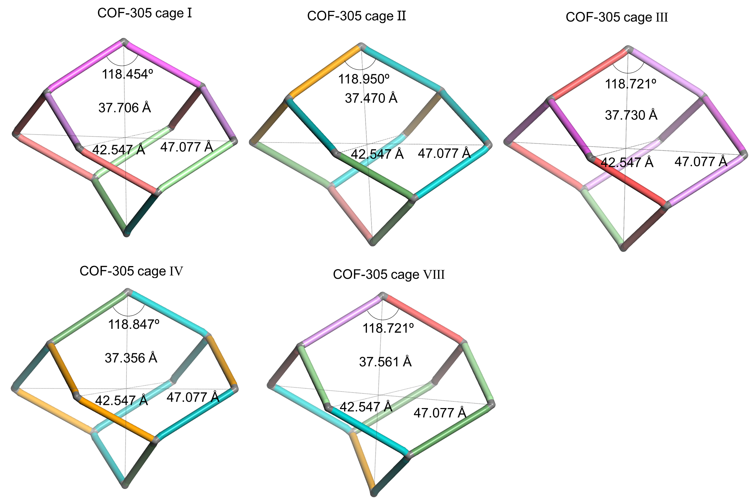
Supplementary Fig. 21. Geometry of the five non-equivalent adamantane cages of COF-305. The perpendicular distances between two vertices vary due to the difference in their composition.

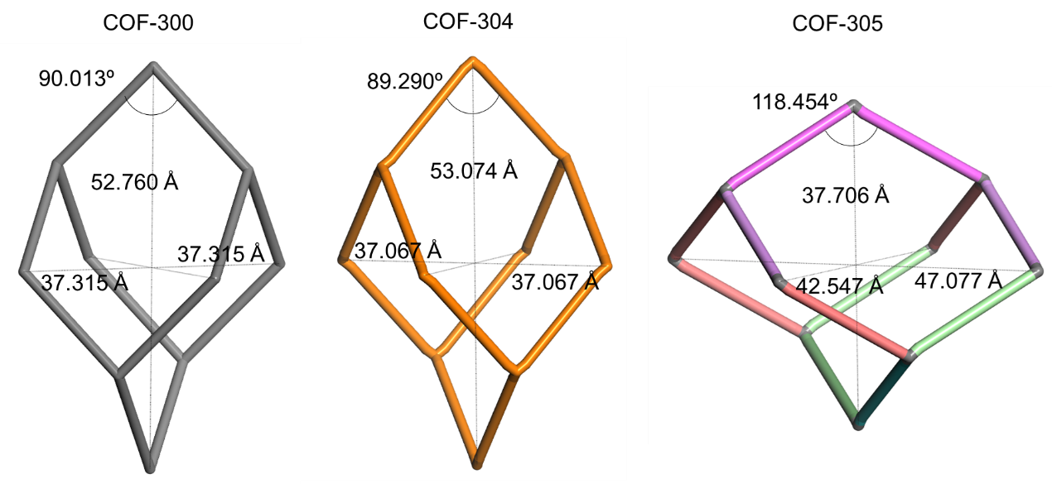
Supplementary Fig. 22. Geometry of adamantane cages of COF-300 (left), COF-304 (middle), and COF-305-cage Ⅰ (right). For COF-300 and COF-304, the distance between two opposite vertices at the horizontal plane are identical, while the perpendicular distance is much larger, resulting in a deviation from the regular geometry of adamantane cage. For COF-305, there is even more deformation in the geometry of adamantane cage as the three distances are different.

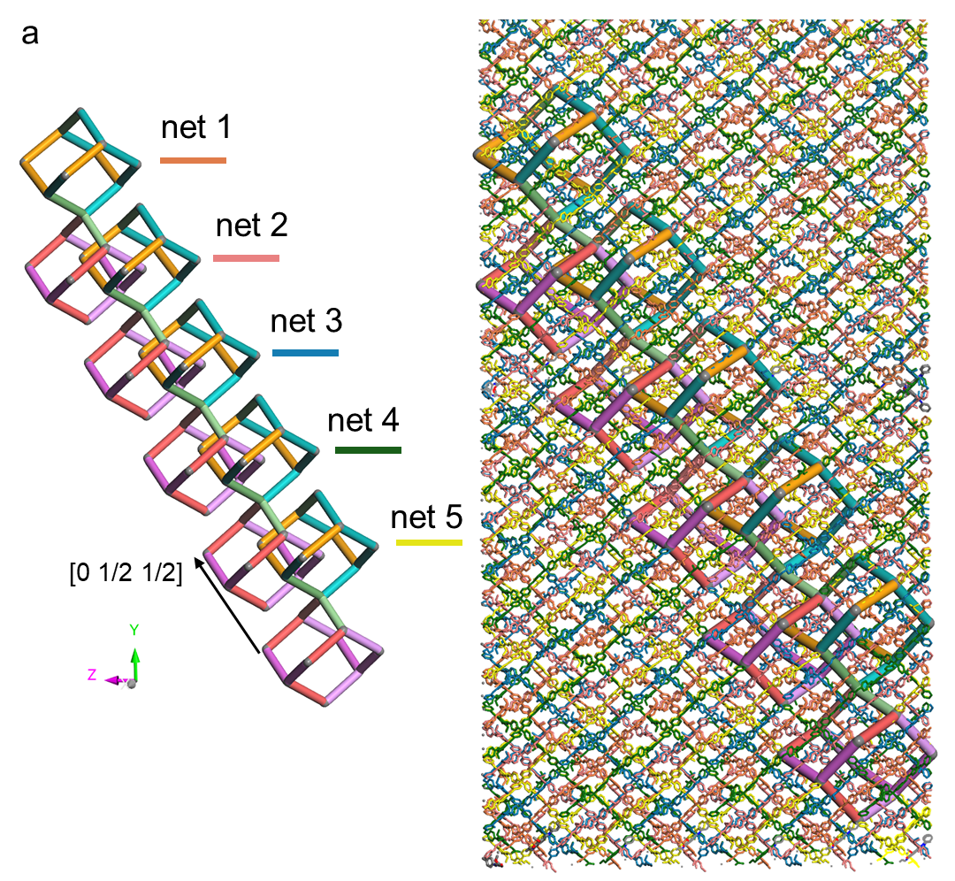
Supplementary Fig. 23. The full interpenetration vectors. A diamond net is displaced relative to each other by [0, 1/2, 1/2]. Right column figure presents the position of these cages in the five nets of COF-305.

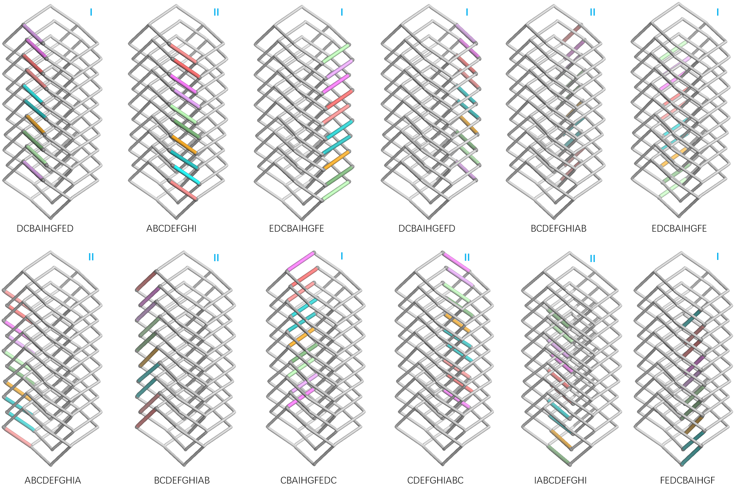
Supplementary Fig. 24. The struts arrays display two type of sequences: Type Ⅰ (DCBAIHGFE) and its reverse sequence, Type Ⅱ (ABCDEFGHI).

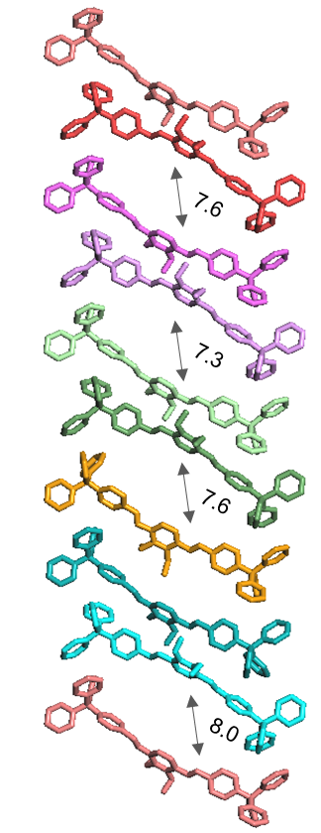
Supplementary Fig. 25. 9 types of struts arranged in a column by pairs, with the struts bent in different directions. As a result, channels are formed perpendicular to the direction of TAM stacking.

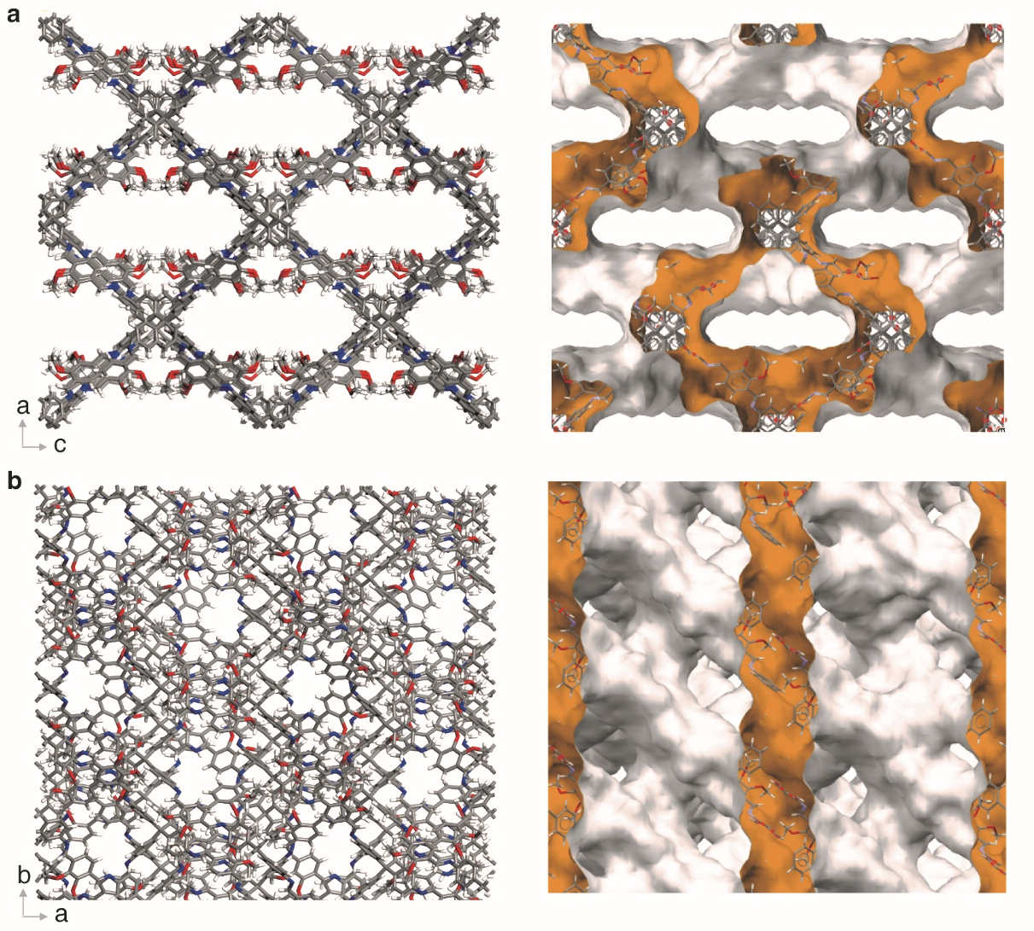
Supplementary Fig. 26. The simulated Connolly surface of COF-305 with Connolly radius of 1.0 Å, performed with Material Studio 2017 software, the simulations are based on the single-crystal structure of COF-305. a) view along b-axis; b) view along c-axis. Carbon, nitrogen, oxygen, and hydrogen atoms are in grey, blue, red, and white, respectively.

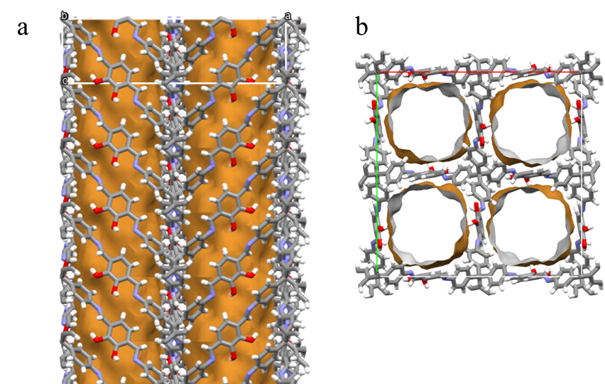
Supplementary Fig. 27. The simulated Connolly surface (orange/grey area) of COF-304 with Connolly radius of 1.0 Å performed with Material Studio 2017 software, the simulations are based on the single-crystal structure of COF-304. a) view along a-axis; b) view along c-axis. Carbon, nitrogen, oxygen, and hydrogen atoms are in grey, blue, red, and white, respectively.

Section S5. Structure analysis of model molecules of analogue of COFs
Supplementary Table 4. Crystallographic data and structural determination for TAM.
Name | TAM
Formula sum | C₂₅H₂₄N₄
Formula Weight | 380.4850
Crystal system | tetragonal
Space group | I4₁/a
a (Å) | 16.7311(9)
b (Å) | 16.7311(9)
c (Å) | 7.1389(6)
V (Å³) | 1998.4(2)
Z | 16
Density(g/cm³) | 1.265
Measured reflections | 5456
unique reflections | 241
Θ range (º) | 4.60-31.09
R₁ | 0.0454
wR₂ | 0.1112
S(GOF) | 1.0933
Parameters | 72
Restraints | 0
Max/min res. Dens., (e Å⁻³) | 0.1107 / -0.2078
Crystal size, mm³ | 0.4×0.2×0.2
Radiation, Å | 1.34139
Temperature (K) | 150
CCDC number | 2292636
^{𝑎}𝑅₁ = ∑||𝐹𝑜| − |𝐹𝑐||/ ∑|𝐹_{𝑜}|; ^{𝑏}𝑤𝑅₂ = [∑ 𝑤 ($F_{0}^{2}$ − $F_{C}^{2}$)²/ ∑ 𝑤 ($F_{0}^{2}$)²]^{1/2}; ^{𝑐}𝑆 = [∑ 𝑤($F_{0}^{2}$ − $F_{C}^{2}$)² /(𝑁_{𝑟𝑒𝑓} - 𝑁_{𝑝𝑎𝑟})]^{1/2}.

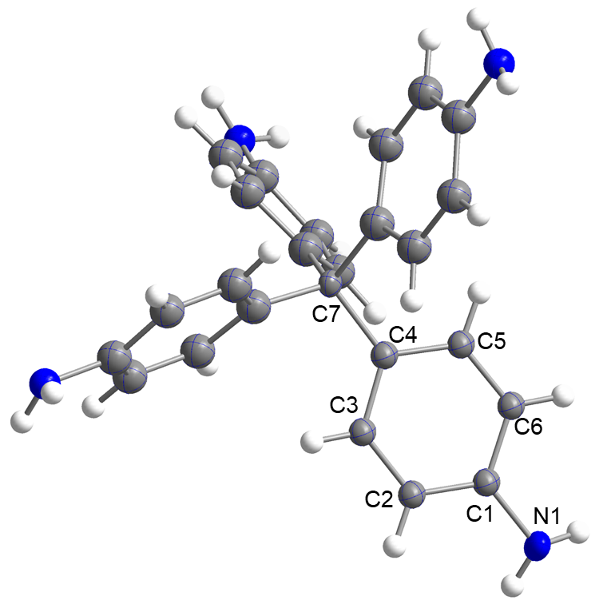
Supplementary Fig. 28. ORTEP drawing of the asymmetric unit in the crystal structure of TAM. Thermal ellipsoids are displayed with a 50% probability. Colour code: N, blue; C, grey; H, white. Symmetry-related atoms are not labeled and represented as spheres.

Supplementary Table 5. Crystallographic data and structural determination for TPM.
Name |  | TPM
 | Formula sum |  | C₅₀H₄₀
Formula Weight |  | 640.8527
Crystal system |  | Tetragonal
Space group |  | P -42₁c
a (Å) |  | 10.8171(8)
b (Å) |  | 10.8171(8)
c (Å) |  | 7.2144(7)
V (Å³) |  | 844.15(12)
Z |  | 40
Density(g/cm³) |  | 1.261
Measured reflections |  | 5849
unique reflections |  | 967
Θ range (º) |  | 2.58-26.18
R₁ |  | 0.0396
wR₂ |  | 0.0928
S(GOF) |  | 1.0731
Parameters |  | 57
Restraints |  | 0
Max/min res. Dens. ,(e Å⁻³) |  | 0.146 / -0.186
100.0Crystal size, mm³ |  | 0.3×0.02×0.02
Radiation, Å |  | 0.71073
Temperature (K) |  | 100
CCDC number |  | 2292637
^{𝑎}𝑅₁ = ∑||𝐹𝑜| − |𝐹𝑐||/ ∑|𝐹_{𝑜}|; ^{𝑏}𝑤𝑅₂ = [∑ 𝑤 ($F_{0}^{2}$ − $F_{C}^{2}$)²/ ∑ 𝑤 ($F_{0}^{2}$)²]^{1/2}; ^{𝑐}𝑆 = [∑ 𝑤($F_{0}^{2}$ − $F_{C}^{2}$)² /(𝑁_{𝑟𝑒𝑓} - 𝑁_{𝑝𝑎𝑟})]^{1/2}.

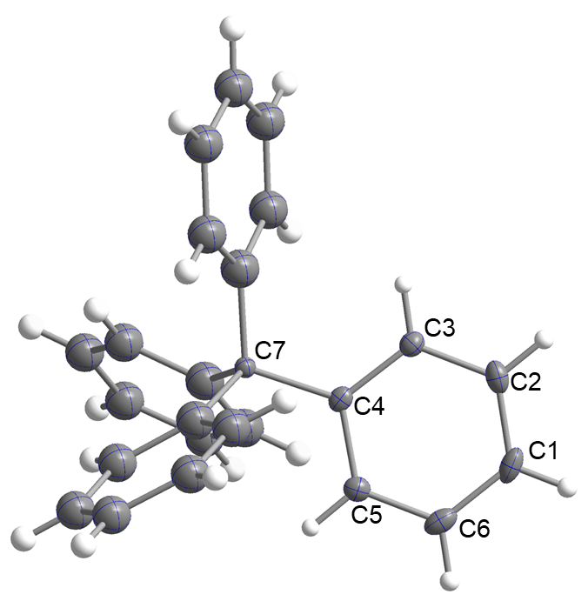
Supplementary Fig. 29. ORTEP drawing of the asymmetric unit in the crystal structure of TPM. Thermal ellipsoids are displayed with a 50% probability. Colour code: N, blue; C, grey; H, white. Symmetry-related atoms are not labeled and represented as spheres.

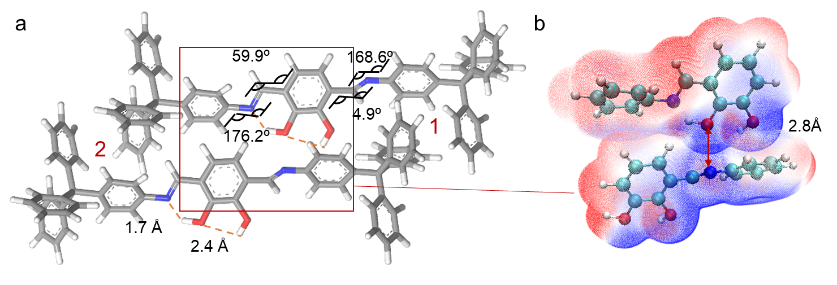
Supplementary Fig. 30. The two columns of TAM motif in COF-304 exhibits herringbone packing, albeit with different dihedral angles (dihedral angle at site 1 is 62º and at site 2 is 67º). This difference arises from the fact that one TAM has hydrogen bonding interaction with DHPA (site 2), while the other does not have any hydrogen bonding interaction (site 1). The electrostatic potential (ESP) illustrate the deviation of the dihedral angle at site 1 from 67º is attributed to steric effects that induce rotation of the imine bond, resulting in a dihedral angle of 59.9º between the imine bond and DHPA motif (b).

Supplementary Table 6. Crystallographic data and structural determination for DHPA.
Name | DHPA
Formula sum | C₁₆H₁₂O₈
Formula Weight | 332.2617
Crystal system | Monoclinic
Space group | P2₁/c
a (Å) | 6.9423(2)
b (Å) | 12.8713(5)
c (Å) | 16.2292(5)
β (º) | 95.985(2)
V (Å³) | 1442.28(8)
Z | 4
Density(g/cm³) | 1.530
56 | 8521
unique reflections | 2806
Θ range (º) | 4.39 - 72.41
R₁ | 0.0417
wR₂ | 0.1495
S(GOF) | 1.0400
Parameters | 221
Restraints | 0
Max/min res. Dens., (e Å⁻³) | -0.2976 / 0.3427
Crystal size, mm³ | 0.3×0.1×0.1
Radiation, Å | 1.5418
Temperature (K) | 293.15
CCDC number | 2292634
^{𝑎}𝑅₁ = ∑||𝐹𝑜| − |𝐹𝑐||/ ∑|𝐹_{𝑜}|; ^{𝑏}𝑤𝑅₂ = [∑ 𝑤 ($F_{0}^{2}$ − $F_{C}^{2}$)²/ ∑ 𝑤 ($F_{0}^{2}$)²]^{1/2}; ^{𝑐}𝑆 = [∑ 𝑤($F_{0}^{2}$ − $F_{C}^{2}$)² /(𝑁_{𝑟𝑒𝑓} - 𝑁_{𝑝𝑎𝑟})]^{1/2}.

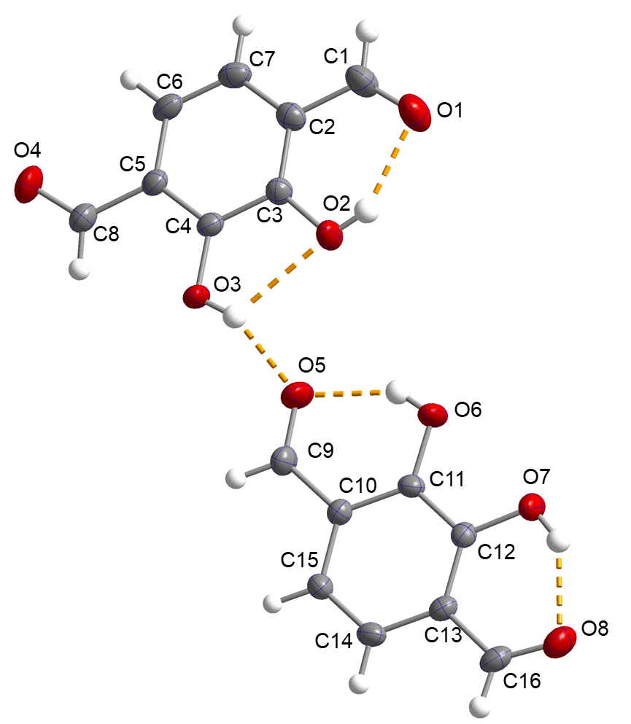
Supplementary Fig. 31. ORTEP drawing of the asymmetric unit in the crystal structure of DHPA. Thermal ellipsoids are displayed with a 50% probability. Colour code: O, red; C, grey; H, white; hydrogen bond, orange dotted line.

Supplementary Table 7. Crystallographic data and structural determination for DMPA.
Name | DMPA
Formula sum | C₄₀H₄₀O₁₆
Formula Weight | 776.72
Crystal system | Monoclinic
Space group | P2₁/c
a (Å) | 7.2898(7)
b (Å) | 14.3216(13)
c (Å) | 9.2901(9)
β (º) | 108.491(5)
V (Å³) | 919.83(15)
Z | 1
Density(g/cm³) | 1.402
Measured reflections | 11918
unique reflections | 1965
Θ range (º) | 5.128 – 58.790
R₁ | 0.0638
wR₂ | 0.1717
S(GOF) | 1.072
Parameters | 130
Restraints | 0
Max/min res. Dens., (e Å⁻³) | -0.379 / 0.276
Crystal size, mm³ | 0.15×0.08×0.08
Radiation, Å | 1.34138
Temperature (K) | 150.0
CCDC number | 2292635
^{𝑎}𝑅₁ = ∑||𝐹𝑜| − |𝐹𝑐||/ ∑|𝐹_{𝑜}|; ^{𝑏}𝑤𝑅₂ = [∑ 𝑤 ($F_{0}^{2}$ − $F_{C}^{2}$)²/ ∑ 𝑤 ($F_{0}^{2}$)²]^{1/2}; ^{𝑐}𝑆 = [∑ 𝑤($F_{0}^{2}$ − $F_{C}^{2}$)² /(𝑁_{𝑟𝑒𝑓} - 𝑁_{𝑝𝑎𝑟})]^{1/2}.

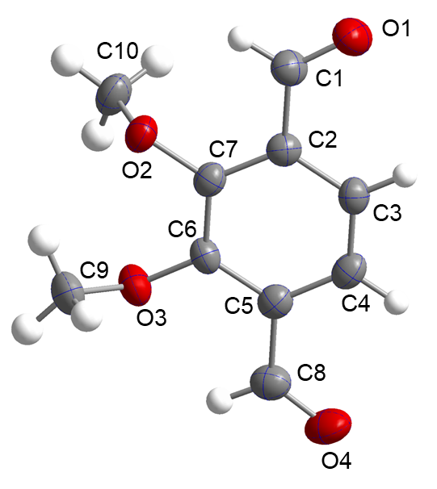
Supplementary Fig. 32. ORTEP drawing of the asymmetrical unit in the crystal structure of DMPA. Thermal ellipsoids are displayed with a 50% probability. Colour code: O, red; C, grey; H, white.

Supplementary Table 8. Crystallographic data and structural determination for M-300.
Name | M-300
Formula sum | C₄₀H₃₂N₄
Formula Weight | 568.7090
Crystal system | Monoclinic
Space group | P2₁/c
a (Å) | 7.4683(4)
b (Å) | 6.0517(3)
c (Å) | 16.3929(8)
β (º) | 90.127 (2)
V (Å³) | 740.89(7)
Z | 4
Density(g/cm³) | 1.275
Measured reflections | 9496
unique reflections | 1030
θ range (º) | 4.694-47.450
R₁ | 0.0353
wR₂ | 0.0870
S(GOF) | 1.052
Parameters | 128
Restraints | 0
Max/min res. Dens., (e Å⁻³) | -0.226 / 0.110
Crystal size, mm³ | 0.3×0.1×0.1
Radiation, Å | 1.34138
Temperature (K) | 150
CCDC number | 2292630
^{𝑎}𝑅₁ = ∑||𝐹𝑜| − |𝐹𝑐||/ ∑|𝐹_{𝑜}|; ^{𝑏}𝑤𝑅₂ = [∑ 𝑤 ($F_{0}^{2}$ − $F_{C}^{2}$)²/ ∑ 𝑤 ($F_{0}^{2}$)²]^{1/2}; ^{𝑐}𝑆 = [∑ 𝑤($F_{0}^{2}$ − $F_{C}^{2}$)² /(𝑁_{𝑟𝑒𝑓} - 𝑁_{𝑝𝑎𝑟})]^{1/2}.

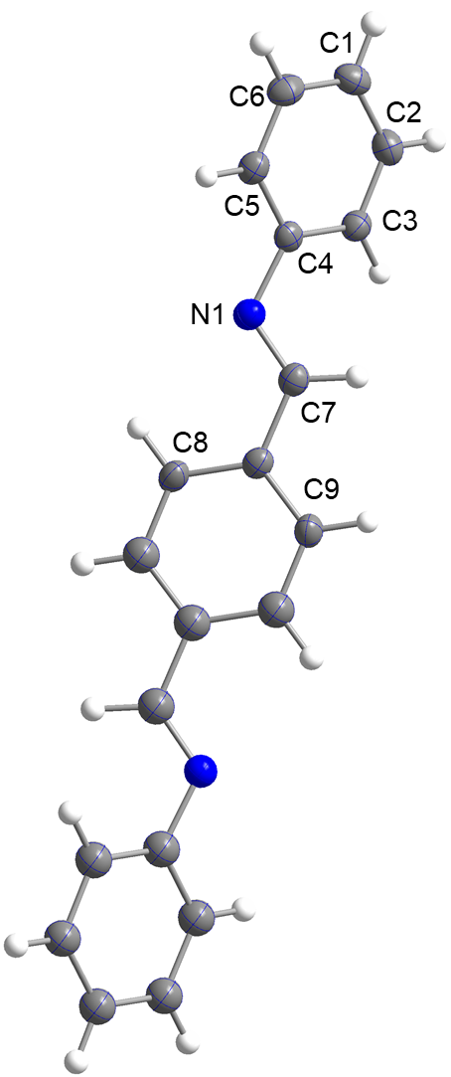
Supplementary Fig. 33. ORTEP drawing of the asymmetric unit in the crystal structure of M-300. Thermal ellipsoids are displayed with a 50% probability. Colour code: N, blue; C, grey; H, white. Symmetry-related atoms are not labeled and represented as spheres.

Supplementary Table 9. Crystallographic data and structural determination for M-304.
Name | M-304
Formula sum | C8₀H₅₆N₈O₈
Formula Weight | 1273.4769
Crystal system | Tetragonal
Space group | P4₃2₁2
a (Å) | 6.9866(2)
b (Å) | 6.9866(2)
c (Å) | 32.7040 (18)
V (Å³) | 1596.37(13)
Z | 8
Density(g/cm³) | 1.316
Measured reflections | 12248
unique reflections | 1044
Θ range (º) | 4.705-46.223
R₁ | 0.0379
wR₂ | 0.0879
S(GOF) | 1.077
Parameters | 110
Restraints | 0
Max/min res. Dens., (e Å⁻³) | -0.306 / 0.133
Crystal size, mm³ | 0.2×0.2×0.01
Radiation, Å | 1.34138
Temperature (K) | 150
CCDC number | 2292631
^{𝑎}𝑅₁ = ∑||𝐹𝑜| − |𝐹𝑐||/ ∑|𝐹_{𝑜}|; ^{𝑏}𝑤𝑅₂ = [∑ 𝑤 ($F_{0}^{2}$ − $F_{C}^{2}$)²/ ∑ 𝑤 ($F_{0}^{2}$)²]^{1/2}; ^{𝑐}𝑆 = [∑ 𝑤($F_{0}^{2}$ − $F_{C}^{2}$)² /(𝑁_{𝑟𝑒𝑓} - 𝑁_{𝑝𝑎𝑟})]^{1/2}.

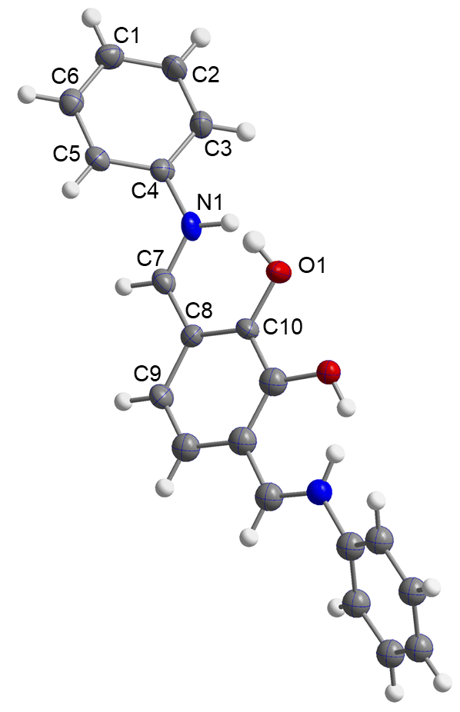
Supplementary Fig. 34. ORTEP drawing of the asymmetric unit in the crystal structure of M-304. Thermal ellipsoids are displayed with a 50% probability. Colour code: N, blue; O, red; C, grey; H, white. Symmetry-related atoms are not labeled and represented as spheres.

Supplementary Table 10. Crystallographic data and structural determination for M-305.
Name | M-305
Formula sum | C₈₈H₈₈N₈O₈
Formula Weight | 1385.6896
Crystal system | Orthorhombic
Space group | Pbcn (No.60)
a (Å) | 15.2464(6)
b (Å) | 11.8485(5)
c (Å) | 9.7805(3)
V (Å³) | 1766.82(12)
Z | 1
Density(g/cm³) | 1.302
Measured reflections | 16360
unique reflections | 952
Θ range (º) | 4.111-42.574
R₁ | 0.0405
wR₂ | 0.1064
S(GOF) | 1.003
Parameters | 119
Restraints | 0
Max/min res. Dens., (e Å⁻³) | 0.112 / -0.495
Crystal size, mm³ | 0.2×0.05×0.05
Radiation, Å | 1.34138
Temperature (K) | 150.0
CCDC number | 2292632
^{𝑎}𝑅₁ = ∑||𝐹𝑜| − |𝐹𝑐||/ ∑|𝐹_{𝑜}|; ^{𝑏}𝑤𝑅₂ = [∑ 𝑤 ($F_{0}^{2}$ − $F_{C}^{2}$)²/ ∑ 𝑤 ($F_{0}^{2}$)²]^{1/2}; ^{𝑐}𝑆 = [∑ 𝑤($F_{0}^{2}$ − $F_{C}^{2}$)² /(𝑁_{𝑟𝑒𝑓} - 𝑁_{𝑝𝑎𝑟})]^{1/2}.

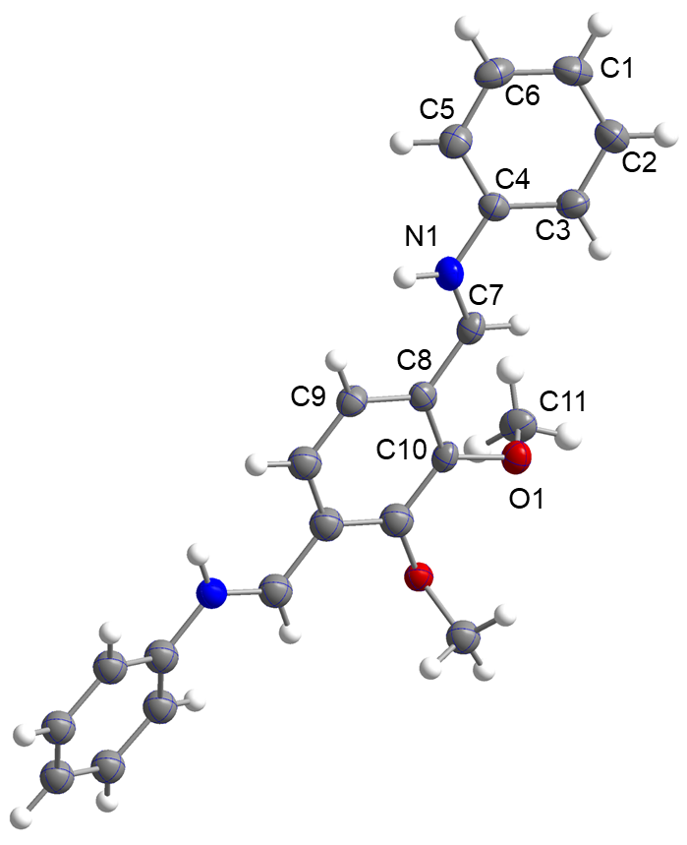
Supplementary Fig. 35. ORTEP drawing of the asymmetric unit in the crystal structure of M-305. Thermal ellipsoids are displayed with a 50% probability. Colour code: N, blue; O, red; C, grey; H, white. Symmetry-related atoms are not labeled and represented as spheres.

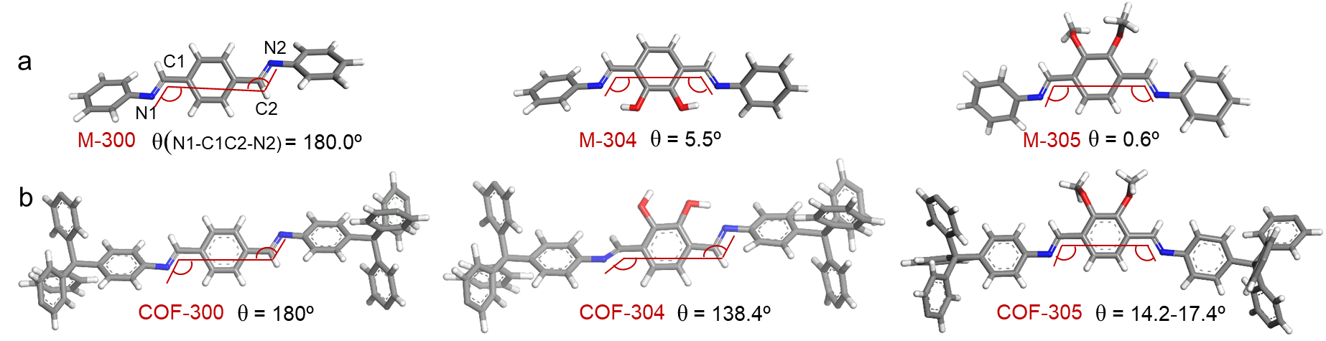
Supplementary Fig. 36. The relative configuration between the two imine bonds. N1, C1, and C2 atoms form one plane and C1, C2, and N2 atoms form the second plane. The dihedral angle of N1-C1C2-N2 is measured. A dihedral angle (θ) close to 0º is referred to as a “C” shape, whereas an angle close to 180º is referred to as “S” shape. Consequently, COF-300, M-300, and COF-304 exhibit an “S” shape, and M-304, M-305, and COF-305 display a “C” shape.

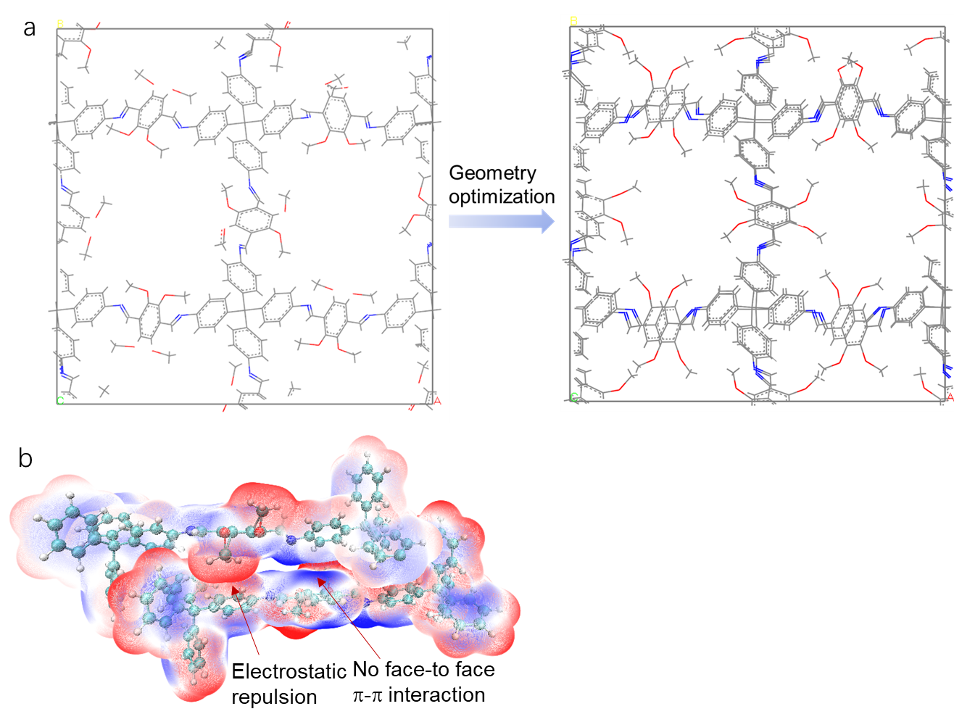
Supplementary Fig. 37. We directly stitch TAM in herringbone packing mode with DMPA in a space group of P1 with unit cell of a = 28 Å, b = 28 Å, c =15 Å. The c dimension is doubled compared to that of COF-300 due to the presence of large group of methoxy group causing significant steric hindrance in the same side. Although we put the methoxy on both sides of the phenyl ring to accommodate the adjacent DMPA, there still exists steric hindrance between the methoxy of DMPA motif and phenyl of TAM motif due to their close proximity at a distance of 1.8 Å. More importantly, the phenyl group of DMPA does not exhibit any interaction with the adjacent strut. Therefore, the COF-305 with herringbone packing similar to COF-300 could not give a feasible COF structure. And we also conducted a geometry optimization on this unfeasible structure, where the TAM packing mode offset the herringbone into a displaced mode.

Supplementary Table 11. Crystallographic data and structural determination for M-305-2.
Name | M-305-2
Formula sum | C₂₄₄H₂₂₄N₁₆O₃₂
Formula Weight | 3892.4780
Crystal system | tetragonal
Space group | I4₁/a (No.88)
a (Å) | 25.5913(13)
b (Å) | 25.5913(13)
c (Å) | 7.7252(6)
V (Å³) | 5059.3(5)
Z | 16
Density(g/cm³) | 1.283
Measured reflections | 11752
unique reflections | 944
Θ range (º) | 3.00-36.77
R₁ | 0.0653
wR₂ | 0.1769
S(GOF) | 1.0485
Parameters | 167
Restraints | 0
Max/min res. Dens., (e Å⁻³) | 0.4916 / -0.3523
Crystal size, mm³ | 0.2×0.02×0.02
Radiation, Å | 1.34138
Temperature (K) | 150.0
CCDC number | 2292633
^{𝑎}𝑅₁ = ∑||𝐹𝑜| − |𝐹𝑐||/ ∑|𝐹_{𝑜}|; ^{𝑏}𝑤𝑅₂ = [∑ 𝑤 ($F_{0}^{2}$ − $F_{C}^{2}$)²/ ∑ 𝑤 ($F_{0}^{2}$)²]^{1/2}; ^{𝑐}𝑆 = [∑ 𝑤($F_{0}^{2}$ − $F_{C}^{2}$)² /(𝑁_{𝑟𝑒𝑓} - 𝑁_{𝑝𝑎𝑟})]^{1/2}.

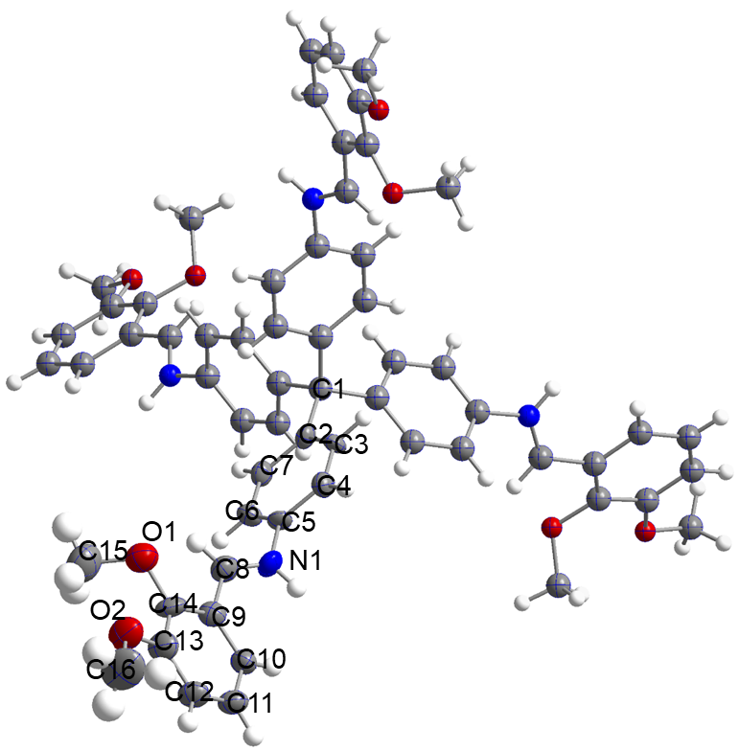
Supplementary Fig. 38. ORTEP drawing of the asymmetric unit in the crystal structure of M-305-2. Thermal ellipsoids are displayed with a 50% probability. Colour code: N, blue; O, red; C, grey; H, white. Symmetry-related atoms are not labeled and represented as spheres.

Supplementary Table 12. The offset of DMPA motif in COF-305, COF-304, M-305 and M-305-2.
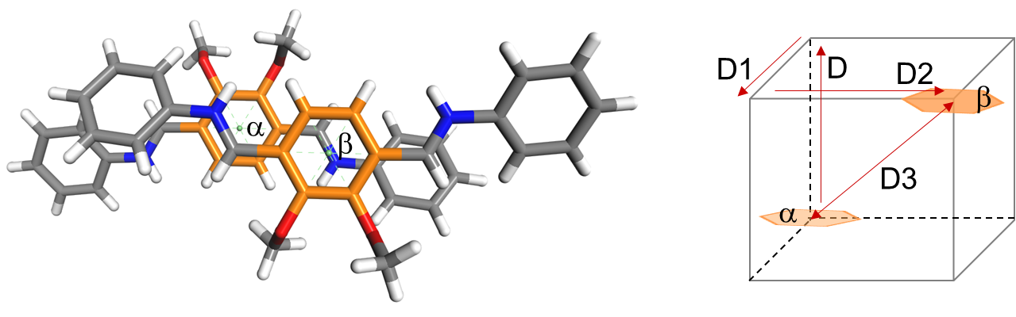
 |  | D (Å) | D1 (Å) | D2 (Å) | D3 (Å) | E (kJ/mol)
COF-305 | CD | 4.0 | 0.6 | 4.8 | 6.3 | -358.7
COF-305 | EF | 4.0 | 0.1 | 4.8 | 6.3 | -374.8
COF-305 | HI | 4.0 | 0.5 | 4.9 | 6.2 | -176.7
COF-305 | AB | 4.0 | 0.2 | 4.8 | 6.3 | -372.1
COF-305 | DE | 6.7 | 6.8 | 3.1 | 10.1 | -293.5
COF-305 | IA | 7.4 | 6.1 | 2.2 | 10.0 | -229.8
COF-305 | BC | 6.7 | 7.1 | 2.7 | 10.1 | -262.0
COF-305 | FG | 6.7 | 6.3 | 2.9 | 10.0 | -79.20
COF-305 | GH | 4.4 | 5.3 | 3.9 | 7.7 | 0
M-305 |  | 3.7 | 0.7 | 3.4 | 5.0 | ——
M-305-2 |  | 3.4 | 1.1 | 0.1 | 3.5 | ——

Section S6. Computational simulation
DFT calculations of COF-305 fragment pairs. For accurate energetic comparisons between the COF-305 fragment pairs, DFT calculations were conducted on each pair. Due to the typically inaccurate positions of H atoms obtained by single crystal X-ray diffraction⁸, it is necessary to perform geometry optimizations before single-point energy calculations. Meanwhile, to investigate the differences among COF fragments in the crystal structure, we performed constrained geometry optimizations. The starting atomic coordinates were taken from single crystal diffraction. The coordinates of hydrogen atoms were optimized using Gaussian09⁹ with the B3LYP functional¹⁰, combined with the def2-SVP basis set¹¹, and Grimme D3 dispersion corrections¹² (Supplementary Fig. 39). Then, single-point energy calculations were performed on DFT optimized structures using the B3LYP functional, the def2-TZVP basis set^{11, 13}, and Grimme D3 dispersion corrections.

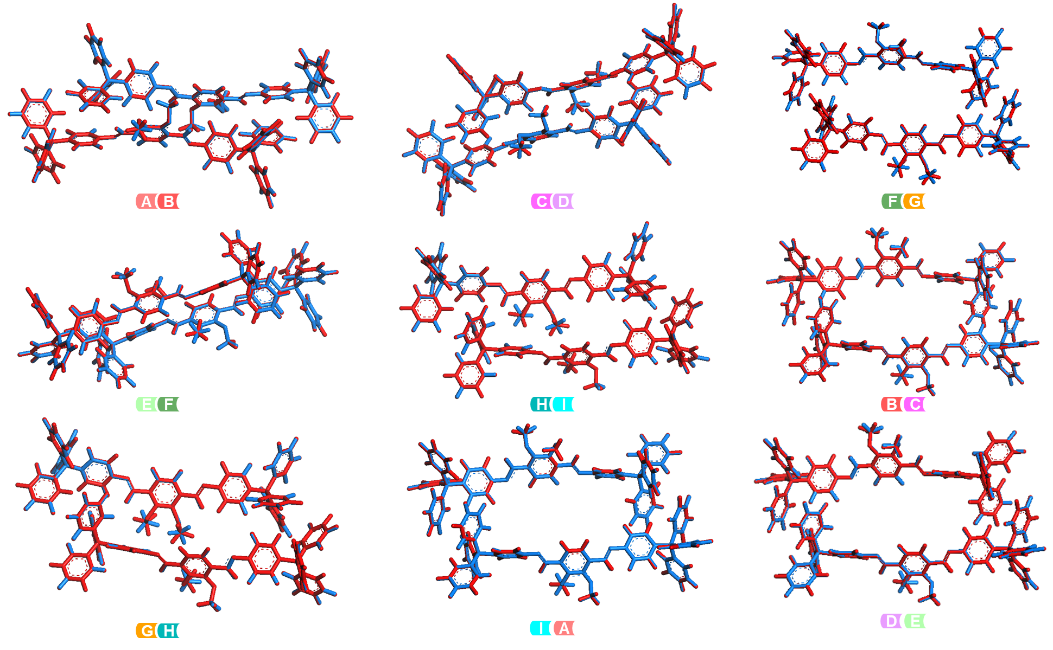
Supplementary Fig. 39. Comparisons of DFT optimized structures of pairs of struts (blue) and structures analyzed by SXRD (red).

1. Otwinowski, Z., Minor, W. Processing of X-ray diffraction data collected in oscillation mode. Methods Enzymol. 276, 307–326, doi:10.1016/S0076-6879(97)76066-X (1997).
2. Bruker, APEX2 Bruker AXS Inc., Madison, Wisconsin, USA. (2010).
3. Sheldrick, G. M. A short history of SHELX. Acta Crystallogr. A 64, 112–122, doi:10.1107/S0108767307043930 Medline (2008).
4. Dolomanov, O. V., Bourhis, L. J., Gildea, R. J., Howard, J. A. K. & Puschmann, H. OLEX2: A complete structure solution, refinement and analysis program. J. Appl. Cryst. 42, 339– 341, doi:10.1107/S0021889808042726 (2009).
5. Pennington, W. T. DIAMOND – Visual Crystal Structure Information System. J. Appl. Cryst. 31, 1028–1029, doi:10.1107/S0021889899011486 (1999).
6. Spek, A. L. PLATON SQUEEZE: A tool for the calculation of the disordered solvent contribution to the calculated structure factors. Acta Crystallogr. C Struct. Chem. 71, 9–18, doi:10.1107/S2053229614024929 Medline (2015).
7. Macrae, C. F. et al. Mercury: Visualization and analysis of crystal structures. J. Appl. Cryst. 39, 453–457, doi:10.1107/S002188980600731X (2006).
8. Wieduwilt, E. K., Macetti, G. & Genoni, A. Climbing Jacob’s Ladder of Structural Refinement: Introduction of a Localized Molecular Orbital-Based Embedding for Accurate X-ray Determinations of Hydrogen Atom Positions. J Phys. Chem. Lett. 12, 463-471, doi: 10.1021/acs.jpclett.0c03421 (2021).
9. M. J. Frisch et al. Gaussian 09 Revision D.01,(Wallingford, CT, 2009).
10. P. J. Stephens, F. J. Devlin, C. F. Chabalowski, and M. J. Frisch, Ab Initio Calculation of Vibrational Absorption and Circular Dichroism Spectra Using Density Functional Force Fields. J. Phys. Chem. C 98, 11623-11627, doi:10.1021/j100096a001 (1994).
11. F. Weigend, R. Ahlrichs, Balanced basis sets of split valence, triple zeta valence and quadruple zeta valence quality for H to Rn: Design and assessment of accuracy. Phys. Chem. Chem. Phys. 7, 3297-3305, doi:10.1039/B508541A (2005).
12. S. Grimme, J. Antony, S. Ehrlich, H. Krieg, A consistent and accurate ab initio parametrization of density functional dispersion correction (DFT-D) for the 94 elements H-Pu. J. Chem. Phys. 132, 154104, doi:10.1063/1.3382344 (2010).
13. F. Weigend, R. Ahlrichs, Accurate Coulomb-fitting basis sets for H to Rn. Phys. Chem. Chem. Phys. 8, 1057-1065, doi:10.1039/B515623H (2006).

