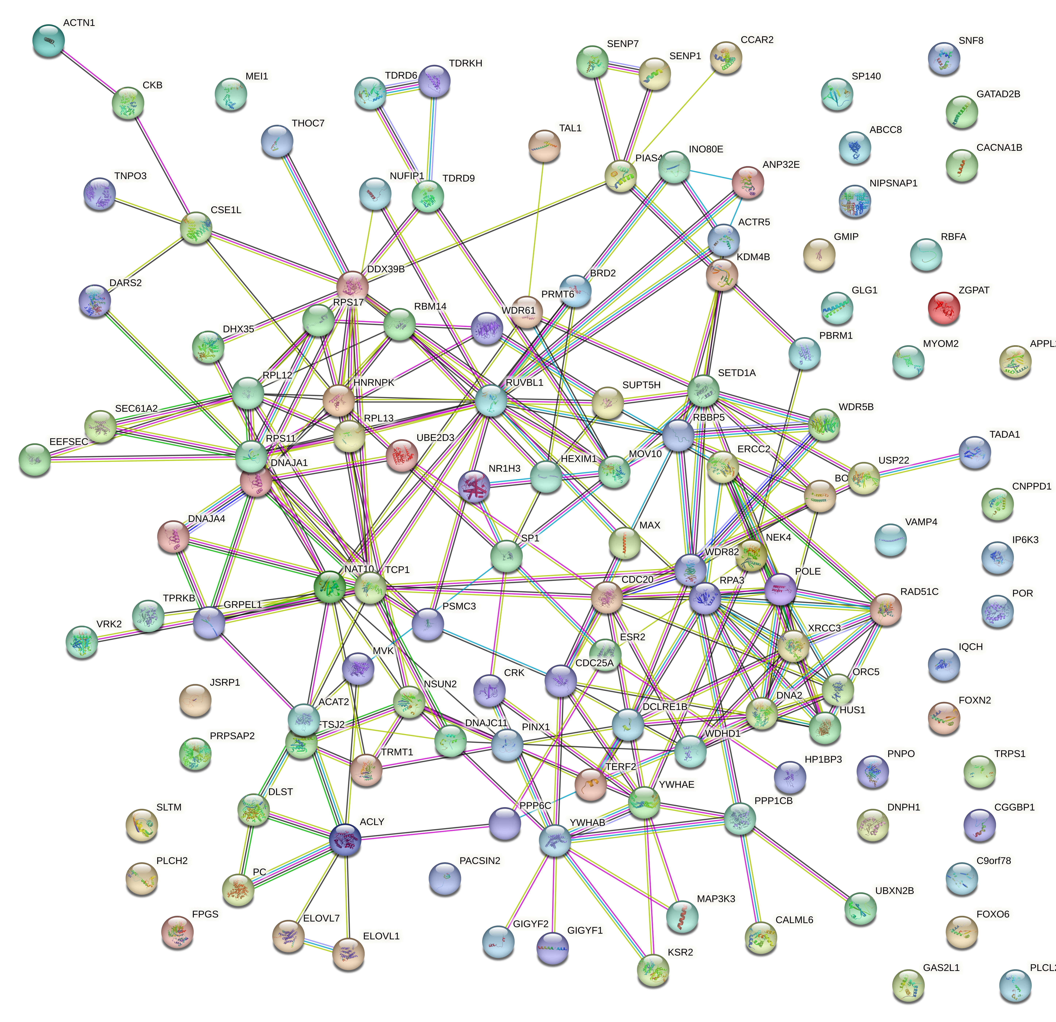
FIG1 PPI analysis of 128 TRG and PD risk genes in brain tissue
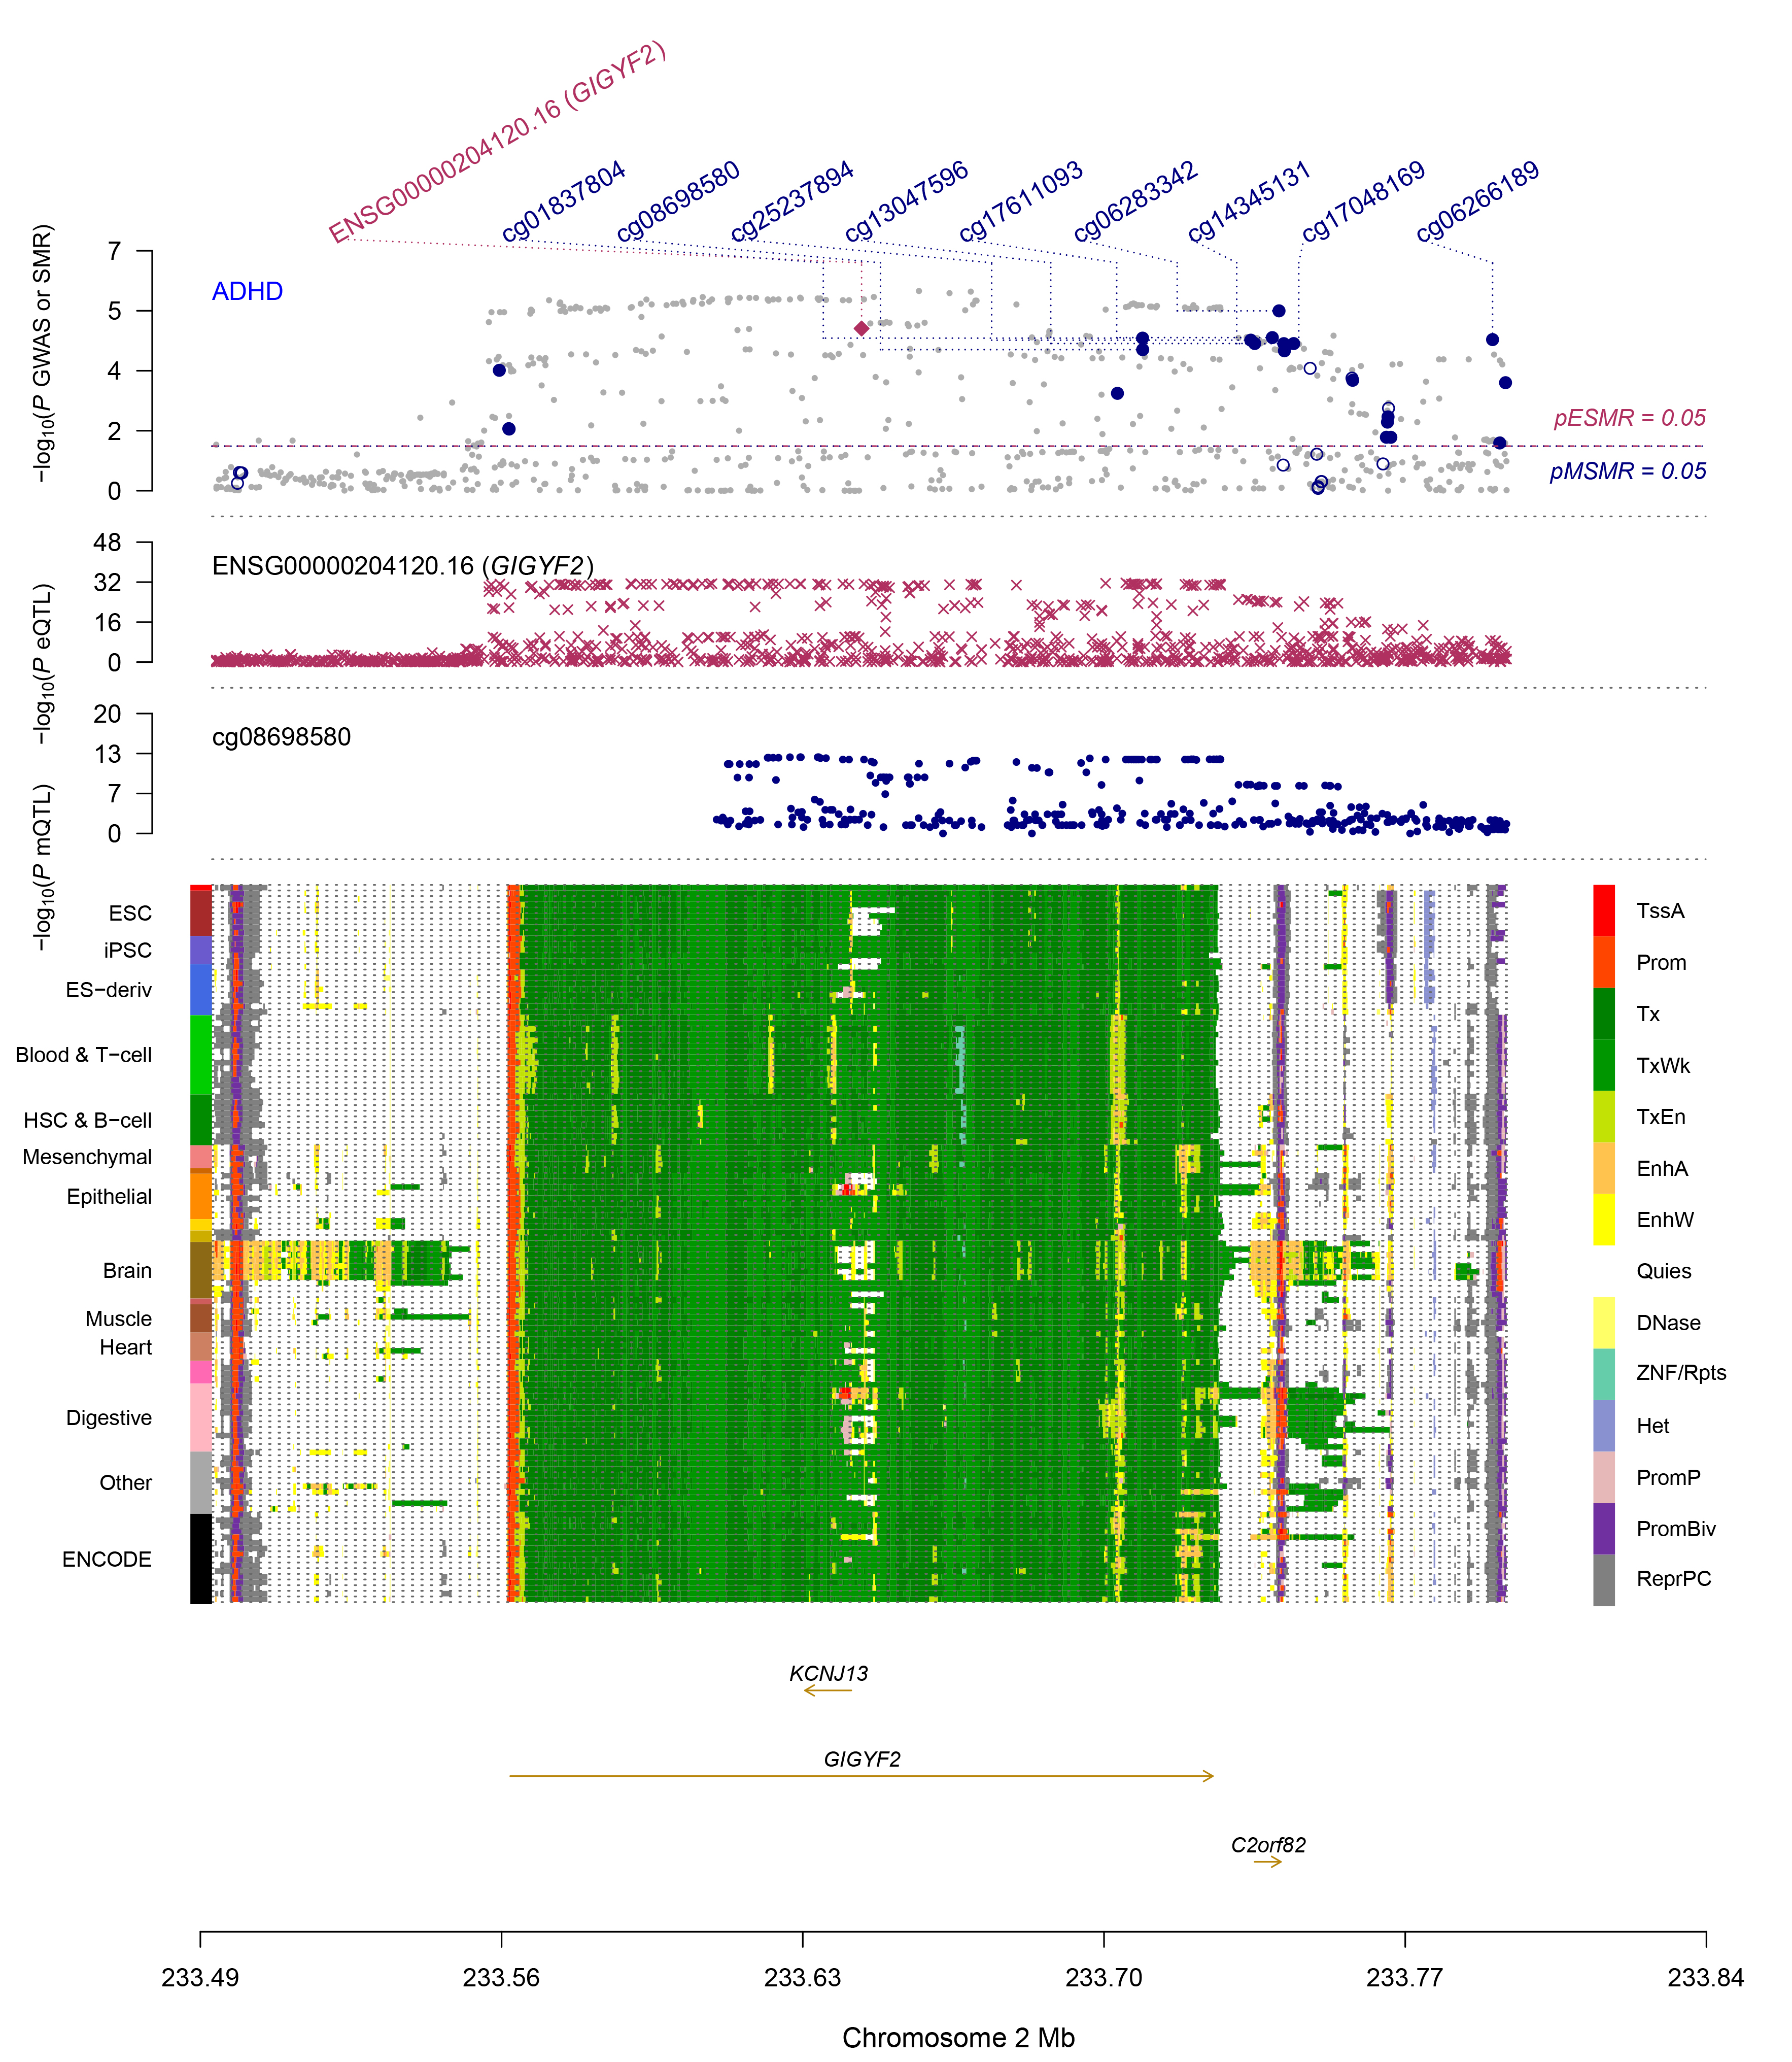
FIG2
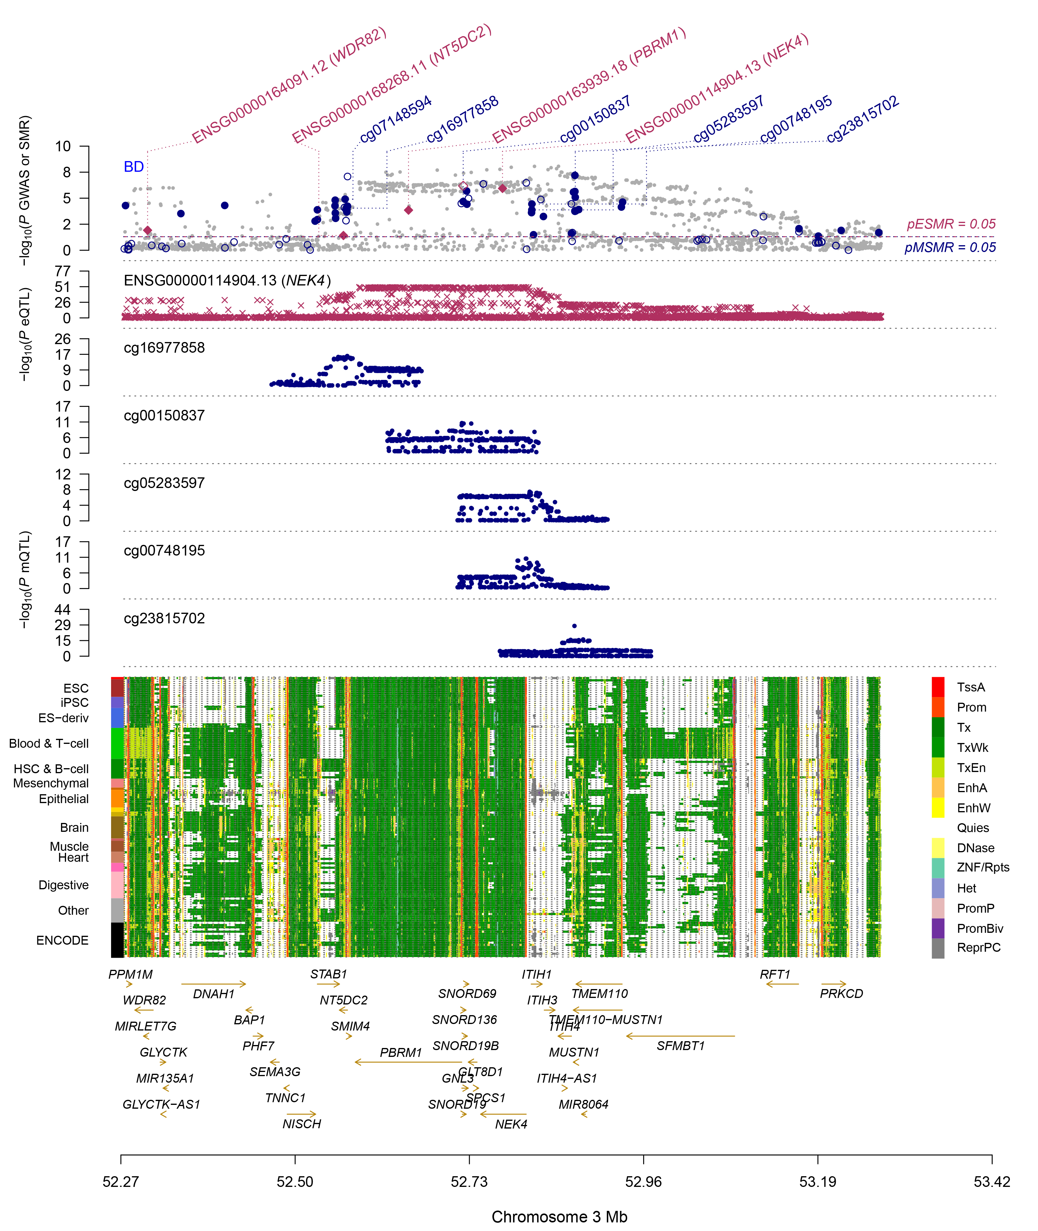
FIG3
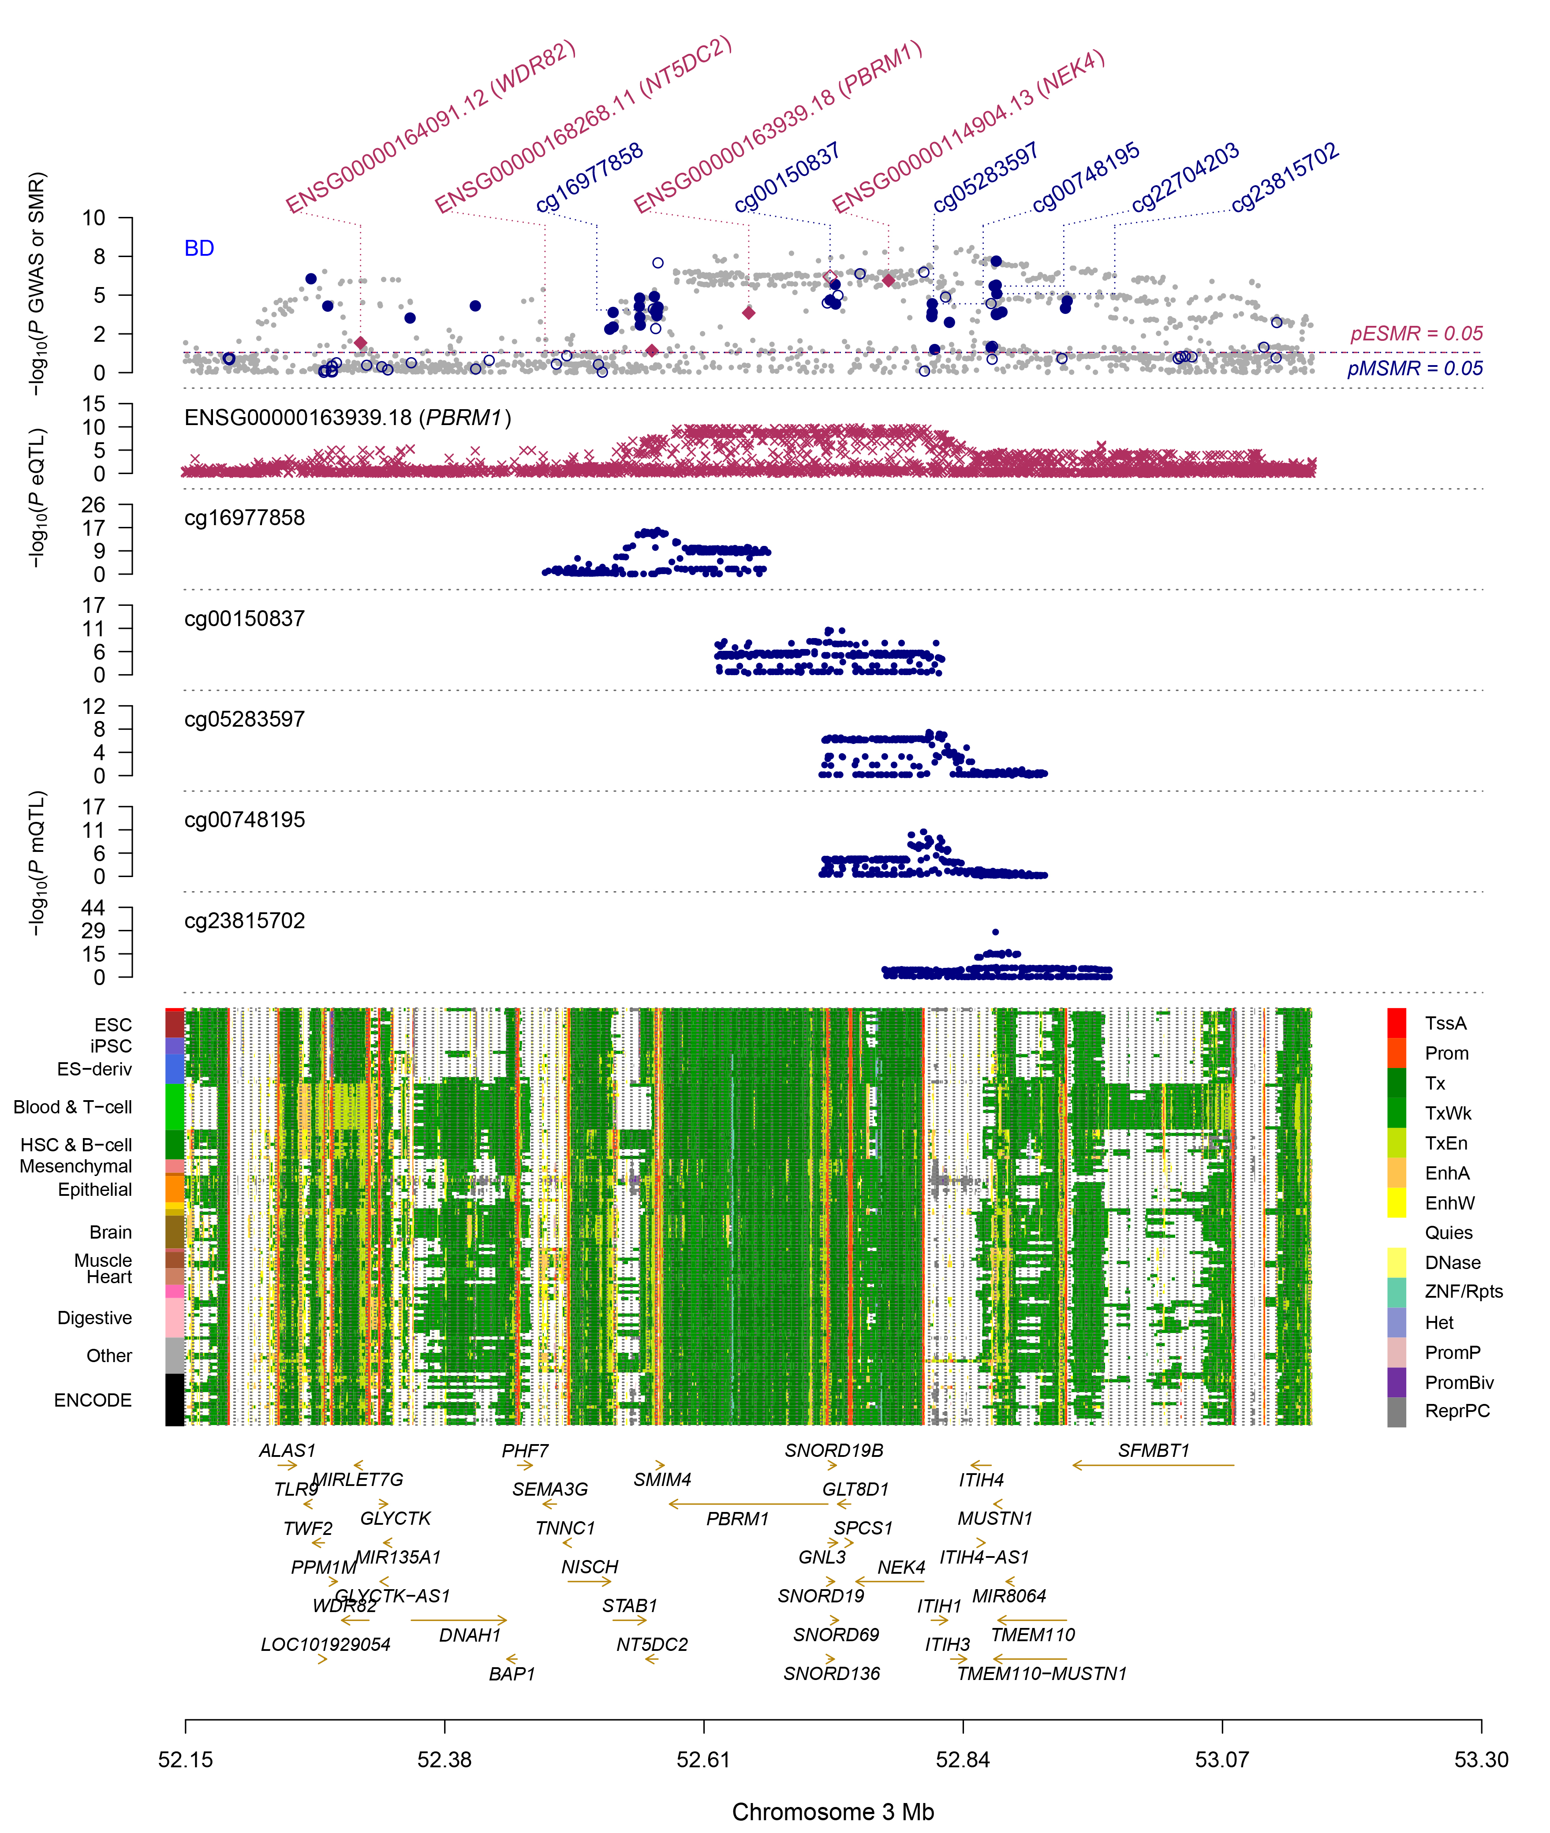
FIG4
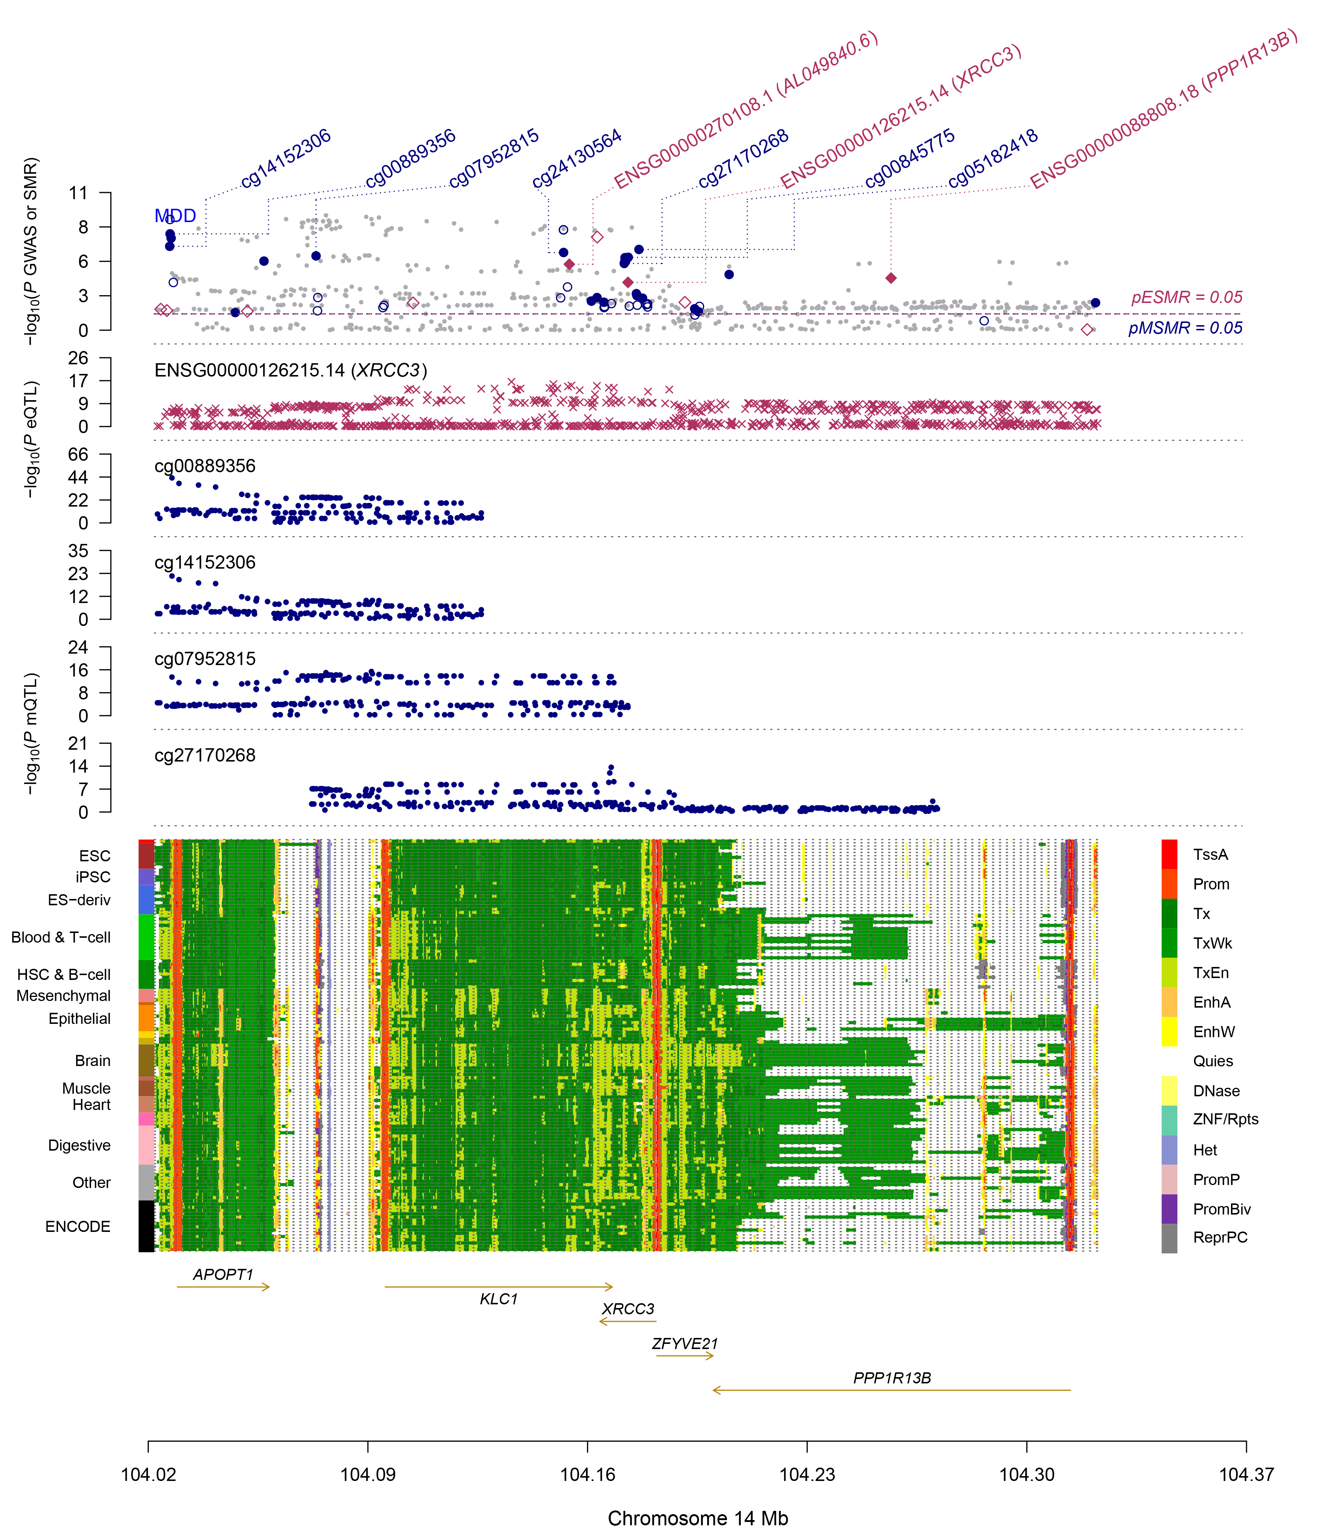
FIG5
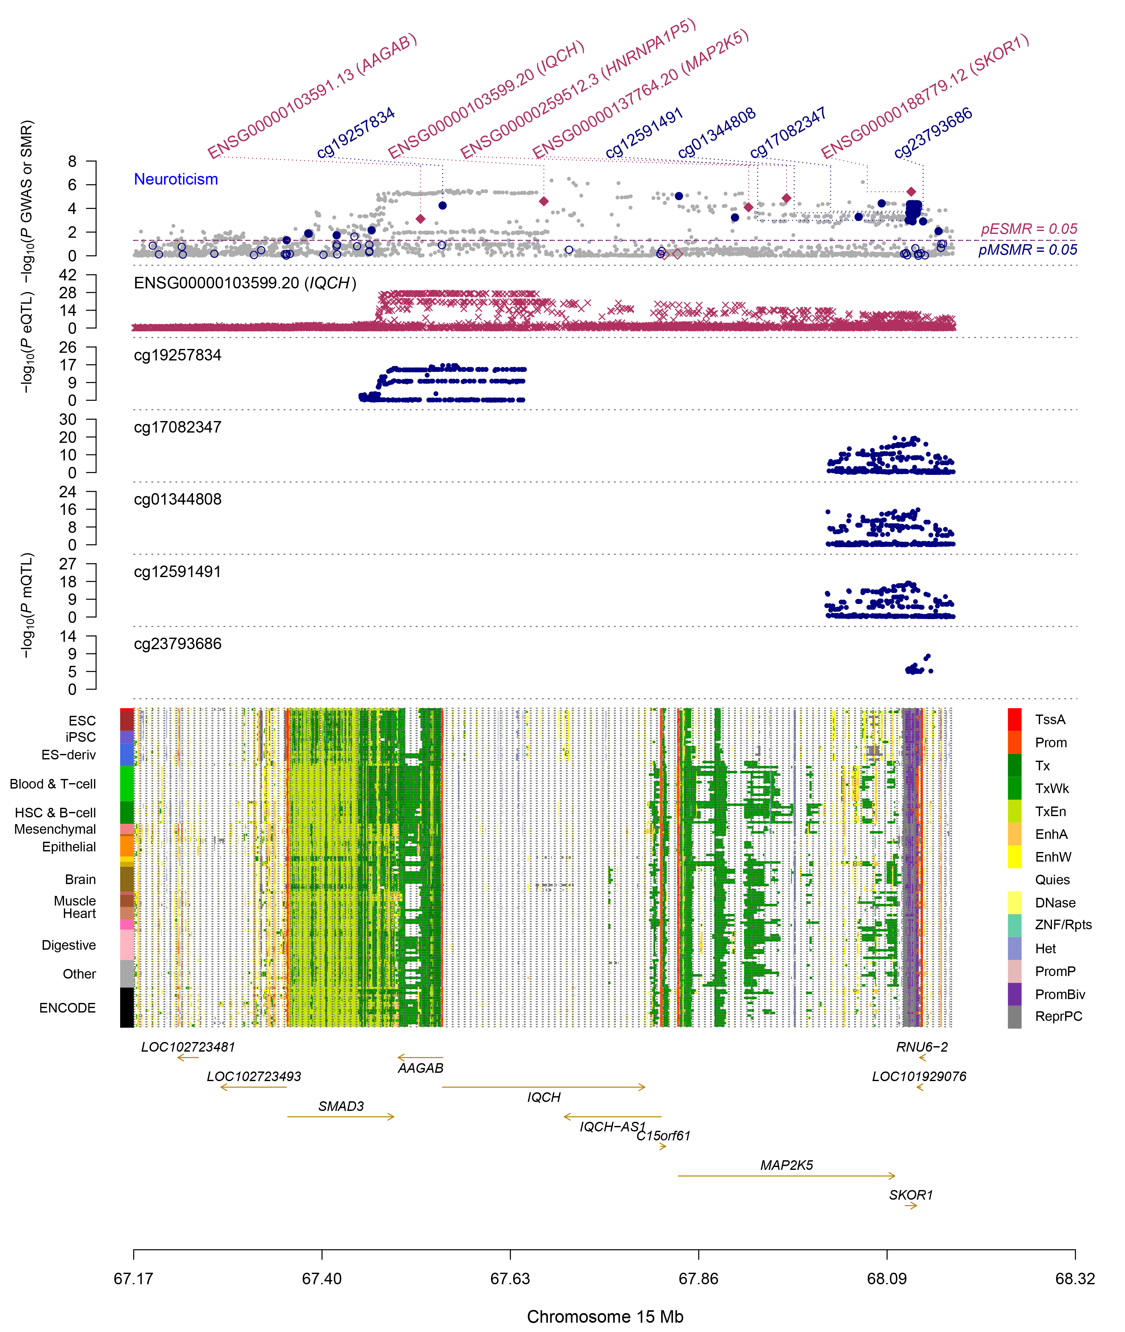
FIG6
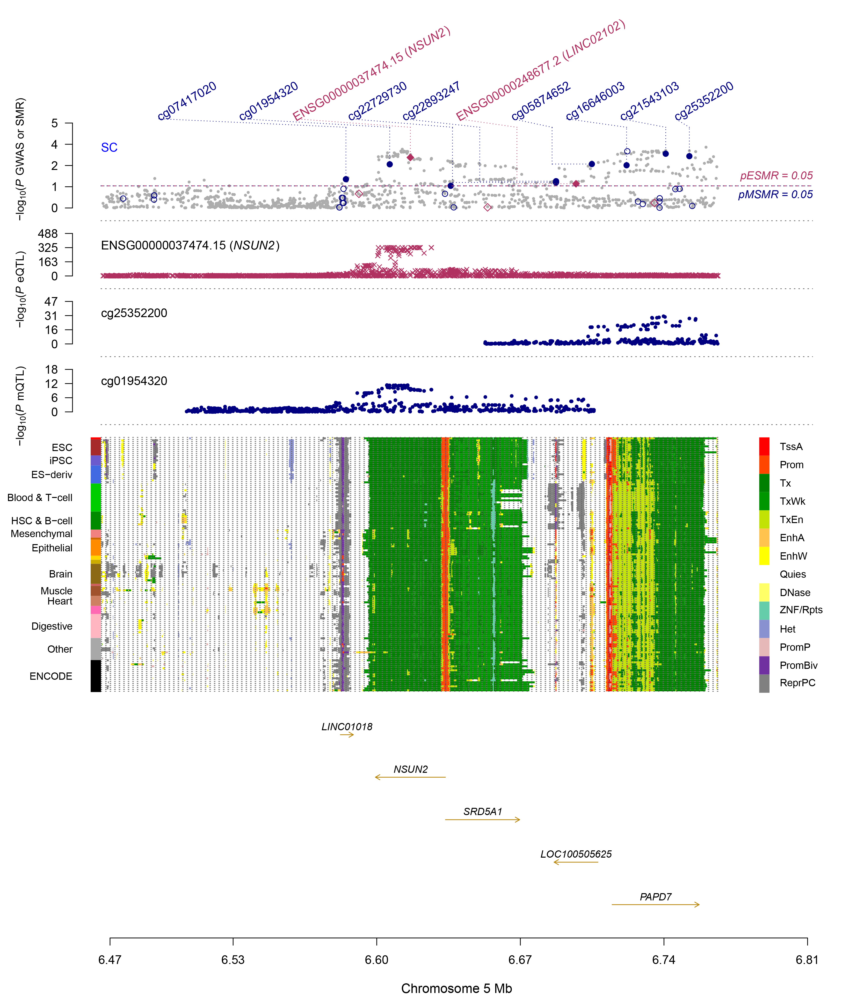
FIG7

FIG 2-7: SMR multi-omics plot show -log 10 (p-value) of SNPs derived from GWAS meta-analysis for PD, respectively. The -log 10 (p-value) for SMR tests of gene expression and DNAm probes for association with the disease is shown by red diamonds and blue circles, respectively. The probes that were validated by the HEIDI test are represented by solid diamonds and circles. The second panel depicts the value of -log10 (p-value) for SNP associations of gene expression probes derived from the brain eQTL data. The third panel represents the -log 10 (P-value) of SNP associations for DNAm probes derived from the brain mQTL study. The bottom panel depicts 14 chromatin state annotations (denoted by distinct colors). These correspond to 127 samples sourced from REMC encompassing various primary cell and tissue types (rows).

