Table 2. Structures, Molecular weights (MW), pI values, Fc (%), and ∆Fc (%) of bsAb Molecule A, B, and C for monomers and LMW species. MW values were calculated based on amino acid sequences. pI values were calculated from an Expasy ProtParam tool. Fc (%) and ∆Fc(%) are as defined in Equation 2 and Equation 3, respectively. Abbreviations used are listed as followed; D = dimer, M = monomer, HH = hole-hole homodimer; KK = knob-knob homodimer; LC = light chain. ∆Fc (%)A, ∆Fc (%)B, and ∆Fc (%)C of LC-M and LC-D are as compared to monomers of Molecule A, B, C, respectively. The more positive ∆Fc (%) between product-related impurities and monomers may suggest higher effectiveness of impurity removal via CHT-P elution.
Molecule | Category | Protein species | Structure | MW (kDa) | pI Value | Fc (%) | ∆Fc (%)
A, B, C | Small LMWs | LC-M | 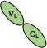 | 23.4 | 7.76 | 0% | -40%^{A}, -29% ^{B},  and -26% ^{C}
A, B, C | Small LMWs | LC-D | 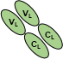 | 46.9 | 7.98 | 0% | -40%^{A}, -29% ^{B},  and -26% ^{C}
A | Target | M | 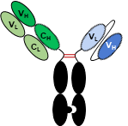 | 124.6 | 8.52 | 40% | 0%
A | Large LMWs | HH | 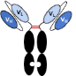 | 103.6 | 8.64 | 48% | 8%
A | Large LMWs | M - LC | 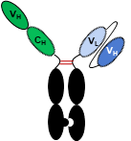 | 101.2 | 8.58 | 49% | 9%
B | Target | M | 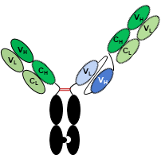 | 172.5 | 8.59 | 29% | 0%
B | Large LMWs | KK | 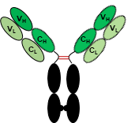 | 145.5 | 8.43 | 35% | 6%
C | Target | M | 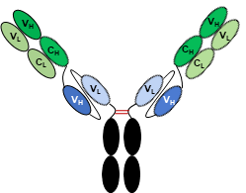 | 199.8 | 8.70 | 26% | 0%
C | Large LMWs | M - LC | 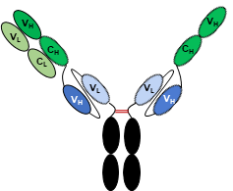 | 176.4 | 8.74 | 29% | 3%
C | Large LMWs | M - 2LC | 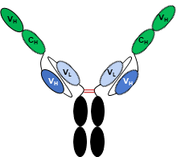 | 153.0 | 8.80 | 33% | 8%

