Supplementary material

Harnessing Ceramic Hydroxyapatite as an Effective Polishing Strategy to Remove Product- and Process-related Impurities in Bispecific Antibody Purification
Nattha Ingavat¹, Wang Xinhui¹, Liew Jia Min¹, Farouq Bin Mahfut², But Ka Pui³, Kok Yee Jiun³, Xuezhi Bi³, Yuansheng Yang², Kobayashi Shintaro⁴, Tsoumpra Maria⁴ and Wei Zhang¹*
¹Downstream Processing Group, Bioprocessing Technology Institute, Agency for Science, Technology and Research (A*STAR), Singapore
²Cell Line Development Group, Bioprocessing Technology Institute, Agency for Science, Technology and Research (A*STAR), Singapore
³Protein Analytics Group, Bioprocessing Technology Institute, Agency for Science, Technology and Research (A*STAR), Singapore
⁴Chromatography Media Business Division, HOYA Technosurgical Corporation, Singapore Branch, Singapore
*Correspondence:
Wei Zhang, zhang_wei@bti.a-star.edu.sg
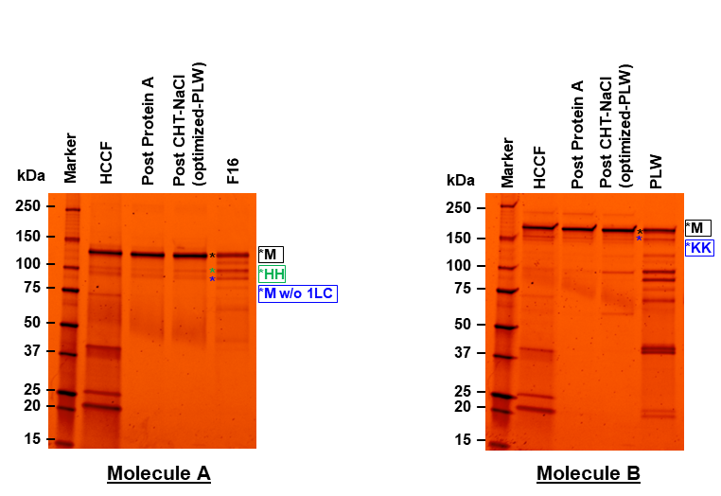
Supplementary Figure 1. Non-reducing SDS-PAGEs, illustrating protein populations in HCCF, Post Protein A, Post CHT-P (optimized-PLW), and elution fractions before main product peaks (Molecule A: F16) or Molecule B: PLW fraction, of Molecule A and B, respectively. Marker units are in kDa. Protein populations, indicated as (*), were proposed as suggested by molecular weights, which were calculated from amino acid sequences. Abbreviations used are listed as followed; M = monomer; HH = hole-hole homodimer; KK = knob-knob homodimer; LC = light chain; w/o = without.

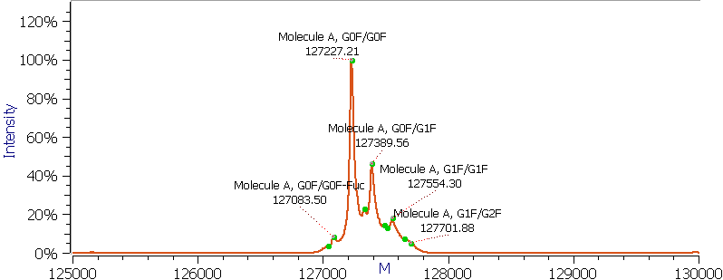
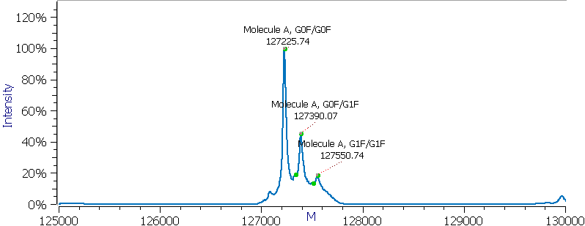
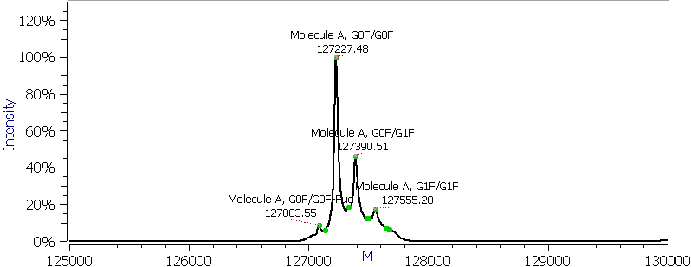
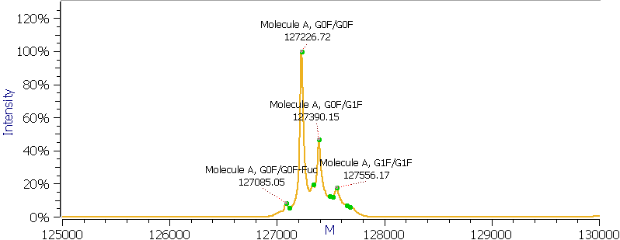
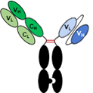
Post Protein A eluate
Post CEX product pool
Post CEX main elution peak
Post CHT-NaCl product pool with PLW optimization
Molecule A
Supplementary Figure 2. Intact mass analysis of Molecule A; post Protein A eluate; post CEX main elution peak; post CEX product pool; and post CHT-NaCl product pool with PLW optimization, respectively.

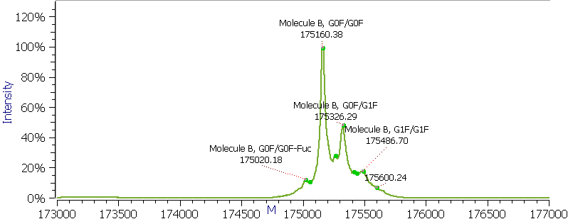
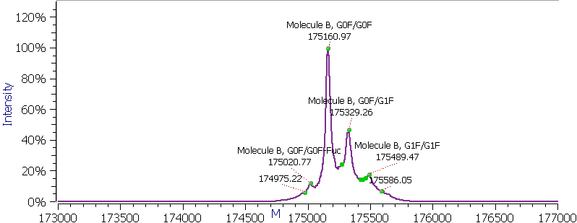
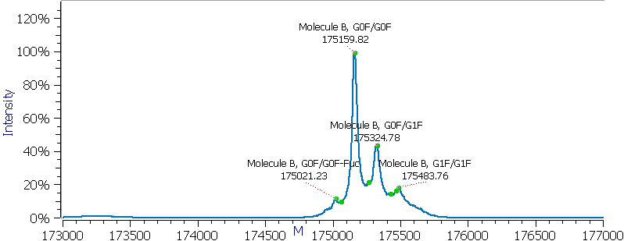
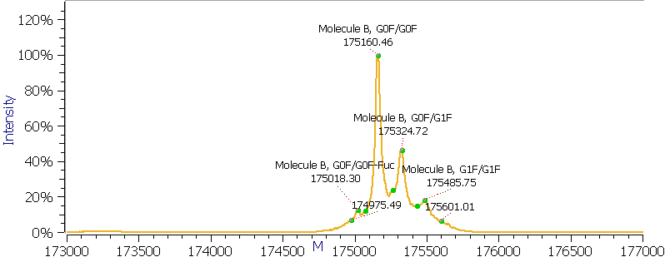
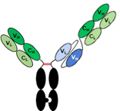
Molecule B
Post Protein A eluate
Post CEX product pool
Post CEX main elution peak
Post CHT-NaCl product pool with PLW optimization

Supplementary Figure 3. Intact mass analysis of Molecule B; post Protein A eluate; post CEX main elution peak; post CEX product pool; and post CHT-NaCl product pool with PLW optimization, respectively.
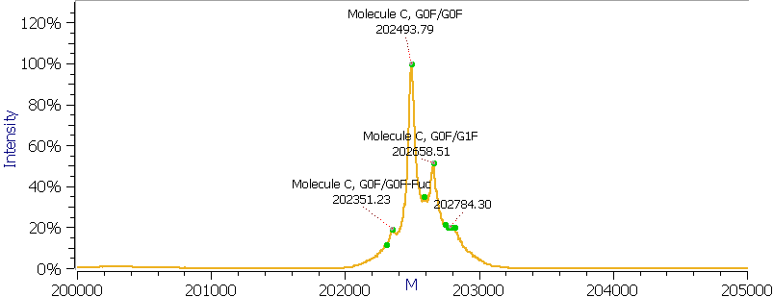
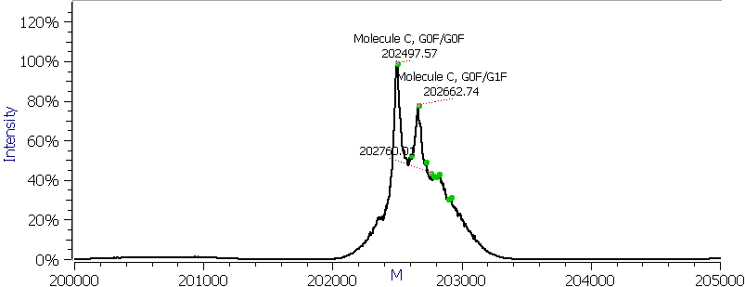
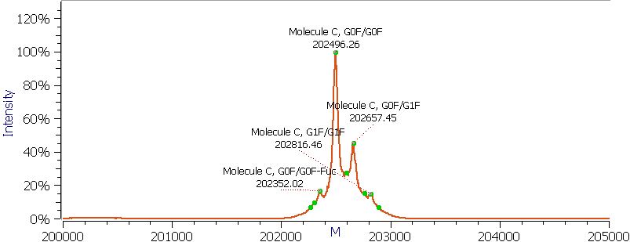
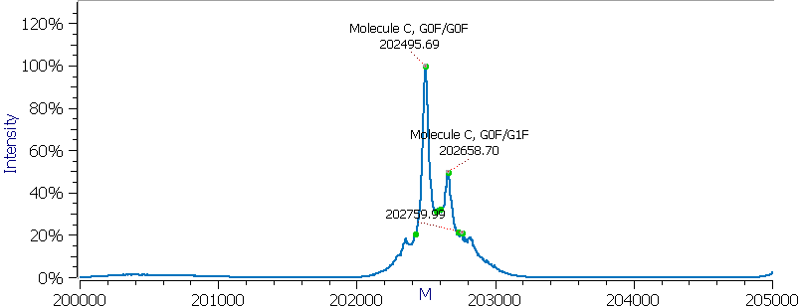
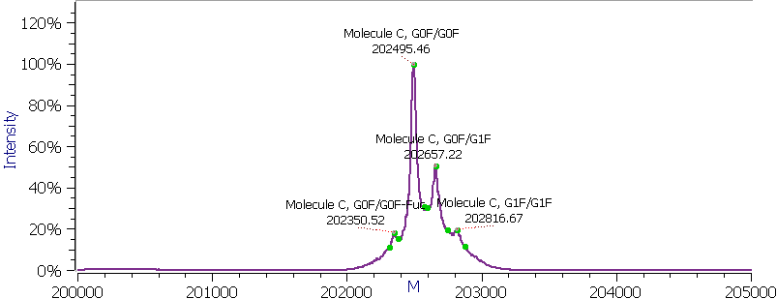
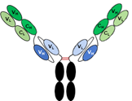
Post CEX main elution peak1
Post CHT-P product pool
Molecule C
Post CEX main elution peak2
Post Protein A eluate
Post CEX product pool

Supplementary Figure 4. Intact mass analysis of Molecule C; post Protein A eluate; post CEX main elution peak1; post CEX main elution peak2; post CEX product pool; and post CHT-P product pool, respectively.
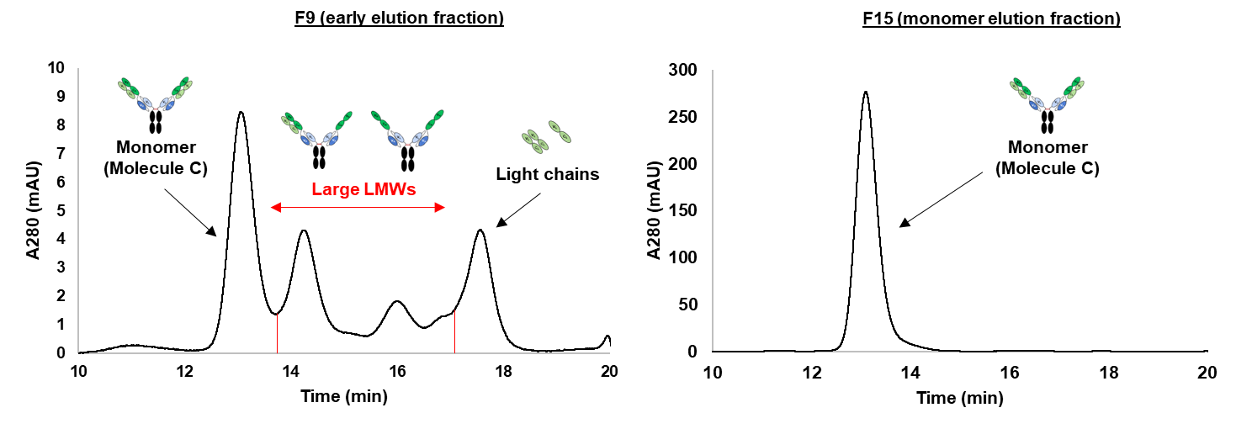

Supplementary Figure 5. SEC-HPLC chromatograms of F9 (early elution fraction and F15 (monomer elution fraction) from a CHT-P run for the symmetric bsAb Molecule C. The chromatogram showed that CHT-P was able to remove large LMW species prior to elution of the target monomer.

