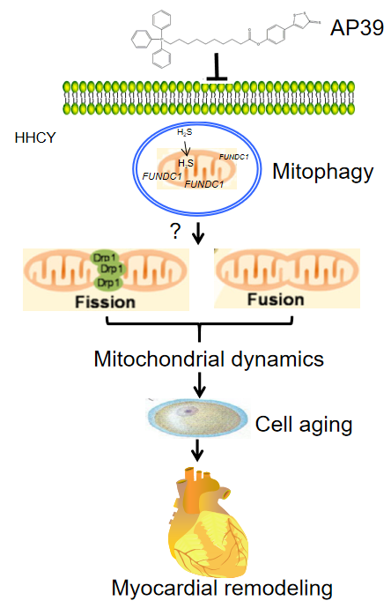
AP39 pro-FUNDC1 mediated mitophagy regulates mitochondrial dynamics to improve HHCY-induced myocardial remodeling

