Supplemental Material
Supplemental methods
Cell Culture
Cell lines (K562, KCL22, KU812, and NB4) were cultured in RPMI-1640 medium with 10% fetal bovine serum (Gibco, USA) and 1% penicillin and streptomycin (Gibco, USA) under a 5% CO2 atmosphere at 37°C. K562, KU812, and NB4 cells were obtained from the Institute of Shanghai Cell Biology, China. The KCL22 cell line was kind gift from Professor Markus Muschen, Children’s Hospital of Los Angeles, CA, USA. K562-IMR and KCL22-IMR cells were developed in our laboratory. Cells were subcultured every 2–4 days, and cells in the logarithmic growth phase were selected for study.
MTT assay
Briefly, cells were seeded at a density of 4 104 cells/mL in 96-well plates (100 μL/well) and treated with saRNA or NC. After 72 h, 20 μL MTT (5 mg/mL) was added to each well and incubated for 4 h. Subsequently, plates were centrifuged at 1200 rpm for 3 min. Each well received 150 μL DMSO after carefully aspirating the supernatant. Cell viability was assessed by measuring absorbance at 570 nm on a Bio-Tek microtiter plate reader. The proliferation inhibition rate was calculated as [1-(experimental group/control group)] x100% after three repetitions.
Soft agar colony formation assay
In the logarithmic growth phase, K562, KCL22, KU812, NB4, K562-IMR, and KCL22-IMR cells were harvested to detect proliferation capacity by the soft agar colony formation assay. After transfection, RPMI-1640 medium containing 20% FBS was mixed with soft agar (Sigma, USA) containing 1.2% in a 1:1 ratio and 2 mL of the mixture was added to each well of the six-well plate to form the lowest gel layer and allowed to solidify. After transfection, RPMI-1640 containing saRNAs was gently combined with 0.3% soft agar on the upper gel. Next, 1 mL was added per well to the bottom gel that had solidified while waiting for the upper gel to solidify. After observing more than 40 cell clonal groups under a microscope, 4% paraformaldehyde was added for 30 minutes. After washing with PBS, 0.6 mL of 0.005% crystal violet solution was added to each well for staining for 1 h to 2 h, and then the staining solution was aspirated and discarded. The cell clusters were washed with PBS until they were visible. Subsequently, photographs of the clusters were obtained, and imageJ and GraphPad were used to determine the number of cell colonies.
Transfection of saRNA drugs
SaRNAs (1-4) and NC (negative control, random sequences) were transfected into K562, KCL22, KU812, NB4, K562-IMR, and KCL22-IMR cells by LipofectamineTM 2000 reagent (Invitrogen, China). The final concentrations of saRNA and NC ranged 30–50 nM. For transfection, LipofectamineTM 2000 reagent was diluted with Opti-MEM and incubated for 5 minutes at room temperature. The saRNAs were diluted in Opti-MEM. After a 5-minute incubation, the LipofectamineTM 2000 reagent was gently mixed in a 1:1 (v/v) ratio with nucleic acid and incubated for 15 min at room temperature. After six hours at 37°C, the wells were replaced with complete medium RPMI-1640 (10% FBS by volume).
Quantitative real-time
To verify the expression of CDH13 mRNA in K562, KCL22, KU812, NB4, and K562-IMR, and KCL22-IMR cells, Trizol (Invitrogen, USA) was used as the extraction method to obtain total RNA from cells. The total RNA (500 ng) was then reverse transcribed using a SuperScript IV first-strand synthesis system (Invitrogen, USA). Relative expression of mRNA was detected by 2x SYBR Green qPCR Master Mix (Bimake, USA) according to the manufacturer's instructions by quantitative real-time PCR (qRT-PCR). The 2-ΔΔCt method was used to determine the relative expression of mRNA.
Western blotting analysis
Following cell lysis with PMSF-containing RIPA buffer (Roche, USA) for 30 minutes. The BCA Protein Assay Kit was utilized to determine total protein concentrations (KeyGen Biotech, China). SDS-PAGE was used to separate a total of 30 µg of protein mixture from each sample, and the separated proteins were then transferred to PVDF membranes (Merck Millipore, Germany). The PVDF membrane was blocked with 5% milk (in PBST) for one hour and then incubated overnight at 4°C with primary antibody against H-Cadherin (Abcam, USA). As a control, antibodies against beta-actin (Abcam, USA) and GAPDH (Abcam) were utilized. Signals were detected using HRP-conjugated anti-rabbit IgG antibodies (Cell Signaling Technology, USA), and were observed using ECL detection. Both reagents were purchased from Cell Signaling Technology.
DNA Methylation Assay
Samples were bisulfite-converted with the EZ DNA MethylationTM Kit (Zymo Research, USA). Methylation-specific PCR (MSP) uses amplification to determine the methylation status of a particular CpG site. Differential amplification of the template with (M) methylated and (U) unmethylated primer sets is crucial to the success of this method. MSP primers were constructed using the online platform available at https://zymoresearch.eu/pages/services.
Flow cytometric detection of apoptosis
Equal numbers of cells were placed in flow cytometry tubes and washed with PBS by centrifugation at 800 rpm for 3 min. Each group of cells were resuspended with 300μL of Binding Buffer. Next. 3 μL of Annexin V-FITC, were added and the solution was mixed gently with a pipette, and then incubate it at room temperature for 15 minutes while shielding it from the light. After carefully adding 3 μL of the Propidium staining solution, the contents of the two vials were combined using a pipette, and then incubated at room temperature for 15 minutes while shielding it from the light.

Supplemental results
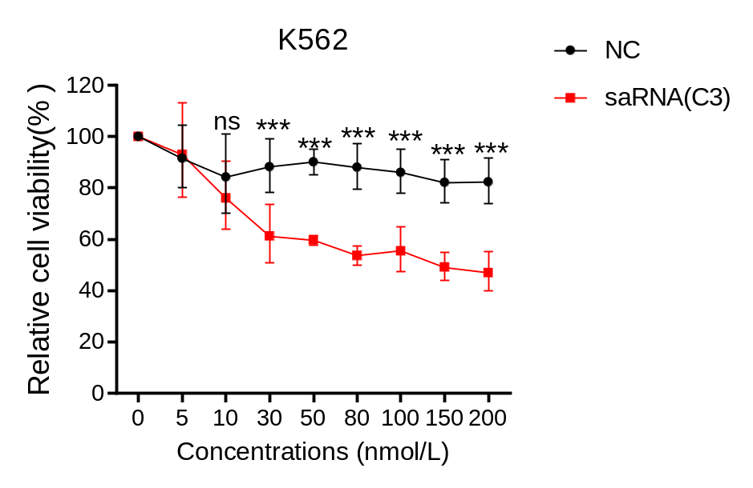
Figure S1. Different concentrations of NC and saRNA (C3) were transfected into K562 cells, and after 72 hours, the relative viability of the cells was detected using the MTT assay（***P<0.001; mean±SD; n=3）. saRNA(C3) shows a cell-inhibiting effect at 30 nM, but the efficacy does not change significantly as the concentration increases.

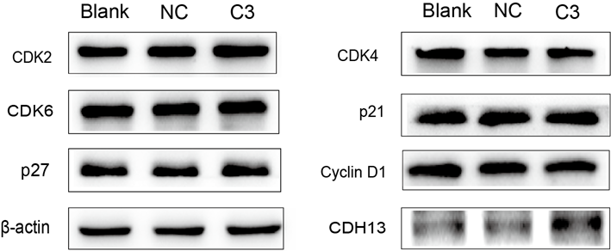

Figure S2. NC and saRNA(C3) were transfected into K562 cells respectively, and the expression of proteins related to the regulation of cell proliferation was examined using western blotting assays.
Activation of CDH13 in K562 cells did not affect the expression of cell proliferation-related proteins.

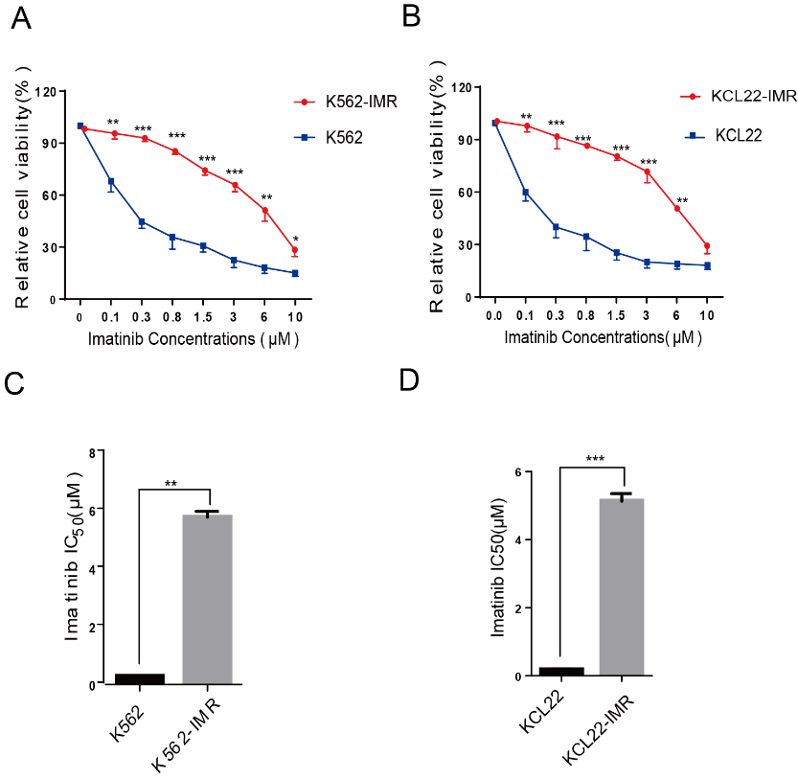
Figure S3. The mutation sites of BCR-ABL1 in K562-IMR were analyzed and sequenced. There were no commonly known mutations of BCR-ABL1 such as T315I in the cell lines, indicating that CML resistant cell lines are imatinib resistant strains independent of BCR-ABL1.

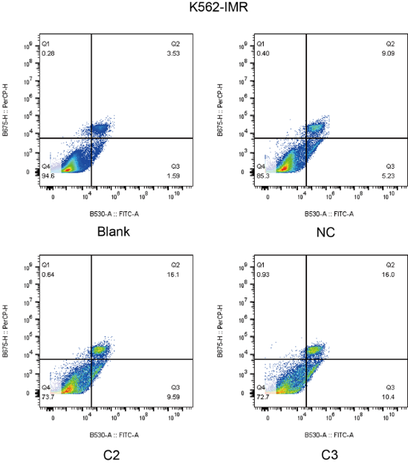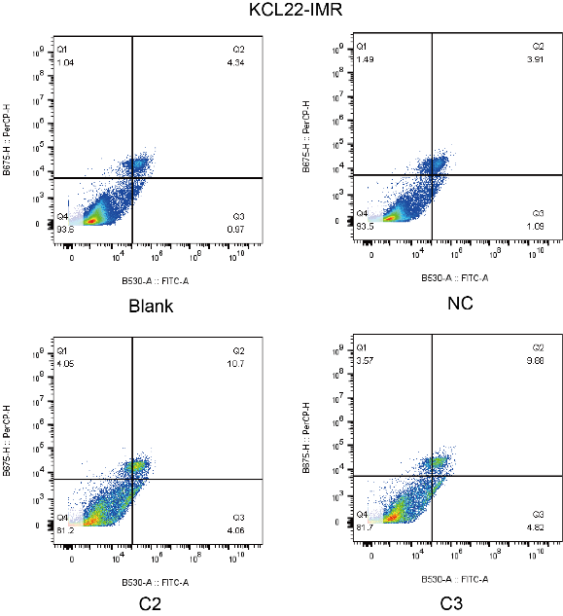
Figure S4. The proportion of cells with early versus late apoptosis was detected by flow cytometry after saRNA (C2,C3) transfection into K562-IMR and KCL22-IMR cells. After saRNA (C2,C3) activates CDH13 and promotes apoptosis in K562-IMR and KCL22-IMR cells.

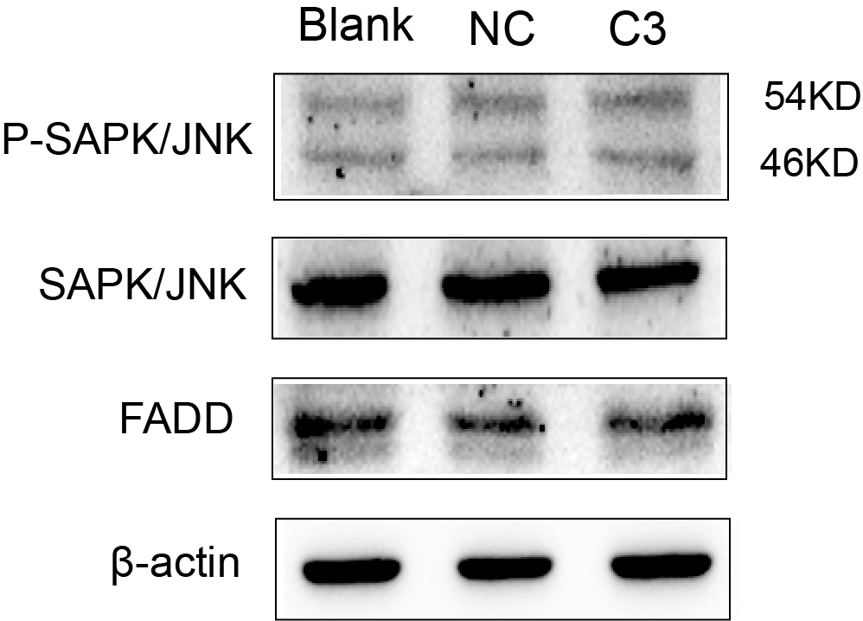
Figure S5. NC and saRNA (C3) were transfected into K562-IMR cells, respectively. The expression of SAPK/JNK and FADD showed no changes in expression using the western Blotting assay.

Figure S6. Identification of K562-IMR/luciferase cells. (A) Enzyme marker showing luciferase activity proportional to cell number. (B) Small animal live imaging system showing fluorescence intensity proportional to cell number. The results showed that K562-IMR^{Luc} cells were successfully constructed.

