Extended Data

Series | Parameters | Values | Distribution
1a | $$μ_{0}$$ | [-0.05, 0, 0.10] | Triangular
 | $$μ_{1}$$ | [0, 0.05, 0.10] | Triangular
1b | $$μ_{0}$$ | [0.001, 0.01, 0.10] | Triangular
 | $$μ_{1}$$ | [1,100,1000] | Triangular
1c | $$μ_{0}$$ | [2.5E-5, 3E-5, 1E-1] | Triangular
 | $$μ_{1}$$ | 0
2 | α | [1.001, 1.0015, 20] | Triangular
 | β | 2
 | t_{peak} | [10, 70, 120] | Triangular
3a - 3b | κ | [0, 0.05, 0.15] | Triangular
3b | $$Ω$$ | [0, κ] | Uniform
Table S1 Characteristics of the parameters for the T and CO₂ time series. Values for triangular distributions give the minimum, the peak and the maximum of the distribution. Values for uniform distribution give the minimum and the maximum.

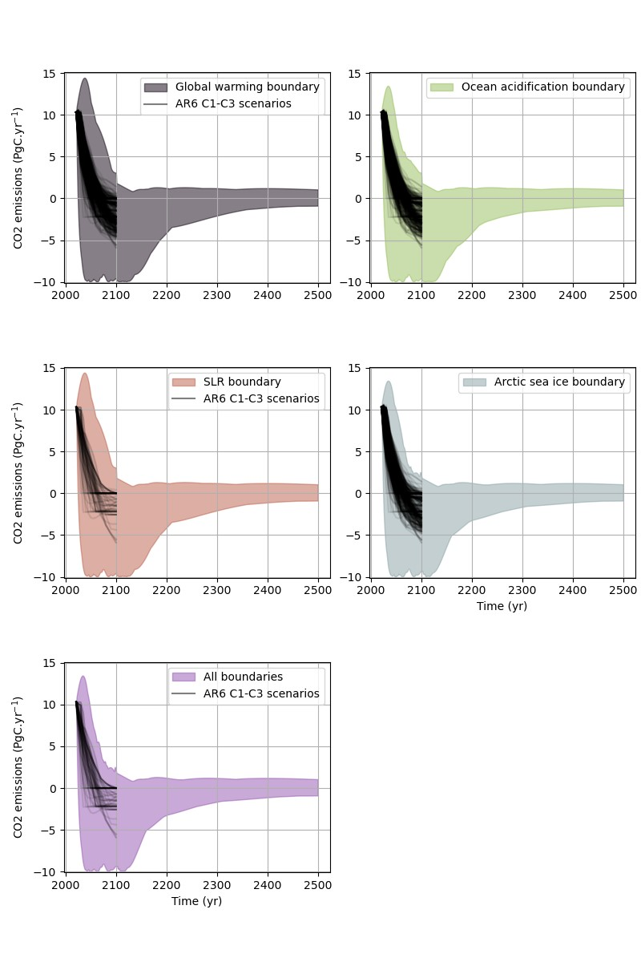
d)
c)
e)
b)
a)
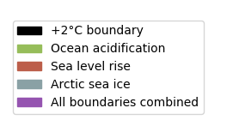
Figure S1: Illustration with the “best guess” configuration of Pathfinder. It is a configuration where we use the mean value of all parameters. In this specific configuration, AR6 C1-C3 scenarios that are Paris-compliant (black lines) are covered by scenarios calculated by Pathfinder in our framework (colored envelopes) under comparable conditions on pathways characteristics: no SRM and up to 10 PgC.yr⁻¹ of CDR. All pathways remain below 2°C. Pathfinder pathways tend to 1.5°C in the long term. Our results show that this coverage is similar in all 1500 configurations of Pathfinder used in this study. Panel a) shows the pathways compatible with the global warming boundary. Panel b) shows pathways compatible with the ocean acidification boundary. Panel c) shows pathways compatible with the SLR boundary. Panel d) shows pathways compatible with the Arctic sea ice boundary. Panel e) shows pathways compatible with all boundaries together.
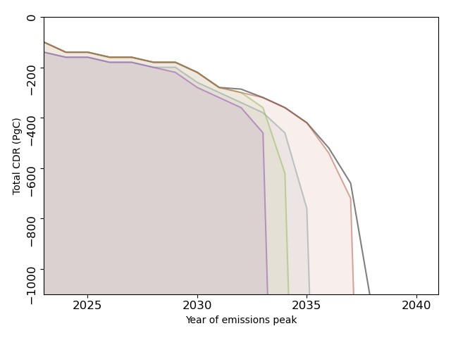
a)
b)
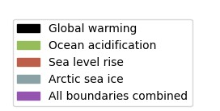
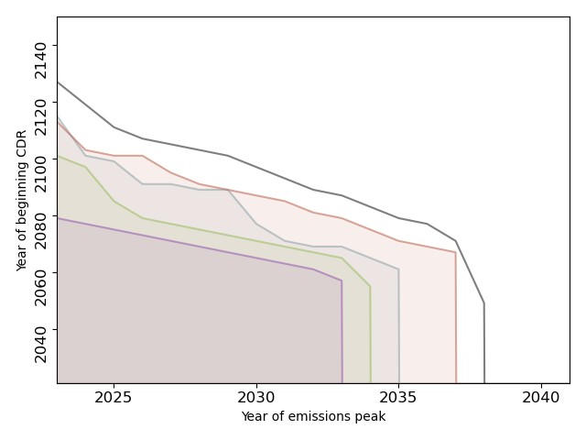
Figure S2: Panel (a) shows the trade-offs between the date of emissions peak and the total amount of CDR needed before 2100, for a 67% safety level. Panels (b) shows the trade-offs interaction between the year when CDR is significantly deployed (more than 0.5 PgC.yr⁻¹) and the year of peak emission for a 67% safety level. Shaded areas represent the spaces compatible with planetary boundaries. Plain lines give the frontier of the compatible space. Black is for the global warming boundary, green for the ocean acidification boundary, red for the SLR boundary, blue for the Arctic sea ice boundary, and purple for the combination all boundaries.
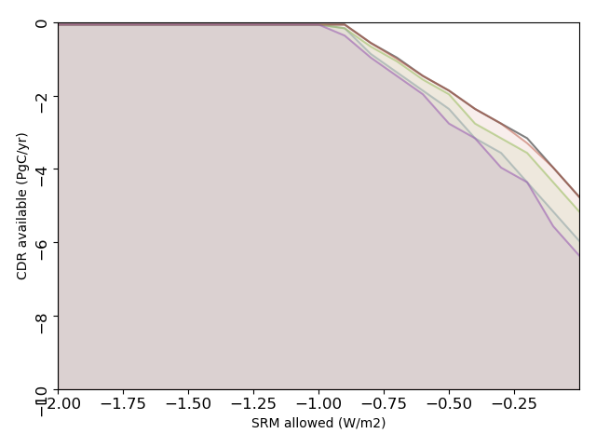
Figure S3: Trade-offs between CDR available and how much SRM is allowed in the case of a peak of CO₂ emission in 2030 for a 67% safety level. Shaded areas represent the spaces compatible with planetary boundaries. Plain lines give the frontier of the compatible space. Black is for the global warming boundary, green for the ocean acidification boundary, red for the SLR boundary, blue for the Arctic sea ice boundary, and purple for the combination all boundaries.
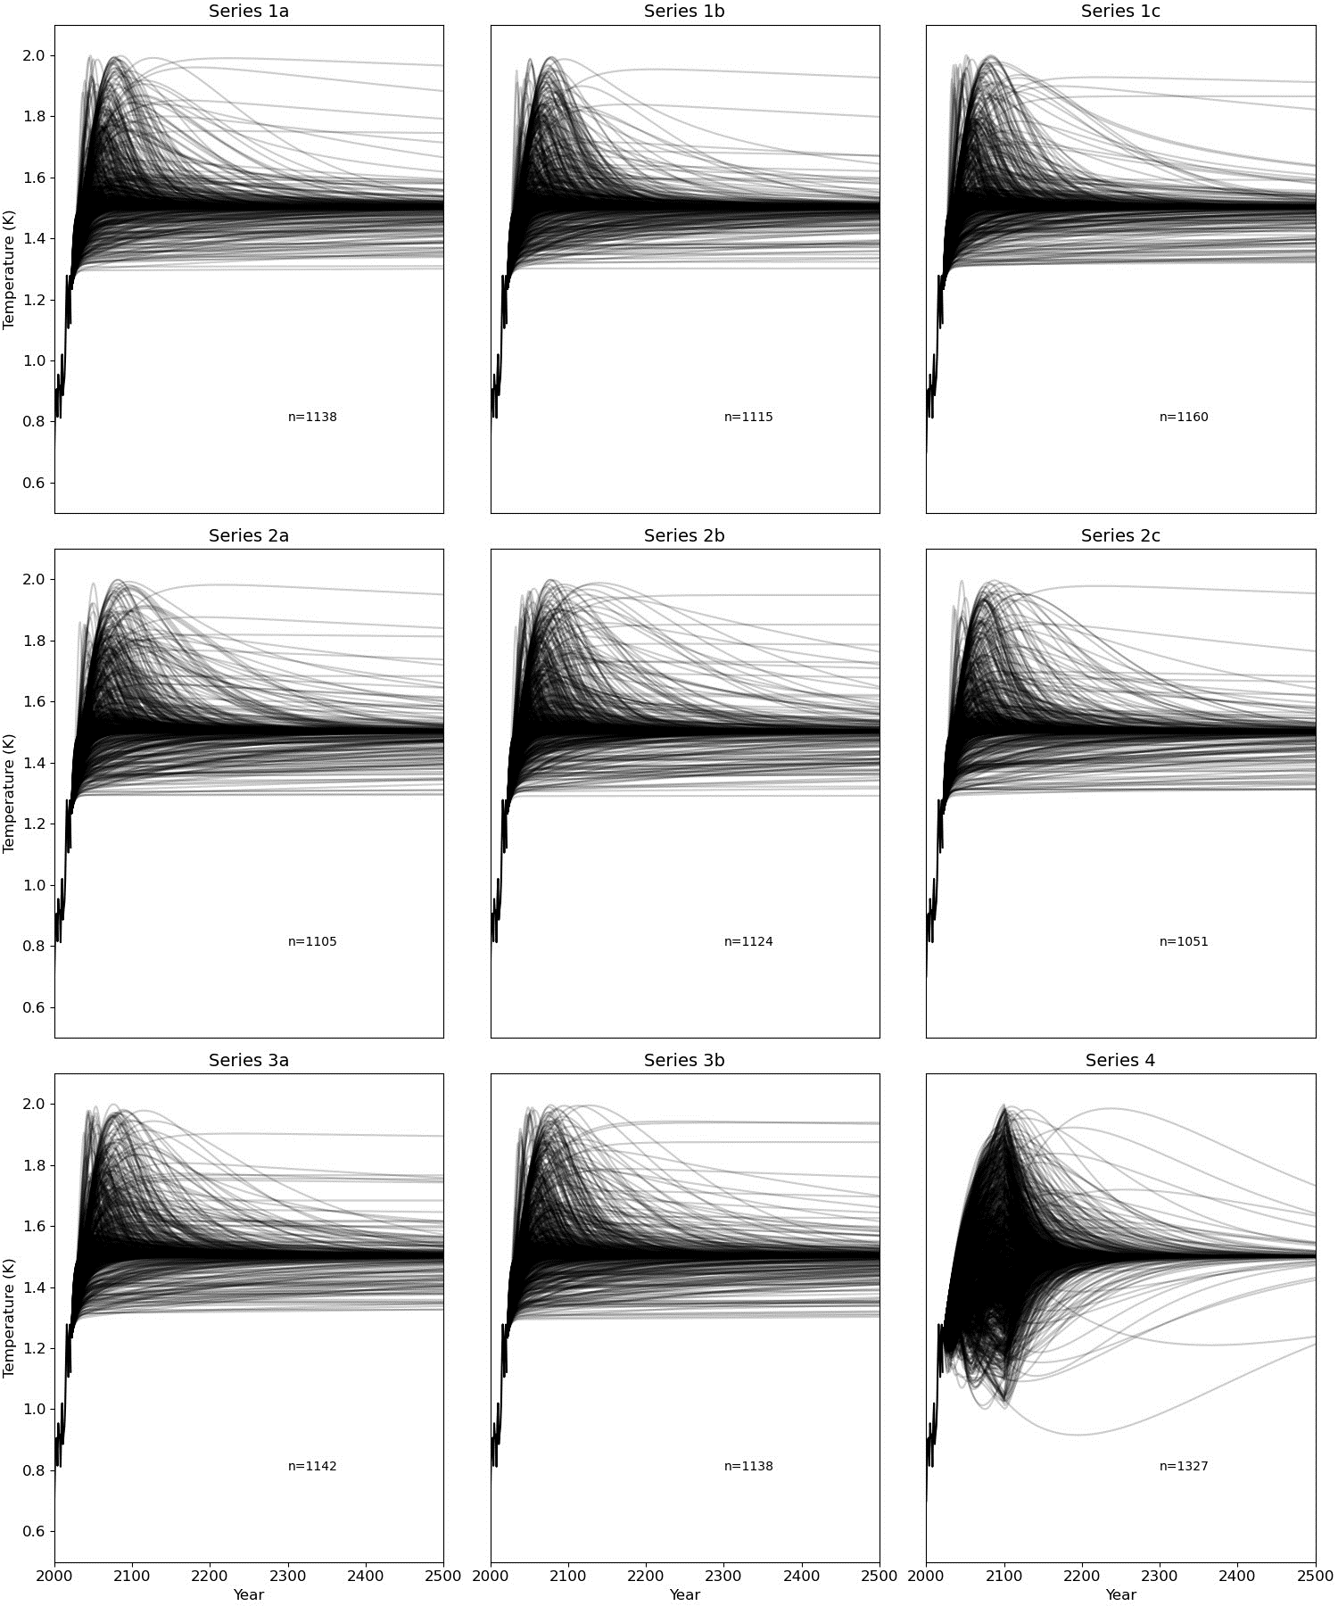
Figure S4: Temperature trajectories classified by series for one configuration of Pathfinder, n is the number of pathways in this configuration.
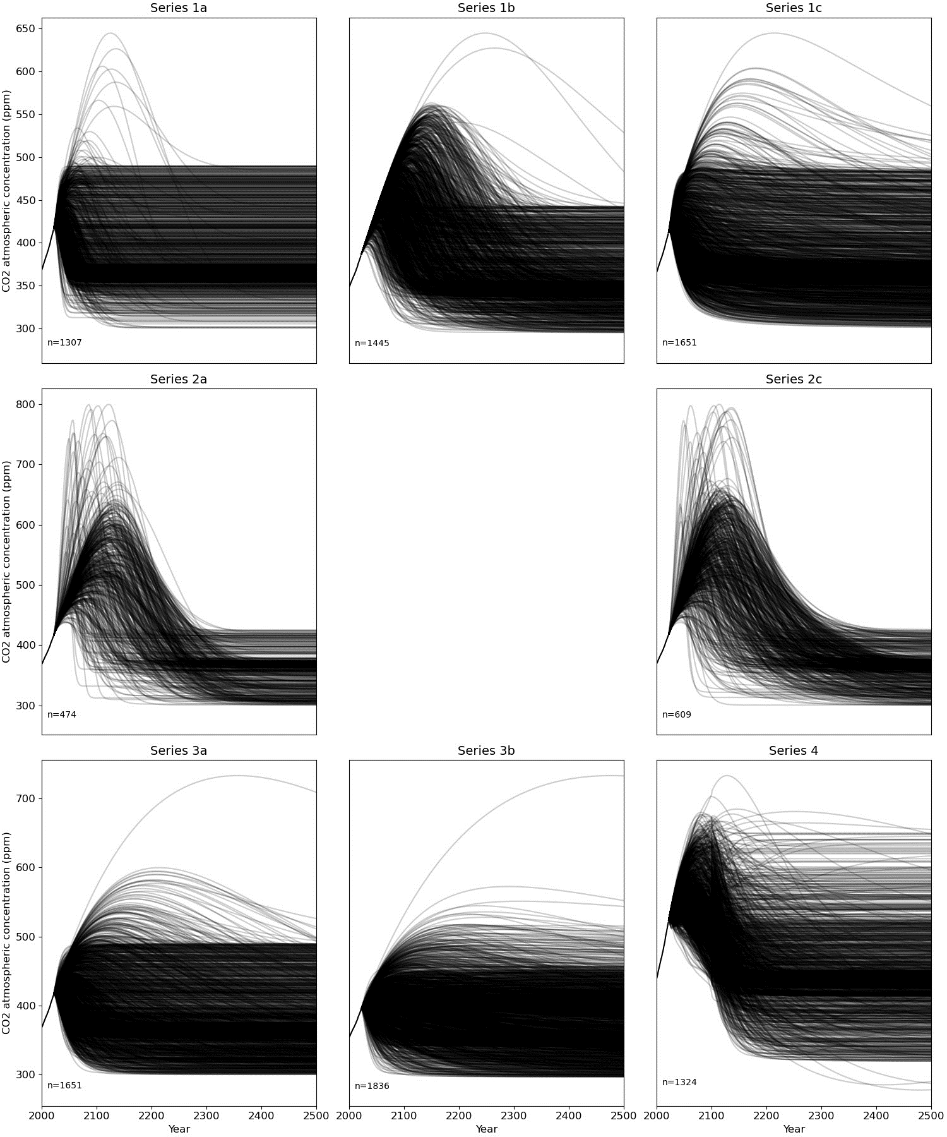
Figure S5: Atmospheric CO₂ concentration classified by series for one configuration of Pathfinder, n is the number of pathways in this configuration.

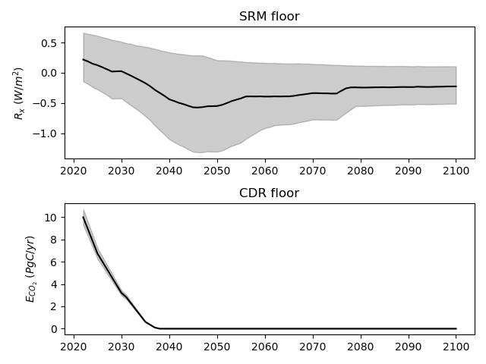
Figure S6: SRM (Panel a) and CDR (Panel b) floors in Pathfinder. Shaded areas show the 1-sigma uncertainty range.
b)
a)
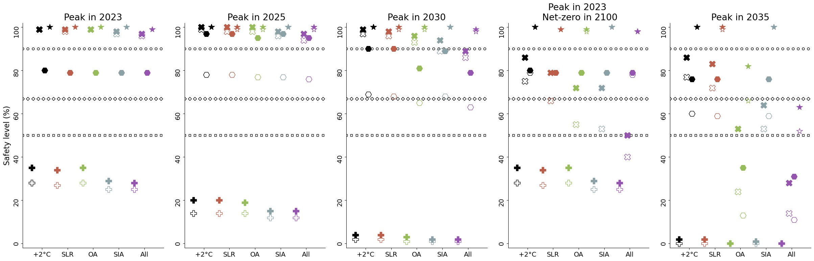 Figure S7: Safety levels of compatible spaces defined by various combinations of conditions on pathway characteristics and for two different definitions of the compatible space. Plain markers reproduce results from Figure 2 by defining a space compatible when there remains at least one pathway. Empty markers give the same values for a space considered compatible only if the relative size of the remaining compatible pathways envelope is kept above a 1% area ratio (Methods). Subplots distinguish conditions on the date of CO₂ emissions peak and of net-zero. Net-zero in 2100 means that CO₂ net-zero is reached in 2100 or later. No information on net-zero means that this pathways characteristic is not constrained. Peak in 2023, 2025, 2030 and 2035 means that the compatible CO₂ pathways reaches their peak in 2023, 2025, 2030, or 2035. Markers distinguish conditions on speculative technologies (CDR and SRM), Up to 10 PgC yr⁻¹ of CDR assumes that SRM will never be available while CDR will be available, possibly up to 10 PgC yr⁻¹. No technologies assumes that neither SRM nor CDR will be available. CDR available and SRM allowed assumes SRM being possibly used up to 2 W m⁻² in addition to CDR. Finally, the No CDR available but up to 2W m⁻² of SRM allowed case assumes that CDR will never be available but SRM can be used up to 2 W m⁻². Marker lines show the 90% safety level, 67% safety level and 50% safety level.
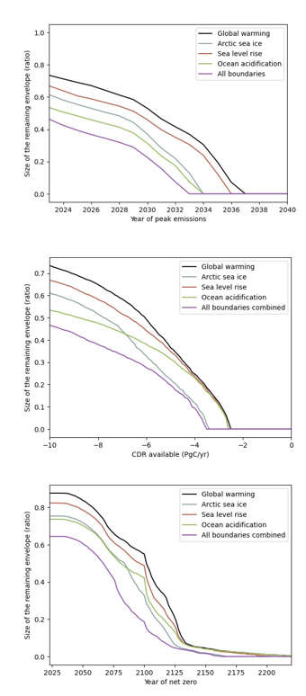
c)
a)
b)
Figure S8: Size of the remaining envelope for different planetary boundaries for a 67% safety level. Panel (a) shows the evolution of the relative size (i.e. area ratio) under different year of CO₂ emission peak with up to 10PgC yr⁻¹ of CDR, no SRM and net-zero CO₂ emissions reachable in 2050. Panel (b) shows the evolution of the relative size under different amount of CDR available at peak deployment with no SRM, CO₂ emissions peak in 2023 and net-zero CO₂ emissions reachable in 2050. Panel (c) shows the evolution of the relative size under different year of net-zero CO₂ emission with up to 10 PgC yr⁻¹ of CDR, no SRM and CO₂ emissions peak in 2023.
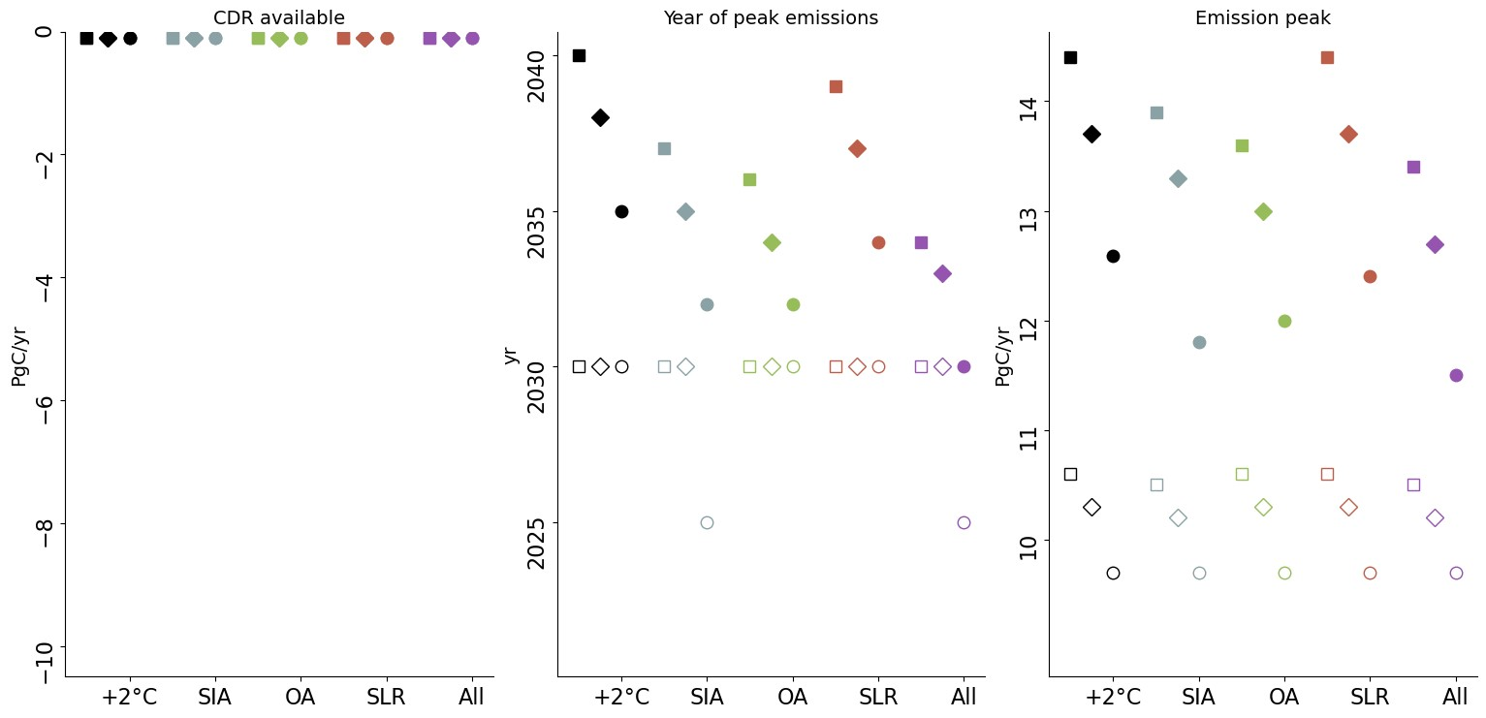
a)
b)
c)

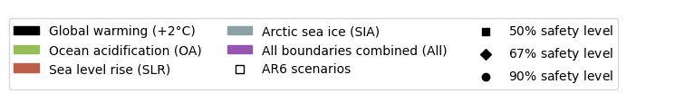
Figure S9: Limits of the compatible space for one key characteristic if the other pathway characteristics are not constrained and for three safety levels: 50% (squares), 67% (diamonds) and 90% (circles). Panel (a) focuses on the amount of CDR available at peak deployment, panel (b) on the year of CO₂ peak emissions and panel (c) focus on the level of CO₂ emission peak. Black is for the global warming boundary, green for the ocean acidification boundary, red for the SLR boundary, blue for the Arctic sea ice boundary, and purple for the combination all boundaries. We compare those limits given by the ensemble of scenarios from Pathfinder (plain markers) to the same limits given by the ensemble of scenarios C1, C2 and C3 from the AR6 database run through Pathfinder (empty markers). If the limit is the same for both scenarios ensemble, we only show plain markers.

