Appendices

POST-INDUCTION HYPOTENSION PREDICTION MODEL SPECIFICATIONS

Measure Title: Post-induction Hypotension among Non-Emergent Noncardiac Surgical Adult Patients.

Description: Patients in which a decrease of the lowest mean arterial pressure (MAP) during anesthesia induction of more than 30% compared with the MAP measurement before induction. The post-induction hypotension (PIH) definition adopted in this study does not consider the time factor.
Rationale: Intra-operative MAP with a decrease of more than 30% among tens-of-thousands of adult patients having non-cardiac surgery was highly associated with the incidence of ischemic stroke, post-operative incidents and death^{1, 2}. The frequency of BP recording was consistent with that of Bijker et al.¹; hence, the PIH definition adopted in this study does not consider the time factor.

Guidance: This prediction model evaluates the proportion of cases in which the patient’s at least one measurement of MAP (during the course of the anesthesia induction) decrease of more than 30% compared with the MAP measurement before induction. MAP was recorded in one-minute intervals from induction of general anesthesia (GA) until the beginning of the operation. The MAP measurement does not consider the time factor. Note that this measure is not intended to substitute for the clinician’s judgement about managing PIH for any given patient, and for some patients the clinician may manage BP using a higher or lower target MAP (e.g., a lower MAP target for patients with chronic hypotension). To report the prediction model, the reporting clinician must submit data on the patient’s MAP over the course of the anesthesia as monitored by an anesthesia information management system (AIMS). The nurse anesthetists must submit intraoperative patient vitals extracted directly from an interface with the monitor. If the record for a given case includes both vitals pulled from the monitor and manually recorded vitals, only those from the monitor will be used to development the prediction model.
BP measurements were collected at three time points in this study (Fig. 1). The first BP reading is measured and recorded by the ward nurse manually before the patient leaves the ward for the operation room. The second BP is defined as the baseline BP measured and recorded by the nurse anesthetists manually when the patient arrives at the operation room before induction, which represents the BP of the patient under stress. The first and baseline BP using non-invasive method. The third and final is the post-induction BP measured by the nurse anesthetists，the post-induction BP measure start time is defined as the anesthesia start time. The post-induction BP measure end time is defined as the beginning of the operation. Post-induction BP was measured by using invasive method. If the nurse anesthetist monitors a patient using more than one method (i.e., using invasive and non-invasive methods) and there are two MAPs available at the same point in time, the measure uses the invasive value for development the prediction model. The measure attributes the full case to all nurse anesthetists who provide care during any portion of the case from the beginning to the end of the measurement period. To determine the patient’s baseline MAP, the measure uses the most recent MAP taken in the operating room before induction of anesthesia. If a nurse anesthetist does not have MAP values available to report either for the baseline MAP or for measurements across the measurement period, the nurse anesthetist may submit pairs of systolic and diastolic blood pressures (SBPs and DBPs) as a replacement for the MAP. The registry collecting the data will use these systolic and diastolic pressure values to calculate MAP values. Specifically, the registry will calculate MAP using the following formula: MAP = 1/3 (SBP) + 2/3 (DBP)³.

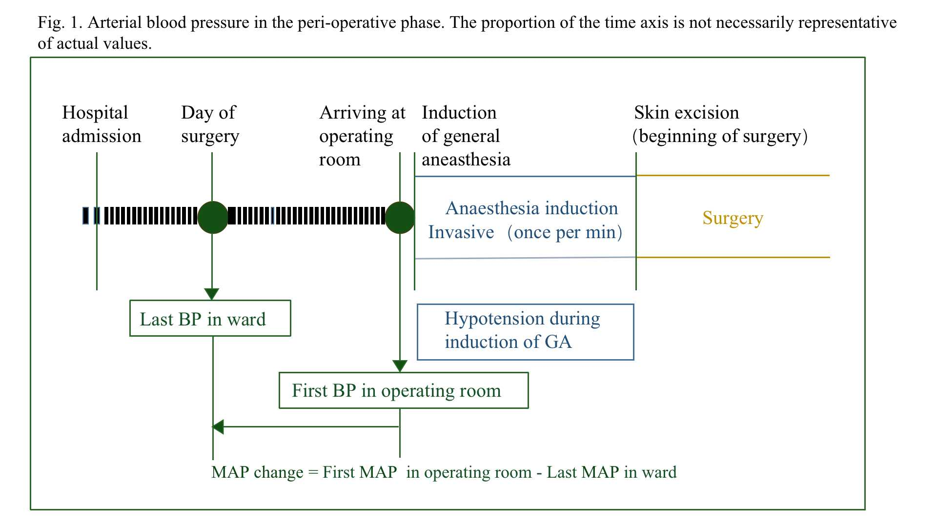

Non-emergency surgeries include both elective and urgent surgeries.
Because longitudinal BP data can contain artifactual values (for example, inaccurate readings caused by the nurse anesthetist’s leaning on the BP cuff), the measure will drop MAP, SBP, and DBP readings that are likely to be artifacts. Specifically, the measure will drop individual MAP readings that meet any of the following criteria:
- Documented as an artifact by the nurse anesthetist
- SBP ≥ 300 mmHg or ≤20 mmHg
- DBP ≤5 mmHg or DBP ≥ 225 mmHg
- SBP and DBP within 5 mmHg
- MAP ≤30 mmHg or ≥ 250 mmHg

Initial population: All cases in which adults (ages 15 and older) with noncardiac, non-emergency surgery require GA
- Data elements and definitions
  - Age: The length of time that the patient has lived. Note: Age in years at the Anesthesia Start Time (see definition below under Numerator). Age will be calculated from the date of birth if available⁴.
  - Non-emergency: Refers to both elective and urgent surgeries.
    - Elective: A surgical, therapeutic, or diagnostic procedure that can be performed at any time or date with an agreement between the surgeon and the patient⁴.
    - Urgent: A surgical, therapeutic, or diagnostic procedure that must be performed to prevent death or permanent impairment but that can be delayed. Note: The procedure may be delayed to allow for medical optimization of the patient or to permit better availability of resources (ex., personnel or equipment)⁴.
  - General anesthesia (GA): A drug-induced loss of consciousness during which patients are not arousable, even by painful stimulation. GA often impairs the patient's cardiovascular function and/or the ability to independently maintain spontaneous ventilation. Under general anesthesia, patient may require assistance in maintaining a patent airway and positive pressure ventilation may be required because of depressed spontaneous ventilation or drug induced depression of Midwives. neuromuscular function⁴.

Risk factors: Variables incorporated into the LASSO model include the following:
- Heart rate
- Body mass index
- ACEI
- MAP change
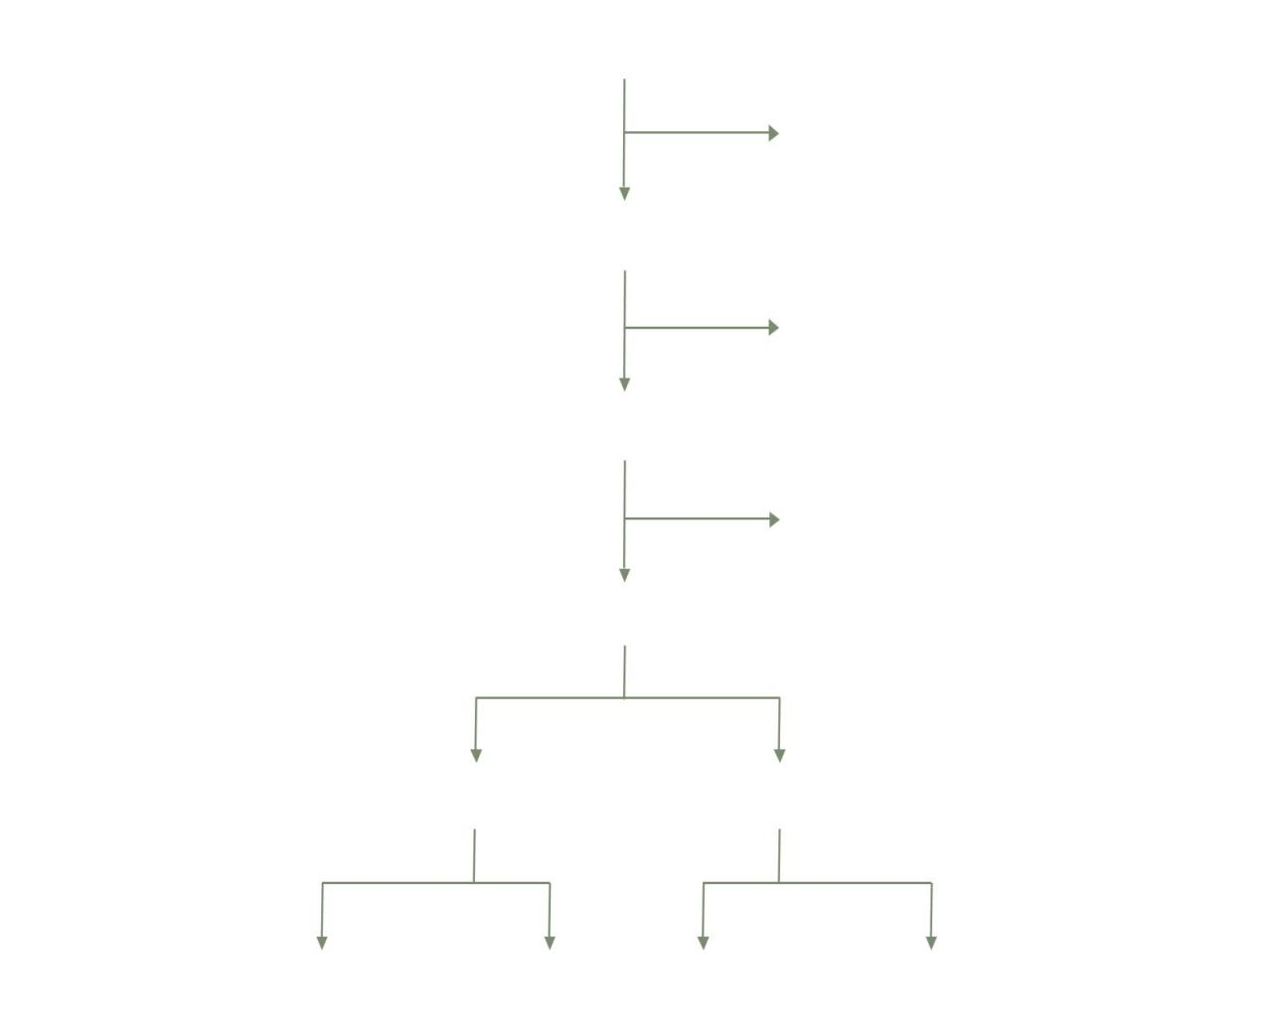
Patients post 2nd screen (n=322)
Excluded for emergency surgery (n=3)
Patients post 1st screen (n=324)
Screening Patients eligible (n=329)
NO-PIH (n=184) PIH (n=16) PIH (n=9) NO-PIH (n=81)

Patients < 18 yr (n=2)
Any data missing (n=2)
Non-invasive ABP measurement (n=27)
Duration of surgery < 30 min (n=5)
Patients included (n=290)
Training set (n=200)
Fig. 3. Flow chart of patient allocation.
Test set (n=90)

variables | Training set(n=200) |  |  | Test set (n=90)
 | PIH  (n=16) | NO-PIH  (n=184) | P | PIH  (n=9) | NO-PIH  (n=81) | P
Age (yr) | 49.19±12.19 | 52.22±13.53 | 0.39 | 50.67±13.50 | 53.57±13.93 | 0.55
Female sex (%) | 9 (56.3) | 122 (66.3) | 0.42 | 4 (44.4) | 47 (58.0) | 0.44
HR (bpm) | 84.25±12.85 | 79.14±13.07 | 0.14 | 84.11±16.10 | 76.68±12.98 | 0.12
BMI (kg/m2) | 22.90±3.20 | 23.84±3.21 | 0.26 | 23.42±2.69 | 24.00±3.28 | 0.68
Long-term medication (%)
ACEI | 1 (6.3) | 2 (1.1) | 0.10 | 1 (11.1) | 0 (0.0) | <0.01
CCB | 0 (0.0) | 7 (3.8) | 0.43 | 0 (0.0) | 3 (3.7) | 0.56
Anti-diabetic | 0 (0.0) | 8 (4.3) | 0.40 | 0 (0.0) | 5 (6.2) | 0.44
Others | 2 (12.5) | 18 (9.8) | 0.73 | 2 (22.2) | 8 (9.9) | 0.26
Propofol and remifentanil does
Propofol (mL h⁻¹) | 28.75±3.30 | 27.98±3.71 | 0.43 | 28.00±3.50 | 27.99±3.71 | 0.99
Remifentanil  (mL h⁻¹) | 7.50±1.10 | 7.59±1.10 | 0.75 | 7.33±1.32 | 7.56±1.14 | 0.59
ASA PS (%)
Ⅰ | 5 (31.3) | 52 (28.3) | 0.97 | 0 (0.0) | 20 (24.7) | 0.09
Ⅱ | 10 (62.5) | 120 (65.2) |  | 8 (88.9) | 55 (67.9)
Ⅲ | 1 (6.3) | 12 (6.5) |  | 1 (11.1) | 6 (7.4)
CCI | 2.63±1.45 | 2.63±1.26 | 1.00 | 2.67±1.58 | 2.69±1.59 | 0.97
Comorbidities (%)
Hypertension | 3 (18.8) | 27 (14.7) | 0.66 | 3 (33.3) | 11 (13.6) | 0.12
Diabetes | 0 (0.0) | 9 (4.9) | 0.37 | 0 (0.0) | 5 (6.2) | 0.44
Arrhythmia | 2 (12.5) | 24 (13.0) | 0.95 | 2 (22.2) | 13 (16.0) | 0.64
Type of surgery (%)
Lung | 6 (37.5) | 58 (31.5) | 0.63 | 5 (55.6) | 25 (30.9) | 0.14
Gynecology | 0 (0.0) | 26 (14.1) | 0.11 | 0 (0.0) | 7 (8.6) | 0.36
Thyroid | 7 (43.8) | 41 (22.3) | 0.05 | 2 (22.2) | 19 (23.5) | 0.93
Digestion | 0 (0.0) | 9 (4.9) | 0.37 | 0 (0.0) | 8 (9.9) | 0.32
Nerve | 0 (0.0) | 9 (4.9) | 0.37 | 0 (0.0) | 5 (6.2) | 0.44
Others | 3 (18.8) | 41 (22.3) | 0.74 | 2 (22.2) | 17 (21.0) | 0.93
Baseline-SBP（mm Hg） | 141.69  ±15.42 | 122.22±16.86 | <0.01 | 139.67  ±15.16 | 120.94±16.71 | <0.01
Baseline-DAP | 84.38±9.13 | 73.78±10.74 | <0.01 | 83.67±10.27 | 73.79±10.41 | <0.01
Baseline-MAP | 103.48±9.39 | 89.92±11.83 | <0.01 | 102.33±9.52 | 89.51±11.75 | <0.01
Pre-SBP | 123.63±17.74 | 130.20±18.15 | 0.17 | 129.67±16.07 | 127.88±17.73 | 0.77
Pre-DAP | 68.19±10.42 | 77.28±9.89 | <0.01 | 68.11±7.30 | 75.88±9.66 | <0.05
Pre-MAP | 85.56±14.02 | 94.71±12.21 | <0.01 | 87.56±13.25 | 93.43±11.96 | 0.17
Post-induction  SBP | 97.06±11.74 | 117.17±15.64 | <0.01 | 97.67±14.37 | 117.11±15.96 | <0.05
Post-induction  DAP | 53.56±6.42 | 70.47±10.33 | <0.01 | 51.56±6.27 | 69.93±10.03 | <0.01
Post-induction  MAP | 68.06±6.47 | 86.04±10.82 | <0.01 | 66.93±6.79 | 85.65±10.77 | <0.01
MAP change | -16.81  ±15.22 | 5.00±11.70 | <0.01 | -15.48  ±17.13 | 5.40±11.04 | <0.01
Predictive variables | Regression coefficient (SE)
Heart rate | 0.031(0.024)
BMI | -0.135(0.104)
ACEI | 1.555(1.551)
MAP change | -0.133(0.028)

References
Table. 2. LASSO regression estimated coefficients for all predictive variables.
Table. 1. Patient baseline characteristics.
Data are presented as median (25th–75th percentile) or number of patients (%). For categorical data, the Chi-Square or Fisher’s exact test was used, as appropriate; for continuous data, the Mann-Whitney U-test. Statistically significant differences (univariate analysis) are shown in bold. ACEI, angiotensin-converting enzyme inhibitor; ASA PS, American Society of Anesthesiologists physical status; baseline-DAP, last DAP measurement from the ward; baseline-MAP, last MAP measurement from the ward; baseline-SBP, last SBP measurement from the ward; BMI, body mass index; CCI, Charlson Comorbidity Index; HR, heart rate; MAP change, MAP upon arrival in the anesthesia induction area minus the last MAP measured before surgery in the ward; NO-PIH, no post-induction hypotension; PIH, post induction hypotension; pre-DAP, last DAP measurement in the ward before surgery; pre-MAP the last MAP measurement in the ward before surgery; pre-SBP, last SBP measurement in the ward before surgery.

1. Bijker JB, Persoon S, Peelen LM, et al. Intraoperative hypotension and perioperative ischemic stroke after general surgery: a nested case-control study. Anesthesiology. Mar 2012;116(3):658-664.
2. Taffe P, Sicard N, Pittet V, Pichard S, Burnand B, group ADSs. The occurrence of intra-operative hypotension varies between hospitals: observational analysis of more than 147,000 anaesthesia. Acta Anaesthesiol Scand. Sep 2009;53(8):995-1005.
3. Sesso HD, Stampfer MJ, Rosner B, et al. Systolic and Diastolic Blood Pressure, Pulse Pressure, and Mean Arterial Pressure as Predictors of Cardiovascular Disease Risk in Men. Hypertension. 2000;36:801-807.
4. Anesthesia Quality Institute .https://www.aqihq.org/

