Development and validation of a risk prediction model for amnestic mild cognitive impairment in older adults residing in communities
Supplementary table 1 Demographic properties and laboratory parameters of the two sets （n=1007）
Variables | Total (n = 1007) | train_set (n = 704) | valid_set (n = 303) | Statistic | P
QoL, Mean ± SD | 73.78 ± 11.40 | 73.83 ± 11.31 | 73.68 ± 11.64 | t=0.184 | 0.854
Sleep, Mean ± SD | 7.02 ± 3.69 | 6.94 ± 3.63 | 7.22 ± 3.81 | t=-1.099 | 0.272
BMI, Mean ± SD | 23.95 ± 3.27 | 24.03 ± 3.28 | 23.76 ± 3.25 | t=1.230 | 0.219
SBP, Mean ± SD | 133.87 ± 19.54 | 134.37 ± 19.82 | 132.72 ± 18.87 | t=1.247 | 0.213
Fbglu, Mean ± SD | 5.67 ± 1.52 | 5.62 ± 1.41 | 5.79 ± 1.74 | t=-1.498 | 0.135
TC, Mean ± SD | 4.88 ± 1.06 | 4.90 ± 1.06 | 4.84 ± 1.06 | t=0.792 | 0.429
TG, Mean ± SD | 1.60 ± 1.16 | 1.60 ± 1.08 | 1.62 ± 1.33 | t=-0.237 | 0.813
HDL-C, Mean ± SD | 1.42 ± 0.40 | 1.43 ± 0.39 | 1.41 ± 0.43 | t=0.719 | 0.472
LDL-C, Mean ± SD | 2.89 ± 0.83 | 2.90 ± 0.83 | 2.85 ± 0.83 | t=0.951 | 0.342
ALT, Mean ± SD | 20.82 ± 18.54 | 20.61 ± 20.60 | 21.32 ± 12.53 | t=-0.663 | 0.507
AST, Mean ± SD | 23.03 ± 15.21 | 22.75 ± 16.16 | 23.69 ± 12.73 | t=-0.990 | 0.323
Tbil, Mean ± SD | 14.42 ± 5.11 | 14.47 ± 4.99 | 14.32 ± 5.38 | t=0.422 | 0.673
Cr, Mean ± SD | 75.17 ± 19.42 | 74.92 ± 18.74 | 75.74 ± 20.94 | t=-0.590 | 0.555
BUN, Mean ± SD | 5.92 ± 1.51 | 5.97 ± 1.54 | 5.82 ± 1.43 | t=1.520 | 0.129
WBC, Mean ± SD | 5.54 ± 1.40 | 5.58 ± 1.43 | 5.44 ± 1.33 | t=1.451 | 0.147
PLT, Mean ± SD | 211.21 ± 56.06 | 213.03 ± 55.47 | 206.97 ± 57.28 | t=1.555 | 0.121
hypertension, n (%) |  |  |  | χ²=0.459 | 0.498
no | 547 (54.32) | 377 (53.55) | 170 (56.11)
yes | 460 (45.68) | 327 (46.45) | 133 (43.89)
hyperlipidemia, n (%) |  |  |  | χ²=0.012 | 0.913
no | 894 (88.78) | 624 (88.64) | 270 (89.11)
yes | 113 (11.22) | 80 (11.36) | 33 (10.89)
heart disease, n (%) |  |  |  | χ²=0.002 | 0.965
no | 875 (86.89) | 611 (86.79) | 264 (87.13)
yes | 132 (13.11) | 93 (13.21) | 39 (12.87)
mild liver/kidney dysfunction, n (%) |  |  |  | χ²=0.486 | 0.486
no | 969 (96.23) | 675 (95.88) | 294 (97.03)
yes | 38 (3.77) | 29 (4.12) | 9 (2.97)
stroke, n (%) |  |  |  | χ²=0.002 | 0.965
no | 945 (93.84) | 660 (93.75) | 285 (94.06)
yes | 62 (6.16) | 44 (6.25) | 18 (5.94)
osteoarthritis, n (%) |  |  |  | χ²=1.018 | 0.313
no | 885 (87.88) | 624 (88.64) | 261 (86.14)
yes | 122 (12.12) | 80 (11.36) | 42 (13.86)
chronic respiratory disease, n (%) |  |  |  | χ²=2.340 | 0.126
no | 986 (97.91) | 693 (98.44) | 293 (96.70)
yes | 21 (2.09) | 11 (1.56) | 10 (3.30)
chronic hepatitis and cirrhosis, n (%) |  |  |  | χ²=0.292 | 0.589
no | 967 (96.03) | 674 (95.74) | 293 (96.70)
yes | 40 (3.97) | 30 (4.26) | 10 (3.30)
mild visual/auditory impairment, n (%) |  |  |  | χ²=0.323 | 0.570
no | 986 (97.91) | 691 (98.15) | 295 (97.36)
yes | 21 (2.09) | 13 (1.85) | 8 (2.64)
metabolic disease, n (%) |  |  |  | χ²=0.192 | 0.661
no | 944 (93.74) | 662 (94.03) | 282 (93.07)
yes | 63 (6.26) | 42 (5.97) | 21 (6.93)
Num. of chronic disease, n (%) |  |  |  | χ²=3.591 | 0.309
0 | 220 (21.85) | 164 (23.30) | 56 (18.48)
1 | 421 (41.81) | 289 (41.05) | 132 (43.56)
2 | 231 (22.94) | 162 (23.01) | 69 (22.77)
3 or more | 135 (13.41) | 89 (12.64) | 46 (15.18)
dementia family history, n (%) |  |  |  | χ²=1.243 | 0.265
no | 933 (92.65) | 657 (93.32) | 276 (91.09)
yes | 74 (7.35) | 47 (6.68) | 27 (8.91)
watching TV, n (%) |  |  |  | χ²=0.149 | 0.700
no | 609 (60.48) | 429 (60.94) | 180 (59.41)
yes | 398 (39.52) | 275 (39.06) | 123 (40.59)
walking, n (%) |  |  |  | χ²=2.673 | 0.102
no | 533 (52.93) | 385 (54.69) | 148 (48.84)
yes | 474 (47.07) | 319 (45.31) | 155 (51.16)
listening to radio/music, n (%) |  |  |  | χ²=0.000 | 1.000
no | 981 (97.42) | 686 (97.44) | 295 (97.36)
yes | 26 (2.58) | 18 (2.56) | 8 (2.64)
playing cards, n (%) |  |  |  | χ²=0.242 | 0.623
no | 890 (88.38) | 625 (88.78) | 265 (87.46)
yes | 117 (11.62) | 79 (11.22) | 38 (12.54)
planting flowers/keeping pets, n (%) |  |  |  | χ²=0.566 | 0.452
no | 966 (95.93) | 678 (96.31) | 288 (95.05)
yes | 41 (4.07) | 26 (3.69) | 15 (4.95)
reading, n (%) |  |  |  | χ²=0.627 | 0.428
no | 911 (90.47) | 633 (89.91) | 278 (91.75)
yes | 96 (9.53) | 71 (10.09) | 25 (8.25)
fishing, n (%) |  |  |  | χ²=0.000 | 1.000
no | 984 (97.72) | 688 (97.73) | 296 (97.69)
yes | 23 (2.28) | 16 (2.27) | 7 (2.31)
regular exercise, n (%) |  |  |  | χ²=3.019 | 0.082
no | 802 (79.64) | 550 (78.12) | 252 (83.17)
yes | 205 (20.36) | 154 (21.88) | 51 (16.83)
group tourism, n (%) |  |  |  | χ²=0.381 | 0.537
no | 977 (97.02) | 681 (96.73) | 296 (97.69)
yes | 30 (2.98) | 23 (3.27) | 7 (2.31)
community activities, n (%) |  |  |  | χ²=0.000 | 1.000
no | 965 (95.83) | 675 (95.88) | 290 (95.71)
yes | 42 (4.17) | 29 (4.12) | 13 (4.29)
playing chess, n (%) |  |  |  | χ²=0.000 | 0.992
no | 982 (97.52) | 686 (97.44) | 296 (97.69)
yes | 25 (2.48) | 18 (2.56) | 7 (2.31)
dancing, n (%) |  |  |  | χ²=0.000 | 1.000
no | 950 (94.34) | 664 (94.32) | 286 (94.39)
yes | 57 (5.66) | 40 (5.68) | 17 (5.61)
singing, n (%) |  |  |  | χ²=0.245 | 0.621
no | 951 (94.44) | 667 (94.74) | 284 (93.73)
yes | 56 (5.56) | 37 (5.26) | 19 (6.27)
others (physical), n (%) |  |  |  | χ²=0.460 | 0.497
no | 962 (95.53) | 670 (95.17) | 292 (96.37)
yes | 45 (4.47) | 34 (4.83) | 11 (3.63)
others (mental), n (%) |  |  |  | χ²=0.000 | 1.000
no | 965 (95.83) | 675 (95.88) | 290 (95.71)
yes | 42 (4.17) | 29 (4.12) | 13 (4.29)
Num. of hobbies, n (%) |  |  |  | χ²=1.285 | 0.526
1 | 479 (47.57) | 333 (47.30) | 146 (48.18)
2 | 384 (38.13) | 275 (39.06) | 109 (35.97)
3 or more | 144 (14.3) | 96 (13.64) | 48 (15.84)
persist in hobbies, n (%) |  |  |  | Fisher | 0.746
as usual | 837 (83.12) | 585 (83.10) | 252 (83.17)
mild difficulty | 87 (8.64) | 63 (8.95) | 24 (7.92)
abandon complex hobbies | 46 (4.57) | 29 (4.12) | 17 (5.61)
keep only simple foreign affairs | 22 (2.18) | 15 (2.13) | 7 (2.31)
stay in room all day | 15 (1.49) | 12 (1.70) | 3 (0.99)
UK, n (%) |  |  |  | Fisher | 1.000
negative | 998 (99.5) | 697 (99.43) | 301 (99.67)
positive | 5 (0.5) | 4 (0.57) | 1 (0.33)
UOB, n (%) |  |  |  | χ²=0.316 | 0.574
negative | 791 (78.86) | 549 (78.32) | 242 (80.13)
positive | 212 (21.14) | 152 (21.68) | 60 (19.87)
UP, n (%) |  |  |  | χ²=0.625 | 0.429
negative | 900 (89.73) | 633 (90.30) | 267 (88.41)
positive | 103 (10.27) | 68 (9.70) | 35 (11.59)
UG, n (%) |  |  |  | χ²=2.748 | 0.097
negative | 938 (93.52) | 662 (94.44) | 276 (91.39)
positive | 65 (6.48) | 39 (5.56) | 26 (8.61)

supplementary figure 1 the AUC curve of MoCA predict aMCI in the training set
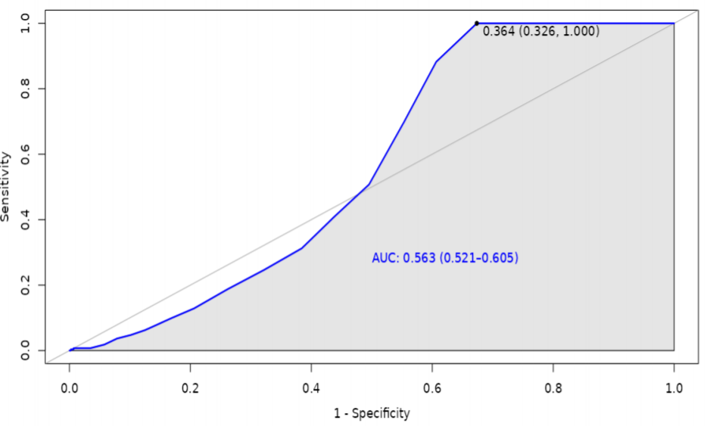

Supplementary table 2 Demographic properties of the two groups （n=1007）
Variable | Total (n = 1007) | NC (n = 606) | MCI (n = 401) | Statistic | P
Center, n (%) |  |  |  | χ²=93.421 | <0.001
Wuchang | 459 (45.58) | 351 (57.92) | 108 (26.93)
Hongshan | 548 (54.42) | 255 (42.08) | 293 (73.07)
Age, Mean ± SD | 71.19 ± 4.85 | 71.14 ± 4.95 | 71.26 ± 4.70 | t=-0.368 | 0.713
Sex, n (%) |  |  |  | χ²=1.542 | 0.214
male | 408 (40.52) | 255 (42.08) | 153 (38.15)
female | 599 (59.48) | 351 (57.92) | 248 (61.85)
Education, n (%) |  |  |  | χ²=6.565 | 0.161
illiterate/semi-illiterate | 35 (3.48) | 23 (3.80) | 12 (2.99)
primary school | 119 (11.82) | 70 (11.55) | 49 (12.22)
junior high school | 336 (33.37) | 187 (30.86) | 149 (37.16)
technical secondary school/high school | 324 (32.17) | 198 (32.67) | 126 (31.42)
college degree or above | 193 (19.17) | 128 (21.12) | 65 (16.21)
Marriage, n (%) |  |  |  | χ²=0.314 | 0.855
married | 810 (80.44) | 484 (79.87) | 326 (81.30)
unmarried/widowed/divorced | 184 (18.27) | 114 (18.81) | 70 (17.46)
unknown | 13 (1.29) | 8 (1.32) | 5 (1.25)
Living, n (%) |  |  |  | χ²=0.274 | 0.600
alone | 99 (9.83) | 62 (10.23) | 37 (9.23)
not alone | 908 (90.17) | 544 (89.77) | 364 (90.77)
Job, n (%) |  |  |  | χ²=54.105 | <0.001
manual | 642 (63.75) | 332 (54.79) | 310 (77.31)
mental | 289 (28.7) | 221 (36.47) | 68 (16.96)
uncertain | 76 (7.55) | 53 (8.75) | 23 (5.74)
Income, n (%) |  |  |  | χ²=6.170 | 0.013
below￥4000 per month | 657 (65.24) | 377 (62.21) | 280 (69.83)
over ￥4000 per month | 350 (34.76) | 229 (37.79) | 121 (30.17)

