Table 1 | Optimization of catalytic depolymerizationª
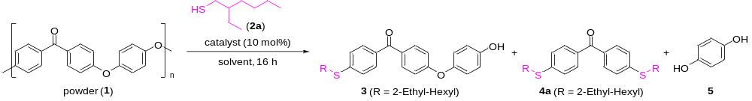
Entry | 2a (equiv.) | Catalyst | Solvent | Temp. (ºC) | 3 (%) | 4a (%) | 5 (%)
1 | 2 | KOH | DMI | 150 | 17 | 41 | 41
2 | 2 | K₃PO₄ | DMI | 150 | 12 | 54 | 56
3 | 2 | KOtBu | DMI | 150 | 12 | 62 | 62
4 | 2 | Cs₂CO₃ | DMI | 150 | 13 | 67 | 67
5 | 2 | DBU | DMI | 150 | 10 | 3 | 3
6 | 2 | P₁-tBu-TP | DMI | 150 | 7 | 2 | 1
7 | 2 | P₂-tBu | DMI | 150 | 14 | 61 | 66
8 | 2 | P₄-tBu | DMI | 150 | 16 | 67 | 72
9 | 2.5 | P₄-tBu | DMI | 150 | 7 | 74 | 73
10 | 2.5 | P₄-tBu (5 mol%) | DMI | 150 | 12 | 58 | 58
11 | 2.5 | P₄-tBu | DMI | 120 | 11 | 50 | 45
12 | 2.5 | P₄-tBu | DMI | 100 | 12 | 37 | 31
13 | 2.5 | P₄-tBu | PhCN | 150 | 28 | 32 | 12
14 | 2.5 | P₄-tBu | Xylene | 150 | 19 | 11 | 2
15 | 2.5 | P₄-tBu | DMAc | 150 | - | 95 | 84
16 | 2.5 | P₄-tBu + K₃PO₄ (5 mol%) | DMAc | 150 | - | >99 (85) | >99 (61)
ª A mixture of 1 (powder, 0.1 mmol relative to the molecular weight of the monomer), thiol (0.2 mmol for entries 1-8, 0.25 mmol for entries 9-16), catalyst (0.01 mmol), and solvent (0.2 mL) was stirred for 16 h. Yields were determined by ¹H NMR. Numbers in parentheses are isolated yields.

Table 2 | Scope or catalytic depolymerization of super engineering plasticsª
Entry | Polymer | Products^{b}
 | 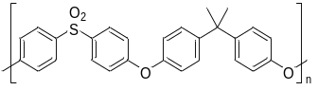 | 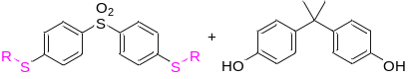
1 | PSU, pellet (M_{w} 35000, M_{n} 16000) (6) | 7a, 89% 8, 94%
2 | PSU, pellet (M_{w} 60000) (6’) | 7a, 99% 8, >99%
3 | 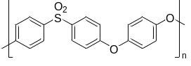  PEES, pellet (-) (9) | 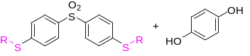  7a, >99% 5, 80%
4 | 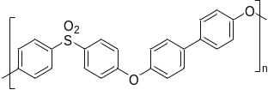  PPSU, powder (-) (10) | 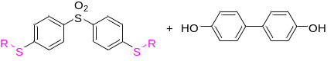  7a, 95% 11, >99%
5^{b} | 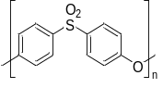  PESU, pellet (-) (12) | 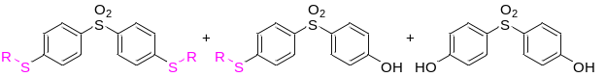  7a, 22% 13, 21% 14, 13%
6 | 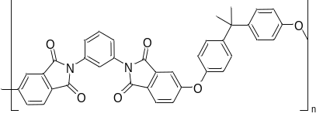  PEI, pellet (-) (15) | 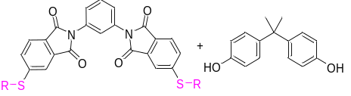  16, 75% 8, >99%
ª A mixture of polymer (0.1 mmol relative to the molecular weight of the monomer), thiol (0.25 mmol), P₄-tBu (0.01 mmol), K₃PO₄ (0.005 mmol) and DMAc (0.2 mL) was stirred for 16 h at 150 ºC. Isolated yields are shown. ^{b} 4-((4-(4-((4-((2-Ethylhexyl)thio)phenyl)- sulfonyl)phenoxy)phenyl)sulfonyl)phenol was obtained in 15% yield.

