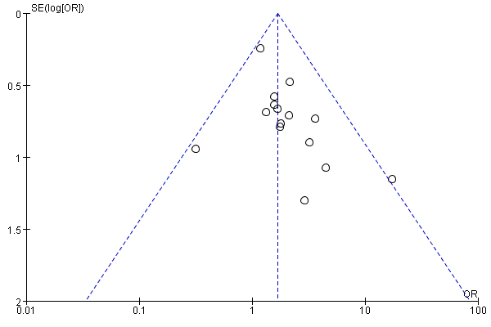
Supplementary Figure 1 – the funnel plot for meta-analysis of the proportion of Gleason scores ≥8 between the group of AR-V7-positive and negative CRPC
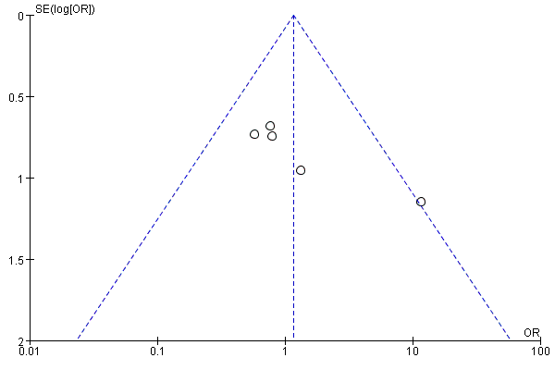
Supplementary Figure 2A – the funnel plot for meta-analysis of the proportion of T3/T4 stage between the group of AR-V7-positive and negative CRPC
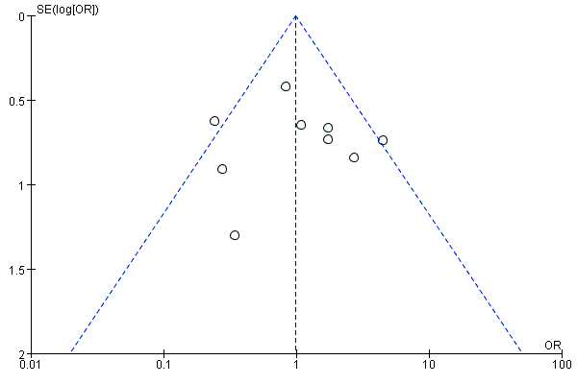
Supplementary Figure 2B – the funnel plot for meta-analysis of the proportion of N1 stage between the group of AR-V7-positive and negative CRPC
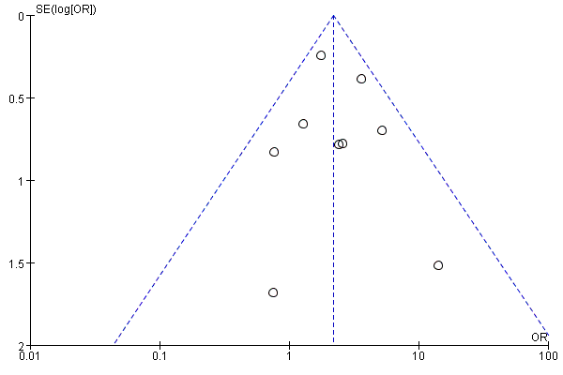
Supplementary Figure 3 A – the funnel plot for meta-analysis of the proportion of any site metastasis between the group of AR-V7-positive and negative CRPC
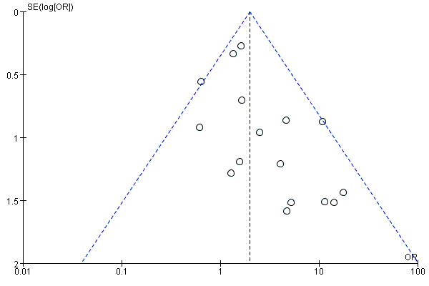
Supplementary Figure 3 B – the funnel plot for meta-analysis of the proportion of bone metastasis between the group of AR-V7-positive and negative CRPC
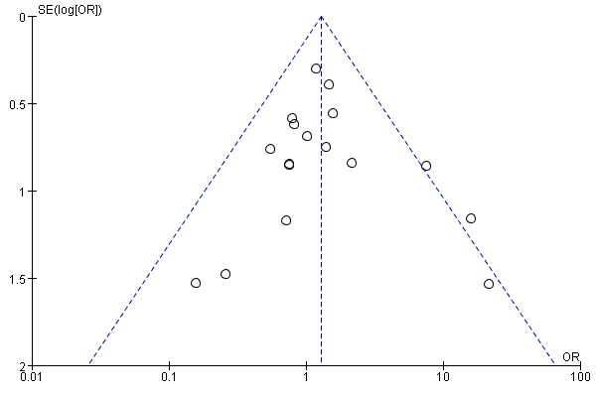
Supplementary Figure 3C – the funnel plot for meta-analysis of the proportion of visceral metastasis between the group of AR-V7-positive and negative CRPC
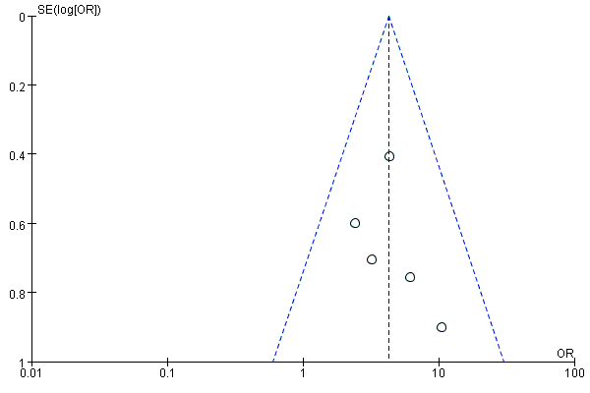
Supplementary Figure 4A – the funnel plot for meta-analysis of the proportion of pain sufferance between the group of AR-V7-positive and negative CRPC
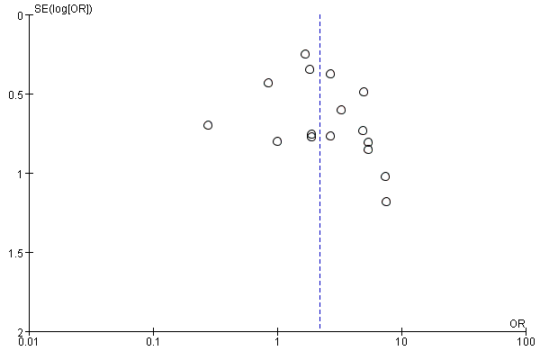
Supplementary Figure 4B – the funnel plot for meta-analysis of the proportion of ECOG score ≥1 between the group of AR-V7-positive and negative CRPC
Supplementary Table 1 – Target specimens and AR-V7 detection assay of studies in the clinicopathological features of different AR-V7 status CRPC meta-analysis.
Study | Target specimens | AR-V7 detection assay
Antonarakis(1) | CTC mRNA | CTC analyses were conducted using the commercially-available AlereTM CTC AdnaTest platform (AdnaGen, Langenhagen, Germany)
Antonarakis(2) | CTC mRNA | CTC analyses were conducted using a modified AdnaTest platform (QIAGEN, Hannover, Germany)
Nakazawa(3) | CTC mRNA | AdnaTest platform for CTC analysis. CTCs were enriched from peripheral blood using the ProstateCancerSelect kit, mRNA expression analysis was conducted using the ProstateCancerDetect kit.
Sharp(4) | IHC on FFPE PC patient tissue biopsies | A recombinant rabbit monoclonal antibody(Clone RM7) was developed against CE3 of AR-V7. Patients baseline characteristics and clinical outcomes were compared by positive(nuclear AR-V7 HS > 10) or negative (nuclear AR-V7 HS ≤ 10) AR-V7 status
Zadra(5) | Immuno-fluorescence staining of mCRPC tissue | The slides were incubated with antibodies against ARV7 (Clone RM7, 31-1109-00, RevMAb Biosciences, dilution 1: 300)
Antonarakis(6) | CTC mRNA | The CTC analyses were conducted using a modification of the commercially available AdnaTest platform (Qiagen)
Sieuwerts(7) | CTC mRNA | CellSearch-enriched CTCs were subjected to RNA isolation using the AllPrep DNA/RNA Micro Kit (Qiagen, Hilden, Germany)
Del Re (8) | plasma-derived exosomal RNA | The analysis of AR-V7 in RNA was performed by ddPCR using the One-Step RT-ddPCR kit, Exosomes were isolated and RNA extracted for analysis of AR-V7 by ddPCR.
Takeuchi T.(9) | Whole blood RNA | Total RNA was extracted from 0.4 mL of whole blood using oligo dT primer and a DNA Extractor® WB-Rapid Kit (Wako Pure Chemical Industries, Ltd, Osaka, Japan).
Lee(10) | Immunofluorescent Staining, Immunohistochemistry of PCa Tissues | Immunofluorescent staining for AR-V7 was performed. The secondary antibody was an Alexa Fluor 488-conjugated goat anti-rabbit antibody (Invitrogen)
Wang(11) | CTC mRNA | Total RNA of CTCs was extracted using the RNAprep pure Tissue Kit (QIAGEN, USA).
Tagawa (12) | CTC mRNA | Total RNA was extracted from the enriched CTCs pool using the RNAeasy Plus Micro kit (Qiagen)
Steinestel (13) | CTC mRNA | For CTC isolation, we employed the AdnaTest ProstateCancerSelect Kit (AdnaGen, Langenhagen, Germany).
Onstenk (14) | CTC mRNA | CTCs were enumerated from 7.5 ml blood drawn in a CellSave tube using the CellSearch System (Janssen Diagnostics LLC, Raritan, NJ, USA).
Zhang (15) | Tissue RNA | Total tissue RNA was isolated from minced fresh tissue usingTrizol reagent (Invitrogen) according to the manufacturer’s instructions.
Saylor (16) | RISH in FFPE tissues | The AR-V7 RNA ISH probe was designed to target the unique cryptic exon CE3 as identified in the NCBI nucleotide database, using multiple tiling probes.
Belderbos (17) | CTC mRNA | CTC enrichment occurred from 7.5 mL of peripheral blood using the CellSearch System.
Cattrini (18) | CTC mRNA | CTC were isolated by immuno-magnetic beads with an EpCAM-based method (AdnaTest Prostate Cancer Select)
Taplin (19) | CTC mRNA | CTC-based AR-V7 clinical trial assay utilized modification of the methods reported by Antonarakis
Sharp (20) | CTC mRNA | Isolation and enrichment of CTCs from mCRPC patient peripheral blood (PB) draws were carried out using the AdnaTest ProstateCancerSelect (Qiagen, Hilden, Germany)
Maillet (21) | CTC mRNA | The CTC enrichment procedure was using the AdnaTest platform(Qiagen)
Okegawa (22) | CTC mRNA | CTC cells were made for On-chip multi-imaging flow cytometry system. The test was adapted for detectionof AR-V7bypolymerase chain reaction (PCR)using custom primers specific for AR-V7
Chung (23) | CTC mRNA | The CTC isolation and mRNA recovery methods are described inour previous study reported by Antonarakis
El-Heliebi (24) | CTC immuno-fluorescence staining | CTCs were enriched from EDTA blood using the size-dependent, label-free Parsortix system (ANGLE plc)
FFPE=formalin fixed paraffin embedded tissue, RRP= radical prostatectomy, TURP= transurethral resection of prostate, RNA ISH = RNA in situ hybridization, qRT-PCR= Quantitative real-time polymerase chain reaction, CTC = circulating tumor cell

1. Antonarakis ES, Lu C, Wang H, et al. AR-V7 and resistance to enzalutamide and abiraterone in prostate cancer. The New England journal of medicine. 2014;371(11):1028-38. Epub 2014/09/04.
2. Antonarakis ES, Lu C, Luber B, et al. Clinical Significance of Androgen Receptor Splice Variant-7 mRNA Detection in Circulating Tumor Cells of Men With Metastatic Castration-Resistant Prostate Cancer Treated With First- and Second-Line Abiraterone and Enzalutamide. Journal of clinical oncology : official journal of the American Society of Clinical Oncology. 2017:JCO2016701961. Epub 2017/04/07.
3. Nakazawa M, Lu C, Chen Y, et al. Serial blood-based analysis of AR-V7 in men with advanced prostate cancer. Annals of oncology : official journal of the European Society for Medical Oncology / ESMO. 2015;26(9):1859-65. Epub 2015/06/29.
4. Sharp A, Coleman I, Yuan W, et al. Androgen receptor splice variant-7 expression emerges with castration resistance in prostate cancer. The Journal of clinical investigation. 2019;129(1):192-208. Epub 2018/10/20.
5. Zadra G, Ribeiro CF, Chetta P, et al. Inhibition of de novo lipogenesis targets androgen receptor signaling in castration-resistant prostate cancer. Proceedings of the National Academy of Sciences of the United States of America. 2019;116(2):631-40. Epub 2018/12/24.
6. Antonarakis ES, Lu C, Luber B, et al. Androgen Receptor Splice Variant 7 and Efficacy of Taxane Chemotherapy in Patients With Metastatic Castration-Resistant Prostate Cancer. JAMA oncology. 2015;1(5):582-91. Epub 2015/07/17.
7. Sieuwerts AM, Onstenk W, Kraan J, et al. AR splice variants in circulating tumor cells of patients with castration-resistant prostate cancer: relation with outcome to cabazitaxel. Mol Oncol. 2019;13(8):1795-807. Epub 2019/06/11.
8. Del Re M, Biasco E, Crucitta S, et al. The Detection of Androgen Receptor Splice Variant 7 in Plasma-derived Exosomal RNA Strongly Predicts Resistance to Hormonal Therapy in Metastatic Prostate Cancer Patients. European urology. 2017;71(4):680-7. Epub 2016/10/14.
9. Takeuchi T, Okuno Y, Hattori-Kato M, Zaitsu M, Mikami K. Detection of AR-V7 mRNA in whole blood may not predict the effectiveness of novel endocrine drugs for castration-resistant prostate cancer. Research and reports in urology. 2016;8:21-5. Epub 2016/02/13.
10. Lee CH, Ku JY, Ha JM, et al. Transcript Levels of Androgen Receptor Variant 7 and Ubiquitin-Conjugating Enzyme 2C in Hormone Sensitive Prostate Cancer and Castration-Resistant Prostate Cancer. The Prostate. 2017;77(1):60-71. Epub 2016/08/24.
11. Wang S, Yang S, Nan C, Wang Y, He Y, Mu H. Expression of Androgen Receptor Variant 7 (AR-V7) in Circulated Tumor Cells and Correlation with Drug Resistance of Prostate Cancer Cells. Med Sci Monit. 2018;24:7051-6. Epub 2018/10/05.
12. Tagawa ST, Antonarakis ES, Gjyrezi A, et al. Expression of AR-V7 and ARv(567es) in Circulating Tumor Cells Correlates with Outcomes to Taxane Therapy in Men with Metastatic Prostate Cancer Treated in TAXYNERGY. Clinical cancer research : an official journal of the American Association for Cancer Research. 2019;25(6):1880-8. Epub 2018/10/12.
13. Steinestel J, Luedeke M, Arndt A, et al. Todenhofer T,Detecting predictive androgen receptor modifications in circulating prostate cancer cells. Oncotarget. 2015. Epub 2015/05/15.
14. Onstenk W, Sieuwerts AM, Kraan J, et al. Efficacy of Cabazitaxel in Castration-resistant Prostate Cancer Is Independent of the Presence of AR-V7 in Circulating Tumor Cells. European urology. 2015;68(6):939-45. Epub 2015/07/21.
15. Zhang X, Morrissey C, Sun S, et al. Androgen receptor variants occur frequently in castration resistant prostate cancer metastases. PloS one. 2011;6(11):e27970. Epub 2011/11/25.
16. Saylor PJ, Lee RJ, Arora KS, et al. Branched chain RNA in situ hybridization for androgen receptor splice variant AR-V7 as a prognostic biomarker for metastatic castration-sensitive prostate cancer. Clinical cancer research : an official journal of the American Association for Cancer Research. 2016. Epub 2016/07/22.
17. Belderbos BPS, Sieuwerts AM, Hoop EO, et al. Associations between AR-V7 status in circulating tumour cells, circulating tumour cell count and survival in men with metastatic castration-resistant prostate cancer. European journal of cancer (Oxford, England : 1990). 2019;121:48-54. Epub 2019/09/23.
18. Cattrini C, Rubagotti A, Zinoli L, et al. Role of Circulating Tumor Cells (CTC), Androgen Receptor Full Length (AR-FL) and Androgen Receptor Splice Variant 7 (AR-V7) in a Prospective Cohort of Castration-Resistant Metastatic Prostate Cancer Patients. Cancers (Basel). 2019;11(9). Epub 2019/09/22.
19. Taplin ME, Antonarakis ES, Ferrante KJ, et al. Androgen Receptor Modulation Optimized for Response-Splice Variant: A Phase 3, Randomized Trial of Galeterone Versus Enzalutamide in Androgen Receptor Splice Variant-7-expressing Metastatic Castration-resistant Prostate Cancer. European urology. 2019. Epub 2019/09/23.
20. Sharp A, Welti JC, Lambros MBK, et al. Clinical Utility of Circulating Tumour Cell Androgen Receptor Splice Variant-7 Status in Metastatic Castration-resistant Prostate Cancer. European urology. 2019. Epub 2019/05/01.
21. Maillet D, Allioli N, Peron J, et al. Improved Androgen Receptor Splice Variant 7 Detection Using a Highly Sensitive Assay to Predict Resistance to Abiraterone or Enzalutamide in Metastatic Prostate Cancer Patients. Eur Urol Oncol. 2019. Epub 2019/11/05.
22. Okegawa T, Ninomiya N, Masuda K, Nakamura Y, Tambo M, Nutahara K. AR-V7 in circulating tumor cells cluster as a predictive biomarker of abiraterone acetate and enzalutamide treatment in castration-resistant prostate cancer patients. The Prostate. 2018;78(8):576-82. Epub 2018/03/07.
23. Chung JS, Wang Y, Henderson J, et al. Circulating Tumor Cell-Based Molecular Classifier for Predicting Resistance to Abiraterone and Enzalutamide in Metastatic Castration-Resistant Prostate Cancer. Neoplasia (New York, NY). 2019;21(8):802-9. Epub 2019/07/06.
24. El-Heliebi A, Hille C, Laxman N, et al. In Situ Detection and Quantification of AR-V7, AR-FL, PSA, and KRAS Point Mutations in Circulating Tumor Cells. Clin Chem. 2018;64(3):536-46. Epub 2018/01/06.

