Supplementary materials
Figure S1. Characterization of DFCs. 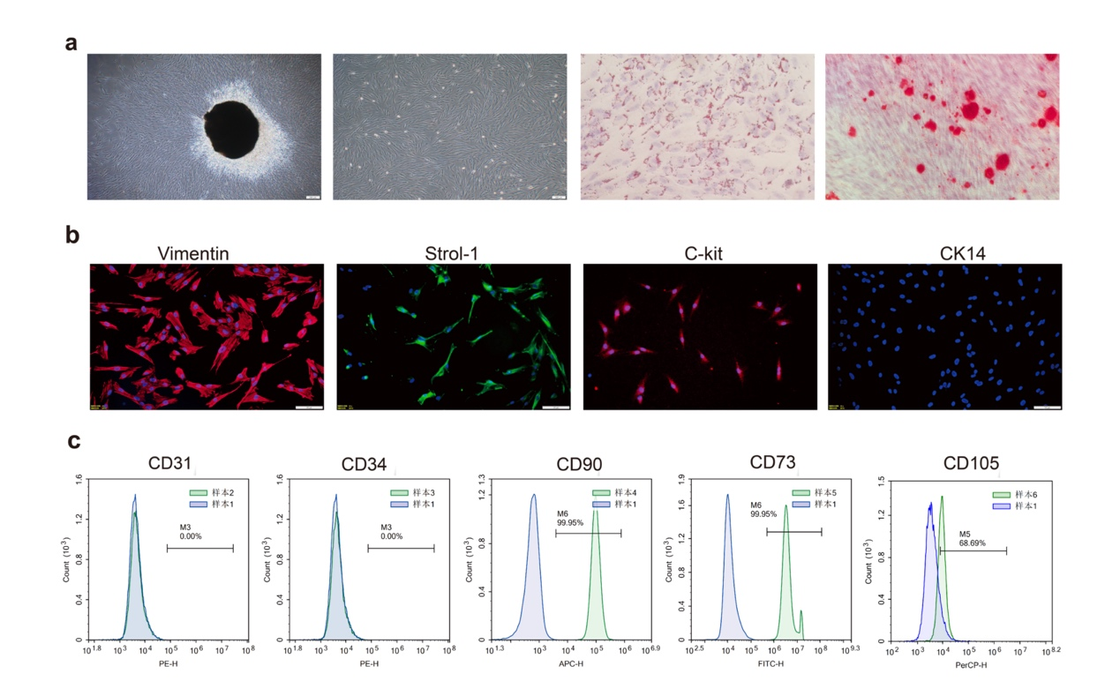
(a)After dental follicle tissue culture for 3 days, polygonal cells spread out in the culture flask. P3 generation cells were polygonal - shaped. Mineralized nodules and lipid droplets were found when DFCs were cultured in osteogenic or adipogenic medium respectively. (b) DFCs were positive for Vimentin、STRO-1 and C-Kit and negative for CK14. (c) Flow cytometric analyses showed that DFCs were positive for CD73 and CD90 and negative for CD31 and CD34. The experiments were performed in triplicates.
Figure S2. Nrf2 knockdown on DFCs.
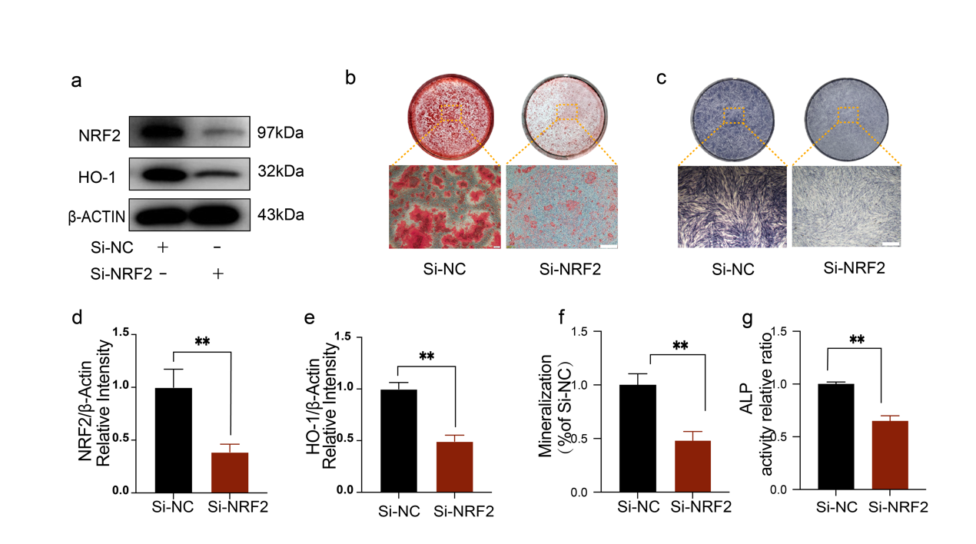
(a) Western blot showing the protein levels of NRF2 and HO-1 in DFCs transfected with siNRF2 and siNC. (b) ARS and (c) and ALP after Nrf2 knockdown. Scale bar =500 μm. The histograms represent the expression of NRF2(d) and HO-1(e). Histograms showing the quantification of mineralization (f) and ALP activity (g) after Nrf2 knockdown.

Figure S3. Construction of xenogeneic bio-root.
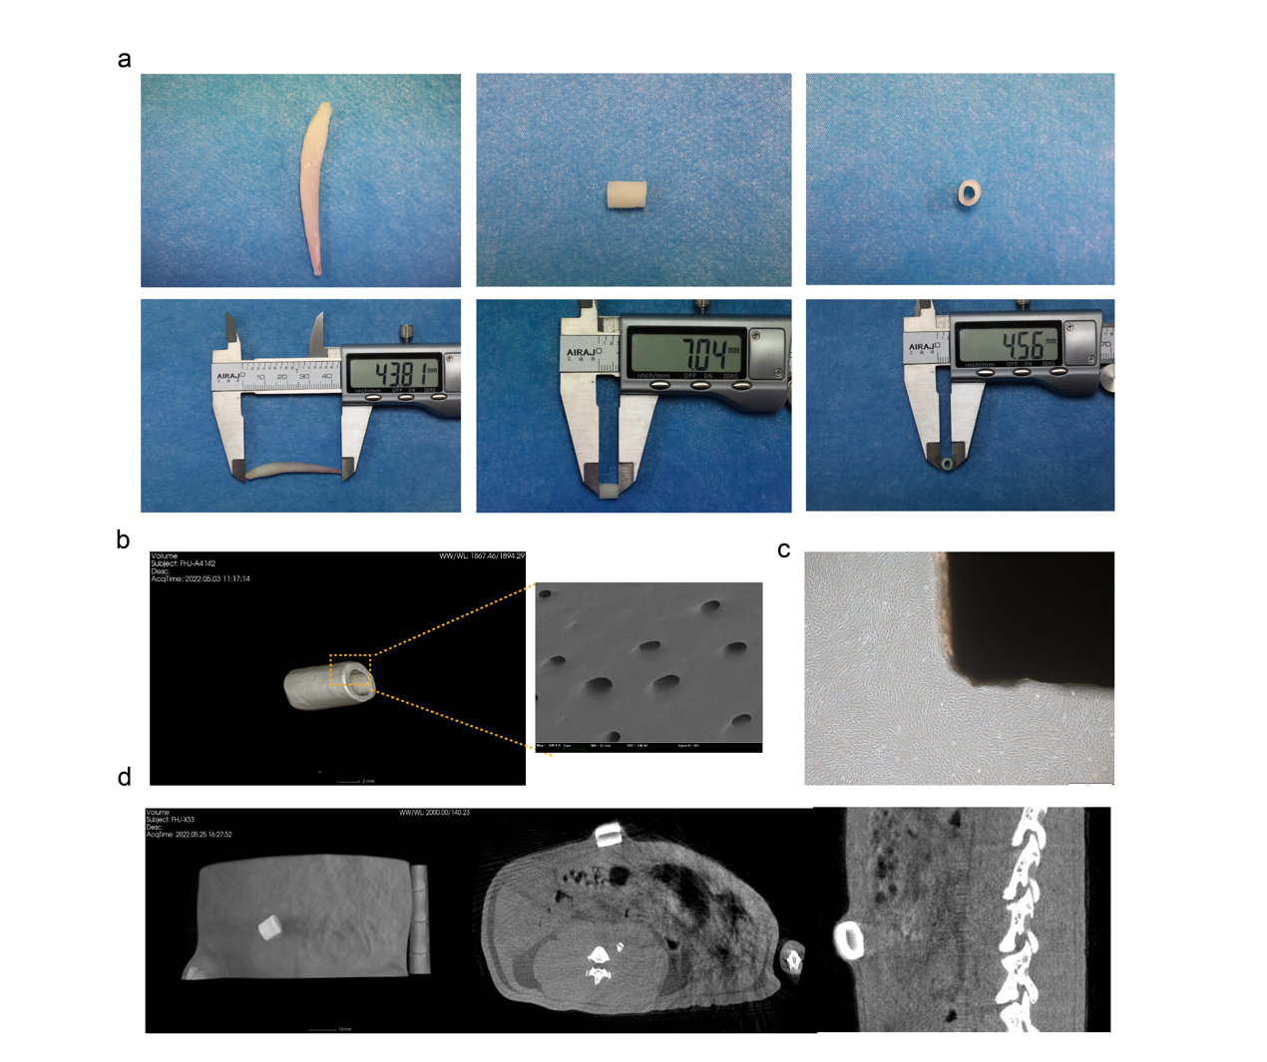
(a)The fabricated xECM with an internal diameter of 4 mm and a height of 5–7 mm. (b) SEM appearance of xECM demonstrating exposed dentinal tubules. (c) Microscopic appearance show that xenogeneic bio-root complex was constructed in vitro with abundantly rDFCs covering over xECM surface at high density on day 7. (d) micro-CT showed that the xenogeneic root was located subcutaneously in the abdomen of the rat.

