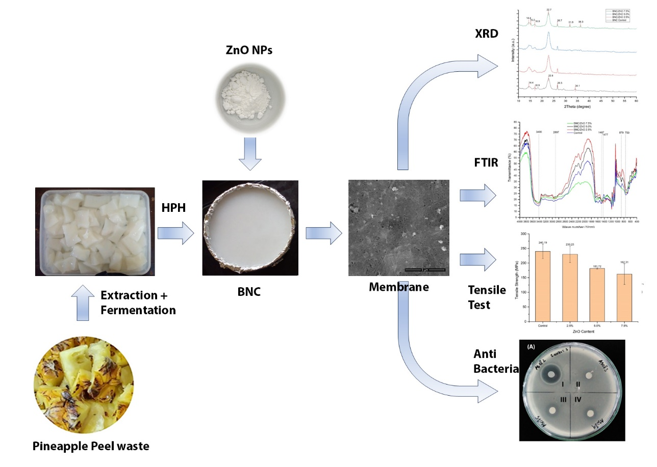
Graphical abstract: Utilization of Pineapple peel waste as nanocomposite membrane with ZnO reinforcement

