Ultra efficient removal of heavy-metal ions and dyes using a novel cellulose-based three-dimensional network

Nan Nan Xia*, Qin Wu, Shi Lin Bi

State Key Laboratory of Biobased Material and Green Papermaking, Key Laboratory of Pulp & Paper Science and Technology of Shandong Province/Ministry of Education, Qilu University of Technology (Shandong Academy of Sciences), Jinan 250353, China

*Correspondence: xianan00001@126.com (N N. X).

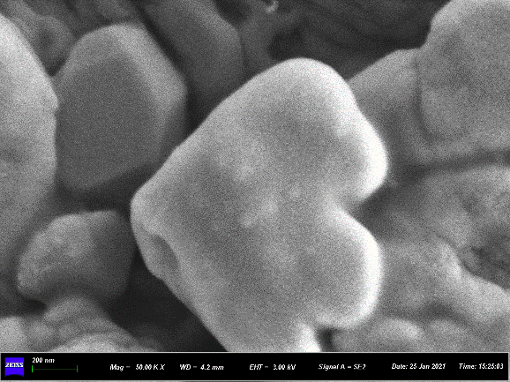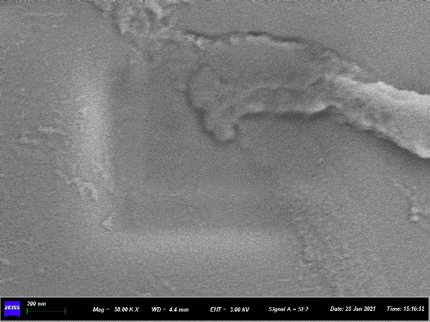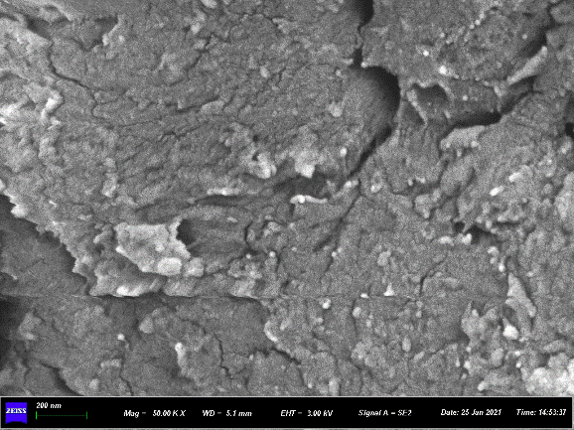
b
200nm
c
200nm
a
200nm
Fig. S1 SEM images of (a) CMC, (b) CPAM, and (c) TA.

Table S1 Pseudo-first-order and pseudo-second-order kinetic model parameters for the adsorption of Cu(II) ions and RhB over CMC–CPAM–TA.
Materials | Pseudo-first-order model |  |  | Pseudo-second-order model
Materials | q_{e} | K₁ | R² | q_{e} | K₂ | R²
Cu | 181.144 | 0.21087 | 0.60804 | 189.922 | 0.00192 | 0.90952
RhB | 146.68 | 0.0646 | 0.72317 | 158.89167 | 6.27555E-4 | 0.91244

Table S2 Langmuir and Freundlich isotherm constants for the adsorption of Cu(II) ions and RhB over CMC–CPAM–TA.
Material | Langmuir constants |  |  | Freundlich constants
 | b (L/mg) | q_{m} (mg/g) | R² | n | K_{f} | R²
Cu(II) ions | 0.00095025 | 669.8 | 0.9996 | 1.3944 | 2.4472 | 0.9943
Rhodamine B | 0.00518 | 202.15 | 0.9807 | 2.7301 | 14.574 | 0.9220

Table S3 Maximum adsorption capacities of different cellulose-based materials for Cu(II) ions.
Adsorbent | Modification (binding functional group) | Capacity (mg/g) | Reference
Cellulose hydrogel | Gelatin | 28.4 | (Teow Y H et al., 2018)
Mercerized cellulose | Succinic anhydride | 30.4 | (Gurgel L V et al., 2008)
Cellulose | Polyethyleneimine and  Ethylenediamine | 35.0 | (Huang Z et al., 2018)
Cellulose | Containing thiol (–SH), carboxyl (–COOH), and imine (–C=N) groups | 36.0 | (Zeng H et al., 2023)
Bacterial cellulose | Diethylenetriamine | 43.2 | (Shen W et al., 2009)
Cellulose nanofiber-based aerogel | Polyphenol-substance tannic acid | 47.6 | (Ji Y et al., 2020)
Cellulose nanofiber membranes | Thiol | 49.0 | (Choi H Y et al., 2020)
Dialdehyde cellulose | Guanyl thiosemicarbazide | 50.0 | (Akl M A et al., 2023)
Cellulose aerogel | magnetic MnFe₂O₄ | 63.3 | (Cui S et al., 2017)
Cellulose | Fe₃O₄ nanoparticles and chitosan | 65.8 | (Peng S et al., 2014)
Succinylated mercerized cellulose | Triethylenetetramine | 69.4 | (Gurgel L V A and L F Gil, 2009)
Cellulose | Guanyl | 83.0 | (Kenawy I M et al., 2018)
Corn straw | Polyethyleneimine | 85.5 | (Zhu C et al., 2023)
Mercerized sugarcane bagasse | EDTA dianhydride | 92.6 | (Júnior O K et al., 2009)
Carboxymethyl cellulose | Polyacrylamide | 99.0 | (Godiya C B et al., 2019)
Carboxymethyl cellulose sodium | Polyvinyl alcohol and cellulose nanocrystals | 109.9 | (Wang H et al., 2022)
Cellulose hydrogels | Epichlorohydrin (ECH) crosslinked | 119.0 | (Santoso S P et al., 2022)
Carboxymethyl Cellulose | EDTA and Chitosan | 142.9 | (Manzoor K et al., 2019)
Cellulose hydrogels | Acrylamide/acrylic acid | 157.5 | (Zhao B et al., 2019)
Cellulose | Sodium alginate chemically modified with polyethyleneimine | 177.1 | (Zhan W et al., 2018)
Cellulose | Dibenzo-18-crown 6 | 192.0 | (Fakhre N A and B M Ibrahim, 2018)
Microfibrillated cellulose (MFC) | Aminopropyl-triethoxysilane (APS) | 200.2 | (Hokkanen S et al., 2014)
Carboxymethyl cellulose | sodium sulfonate groups | 200.4 | (Sun Z et al., 2022)
Cellulose hydrogel | Diethylenetriaminepentaacetic acid (DTPA) | 298.6 | (Gao J et al., 2022)
Cellulose aerogels | Coupling brushite and polyethyleneimine (PEI) | 332.7 | (Wang Q et al., 2022)
Cellulose-chitosan composite hydrogel | Amine-bilayer-functionalized | 434.8 | (Godiya C B et al., 2022)
Sugarcane cellulose | Epichlorohydrin as a coupling agent, EDA, and carbon disulfide as reagents. | 446.2 | (Wang F et al., 2017)
Carboxymethyl cellulose | Chitosan nanoparticles, sodium alginate, and hydroxyapatite | 512.8 | (Sasirekha R et al., 2023)

Table S4 Maximum adsorption capacities of different cellulose-based materials for RhB.
Adsorbent | Modification (binding functional group) | Capacity (mg/g) | Reference
Bacterial cellulose | Metal-organic Framework | 2.8 | (Ashour R M et al., 2020)
Raw orange peel | Reduction of chemical oxygen demand | 4.6 | (Oyekanmi A A et al., 2019)
Sodium alginate/hydroxyethyl cellulose | Humic acid | 18.8 | (Shenvi S S et al., 2015)
Carboxymethyl cellulose | Polyacrylamide and copper sulfide | 19.9 | (Zhao H et al., 2022)
Banana peel |  | 20.6 | (Gurusamy Annadurai R-S J, Duu-Jong Lee, 2002)
Garlic peel | Acid oxidation with HNO₃/C₆H₈O₇ | 26.5 | (Zhao Y et al., 2019)
Cellulose | Activated carbon | 33.4 | (Bai Q et al., 2017)
Cellulose | Acid-activated clay | 47.1 | (Kausar A et al., 2021)
Cassava slag biochar | Hydrothermal carbonization treatment | 105.3 | (Wu J et al., 2020)
Cellulose | Magnetic Fe₃O₄ | 151.8 | (Li B et al., 2020)
Cellulose filter membranes | Poly(diallyl dimethyl ammonium chloride) | 182.6 | (Lu S et al., 2018)

Table S5 Elemental analysis of CMC–CPAM–TA before and after adsorption of Cu(II) ions and RhB
Samples | Elements
Samples | C (wt%) | O (wt%) | Cu (wt%)
Before adsorption | 77.52 | 22.48 | 0
Adsorption of Cu | 53.28 | 17.62 | 28.34
Adsorption of RhB | 87.15 | 12.85 | 0

Table S6 Elemental analysis of CMC–CPAM–TA after desorption of Cu(II) ions and RhB
Samples | Elements
Samples | C (wt%) | O (wt%) | Cu (wt%)
Desorption of Cu | 84.89 | 14.87 | 0.24
Desorption of RhB | 81.42 | 18.33 | 0

Reference
Akl MA, El-Zeny AS, Ismail M, Abdalla M, Abdelgelil D, Mostafa AG (2023) Smart guanyl thiosemicarbazide functionalized dialdehyde cellulose for removal of heavy metal ions from aquatic solutions: adsorption characteristics and mechanism study. Appl Water Sci 13(6): 1-18. https://doi.org/10.1007/s13201-023-01948-9
Ashour RM, Abdel-Magied AF, Wu Q, Olsson RT, Forsberg K (2020) Green synthesis of metal-organic framework bacterial cellulose nanocomposites for separation applications. Polymers 12(5):1104. https://doi.org/10.3390/polym12051104
Bai Q, Xiong Q, Li C, Shen Y, Uyama H (2017) Hierarchical porous cellulose/activated carbon composite monolith for efficient adsorption of dyes. Cellulose 24: 4275-4289. https://doi.org/10.1007/s10570-017-1410-y
Choi HY, Bae JH, Hasegawa Y, An S, Kim IS, Lee H, Kim M (2020) Thiol-functionalized cellulose nanofiber membranes for the effective adsorption of heavy metal ions in water. Carbohydr Polym 234: 115881. https://doi.org/10.1016/j.carbpol.2020.115881
Cui S, Wang X, Zhang X, Xia W, Tang X, Lin B, Wu Q, Zhang X, Shen X (2017) Preparation of magnetic MnFe₂O₄-Cellulose aerogel composite and its kinetics and thermodynamics of Cu(II) adsorption. Cellulose 25: 735-75. https://doi.org/10.1007/s10570-017-1598-x
Fakhre NA, Ibrahim BM (2018) The use of new chemically modified cellulose for heavy metal ion adsorption. J Hazard Mater 343: 324-331. https://doi.org/10.1016/j.jhazmat.2017.08.043
Gao J, Zhang L, Liu S, Liu X (2022) Enhanced adsorption of copper ions from aqueous solution by two-step DTPA-modified magnetic cellulose hydrogel beads. Int J Biol Macromol 211: 689-699. https://doi.org/10.1016/j.ijbiomac.2022.05.073
Godiya CB, Cheng X, Li D, Chen Z, Lu X (2019) Carboxymethyl cellulose/polyacrylamide composite hydrogel for cascaded treatment/reuse of heavy metal ions in wastewater. J Hazard Mater 364: 28-38. https://doi.org/10.1016/j.jhazmat.2018.09.076
Godiya CB, Revadekar C, Kim J, Park BJ (2022) Amine-bilayer-functionalized cellulose-chitosan composite hydrogel for the efficient uptake of hazardous metal cations and catalysis in polluted water. J Hazard Mater 436: 129112. https://doi.org/10.1016/j.jhazmat.2022.129112
Gurgel LV, Junior OK, Gil RP, Gil LF (2008) Adsorption of Cu(II), Cd(II), and Pb(II) from aqueous single metal solutions by cellulose and mercerized cellulose chemically modified with succinic anhydride. Bioresour Technol 99: 3077-3083. https://doi.org/10.1016/j.biortech.2007.05.072
Gurgel LVA, Gil LF (2009) Adsorption of Cu(II), Cd(II), and Pb(II) from aqueous single metal solutions by succinylated mercerized cellulose modified with triethylenetetramine. Carbohydr Polym 77: 142-149. https://doi.org/10.1016/j.carbpol.2008.12.014
Gurusamy Annadurai R-SJ, Duu-Jong Lee (2002) Use of cellulose-based wastes for adsorption of dyes from aqueous solutions. J Hazard Mater 92: 263-274. https://doi.org/https://doi.org/10.1016/S0304-3894(02)00017-1
Hokkanen S, Repo E, Suopajärvi T, Liimatainen H, Niinimaa J, Sillanpää M (2014) Adsorption of Ni(II), Cu(II) and Cd(II) from aqueous solutions by amino modified nanostructured microfibrillated cellulose. Cellulose 21: 1471-1487. https://doi.org/10.1007/s10570-014-0240-4
Huang Z, Huang Z, Feng L, Luo X, Wu P, Cui L, Mao X (2018) Modified cellulose by polyethyleneimine and ethylenediamine with induced Cu(II) and Pb(II) adsorption potentialities. Carbohydr Polym 202: 470-478. https://doi.org/10.1016/j.carbpol.2018.08.136
Júnior OK, Gurgel LVA, de Freitas RP, Gil LF (2009) Adsorption of Cu(II), Cd(II), and Pb(II) from aqueous single metal solutions by mercerized cellulose and mercerized sugarcane bagasse chemically modified with EDTA dianhydride (EDTAD). Carbohydr Polym 77: 643-650. https://doi.org/10.1016/j.carbpol.2009.02.016
Ji Y, Wen Y, Wang Z, Zhang S, Guo M (2020) Eco-friendly fabrication of a cost-effective cellulose nanofiber-based aerogel for multifunctional applications in Cu(II) and organic pollutants removal. J Clean Prod 255: 120276. https://doi.org/10.1016/j.jclepro.2020.120276
Kausar A, Shahzad R, Asim S, BiBi S, Iqbal J, Muhammad N, Sillanpaa M, Din IU (2021) Experimental and theoretical studies of Rhodamine B direct dye sorption onto clay-cellulose composite. J Mol Liq 328: 115165. https://doi.org/10.1016/j.molliq.2020.115165
Kenawy IM, Hafez MAH, Ismail MA, Hashem MA (2018) Adsorption of Cu(II), Cd(II), Hg(II), Pb(II) and Zn(II) from aqueous single metal solutions by guanyl-modified cellulose. Int J Biol Macromol 107: 1538-1549. https://doi.org/10.1016/j.ijbiomac.2017.10.017
Li B, Li M, Zhang J, Pan Y, Huang Z, Xiao H (2019) Adsorption of Hg (II) ions from aqueous solution by diethylenetriaminepentaacetic acid-modified cellulose. Int J Biol Macromol 122: 149-156. https://doi.org/10.1016/j.ijbiomac.2018.10.162
Lu S, Tang Z, Li W, Ouyang X, Cao S, Chen L, Huang L, Wu H, Ni Y (2018) Diallyl dimethyl ammonium chloride-grafted cellulose filter membrane via ATRP for selective removal of anionic dye. Cellulose 25: 7261-7275. https://doi.org/10.1007/s10570-018-2052-4
Manzoor K, Ahmad M, Ahmad S, Ikram S (2019) Synthesis, characterization, kinetics, and thermodynamics of EDTA-modified chitosan-carboxymethyl cellulose as Cu(II) ion adsorbent. ACS omega 4: 17425-17437. https://doi.org/10.1021/acsomega.9b02214
Oyekanmi AA, Ahmad A, Hossain K, Rafatullah M (2019) Statistical optimization for adsorption of Rhodamine B dye from aqueous solutions. J Mol Liq 281: 48-58. https://doi.org/10.1016/j.molliq.2019.02.057
Peng S, Meng H, Ouyang Y, Chang J (2014) Nanoporous magnetic cellulose–chitosan composite microspheres: preparation, characterization, and application for Cu(II) adsorption. Ind Eng Chem Res 53: 2106-2113. https://doi.org/10.1021/ie402855t
Santoso SP, Angkawijaya AE, Bundjaja V, Kurniawan A, Yuliana M, Hsieh C-W, Go AW, Cheng K-C, Soetaredjo FE, Ismadji S (2022) Investigation of the influence of crosslinking activation methods on the physicochemical and Cu(II) adsorption characteristics of cellulose hydrogels. J Environ Chem Eng 10: 106971. https://doi.org/10.1016/j.jece.2021.106971
Sasirekha R, Vijayakumar S, Pazhanisamy P, Joseph JJ, Gomathi T (2023) Biosorption of copper (II) ion using chitosan nanoparticles/alginate/carboxymethyl cellulose/novel hydroxyapatite biocomposite from aqueous solution. Mater Today Commun 35: 106339. https://doi.org/10.1016/j.mtcomm.2023.106339
Shen W, Chen S, Shi S, Li X, Zhang X, Hu W, Wang H (2009) Adsorption of Cu(II) and Pb(II) onto diethylenetriamine-bacterial cellulose. Carbohydr Polym 75: 110-114. https://doi.org/10.1016/j.carbpol.2008.07.006
Shenvi SS, Isloor AM, Ismail AF, Shilton SJ, Al Ahmed A (2015) Humic acid based biopolymeric membrane for effective removal of methylene blue and Rhodamine B. Ind Eng Chem Res 54: 4965-4975. https://doi.org/10.1021/acs.iecr.5b00761
Sun Z, Yin Y, An Y, Deng C, Wei Z, Jiang Z, Duan X, Xu X, Chen J (2022) A novel modified carboxymethyl cellulose hydrogel adsorbent for efficient removal of poisonous metals from wastewater: Performance and mechanism. J Environ Chem Eng 10: 108179. https://doi.org/10.1016/j.jece.2022.108179
Teow YH, Kam LM, Mohammad AW (2018) Synthesis of cellulose hydrogel for copper (II) ions adsorption. J Environ Chem Eng 6: 4588-4597. https://doi.org/10.1016/j.jece.2018.07.010
Wang F, Pan Y, Cai P, Guo T, Xiao H (2017) Single and binary adsorption of heavy metal ions from aqueous solutions using sugarcane cellulose-based adsorbent. Bioresour Technol 241: 482-490. https://doi.org/10.1016/j.biortech.2017.05.162
Wang H, Fang S, Zuo M, Li Z, Yu X, Tang X, Sun Y, Yang S, Zeng X, Lin L (2022) Removal of copper ions by cellulose nanocrystal-based hydrogel and reduced adsorbents for its catalytic properties. Cellulose 29: 4525-4537. https://doi.org/10.1007/s10570-022-04547-0
Wang Q, Zuo W, Tian Y, Kong L, Cai G, Zhang H, Li L, Zhang J (2022) Flexible brushite/nanofibrillated cellulose aerogels for efficient and selective removal of copper(II). Chem Eng J 450: 138262. https://doi.org/10.1016/j.cej.2022.138262
Wu J, Yang J, Huang G, Xu C, Lin B (2020) Hydrothermal carbonization synthesis of cassava slag biochar with excellent adsorption performance for Rhodamine B. J Clean Prod 251: 119717. https://doi.org/10.1016/j.jclepro.2019.119717
Zeng H, Su Y, Gong X, Zheng L, Zhang L, Meng P, Zhou Q, Ren J (2023) Competitive adsorption behavior of typical heavy metal ions from acid mine drainage by multigroup-functionalization cellulose: qualitative and quantitative mechanism. Environ Sci Pollut Res Int 30: 68191-68205. https://doi.org/10.1007/s11356-023-27188-7
Zhan W, Xu C, Qian G, Huang G, Tang X, Lin B (2018) Adsorption of Cu(ii), Zn(ii), and Pb(ii) from aqueous single and binary metal solutions by regenerated cellulose and sodium alginate chemically modified with polyethyleneimine. RSC Adv 8: 18723-18733. https://doi.org/10.1039/c8ra02055h
Zhao B, Jiang H, Lin Z, Xu S, Xie J, Zhang A (2019) Preparation of acrylamide/acrylic acid cellulose hydrogels for the adsorption of heavy metal ions. Carbohydr Polym 224: 115022. https://doi.org/10.1016/j.carbpol.2019.115022
Zhao H, Liang ZX, Gao ZZ (2022) Facile preparation of floatable carboxymethyl cellulose-based composite hydrogel for efficient removal of organic dyes. Colloid Interface Sci Commun 49: 100637. https://doi.org/10.1016/j.colcom.2022.100637
Zhao Y, Zhu L, Li W, Liu J, Liu X, Huang K (2019) Insights into enhanced adsorptive removal of Rhodamine B by different chemically modified garlic peels: Comparison, kinetics, isotherms, thermodynamics and mechanism. J Mol Liq 293: 111516. https://doi.org/10.1016/j.molliq.2019.111516
Zhu C, Wang W, Wu Z, Zhang X, Chu Z, Yang Z (2023) Preparation of cellulose-based porous adsorption materials derived from corn straw for wastewater purification. Int J Biol Macromol 233: 123595. https://doi.org/10.1016/j.ijbiomac.2023.123595

