Table 1. Performance of the PPI-Hotspot^{ID} vs. FTMap and SPOTONE
Method | PPI-Hotspot^{ID} | FTMap | SPOTONE | 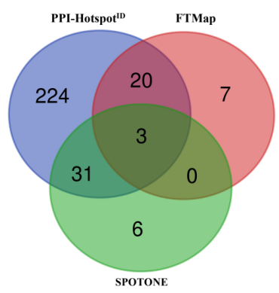
TP | 278 | 30 | 40
FN | 136 | 384 | 374
TN | 417 | 487 | 481
FP | 87 | 17 | 23
Sensitivity | 0.67 | 0.07 | 0.10
Precision | 0.76 | 0.64 | 0.64
F1 | 0.71 (0.66)ª | 0.13 | 0.17
Specificity | 0.83 | 0.97 | 0.95
ªThe F1 score in parentheses corresponds to the validation F1 score.

