Ultrafine Fe₂O₃ nanoparticles encapsulated in the pores of a metal-organic framework for highly efficient electrosynthesis of urea
Da-Shuai Huang,¹ Xiao-Feng Qiu,¹ Jia-Run Huang,¹ Min Mao,⁴ Lingmei Liu,⁴ Yu Han,^{2,3} Pei-Qin Liao,^{*,1} Xiao-Ming Chen¹
¹MOE Key Laboratory of Bioinorganic and Synthetic Chemistry, GBRCE for Functional Molecular Engineering, School of Chemistry, IGCME, Sun Yat-Sen University, Guangzhou, 510275, China.
²Electron Microscopy Center, South China University of Technology, Guangzhou, China.
³School of Emergent Soft Matter, South China University of Technology, Guangzhou, China.
⁴Multi-Scale Porous Materials Center, Institute of Advanced Interdisciplinary Studies & School of Chemistry and Chemical Engineering, Chongqing University, Chongqing, 400044 China.
*E-mail: liaopq3@mail.sysu.edu.cn;

Table of Contents
Supplementary Fig. 1 Structure diagram of γ-Fe₂O₃@Ni-HITP.
Supplementary Fig. 2 PXRD characterization of Ni-HITP and γ-Fe₂O₃@Ni-HITP.
Supplementary Fig. 3 SEM characterization of Ni-HITP and γ-Fe₂O₃@Ni-HITP.
Supplementary Fig. 4 TGA characterization of Ni-HITP and γ-Fe₂O₃@Ni-HITP.
Supplementary Fig. 5 N₂ sorption isotherms at 77 K of Ni-HITP and γ-Fe₂O₃@Ni-HITP.
Supplementary Fig. 6 HR-TEM images of Ni-HITP.
Supplementary Fig. 7 HR-TEM image and EDS of γ-Fe₂O₃@Ni-HITP.
Supplementary Fig. 8 XPS characterization of γ-Fe₂O₃@Ni-HITP.
Supplementary Fig. 9 XAS spectra of Fe K-edge of γ-Fe₂O₃@Ni-HITP.
Supplementary Fig. 10 EXAFS spectra and fitting results of Fe K-edge.
Supplementary Fig. 11 EIS characterization of Ni-HITP and γ-Fe₂O₃@Ni-HITP.
Supplementary Fig. 12 ECSA characterization of Ni-HITP and γ-Fe₂O₃@Ni-HITP.
Supplementary Fig. 13 Gas chromatography measurements of gas products.
Supplementary Fig. 14 Gas chromatography measurements of gas products.
Supplementary Fig. 15 UV-vis measurements of the concentrations of urea.
Supplementary Fig. 16 UV-vis measurements of the concentrations of NH₃.
Supplementary Fig. 17 UV-vis measurements of the concentrations of NO₂⁻.
Supplementary Fig. 18 UV-vis measurements of γ-Fe₂O₃(< 2 nm)@Ni-HITP.
Supplementary Fig. 19 PXRD characterization of as-synthesized γ-Fe₂O₃ nanoparticles.
Supplementary Fig. 20 SEM characterization of γ-Fe₂O₃ nanoparticles.
Supplementary Fig. 21 UV-vis measurements by γ-Fe₂O₃ nanoparticles.
Supplementary Fig. 22 Electrocatalytic co-reduction of CO₂ and NO₃⁻ performance by γ-Fe₂O₃ nanoparticles.
Supplementary Fig. 23 UV-vis measurements by Ni-HITP.
Supplementary Fig. 24 Electrocatalytic co-reduction of CO₂ and NO₃⁻ performance of Ni-HITP.
Supplementary Fig. 25 SEM characterization of γ-Fe₂O₃(24 nm)/Ni-HITP.
Supplementary Fig. 26 UV-vis measurements by γ-Fe₂O₃(24 nm)/Ni-HITP.
Supplementary Fig. 27 Electrocatalytic co-reduction of CO₂ and NO₃⁻ performance of γ-Fe₂O₃(24 nm)/Ni-HITP.
Supplementary Fig. 28 TEM characterization of 7.9 nm γ-Fe₂O₃ nanoparticles encapsulated in Ni-HITP.
Supplementary Fig. 29 UV-vis measurements by 7.9 nm γ-Fe₂O₃ nanoparticles encapsulated in Ni-HITP.
Supplementary Fig. 30 Electrocatalytic co-reduction of CO₂ and NO₃⁻ performance by 7.9 nm γ-Fe₂O₃ nanoparticles encapsulated in Ni-HITP.
Supplementary Fig. 31 TEM characterization of 3.8 nm γ-Fe₂O₃ nanoparticles encapsulated in Ni-HITP.
Supplementary Fig. 32 UV-vis measurements by 3.8 nm γ-Fe₂O₃ nanoparticles encapsulated in Ni-HITP.
Supplementary Fig. 33 Electrocatalytic co-reduction of CO₂ and NO₃⁻ performance by 3.8 nm γ-Fe₂O₃ nanoparticles encapsulated in Ni-HITP.
Supplementary Fig. 34 The relationship between performance for electrosynthesis of urea and particle size of γ-Fe₂O₃ nanoparticles encapsulated in Ni-HITP.
Supplementary Fig. 35 ¹H NMR measurements of the concentrations of urea.
Supplementary Fig. 36 ¹H NMR measurements of urea by γ-Fe₂O₃(< 2 nm)@Ni-HITP as electrocatalyst.
Supplementary Fig. 37 Co-reduction of CO₂ and NO₃⁻ performance comparison of γ-Fe₂O₃(< 2 nm)@Ni-HITP.
Supplementary Fig. 38 Influence of co-existing nitrite on the quantification of urea by diacetyl monoxime method.
Supplementary Fig. 39 ¹H NMR measurements of liquid products.
Supplementary Fig. 40 Electrocatalytic reduction of CO₂ performance by γ-Fe₂O₃(< 2 nm)@Ni-HITP.
Supplementary Fig. 41 UV-vis measurements by γ-Fe₂O₃(< 2 nm)@Ni-HITP.
Supplementary Fig. 42 Electrocatalytic reduction of NO₃⁻ performance of γ-Fe₂O₃(< 2 nm)@Ni-HITP.
Supplementary Fig. 43 XAS spectra of Ni K-edge of γ-Fe₂O₃(< 2 nm)@Ni-HITP.
Supplementary Fig. 44 EXAFS spectra and fitting results of γ-Fe₂O₃(< 2 nm)@Ni-HITP.
Supplementary Fig. 45 Electrocatalytic co-reduction of CO₂and NO₃⁻ performance by a flow cell with a larger window area of 25 cm².
Supplementary Fig. 46 UV-vis measurements by γ-Fe₂O₃(< 2 nm)@Ni-HITP in 1 M KHCO₃ + 0.1 M KNO₃.
Supplementary Fig. 47 Electrocatalytic co-reduction of CO₂ and NO₃⁻ performance of γ-Fe₂O₃(< 2 nm)@Ni-HITP in 1 M KHCO₃ + 0.1 M KNO₃.
Supplementary Fig. 48 Operando ATR-FTIR spectra of γ-Fe₂O₃@Ni-HITP.
Supplementary Fig. 49 UV-vis measurements of urea with CO and NO₃⁻ as feedstocks, respectively.
Supplementary Fig. 50 Schematic illustration of Ni-HHTP and γ-Fe₂O₃@Ni-HHTP.
Supplementary Fig. 51 PXRD characterization of Ni-HHTP and γ-Fe₂O₃@Ni-HHTP.
Supplementary Fig. 52 SEM characterization of Ni-HHTP and γ-Fe₂O₃@Ni-HHTP.
Supplementary Fig. 53 TEM characterization of Ni-HHTP and γ-Fe₂O₃@Ni-HHTP.
Supplementary Fig. 54 XAS spectra of Fe K-edge of γ-Fe₂O₃@Ni-HHTP.
Supplementary Fig. 55 UV-vis measurements by γ-Fe₂O₃@Ni-HHTP.
Supplementary Fig. 56 Electrocatalytic co-reduction of CO₂ and NO₃⁻ performances of Ni-HHTP and γ-Fe₂O₃@Ni-HHTP.
Supplementary Fig. 57 Comparison of the performances for urea electrosynthesis of γ-Fe₂O₃@Ni-HITP with γ-Fe₂O₃@Ni-HHTP.
Supplementary Fig. 58 EXAFS spectra and fitting results of Ni-HITP.
Supplementary Table 1 ICP-AES analysis results.
Supplementary Table 2 EXAFS data fitting results of Fe K-edge of γ-Fe₂O₃@Ni-HITP.
Supplementary Table 3 EXAFS data of three different fitting results of Fe K-edge of γ-Fe₂O₃@Ni-HITP.
Supplementary Table 4 EXAFS data fitting results of Ni K-edge of γ-Fe₂O₃@Ni-HITP.
Supplementary Table 5 EXAFS data fitting results of Fe K-edge of γ-Fe₂O₃@Ni-HHTP.
Supplementary Table 6 Comparison of the performances for co-reduction of CO₂ and NO₃⁻ of reported electrocatalysts.

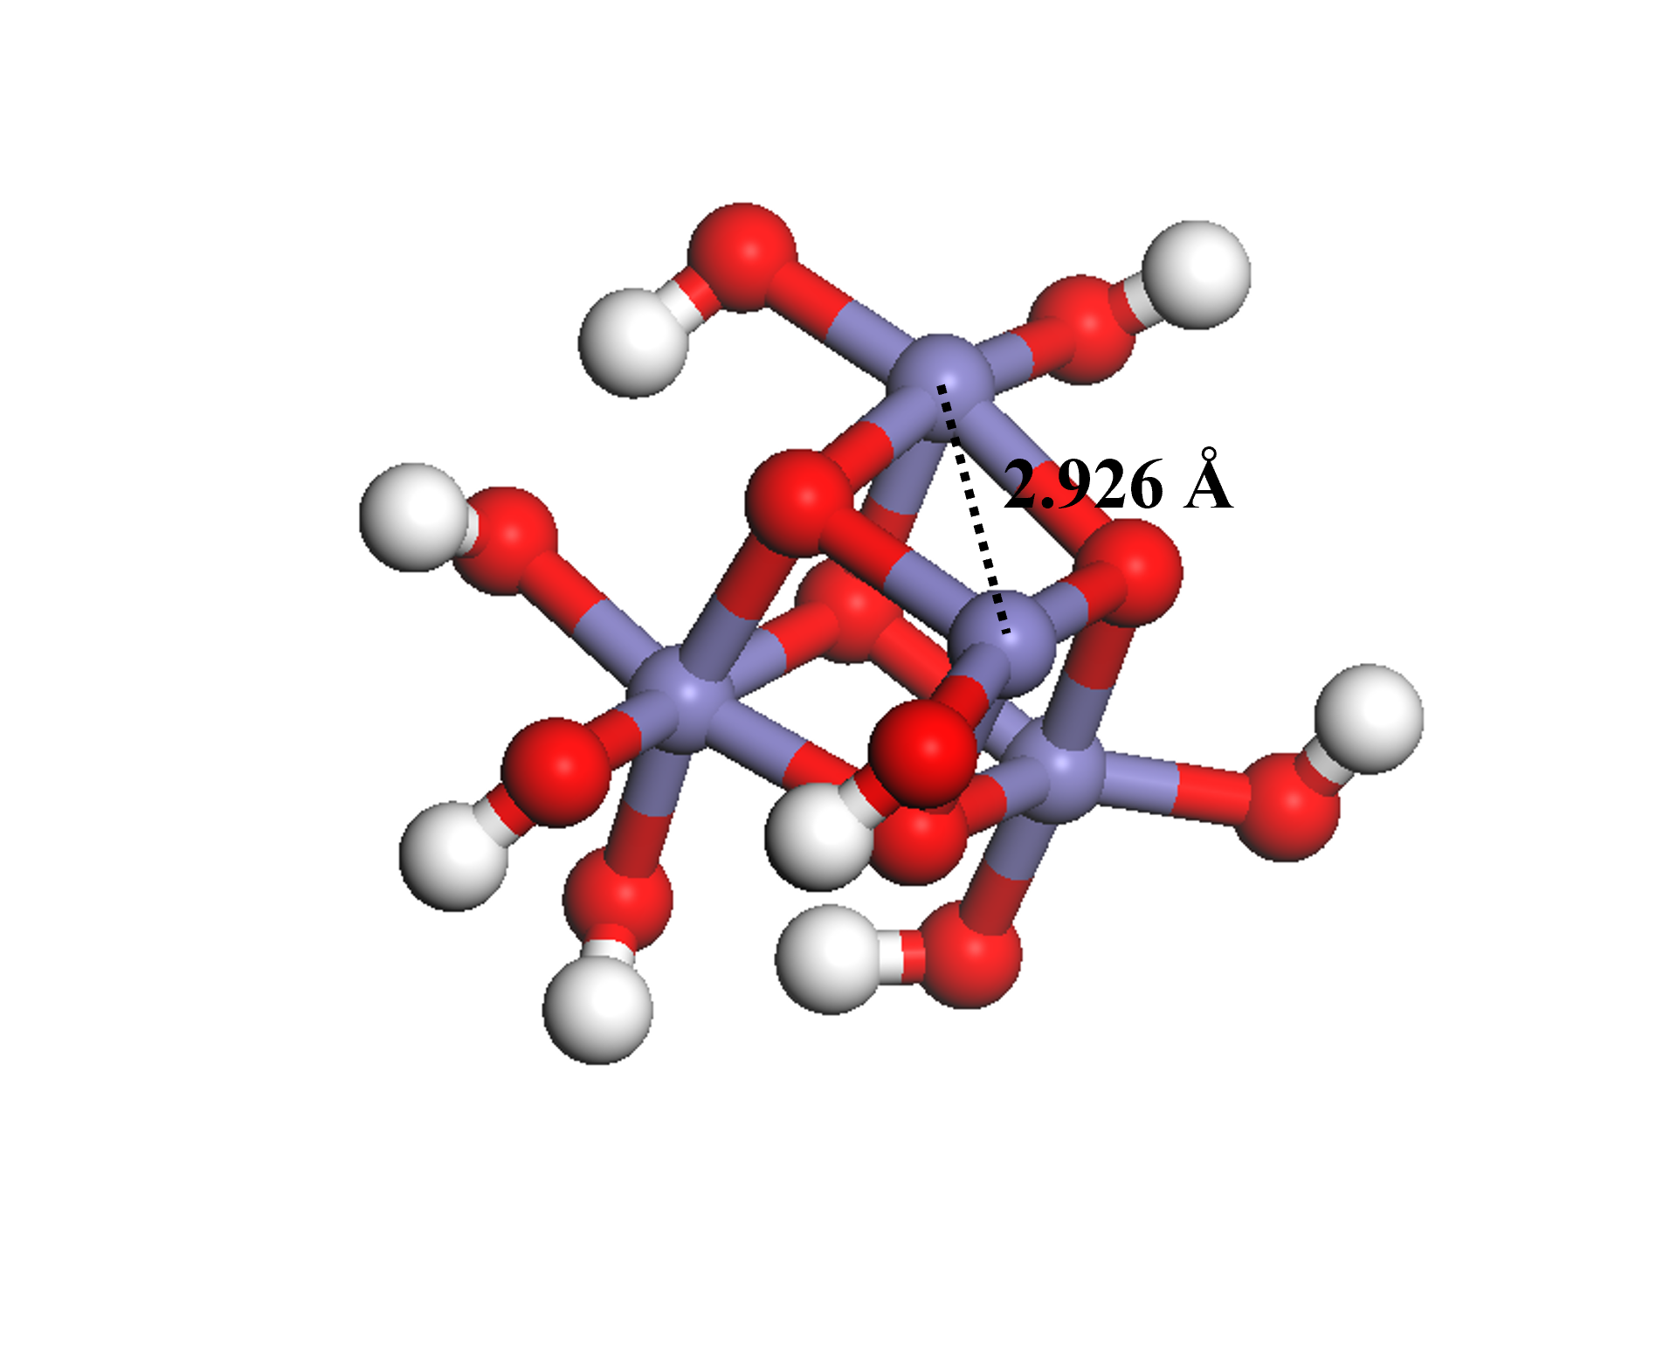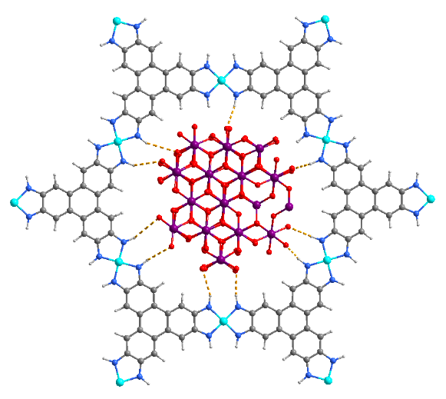
Supplementary Fig. 1 | Structure diagram of γ-Fe₂O₃@Ni-HITP. Two adjacent iron(III) ions in γ-Fe₂O₃ is 2.926 Å (left) and the hydrogen bonds between Ni-HITP and γ-Fe₂O₃ nanoparticles (right). Colour codes: Ni, wathet; Fe, violet; O, red; N, blue; H, grey.

Supplementary Fig. 2 | PXRD characterization of Ni-HITP and γ-Fe₂O₃@Ni-HITP. PXRD patterns of Ni-HITP and γ-Fe₂O₃@Ni-HITP before and after electrocatalysis, respectively.

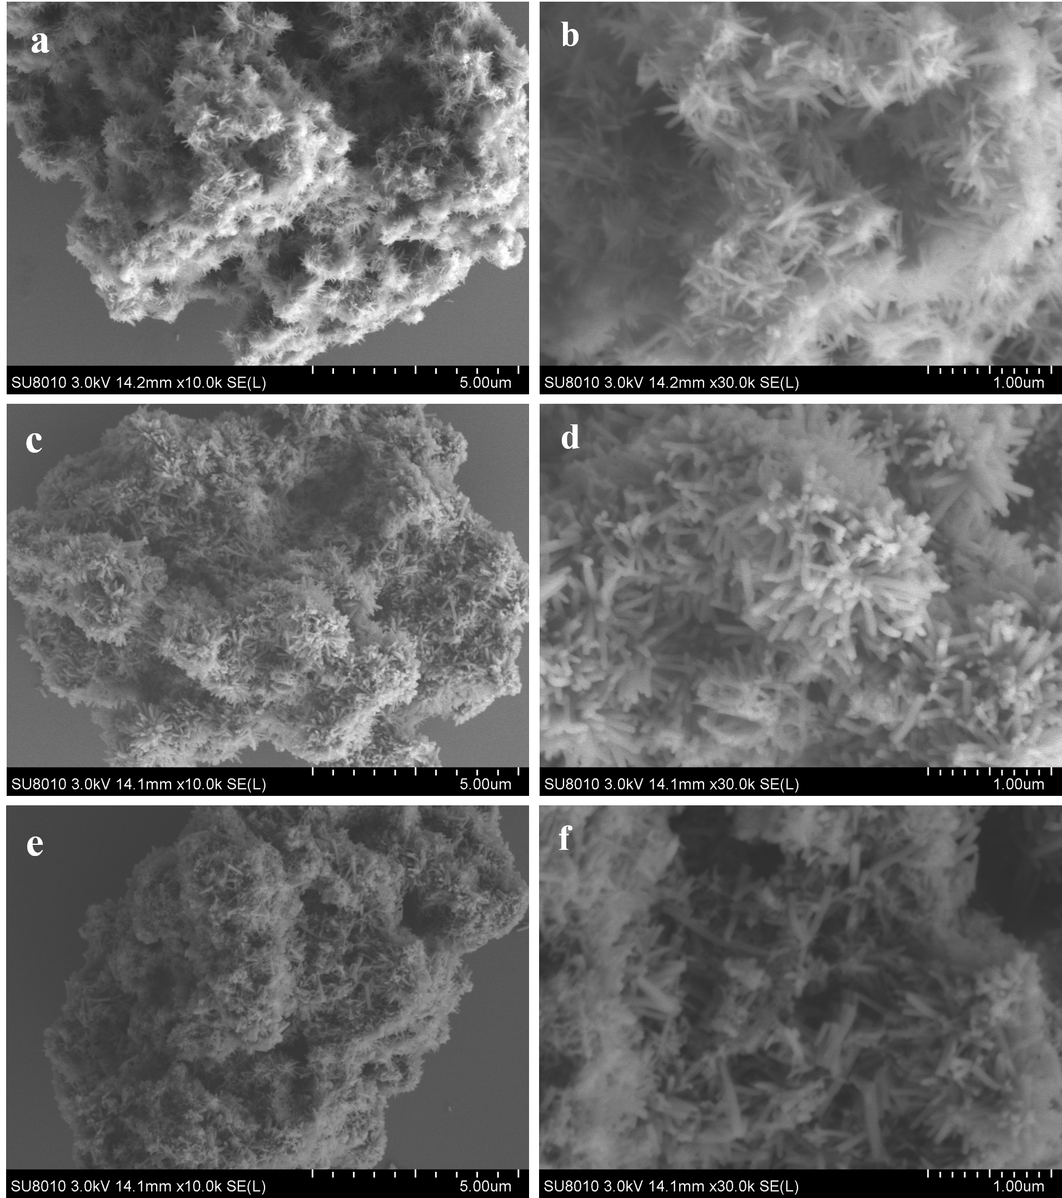
Supplementary Fig. 3 | SEM characterization of Ni-HITP and γ-Fe₂O₃@Ni-HITP. a-f, SEM images of Ni-HITP (a, b) and γ-Fe₂O₃@Ni-HITP before (c, d) and after electrocatalysis (e, f) at different resolutions.

Supplementary Fig. 4 | TGA characterization of Ni-HITP and γ-Fe₂O₃@Ni-HITP. It can be seen from the figure that the thermogravimetric curves of Ni-HITP and γ-Fe₂O₃@Ni-HITP are similar. The first mass loss before 100 ℃ is due to the release of solvent molecules.

Supplementary Fig. 5 | N₂ sorption isotherms at 77 K of Ni-HITP and γ-Fe₂O₃@Ni-HITP. N₂ sorption isotherms of Ni-HITP and γ-Fe₂O₃@Ni-HITP measured at 77 K.
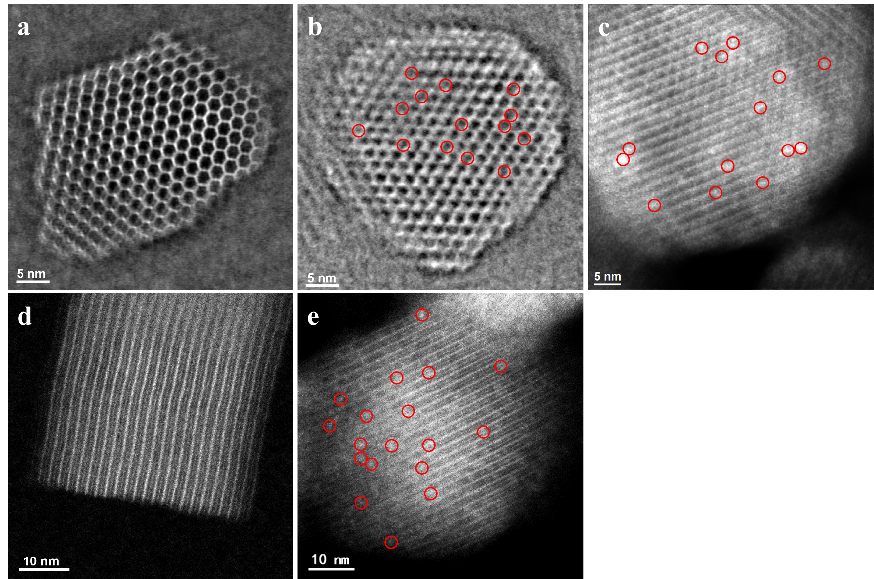
Supplementary Fig. 6 | Scanning transmission electron microscopy characterization. iDPC-STEM images of Ni-HITP (a) and γ-Fe₂O₃@Ni-HITP (b), acquired along the [001] direction. c, HAADF-STEM images of γ-Fe₂O₃@Ni-HITP, acquired along the [001] direction. HAADF-STEM images of Ni-HITP (d) and γ-Fe₂O₃@Ni-HITP (e), acquired along the [110] direction.
Compared to pristine Ni-HITP, γ-Fe₂O₃@Ni-HITP exhibits inverted contrast when viewed along the channels and diffused bright contrast across channels when viewed along the normal of the channels. These results collectively indicate the successful loading and uniform distribution of ultrafine γ-Fe₂O₃ nanoparticles within Ni-HITP.

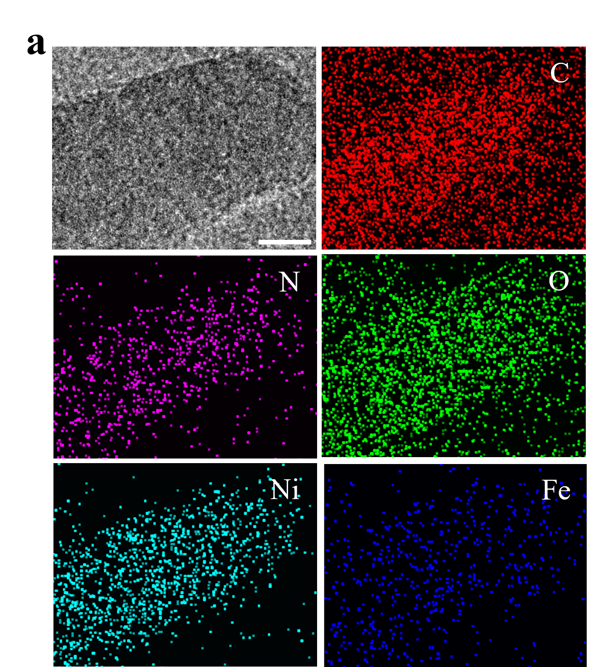
Supplementary Fig. 7 | HR-TEM image and EDS of γ-Fe₂O₃@Ni-HITP. TEM and EDS mapping of γ-Fe₂O₃@Ni-HITP. Scale bar: 10 nm.

Supplementary Fig. 8 | XPS characterization of γ-Fe₂O₃@Ni-HITP. a, Wide scanning survey spectrum of γ-Fe₂O₃@Ni-HITP before and after electrocatalysis. b, The XPS spectra and fit of Ni 2p of Ni-HITP, before and after electrocatalysis of γ-Fe₂O₃@Ni-HITP. It can be seen that the valance of Ni is +2, indicating the structure stability. c, The XPS spectra and fit of Fe 2p of γ-Fe₂O₃@Ni-HITP before and after electrocatalysis. d, The XPS spectra and fit of Fe 2p of γ-Fe₂O₃ nanoparticles.

Supplementary Fig. 9 | XAS spectra of Fe K-edge of γ-Fe₂O₃@Ni-HITP. a, b, Fe K-edge XANES (a) spectra and Fourier transformed EXAFS (b) spectra of before and after electrocatalysis of γ-Fe₂O₃@Ni-HITP and reference samples, respectively. c-f, Fe K-edge EXAFS (points) and curve fit (line) for γ-Fe₂O₃@Ni-HITP before (c, d) and after (e, f) electrocatalysis, shown in R-space (FT magnitude (c, e) and imaginary (d, f) component). The data are k³-weighted and not phase-corrected.

Supplementary Fig. 10 | EXAFS spectra and fitting results of Fe K-edge. a-d, Fe K-edge EXAFS (points) and curve fit (line) using α-Fe₂O₃ crystal structure (a, b) or Fe-HITP (c, d) for γ-Fe₂O₃@Ni-HITP, shown in R-space (FT magnitude (a, c) and imaginary (b, d) component). The data are k³-weighted and not phase-corrected. It can be seen that compared with γ-Fe₂O₃, by using the structure of α-Fe₂O₃ and Fe-HITP as the fitting result, the fitting results are poor, which mean that the structural model of γ-Fe₂O₃ is more consistent with the experimental data. Therefore, we concluded that the Fe_{x}O_{y} nanoparticles are γ-Fe₂O₃ (Supplementary Figs 9 and 10, Table 2) rather than α-Fe₂O₃ or the Fe ions replacing Ni ions in the Ni-HITP framework.

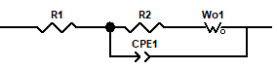
Supplementary Fig. 11 | EIS characterization of Ni-HITP and γ-Fe₂O₃@Ni-HITP. Nyquist plots of Ni-HITP and γ-Fe₂O₃@Ni-HITP over the frequency ranging from 1 MHz to 0.1 Hz fitting using Zview software. Insert graph is the equivalent circuits. R1: solution resistance (R_{s}) of the electrolysis cell, R2: charge transfer resistance (R_{ct}), W_{o}1: Warberg impedance of mass transfer resistance (R_{mt}), CPE1: constant phase angle element¹. Testing potential: open circuit voltage of 0 V vs. RHE.

Supplementary Fig. 12 | ECSA characterization of Ni-HITP and γ-Fe₂O₃@Ni-HITP . a, b, CV curves of various scan rate at non-Faradaic of Ni-HITP (a) and γ-Fe₂O₃@Ni-HITP (b). c, Fitting the current density difference, Δj/2, from the CV curves, to the scanning rate in a straight line, and the slope obtained is the double layer capacitance value of Ni-HITP (a) and γ-Fe₂O₃@ Ni-HITP (b), respectively.

Supplementary Fig.13 | Gas chromatography measurements of gas products. a, CO, CH₄, and C₂H₄ are detected by flame ionization detector (FID). b, H₂ is detected by thermal conductivity detector (TCD), and. c-f, The standard curves of H₂ (c), CO (d), CH₄ (e), and C₂H₄ (f) at different concentrations of 50 ppm, 100 ppm, 500 ppm, 1000 ppm and 5000 ppm.

Supplementary Fig. 14 | Gas chromatography measurements of gas products. a-h, GC profiles of gas products with γ-Fe₂O₃(< 2 nm)@Ni-HITP (a, b), Ni-HITP (c, d) Ni-HHTP (e, f) and γ-Fe₂O₃(24 nm)/Ni-HITP (g, h) as electrocatalyst at the potentials of −0.6 V, −0.7 V, −0.8 V, −0.9 V and −1.0 V vs. RHE, respectively.

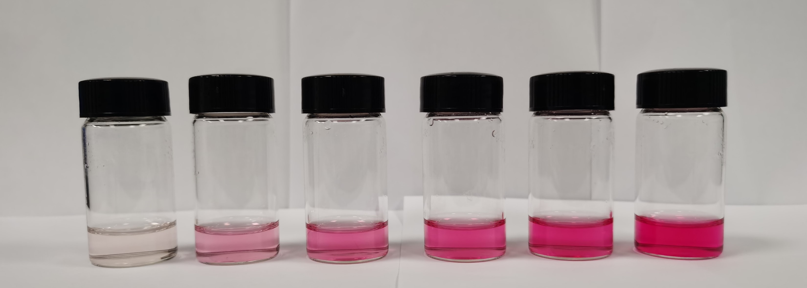
Supplementary Fig. 15 | UV-vis measurements of the concentrations of urea. a, UV-vis spectra of a series of urea standard solutions (0 ppm, 2 ppm, 4 ppm, 6 ppm, 8 ppm and 10 ppm). b, The calibration curve for quantification of urea indicates good linear relation of absorbance with urea concentration (y = 0.0734x + 0.0371, R² = 0.9999) of three times independent calibration curves, the inset is the picture of pink solutions with different urea concentrations.

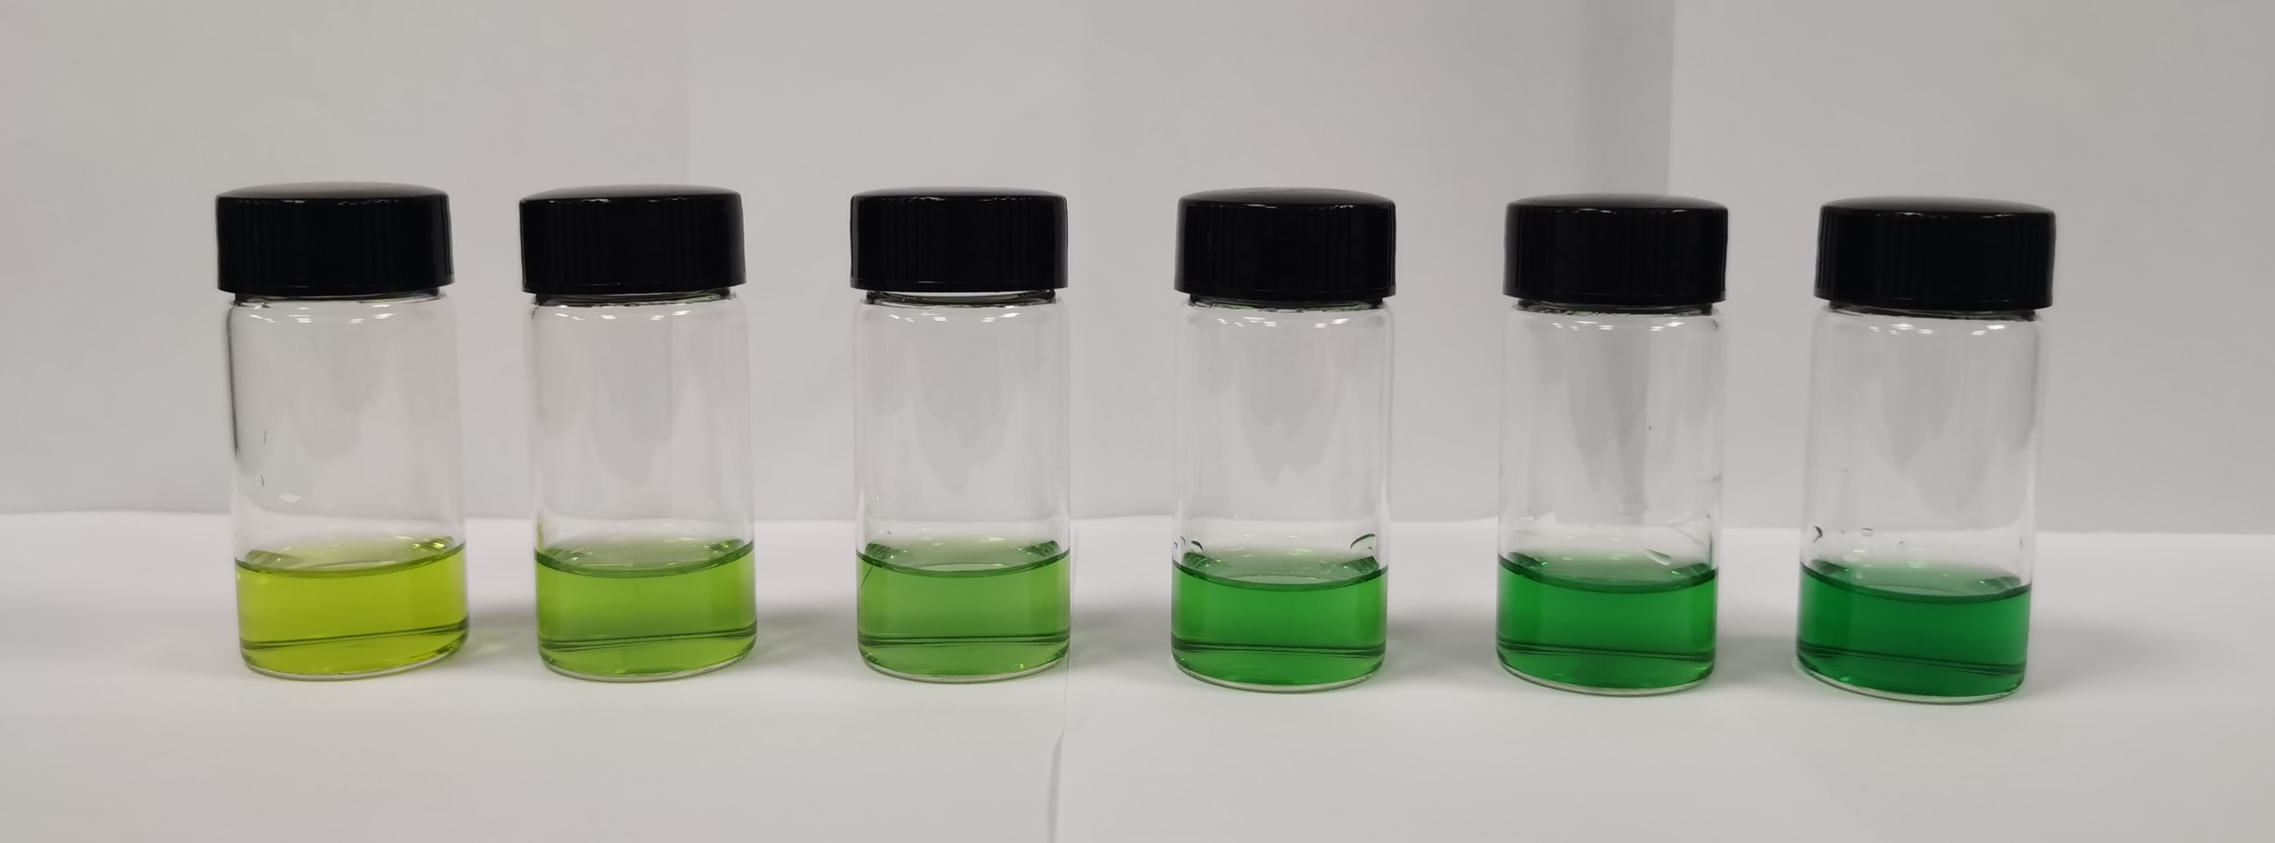
Supplementary Fig. 16 | UV-vis measurements of the concentrations of NH₃. a, UV-vis spectra of a series of NH₃ standard solutions (0 ppm, 2 ppm, 4 ppm, 6 ppm, 8 ppm and 10 ppm). b, The calibration curve for quantification of NH₃ indicates good linear relation of absorbance with NH₃ concentration (y = 0.0837x + 0.1415, R² = 0.9999) of three times independent calibration curves, the inset is the picture of chartreuse solutions with different NH₃ concentrations.

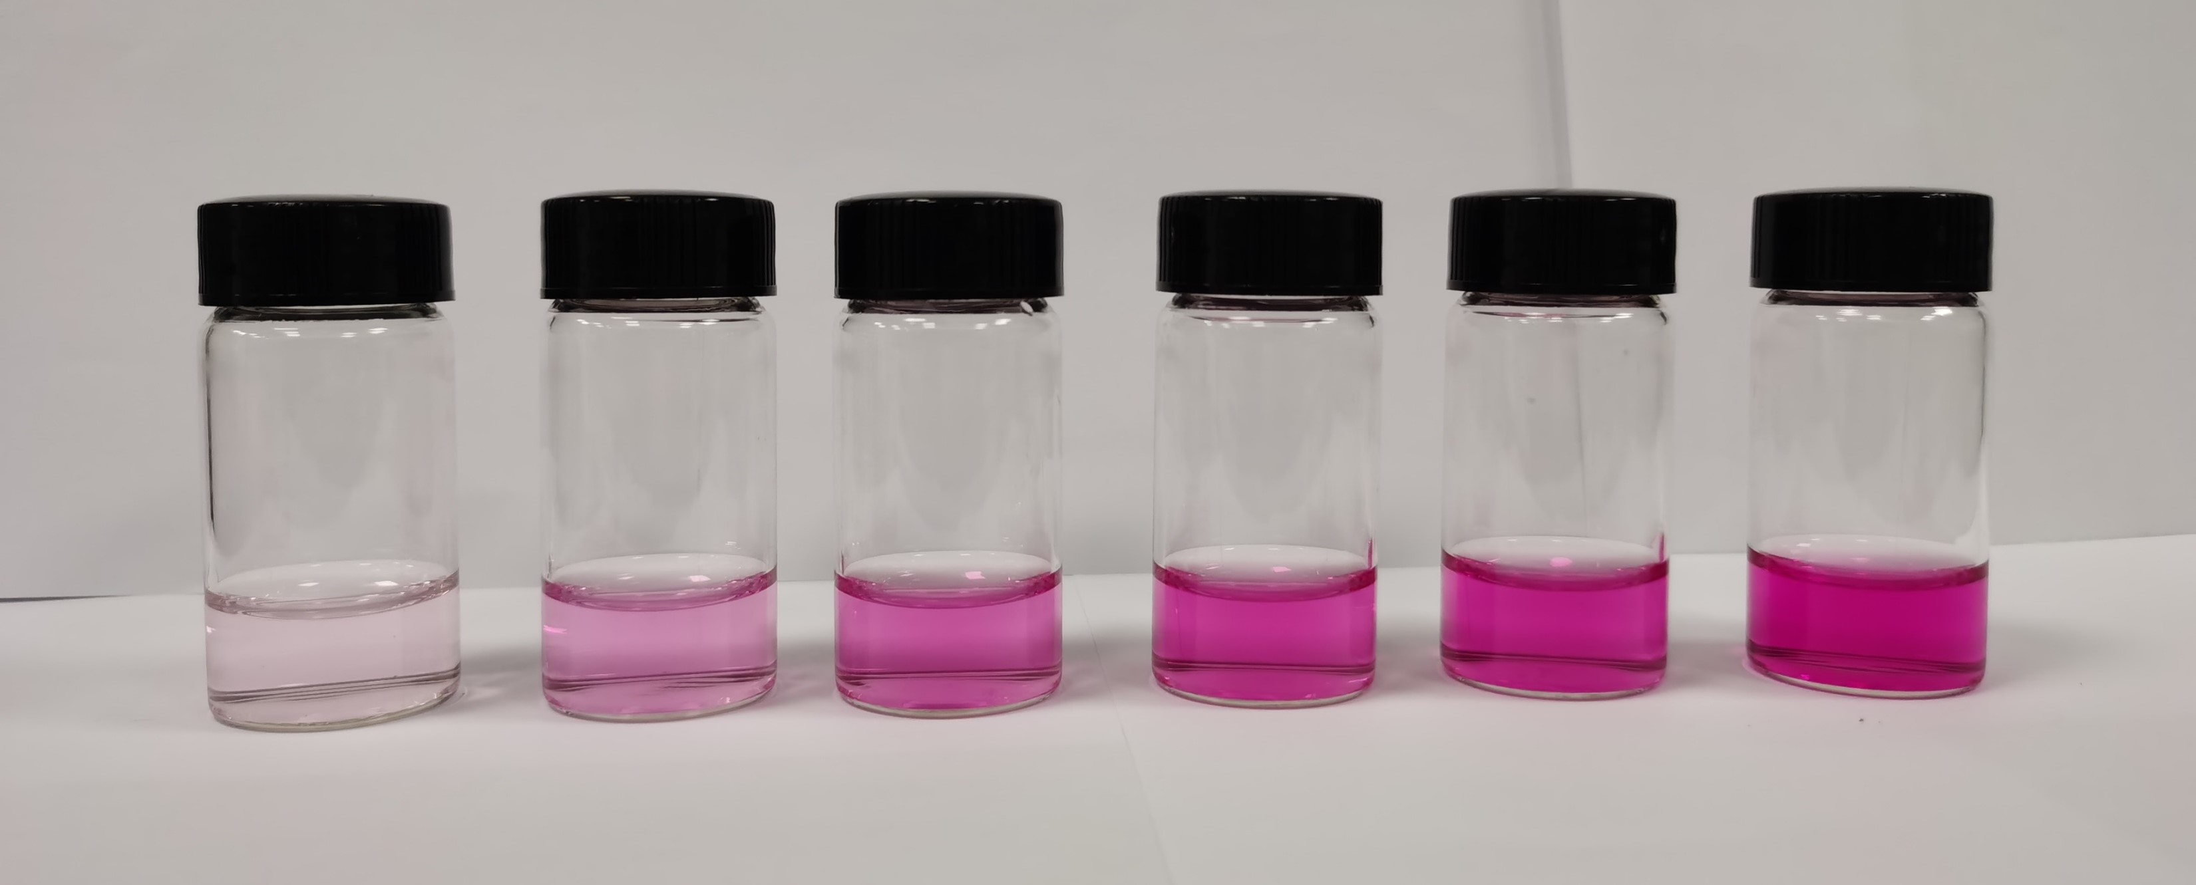
Supplementary Fig. 17 | UV-vis measurements of the concentrations of NO₂⁻. a, UV-vis spectra of a series of urea standard solutions (0 ppm, 2 ppm, 4 ppm, 6 ppm, 8 ppm and 10 ppm). b, The calibration curve for quantification of NO₂⁻ indicates good linear relation of absorbance with NO₂⁻ concentration (y = 0.0647x + 0.0337, R² = 0.9998) of three times independent calibration curves, the inset is the picture of wine solutions with different NO₂⁻ concentrations.

Supplementary Fig. 18 | UV-vis measurements of γ-Fe₂O₃(< 2 nm)@Ni-HITP. a-c, UV-vis measurements of urea (a), NH₃ (b), and NO₂⁻ (c) with γ-Fe₂O₃(< 2 nm)@Ni-HITP as electrocatalyst at the potentials of −0.6 V, −0.7 V, −0.8 V, −0.9 V and −1.0 V vs. RHE, respectively.

Supplementary Fig. 19 | PXRD characterization of as-synthesized γ-Fe₂O₃ nanoparticles. PXRD pattern of as-synthesized γ-Fe₂O₃ nanoparticles.

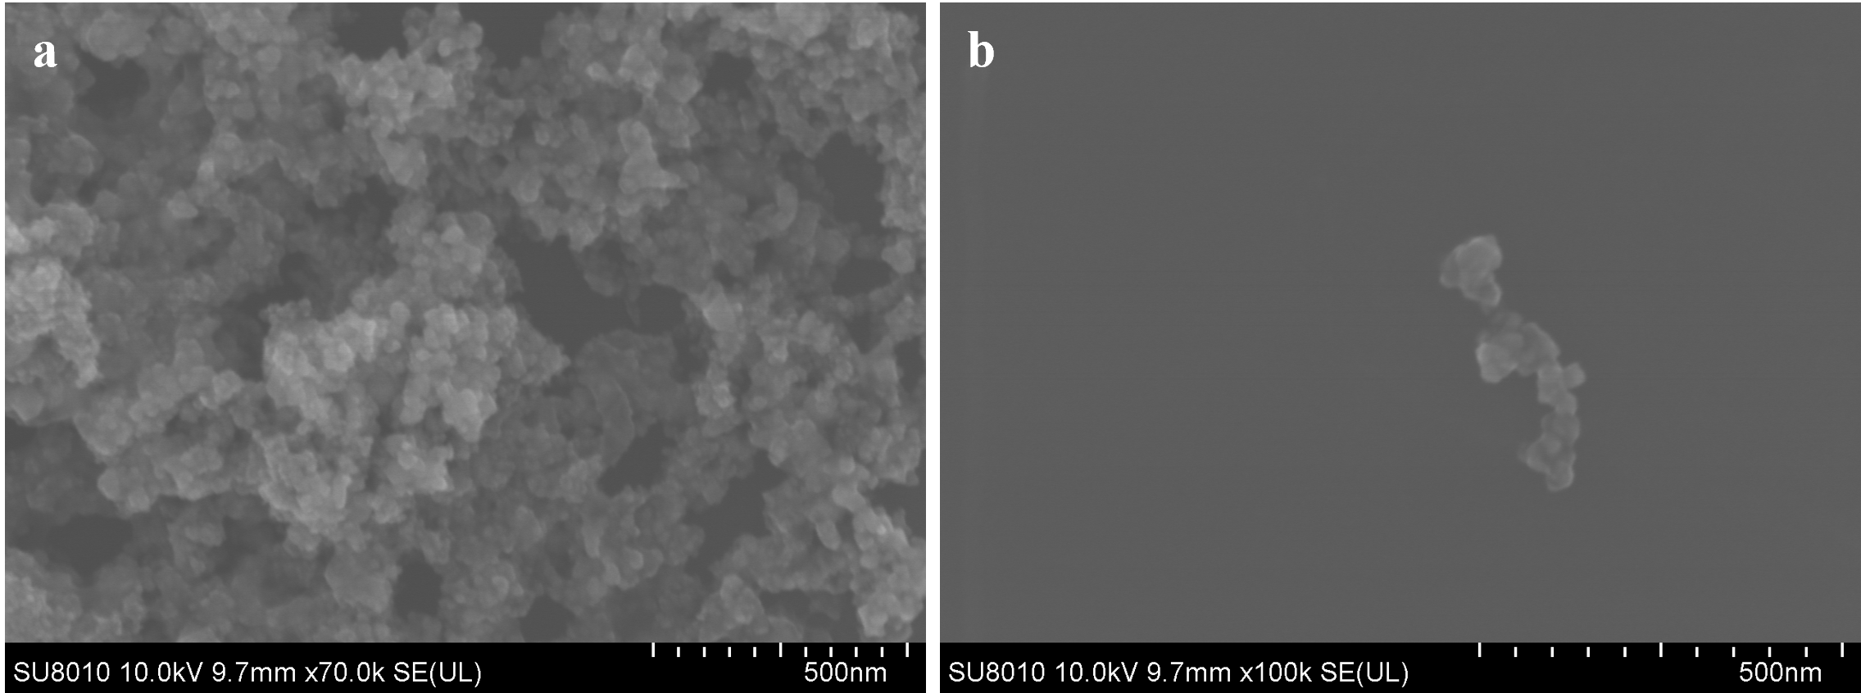

Supplementary Fig. 20 | SEM characterization of γ-Fe₂O₃ nanoparticles. a, b, SEM images of γ-Fe₂O₃ nanoparticles at different resolutions. c, Particle size distribution of γ-Fe₂O₃ nanoparticles.

Supplementary Fig. 21 | UV-vis measurements by γ-Fe₂O₃ nanoparticles. a-c, UV-vis measurements of urea (a), NH₃ (b), and NO₂⁻ (c) by γ-Fe₂O₃ nanoparticles as electrocatalyst at the potentials of −0.6 V, −0.7 V, −0.8 V, −0.9 V and −1.0 V vs. RHE, respectively.

Supplementary Fig. 22 | Electrocatalytic co-reduction of CO₂ and NO₃⁻ performance by γ-Fe₂O₃ nanoparticles. a, LSV curve of γ-Fe₂O₃ nanoparticles. b, i-t curves at different potentials. c, FEs of HCOO⁻ and H₂ by γ-Fe₂O₃ nanoparticles as electrocatalyst.

Supplementary Fig. 23 | UV-vis measurements by Ni-HITP. a-c, UV-vis measurements of urea (a), NH₃ (b), and NO₂⁻ (c) with Ni-HITP as electrocatalyst at the potentials of −0.6 V, −0.7 V, −0.8 V, −0.9 V and −1.0 V vs. RHE, respectively.

Supplementary Fig. 24 | Electrocatalytic co-reduction of CO₂ and NO₃⁻ performance of Ni-HITP. a, LSV curve of Ni-HITP. b, i-t curves at different potentials. c, FEs of urea, NH₃, NO₂⁻, and H₂ with Ni-HITP as electrocatalyst. d, i-t curves at different potentials with γ-Fe₂O₃@Ni-HITP as electrocatalyst.

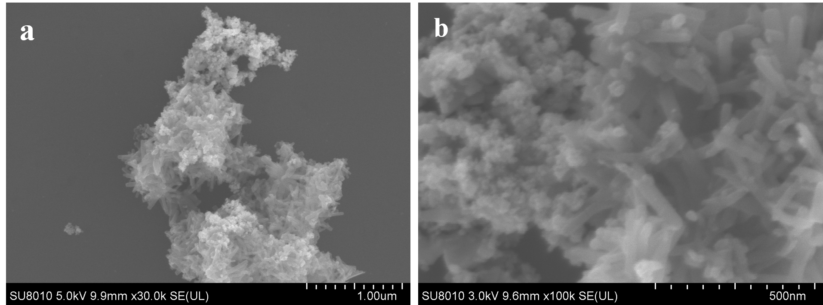
Supplementary Fig. 25 | SEM characterization of γ-Fe₂O₃(24 nm)/Ni-HITP. a, b, SEM images of γ-Fe₂O₃(24 nm)/Ni-HITP at different resolutions.

Supplementary Fig. 26 | UV-vis measurements by γ-Fe₂O₃(24 nm)/Ni-HITP. a-c, UV-vis measurements of urea (a), NH₃ (b), and NO₂⁻ (c) with γ-Fe₂O₃(24 nm)/Ni-HITP as electrocatalyst at the potentials of −0.6 V, −0.7 V, −0.8 V, −0.9 V and −1.0 V vs. RHE, respectively.

Supplementary Fig. 27 | Electrocatalytic co-reduction of CO₂ and NO₃⁻ performance of γ-Fe₂O₃(24 nm)/Ni-HITP. a, LSV curve of γ-Fe₂O₃(24 nm)/Ni-HITP. b, i-t curves at different potentials. c, FEs of urea, NH₃, NO₂⁻, and H₂ with γ-Fe₂O₃(24 nm)/Ni-HITP as electrocatalyst.

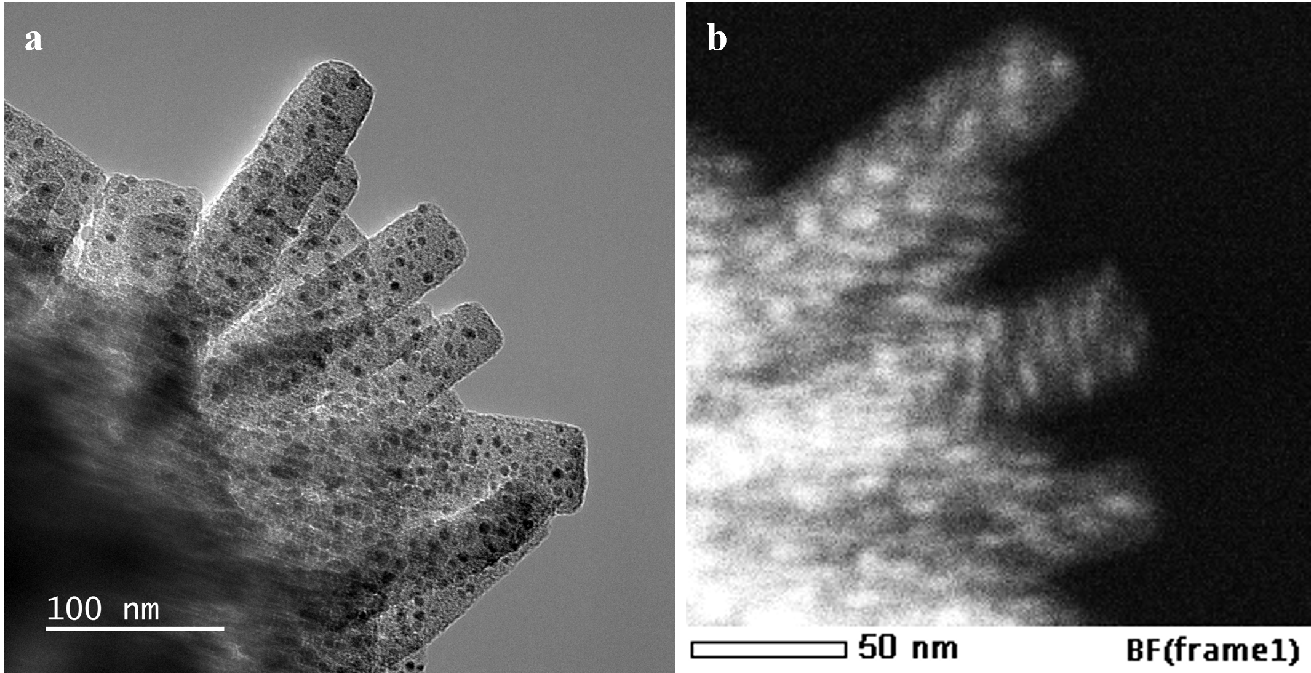
Supplementary Fig. 28 | TEM characterization 7.9 nm γ-Fe₂O₃ nanoparticles encapsulated in Ni-HITP. a, b, TEM image (a) and STEM image (b) of 7.9 nm γ-Fe₂O₃ NPs encapsulated in Ni-HITP. c, Particle size distribution of γ-Fe₂O₃ in γ-Fe₂O₃(7.9 nm)@Ni-HITP.

Supplementary Fig. 29 | UV-vis measurements by 7.9 nm γ-Fe₂O₃ nanoparticles encapsulated in Ni-HITP. a-c, UV-vis measurements of urea (a), NH₃ (b), and NO₂⁻ (c) with γ-Fe₂O₃(7.9 nm)@Ni-HITP as electrocatalyst at the potentials of −0.6 V, −0.7 V, −0.8 V, −0.9 V and −1.0 V vs. RHE, respectively.

Supplementary Fig. 30 | Electrocatalytic co-reduction of CO₂ and NO₃⁻ performance by 7.9 nm γ-Fe₂O₃ nanoparticles encapsulated in Ni-HITP. a, LSV curve of γ-Fe₂O₃(7.9 nm)@Ni-HITP. b, i-t curves at different potentials. c, FEs of urea, NH₃, NO₂⁻ and H₂ with γ-Fe₂O₃(7.9 nm)@Ni-HITP as electrocatalyst.

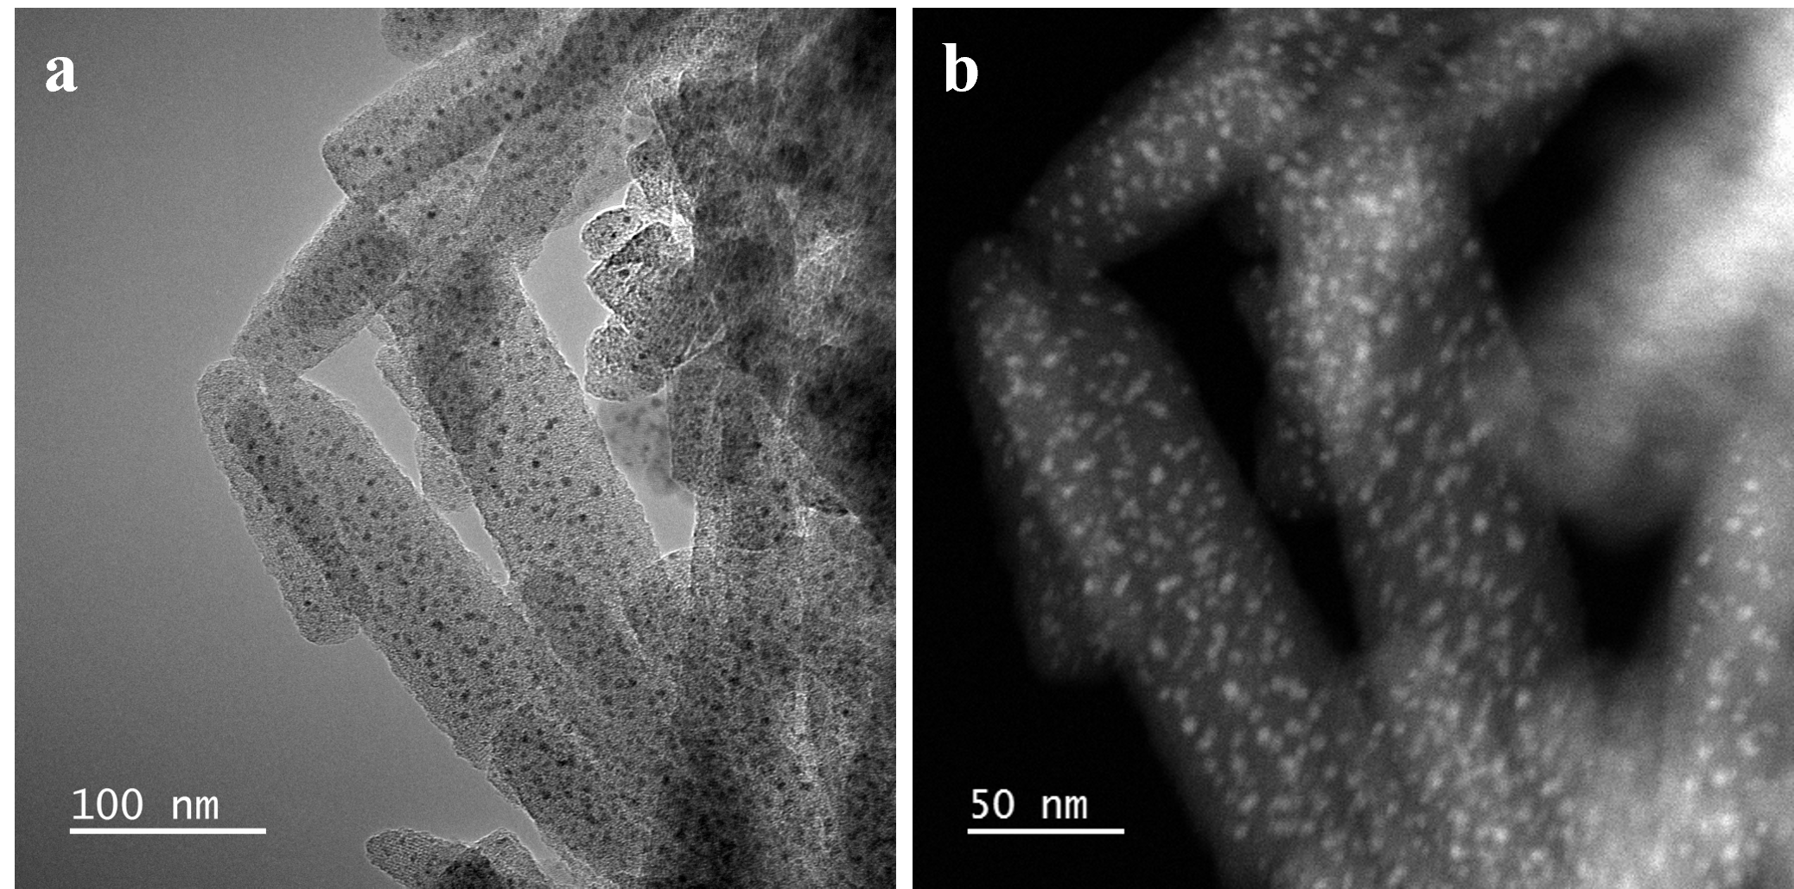
Supplementary Fig. 31 | TEM characterization of 3.8 nm γ-Fe₂O₃ nanoparticles encapsulated in Ni-HITP. a, b, TEM image (a) and STEM image (b) of 3.8 nm γ-Fe₂O₃ NPs encapsulated in Ni-HITP. c, Particle size distribution of γ-Fe₂O₃ in γ-Fe₂O₃(3.8 nm)@Ni-HITP

Supplementary Fig. 32 | UV-vis measurements by 3.8 nm γ-Fe₂O₃ nanoparticles encapsulated in Ni-HITP. a-c, UV-vis measurements of urea (a), NH₃ (b), and NO₂⁻ (c) with γ-Fe₂O₃(3.8 nm)@Ni-HITP as electrocatalyst at the potentials of −0.6 V, −0.7 V, −0.8 V, −0.9 V and −1.0 V vs. RHE, respectively.

Supplementary Fig. 33 | Electrocatalytic co-reduction of CO₂ and NO₃⁻ performance by 3.8 nm γ-Fe₂O₃ nanoparticles encapsulated in Ni-HITP. a, LSV curve of γ-Fe₂O₃(3.8 nm)@Ni-HITP. b, i-t curves at different potentials. c, FEs of urea, NH₃, NO₂⁻ and H₂ with γ-Fe₂O₃(3.8 nm)@Ni-HITP as electrocatalyst.

Supplementary Fig. 34 | Performance for electrosynthesis of urea. The relationship between performance for electrosynthesis of urea and particle size of γ-Fe₂O₃ nanoparticles encapsulated in Ni-HITP.

Supplementary Fig. 35 | ¹H NMR measurements of the concentrations of urea. a, ¹H NMR spectra of a series of urea standard solutions (0 ppm, 2.5 ppm, 5 ppm, 10 ppm, and 15 ppm). b, The calibration curve for quantification of NO₂⁻ indicates good linear relation of integral area with urea concentration (y = 0.0017x + 0.0001, R² = 0.997).

Supplementary Fig. 36 | ¹H NMR measurements of urea with γ-Fe₂O₃(< 2 nm)@Ni-HITP as electrocatalyst. ¹H NMR measurements of urea with γ-Fe₂O₃@Ni-HITP as electrocatalyst at the potentials of −0.6 V, −0.7 V, −0.8 V, −0.9 V and −1.0 V vs. RHE, respectively.

Supplementary Fig. 37 | Co-reduction of CO₂ and NO₃⁻ performance comparison of γ-Fe₂O₃(< 2 nm)@Ni-HITP. The quantification of Faradaic efficiency of urea by the methods of UV-vis and ¹H NMR. It can be seen that the results are similar, indicating the accuracy of the results.

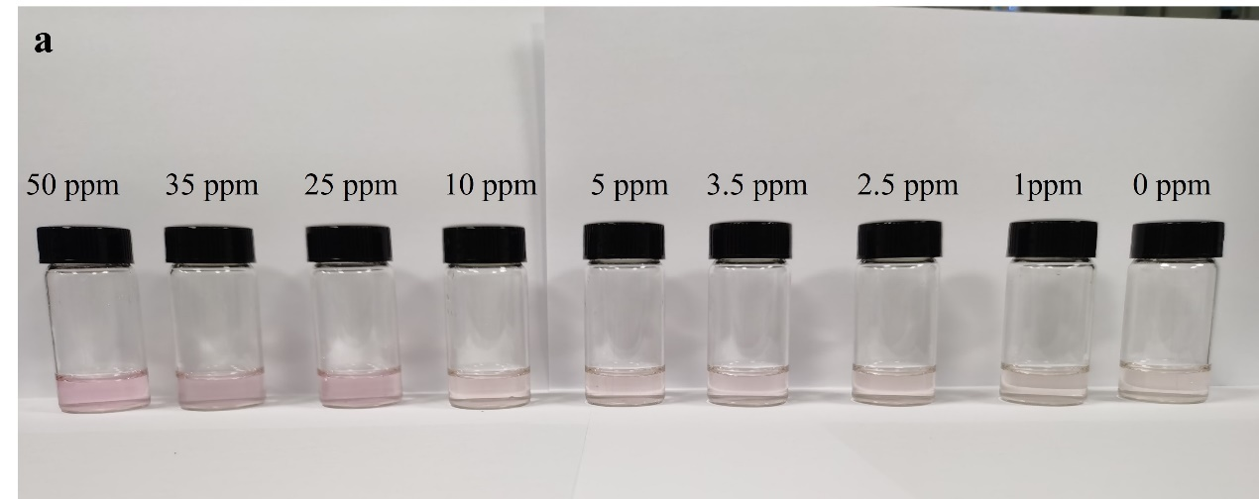
Supplementary Fig. 38 | Influence of co-existing nitrite on the quantification of urea by diacetyl monoxime method. a, Color of different concentrations of nitrite standard solutions without urea quantified by diacetyl monoxime method. b, UV-vis spectra of different concentrations of nitrite standard solutions without urea quantified by diacetyl monoxime method. c, UV-vis spectra of 9 ppm urea standard solution with/without 3 ppm NO₂⁻ electrolyte. d, ¹H NMR spectra of 9 ppm urea standard solution with/without 3 ppm NO₂⁻ electrolyte.

Supplementary Fig. 39 | ¹H NMR measurements of liquid products. a, b, The standard curves of HCOO⁻ at different concentrations of 0 ppm, 20 ppm, 40 ppm, 60 ppm, 80 ppm and 100 ppm. c, ¹H NMR measurements of liquid products with γ-Fe₂O₃(< 2 nm)@Ni-HITP as electrocatalyst and KHCO₃ as electrolyte at the potentials of −0.6 V, −0.7 V, −0.8 V, −0.9 V and −1.0 V vs. RHE, respectively

Supplementary Fig. 40 | Electrocatalytic reduction of CO₂ performance by γ-Fe₂O₃(< 2 nm)@Ni-HITP. a, LSV curve of γ-Fe₂O₃(< 2 nm)@Ni-HITP. b, i-t curves at different potentials. c, FEs of HCOO⁻ and H₂ with γ-Fe₂O₃(< 2 nm)@Ni-HITP as electrocatalyst.

Supplementary Fig. 41 | UV-vis measurements by γ-Fe₂O₃(< 2 nm)@Ni-HITP. a-b, UV-vis measurements of NH₃ (a), and NO₂⁻ (b) with γ-Fe₂O₃(< 2 nm)@Ni-HITP as electrocatalyst and NO₃⁻ as the electrolyte at the potentials of −0.6 V, −0.7 V, −0.8 V, −0.9 V and −1.0 V vs. RHE, respectively.

Supplementary Fig. 42 | Electrocatalytic reduction of NO₃⁻ performance of γ-Fe₂O₃(< 2 nm)@Ni-HITP. a, LSV curve of γ-Fe₂O₃(< 2 nm)@Ni-HITP. b, i-t curves at different potentials. c, FEs of urea, NH₃, NO₂⁻, and H₂ with γ-Fe₂O₃(< 2 nm)@Ni-HITP as electrocatalyst.

Supplementary Fig. 43 | XAS spectra of Ni K-edge of γ-Fe₂O₃(< 2 nm)@Ni-HITP. a, Normalized Ni K-edge XANES spectra. b, Ni K-edge EXAFS spectra of γ-Fe₂O₃@Ni-HITP before and after electrocatalysis, as well as the standard spectra of Ni foil and NiO.

Supplementary Fig. 44 | EXAFS spectra and fitting results of γ-Fe₂O₃(< 2 nm)@Ni-HITP. a-d, Ni K-edge EXAFS (points) and curve fit (line) for γ-Fe₂O₃(< 2 nm)@Ni-HITP before (a, b) and after (c, d) electrocatalysis, shown in R-space (FT magnitude (a, c) and imaginary (b, d) component). The data are k³-weighted and not phase-corrected.

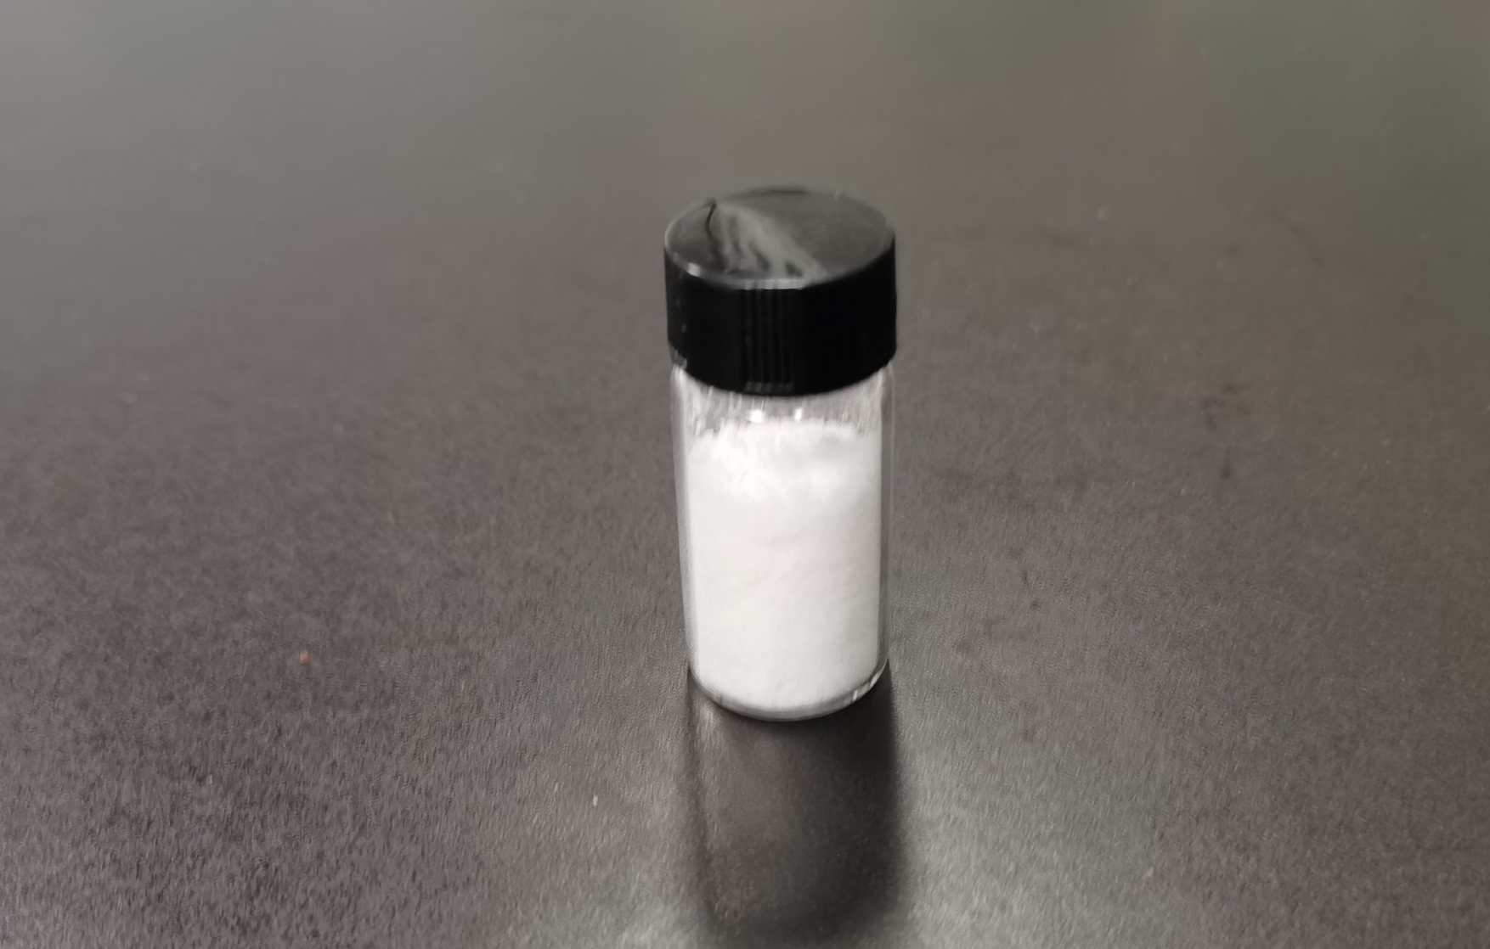
Supplementary Fig. 45 | Electrocatalytic co-reduction of NO₃⁻ and CO₂ performance by a flow cell with a larger window area (5 5 cm²). a, Long-term i-t stability. b, ¹H NMR spectra of urea products at different times. c, Time-resolved urea yield amount. Insert: the produced urea. d, NO₂⁻ measurement.

Supplementary Fig. 46 | UV-vis measurements of γ-Fe₂O₃(< 2 nm)@Ni-HITP in 1 M KHCO₃ + 0.1 M KNO₃. a-c, UV-vis measurements of urea (a), NH₃ (b), and NO₂⁻ (c) with γ-Fe₂O₃(< 2 nm)@Ni-HITP as electrocatalyst at 1 M KHCO₃ + 0.1 M KNO₃ electrolyte at the potentials of −0.6 V, −0.7 V, −0.8 V, −0.9 V and −1.0 V vs. RHE, respectively.

Supplementary Fig. 47 | Electrocatalytic co-reduction of CO₂ and NO₃⁻ performance of γ-Fe₂O₃(< 2 nm)@Ni-HITP in 1 M KHCO₃ + 0.1 M KNO₃. a, LSV curve of γ-Fe₂O₃(< 2 nm)@Ni-HITP in 1 M KHCO₃ + 0.1 M KNO₃. b, i-t curves at different potentials. c, FEs of urea, NH₃, NO₂⁻ and H₂ with γ-Fe₂O₃(< 2 nm)@Ni-HITP as electrocatalyst.

Supplementary Fig. 48 | Operando ATR-FTIR spectra of γ-Fe₂O₃@Ni-HITP. a, b, Operando ATR-FTIR spectra of γ-Fe₂O₃@Ni-HITP during electrolysis in 0.04 M KNO₃ and 0.1 M KHCO₃, respectively.

Supplementary Fig. 49 | UV-vis measurements of urea with CO and NO₃⁻ as feedstocks. UV-vis measurements of urea with CO and NO₃⁻ as feedstocks at the potentials of −0.6 V, −0.7 V, −0.8 V, −0.9 V and −1.0 V vs. RHE, respectively.

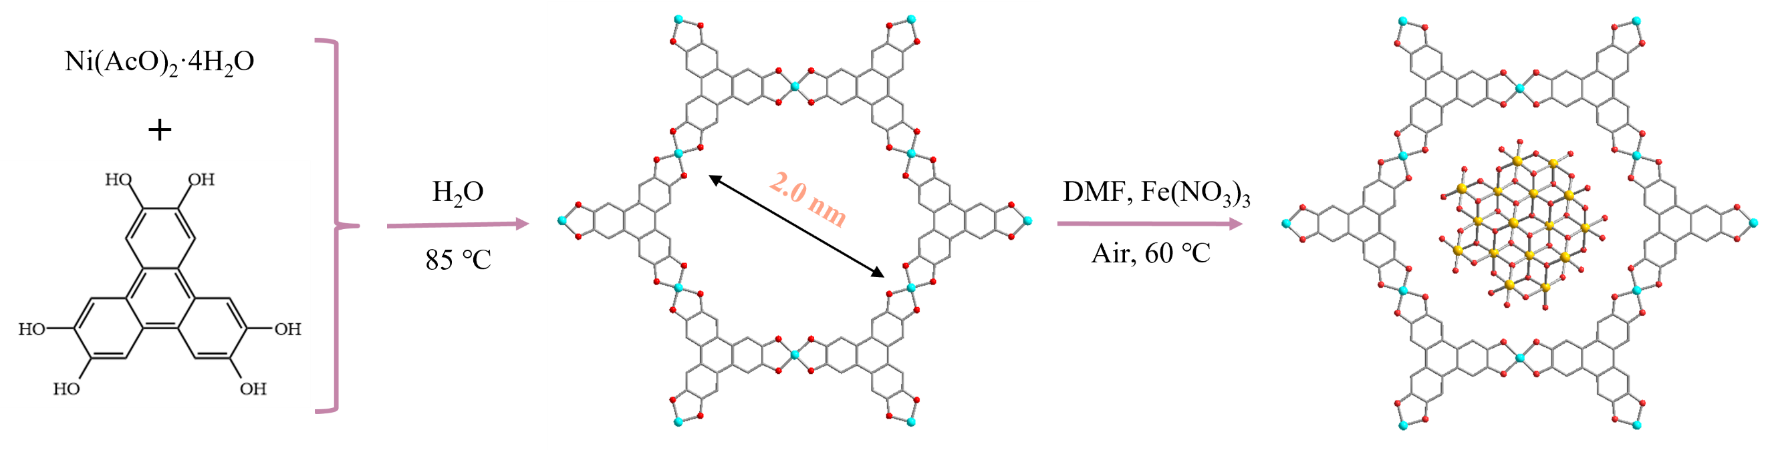
Supplementary Fig. 50 | Schematic illustration of Ni-HHTP and γ-Fe₂O₃@Ni-HHTP. Illustration of the synthesis of Ni-HHTP and γ-Fe₂O₃@Ni-HHTP. Colour codes: Ni, wathet; Fe, yellow; C, gray; O, red.

Supplementary Fig. 51 | PXRD characterization of Ni-HHTP and γ-Fe₂O₃@Ni-HHTP. PXRD patterns of Ni-HHTP simulated, Ni-HHTP synthesized and γ-Fe₂O₃@Ni-HHTP, respectively.

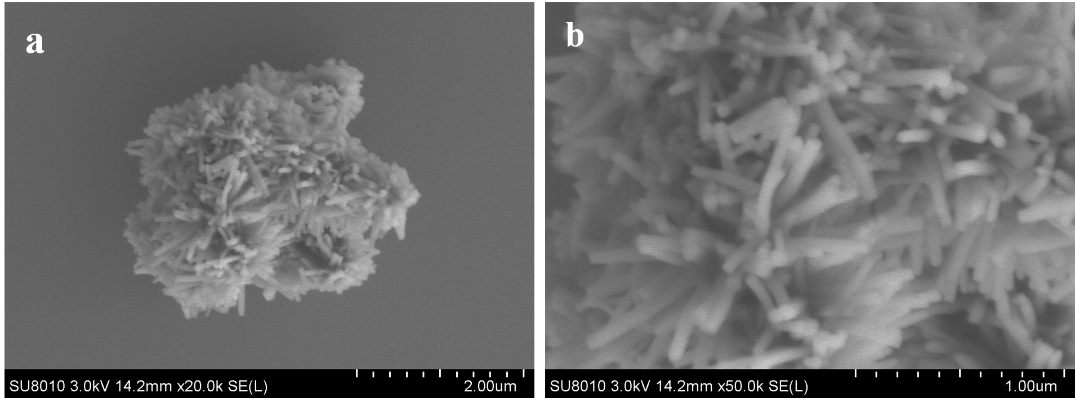
Supplementary Fig. 52 | SEM characterization of Ni-HHTP and γ-Fe₂O₃@Ni-HHTP. a, b, SEM images of γ-Fe₂O₃@Ni-HHTP at different resolutions.

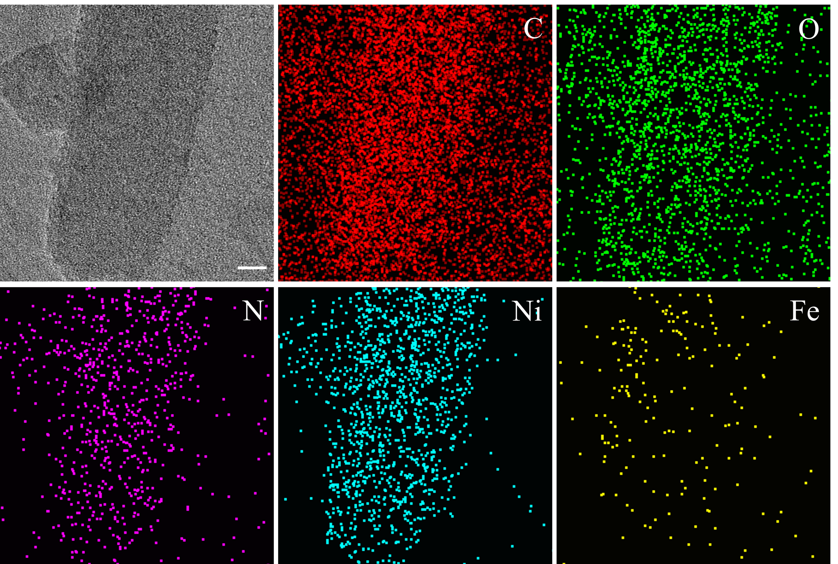
Supplementary Fig. 53 | TEM characterization of Ni-HHTP and γ-Fe₂O₃@Ni-HHTP. TEM image and EDS mapping of γ-Fe₂O₃@Ni-HHTP. Scale bar: 10 nm.

Supplementary Fig. 54 | XAS spectra of Fe K-edge of γ-Fe₂O₃@Ni-HHTP. a, b, Fe K-edge XANES (a) spectra and Fourier transformed EXAFS (b) spectra of γ-Fe₂O₃@Ni-HHTP and reference samples, respectively. c, d, Fe K-edge EXAFS (points) and curve fit (line) for γ-Fe₂O₃@Ni-HHTP, shown in R-space (FT magnitude (c) and imaginary (d) component). The data are k³-weighted and not phase-corrected.

Supplementary Fig. 55 | UV-vis measurements by γ-Fe₂O₃@Ni-HHTP. a-c, UV-vis measurements of urea (a), NH₃ (b), and NO₂⁻ (c) with γ-Fe₂O₃@Ni-HHTP as electrocatalyst at the potentials of −0.6 V, −0.7 V, −0.8 V, −0.9 V and −1.0 V vs. RHE, respectively.

Supplementary Fig. 56 | Electrocatalytic co-reduction of CO₂ and NO₃⁻ performance of γ-Fe₂O₃@Ni-HHTP. a, LSV curve of γ-Fe₂O₃@Ni-HHTP. b, i-t curves at different potentials. c, FEs of urea, NH₃, NO₂⁻, and H₂ with γ-Fe₂O₃@Ni-HHTP as electrocatalyst.

Supplementary Fig. 57 | Comparison of the performances for urea electrosynthesis of γ-Fe₂O₃@Ni-HITP with γ-Fe₂O₃@Ni-HHTP. Performance comparison between γ-Fe₂O₃@Ni-HITP and γ-Fe₂O₃@Ni-HHTP.

Supplementary Fig. 58 | EXAFS spectra and fitting results of Ni-HITP. a, b, Ni K-edge EXAFS (points) and curve fit (line) for Ni-HITP shown in R-space (FT magnitude (a) and imaginary (b) component). The data are k³-weighted and not phase-corrected.

Supplementary Table 1 | ICP-AES analysis results.
Sample | Ni-HITP | γ-Fe₂O₃@Ni-HITP | γ-Fe₂O₃@Ni-HHTP
Ni (mg L⁻¹) | 5.64 | 5.420 | 4.920
Ni (mmol L⁻¹) | 0.0961 | 0.0923 | 0.0838
Fe (mg L⁻¹) | 0 | 0.810 | 0.923
Fe (mmol L⁻¹) | 0 | 0.0145 | 0.0165
Fe₂O₃ (wt%) | 0 | 4.49 | 5.57

Supplementary Table 2 | EXAFS data fitting results of Fe K-edge of γ-Fe₂O₃@Ni-HITP.
Curve fitting Parameters* for Fe K-edge EXAFS for γ-Fe₂O₃@Ni-HITP
Edge | Sample | Paths | R (Å) | CN | Debye Waller factor (Å²) | Energy shift ΔE (eV) | R factor
Fe K-edge  S₀² = 0.9 | before electrocatalysis | Fe−O | 2.01(3) | 5.5(11) | 0.009(3) | 1.0(18) | 0.008
Fe K-edge  S₀² = 0.9 | before electrocatalysis | Fe···Fe | 3.06(9) | 3.4(28) | 0.010(9) | 1.0(18) | 0.008
Fe K-edge  S₀² = 0.9 | after electrocatalysis | Fe−O | 2.00(4) | 4.8(10) | 0.007(3) | 1.4(17) | 0.011
Fe K-edge  S₀² = 0.9 | after electrocatalysis | Fe···Fe | 3.06(10) | 3.3(43) | 0.015(10) | 1.4(17) | 0.011
* S₀² is the amplitude reduction factor, which was fixed as 0.9; Data ranges: 2.5 ≤ k ≤ 9.5 Å⁻¹, 1 ≤ R ≤ 3 Å for before electrocatalysis and 2.3 ≤ k ≤ 9.3 Å⁻¹, 1 ≤ R ≤ 3 Å for after electrocatalysis. The distances for Fe−O and Fe···Fe are from the crystal structure of γ-Fe₂O₃ (cif 1532121). R is interatomic distance (the bond length between central atoms and surrounding coordination atoms); CN is the coordination number; ΔE was refined as a global fit parameter. R factor is used to value the goodness of the fitting.
* X-ray absorption data reduction and analysis were processed by Athena and Artemis software².

Supplementary Table 3 | EXAFS data of three different fitting results of Fe K-edge of γ-Fe₂O₃@Ni-HITP.
Curve fitting Parameters* for Fe K-edge EXAFS for γ-Fe₂O₃@Ni-HITP
Edge | Sample | Paths | R (Å) | CN | Debye Waller factor (Å²) | Energy shift ΔE (eV) | R factor
Fe K-edge  S₀² = 0.9 | γ-Fe₂O₃@Ni-HITP | ªFe−O | 2.02(4) | 6.1(27) | 0.011(9) | 1.8(42) | 0.079
Fe K-edge  S₀² = 0.9 | γ-Fe₂O₃@Ni-HITP | ªFe···Fe | 2.81(9) | −6.4(145) | 0.025(33) | 1.8(42) | 0.079
Fe K-edge  S₀² = 0.9 | γ-Fe₂O₃@Ni-HITP | ^{b}Fe−N | 1.69(14) | −4.3 (67) | 0.020(20) | −38.6(127) | 0.138
Fe K-edge  S₀² = 0.9 | γ-Fe₂O₃@Ni-HITP | ^{b}Fe···C | 2.34(90) | 84(132) | 0.040(97) | −38.6(127) | 0.138
Fe K-edge  S₀² = 0.9 | γ-Fe₂O₃@Ni-HITP | ^{c}Fe−O | 2.01(3) | 5.5(11) | 0.009(2) | 1.0(18) | 0.008
Fe K-edge  S₀² = 0.9 | γ-Fe₂O₃@Ni-HITP | ^{c}Fe···Fe | 3.06(9) | 3.4(28) | 0.010(9) | 1.0(18) | 0.008

ª The distances for Fe−O and Fe···Fe are from the crystal structure of α-Fe₂O₃ (cif 1532120).
^{b} The distances for Fe−N and Fe···C are from the crystal structure of Fe-HITP.
^{c} The distances for Fe−O and Fe···Fe are from the crystal structure of γ-Fe₂O₃ (cif 1532121).
* S₀² is the amplitude reduction factor, which was fixed as 0.9; Data ranges: 2.5 ≤ k ≤ 9.5 Å⁻¹, 1 ≤ R ≤ 3 Å for both fitting results. R is interatomic distance (the bond length between central atoms and surrounding coordination atoms); CN is the coordination number; ΔE was refined as a global fit parameter. R factor is used to value the goodness of the fitting.
* According to the fitting results of Fe−O, Fe···Fe and Fe−N paths in the three crystal structures, it can be seen that they should be γ-Fe₂O₃ nanoparticles.

Supplementary Table 4 | EXAFS data fitting results of Ni K-edge of γ-Fe₂O₃@Ni-HITP.
Curve fitting Parameters* for Ni K-edge EXAFS for γ-Fe₂O₃@Ni-HITP
Edge | Sample | Paths | R (Å) | CN | Debye Waller factor (Å²) | Energy shift ΔE (eV) | R factor
Ni K-edge  S₀² = 0.9 | before electrocatalysis | Ni−N | 1.84(1) | 2.7(4) | 0.001(2) | 3.0(14) | 0.016
Ni K-edge  S₀² = 0.9 | before electrocatalysis | Ni···C | 2.68(2) | 3.0(6) | 0.001 | 3.0(14) | 0.016
Ni K-edge  S₀² = 0.9 | after electrocatalysis | Ni−N | 1.84(1) | 2.3(6) | 0.001(3) | 1.1(20) | 0.029
Ni K-edge  S₀² = 0.9 | after electrocatalysis | Ni···C | 2.67(2) | 3.7(16) | 0.002(5) | 1.1(20) | 0.029
* S₀² is the amplitude reduction factor, which was fixed as 0.9; Data ranges: 3 ≤ k ≤ 11 Å⁻¹, 1 ≤ R ≤ 3 Å for before and after electrocatalysis. The distances for Ni−N and Ni···C are from the crystal structure of Ni-HITP. R is interatomic distance (the bond length between central atoms and surrounding coordination atoms); CN is the coordination number; ΔE was refined as a global fit parameter. R factor is used to value the goodness of the fitting.

Supplementary Table 5 | EXAFS data fitting results of Fe K-edge of γ-Fe₂O₃@Ni-HHTP.
Curve fitting Parameters* for Fe K-edge EXAFS for γ-Fe₂O₃@Ni-HHTP
Edge | Sample | Paths | R (Å) | CN | Debye Waller factor (Å²) | Energy shift ΔE (eV) | R factor
Fe K-edge  S₀² = 0.9 | γ-Fe₂O₃@Ni-HHTP | Fe−O | 1.94(1) | 4.8(6) | 0.009(2) | −5.1(15) | 0.005
Fe K-edge  S₀² = 0.9 | γ-Fe₂O₃@Ni-HHTP | Fe···Fe | 2.92(2) | 1.4(9) | 0.011(7) | −5.1(15) | 0.005
* S₀² is the amplitude reduction factor, which was fixed as 0.9; Data ranges: 3 ≤ k ≤ 10 Å⁻¹, 1 ≤ R ≤ 3 Å for γ-Fe₂O₃@Ni-HHTP. The distances for Fe−O and Fe···Fe are from the crystal structure of γ-Fe₂O₃ (cif 1532121). R is interatomic distance (the bond length between central atoms and surrounding coordination atoms); CN is the coordination number; ΔE was refined as a global fit parameter. R factor is used to value the goodness of the fitting.

Supplementary Table 6 | Comparison of the performances for co-reduction of CO₂ and NO₃⁻ of reported electrocatalysts.
Catalyst | Electrolyte | Current density (mA cm⁻²) | FE  (Urea) | N_{urea}-selectivity | Cell type | Apparent rate (mg h⁻¹ cm⁻²) | Urea yield  (g h⁻¹ g⁻¹) | Ref
γ-Fe₂O₃@Ni-HITP | 0.1 M KHCO₃+ 0.04 M KNO₃ | −54 | 62.3% | 81.6% | flow cell | 5.5 | 14.67 | This work
γ-Fe₂O₃@Ni-HITP | 1 M KHCO₃+ 0.1 M KNO₃ | −90 | 65.8% | 86.2% | flow cell | 7.65 | 20.41 | This work
In(OH)₃-S | 0.1 M KNO₃ | *−1 | 54.3% | 82.9% | H-cell | 0.05 | 0.533 | ³
TiO₂-Nafion | 0.1 M KNO₃ | −0.2 | 40% | NA | H-cell | NA | 0.33 μmol⋅h ⁻¹ | ⁴
Cu-N₄ | 0.1 M KHCO₃+ 0.1 M KNO₃ | −27 | 28% | NA | H-cell | 0.92 | 1.84 | ⁵
F-doped CNT | 0.1 M KNO₃ | −1.7 | 18% | NA | H-cell | 0.0382 | 0.382 | ⁶
diatomic Fe–Ni catalyst | 0.1 M KHCO₃+ 0.05 M KNO₃ | *−42.5 | 17.8% | NA | H-cell | 0.242 | 1.21 | ⁷
AuPd nanoalloy | 0.075 M KHCO₃+ 0.025 M KNO₃ | *−6 | 15.6% | NA | H-cell | 0.049 | 0.204 | ⁸
Vo-CeO₂-750 | 0.1 M KHCO₃+ 0.05 M KNO₃ | *−40 | *4% | NA | H-cell | 0.188 | 0.94 | ⁹
Cu₁-CeO₂ | 0.1 M KHCO₃+ 0.05 M KNO₃ | *−26 | *6% | NA | H-cell | 0.634 | 3.17 | ¹⁰
Cu₉₇In₃-C | 0.1 M KHCO₃+ 0.01 M KNO₃ | NA | *5% | NA | H-cell | 0.1572 | 0.786 | ¹¹
F-CNTs | 0.1 M KNO₃ | *−1 | 51% | NA | H-cell | 0.0592 | 0.592 | ¹²
Cu@Zn Nanowires | 0.2 M KHCO₃ +0.1 M KNO₃ | −34 | 9.28% | NA | H-cell | 0.438 | NA | ¹³
PdCu/CBC | 0.05 M KNO₃ | *−6 | 59.7% | NA | H-cell | 0.19 | 0.76 | ¹⁴
BIF-29(Cu) | 0.1 M KHCO₃ +0.1 M KNO₃ | 0.424 | 68.5% | NA | H-type cell | NA | NA | ¹⁵
Cu-loaded  GDE | 0.2 M + 0.1 M | N.A. | 35% | NA | flow cell | NA | N.A. | ¹⁶
Fe(a)@C-Fe₃O₄/CNTs | 0.1 M KNO₃ | *−3.7 | 16.5% | *31% | flow cell | 0.067 | 1.34 | ¹⁷
CoPc-COF@TiO₂ NTs | 0.3 M KHCO₃+ 0.2 M KNO₃ | *−15 | 49% | NA | flow cell | 1.2 | 0.753 | ¹⁸
Cu-SP-OMe | 0.1 M KHCO₃+ 0.01 M KNO₃ | *−1 | 57.9% | 62.9% | flow cell | 0.286 | 3.64 | ¹⁹
CuWO₄ | 0.1 M KNO₃ | *−1 | 70.1% | NA | flow cell | 0.398 | 0.398 | ²⁰
3D Zn/Cu  hybrid  catalyst | 0.02 M KNO₃ | *−3 | 63% | NA | flow cell | 1.6 | 3.57 | ²¹
Pd₄Cu₁-Ni(OH)₂ | 0.1 M KHCO₃ + 0.1 M KNO₃ | −2.3 | 64.4% | NA | flow cell | 0.3628 | 3.628 | ²²
Co₁-TiO₂ | 0.9 M KHCO₃ + 0.1 M KNO₃ | −50.8 | 36.2% | NA | flow cell | 2.56 | NA | ²³

References
1. Tadi, K. K. & Motghare, R. V. Voltammetric determination of pindolol in biological fluids using molecularly imprinted polymer based biomimetic sensor. J. Electrochem. Soc. 163, B286-B292 (2016).
2. Ravel, B. & Newville, M. ATHENA, ARTEMIS, HEPHAESTUS: data analysis for X-ray absorption spectroscopy using IFEFFIT. J. Synchrotron Radiat. 12, 537-541 (2005).
3. Lv, C. et al. Selective electrocatalytic synthesis of urea with nitrate and carbon dioxide. Nat. Sustain. 4, 868-876 (2021).
4. Saravanakumar, D., Song, J., Lee, S., Hur, N. H. & Shin, W. Electrocatalytic conversion of carbon dioxide and nitrate ions to urea by a titania-nafion composite electrode. ChemSusChem 10, 3999-4003 (2017).
5. Leverett, J. et al. Tuning the coordination structure of Cu−N−C single atom catalysts for simultaneous electrochemical reduction of CO₂ and NO₃⁻ to urea. Adv. Energy Mater. 12, 2201500 (2022).
6. Liu, X. et al. Carbon nanotubes with fluorine-rich surface as metal-free electrocatalyst for effective synthesis of urea from nitrate and CO₂. Appl. Catal. B 316, 121618 (2022).
7. Zhang, X. et al. Identifying and tailoring C−N coupling site for efficient urea synthesis over diatomic Fe−Ni catalyst. Nat. Commun. 13, 5337-5345 (2022).
8. Wang, H. et al. Realizing efficient C−N coupling via electrochemical co-reduction of CO₂ and NO₃⁻ on AuPd nanoalloy to form urea: key C−N coupling intermediates. Appl. Catal. B 318, 121819 (2022).
9. Wei, X. et al. Oxygen vacancy-mediated selective C−N coupling toward electrocatalytic urea synthesis. J. Am. Chem. Soc. 144, 11530-11535 (2022).
10. Wei, X. et al. Dynamic reconstitution between copper single atoms and clusters for electrocatalytic urea synthesis. Adv. Mater. 35, e2300020 (2023).
11. Liu, Y. et al. C-bound or O-bound surface: which one boosts electrocatalytic urea synthesis? Angew. Chem. Int. Ed. 62, e202300387 (2023).
12. Lv, C. et al. A defect engineered electrocatalyst that promotes high-efficiency urea synthesis under ambient conditions. ACS Nano 16, 8213-8222 (2022).
13. Meng, N. et al. Oxide-derived core−shell Cu@Zn nanowires for urea electrosynthesis from carbon dioxide and nitrate in water. ACS Nano 16, 9095-9104 (2022).
14. Zhang, S. et al. High-efficiency electrosynthesis of urea over bacterial cellulose regulated Pd−Cu bimetallic catalyst. EES Catalysis 1, 45-53 (2023).
15. Gerke, C. S. et al. Electrochemical C–N bond formation within boron imidazolate cages featuring single copper sites. J. Am. Chem. Soc. 145, 26144-26151 (2023).
16. Shibata, M., Yoshida, K. & Furuya, N. Electrochemical synthesis of urea on reduction of carbon dioxide with nitrate and nitrite ions using Cu−loaded gas−diffusion electrode. J. Electroanal. Chem. 387, 143-145 (1995).
17. Geng, J. et al. Ambient electrosynthesis of urea with nitrate and carbon dioxide over iron-based dual-sites. Angew. Chem. Int. Ed. 62, e202210958 (2023).
18. Li, N. et al. Metalphthalocyanine frameworks grown on TiO₂ nanotubes for synergistically and efficiently electrocatalyzing urea production from CO₂ and nitrate. Sci China Chem 66, 1417-1424 (2023).
19. Zhao, Q. et al. Sustainable and high-rate electrosynthesis of nitrogen fertilizer. Angew. Chem. Int. Ed. 62, e202307123 (2023).
20. Zhao, Y. et al. Efficient urea electrosynthesis from carbon dioxide and nitrate via alternating Cu−W bimetallic C−N coupling sites. Nat. Commun. 14, 4491-4502 (2023).
21. Luo, Y. et al. Selective electrochemical synthesis of urea from nitrate and CO₂ via relay catalysis on hybrid catalysts. Nat. Catal. 6, 939-948 (2023).
22. Xu, M. et al. Kinetically matched C–N coupling toward efficient urea electrosynthesis enabled on copper single-atom alloy. Nat. Commun. 14, 6994-7005 (2023).
23. Tu, X. et al. A universal approach for sustainable urea synthesis via intermediate assembly at the electrode/electrolyte interface. Angew. Chem. Int. Ed., e202317087 (2023).

