Supporting Information
Free Radical Assisted Photocatalytic Degradation of Antibiotics in aqueous medium: Kinetics, Transformation Products, and Toxicity Assessment

A. Patidar, V.R. Dugyala, S. Chakma, M.N. Galodiya and A. S. Giri *
Indian Institute of Science Education and Research, Bhopal Bhauri, Bhopal-462066, INDIA
*Email: drasg82@gmail.com

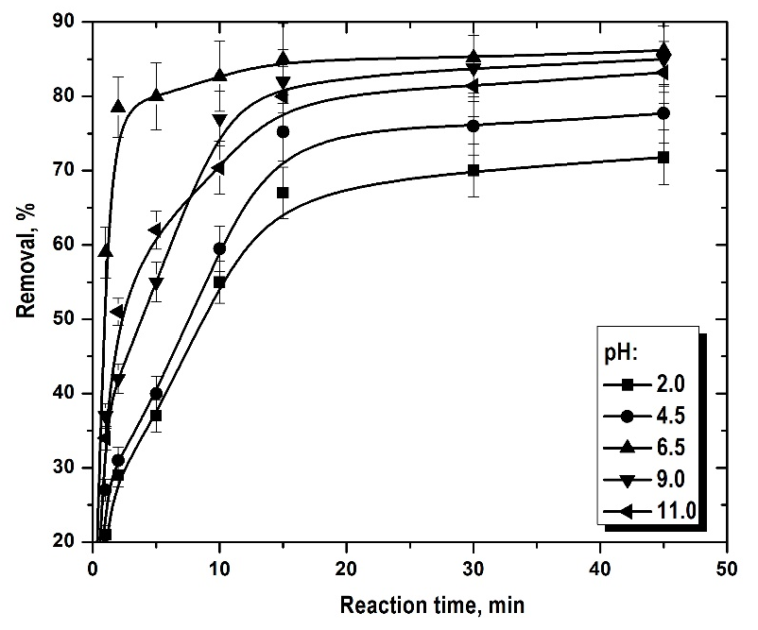
Fig. S1 Effect of pH on removal of TCL in photocatalytic process. Experimental conditions: [TCL]₀ = 100 mg/L, AC/TiO₂ NC = 1.25 g/L and temperature = 25°C. Photo-reaction with an UV lamp of 15W.

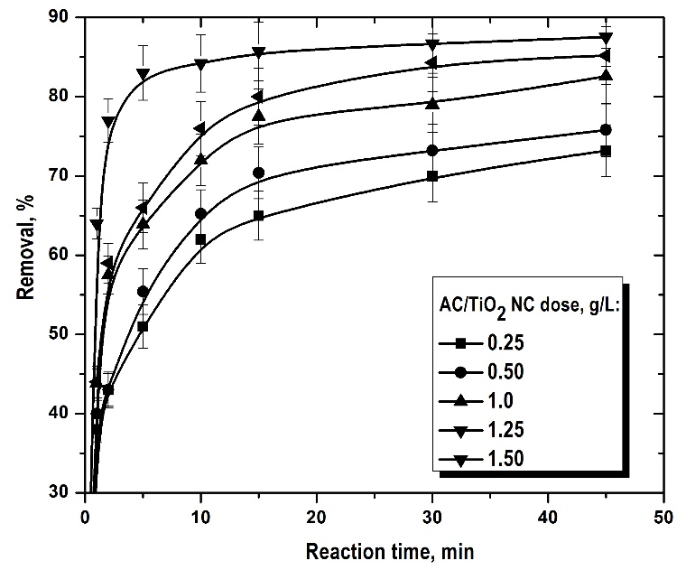
Fig. S2 Effect of catalyst dose on removal of TCL in photocatalytic process. Experimental conditions: [TCL]₀ = 100 mg/L, pH = 6.5 and temperature = 25°C. Photo-reaction with an UV lamp of 15W.

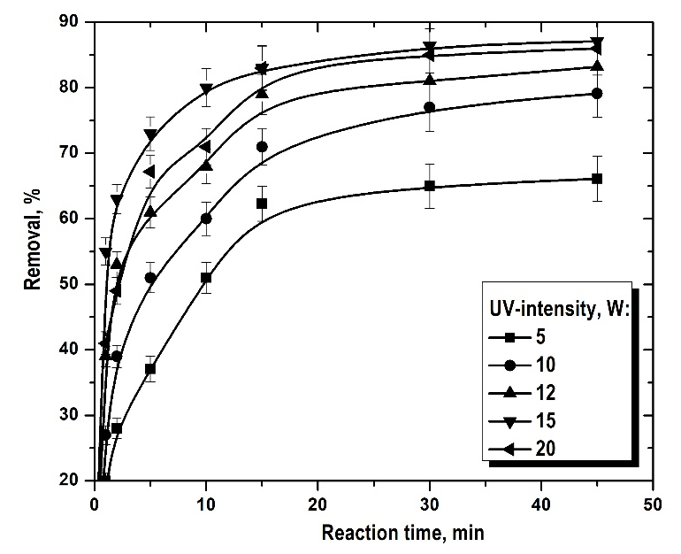
Fig. S3 Effect of UV-light irradiation on removal of TCL in photocatalytic process. Experimental conditions: [TCL]₀ = 100 mg/L, pH = 6.5, AC/TiO₂ NC = 1.25 g/L and temperature = 25°C.

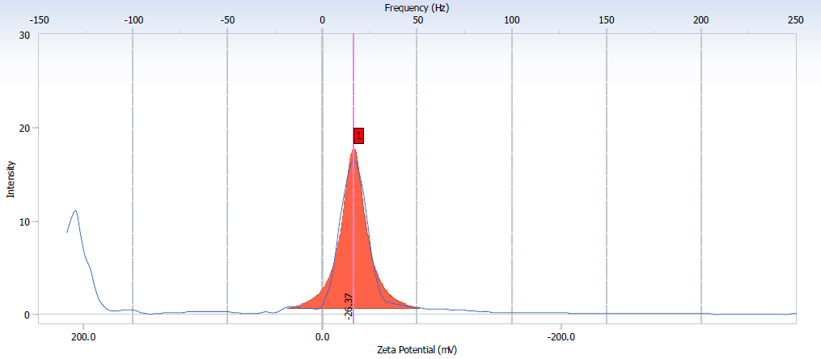
Fig. S4 Zeta Potential curve of the AC/TiO₂ Composite
Fig. S5 Mass spectra of TCL drug in aqueous solution after at 45 min photoreaction with an UV lamp of 15W. Experimental conditions: [TCL]₀ = 100 mg/L, AC/TiO₂ NC = 1.25 g/L, pH = 6.5, reaction time = 45 min and temperature = 25°C.

Table S1 Proposed intermediate products of TCL
Molecule | m/z  (Exact) | Mol. formula | Proposed structure | Mass error (g/mol)  (Exact-proposed) | DBE¥
TCL | 444.43 | C₂₂H₂₄N₂O₈ | 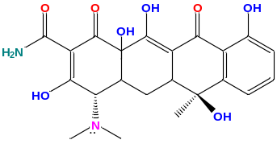 | 0.04 | 12
D₁ | 411.12 | C₂₃H₂₅O₆ | 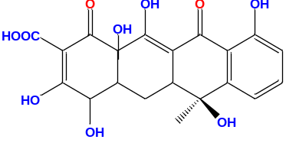 | 0.11 | 11
D₂ | 363.11 | C₁₉H₁₅O₈ | 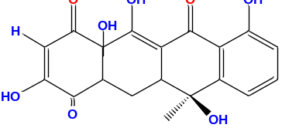 | 0.10 | 11
D₃ | 301.08 | C₁₇H₁₆O₇ | 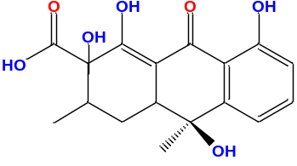 | -0.18 | 09
D₄ | 227.13 | C₁₅H₁₄O₅ | 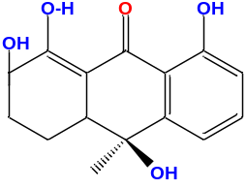 | 0.07 | 08
D₅ | 289.30 | C₁₃H₁₆O₆ | 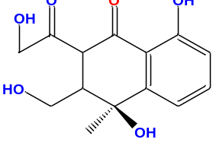 | 0.19 | 07
D₆ | 433.09 | C₂₁H₂₂O₉N | 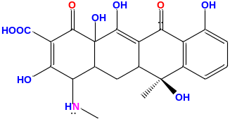 | 0.03 | 11
D₇ | 430.19 | C₂₀H₂₄O₉N | 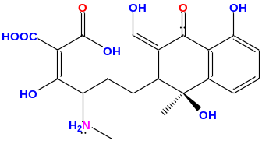 | -0.10 | 09
D₈ | 363.11 | C₁₇H₁₉O₅ | 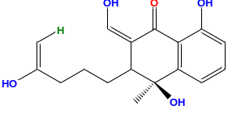 | 0.09 | 08
D₉ | 399.08 | C₁₇H₂₂O₇ | 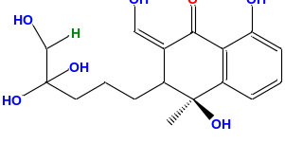 | -0.08 | 07
D₁₀ | 122.11 | C₃H₈O₄ | 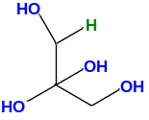 | -0.45 | 00
D₁₁ | 328.03 | C₁₂H₁₂O₅ | 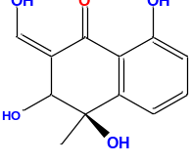 | 0.03 | 07
D₁₂ | 289.12 | C₁₀H₈O₄ | 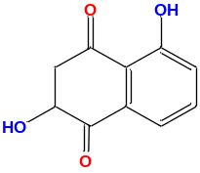 | 0.87 | 07
D₁₃ | 289.12 | C₉H₈O₆ | 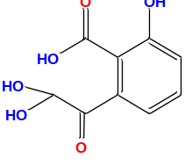 | -0.13 | 05
D₁₄ | 183.09 | C₆H₆O₃ | 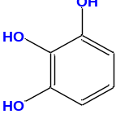 | -0.04 | 03

¥: Double bond equivalent: It is the summations of total number of pi bonds (π) and the residual ring(s). It signifies the degree of unsaturation of degraded products.

