Supplementary Tables
Supplementary Table 1: Analyzed genes with used primers in qRT-PCR*
iGluR Subtype | Receptor subunit | Genes symbol | Taqman assay ID
NMDAR | GluN1 | GRIN1 | Hs00609561_m1
NMDAR | GluN2A | GRIN2A | Hs00168219_m1
NMDAR | GluN2B | GRIN2B | Hs01002012_m1
NMDAR | GluN2C | GRIN2C | Hs01016628_m1
NMDAR | GluN2D | GRIN2D | Hs00181352_m1
NMDAR | GluN3A | GRIN3A | Hs00370290_m1
NMDAR | GluN3B | GRIN3B | Hs00879911_g1
AMPAR | GluA1 | GRIA1 | Hs00181348_m1
AMPAR | GluA2 | GRIA2 | Hs01564838_m1
AMPAR | GluA3 | GRIA3 | Hs01557464_m1
AMPAR | GluA4 | GRIA4 | Hs00898779_m1
KAR | GluK1 | GRIK1 | Hs00543710_m1
KAR | GluK2 | GRIK2 | Hs00222637_m1
KAR | GluK3 | GRIK3 | Hs00168182_m1
KAR | GluK4 | GRIK4 | Hs00205979_m1
KAR | GluK5 | GRIK5 | Hs00361585_m1
* GAPDH was used as housekeeping gene (Taqman assay ID: Hs99999905_m1)

Supplementary Table 2: The details of tripartite chips used for each experiment.
 |  |  | SPONTANEOUS RESPONSE (DAILY BASELINES) |  |  |  |  |  |  |  |  |  | RESPONSES TO GLUTAMATERGIC RECEPTOR MODULATORS
 |  |  | PROXIMAL (1 compartment) |  |  |  |  | DISTAL (2 compartments) |  |  |  |  | PROXIMAL (1 compartment) |  |  |  |  |  | DISTAL (2 compartments)
MEA  # | ND | BL | 3-dpt | 6-dpt | 7/8-dpt ✪ | 10-dpt | 13-dpt | 3-dpt | 6-dpt | 7/8-dpt | 10-dpt | 13-dpt | 3-dpt NMDA | 3-dpt  AMPA | 6-dpt  NMDA | 6-dpt  AMPA | 13-dpt  NMDA | 13-dpt  AMPA | 3-dpt NMDA | 3-dpt  AMPA | 6-dpt  NMDA | 6-dpt  AMPA | 13-dpt  NMDA | 13-dpt  AMPA
1 | ✔ | ✔ | ✔ | ✔ | ✔ | ✔ | ✔ | ✔✔ | ✔✔ | ✔✔ | ✔✔ | ✔✔ |  |  |  |  | ✔ | ✔ |  |  |  |  | ✔✔ | ✔✔
2 | ✔ | ✔ | ✔ | ✔ | ✔ | ✔ | ** | ✔✔ | ✔✔ | *✔ | *✔ | ** |  |  |  |  | ** | ** |  |  |  |  | ** | **
3 | ✔ | ✔ | ✔ | ✔ | ✔ | ✔ | ✔ | ✔✔ | ✔✔ | ✔✔ | ✔✔ | ✔✔ |  |  |  |  | ✔ | ✔ |  |  |  |  | ✔✔ | ✔✔
4 | ✔ | ✔ | ✔ |  |  |  |  | ✔✔ |  |  |  |  | ✔ | ✔ |  |  |  |  | ✔✔ | ✔✔
5 | ✔ | ✔ | ✔ | ✔ |  |  |  | ✔✔ | ✔✔ |  |  |  |  |  | ✔ | ✔ |  |  |  |  | ✔✔ | *✔
6 | ✔ | ✔ | ✔ | ✔ | ✔ | ✔ | ✔ | *✔ | ✔✔ | ✔✔ | ✔✔ | ✔✔ |  |  |  |  | ✔ | ✔ |  |  |  |  | ✔✔ | ✔✔
7 | ✔ | ✔ | ✔ |  |  |  |  | ✔✔ |  |  |  |  | ✔ | ✔ |  |  |  |  | ✔✔ | ✔✔
8 | ✔ | ✔ | ✔ |  |  |  |  | *✔ |  |  |  |  | ✔ | ✔ |  |  |  |  | *✔ | ✔✔
9 | ✔ | ✔ | ✔ |  |  |  |  | ✔✔ |  |  |  |  | ✔ | ✔ |  |  |  |  | ✔✔ | ✔✔
10 | ✔ | ✔ | * |  |  |  |  | * |  |  |  |  | * | ✔ |  |  |  |  | * | *✔
11 | ✔ | ✔ | ✔ | * |  |  |  | ✔✔ | * |  |  |  |  |  | * | ✔ |  |  |  |  | * | ✔✔
12 | ✔ | ✔ | ✔ | ✔ | ✔ | ✔ |  | ✔✔ | ✔✔ | ✔✔ | ✔✔ | **
13 | ✔ | ✔ | ✔ | ✔ |  |  |  | ✔✔ | ✔✔ |  |  |  |  |  | ✔ | ✔ |  |  |  |  | ✔✔ | ✔✔
14 | ✔ | ✔ | ✔ | ✔ |  |  |  | ✔✔ | ✔✔ |  |  |  |  |  | ✔ | ✔ |  |  |  |  | ✔✔ | ✔✔
15 | ✔ | ✔ | ✔ | ✔ |  |  |  | *✔ | ✔✔ |  |  |  |  |  | ✔ | ✔ |  |  |  |  | ✔✔ | ✔✔
16 | ✔ | ✔ | ✔ | ✔ |  |  |  | ✔✔ | ✔✔ |  |  |  |  |  | ✔ | ✔ |  |  |  |  | ✔✔ | ✔✔
17 | ✔ | ✔ | ✔ |  | ✔ | ✔ | ✔ | ✔✔ |  | ✔✔ | ✔✔ | ✔✔ |  |  |  |  | ✔ | ✔ |  |  |  |  | ✔✔ | ✔✔
18 | ✔ | ✔ | ✔ |  | ✔ | ✔ | ✔ | ✔✔ |  | ✔✔ | ✔✔ | ✔✔ |  |  |  |  | ✔ | ✔ |  |  |  |  | ✔✔ | ✔✔
19 | ✔ | ✔ | ✔ |  |  |  |  | ✔✔ |  |  |  |  | ✔ | ✔ |  |  |  |  | ✔✔ | *
20 | ✔ | ✔ | ✔ |  | ✔ | ✔ | ✔ | ✔✔ |  | ✔✔ | ✔✔ | ✔✔ |  |  |  |  | ✔ | ✔ |  |  |  |  | ✔✔ | ✔✔
21 | ✔ | ✔ | ✔ |  | ✔ | ✔ | ✔ | ✔✔ |  | ✔✔ | ✔✔ | ✔✔ |  |  |  |  | ✔ | ✔ |  |  |  |  | ✔✔ | ✔✔
22 | ✔ | ✔ | ✔ |  |  |  |  | ✔✔ |  |  |  |  | ✔ | ✔ |  |  |  |  | ✔✔ | ✔✔
23 | ✔ | ✔ | ✔ |  |  |  |  | ✔✔ |  |  |  |  | ✔ | ✔ |  |  |  |  | ✔✔ | ✔✔
24 | ✔ | ✔ | ✔ |  | ✔ | ✔ | ✔ | ✔✔ |  | ✔✔ | ✔✔ | ✔✔ |  |  |  |  | ✔ | ✔ |  |  |  |  | ✔✔ | ✔✔
25 | ✔ | ✔ | * | ✔ |  |  |  | ✔✔ | ✔✔ |  |  |  |  |  | ✔ | ✔ |  |  |  |  | ✔✔ | ✔✔
26 | ✔ | ✔ | ✔ | ✔ |  |  |  | ✔✔ | ✔✔ |  |  |  |  |  | ✔ | ✔ |  |  |  |  | ✔✔ | ✔✔
27 | ✔ | ✔ | ✔ |  |  |  |  | ✔✔ |  |  |  |  | ✔ | ✔ |  |  |  |  | ✔✔ | ✔✔
28 | ✔ | ✔ | ✔ |  |  |  |  | ✔✔ |  |  |  |  | ✔ | ✔ |  |  |  |  | ✔✔ | ✔✔
29 | ✔ | ✔ | ✔ |  | * | ✔ | ✔ | *✔ |  | *✔ | ✔✔ | ✔✔ |  |  |  |  | * | ✔ |  |  |  |  | * | ✔✔
30 | ✔ | ✔ | ✔ | ✔ |  |  |  | ✔✔ | ✔✔ |  |  |  |  |  | ✔ | ✔ |  |  |  |  | ✔✔ | ✔✔
31 | ✔ | ✔ | ✔ | ✔ |  |  |  | ✔✔ | ✔✔ |  |  |  |  |  | ✔ | ✔ |  |  |  |  | ✔✔ | ✔✔
32 | ✔ | ✔ | ✔ | ✔ |  |  |  | ✔✔ | ✔✔ |  |  |  |  |  | ✔ | ✔ |  |  |  |  | ✔✔ | *✔
(n) | 32 | 32 | 30 | 15 | 10 | 11 | 9 | 58 | 30 | 20 | 21 | 18 | 9 | 10 | 10 | 11 | 8 | 9 | 17 | 17 | 20 | 20 | 16 | 18
Red and blue boxes indicate PFF treated and control circular tripartite models, respectively. Black boxes are MEAs which were not recorded in that time point (used/reserved for another time point).
single tick (✔): proximal compartment recorded and used for analysis, double thick (✔ ✔): both distal compartments recorded and used for analysis one asterix and single tick (*✔) : one of the distal compartments recorded and used for analysis, and one asterix (*): both distal compartments discarded from analysis (**): MEA was totally damaged/not recorded. Unused or discarded recordings were because of technical failure during the recording, noise or because of damaged MEA.
✪ MEAs recorded day 7 were not recorded on day 8 and vice versa. Day 7 and 8 recordings were pooled/analyzed together.
ND: Network development analysis
BL: Baseline recordings before PFF treatment

Supplementary Table 3: Details for confocal microscopy tiles used for quantifying presynaptic protein content and α–s aggregation.
Time point | Treatment | Number of Regions | Number of Tiles (n)*
3-dpt | PBS | 6 | 34
3-dpt | PFF | 6 | 36
6-dpt | PBS | 5 | 31
6-dpt | PFF | 4 + 3 ** | 24 + 19**
13-dpt | PBS | 5 | 29
13-dpt | PFF | 6 | 29
* Each tile has 0.118 x 0.118 mm size taken in the vicinity of starting regions
**3 additional regions N=19 tiles taken for presynaptic protein content quantification

Supplementary Figures

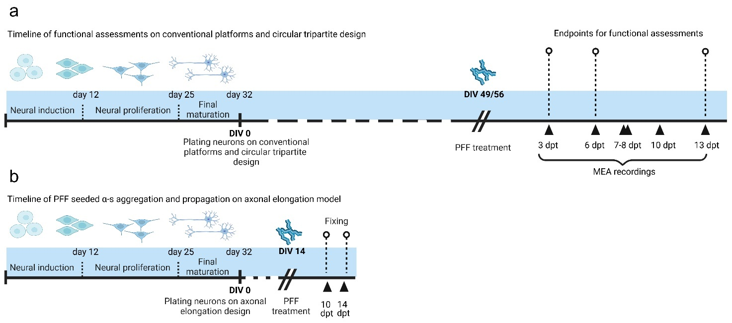
Supplementary Figure 1. Timeline of development of cortical neurons and PFF seeding experiments. Differentiation and maturation of cortical neurons before plating on final culturing platforms includes neural induction stage (first 12 days), neural proliferation stage (day 13 to day 25) and final maturation stage (day 26 to 32). Cells were cultured on conventional, axonal elongation, or circular tripartite platforms (DIV 0). a For functional studies PFF treatment on circular tripartite design was performed at DIV 49 or 56. MEA recordings were obtained 3, 6, 7-8, 10 and 13 days after PFF treatment and glutamatergic modulators were applied on endpoints at 3, 6 and 13 dpt. d To test and optimize PFF-induced α-s aggregation and axonal transport, the axonal elongation design was treated with PFF at DIV 14 and aggregation was analyzed at 10 and 14 dpt.

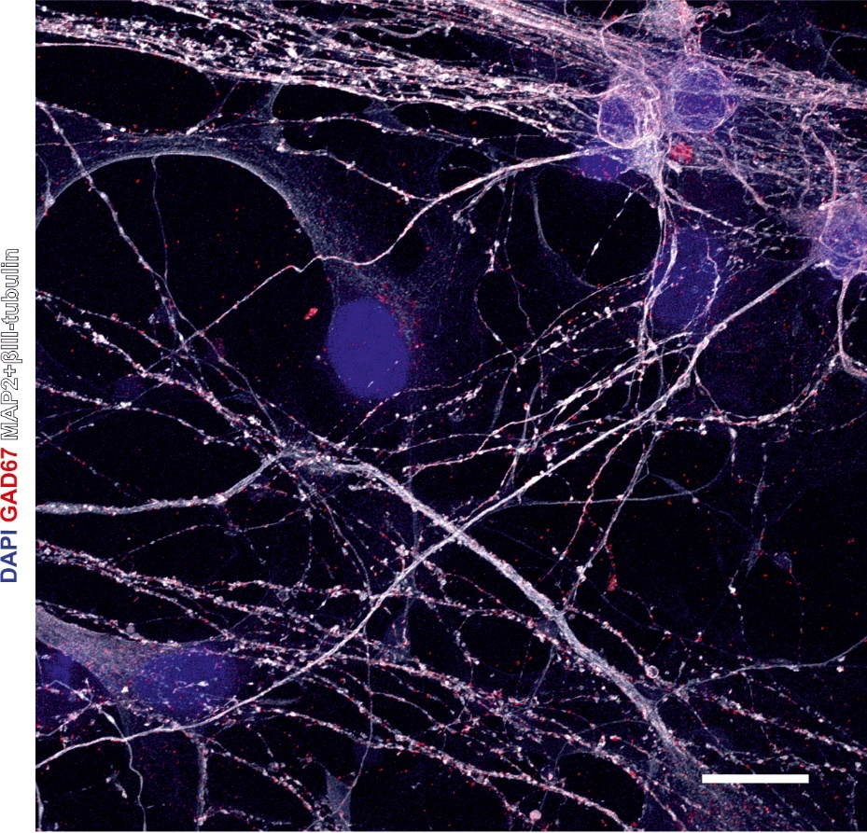
Supplementary Figure 2. GABAergic markers in neuronal cells. Representative image depicting the expression of the GABAergic marker GAD67 in hiPSC-derived cortical neurons at DIV 35, prominently localized within neurites identifiable by MAP2 and βIII-tubulin, and is visualized as red puncta. Scale bar is 10µm.
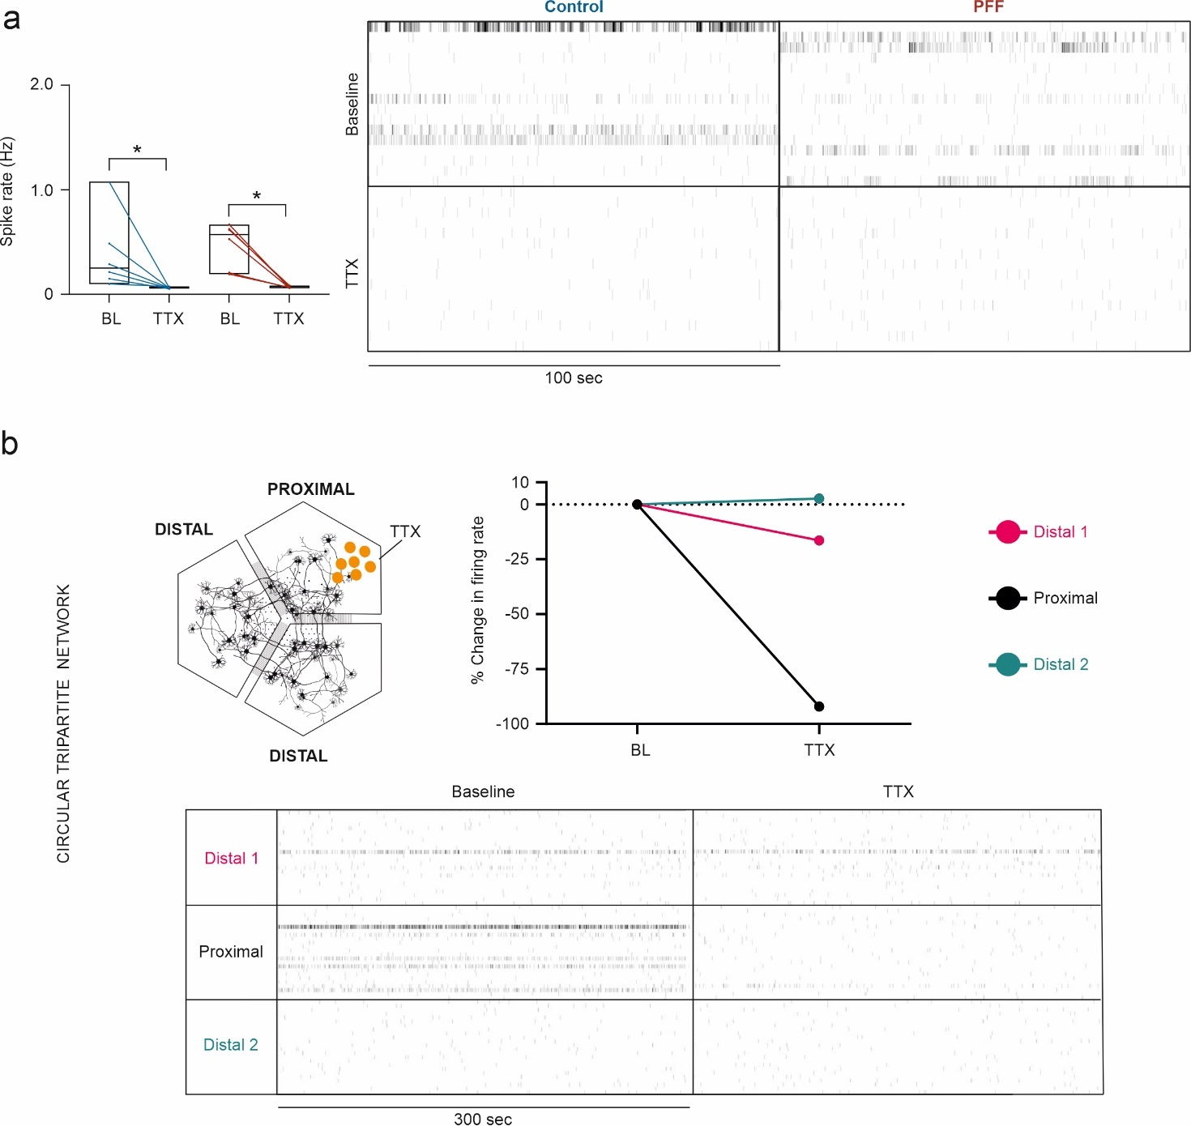
Supplementary Figure 3. Effect of Na⁺ channel blocker tetrodotoxin on conventional and circular tripartite networks. a Na⁺ channel blocker tetrodotoxin (TTX) significantly silences the neuronal activity in MEA wells (n=6) in conventional networks. p values were calculated with Wilcoxon Signed Ranked test for pairwise comparison of TTX application to baseline (BL) (*p<0.05). Raster plots represent the neuronal activity before and after TTX application b TTX application silenced the neuronal activity majorly in the applied proximal compartment while affecting the distal compartments minimally or not at all. Raster plots represent the proximal and distal compartments of the experimented circular tripartite network.
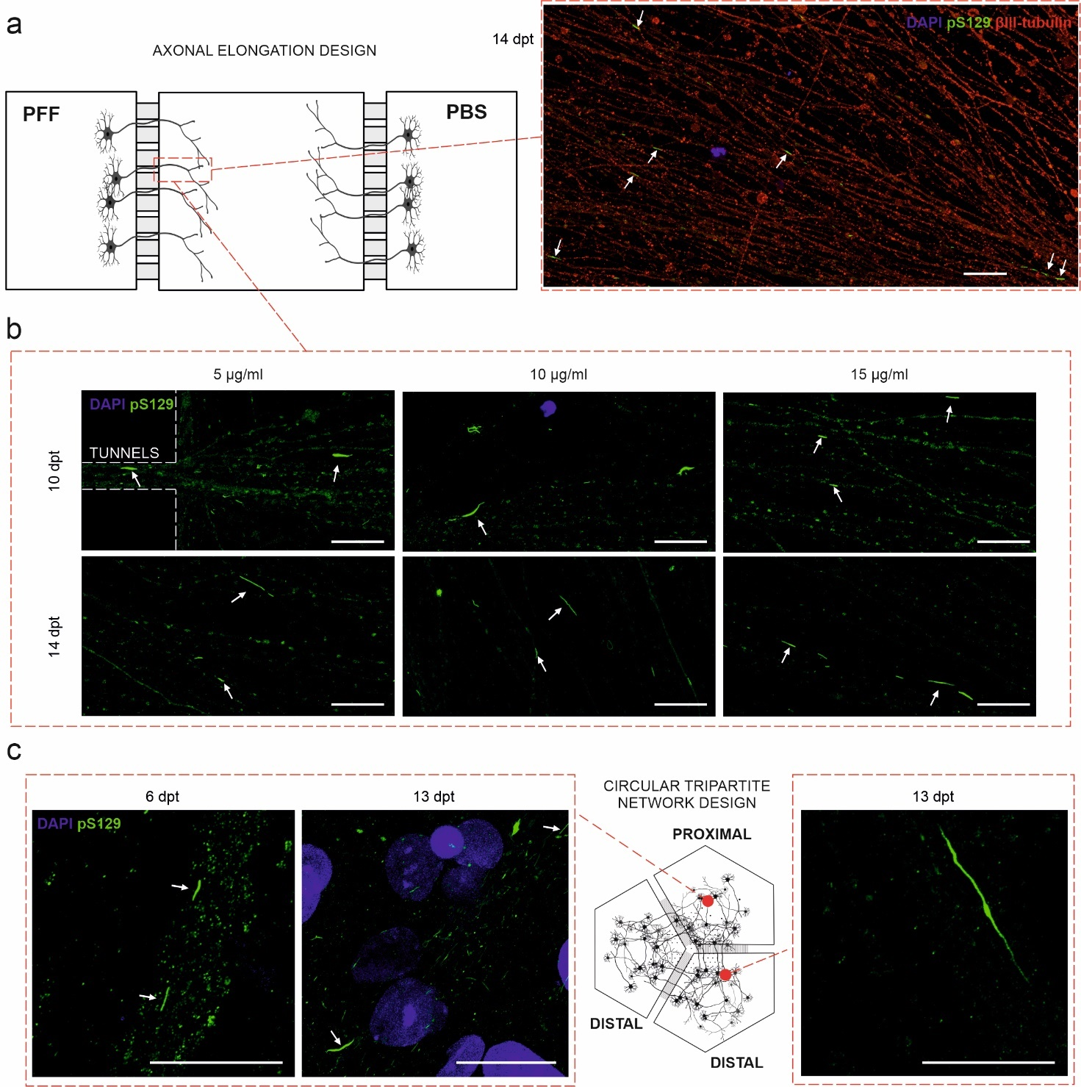
Supplementary Figure 4. PFF seeded α-s aggregation and propagation of aggregated forms with different PFF concentrations. a Representative image from the axon alignment model demonstrate pS129 (green indicated with white arrows) positive α-s aggregates shown in middle compartment close to the PFF treated compartment. Aggregates are aligned with axons (βIII-tubulin, red). Also, b pS129 positive α-s aggregates (green indicated with white arrows) observed as a result of PFF seeding exposed in concentrations of 5, 10 and 15 µg/ml at 10 and 14 dpt in middle compartment close to the PFF treated compartment. c Representative images from the circular tripartite model showing pS129 positive aggregates (green indicated with white arrows) at 6 and 13 dpt in proximal compartment and at 13 dpt in distal compartment. All the scale bars are 20µm.

