Supplemental Material 1:
Supplemental methods
Intervention development: the intervention included the following surgical units: general surgery, liver surgery, colorectal, upper gastrointestinal, pancreatic surgery, gynaecology, otorhinolaryngology, plastic surgery, urology, vascular surgery, and orthopaedic surgery.
Moving from previous initiatives focused on single pathways and processes, the hospital implemented a systematic Value Based Care Model, including the following steps.

- Evidence-based re-design of preoperative pathway. This phase included the validation of clinical pathways in compliance through an evidence-based evaluation and was conducted by multidisciplinary teams and through structured meetings between clinicians.
- Organizational process. After the revision of the clinical pathway, we designed the organizational process (including the operationalization of the clinical pathway), and designed a digital governance system with indicators and metrics.
- Business case. This phase allowed the creation of the economic analysis (including costs and sustainability), the definition of the action plan, and the validation of a final dashboard with indicators on outcomes, process, quality of care and costs.

Training and validation phase: The entire year of 2020 was spent to training personnel, validating the intervention, and establishing the informatic support to automate the procedure. During the validation phase, the questionnaire was used and modified according to surgeons’, patients’ and anaesthesiologists’ feedback, and was maintained simple and quick in its development. The questionnaire can indeed be completed in a few minutes based on patients’ answers.
To exemplify, if the patient answers “no” to three initial screening questions, the questionnaire stops and the patient is directly classified as low medical risk. In contrast, the questionnaire continues, but “red/stopping” answers directly designate the patients at high-medical risk.
The medical risk questionnaire was maintained the same across all areas. In contrast, each IPUs classified the surgical interventions, ICD-9 code by ICD-9 code, in the three different surgical risks (low, medium, and high). The 11 IPUs' unique risk matrices were created by combining these two risk within each of the 11 IPUs. To facilitate this process, we were able to build an automated procedure directly into the EHR system. In this automated process, the clinicians follow the medical risk questionnaire directly on the EHR, and similarly the surgical risk is automatically extracted from the ICD9 code. In a few “clicks”, the EHR automatically generates the preoperative risk matrix and assign the patient to a category of risk and to the corresponding preoperative pathway.

Data reporting and statistical analysis
Potential source of bias in cohort study were identified in selection and reporting bias. Selection biases were considered to have minimal impact in this cohort study, given the nature of EHR analysis (there was no change in EHR structure between 2019 and 2021), the study selection criteria, and the large population extracted. Reporting bias may have influenced quality and completeness of entered data. For example, some data may be occasionally under-reported, however this type of error is unlikely to have changed over time or have significant time trends, and is limited by the medical-legal requirements which mandate completeness of EHR documentation.
Variables were described by frequencies (percentage) or mean (SD) and median (IQR), as appropriate. Univariate associations were tested by Chi-Square test, and Mann-Whitney U test as appropriate, considering a threshold of 0.05 for statistical significance. All statistical analyses were performed using R software, version 4.2.1.

Supplemental material 2: Medical History Questionnaire
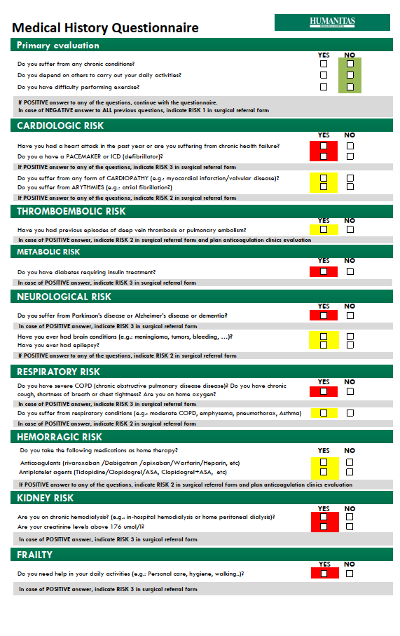
Supplemental material 3: Algorithmic Flowchart of Medical Questionnaire decision process
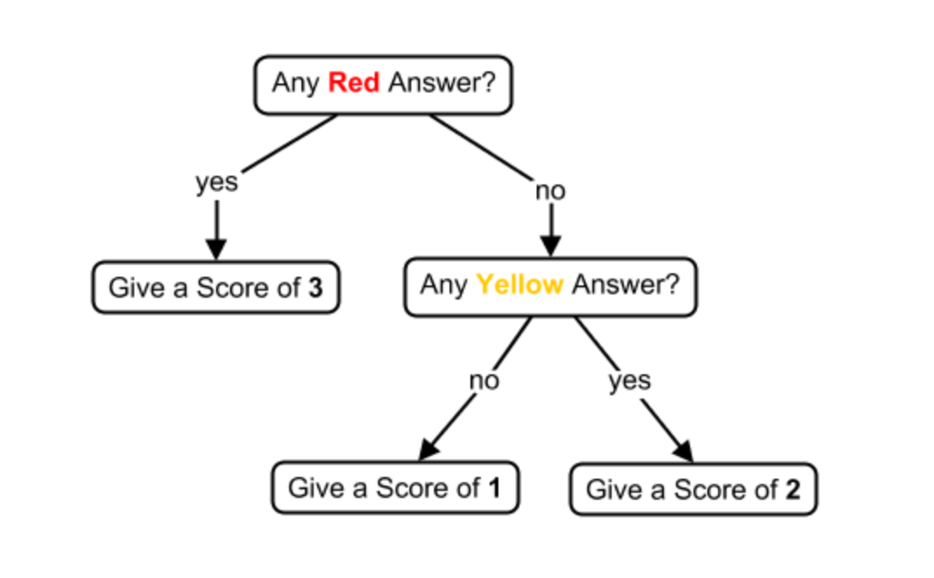

Supplemental material 4 - the cycle of care and Humanitas Risk Matrix
The cycle of care. The overall cycle of care of the surgical patient was considered in this study. The surgeon’s visit represents the beginning point, when the hospitalization proposal is filled in. During this phase the surgeon identifies i) the patient’s risk through a questionnaire (according to his medical condition) and ii) the surgery’s severity (following standards previously identified). Successively, the surgery is scheduled and the visits and medical tests of pre-operative assessment (i.e., the pre-operative assessment pathway) are identified according to the matrix based on the patient’s risk and surgery’s severity.
As reported in Manuscript Figure 1, pre-operative assessment is composed by different tests/visits according to three levels of complexity:
- Low complexity – includes the surgeries classified as “minor severity” by surgeons and with medical risk class 1 and 2 (No test or simplified test routine)
- Medium complexity – includes the surgeries classified as “intermediate severity” or “major severity” and with medical risk class 1 and 2, or the surgeries classified as “minor severity” or “intermediate severity” and with medical risk class 3 (blood test and ECG in addition to vitals detection)
For major severity surgeries with medical risk class 2 and intermediate surgeries with medical risk class 3 we added a preoperative cardiology consult;
- High complexity – includes “major severity” surgeries with medical risk class 3. We require a complete preoperative assessment with blood test, EKG, vitals detection, a cardiac visit and a multidisciplinary clinic dedicated to high-complexity patients.

Supplemental material 5: Bubble chart representing the use percentage variation in preoperative testing and clinics before and after the intervention, comparing Hospitalized and Day Surgery patients
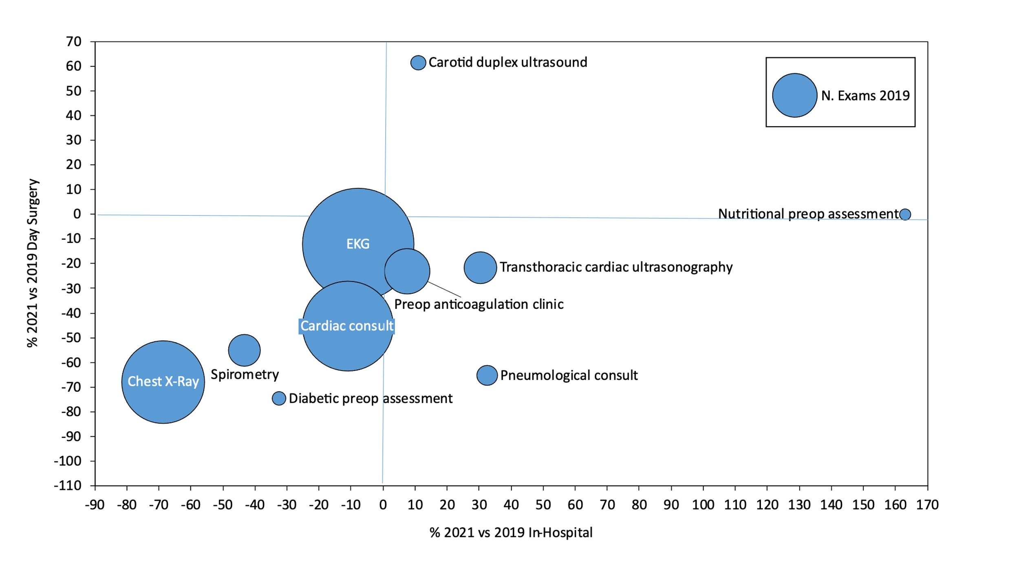

Supplemental material 6: Preoperative thoracic X-Ray before and after intervention by year and surgical specialty

Supplemental material 7: Spider plot on preoperative test and exam variations
Figure A represents the percentage reduction in preoperative tests and visits before and after the intervention, in Hospitalized vs Day Surgery patients. Figure B represent the percentage increase in preoperative tests and visits. Figure C merges both in a single plot, representing the percentage variation (above and below 0%) of preoperative test and visits after the intervention.
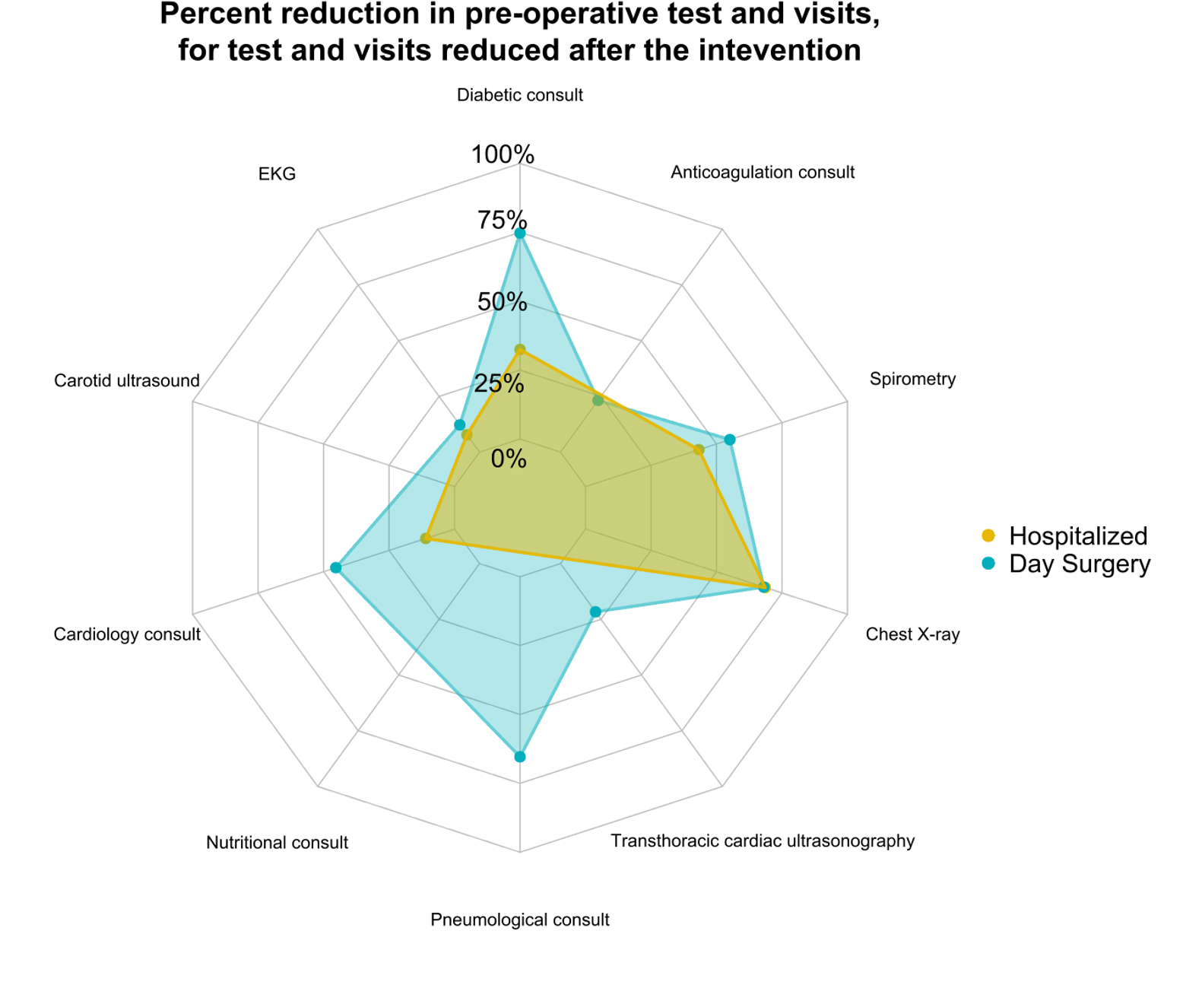
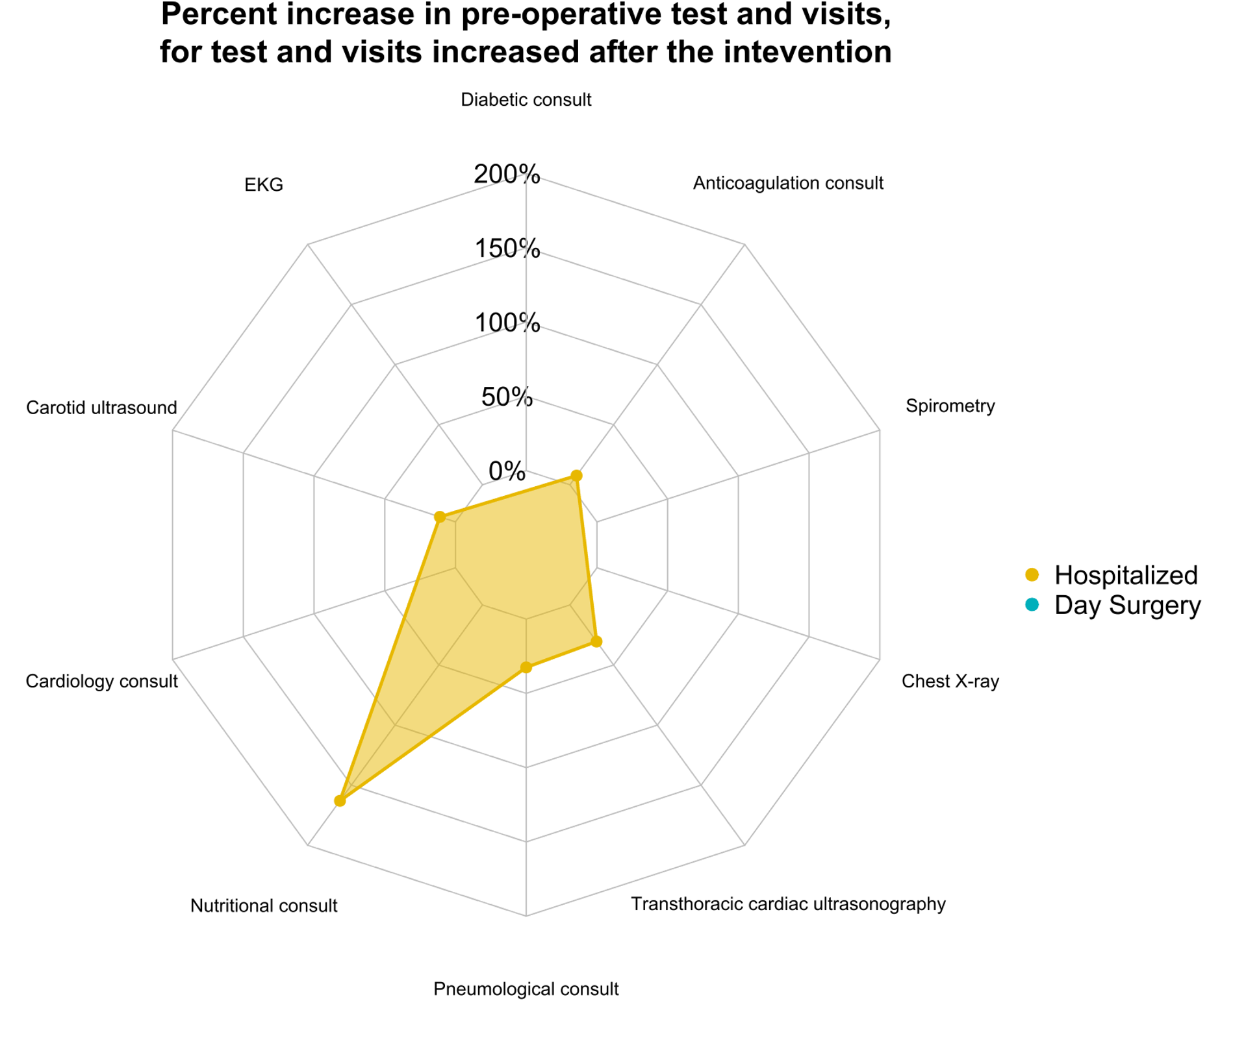
A
B

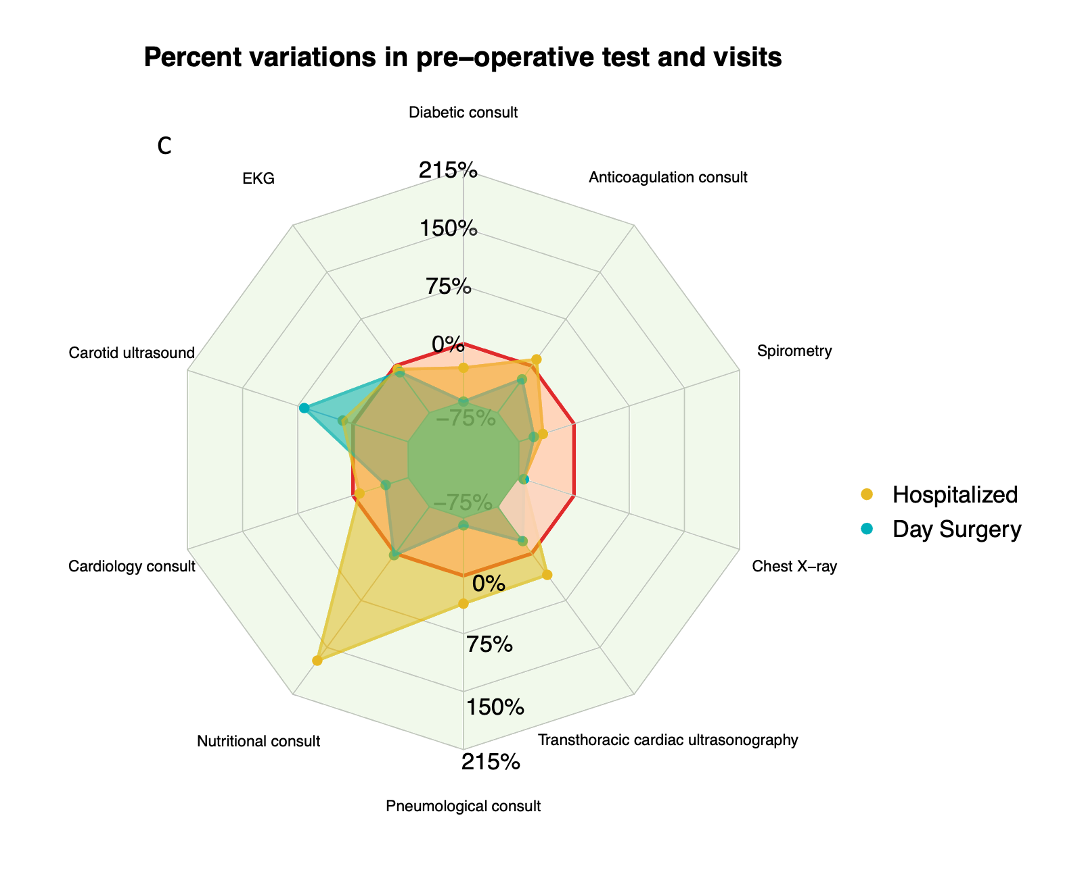
Supplemental material 8:
Initial experience of external validation in another hospital from our organization.
In past two years, we were able to transfer our VBHC strategy to a different hospital within our organization. The Humanitas Istituto Clinico Catanese, in Sicily, differs in terms of size (approximately 180 hospital beds compared to more than 800 in our study), surgical volume and surgical characteristics (mostly oncological patients). Moreover, it is situated in a different regional healthcare system (Sicilian regional healthcare system), which has some organizational differences compared to ours (to Lombardy Healthcare System). Even though we were unable yet to collect data from this secondary centre and evaluate efficacy in this context, the intervention was implemented without undue delay.

Supplemental material 9: Compliance with preoperative pathway
The table reports the percentage of adjunctive preoperative test requested by physician during preoperative consult, over the total number of the test in the preoperative pathway.
Test | Abdominal surgery | Liver  surgery | Plastic  surgery | Vascular  surgery | Pancreatic  surgery | Gynecological surgery | ENT surgery | Orthopedic  surgery | Urological  surgery | Overall
Chest X-ray | 1.8% | 1% | 0% | 1% | 1% | 1% | 1% | 1% | 2% | 1%
Preoperative cardiology consult | 6.8% | 9% | 7% | 11% | 9% | 6% | 8% | 7% | 12% | 8%

