Table S1 Genomic information of strains used in this study. Items that were excluded in the phylogenomic analysis for low quality (fewer core genes were detected) are marked in red.
Species | Strain | Genome size | GC content (%) | Assemble
Nesterenkonia aerolata sp. nov. | LY-0111 | 2.84 | 66.5 | GCA_031470965.1
Nesterenkonia alba | DSM 19423 | 2.59 | 63.7 | GCA_000421745.1
Nesterenkonia alkaliphila | CGMCC 1.12781 | 3.40 | 64.8 | GCA_014639295.1
Nesterenkonia aurantiaca | DSM 27373 | 2.95 | 67.6 | GCA_004364585.1
Nesterenkonia cremea | CGMCC 1.15388 | 3.08 | 66.9 | GCA_014642675.1
“Nesterenkonia ebinurensis” | MD2 | 3.70 | 63.8 | GCA_008711175.1
Nesterenkonia flava | CCTCC AB 207010 | 2.86 | 65.5 | GCA_031470965.1
Nesterenkonia haasae | Hz 6-5 | 3.43 | 60.8 | GCA_010119385.1
Nesterenkonia halophila | DSM 16378 | 2.19 | 71.7 | GCA_009467795.1
Nesterenkonia halotolerans | DSM 15474 | 2.97 | 66.2 | GCA_014874065.1
Nesterenkonia jeotgali | DSM 19081 | 3.00 | 67.4 | GCA_014138825.1
Nesterenkonia lacusekhoensis | DSM 12544 | 2.74 | 66.7 | GCA_017876395.1
Nesterenkonia lutea | DSM 15666 | 2.96 | 66.7 | GCA_014873955.1
Nesterenkonia massiliensis | NP1 | 2.67 | 62.7 | GCA_000455245.1
Nesterenkonia muleiensis | RB2 | 3.70 | 63.5 | GCA_003600155.1
Nesterenkonia natronophila | M8 | 2.52 | 61.8 | GCA_003595215.1
Nesterenkonia pannonica | DSM 29786 | 2.70 | 66.1 | GCA_019575955.1
Nesterenkonia populi | DSM 27959 | 2.55 | 66.8 | GCA_007994735.1
Nesterenkonia salmonea | GY074 | 3.28 | 61.1 | GCA_005771525.1
Nesterenkonia sandarakina | DSM 15664 | 3.02 | 67.5 | GCA_013410215.1
Nesterenkonia sedimenti | MY13 | 3.10 | 63.7 | GCA_012641515.1
Nesterenkonia sphaerica | GY239 | 2.79 | 64.2 | GCA_005771565.1
Nesterenkonia xinjiangensis | DSM 15475 | 3.57 | 68.8 | GCA_013410745.1
Acaricomes phytoseiuli | DSM 14247 | 2.42 | 62.3 | GCA_000376245.1
Arthrobacter agilis | DSM 20550 | 3.24 | 68.8 | GCA_006494655.1
Arthrobacter alpinus | DSM 22274 | 4.62 | 60.6 | GCA_900105965.1
Arthrobacter antioxidans | QL17 | 3.78 | 69.5 | GCA_023100725.1
Arthrobacter bussei | KR32 | 3.63 | 69.2 | GCA_009377195.2
Arthrobacter castelli | DSM 16402 | 4.59 | 63.6 | GCA_000430705.1
Arthrobacter cheniae | Hz2 | 4.02 | 66.2 | GCA_003602275.1
Arthrobacter citreus | DSM 20133 | 3.55 | 65.6 | GCA_009192745.1
“Arthrobacter crusticola” | SLN-3 | 3.67 | 68.1 | GCA_004357995.1
Arthrobacter cryoconiti | Cr6-08 | 3.60 | 58.5 | GCA_020905375.1
Arthrobacter crystallopoietes | DSM 20117 | 5.20 | 64.4 | GCA_900100805.1
Arthrobacter cupressi | DSM 24664 | 4.09 | 66.9 | GCA_013409905.1
Arthrobacter deserti | CGMCC 1.15091 | 3.26 | 65.4 | GCA_012395865.1
Arthrobacter echini | AM23 | 3.18 | 67.0 | GCA_004803505.1
Arthrobacter gandavensis | JCM 13316 | 3.72 | 65.4 | GCA_009192735.1
Arthrobacter glacialis | HLT2-12-2 | 4.47 | 61.4 | GCA_002909445.1
Arthrobacter globiformis | NBRC 12137 | 4.95 | 66.2 | GCA_000238915.2
Arthrobacter jiangjiafuii | zg-ZUI227 | 3.59 | 66.1 | GCA_018622995.1
Arthrobacter koreensis | DSM 16760 | 3.55 | 65.8 | GCA_009193255.1
Arthrobacter liuii | CGMCC 1.12778 | 4.82 | 65.5 | GCA_014639275.1
Arthrobacter livingstonensis | LI2 | 5.04 | 64.8 | GCA_003219815.1
Arthrobacter luteolus | DSM 13067 | 3.87 | 66.0 | GCA_008973725.1
Arthrobacter mobilis | E918 | 4.40 | 68.7 | GCA_012395835.1
“Arthrobacter nitrophenolicus” | SJCon | 4.39 | 66.2 | GCA_000332815.1
Arthrobacter oryzae | DSM 25586 | 4.31 | 67.1 | GCA_003634095.1
Arthrobacter pascens | DSM 20545 | 4.81 | 65.7 | GCA_017052465.1
Arthrobacter pigmenti | DSM 16403 | 3.79 | 63.5 | GCA_011927905.1
Arthrobacter pityocampae | Tp2 | 3.64 | 69.6 | GCA_002927275.1
Arthrobacter polaris | C1-1 | 4.17 | 58.9 | GCA_021398215.1
Arthrobacter psychrochitiniphilus | DSM 23143 | 4.10 | 59.7 | GCA_013408645.1
Arthrobacter rhizosphaerae | CCNWLXL 1-35 | 5.02 | 61.9 | GCA_023062595.1
“Arthrobacter roseus” | DSM 14508 | 3.08 | 60.1 | GCA_016907875.1
Arthrobacter ruber | MDB1-42 | 3.66 | 69.0 | GCA_002954225.1
Arthrobacter saudimassiliensis | 11W110_air | 3.55 | 70.3 | GCA_900016675.1
Arthrobacter sedimenti | MIC A30 | 4.42 | 67.2 | GCA_011750795.2
Arthrobacter silviterrae | DSM 27180 | 4.29 | 65.8 | GCA_011045165.1
Arthrobacter stackebrandtii | DSM 16005 | 4.43 | 65.6 | GCA_017876675.1
Arthrobacter sulfonylureivorans | LAM7117 | 4.13 | 65.9 | GCA_004000035.1
Arthrobacter sunyaminii | zg-ZUI122 | 3.91 | 64.5 | GCA_018866305.1
Arthrobacter terrae | Z1-20 | 4.43 | 62.6 | GCA_015708085.1
Arthrobacter terricola | JH1-1 | 5.57 | 63.6 | GCA_004354015.1
Arthrobacter tumbae | DSM 16406 | 3.70 | 63.8 | GCA_016907495.1
Arthrobacter woluwensis | DSM 10495 | 3.86 | 68.1 | GCA_900105345.1
Arthrobacter yangruifuii | 785 | 3.54 | 66.1 | GCA_009192775.1
Arthrobacter zhaoguopingii | J391 | 3.89 | 68.0 | GCA_009828595.1
Auritidibacter ignavus | DSM 45359 | 2.63 | 59.4 | GCA_011758685.1
Citricoccus muralis | DSM 14442 | 3.52 | 68.7 | GCA_003386075.1
Citricoccus zhacaiensis | CGMCC 1.7064 | 3.69 | 68.9 | GCA_014645315.1
Enteractinococcus coprophilus | DSM 24083 | 2.88 | 56.7 | GCA_006716305.1
“Enteractinococcus helveticum” | UASWS1574 | 3.67 | 56.2 | GCA_001657475.1
Galactobacter caseinivorans | JZ R-183 | 2.95 | 67.4 | GCA_003640665.1
Galactobacter valiniphilus | JZ R-35 | 3.42 | 70.6 | GCA_003575975.1
Garicola koreensis | DSM 28238 | 2.25 | 65.4 | GCA_014195445.1
Glutamicibacter ardleyensis | CGMCC 1.3685 | 3.94 | 56.5 | GCA_014644555.1
Glutamicibacter arilaitensis | Re117 | 3.92 | 59.3 | GCA_000197735.1
Glutamicibacter halophytocola | KLBMP 5180 | 3.92 | 60.0 | GCA_001302565.1
Glutamicibacter mishrai | S5-52 | 3.57 | 59.4 | GCA_012221945.1
Glutamicibacter nicotianae | NBRC 14234 | 3.55 | 61.9 | GCA_006539525.1
Glutamicibacter protophormiae | DSM 20168 | 3.87 | 64.0 | GCA_017876615.1
Glutamicibacter uratoxydans | NBRC 15515 | 3.79 | 61.1 | GCA_006539925.1
Haematomicrobium sanguinis | DSM 21259 | 2.93 | 61.9 | GCA_000688395.1
Kocuria carniphila | CCM 132 | 3.42 | 64.2 | GCA_004136555.1
Kocuria coralli | SCSIO 13007 | 3.43 | 68.6 | GCA_008831305.1
Kocuria dechangensis | CGMCC 1.12187 | 4.46 | 72.3 | GCA_014636775.1
Kocuria flava | HO-9041 | 3.64 | 73.9 | GCA_001482365.1
Kocuria indica | NIO-1021 | 2.88 | 68.9 | GCA_900177335.1
Kocuria palustris | TAGA27 | 2.90 | 70.2 | GCA_016907795.1
Kocuria polaris | CMS 76or | 3.78 | 72.8 | GCA_000786195.1
Kocuria rhizophila | TA68 | 2.70 | 70.7 | GCA_003667225.1
Kocuria rosea | ATCC 186 | 3.95 | 72.8 | GCA_006094695.1
“Kocuria sediminis” | JCM 17929 | 3.93 | 72.8 | GCA_009735315.1
Kocuria soli | M5W7-7 | 2.95 | 67.0 | GCA_003797835.1
Kocuria subflava | YIM 13062 | 3.03 | 64.4 | GCA_012163155.1
Kocuria turfanensis | HO-9042 | 4.16 | 72.7 | GCA_001580365.1
“Kocuria tytonicola” | DSM 104133 | 2.61 | 71.0 | GCA_003687455.1
Kocuria tytonis | 442 | 2.72 | 70.8 | GCA_003226895.2
Kocuria varians | NBRC 15358 | 2.84 | 70.6 | GCA_006539885.1
Micrococcus aloeverae | DSM 27472 | 2.52 | 72.9 | GCA_022664405.1
Micrococcus cohnii | DSM 23974 | 2.28 | 70.7 | GCA_014205175.1
Micrococcus endophyticus | DSM 17945 | 2.71 | 73.6 | GCA_014205115.1
Micrococcus flavus | DSM 19079 | 2.55 | 73.4 | GCA_014204815.1
Micrococcus luteus | ATCC 4698 | 2.56 | 73.1 | GCA_006094415.1
Micrococcus lylae | NBRC 15355 | 2.69 | 71.3 | GCA_001570885.1
Micrococcus terreus | CGMCC 1.7054 | 3.09 | 68.9 | GCA_900116905.1
Micrococcus yunnanensis | DSM 24531 | 2.47 | 73.0 | GCA_014874165.1
Neomicrococcus lactis | DSM 23694 | 2.70 | 58.6 | GCA_014200305.1
Paenarthrobacter aurescens | NBRC 12136 | 4.31 | 62.0 | GCA_006538985.1
Paenarthrobacter histidinolovorans | JCM 2520 | 4.65 | 62.9 | GCA_014647595.1
Paenarthrobacter ilicis | DSM 20138 | 3.97 | 62.9 | GCA_016907545.1
Paenarthrobacter nicotinovorans | ATCC 49919 | 4.48 | 63.1 | GCA_021919345.1
Paenarthrobacter nitroguajacolicus | JCM 14115 | 5.13 | 62.2 | GCA_001313365.1
Paenarthrobacter ureafaciens | DSM 20126 | 4.40 | 63.4 | GCA_004028095.1
Paeniglutamicibacter cryotolerans | DSM 22826 | 4.14 | 64.8 | GCA_014190875.1
Paeniglutamicibacter gangotriensis | Lz1y | 4.32 | 63.0 | GCA_000348945.1
Paeniglutamicibacter kerguelensis | DSM 15797 | 4.81 | 64.2 | GCA_017876535.1
Paeniglutamicibacter psychrophenolicus | DSM 15454 | 4.91 | 65.8 | GCA_017876575.1
Paeniglutamicibacter quisquiliarum | ABSL32-1 | 4.44 | 66.0 | GCA_019084045.1
Pseudarthrobacter albicanus | NJ-Z5 | 4.57 | 67.1 | GCA_018224015.1
Pseudarthrobacter chlorophenolicus | A6 | 5.02 | 65.9 | GCA_900104315.1
Pseudarthrobacter enclensis | NIO-1008 | 4.23 | 67.1 | GCA_900094675.1
Pseudarthrobacter equi | IMMIB L-1606 | 4.46 | 66.1 | GCA_900105535.1
Pseudarthrobacter humi | RMG13 | 4.42 | 65.1 | GCA_024294965.1
Pseudarthrobacter phenanthrenivorans | Sphe3 | 4.54 | 65.4 | GCA_000189535.1
Pseudarthrobacter psychrotolerans | YJ56 | 5.17 | 64.7 | GCA_009911795.1
Pseudarthrobacter scleromae | CGMCC 1.3601 | 4.20 | 66.0 | GCA_014644515.1
Pseudarthrobacter siccitolerans | 4J27 | 4.77 | 65.1 | GCA_001046895.1
Pseudarthrobacter sulfonivorans | ALL | 4.93 | 65.1 | GCA_014712225.1
Pseudoglutamicibacter cumminsii | DSM 10493 | 2.26 | 60.4 | GCA_016907775.1
Psychromicrobium lacuslunae | IHBB 11108 | 3.60 | 59.0 | GCA_000950575.1
Psychromicrobium silvestre | DSM 102047 | 3.17 | 59.8 | GCA_013408295.1
Renibacterium salmoninarum | ATCC 33209 | 3.16 | 56.3 | GCA_000018885.1
Rothia aeria | JCM 11412 | 2.59 | 56.8 | GCA_002355935.1
Rothia aerolata | CCM 8669 | 2.46 | 57.9 | GCA_014635585.1
Rothia dentocariosa | ATCC 17931 | 2.51 | 53.7 | GCA_000164695.2
Rothia koreensis | JCM 15915 | 2.93 | 64.4 | GCA_009734705.1
Rothia kristinae | ATCC 27570 | 2.36 | 71.9 | GCA_004136565.1
Rothia mucilaginosa | ATCC 25296 | 2.26 | 59.5 | GCA_000175615.1
Rothia terrae | LMG 23708 | 2.48 | 53.4 | GCA_012396615.1
Sinomonas albida | LC13 | 3.78 | 69.5 | GCA_004919045.1
Sinomonas atrocyanea | NBRC 12956 | 4.43 | 71.4 | GCA_006539205.1
Sinomonas humi | MUSC 117 | 4.42 | 67.2 | GCA_000802235.1
Sinomonas mesophila | MPKL 26 | 4.01 | 71.1 | GCA_001999765.1
Sinomonas notoginsengisoli | KCTC 29237 | 3.59 | 68.8 | GCA_021554725.1
Sinomonas susongensis | A31 | 3.77 | 68.6 | GCA_005877005.1
Specibacter cremeus | C1-50 | 4.31 | 68.8 | GCA_003946885.1
Tersicoccus solisilvae | CGMCC 1.15480 | 3.34 | 71.9 | GCA_014643255.1
Yaniella halotolerans | DSM 15476 | 2.78 | 55.6 | GCA_000420805.1
Zhihengliuella flava | DSM 26152 | 2.90 | 66.4 | GCA_015751895.1
Zhihengliuella halotolerans | DSM 17364 | 3.58 | 68.4 | GCA_004217565.1
Zhihengliuella salsuginis | KCTC 19466 | 3.37 | 69.8 | GCA_014651715.1

Table S2 Average amino acid identity (AAI) analysis among the genus Nesterenkonia.
Strain | LY-0111^{T} | N. flava | N. alba | N. massiliensis | N. natronophila | N. muleiensis | N. aurantiaca | N. salmonea | N. sphaerica | N. populi | "N. ebinurensis" | N. halophila | N. haasae | N. sedimenti | N. sandarakina | N. xinjiangensis | N. jeotgali | N. alkaliphila | N. cremea | N. lutea | N. halotolerans | N. lacusekhoensis
LY-0111^{T} | - | 65.03 | 63.98 | 65.43 | 64.05 | 63.10 | 65.70 | 63.46 | 64.49 | 63.32 | 62.48 | 66.21 | 62.59 | 63.62 | 64.88 | 66.87 | 64.62 | 63.75 | 65.84 | 64.52 | 64.76 | 66.21
N. flava | 65.03 | - | 70.31 | 75.26 | 69.01 | 68.21 | 68.00 | 69.13 | 69.12 | 69.55 | 68.81 | 64.86 | 68.35 | 69.17 | 66.74 | 66.41 | 66.83 | 70.15 | 69.37 | 67.00 | 66.75 | 69.18
N. alba | 63.98 | 70.31 | - | 70.53 | 68.70 | 68.51 | 66.37 | 68.57 | 68.36 | 70.41 | 68.96 | 64.27 | 67.78 | 68.50 | 65.24 | 65.56 | 65.54 | 69.94 | 67.68 | 65.59 | 65.53 | 67.10
N. massiliensis | 65.43 | 75.26 | 70.53 | - | 70.21 | 69.64 | 68.58 | 70.04 | 69.86 | 69.09 | 69.54 | 65.04 | 69.12 | 69.90 | 67.35 | 66.84 | 67.41 | 71.37 | 68.81 | 67.36 | 67.08 | 69.22
N. natronophila | 64.05 | 69.01 | 68.70 | 70.21 | - | 74.93 | 67.08 | 83.03 | 84.81 | 67.07 | 73.32 | 63.34 | 82.68 | 71.40 | 65.62 | 65.39 | 65.80 | 74.35 | 66.79 | 65.51 | 65.31 | 66.39
N. muleiensis | 63.10 | 68.21 | 68.51 | 69.64 | 74.93 | - | 65.28 | 74.35 | 73.59 | 67.67 | 74.74 | 63.26 | 72.75 | 70.70 | 64.56 | 64.16 | 64.69 | 74.27 | 66.08 | 64.44 | 64.38 | 66.13
N. aurantiaca | 65.70 | 68.00 | 66.37 | 68.58 | 67.08 | 65.28 | - | 66.59 | 66.65 | 65.49 | 64.82 | 66.35 | 65.94 | 64.94 | 86.38 | 68.28 | 86.56 | 66.16 | 68.51 | 81.71 | 81.61 | 68.27
N. salmonea | 63.46 | 69.13 | 68.57 | 70.04 | 83.03 | 74.35 | 66.59 | - | 80.98 | 67.70 | 72.64 | 62.98 | 86.91 | 72.13 | 65.70 | 64.77 | 66.01 | 75.38 | 66.93 | 65.37 | 65.22 | 66.67
N. sphaerica | 64.49 | 69.12 | 68.36 | 69.86 | 84.81 | 73.59 | 66.65 | 80.98 | - | 67.28 | 72.82 | 63.42 | 79.84 | 72.30 | 65.36 | 65.34 | 65.92 | 74.56 | 67.09 | 65.35 | 65.21 | 66.76
N. populi | 63.32 | 69.55 | 70.41 | 69.09 | 67.07 | 67.67 | 65.49 | 67.70 | 67.28 | - | 67.63 | 63.39 | 66.19 | 67.96 | 64.18 | 64.75 | 64.60 | 68.08 | 68.06 | 64.52 | 64.22 | 67.01
N. ebinurensis | 62.48 | 68.81 | 68.96 | 69.54 | 73.32 | 74.74 | 64.82 | 72.64 | 72.82 | 67.63 | - | 62.72 | 72.14 | 71.17 | 64.03 | 63.37 | 64.56 | 80.89 | 66.21 | 64.49 | 64.27 | 66.10
N. halophila | 66.21 | 64.86 | 64.27 | 65.04 | 63.34 | 63.26 | 66.35 | 62.98 | 63.42 | 63.39 | 62.72 | - | 62.58 | 62.05 | 65.59 | 70.43 | 65.10 | 62.76 | 66.54 | 65.19 | 65.30 | 65.94
N. haasae | 62.59 | 68.35 | 67.78 | 69.12 | 82.68 | 72.75 | 65.94 | 86.91 | 79.84 | 66.19 | 72.14 | 62.58 | - | 70.36 | 65.58 | 64.66 | 65.26 | 73.17 | 66.09 | 66.06 | 65.56 | 65.75
N. sedimenti | 63.62 | 69.17 | 68.50 | 69.90 | 71.40 | 70.70 | 64.94 | 72.13 | 72.30 | 67.96 | 71.17 | 62.05 | 70.36 | - | 64.00 | 64.31 | 64.84 | 73.80 | 67.74 | 64.61 | 64.23 | 67.22
N. sandarakina | 64.88 | 66.74 | 65.24 | 67.35 | 65.62 | 64.56 | 86.38 | 65.70 | 65.36 | 64.18 | 64.03 | 65.59 | 65.58 | 64.00 | - | 67.70 | 96.71 | 65.00 | 67.65 | 81.48 | 81.66 | 67.68
N. xinjiangensis | 66.87 | 66.41 | 65.56 | 66.84 | 65.39 | 64.16 | 68.28 | 64.77 | 65.34 | 64.75 | 63.37 | 70.43 | 64.66 | 64.31 | 67.70 | - | 67.73 | 64.41 | 68.66 | 67.49 | 67.55 | 68.64
N. jeotgali | 64.62 | 66.83 | 65.54 | 67.41 | 65.80 | 64.69 | 86.56 | 66.01 | 65.92 | 64.60 | 64.56 | 65.10 | 65.26 | 64.84 | 96.71 | 67.73 | - | 65.34 | 67.60 | 81.07 | 81.32 | 67.32
N. alkaliphila | 63.75 | 70.15 | 69.94 | 71.37 | 74.35 | 74.27 | 66.16 | 75.38 | 74.56 | 68.08 | 80.89 | 62.76 | 73.17 | 73.80 | 65.00 | 64.41 | 65.34 | - | 66.99 | 65.19 | 64.86 | 67.37
N. cremea | 65.84 | 69.37 | 67.68 | 68.81 | 66.79 | 66.08 | 68.51 | 66.93 | 67.09 | 68.06 | 66.21 | 66.54 | 66.09 | 67.74 | 67.65 | 68.66 | 67.60 | 66.99 | - | 67.57 | 67.59 | 88.17
N. lutea | 64.52 | 67.00 | 65.59 | 67.36 | 65.51 | 64.44 | 81.71 | 65.37 | 65.35 | 64.52 | 64.49 | 65.19 | 66.06 | 64.61 | 81.48 | 67.49 | 81.07 | 65.19 | 67.57 | - | 85.35 | 67.44
N. halotolerans | 64.76 | 66.75 | 65.53 | 67.08 | 65.31 | 64.38 | 81.61 | 65.22 | 65.21 | 64.22 | 64.27 | 65.30 | 65.56 | 64.23 | 81.66 | 67.55 | 81.32 | 64.86 | 67.59 | 85.35 | - | 66.98
N. lacusekhoensis | 66.21 | 69.18 | 67.10 | 69.22 | 66.39 | 66.13 | 68.27 | 66.67 | 66.76 | 67.01 | 66.10 | 65.94 | 65.75 | 67.22 | 67.68 | 68.64 | 67.32 | 67.37 | 88.17 | 67.44 | 66.98 | -

Table S3 Numbers of genes associated with the KEGG functional pathways in strain LY-0111^{T} and the reference type strains
Function category | LY-0111 | N. flava | N. haasae | N. xinjiangensis
Carbon fixation in photosynthetic organisms | 7 | 8 | 7 | 6
Carbon fixation pathways in prokaryotes | 13 | 15 | 14 | 14
Methane metabolism | 14 | 19 | 15 | 15
Nitrogen metabolism | 8 | 12 | 10 | 10
Sulfur metabolism | 7 | 5 | 9 | 11
Peptidoglycan biosynthesis | 13 | 13 | 11 | 12
Teichoic acid biosynthesis | 4 | 4 | 4 | 4
Thiamine metabolism | 12 | 10 | 9 | 10
Nicotinate and nicotinamide metabolism | 12 | 13 | 13 | 14
Pantothenate and CoA biosynthesis | 15 | 15 | 11 | 12
Lipoic acid metabolism | 10 | 10 | 10 | 10
Folate biosynthesis | 11 | 11 | 11 | 12
One carbon pool by folate | 11 | 11 | 12 | 12
Porphyrin metabolism | 12 | 14 | 13 | 11
Ubiquinone and other terpenoid-quinone biosynthesis | 8 | 7 | 7 | 8
Terpenoid backbone biosynthesis | 8 | 9 | 9 | 9
RNA polymerase | 4 | 4 | 2 | 2
Ribosome | 53 | 53 | 45 | 44
ABC transporters | 41 | 51 | 55 | 57
Phosphotransferase system | 1 | 2 | 1 | 4
Bacterial secretion system | 12 | 12 | 9 | 11
Two-component system | 25 | 22 | 20 | 24
Peroxisome | 8 | 7 | 6 | 8
Quorum sensing | 21 | 18 | 20 | 21
beta-Lactam resistance | 2 | 2 | 3 | 3
Antifolate resistance | 4 | 4 | 3 | 3

Table S4 The compositions of cellular fatty acid contents (%) of strains LY-0111^{T} and two reference strains.
Taxa: 1, strain LY-0111^{T}; 2, Nesterenkonia flava CCTCC AB 207010^{T}; 3, Nesterenkonia haasae Hz 6–5^{T}.
Fatty acid | 1 | 2 | 3
C_{12:0} | 0.3 | 1.5 | 1.3
C_{14:0} | 0.7 | 0.4 | 0.6
C_{16:0} | 1.1 | 6.2 | 2.0
C_{18:0} | 0.2 | - | 2.3
C_{15:1} ω5c | - | 0.1 | 2.1
C_{16:1} ω7c alcohol | - | - | 2.0
iso-C_{14:0} | 1.5 | 0.4 | 6.3
iso-C_{15:1} G | - | 1.3 | -
iso-C_{15:0} | 25.6 | 13.4 | 57.7
iso-C_{16:1} G | - | 1.7 | -
iso-C_{16:0} | 4.9 | 11.2 | 2.8
iso-C_{17:1} ω5c | - | - | 2.3
iso-C_{17:0} | 0.7 | 4.1 | 2.3
anteiso-C_{14:0} | 1.3 | 1.8 | -
anteiso-C_{15:0} | 52.6 | 30.9 | 14.1
anteiso-C_{17:1} ω9c | 0.0 | 1.0 | 0.2
anteiso-C_{17:0} | 9.0 | 24.5 | 1.4

All data are from this study. Values are percentages of total fatty acids, the major fatty acids (>10%) values are bolded, and fatty acids with percentages of <0.5% in all strains are omitted; -, not detected.

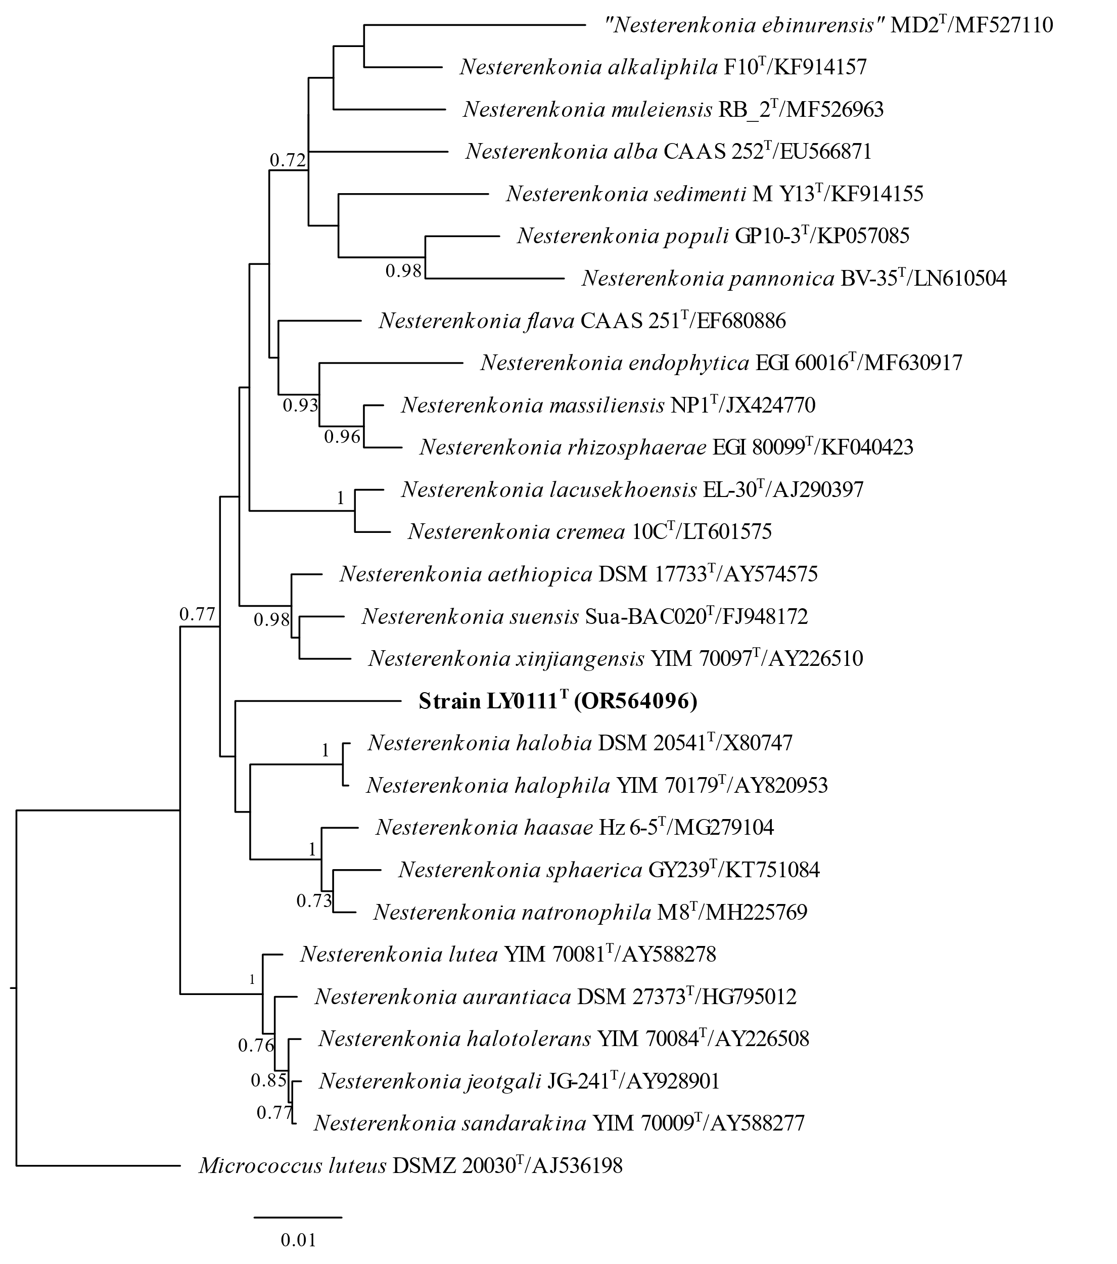
Fig. S1 Minimum Evolution phylogenetic tree based on 16S rRNA gene sequences showing the position of strain LY-0111^{T}. Bootstrap values (expressed as percentages of 1000 replications) of above 0.7 are shown at the branch points nodes. Micrococcus luteus DSMZ 20030^{T} is used as outgroup. Bar, 0.01 substitutions per nucleotide position.

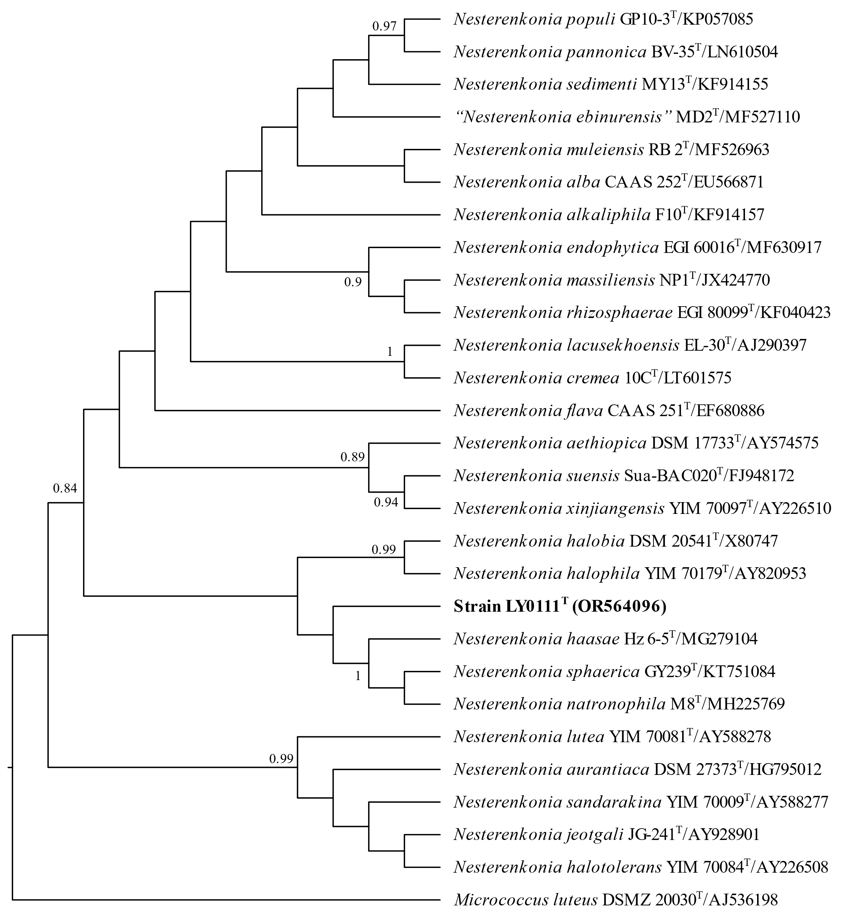
Fig. S2 Maximum-parsimony phylogenetic tree based on 16S rRNA gene sequences showing the position of strain LY-0111^{T}. Bootstrap values (expressed as percentages of 1000 replications) of above 0.7 are shown at the branch points nodes. Micrococcus luteus DSMZ 20030^{T} is used as outgroup.

Fig. S3 Cell morphology of strain LY-0111^{T} under scanning electron microscopy. Cells are cultured on TSA medium at 35 °C for 2 days. Bar, 2 μm.

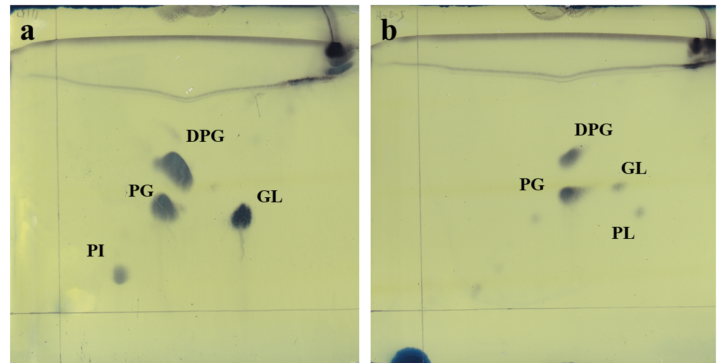
Fig. S4 Two-dimensional thin-layer chromatogram of all polar lipids in the cells of strain LY-0111^{T} and its reference strain Nesterenkonia haasae Hz 6-5^{T}.
a, LY-0111^{T}; b, Nesterenkonia haasae Hz 6-5^{T}. DPG, diphosphatidylglycerol; PG, phosphatidylglycerol; PI, phosphatidylinositol; GL, unidentified glycolipid; PL, unidentified phospholipids.

