Supplementary Text
Cell lines and culture
The HEK 293 immortalized cell line was purchased from the National Collection of Authenticated Cell Cultures (Shanghai, China). The HGC-27 gastric cancer cell line was purchased from the Institute of Biochemistry and Cell Biology, Chinese Academy of Sciences (Shanghai, China). DMEM (DearyTech, DT-12800) medium was supplemented with 10% FBS and 1% penicillin-streptomycin to make DMEM complete medium. HEK 293, MCF-7, HaCaT, and HGC-27 were cultured in DMEM complete medium in an incubator with 37℃ and 5% CO₂. For passage, after rinsing with PBS (DearyTech, DT-20012), all cells were treated with 0.25% trypsin-EDTA to detach from the dish.
Fabrication of circular microstructures
Microstructures were 3D-printed using a commercially available two-photon polymerization system (Photonic Professional GT2, Nanoscribe GmbH, Germany) with a 25× objective (numerical aperture=0.8) and IP-S resin on an ITO-coated dill glass substrate. Following fabrication, the microstructures were developed with propylene glycol methyl ether acetate solution (PGMEA) for 20 minutes and isopropanol (IPA) for 30 seconds to remove the remaining resin. After development, the microstructures were cured under UV light to solidify unprinted IP-S resin.
Cell sorting and live imaging
The cells were stained separately with Dil (C1991S, Beyotime), or DiO (C1993S, Beyotime) for 20 min at 37 ℃. Cells were washed extensively with medium after staining. The dye-stained cells were mixed at ratios of 1:1 (HEK293: HGC-27 = 1:1, MCF-7: HGC-27 = 1:1, and HaCaT: HGC-27 = 1:1). The mixture of cells was added into a dish with microstructures at 1.8 million cells/ml. After 5 hours of static culture, the medium was changed to remove excessive cells. Fluorescent images of the sorting process are recorded using spinning disk confocal microscope (Crest Optics X-Light V3, Nikon) every 15 min for 30 hours at an onstage cell culture chamber (37°C and 5% CO₂).
Immunofluorescence staining of cells
After removal of the culture medium, specimens were fixed with Immunol Staining Fix Solution (P0098, Beyotime) for 60 minutes at room temperature. Following washing 3×5 min with PBS, the samples were then incubated in Immunostaining Permeabilization Solution with Triton X-100 (P0096, Beyotime) for 10 minutes at room temperature. Following washing 3×5 min with Immunol Staining Wash Buffer (P0106, Beyotime), the samples were then incubated in QuickBlock™ Blocking Buffer for Immunol Staining (P0260, Beyotime) for at least 50 minutes at room temperature. After blocking, the samples were then incubated in primary antibody (E-Cadherin Mouse Monoclonal Antibody: AF0138, Beyotime) overnight at 4℃. Following washing 5×5 min with Immunol Staining Wash Buffer, the samples were then incubated in secondary antibody solution (Alexa Fluor 488-labeled Goat Anti-Mouse IgG(H+L): A0428, Beyotime) for 2 hours at room temperature. Following washing 5×5 min with Immunol Staining Wash Buffer, the samples were then incubated in Hoechst 33342 (C1026, Beyotime) for 5 minutes at room temperature. Following washing washed 5×5 min in Immunol Staining Wash Buffer, the samples were then imaged. The staining results are shown in Fig. S1.
Image acquisition and analysis
All images acquired on the Nikon spinning disk confocal microscope were denoised using the Nikon NIS-Elements software. ImageJ software (https://imagej.nih.gov/ij/) was used to analyze the E-cadherin fluorescence intensity of cells. The number of independent experiments and the statistical test employed are indicated in the respective figure legends. A p-value less than 0.05 was statistically significant.
Cell sorting simulation
CompuCell3D 4.3.1 software (https://compucell3d.org/) was used to simulate cell sorting behaviors. CompuCell3D is based on the Glazier-Graner-Hogeweg (GGH) model, which used cell-medium adhesion, and cell-cell adhesion to build the effective energy function governing cellular behaviors in this paper. In our model, we considered three cell types in each experiment: NoAdh, LowAdh (or MidAdh, HighAdh), and Medium. NoAdh, LowAdh, MidAdh, and HighAdh respectively represent the cells with adhesion force from low to high. The contact energies at these interfaces can be presented as NoAdh-NoAdh, NoAdh-LowAdh, LowAdh-LowAdh, NoAdh-Medium, and LowAdh-Medium contact energies. NoAdh represents weak adhesion cells. LowAdh (or MidAdh, HighAdh) represents strong adhesion cells.
Steinberg²⁴ proposed that two types of cellular are segregated when: $W_{WW}<W_{SW}<\frac{W_{SS}+W_{WW}}{2},and{ W}_{SW}<W_{SS}$. Where $W_{SS}$, $W_{WW}$, and $W_{SW }$ each denotes the work of adhesion between strong adhesion cells, the work of adhesion between weak adhesion cells, the work of adhesion between strong adhesion cell and weak adhesion cell. Cell differential adhesion sorting simulations must satisfy the above requirements. In CompuCell3D simulation, we set the contact energy between strong adhesion cells to$E_{SS}$, the contact energy between weak adhesion cells to $E_{WW}$, and the contact energy between strong adhesion cell and weak adhesion cell to $E_{SW}$. The three parameters need to satisfy the following: $E_{WW}>E_{SW}>\frac{E_{SS}+E_{WW}}{2},and{ E}_{SW}>E_{SS}$.
To investigate the reasons for the nonlinear relationship between adhesion difference level and sorting time, we used CompuCell3D simulation to increase the contact energy $E_{SS}$ and $E_{SW}$, respectively. The results showed that the sorting time had two peaks by increasing contact energy $E_{SW}$, and these two peaks are always distributed in interval $\left(\frac{E_{SS}+E_{WW}}{2}\right.,\left.\frac{E_{SS}+3E_{WW}}{4}\right)$ and interval $\left(\frac{E_{SS}+3E_{WW}}{4}\right.,\left.E_{WW}\right)$ respectively (Fig. S2B). The curve of changes in sorting time with increasing contact energy $E_{SS}$ goes from one peak to two peaks by increasing contact energy $E_{SW}$ (Fig. S2C). The results demonstrated that increasing the two contact energies $E_{SS}$ and $E_{SW}$ does not always increase or decrease the sorting time, i.e., it does not always promote or inhibit sorting. The simulation results are shown in Fig. S2.
Robot design
Each robot contains a lithium battery (M5Stack), development board (StickC PLUS: M5Stack), programmable robot base (BugC: M5Stack), outer shell, and magnets. M5StickC PLUS is a portable open-source IoT (Internet of Things) development board. It is equiped with an ESP32-PICO-D4 microcontroller with Wi-Fi. M5StickC PLUS can be programmed using C language on the Arduino IDE (Integrated Development Environment). BugC is a programmable robot base with four DC motors and their drivers, two RGB LED lights, a battery holder, and a switch. The BugC is equiped with an STM32F030F4 microcontroller, which can control all motors using I2C protocol (0x38) through M5StickC controller. The outer shells are three-dimensional printed in PLA (polylactic acid) plastic. The pentagonal outer shells and hexagonal outer shells are external polygons of circular outer shells. The neodymium iron boron magnets with nickel plating are mounted on the outer shells to generate adhesion forces of robots. Several magnets with different sizes were used to adjust the adhesion forces.
Robot motion
The speed of each robot was set at a constant. The trajectory of each robot is designed as an alternative between straight lines and circles to avoid being blocked at the corners of the table. Due to the variation of motors, the trajectories of robots have a large deviation.
Force model of robots
$F_{v}$, $F_{M}$ each denotes driving force of robot motors and adhesion force between robots respectively. The driving force of robot motors is adjusted by the speed of robots. The driving force $F_{v}$ and the adhesion force $F_{M}$ determine whether the system will gather or disperse: if $F_{v}>F_{M}$, the robots tend to disperse from each other; if $F_{v}<F_{M}$, the robots tend to aggregate together. Keeping the driving force constant, therefore, the aggregation or dispersion of robot swarms can be controlled by changing the adhesion force among robots, as shown in Fig. S3.
In this paper, the adhesion forces between different types of robots are ranked as follows: $F_{ss}>F_{sw} >{ F}_{ww}$ . $F_{ss}$, $F_{sw}$, and ${ F}_{ww}$ each denotes the adhesion force between orange robots (strong adhesion), the adhesion force between the orange robot and green robot, and the adhesion force between the green robots (weak adhesion). During the experiments (Fig. 3), this relationship is still solid when the magnetic strength of the orange robot increases.
Adhesion force of minimal robot systems
The minimal circular robot system has three adhesion sites. The magnetic adhesion force of each site is $F_{M}$. The magnetic adhesion force of the minimal circular robot system is $3×F_{M}$. The three adhesion sites form a stable triangle. The minimal hexagonal robot system has six adhesion sites, thus the total magnetic adhesion force is $6×F_{M}$. The adhesion sites also form a stable triangle, as shown in Fig. S4. The minimum pentagonal robot system has four adhesion sites, thus the total magnetic adhesion force is $4×F_{M}$. The adhesion sites cannot form a stable triangle because the sites are only on two edges of this system, as shown in Fig. S4. The magnetic adhesion force and geometrical difference together affect the adhesion force among robots. Considering these two factors, the rank of adhesion forces of the three minimal systems is: $hexagonal robots > pentagonal robots, and hexagonal robots >circular robots$. The adhesion relationship between pentagonal robots and circular robots cannot be determined because adhesion distribution of minimum swarms of pentagonal robots is not a stable triangle.
Magnetic adhesion force measurement experiment
The magnetic adhesion force $F_{M}$ between two contacted magnets was measured as the breaking force of the two contacted magnets. The first magnet was placed in a paper holder attached to a stand; the second paper holder with a magnet in it was then adhered to the first magnet. The second paper holder was attached to a dish with sand. As the sand outweighed the adhesion force between the two magnets, the second paper holder fell. The weight of the paper holder, dish, and sand was measured to obtain $F_{M}$, as shown in Fig. S5.
Sizes of magnets and their positions on the outer shells
All magnets are circles, with specific sizes of 3mm×1mm, 4mm×1mm, 4mm×1.5mm, 5mm×1.5mm, and 6mm×1.5mm (diameter × thickness). The sizes of magnets used in Figure 3 were 3mm×1mm:4mm×1.5mm, 3mm×1mm:5mm×1.5mm, and 3mm×1mm:6mm×1.5mm. Twelve magnets are evenly arranged on the circular outer shell. The green robots had weak adhesion force, and the size of the magnets was 3mm×1mm. The orange robots had strong adhesion force, and the sizes of the magnets were 4mm×1.5mm, 5mm×1.5mm, and 6mm×1.5mm.
The sizes of magnets used in Figure 4 were 4mm×1mm, 5mm×1.5mm, and 6mm×1.5mm. Twelve magnets are evenly arranged on the outer shell. The circular robots were orange, the hexagonal robots were green, and the pentagonal robots were blue.
The sizes of magnets used in Figure 5 were 5mm×1mm and 6mm×1.5mm. The positions of the magnets are shown in Figure 5. The gray was 5mm×1mm, and the black was 6mm×1.5mm.
Rules of magnets arrangement for forming functional morphologies
We used strong magnets (6mm×1.5mm) and weak magnets (5mm×1mm) in this experiment. The adhesion force between two strong magnets is $F_{11}$, the adhesion force between two weak magnets is $F_{22}$, and the adhesion force between one strong magnet and one weak magnet is $F_{12}$. When two edges of outer shells match according to pre-defined pattern, the adhesion force is larger than the driving force, which is less than or equal to $3×F_{12}$. The adhesion forces of all other matches between the edges are programmed less than the driving force. Following this rule, we properly arranged the digital value for every slot on four robots with different shapes, such that the robots formed functional morphologies, a “T” shape or an “I” shape.
Forming “T”, three robots were around the fourth robot. We arranged the strong magnets in the fourth robot and the weak magnets in the other three robots. In this way, there will be no interaction of two strong magnets. When the edges were wrongly matched, all of the possible adhesion forces were $2×F_{12}$, $2×F_{22}$, $F_{12}$ and $F_{22}$, all of which were smaller than the driving force.
Forming “I”, the positions of the magnets were designed as alternatives between strong and weak magnets. When the edges were wrongly matched, all of the possible adhesion forces were $2×F_{12}$, $F_{11}$, $F_{12}$ and $F_{22}$, all of which were smaller than the driving force.
Functional morphologies accomplish tasks
The functional morphology, “T” or “I”, was formed with four robots. Each robot was connected to the MQTTX cloud platform built on the computer through Wi-Fi. The motion of the functional morphology as a whole required all robots to work together. Thus, we designed four control commands, W, S, A, and D, to control motion of the functional morphology. W was for forward command, S was for backward command, A was for counterclockwise rotation command and D was for clockwise rotation command.

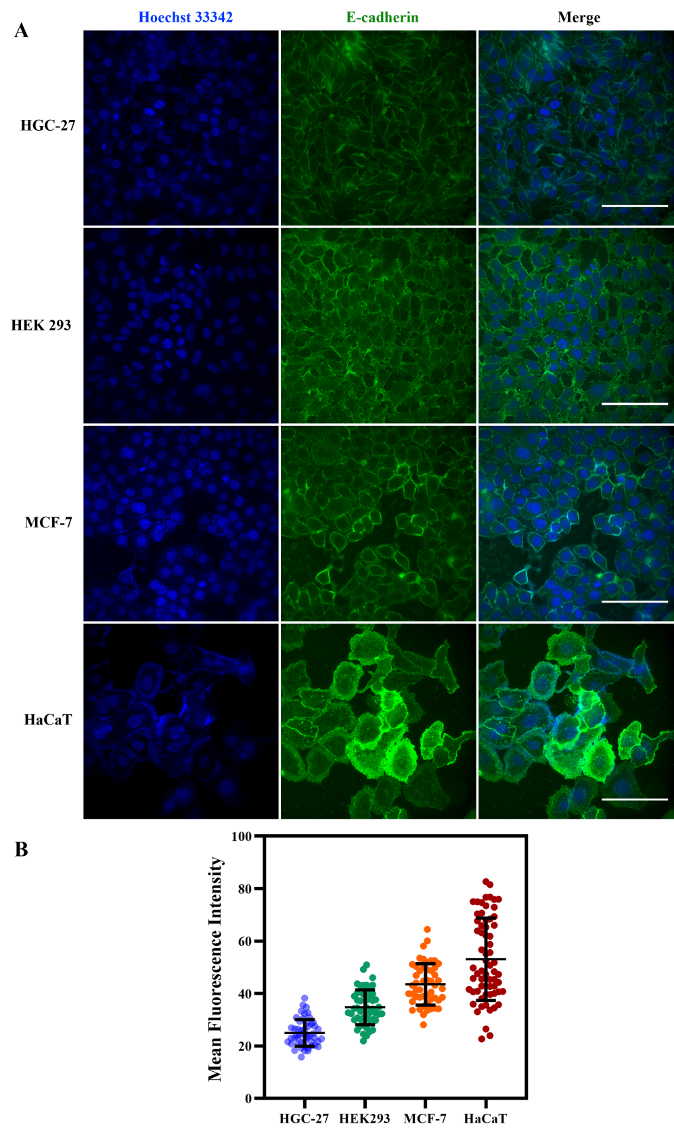

Fig. S1. The fluorescence image of E-cadherin. (A) The staining results of the cells. Scale bars, 100 μm. (B) The mean fluorescence intensity of E-cadherin in different cells. Error bars represent Standard Deviations.

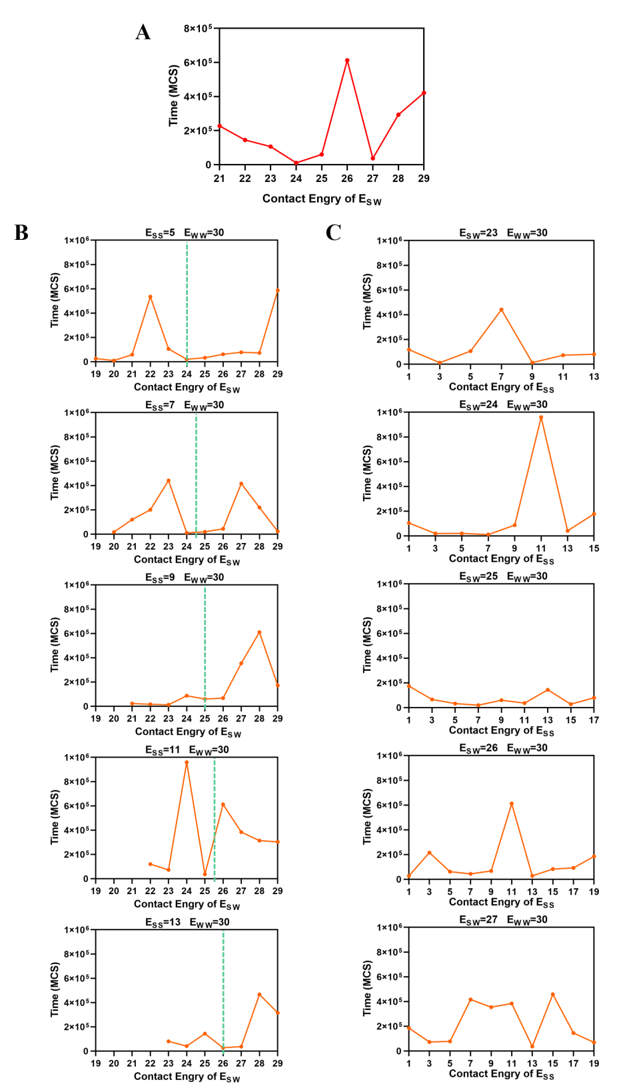

Fig. S2. The sorting time of mixed cells under different conditions in simulation experiments. $E_{SS}$ represents contact energy between strong adhesion cells. $E_{WW}$ represents contact energy between weak adhesion cells. $E_{SW}$ represents contact energy between strong adhesion cell and weak adhesion cell. (A) $E_{SW}$ and $E_{SS}$ increase at the same time. (B) $E_{SW}$ changes while keeping the $E_{SS}$ constant. (C) $E_{SS}$ changes while keeping the $E_{SW}$ constant.

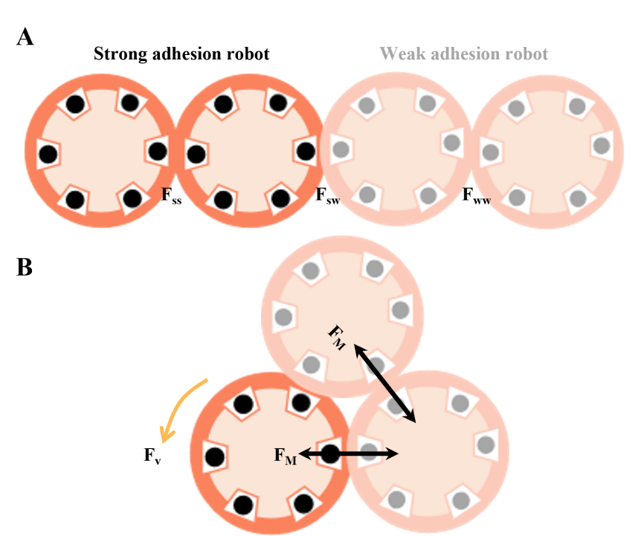

Fig. S3. Physical model of forces analysis in circular robots. (A) The rank of adhesion forces among robots is: $F_{ss}>F_{sw} >{ F}_{ww}$. (B) $F_{v}$ represents the driving force of robot motors. $F_{M}$ represents the adhesion force. Black dots represent strong adhesion. Gray dots represent weak adhesion.

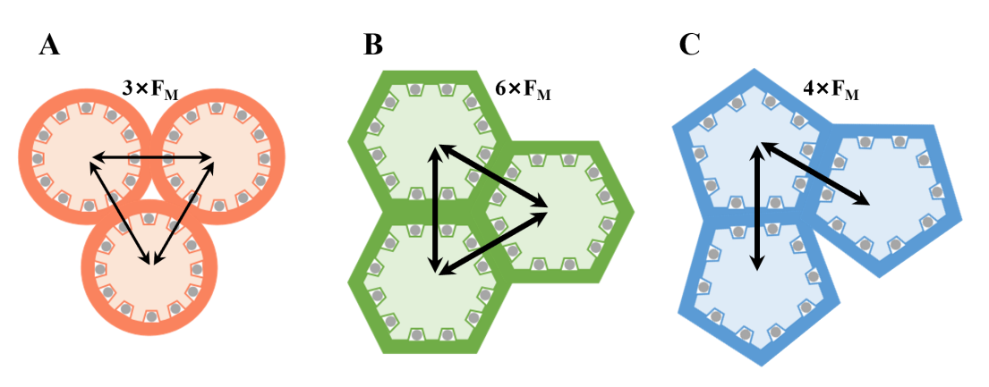

Fig. S4. Adhesion force analysis of minimal robot system. (A) The adhesion force of circular robot system is $3×F_{M}$. (B) The adhesion force of hexagonal robot system is $6×F_{M}$. (C) The adhesion force of pentagonal robot system is $4×F_{M}$. The thin double arrows represent adhesion force $F_{M}$. The thick double arrows represent adhesion force $2×F_{M}$.

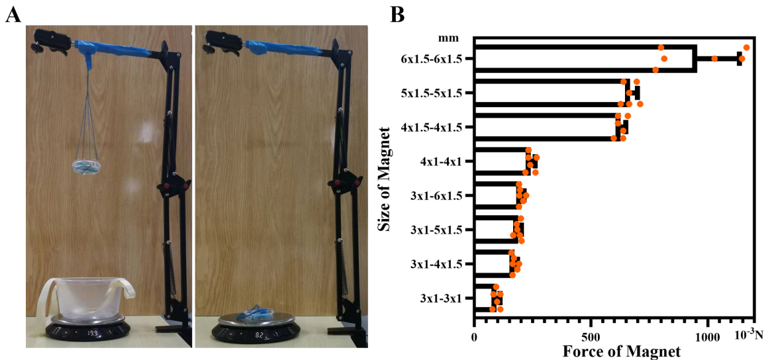

Fig. S5. Experiment for measuring magnetic adhesion forces. (A) The measuring device. (B) The magnetic adhesion forces. Error bars represent SD.

Movie S1.
The level of adhesion difference affects aggregation and sorting in cell collectives.

Movie S2.
The level of adhesion difference affects aggregation and sorting in robot swarms.

Movie S3.
The shapes of robots affect aggregation and sorting in robot swarms.

Movie S4.
Adhesion and shape of robots program robot swarms.

