Supplementary Information

Biporous silica nanostructure-induced nanovortex in a microfluidic channel for nucleic acid enrichment, isolation, and PCR-free detection
Eunyoung Jeon^{1,2,8}, Bonhan Koo^{3,8}, Suyeon Kim^{1,2,8}, Jieun Kim⁴, Yeonuk Yu⁴, Hyowon Jang⁵, Minju Lee³, Sung-Han Kim⁶, Taejoon Kang⁵, Sang Kyung Kim⁷, Rhokyun Kwak⁴*, Yong Shin³*, Joonseok Lee^{1,2}*

¹Department of Chemistry, Hanyang University, Seoul 04763, Republic of Korea
²Research Institute for Convergence of Basic Sciences, Hanyang University, Seoul 04763, Republic of Korea
³Department of Biotechnology, College of Life Science and Biotechnology, Yonsei University, Seoul 03722, Republic of Korea
⁴Department of Mechanical Convergence Engineering, Hanyang University, Seoul 04763, Republic of Korea
⁵Bionanotechnology Research Center, Korea Research Institute of Bioscience and Biotechnology (KRIBB), Daejeon 34141, Republic of Korea
⁶Department of Infectious Diseases, Asan Medical Center, University of Ulsan College of Medicine, Seoul 05505, Republic of Korea
⁷Center for Augmented Safety Systems with Intelligence, Sensing and Tracking (ASSIST), Korea Institute of Science and Technology (KIST), Seoul 02792, Republic of Korea

⁸These authors contributed equally.
* e-mail: joonseoklee@hanyang.ac.kr; shinyongno1@yonsei.ac.kr; rhokyun@hanyang.ac.kr

Supplementary Information
Supplementary methods, text, Figs. 1-15, and Tables
Supplementary Video1
Video of flow simulation of the PSNF model.
Supplementary Video 2
Video of flow simulation of the BSNF model.
Supplementary Video 3
Video of flow simulation of the Flat model.
Supplementary Video 4
Video of Fig. 3k.

Methods
Conventional methods for NA isolation and detection
Conventional methods for NA isolation and detection, such as the spin column method and qPCR, were employed to evaluate and validate the BSNFs-chip for pathogen and NA enrichment/isolation, along with the LRET assay for PCR-free detection. For the NA isolation, serial diluted HCT116 cells (from 1 × 10⁴ to 1 × 10⁰ cell ml⁻¹) and SARS-CoV-2 culture fluid (from 0.96 × 10⁴ to 0.96 × 10⁻¹ PFU ml⁻¹) were prepared in 1.5 mL microcentrifuge tubes. Genomic DNA, RNA, and viral RNA were directly extracted from 100 µl of the serial diluted samples and 100 µl of pathogens concentrated and isolated by the BSNFs-chip. This was achieved using QIAamp DNA Mini kit (Cat no. 51306, Qiagen, Hilden, Germany), QIAamp RNA Blood Mini kit (Cat no. 52304, Qiagen), and QIAamp Viral RNA Mini Kit (Cat no. 52906, Qiagen), respectively. The NAs were then eluted with 100 µL of elution buffer supplied in the kits and stored at −20 or −80 °C until further use. For NA detection, primer and probe sets were designed for each target NAs and mixed with 5 µl of eluted NAs to prepare PCR mixes. qPCR was performed for DNA of the ACTB gene (40 cycles; denaturation at 95 °C for 10 s, annealing at 60 °C for 20 s, and extension at 72 °C for 20 s) using Brilliant III Ultra-Fast SYBR Green qPCR Master Mix (Cat no. 600882, Agilent Technologies, Santa Clara, CA, USA). qRT-PCR was performed for RNA of 18s rRNA gene (reverse transcription at 50 °C for 20 minutes and 40 cycles; denaturation at 95 °C for 15 s, annealing at 58 °C for 15 s, and extension at 72 °C for 30 s) using Brilliant III Ultra-Fast SYBR Green qRT-PCR Master Mix (Cat no. 600886, Agilent Technologies). qRT-PCR for viral RNA of the S gene of SARS-CoV-2 was performed (reverse transcription at 50 °C for 10 minutes and 45 cycles; denaturation at 95 °C for 5 s and annealing/extension at 60 °C for 30 s) using LightCycler Multiplex RNA Virus Master Mix (Cat no. 06754155001, Roche, Basel, Switzerland). The primers and probe used are listed in Supplementary Table 2. The amplified products were detected through SYBR green and Cy5 fluorescence signals using the CFX96 Real-Time PCR System (Bio-Rad, Hercules, CA, USA).

Synthesis of the lanthanide-doped nanoparticles (LnNPs)
The core LnNPs were synthesized through thermal decomposition of lanthanide acetate precursors. First, 0.4 mmol of Y(CH₃CO₂)₃ (99.9%, Sigma Aldrich) was mixed with 3 ml oleic acid (90%, Sigma Aldrich) and 7 ml 1-octadecene (90%, Sigma Aldrich), and the resulting mixture was heated to 150 ℃ for 60 minutes. The solution was then cooled down to 50 ℃, and 1 mmol of NaOH (≥ 98%, Sigma Aldrich) in methanol and 1.6 mmol of NH₄F (≥ 99.9%, Sigma Aldrich) in methanol (≥ 99.8%, Sigma Aldrich) were added. The mixture was stirred, and the residual methanol was evaporated by heating the solution to 100 ℃ and keeping it under vacuum. To heat the solution in an argon environment, the vacuum-argon state was changed three times, and then the argon state was maintained. The resulting core nanoparticles were collected by centrifugation and washed after the resulting solution was heated to 300 ℃, held for 1 hour, and then cooled to room temperature. The resulting product was re-dispersed in cyclohexane (≥ 99%, Sigma Aldrich) for later synthesis. The synthesis of each batch of nanoparticles followed a similar procedure to that used for the core nanoparticles. Ln(CH₃CO₂)₃ (Ln = Y, Yb, and Tm, total 0.2 mmol) (99.9%, Sigma Aldrich) and Y(CH₃CO₂)₃ (0.1 mmol) were used for the synthesis of NaYF₄@NaYF₄,Yb,Tm and NaYF₄@NaYF₄,Yb,Tm@NaYF₄, respectively.

Characterization of the LRET donor
The morphology of the LnNPs was analyzed on a JEM-2100F (JEOL Ltd., Japan) installed at Hanyang LINC3.0 Analytical Equipment Center (Hanyang University, Seoul, Republic of Korea) at an accelerating voltage of 200 kV. The XRD patterns of the LnNPs were characterized by an XRD-7000 diffractometer. The Fourier transform infrared (FT-IR) spectra of the LnNPs were obtained by using a Nicolet iS50 FT-IR spectrophotometer (Thermo Fisher Scientific Co., USA). The hydrodynamic diameter and zeta potential were measured by a Zetasizer Nano ZSP (Malvern Co., UK). The photoluminescence (PL) emission spectra were recorded by a spectrometer (Andor, Kymera 193i) and an intensified sCMOS detector (Andor, ISTAR-SCMOS-18F-73) under external excitation at 980 nm provided by a 980nm laser diode (Changchun New Industries Optoelectronics Tech. CO., China, MDL-III-980-2W). The PL lifetime was measured using a photomultiplier tube detector (H10721-01; Hamamatsu, Shizuoka, Japan) attached to the spectrometer and a digital oscilloscope (Rhode & Schwarz, Munich, Germany, RTM3002) under excitation at 980 nm using pulsed laser (optical parametric oscillator (OPO) laser, Q-switched Nd-YAG laser, EKSPLA NT342). The PL emission wavelength was selectively measured using a bandpass filter (Semrock, ff-01-800/12-25) and shortpass filter (Semrock, ff-01-950/sp-25) placed in front of the detectors.

Supplementary Text
Characterization of LnNPs modified with DNA oligo
We synthesized inert-core/active-shell/inert-shell LnNPs (NaYF₄@NaYF₄, Yb₄₈, Tm₂@NaYF₄) through a thermal decomposition method and employed it as an LRET donor. The average diameters of monodispersed core, core/shell, and core/shell/shell LnNPs were 12.8±0.5 nm, 21.8±0.8 nm, and 24.2±0.9 nm, respectively, evidenced by transmission electron microscopy (TEM) images (Supplementary Fig. 12a). Energy dispersive X-ray spectroscopy (EDS) mapping images indicated that the core/shell/shell nanoparticles were mainly composed of Na, Y, and F as a lattice host, with increased distribution of the dopant ions (Yb³⁺, Tm³⁺) in the outer region of LnNPs (Supplementary Fig. 12b). An X-ray diffraction (XRD) analysis (Supplementary Fig. 12c) showed that the LnNPs consisted of hexagonal NaYF₄ (JCPDS:16-0334), which is an effective upconverting host lattice structure owing to its low lattice phonon energy ^{1,2,3,4}. As shown in Supplementary Fig. 12d, emission intensity at 800 nm of LnNPs was approximately 79-fold enhanced by coating an inert-shell.
We conjugated the LRET donors with the capture DNA oligonucleotide complementary to a target site of SARS-CoV-2 RNA (Supplementary Fig. 13a). The hydrophobic surface of the an-synthesized donors led us to perform ligand exchange into hydrophilic amine functionalities prior to DNA conjugation. The amine-modified donors (NH₂-donors) were sulfosuccinimidyl 4-[N-maleimidomethyl] cyclohexane-1-carboxylate (sulfo-SMCC)-treated, and sequentially bound to the thiolate DNA via thiol-maleimide reaction^{5,6}. The Fourier transform infrared (FT-IR) peaks for each ligand exchange step from the as-synthesized donors to DNA-modified donors (denoted as DNA-donors) indicated the successful chemical conjugation of DNA oligo onto the donors (Supplementary Fig. 13b). For the as-synthesized donors, transmission bands for the COO- (1449 cm⁻¹) and CH₂ groups (2850 and 2923 cm⁻¹) were observed, which were attributed to the presence of oleic acid on the surface. Two new bands for the NH₂ group at 1643 and 3245 cm⁻¹ were observed after surface modification with amine functionalities ⁷. The resulting DNA-donors showed two bands for C-O groups of ribose (1057 cm⁻¹) and NH₂ group (1673 cm⁻¹), which were attributed to DNA ⁸. We further confirmed the successful immobilization of DNA using dynamic light scattering (DLS) and zeta potential measurements. The hydrodynamic diameter of the donors gradually increased after the sulfo-SMCC treatment and DNA conjugation (Supplementary Fig. 13c). The surface charge of +33.8 mV for NH₂-donors decreased to -32.7 mV after sulfo-SMCC treatment, which eventually increased to -28.3 mV after the immobilization of DNA oligo (Supplementary Fig. 13d).

Core/shell/shell structure for effective LRET
High-sensitive LRET-based detection of target RNA is achieved by improving LRET efficiency. LRET is a process of short-range resonance energy transfer (RET), which occurs under conditions of the spectral overlap of the donor's emission and the acceptor's absorption, and donor-acceptor spatial proximity^{9,10,11}. Nanoparticle-based LRET technologies using active-core nanoparticles show limitations including their dimensional problem such as the limited distance from the donor to the acceptor. We employed an approach to construct an inert-core/active-shell/inert-shell LnNP as an LRET donor for effective LRET (Supplementary Fig. 12). The NaYF₄ inert-core was encapsulated in a NaYF₄, Yb, Tm active-shell, which exhibits a strong emission peak at 800 nm under 980 nm excitation. Spatial confinement of an activator (Tm³⁺) within the active shell shortened the energy-transfer distance, increasing the number of activator ions participating in effective energy transfer^{7,12,13}. Finally, the inert-core/active-shell nanoparticles were encapsulated in a NaYF₄ inert-shell to minimize surface defect-induced energy quenching and increase upconversion photoluminescence intensity at 800 nm. The outermost inert-shell was synthesized with ultra-thin thickness (~ 1.2 nm) to achieve an efficient LRET process (Supplementary Fig. 12a).

Supplementary Fig. 1. Scheme illustration of CTA⁺-Sal⁻ micelles at different pH.

The synthesis of the biporous nanostructure involved using cetyltrimethylammonium chloride (CTAC) as a structure-directing surfactant, sodium salicylate (NaSal) as an auxiliary spacer, and triethanolamine (TEA) as a pH adjuster and catalyst to form pH-sensitive micelles^{14,15,16,17}. At high pH, where OH⁻ predominates and Sal⁻ interacts less with CTA⁺, micelles exhibited a highly positive charge density, inducing intermicellar electrostatic repulsion and small pore formation in the PSNF. At low pH, the enhanced interaction between Sal- and CTA+ reduces charge density, leading to micelle aggregation, which serves as templates for large pores in BSNF.

Supplementary Fig. 2. a, FT-IR spectrum of BSNF-NH₂. b, water contact angle of bare PET film, BSNF and BSNF-NH₂. Fourier transform infrared (FT-IR) spectrum analysis revealed the presence of the 3350 cm⁻¹ peak for the N-H group, along with an increase in the water contact angle of the BSNF following APDMS treatment, indicating amine functionalization of the BSNF.

Supplementary Fig. 3. Top-view and cross-sectional SEM images of PSNF and BSNF on PET film.

Supplementary Fig. 4. Histograms of the Feret diameter distribution of PSNF and BSNF; total pore count was 273 in PSNF and 79 in BSNF.

Supplementary Fig. 5. Small-angle x-ray scattering (SAXS) intensity as a function of the scattering vector for PSNF and BSNF.

Supplementary Fig. 6. a, Representative fluorescence microscopy images, b, the line-scan profiles of gray value and c, mean gray values of chips with Flat-chip, PSNFs-chip or BSNFs-chip incorporating quantum dots (QDs). White dashed lines indicate the line profile cross the microchannel. (Scale bar: 500 μm, QDs emission: 645 nm). We assessed the mean fluorescence intensity resulting from QDs capture. Both the PSNFs- and BSNFs-chips exhibited higher fluorescence intensity due to their increased surface area compared to the Flat-chip, a conventional sample preparation chip with a flat surface.

Supplementary Fig. 7. a-c, Three simulation models with (a), Flat, (b) PSNF and (c) BSNF on the bottom of the microchannel. The geometric parameters of the computational domain are addressed in Supplementary Table 1. In order to observe the flow in the nanostructure region, the height of the fluid channel was simulated to be 3 μm, which is a reduced scale (1/100) of the actual BSNFs-chip channel height of 300 μm, and then the images were cropped to a height of 600 nm.

Supplementary Fig. 8. Dynamic flow profile of the Flat PET. a,b, 3D and c, 2D plane images of flow velocity field and in the virtual model under a given average flow velocity (7.7 x 10⁻⁷ m s⁻¹).

Supplementary Fig.9. Schematic overviews of the sample preparation process of chips with a, BSNFs-chip and b, Flat-chip.

Supplementary Fig. 10. NA elution flow rate test to increase the yield of NAs in the BSNFs-chip.

Supplementary Fig. 11. a, SEM images showing stability of BSNF after sample preparation process. b, Analysis of structural robustness and reusability in pathogen and NA enrichment/isolation using the BSNFs-chip.

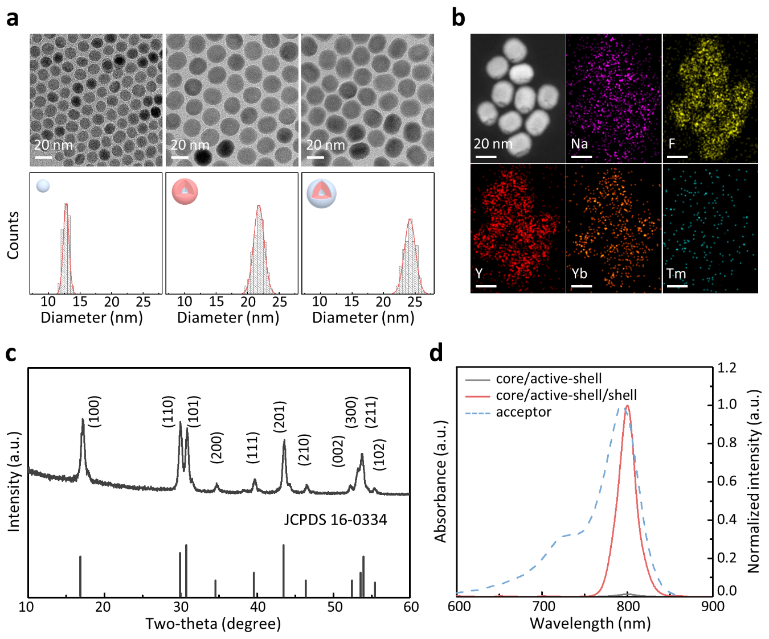
Supplementary Fig. 12. Characterization of core/active-shell/shell LnNPs as an LRET donor. a, TEM images and size distributions of inert-core (NaYF₄), inert-core/active-shell (NaYF₄@NaYF₄, Yb, Tm), and inert-core/active-shell/inert-shell (NaYF₄@NaYF₄, Yb, Tm@NaYF₄) LnNPs. b,c EDS mapping images (b) and XRD patterns (c) of the core/active-shell/shell LnNPs. d, Absorbance spectra of LRET acceptor (IRdye800) and emission spectra of core/active-shell and core/active-shell/shell LnNPs (under 980 nm excitation).

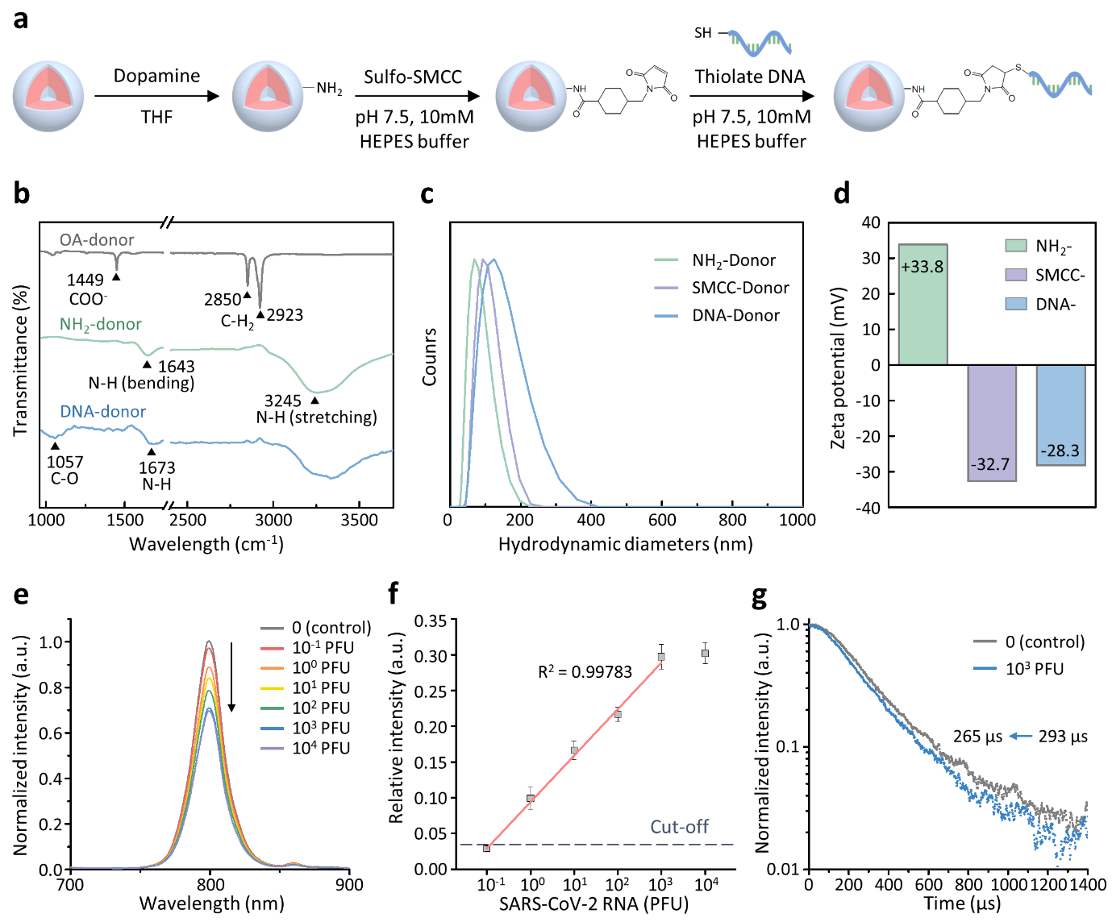
Supplementary Fig. 13. Surface modification of the LRET donor. a, Schematic illustration of conjugation path of capture DNA and LnNP. b, FT-IR spectra of oleic acid capped, NH₂-, and DNA-donor. c,d, Dynamic light scattering spectra (c) and zeta potentials (d) of NH₂-, SMCC-, and DNA-donor. e, Emission spectra of the LRET donor with various concentrations of SARS-CoV-2 RNA. f, Calibration curve of quenching efficiencies with increasing concentrations of SARS-CoV-2 RNA. A linear fit to the data over this concentration range yielded the relation (I₀- I_{x})/I₀=0.065×logC + 0.094, where C is the concentration of RNA, with a correlation coefficient R²=0. 998. All reported values represent the mean ±SD, n =3. The cut-off value was determined by applying optimal combinations of clinical sensitivity and specificity from ROC curve based on the Youden index point. g, Luminescence lifetime curves at 800 nm of LRET donor in the absence or presence of target RNA (under 980 nm excitation).

Supplementary Fig. 14. qRT-PCR detection of SARS-CoV-2 RNA extracted from the BSNFs-chip using 30 nasopharyngeal (NP) swab samples identified as confirmed cases by clinical definitions.
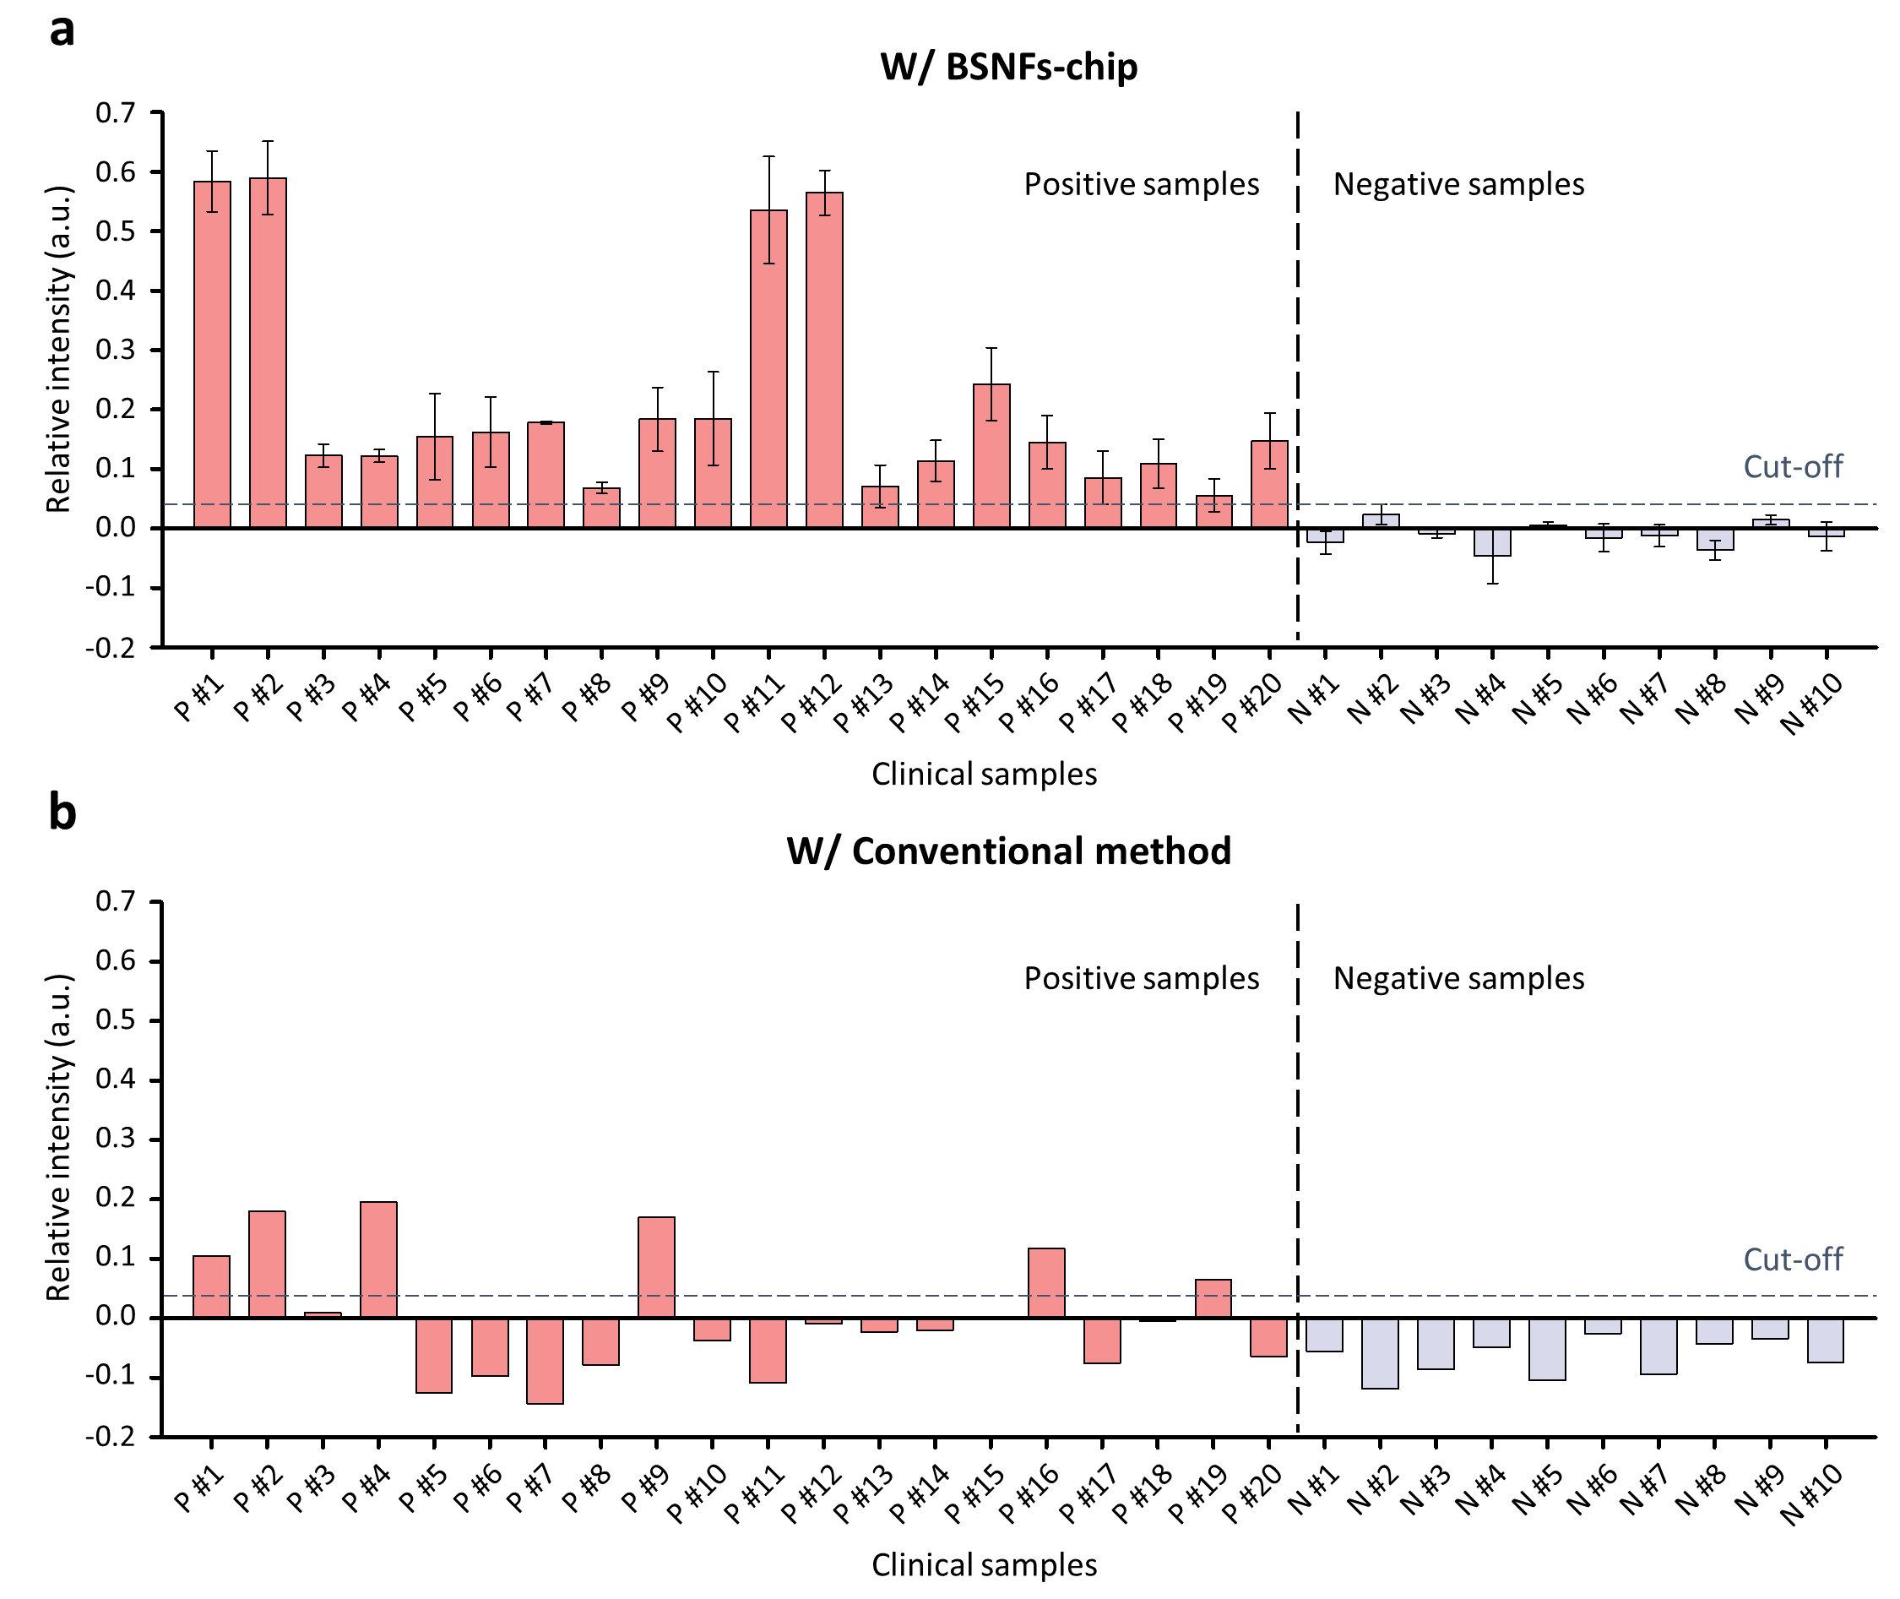
Supplementary Fig. 15. a,b, LRET assay for SARS-CoV-2 RNA in clinical samples collected from (a) the BSNFs- chip and (b) the conventional extraction method.

Supplementary Table 1. Parameters for numerical computation of simulation models.
Object |  | Parameters
Microchannel |  | - H (channel height): 3 μm  - L (channel width): 500 nm
Nanostructure | PSNF | - h_{PSNF} (pore height): 145 nm  - H_{PSNF} (Total height of PSNF model): 3.145 μm
Nanostructure | BSNF | - h_{BSNF} (pore height): 255 nm  - H_{BSNF} (Total height of BSNF model): 3.400 μm

Supplementary Table 2. Primer and probe sets used in this study.
qPCR-based  methods | Target  (Gene) | Sequence (5'-3') |  | Mer | Modification
qPCR | HCT116  (ACTB) | Forward | CTG GAA CGG TGA AGG TGA CA | 20
qPCR | HCT116  (ACTB) | Reverse | AAG GGA CTT CCT GTA ACA ATG CA | 23
qRT-PCR | HCT116  (18s rRNA) | Forward | GCT TAA TTT GAC TCA ACA CGG GA | 23
qRT-PCR | HCT116  (18s rRNA) | Reverse | AGC TAT CAA TCT GTC AAT CCT GTC | 24
qRT-PCR | SARS-CoV-2  (S gene) | Forward | TCC GCA TCA TTT TCC ACT TTT AA | 23
qRT-PCR | SARS-CoV-2  (S gene) | Reverse | TAA CGC AGC CTG TAA AAT CAT CTG | 24
qRT-PCR | SARS-CoV-2  (S gene) | Probe | AAG TCA GAC AAA TCG CTC CAG GGC AAA | 27 | Cy5 (5')  BHQ-2 (3')

Supplementary Table 3. Raw qPCR data showing the LODs for genomic DNA using the HCT116 cell, comparing the conventional method, Flat-chip, PSNFs-chip, and BSNFs-chip.
Raw data of qPCR for genomic DNA
(ACTB gene from HCT116 cell)
Type | Concentration  (1 x 10^{N} Cell/mL) | #1 | #2 | #3 | #4 | Mean | STDEV
Conventional  method | 4 | 31.18 | 31.03 | 31.07 | . | 31.09 | 0.06
Conventional  method | 3 | 34.28 | 34.17 | 34.11 | . | 34.19 | 0.07
Conventional  method | 2 | 40 | 40 | 40 | . | . | .
Conventional  method | 1 | 40 | 40 | 40 | . | . | .
Conventional  method | 0 | 40 | 40 | 40 | . | . | .
Flat-chip | 4 | 28.43 | 28.09 | 27.88 | 28.32 | 28.18 | 0.21
Flat-chip | 3 | 32.47 | 31.73 | 31.62 | 31.83 | 31.91 | 0.33
Flat-chip | 2 | 36.03 | 35.50 | 35.42 | 35.79 | 35.69 | 0.24
Flat-chip | 1 | 40 | 40 | 40 | 40 | . | .
Flat-chip | 0 | 40 | 40 | 40 | 40 | . | .
PSNFs-chip | 4 | 27.88 | 28.06 | 28.30 | 28.12 | 28.09 | 0.15
PSNFs-chip | 3 | 31.82 | 31.86 | 31.56 | 31.61 | 31.71 | 0.13
PSNFs-chip | 2 | 34.63 | 34.49 | 35.03 | 35.14 | 34.82 | 0.27
PSNFs-chip | 1 | 38.42 | 38.44 | 38.17 | 38.23 | 38.32 | 0.12
PSNFs-chip | 0 | 40 | 40 | 40 | 40 | . | .
BSNFs-chip | 4 | 27.85 | 27.81 | 27.89 | 27.56 | 27.78 | 0.13
BSNFs-chip | 3 | 31.61 | 31.39 | 31.58 | 31.55 | 31.53 | 0.08
BSNFs-chip | 2 | 34.77 | 34.74 | 34.53 | 34.34 | 34.60 | 0.17
BSNFs-chip | 1 | 37.85 | 37.93 | 37.61 | 37.68 | 37.77 | 0.13
BSNFs-chip | 0 | 40 | 40 | 40 | 40 | . | .

Supplementary Table 4. Raw qRT-PCR data showing the LODs for genomic RNA using the HCT116 cell, comparing the conventional method, Flat-chip, PSNFs-chip, and BSNFs-chip.
Raw data of qRT-PCR for genomic RNA
(18S rRNA gene from HCT116 cell)
Type | Concentration  (1 x 10^{N} Cell/mL) | #1 | #2 | #3 | #4 | Mean | STDEV
Conventional  method | 4 | 31.76 | 31.60 | 31.49 | . | 31.62 | 0.11
Conventional  method | 3 | 34.95 | 35.17 | 34.76 | . | 34.96 | 0.17
Conventional  method | 2 | 40 | 40 | 40 | . | . | .
Conventional  method | 1 | 40 | 40 | 40 | . | . | .
Conventional  method | 0 | 40 | 40 | 40 | . | . | .
Flat-chip | 4 | 28.81 | 28.79 | 28.91 | 29.09 | 28.90 | 0.12
Flat-chip | 3 | 32.23 | 32.22 | 32.36 | 32.47 | 32.32 | 0.10
Flat-chip | 2 | 35.89 | 35.92 | 36.14 | 36.16 | 36.03 | 0.12
Flat-chip | 1 | 40 | 40 | 40 | 40 | . | .
Flat-chip | 0 | 40 | 40 | 40 | 40 | . | .
PSNFs-chip | 4 | 29.01 | 28.87 | 28.43 | 28.47 | 28.70 | 0.25
PSNFs-chip | 3 | 31.94 | 31.99 | 32.23 | 32.38 | 32.14 | 0.18
PSNFs-chip | 2 | 35.79 | 35.76 | 35.96 | 35.84 | 35.84 | 0.08
PSNFs-chip | 1 | 40 | 40 | 40 | 40 | . | .
PSNFs-chip | 0 | 40 | 40 | 40 | 40 | . | .
BSNFs-chip | 4 | 28.64 | 28.57 | 28.42 | 28.29 | 28.48 | 0.14
BSNFs-chip | 3 | 31.78 | 31.99 | 32.26 | 32.01 | 32.01 | 0.17
BSNFs-chip | 2 | 35.41 | 35.32 | 35.59 | 35.43 | 35.44 | 0.10
BSNFs-chip | 1 | 38.72 | 38.84 | 38.61 | 38.56 | 38.68 | 0.11
BSNFs-chip | 0 | 40 | 40 | 40 | 40 | . | .

Supplementary Table 5. Raw qRT-PCR data showing the LODs for viral RNA using the SARS-CoV-2 culture fluid, comparing the conventional method, Flat-chip, PSNFs-chip, and BSNFs-chip.
Raw data of qRT-PCR for viral RNA
(S gene from SARS-CoV-2)
Type | Concentration  (0.96 x 10^{N} PFU/mL) | #1 | #2 | #3 | Mean | STDEV
Conventional  method | 4 | 30.07 | 30.07 | 30.41 | 30.18 | 0.16
Conventional  method | 3 | 33.37 | 33.67 | 33.82 | 33.62 | 0.19
Conventional  method | 2 | 36.83 | 36.99 | 37.45 | 37.09 | 0.26
Conventional  method | 1 | 45 | 45 | 45 | . | .
Conventional  method | 0 | 45 | 45 | 45 | . | .
Conventional  method | −1 | 45 | 45 | 45 | . | .
Flat-chip | 4 | 27.55 | 27.69 | 27.72 | 27.65 | 0.07
Flat-chip | 3 | 30.84 | 30.60 | 30.75 | 30.73 | 0.10
Flat-chip | 2 | 34.47 | 34.41 | 34.29 | 34.39 | 0.07
Flat-chip | 1 | 36.91 | 36.88 | 36.99 | 36.93 | 0.05
Flat-chip | 0 | 45 | 45 | 45 | . | .
Flat-chip | −1 | 45 | 45 | 45 | . | .
PSNFs-chip | 4 | 27.24 | 27.31 | 27.69 | 27.41 | 0.20
PSNFs-chip | 3 | 30.51 | 30.59 | 30.39 | 30.50 | 0.08
PSNFs-chip | 2 | 33.72 | 34.04 | 34.08 | 33.95 | 0.16
PSNFs-chip | 1 | 36.69 | 36.64 | 37.01 | 36.78 | 0.16
PSNFs-chip | 0 | 45 | 45 | 45 | . | .
PSNFs-chip | −1 | 45 | 45 | 45 | . | .
BSNFs-chip | 4 | 26.99 | 26.80 | 26.93 | 26.91 | 0.08
BSNFs-chip | 3 | 30.03 | 30.16 | 30.15 | 30.11 | 0.06
BSNFs-chip | 2 | 33.41 | 32.92 | 33.05 | 33.13 | 0.21
BSNFs-chip | 1 | 36.81 | 36.50 | 36.36 | 36.56 | 0.19
BSNFs-chip | 0 | 40.25 | 40.29 | 40.34 | 40.29 | 0.04
BSNFs-chip | −1 | 45 | 45 | 45 | . | .

Supplementary Table 6. The oligo sequences used in the LRET assay for SARS-CoV-2 S gene detection.
 | Sequence (5'-3') | Mer | Modification
DNA oligo for LRET donor | AAG TGG AAA ATG ATG CGG | 20 | Thiol (5’)
DNA oligo for LRET acceptor | AGA CAC TCC ATA ACA CTT AA | 18 | IR800 (5’)
Target site | CCG CAU CAU UUU CCA CUU UUA AGU GUU AUG GAG UGU CU | 38

References
1. Shen, J. et al. Tunable Near Infrared to Ultraviolet Upconversion Luminescence Enhancement in (alpha-NaYF4:Yb,Tm)/CaF2 Core/Shell Nanoparticles for In situ Real-time Recorded Biocompatible Photoactivation. Small 9, 3213-3217 (2013).
2. Du, Z., Gao, N., Wang, X. H., Ren, J. S. & Qu, X. G. Near-Infrared Switchable Fullerene-Based Synergy Therapy for Alzheimer's Disease. Small 14, (2018).
3. Kang, D., Jeon, E., Kim, S. & Lee, J. S. Lanthanide-Doped Upconversion Nanomaterials: Recent Advances and Applications. Biochip J. 14, 124-135 (2020).
4. Wen, S. H. et al. Advances in highly doped upconversion nanoparticles. Nat. Commun. 9, (2018).
5. Kim, S. et al. On-Site Remote Monitoring System with NIR Signal-Based Detection of Infectious Disease Virus in Opaque Salivary Samples. Acs Sensors 8, 1299-1307 (2023).
6. Kang, D. et al. A local water molecular-heating strategy for near-infrared long-lifetime imaging-guided photothermal therapy of glioblastoma. Nat. Commun. 14, (2023).
7. Kang, D. et al. An NIR dual-emitting/absorbing inorganic compact pair: A self-calibrating LRET system for homogeneous virus detection. Biosens. Bioelectron. 190, (2021).
8. Hassan, A., Macedo, L. J. A., de Souza, J. C. P., Lima, F. C. D. A. & Crespilho, F. N. A combined Far-FTIR, FTIR Spectromicroscopy, and DFT Study of the Effect of DNA Binding on the [4Fe4S] Cluster Site in EndoIII. Sci. Rep. 10, (2020).
9. Pilch-Wrobel, A., Kotulska, A. M., Lahtinen, S., Soukka, T. & Bednarkiewicz, A. Engineering the Compositional Architecture of Core-Shell Upconverting Lanthanide-Doped Nanoparticles for Optimal Luminescent Donor in Resonance Energy Transfer: The Effects of Energy Migration and Storage. Small 18, (2022).
10. Kotulska, A. M., Pilch-Wrobel, A., Lahtinen, S., Soukka, T. & Bednarkiewicz, A. Upconversion FRET quantitation: the role of donor photoexcitation mode and compositional architecture on the decay and intensity based responses. Light-Sci. Appl. 11, (2022).
11. Rong, Y. W. et al. An upconversion biosensor based on DNA hybridization and DNA-templated silver nanoclusters for the determination of acrylamide. Biosens. Bioelectron. 215, (2022).
12. Chen, T., Shang, Y. F., Zhu, Y. Y., Hao, S. W. & Yang, C. H. Activators Confined Upconversion Nanoprobe with Near-Unity Forster Resonance Energy Transfer Efficiency for Ultrasensitive Detection. Acs Appl. Mater. Interfaces 14, 19826-19835 (2022).
13. Kang, D., Lee, S., Shin, H., Pyun, J. & Lee, J. An efficient NIR-to-NIR signal-based LRET system for homogeneous competitive immunoassay. Biosens. Bioelectron. 150, (2020).
14. Yan, H., Han, Z., Li, K. M., Li, G. Y. & Wei, X. L. Molecular Dynamics Simulation of the pH-Induced Structural Transitions in CTAB/NaSal Solution. Langmuir 34, 351-358 (2018).
15. Zhou, Y. & Zeng, H. C. Simultaneous Synthesis and Assembly of Noble Metal Nanoclusters with Variable Micellar Templates. J. Am. Chem. Soc. 136, 13805-13817 (2014).
16. Yang, Y. N. et al. Multi-shelled Dendritic Mesoporous Organosilica Hollow Spheres: Roles of Composition and Architecture in Cancer Immunotherapy. Angew. Chem. Int. Edit. 56, 8446-8450 (2017).
17. Wang, R. C. et al. Precisely Controlled Vertical Alignment in Mesostructured Carbon Thin Films for Efficient Electrochemical Sensing. Acs Nano 15, 7713-7721 (2021).

