Supplementary Material

Study of the Preparation and Quality of Gastrodia elata with Different Drying Processes
Nannan Wang^{a,b}, Xindi Jin^{a,c}, Yongxiang Li^{a,b}, Tong Zhao^{a,b}, Yangyang Lu^{a,b}, Jiale Chang^{a,d}, Bin Liu^{a,b}, Zhenpeng Gao^{a,b}, Xubo Zhao^{a,b,}*
Author address
ªCollege of Food Science and Engineering, Northwest A&F University, No.22 Xinong Road, Yangling, Shaanxi 712100, P. R. China
^{b}Laboratory of Quality & Safety Risk Assessment for Agro-products (Yangling), Ministry of Agriculture and Rural Affairs, Yangling, Shaanxi 712100, P. R. China
^{c}Shaanxi Province Grain and Oil Science Research Institute, Xi’an, Shaanxi 710000, P. R. China
^{d}Yangling Digital Agricultural Technology Co., Ltd., Xi’an, Shaanxi 710000, P. R. China
*Corresponding author
E-mail: zhxubo@nwafu.edu.cn Tel: +86 13636717902

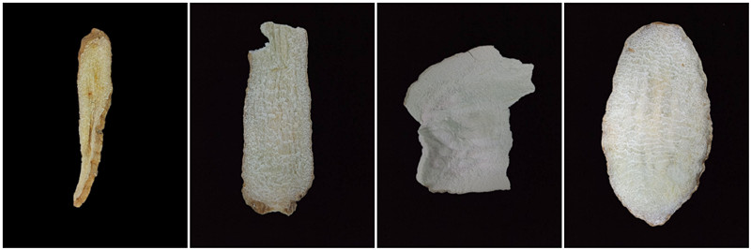
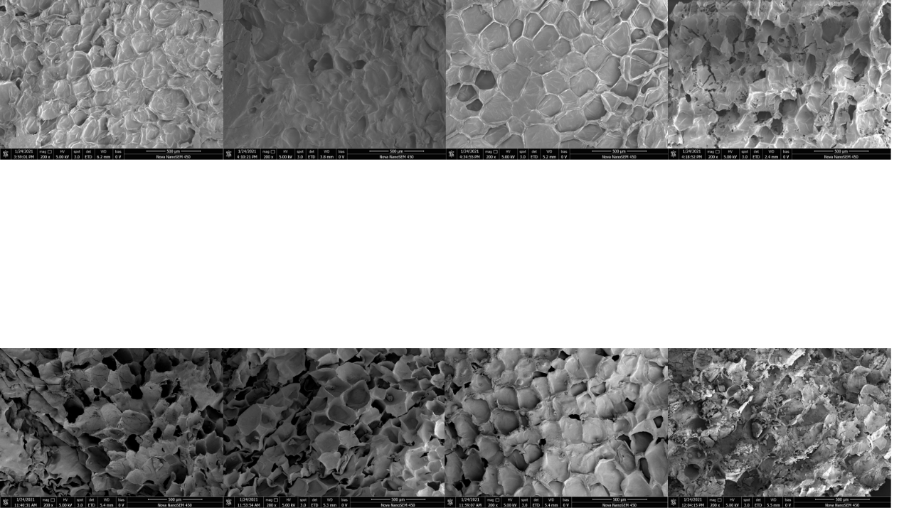
(a) Unprocessed group (NGB-NAD, NGB-HAD, NGB-CFD, NGB-VMD from left to right)
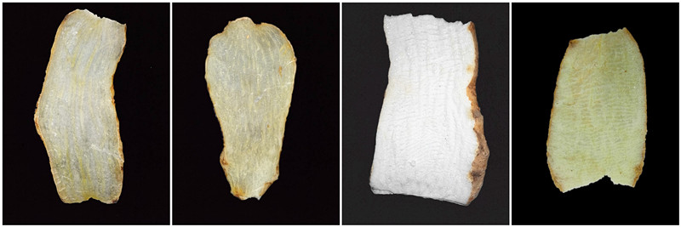
(b) steam processed group（PGB-NAD、PGB-HAD、PGB-CFD、PGB-VMD from left to right）
Fig. S1. The morphology and microstructure of G. elata affected by different processing and drying methods.

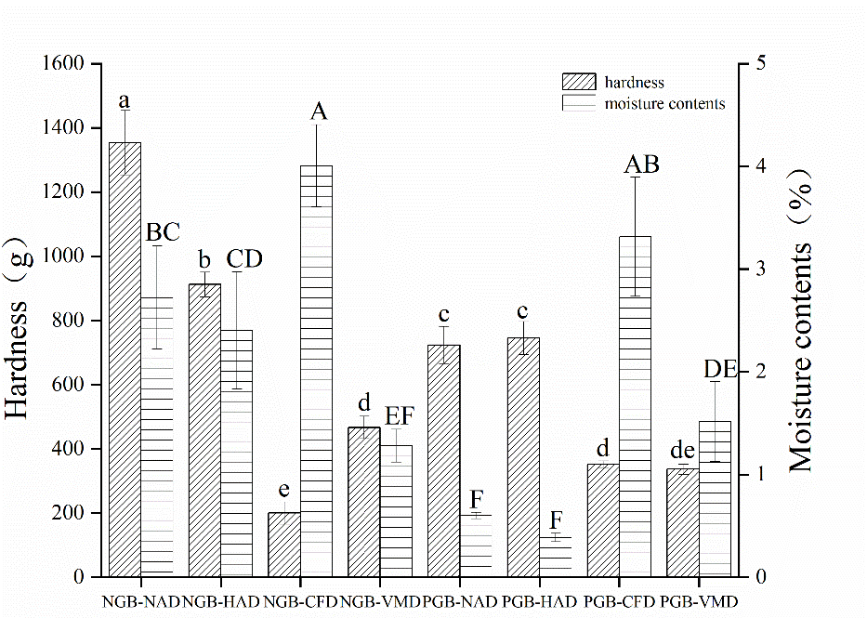
Fig. S2. Hardness and moisture content of G. elata tablets affected by different processing and drying methods. Different lowercase letters indicate that the hardness of G. elata is significantly different at p < 0.05. Different capital letters indicate that there is a significant difference in the moisture content at p < 0.05.
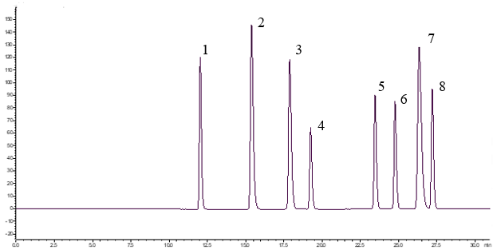

Fig. S3. High performance liquid chromatography of mixed reference. 1-gastrodin, 2- p-hydroxybenzyl alcohol, 3-vanillyl alcohol, 4-parishin E, 5-parishin B, 6-parishin C, 7-vanillin, 8-parishin A.

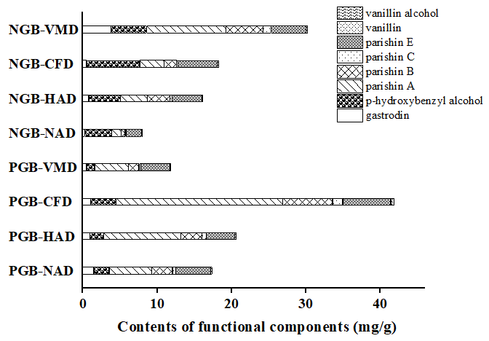
Fig. S4. The content of eight compounds in G. elata with different processing and drying methods.

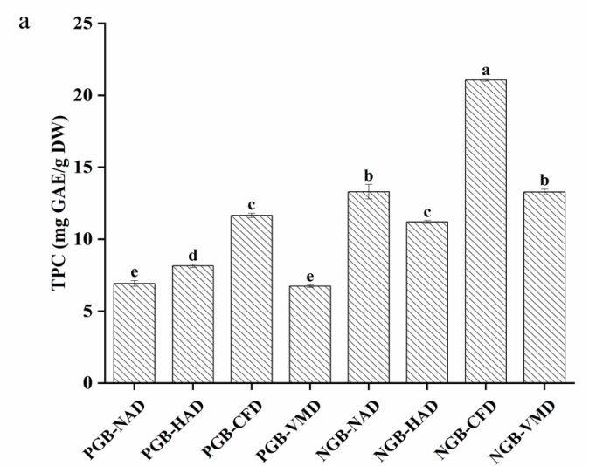
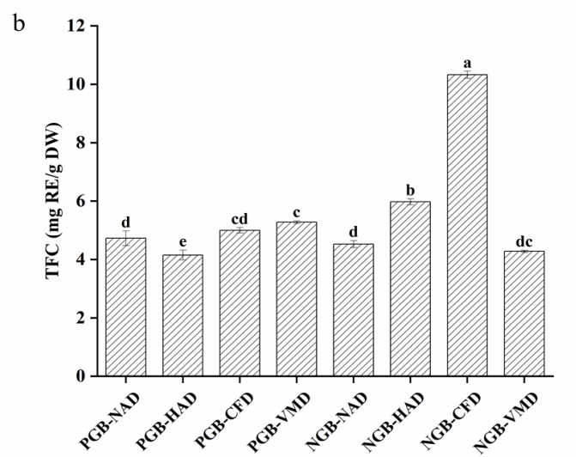
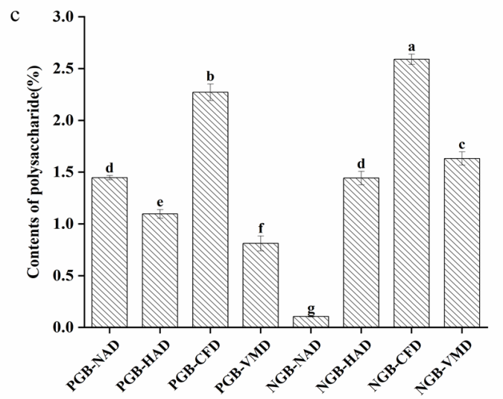
Fig. S5. Total phenol, total flavonoid and polysaccharide contents in G. elata with different processing and drying methods.

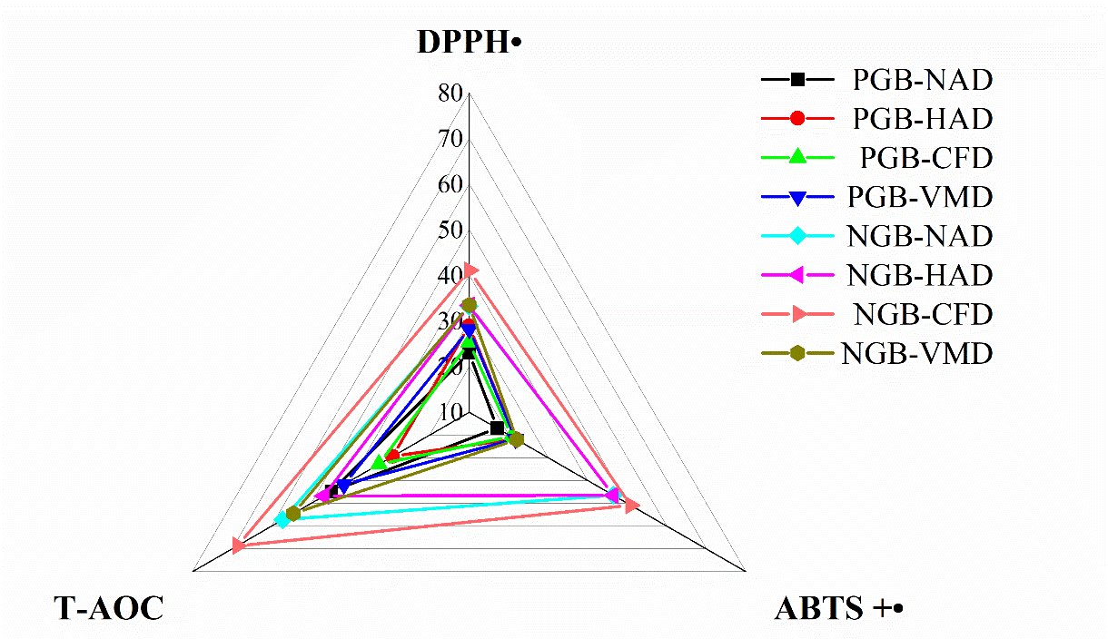
Fig. S6. Antioxidant activity of G. elata with different processing and drying methods.

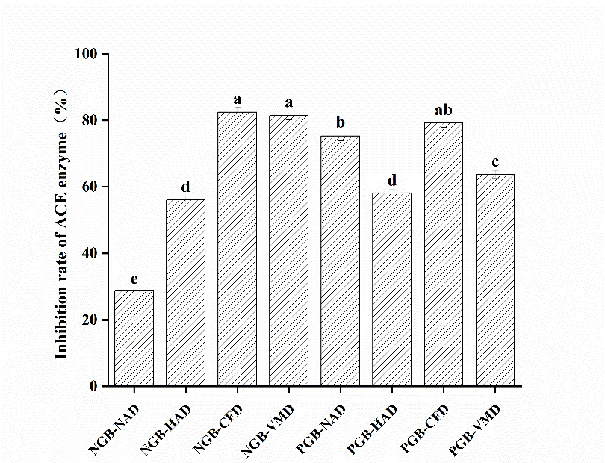
Fig. S7. Inhibition rate of ACE enzyme in G. elata with different processing and drying methods.

Table S1. The standard curve and R² of the standard
Compounds | Equation | R² | Precision  RSD/% | Reproducibility  RSD/% | Stability  RSD/% | The average recoveries of standard addition % | Recovery rate  RSD/%
gastrodin | y = 2×10⁷ x -22878 | 0.9995 | 0.11 | 1.38 | 2.26 | 91.30 | 2.78
p-hydroxybenzyl alcohol | y = 3×10⁷ x -45394 | 0.9993 | 0.59 | 2.41 | 3.64 | 108.74 | 2.46
vanillin | y = 4×10⁷ x -3325.1 | 1 | 0.37 | 1.42 | 4.42 | 81.06 | 4.33
vanillyl alcohol | y = 2×10⁷x-4076.5 | 0.9999 | 0.89 | 2.32 | 2.96 | 104.87 | 1.69
parishin A | y = 2×10⁷x-9266.2 | 0.9998 | 0.95 | 2.54 | 0.34 | 86.00 | 1.79
parishin B | y = 2×10⁷x-11542 | 0.9999 | 0.177 | 2 | 3.13 | 96.85 | 1.03
parishin C | y = 10⁷x-4309.4 | 0.9999 | 0.57 | 2.3 | 2.28 | 91.54 | 2.80
parishin E | y = 10⁷x-1884.2 | 1 | 1.67 | 1.52 | 0.94 | 108.74 | 3.82

Table S2. Quality evaluation score of G. elata with different processing and drying methods
Scoring Indicators | NGB-  NAD | NGB-  HAD | NGB-  CFD | NGB-  VMD | PGB-  NAD | PGB-  HAD | PGB-  CFD | PGB-  VMD
appearance score | 6 | 7 | 8 | 8 | 8 | 8 | 8 | 8
eight functional ingredients content | 2 | 4 | 5 | 7 | 4 | 6 | 8 | 3
polysaccharides | 3 | 5 | 8 | 6 | 5 | 4 | 7 | 4
total phenols | 7 | 5 | 8 | 7 | 3 | 4 | 6 | 3
total flavonoids | 4 | 7 | 8 | 3 | 4 | 3 | 5 | 6
DPPH | 7 | 7 | 8 | 7 | 4 | 6 | 5 | 6
ABTS | 7 | 7 | 8 | 6 | 3 | 5 | 4 | 5
T-AOC | 7 | 5 | 8 | 6 | 3 | 1 | 2 | 4
ACE inhibition | 7 | 5 | 8 | 6 | 4 | 6 | 8 | 8
total score | 50 | 52 | 69 | 56 | 38 | 42 | 53 | 47

