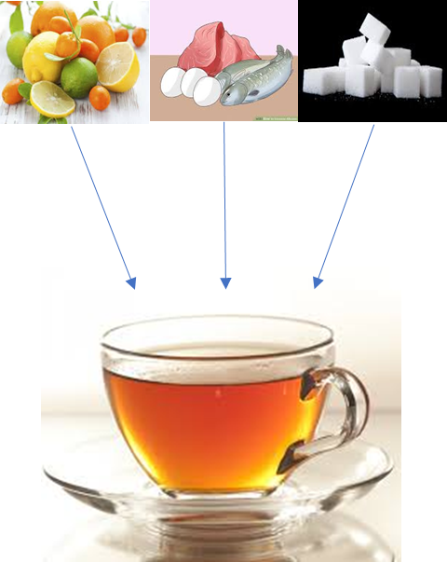
Eating albumin source (egg, fish) before tea drinking, with addition of sucrose and vitamin C source (lemon) increase the iron bio-availability.

