Did aid to the Ebola crisis divert aid for reproductive, maternal, and newborn health? An analysis of donor-reported data in Sierra Leone.
Supplementary Information

ANNEX ONE: EXCLUDED RECORDS
- “SIERRA LEONE DELIVERY UNIT PHASE II Sierra Leone Delivery Unit Phase II support the Government of Sierra Leone's efforts to recover from the Ebola crisis and accelerate development by adopting a new, results-focused approach to delivering the most important priorities.”
- “SIERRA LEONE EARLY RECOVERY ON HEALTH AND WASH Sierra Leone Early Recovery on Health and WASH To support early recovery from the effects of Ebola through supporting basic services and addressing urgent needs in Sierra Leone in 2015”
- “STRENGTHENING THE HEALTH SYSTEM IN SIERRA LEONE POST EBOLA THROUGH SCALING UP A NEW MIDWIFERY SCHOOL IN BO DISTRICT / SOUTHERN PROVINCE Strengthening the health system in Sierra Leone Post Ebola through scaling up a new midwifery school in Bo district / Southern Province Strengthening the health system in Sierra Leone Post Ebola through scaling up a new midwifery school in Bo district / Southern Province”
- “NUFU AGREEMENT NUFU Agreement ZOOTOX-2007-11: Collaborative research in environmental toxicology and zoonotic diseases in the Human Domestic animal Wildlife interface areas of Eastern and Southern Africa - A South-North Veterinary Network”

ANNEX 2: DETAILED BREAKDOWN OF ALL SECTOR DATA: AID TO SIERRA LEONE, WEST AFRICA REGION AND UNSPECIFIED BILATERAL AID
2a: Total aid for all sectors by sector
The total value of aid to Sierra Leone nearly doubled from annual averages in the 2010-13 period to the 2 main years of the Ebola outbreak (2014-15). This increase was primarily driven by a dramatic increase in humanitarian aid, but also a very substantial increase in general budget support, and a lesser increase in aid categorised as being within the health sector. A substantial increase in humanitarian funding directed towards relevant African regions also occurred in 2014, but returned to pre-crisis levels the following year although total regional aid continued to increase to the end of the study period (2019). Bilateral aid to unspecified recipients also sees an increase in total aid, mainly to general budget support, from 2015.
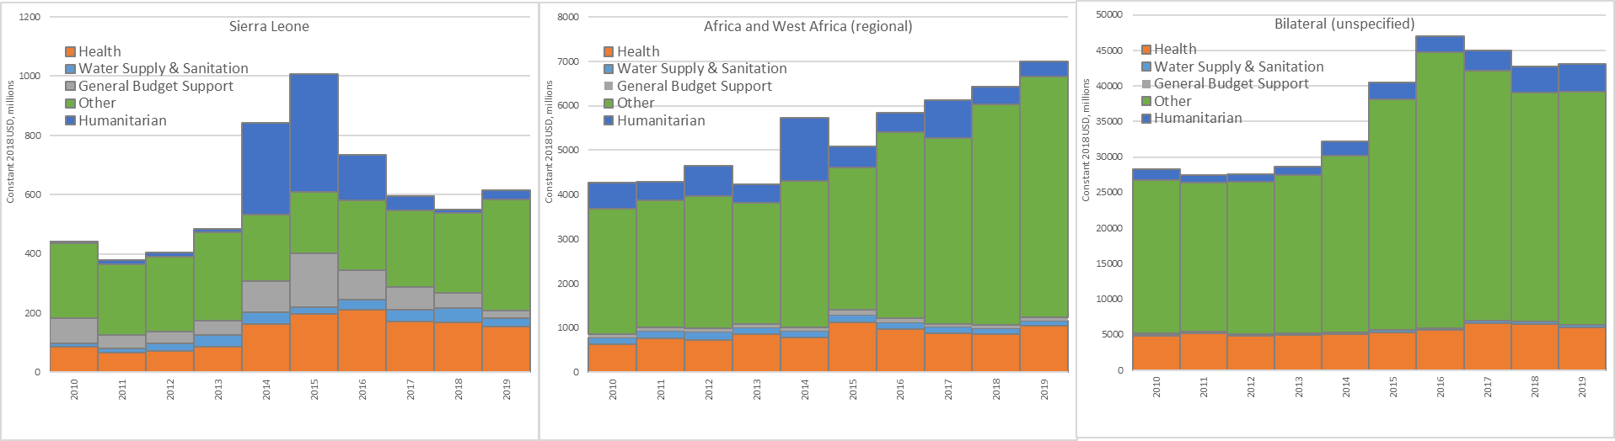
2b: Aid for Ebola by sector
No aid was provided to Sierra Leone or relevant African regions which specifically mentioned Ebola or related terms in the period 2010-13. In that period, aid was provided to “South of Sahara, regional” by the EU Institutions, channelled through WHO, for $0.90m in 2008, $1.10m in 2010, and $0.36m in 2013, which was described as: “SUPPORT COUNTRIES EMERGENCY PREPAREDNESS AND RESPONSE TO MAJOR EPIDEMIC PRONE DISEASES IN WEST AND CENTRAL AFRICA Support countries emergency preparedness and response to major epidemic prone diseases in West and Central Africa The project enhances country capacity to detect and control epidemics of meningitis, yellow fever, Ebola, Marburg and plague in West Africa and Central Africa”. Other aid for Ebola before 2014 related to previous Ebola epidemics elsewhere in Africa and to efforts to improve medical training to address outbreaks.
In 2014, more than $300m was provided and in 2015, this aid for Ebola in Sierra Leone rose to over $400m. Most aid for Ebola was classified as falling within the humanitarian sector, although a substantial proportion – and most of the “bilateral, unspecified” funding – was classified within the health sector, largely in the purpose code for other infectious diseases (i.e. not malaria, HIV, or TB). Increased bilateral (unspecified) funding is seen through to the end of the study period (2019).
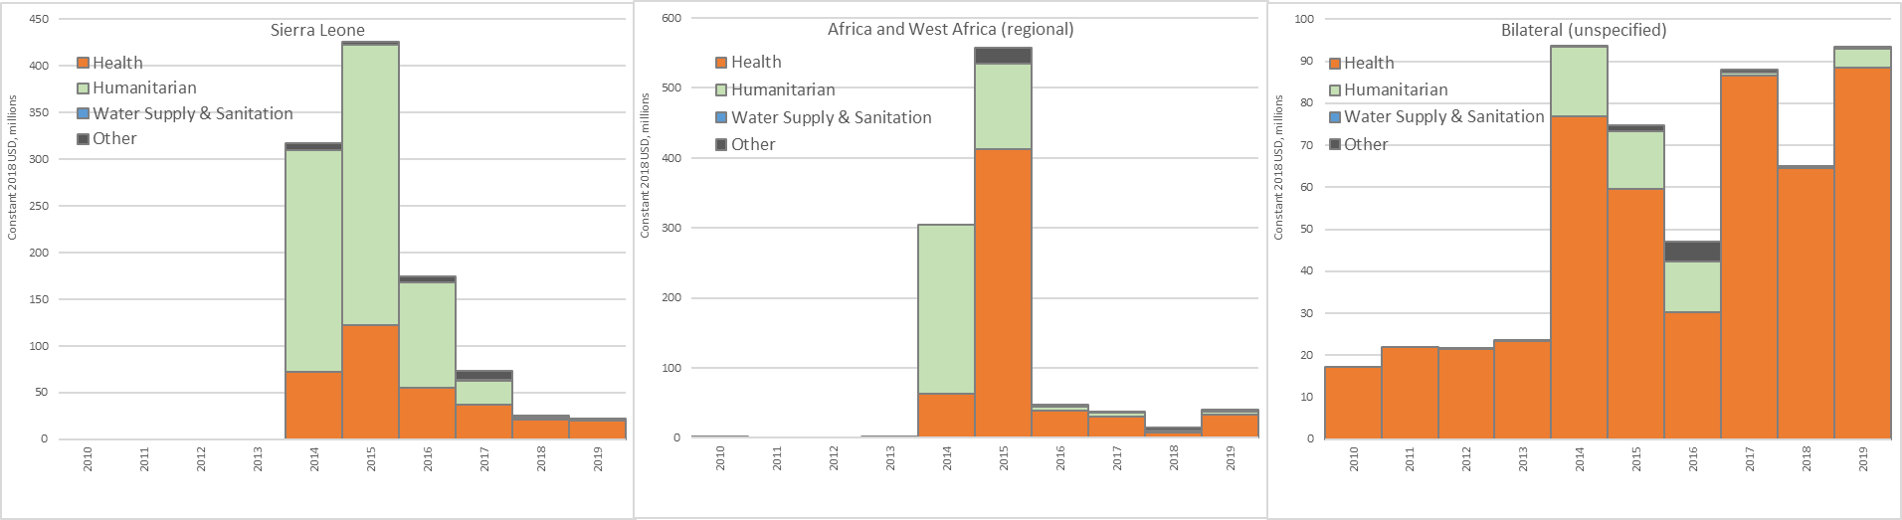
2c: Aid for RMNH based on Muskoka2
Aid for RMNH to Sierra Leone appears to remain stable in the first two years of the outbreak, 2014 and 2015, before increasing very substantially in 2016, and subsequently returning quickly to pre-epidemic levels in 2017. Regional aid for RMNH begins to increase only in 2017, after the epidemic, rising substantially in 2019. Bilateral unspecified aid remains largely stable between 2010-2019.
