Supplementary information

Inductive nanopore synapse element for iontronic neuromorphic computing

Patricio Ramirez,¹ Agustín Bou,² Javier Cervera,³ Juan Bisquert*²
¹Dept. de Física Aplicada, Universitat Politècnica de València, E-46022 València, Spain
²Institute of Advanced Materials (INAM), Universitat Jaume I, 12006 Castelló, Spain
³Dept. de Física de la Terra i Termodinàmica, Universitat de València, E-46100 Burjassot, Spain

Email:bisquert@uji.es

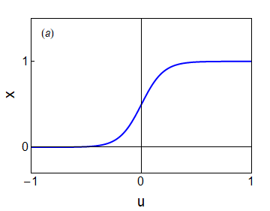 | 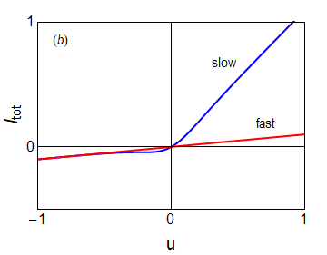
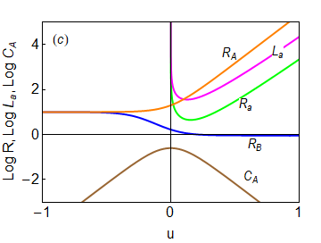 | 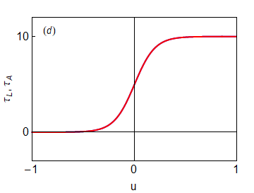
Fig. S1. Representation of model functions, with respect to the voltage in the nanopore. (a) The state variable $x$ at steady state. (b) The current-voltage curve at steady state and under a fast voltage sweep. (c) Equivalent circuit elements. (d) The characteristic time constant of inductor and surface polarization. Parameters: $R_{H}=10, R_{L}=1, C_{m}=0.01, C_{P}=0.1, τ_{k}=10, V_{m}=0.100$.

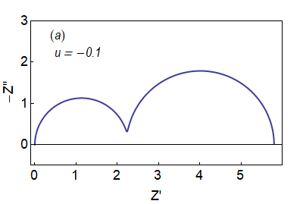 | 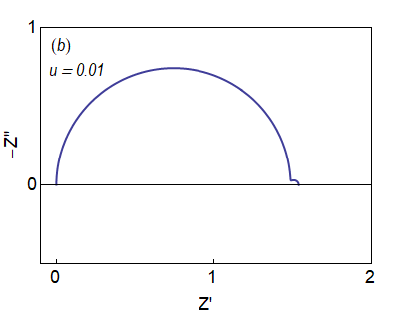
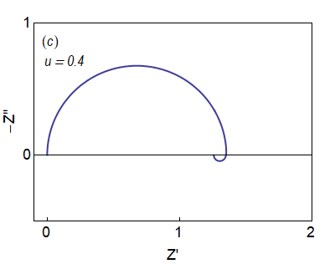 | 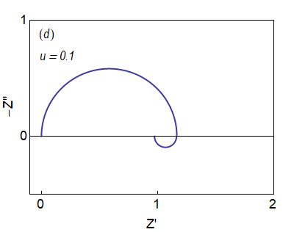
Fig. S2. Impedance spectra at selected values of the voltage in the nanopore. Parameters: $R_{H}=10, R_{L}=1,R_{s}=0, C_{m}=0.01, C_{P}=0.1, τ_{k}=10, V_{m}=0.100$.

Figure S3. Element values extracted from the fitting of the impedance spectra using the circuit in Fig. 5b. (a) shows the values of the resistances directly extracted and the dc resistance calculated from the three parallel resistances. Note that the dc resistance is governed by the lowest resistances, since they are in parallel. (b) and (c) are the capacitor and inductor values of the RC and RL branches, each of them represented in the same color as their series resistance, and the high frequency capacitor $C_{m}$.

Figure S4. Average element values for a single of the pours, calculated from the fitting in Figure S3 (that corresponds to a total of 300 pores). (a) shows the values of the resistances directly extracted and the dc resistance calculated from the three parallel resistances. Note that the dc resistance is governed by the lowest resistances, since they are in parallel. (b) and (c) are the capacitor and inductor values of the RC and RL branches, each of them represented in the same color as their series resistance, and the high frequency capacitor $C_{m}$.

