Supplementary Information
FAIRCog: Fair and Interpretable Representation of Cognition using semi-supervised deep learning on clock drawing tests
Jiaqing Zhang, MS, Sabyasachi Bandyopadhyay, MS, David J. Libon, PhD, Catherine Price, PhD, Parisa Rashidi, PhD.
This supplementary material has been provided by the authors to give the readers additional information about their work.
Supplementary Figures
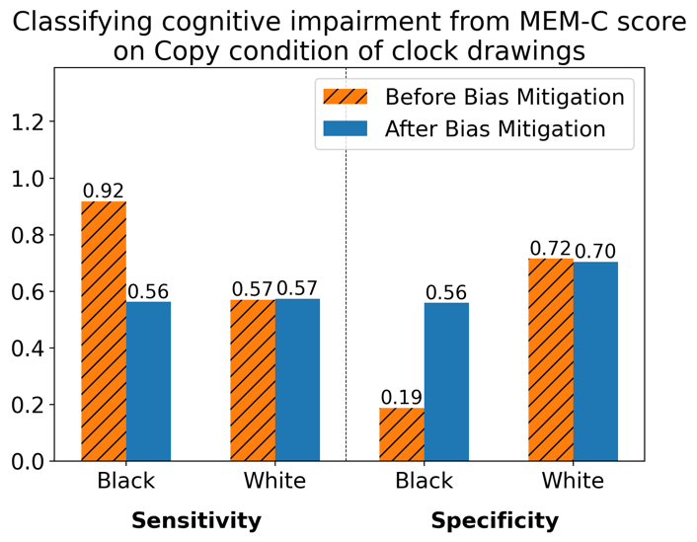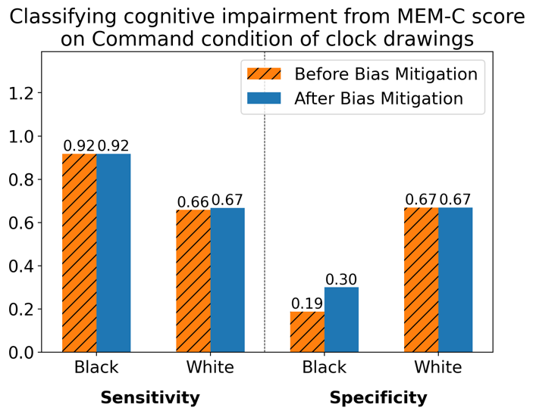
a b
Supplementary Figure S1. Sensitivity and specificity plot before and after bias mitigation in the white patients and black patients. a. shows the model trained on the copy condition of clock drawings for predicting MEM-C score. b. presents the model trained on the command condition of clock drawings.

Supplementary Table 1 PRECEDE vs NHATS
Task | Dataset | AUROC (95% C.I.) | F1- score (95% C.I.)
Mini-Mental State Examination | NHATS | 0.70 (0.66-0.74) | 0.47 (0.43-0.51)
Mini-Mental State Examination | PRECEDE | 0.69 (0.63-0.74) | 0.43 (0.37-0.50)
Attention composite z-score | NHATS | 0.71 (0.64-0.75) | 0.41 (0.34-0.48)
Attention composite z-score | PRECEDE | 0.63 (0.55-0.69) | 0.33 (0.26-0.41)
Memory composite z-score | NHATS | 0.67 (0.62-0.71) | 0.61 (0.56-0.65)
Memory composite z-score | PRECEDE | 0.66 (0.61-0.70) | 0.61 (0.55-0.66)
Abbreviations. NHATS - the National Health and Aging Trends Study, AUROC - area under the receiver operating curve, C.I - confidence interval

Supplementary Table 2 Protecting race when MEM
Task | Dataset (Train:Test) | Fairness | AUROC (95% C.I.) | F1- score (95% C.I.) | Sensitivity (95% C.I.) | Specificity (95% C.I.) | Precision (95\% C.I.) | 1-min(DI, 1/DI) $↓$ | AOD $↓$
MEM-C | Copy (509:220) | - | 0.68 (0.61-0.74) | 0.62 (0.57-0.72) | 0.66 (0.57-0.74) | 0.64 (0.55-0.73) | 0.59 (0.53-0.72) | 0.45 | 0.38
MEM-C | Copy (509:220) | √ | 0.64 (0.57-0.71) | 0.59 (0.51-0.66) | 0.58 (0.49-0.65) | 0.68 (0.58-0.76) | 0.60 (0.51-0.73) | 0.18 | 0.05
MEM-C | Command (510:220) | - | 0.71 (0.64-0.78) | 0.65 (0.59-0.74) | 0.73 (0.64-0.81) | 0.60 (0.50-0.69) | 0.59 (0.51-0.70) | 0.44 | 0.38
MEM-C | Command (510:220) | √ | 0.69 (0.62-0.76) | 0.66 (0.60-0.76) | 0.74 (0.65-0.81) | 0.62 (0.53-0.71) | 0.61 (0.52-0.72) | 0.41 | 0.30
MEM-C | Copy+Command (1019:440) | - | 0.65 (0.60-0.70) | 0.58 (0.52-0.63) | 0.57 (0.50-0.63) | 0.66 (0.61-0.72) | 0.59 (0.51-0.67) | 0.54 | 0.41
MEM-C | Copy+Command (1019:440) | √ | 0.65 (0.60-0.70) | 0.58 (0.52-0.63) | 0.58 (0.51-0.64) | 0.65 (0.59-0.69) | 0.58 (0.50-0.64) | 0.21 | 0.10
Abbreviations. MEM-C – memory composite Z-score, AUROC - area under the receiver operating curve, C.I - confidence interval, DI - disparate impact, AOD - average odds different
Binarizing threshold. MEM - values greater than or equal to -1 are categorized as class 0, while values less than -1 are categorized as class 1.

Supplementary Table 3 digital-clock drawing test variables
Task (clock version) | dCDT variables | Sample size (Training:Test) | AUROC (95% C.I.) | F1- score (95% C.I.)
Mini-Mental State Examination (copy) | w/ | 327:144 | 0.77 (0.70-0.84) | 0.48 (0.40-0.56)
Mini-Mental State Examination (copy) | w/o | 587:251 | 0.69 (0.60-0.78) | 0.35 (0.26-0.47)
Attention composite z-score (copy) | w/ | 274:120 | 0.64 (0.52-0.75) | 0.29 (0.18-0.42)
Attention composite z-score (copy) | w/o | 511:218 | 0.71 (0.64-0.75) | 0.41 (0.34-0.48)
Memory composite z-score (command) | w/ | 510:220 | 0.70 (0.64-0.78) | 0.64 (0.58-0.74)
Memory composite z-score (command) | w/o | 510:220 | 0.67 (0.62-0.71) | 0.61 (0.56-0.65)

Supplementary Table 4 T-Test results for sensitivity and specificity differences w/ and w/o reweighting method
Task (clock version) | Sensitivity for Low Edu group | Sensitivity for High Edu group | Specificity for Low Edu group | Specificity for High Edu group
MMES (copy) | 4.27e-53 | nan | 0 | 1.02e-43
MMES (command) | 2.49e-49 | 4.09e-35 | 1.94e-41 | 757e-26
ATT-C (copy) | 8.42e-34 | nan | 2.06e-37 | 9.67e-23
ATT-C (command) | 9.40e-21 | 3.02e-33 | 2.05e-37 | 9.25e-37
MEM-C (command) | nan | nan | nan | nan
Abbreviations. MMSE - mini-mental state examination score, ATT-C – attention composite Z-score, MEM-C – memory composite Z-score

