Supplementary Data

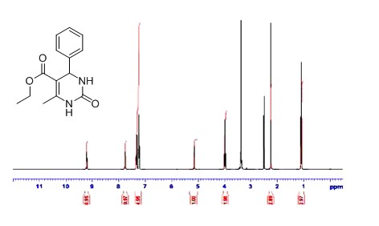
1) HNMR of 5-Ethoxycarbonyl-4-(4-phenyl)-6-methyl-3,4-dihydropyrimidin-2(1H)-one in DMSOd_{6 .}

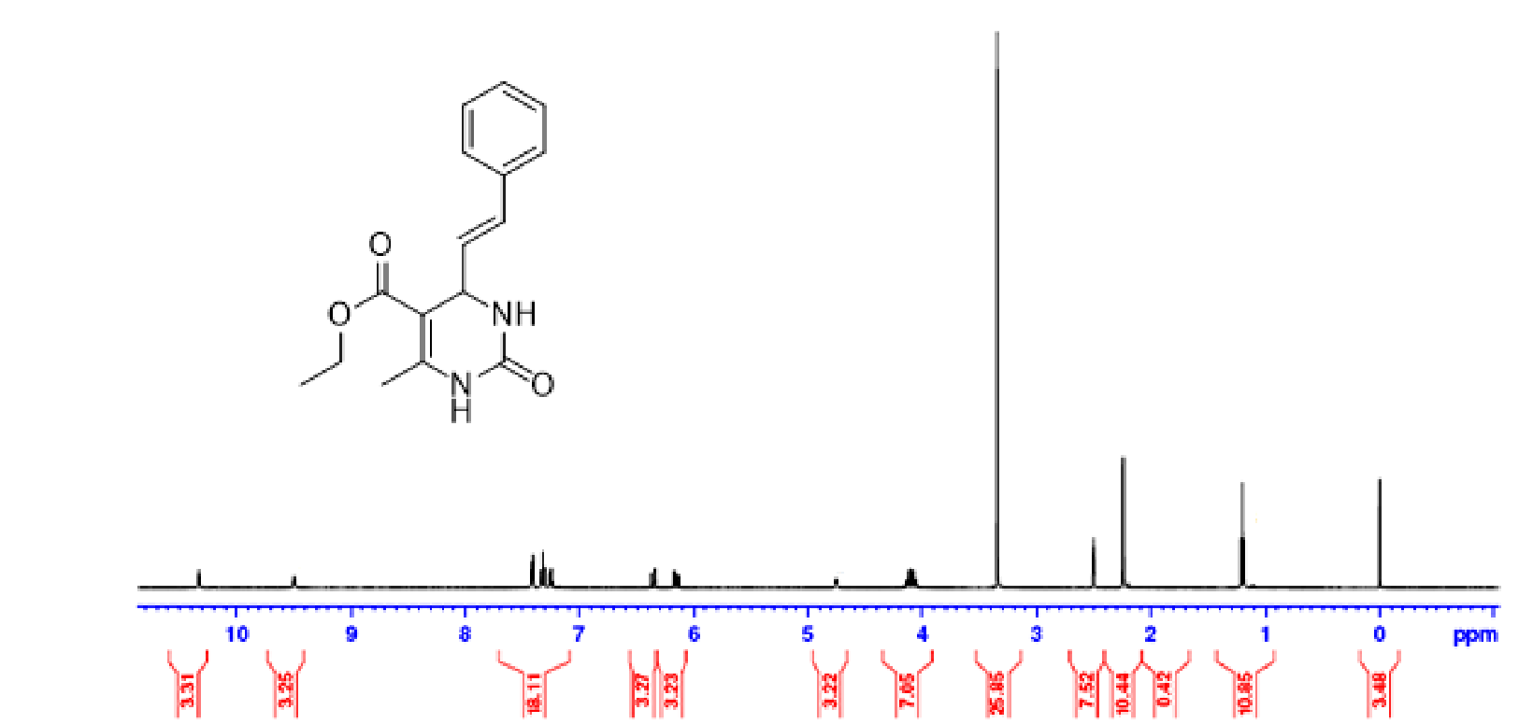

- HNMR of 5-Ethoxycarbonyl-6-methyl-4-cinnamyl-3,4-dihydropyrimidin-2(1H)-one in DMSOd₆
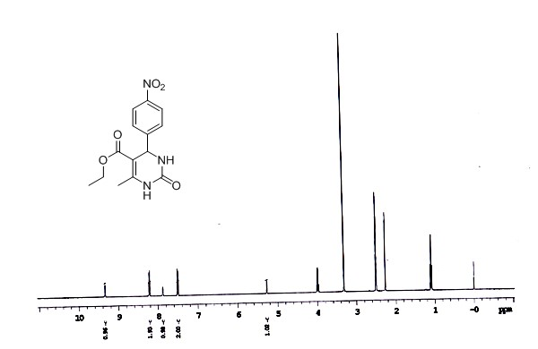
3) HNMR of 5-Ethoxycarbonyl-4-(4-nitro)-6-methyl-3,4-dihydropyrimidin-2(1H)-one in DMSOd₆

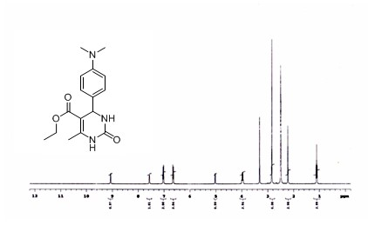
4) ¹HNMR of 5-Ethoxycarbonyl-4-(4-N(CH₃)₂)l-6-methyl-3,4-dihydropyrimidin-2(1H)-one in DMSOd₆

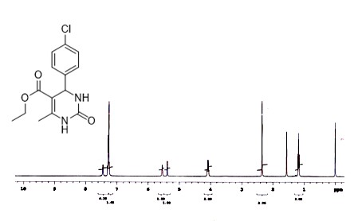

- ¹HNMR 5-of Ethoxycarbonyl-4(4-chloro)-6-methyl-3,4 dihydropyrimidin-2 (1H)- one in DMSOd₆

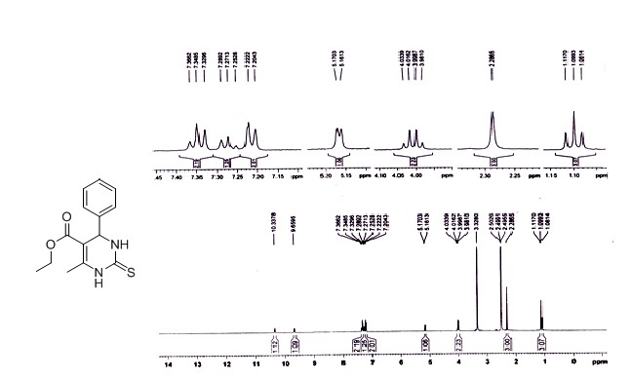
6) HNMR of Ethoxycarbonyl-4-(4-phenyl)-6-methyl-3,4-dihydropyrimidin-2(1H)-thione in DMSOd₆

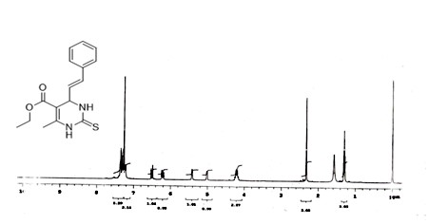
7) HNMR of 5-Ethoxycarbonyl-6-methyl-4-cinnamyl-3,4-dihydropyrimidin-2(1H)-thione in DMSOd₆

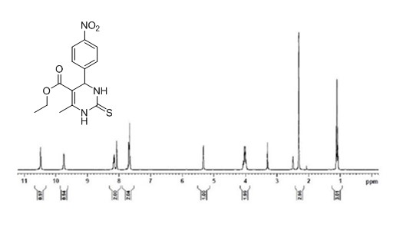
- HNMR of 5-Ethoxycarbonyl-4-(4-nitrophenyl)-6-methyl-3,4-dihydropyrimidin-2(1H)-thione in DMSOd₆

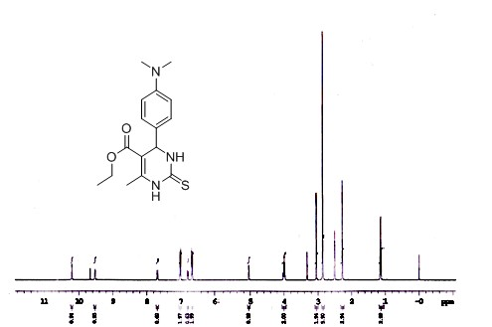

9) HNMR of 5-Ethoxycarbonyl-4-(4-N(CH₃)₂)l-6-methyl-3,4-dihydropyrimidin-2(1H)-thione in DMSOd₆

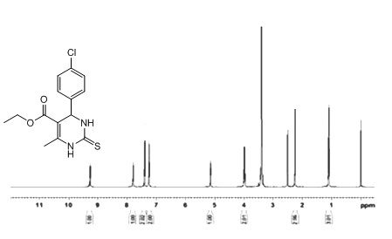

10) HNMRof 5-Ethoxycarbonyl-4-(4-chlorophenyl)-6-methyl-3,4-dihydropyrimidin-2(1H)-thione in DMSOd₆

