SUPPLEMENTARY MATERIAL
Andréa Davrinche & Sylvia Haider. Complementarity behind tree-level trait expression and variation: soil conditions modify species diversity effects. Scientific Reports.

Table S1: List of tree species included in the study. Nomenclature according to The Flora of China (http://flora.huh.harvard.edu/china). Species were planted in pairs in all possible combinations within each set. Abb.: abbreviated name; Acq.: acquisitive; Cons.: conservative according the a PCA based on the measured functional traits (Fig. S1).
Species name | Abb. | Author | Family | Growth strategy | Set
Choerospondias axillaris | Ca | (Roxb.) B.L.Burtt & A.W.Hill | Anacardiaceae | Acq. | A
Koelreuteria bipinnata | Kb | Franch. | Sapindaceae | Acq. | A
Quercus fabri | Qf | Hance | Fagaceae | Acq. | B
Quercus serrata | Qs | Thunberg | Fagaceae | Acq. | A
Sapium sebiferum | Ss | (L.) Roxb. | Euphorbiaceae | Acq. | A
Cyclobalanopsis glauca | Cg | (Thunberg) Oersted | Fagaceae | Cons. | B
Rhus chinensis | Rc | Mill. | Anacardiaceae | Cons. | B
Schima superba | Ssu | Gardn. & Champion | Theaceae | Cons. | B

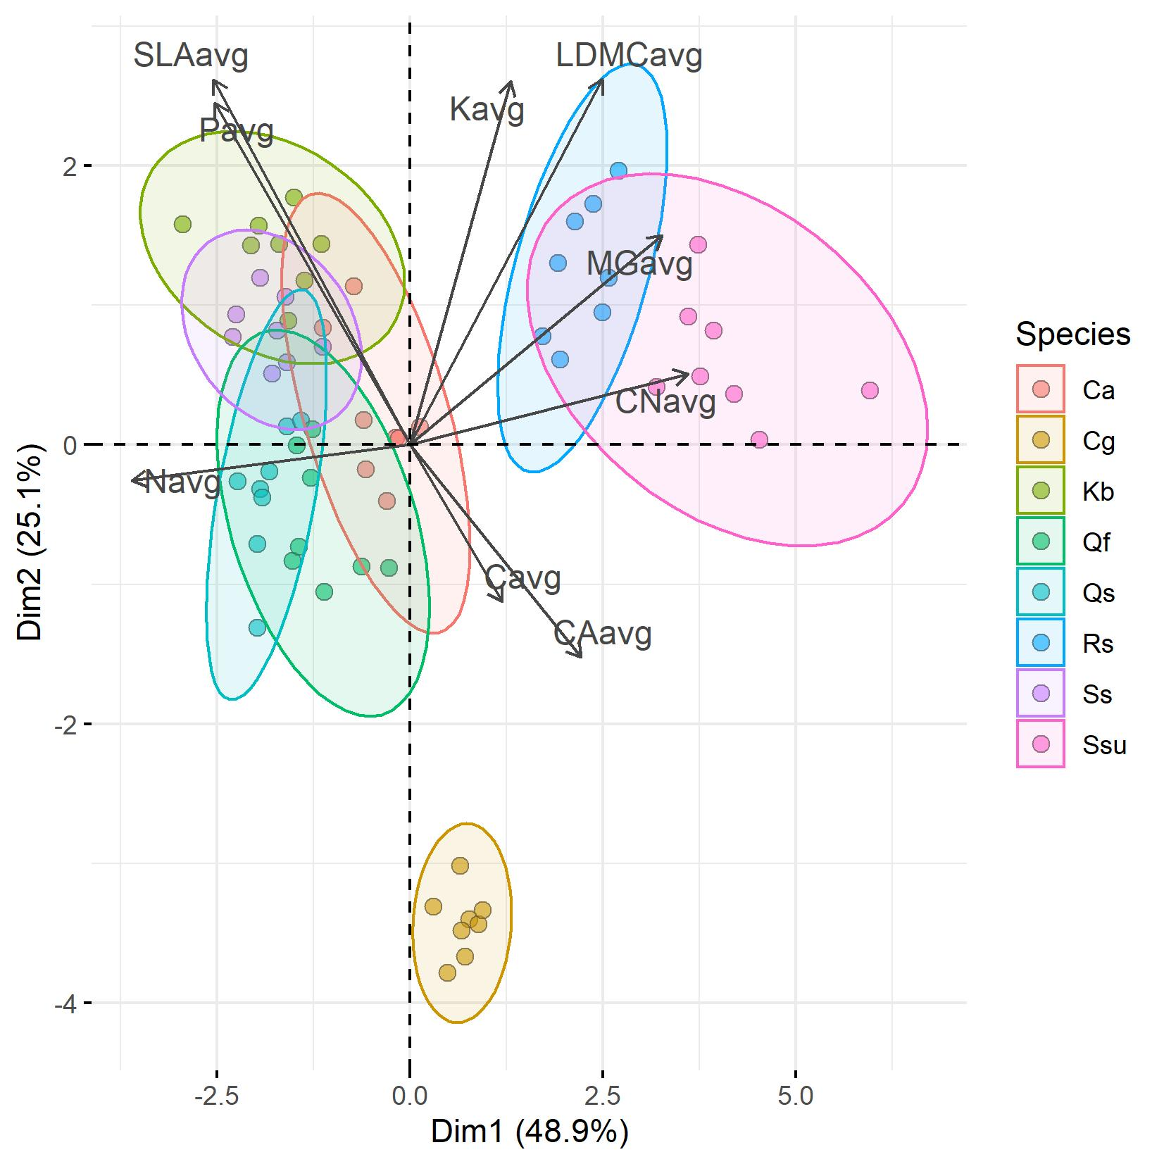
Fig. S1: Principal component analysis performed on all trait values, averaged for each treatment combinations of each species. The two groups delimited by the first dimension were used as separation between acquisitive (Ca, Kb, Qf, Qs and Ss) and conservative species (Cg, Rc, Ssu). Species abbreviations are detailed in Table S1.

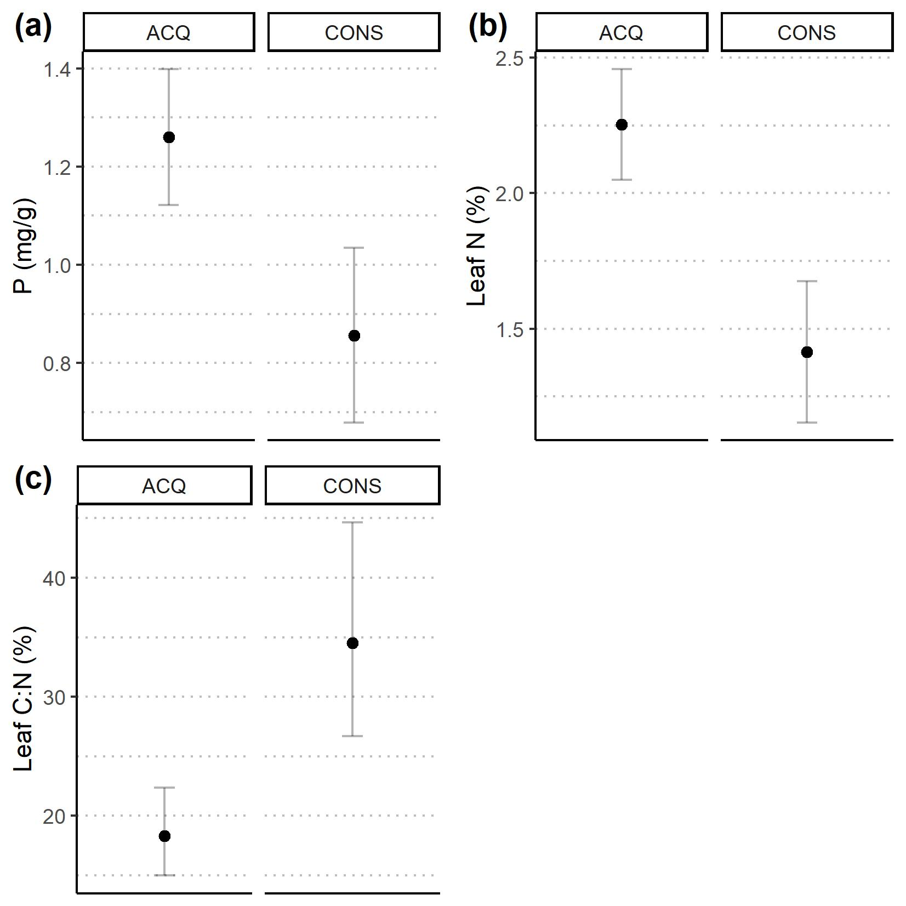
Fig. S2: Effect of trees species growth strategy on leaf traits (ACQ: acquisitive, CONS: conservative; see also Supp. Table S1 & Fig. S1). Dots indicate trait values averaged at the leaf level predicted from significant effects of the respective trait linear mixed model (see Table 1). Error bars represent two standard errors around the mean.

