Appendix 1

Activity Calibration

We calibrated the activity sensors in the mountain goat collars separately for Alaska and Alberta because different collars were used. For Alaska, focal observations of 6 mountain goats with GPS collars were made in the field to record the proportion of time spent active for the 15-minute period when activity was recorded by the collar. Only the fully active or fully inactive sequences were kept for calibration to increase the level of accuracy. A total of 92 observations were kept for the calibration. For the continental collars, technical issues with the retrieval of the data from collars installed on mountain goats for calibration forced us to use one collar installed on a mountain goat and 5 collars on domestic sheep. The same protocol was used as for the Alaskan collars and a total of 348 observations were kept for calibration.

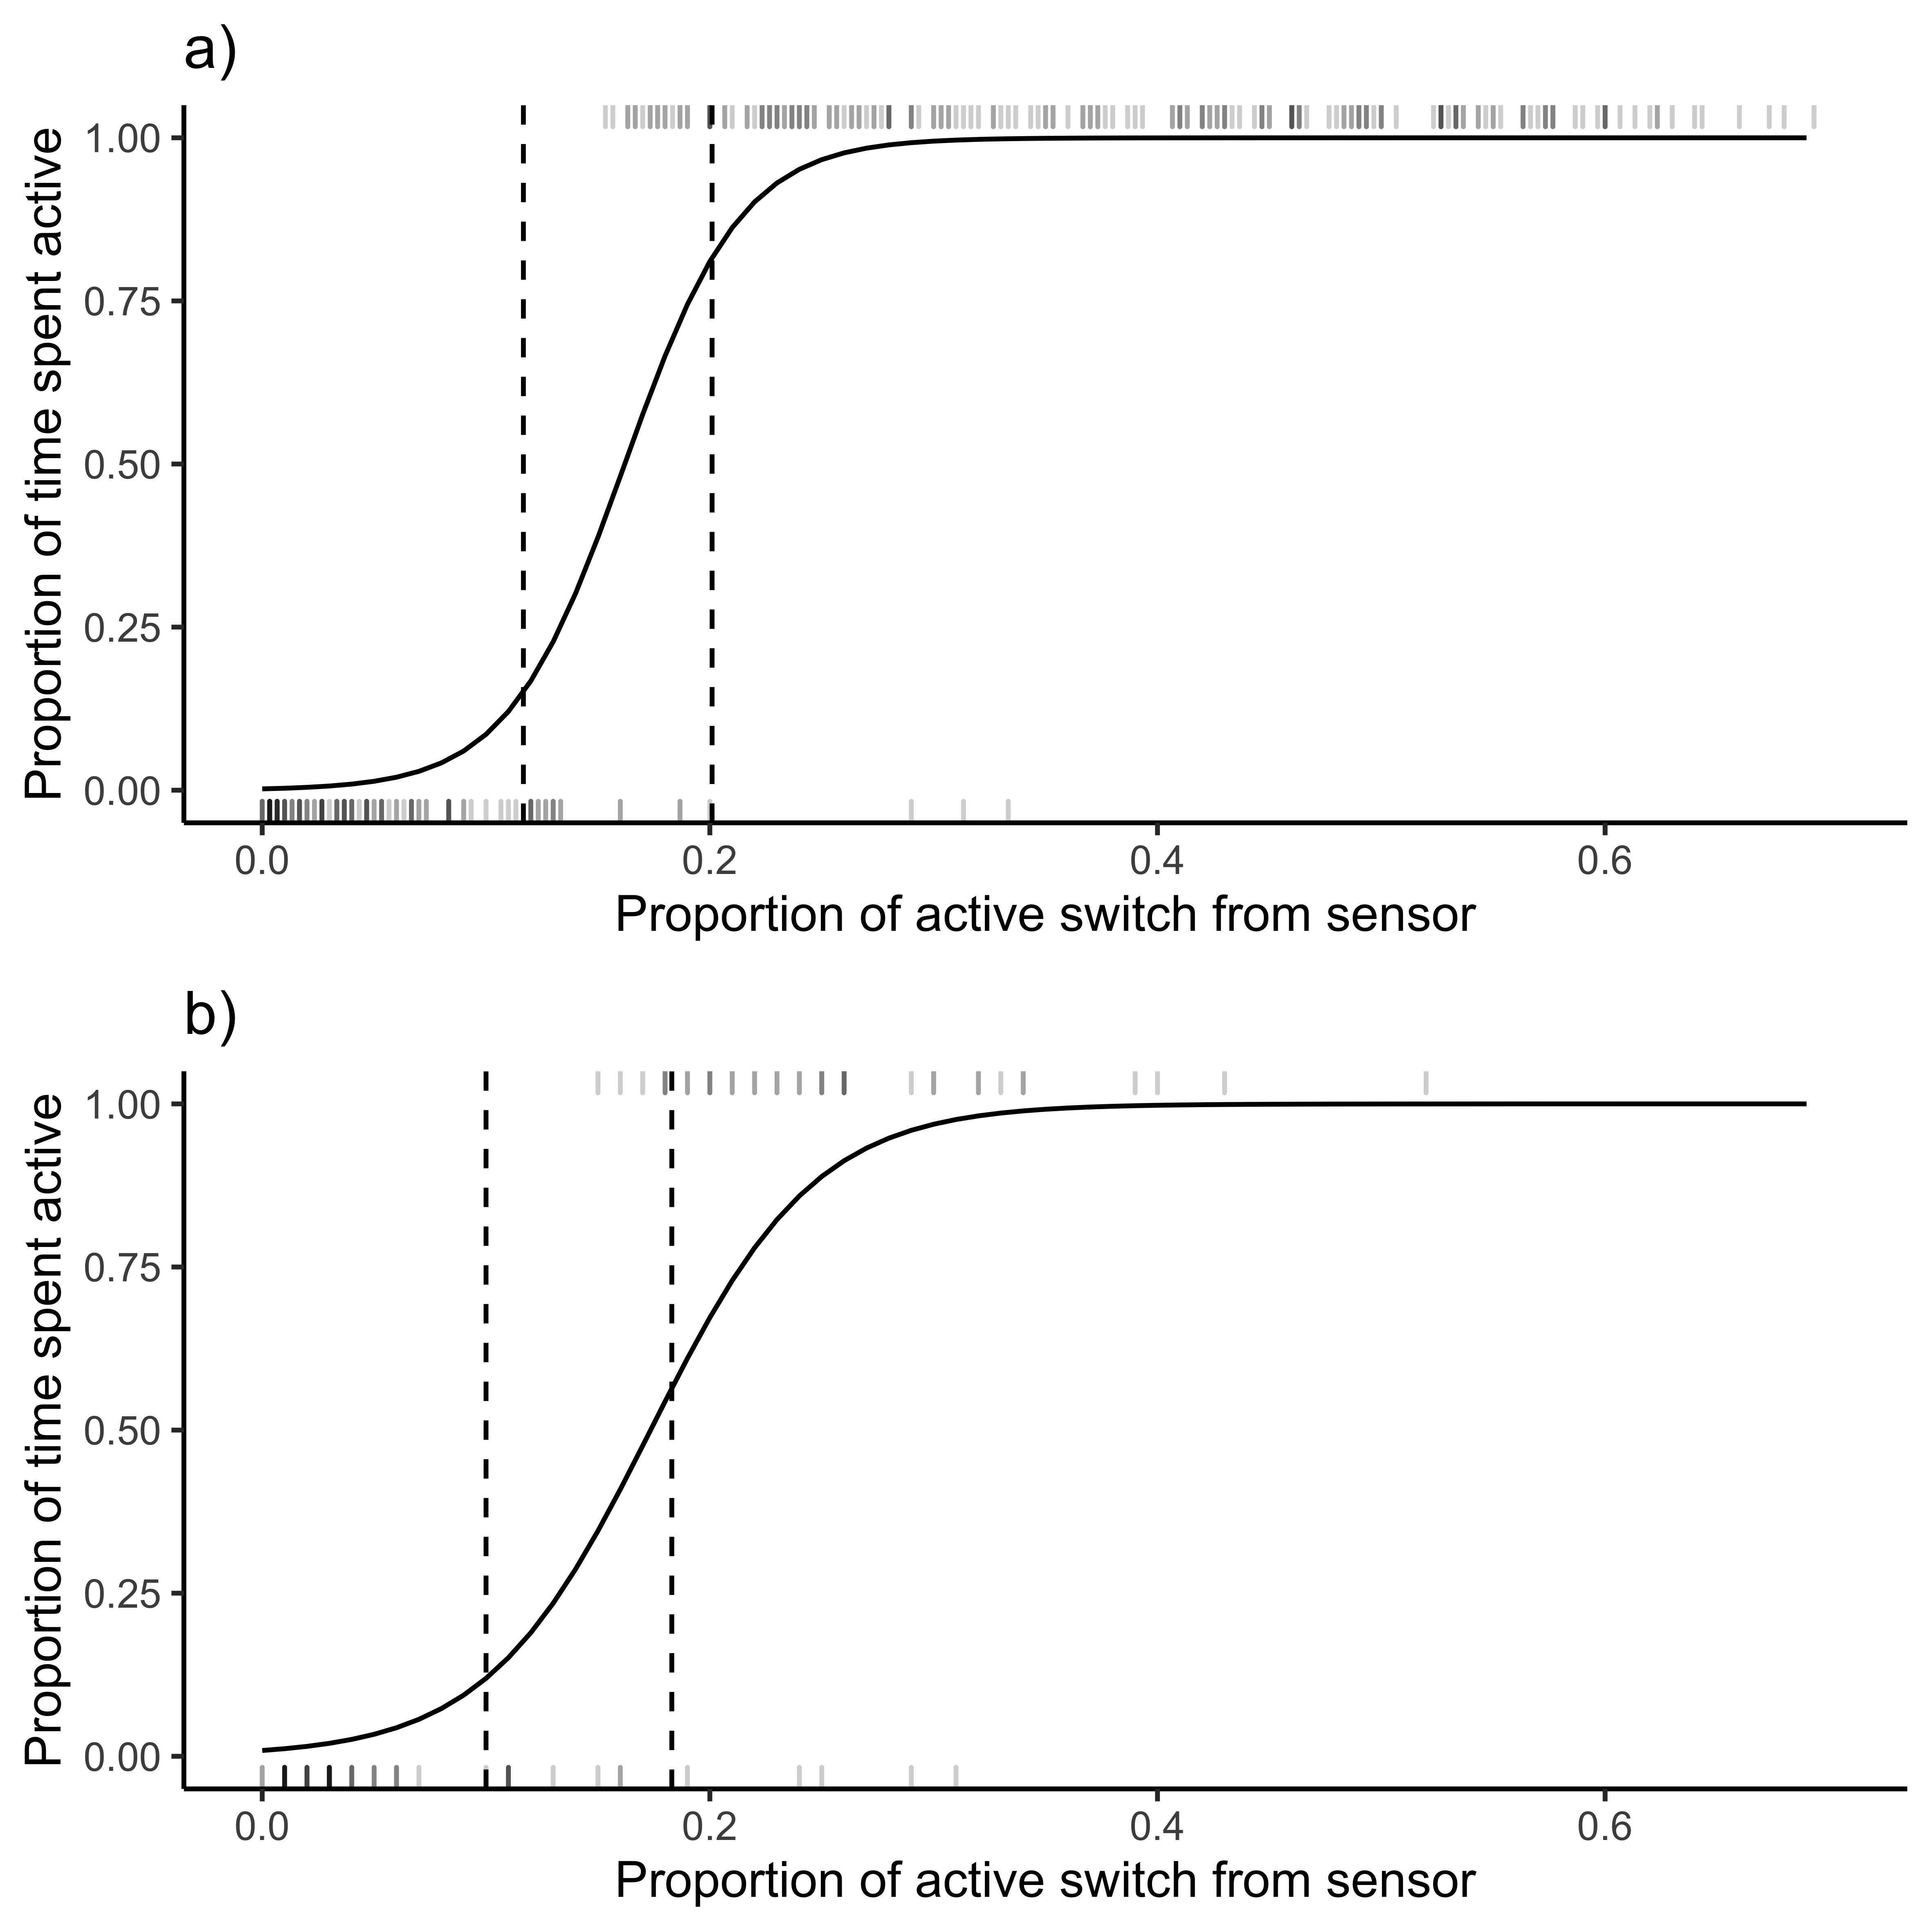
Figure A1. Probability that the animal was active in relation to GPS collar activity sensor values for a) Vectronic collars fitted on domestic sheep and one mountain goat, b) Telonic collars fitted on wild mountain goats. The rugs at the top of the graphs represent active bouts while the rugs at the bottom represent resting bouts. The dashed vertical lines show the 0.15 and 0.85 proportion of time spent active, all data between these two lines were excluded from analysis. Activity sensor values were standardized by dividing the raw value by the maximum possible active seconds (i.e. 900). Only records when animals were completely bedded or active for the entire 900 second evaluation period were used.
A generalized linear mixed model was fitted with all the observations for one ecotype using the “glm” function, a binomial family and a “logit” link. The collar ID was used as a random variable to account for differences between collars. The following formulas were used to calibrate the activity data used in the activity analyses.

Coastal formula:
$$P_{Active}=e^{0.0468*Collar activity-5.93745}/(1+e^{0.0468*Collar activity-5.937})$$
Continental formula:
$$P_{Active}=e^{0.042464*Collar activity-6.190}/(1+e^{0.042464*Collar activity-6.190})$$

Appendix 2

To further assess the reliability of the North American Regional Reanalysis (NARR) data and confirm the findings of (Trubilowicz et al. 2016), we compared temperatures extracted from the NARR to a HOBO pendant temperature logger (Onset and model: #UA-001-64) located at the same elevation as the temperatures extracted at a 3h interval.

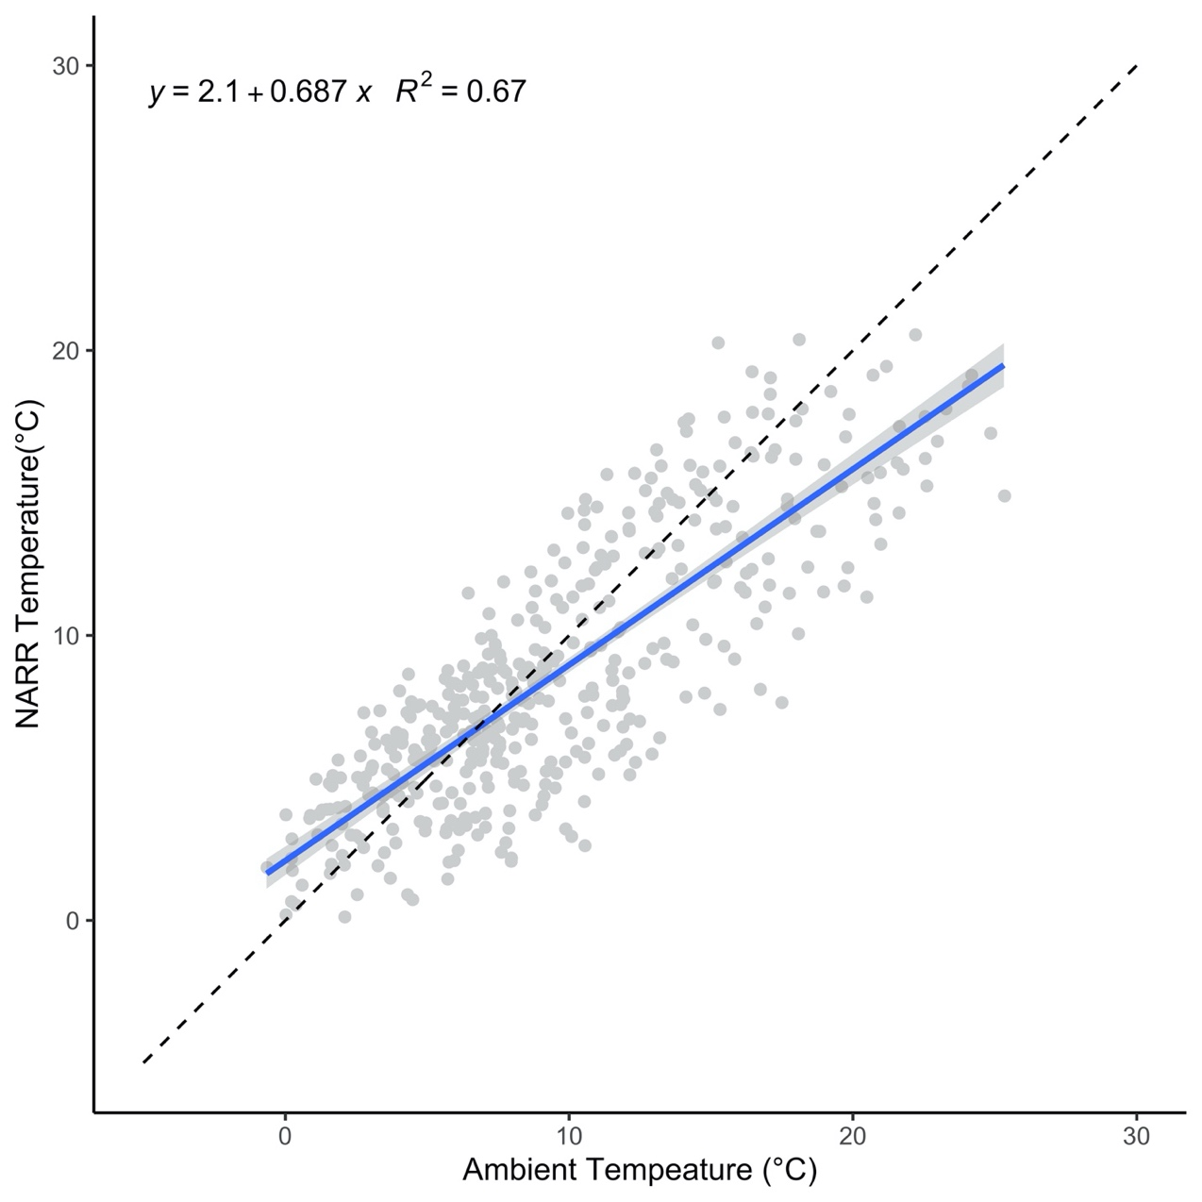
Figure A2. Relationship between North American Regional Reanalysis (NARR) and ambient temperatures. The grey dots represent data points, the blue line represents the predicted relationship, the gray areas are the 95% confidence intervals, and the dotted line represents the reference for the perfect relationship. NARR data were extracted for the 1900m level. Ambient temperatures were measured using a HOBO temperature sensor located at 1900 m in the Caw Ridge study area from June to August 2020, N=477.

Appendix 3

Temperature calibration

The temperature sensors in the mountain goat collars were calibrated by matching the temperatures recorded inside the collars to temperatures recorded by Hobo temperature loggers (©Onset) in Alberta and ibutton temperature loggers (©Ibuttonlink) in Alaska. Temperature loggers were installed in multiple locations over the study areas and shaded with white soccer cones to avoid the effect of direct sunlight on temperature readings. For Alberta, data were collected from 5 mountain goats at Caw Ridge between 1 July 2020 – 10 September 2020 (n=832). Ambient temperatures were measured using Hobo temperature sensors located within linear distances of 200 m (mean = 147 m) from mountain goat locations. For Alaska, data were collected from 6 mountain goats in the Takshanuk Ridge and Grandchild Peaks areas in the Lynn canal study site between 9 August 2010 – 3 March 2012 (n=437). Ambient temperatures were measured using ibutton temperature sensors located within linear distances of 200 m (mean = 131 m) from mountain goat locations.
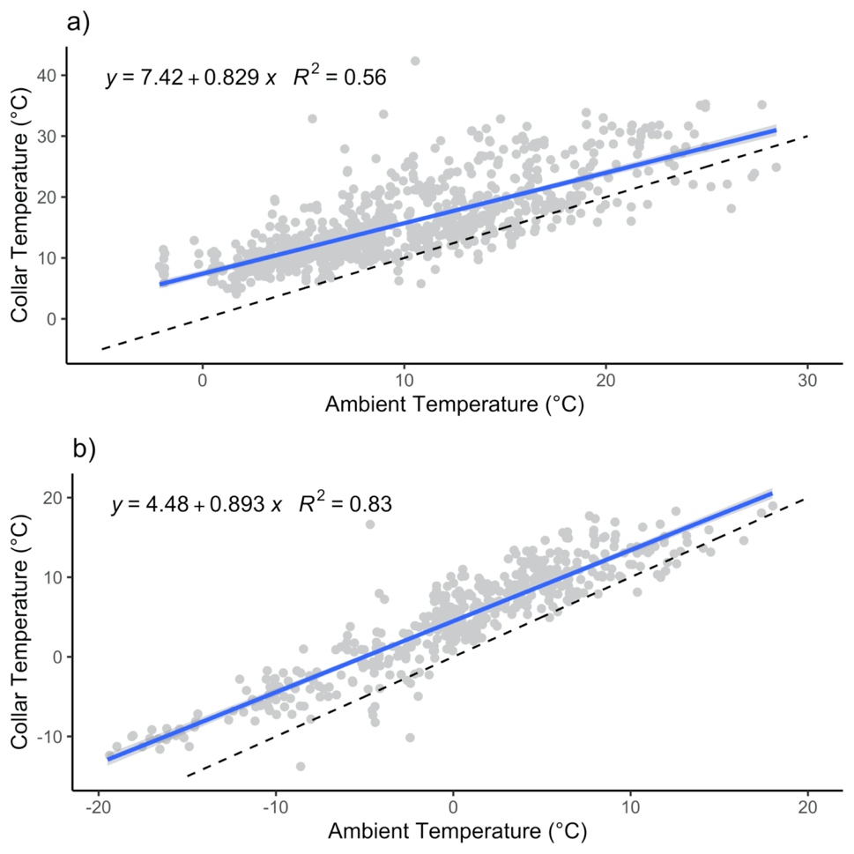
Figure A3. Relationships between temperatures recorded by sensors in mountain goat GPS collars (a) Alberta; b) Alaska) and ambient temperatures. The grey dots represent data points, the blue lines represent the predicted relationships, the gray areas are the 95% confidence intervals, and the dotted lines represent the reference for the perfect relationship. Panel a) represents the calibration for Albertan collars and panel b) Alaskan collars.

Appendix 4

To represent the proportion of habitats available and used for continental and coastal mountain goat ecotypes (Figure A4), we computed frequency of used locations recorded every 3h for the continental ecotype (Jasper and Caw Ridge, Alberta Canada, 2011-2019) and every 3h or 6h for the coastal ecotype (Baranof Island and Lynn Canal, Alaska, USA, 2005-2019) between 1 June and 31 August. For each available location, we selected five random points within the home range of each individual.

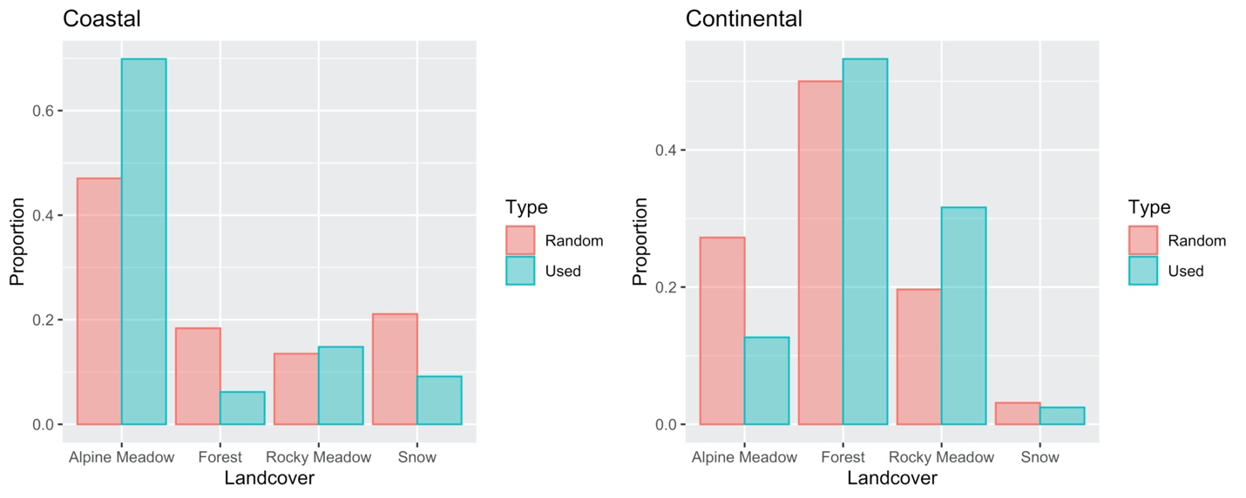
Figure A4. Proportion of available and used habitats for both coastal (Baranof Island and Lynn Canal, Alaska, USA, 2005-2019) and continental ecotypes (Jasper and Caw Ridge, Alberta Canada, 2011-2019) and during the summer (1 June– 31 August).

Appendix 5

Quadratic models illustrating the link between Julian day on NARR temperature readings during the summer period for both Coastal and Continental sites.

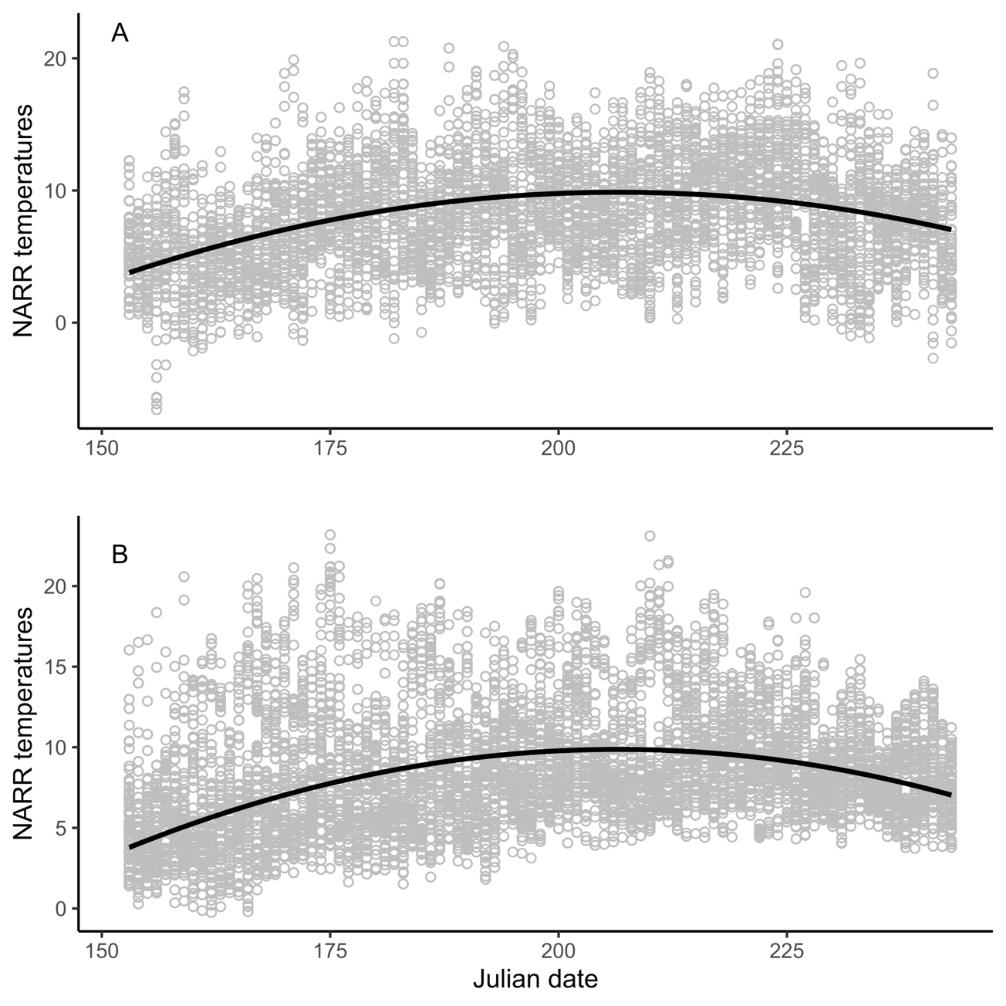
Figure A5. Relationships between Julian day and NARR temperatures for the continental (A, Jasper and Caw Ridge, Alberta Canada, 2011-2019) and coastal (B, Baranof Island and Lynn Canal, Alaska, USA, 2005-2019) mountain goat ecotypes during the summer (1 June – 31 August) (N= 17 511 for continental, and N=64 080 for coastal). The lines represent quadratic models between Julian date and NARR temperatures and the grey dots are the residuals.

Appendix 6

Predicted activity patterns in relation to temperature and its interaction with wind, precipitation, age and sex (Figure A6).

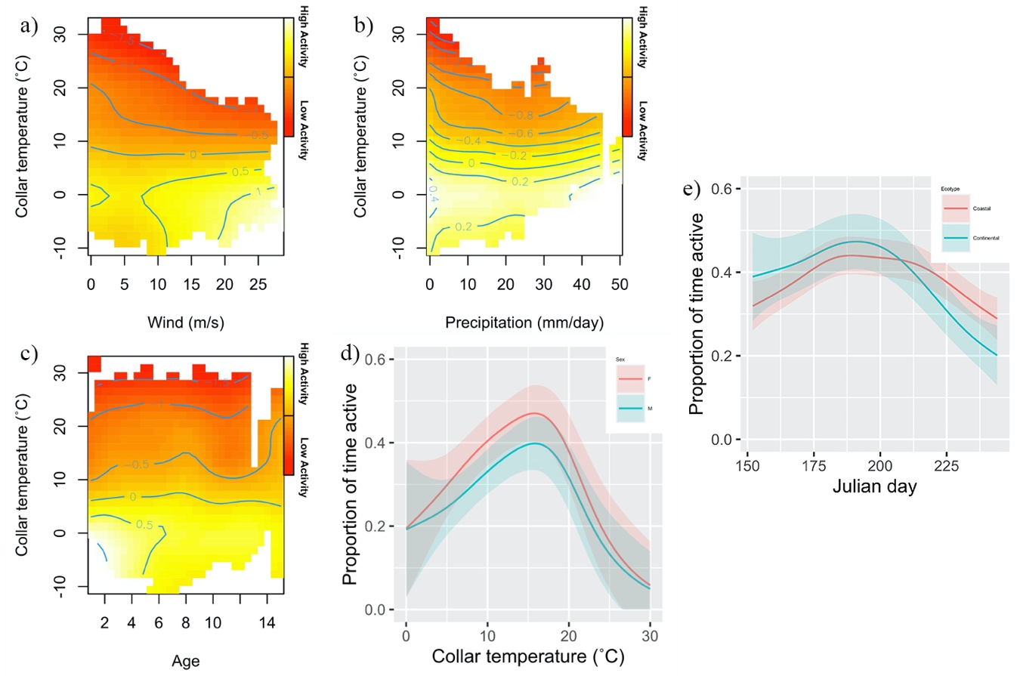
Figure A6. Proportion of time spent active in relationship with temperature and wind speed, daily precipitation, age of the goat, and sex of the goat. For panels a), b), and c), red represents low activity and yellow represents activity peaks. These graphs represent predictions for the continental ecotype at noon on 15 July. Data were collected for the continental ecotype (Jasper and Caw Ridge, Alberta Canada, 2011-2019). Results were similar for coastal goats as there was no interaction between these parameters and ecotype in our model. The panel e) shows the interaction of the Julian day and site on the proportion of time spent active

Appendix 7

Mass differences (kg) between mountain goats from the coastal and continental ecotypes by sex and age (Figure A6). All masses were standardized to the 1st of July to account for mass gain throughout the summer and ensure all masses were comparable.
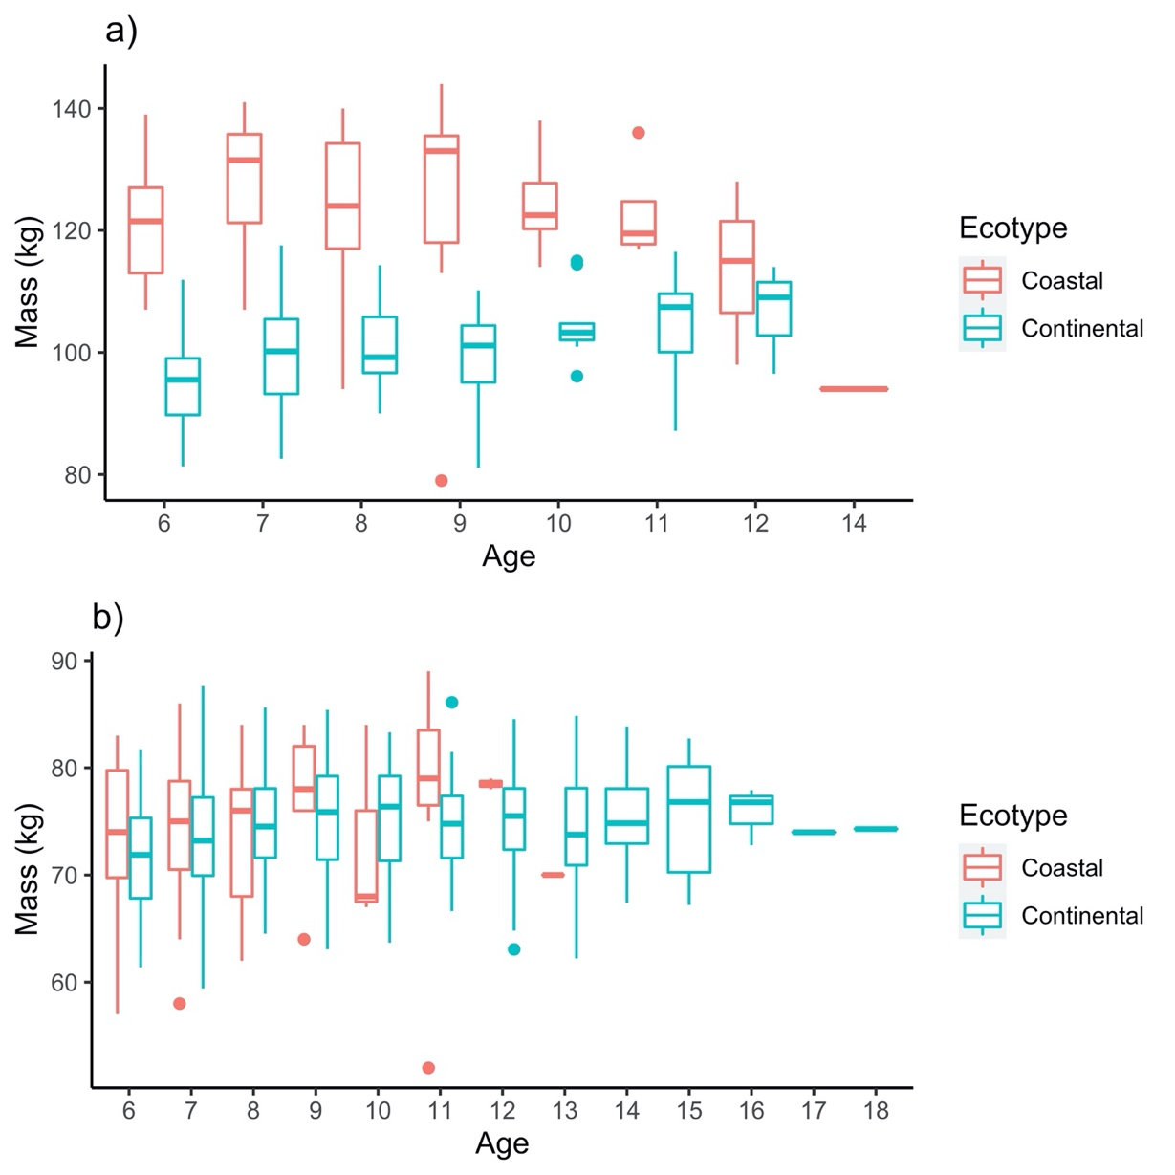
Figure A7. Comparison of the mass (kg) of males (a) and females (b) mountain goats in the coastal and continental ecotypes. Masses for the coastal ecotype were measured from captured goats (Lynn Canal and Baranof Island study areas between 2005 and 2020) using a net and scale for a total of 63 males and 59 females of 6 years and older. Masses for the continental ecotype were measured both at capture and using salt baited scales for a total of 58 males and 121 females older than 6 years old (Caw Ridge and Jasper Study areas between 1996 and 2019). All mass readings were standardized to the mass on the 1st of July. The centre line represents the mean, the edges of the boxes represent de 25th and 50th percentile and the lines represent the minimum and maximum without outliers. The dots are data points considered to be outliers.

