Appendix #1

  - Correlation plot of all the factors (the factor “abundance of the focal species” is not included here as this one changes for every species). Land.Div: landscape diversity; Wood: Wooded area; Built: built area; S.Lights: number of street lights; ALAN= artifical lights at night from the VIIRS data; Noise: level of traffic noise; AB: bird total abundance; SR: bird species richness; DIV: bird species diversity (Shannon index); TFSD: normalized Time and Frequency Second Derivative.
  - List of the species recorded
Scientific name | English name | Abbreviate name
Aegithalos caudatus | Long-tailed Tit | AEGCAU
Carduelis carduelis | European Goldfinch | CARCAR
Certhia brachydactyla | Short-toed Treecreeper | CERBRA
Cettia cetti | Cetti's Warbler | CETCET
Chloris chloris | European Greenfinch | CHLCHL
Cisticola juncidis | Zitting Cisticola | CISJUN
Columba palumbus | Common Wood Pigeon | COLPAL
Corvus corone | Carrion Crow | CORCOR
Coloeus monedula | Western Jackdaw | CORMON
Cuculus canorus | Common Cuckoo | CUCCAN
Cyanistes caeruleus | Eurasian Blue Tit | CYACAE
Erithacus rubecula | European Robin | ERIRUB
Fringilla coelebs | Common Chaffinch | FRICOE
Hippolais polyglotta | Melodious Warbler | HIPPOL
Hirundo rustica | Barn Swallow | HIRRUS
Lophophanes cristatus | Crested Tit | LOPCRI
Lullula arborea | Woodlark | LULARB
Luscinia megarhynchos | Common Nightingale | LUSMEG
Oriolus oriolus | Eurasian Golden Oriole | ORIORI
Parus major | Great Tit | PARMAJ
Passer domesticus | House Sparrow | PASDOM
Phoenicurus ochruros | Black Redstart | PHOOCH
Phylloscopus collybita | Common Chiffchaff | PHYCOL
Pica pica | Eurasian Magpie | PICPIC
Prunella modularis | Dunnock | PRUMOD
Regulus ignicapilla | Common Firecrest | REGIGN
Serinus serinus | European Serin | SERSER
Sitta europaea | Eurasian Nuthatch | SITEUR
Streptopelia decaocto | Eurasian Collared Dove | STRDEC
Streptopelia turtur | European Turtle Dove | STRTUR
Sturnus vulgaris | Common Starling | STUVUL
Sylvia atricapilla | Eurasian Blackcap | SYLATR
Sylvia borin | Garden Warbler | SYLBOR
Troglodytes troglodytes | Eurasian Wren | TROTRO
Turdus merula | Common Blackbird | TURMER
Turdus philomelos | Song Thrush | TURPHI
Turdus viscivorus | Mistle Thrush | TURVIS

  - Occurrence of the species (number of stations where the species were recorded among the 36 stations)

  - Abundance of the species per station (in number of individuals)

  - First song hour (FIRST) (in minutes after midnight)
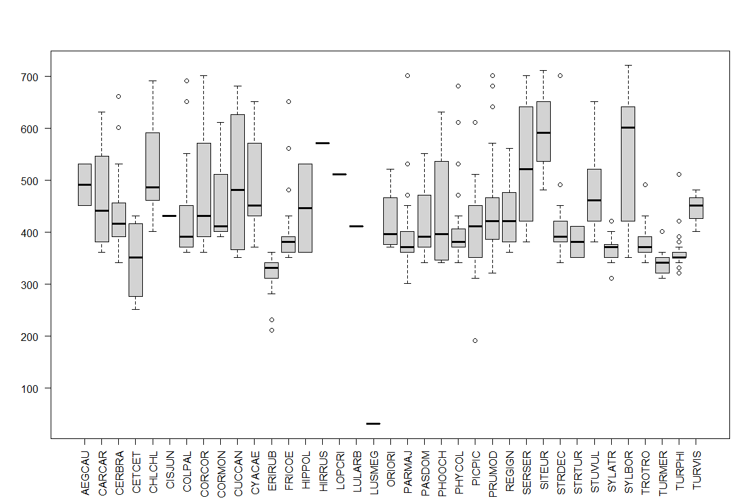
  - Peak song hour (PEAK) (in minutes after midnight)
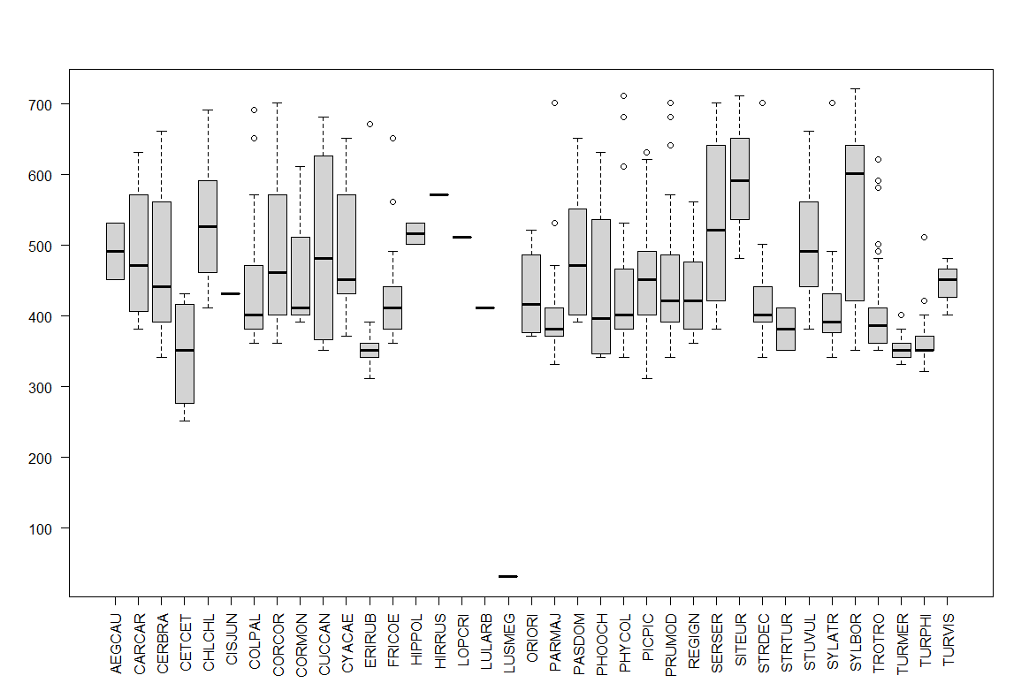

  - Mean song hour (MEAN) (in minutes after midnight)
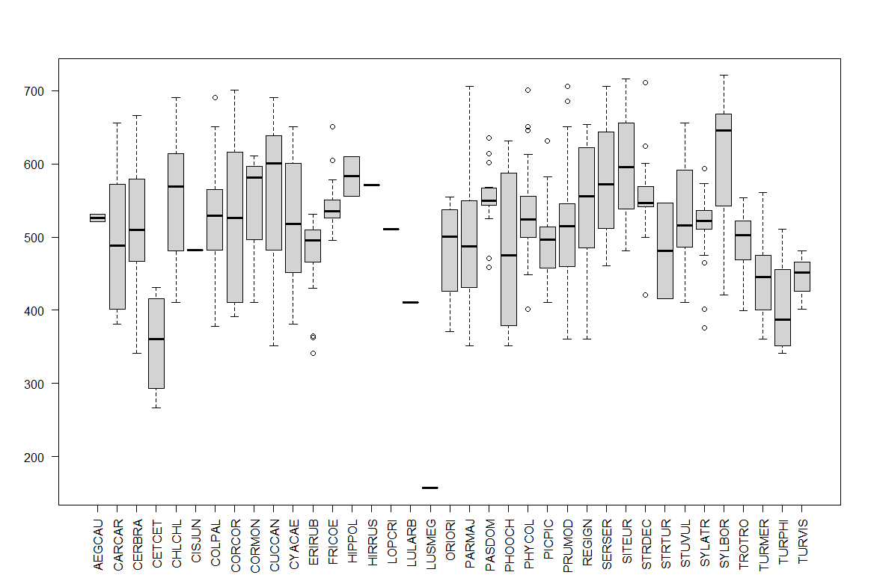
  - Median song hour (MED) (in minutes after midnight)
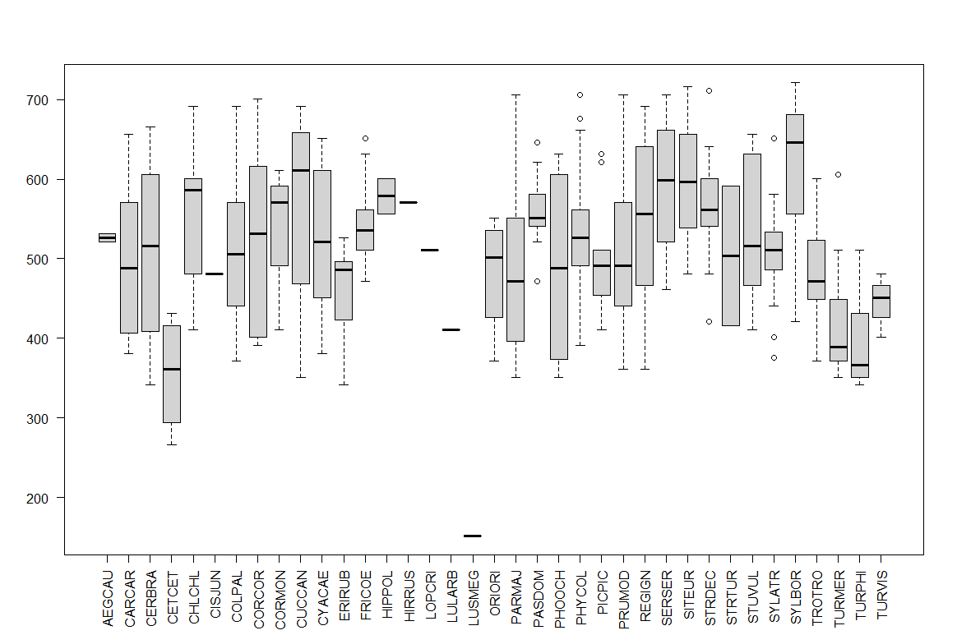

  - Night song rate (NIGHT) (in %)
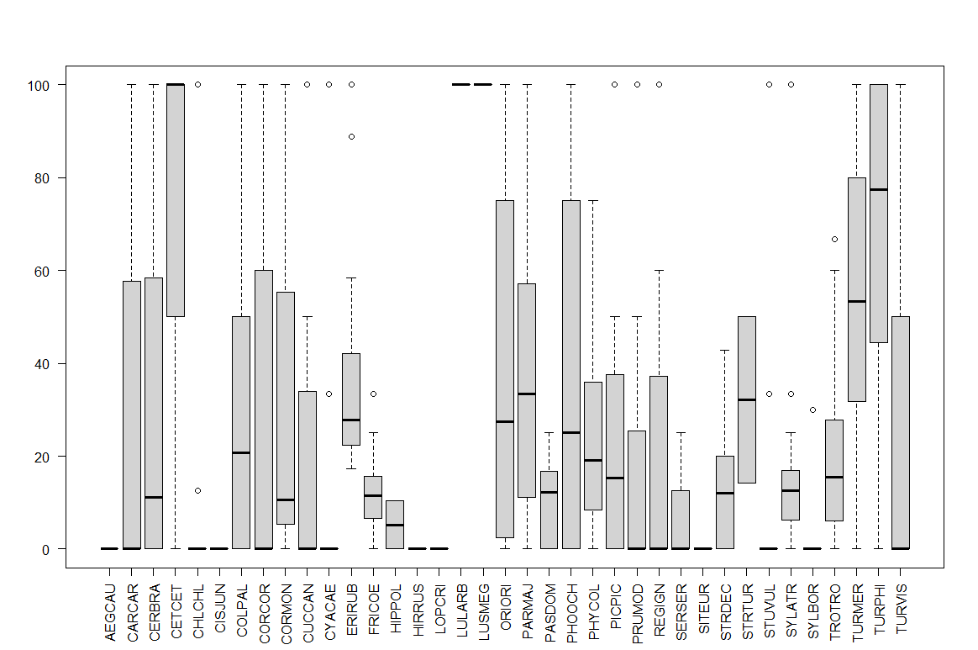

  - Song duration (DUR) (in number of 1-min time sequences where the species sing (among 73 time sequences from midnight to noon))
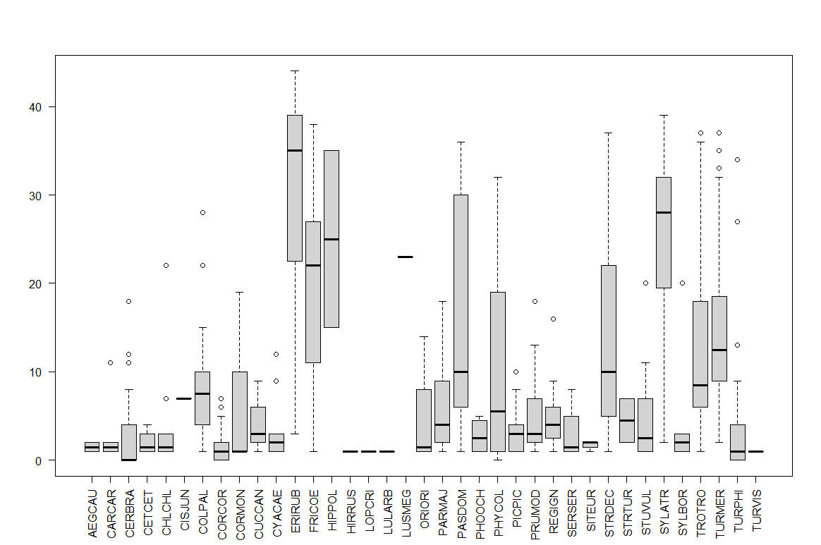

  - Correlation plot of the song indices and song duration for all the species

