Appendix A
LETTER TO THE DEAN



Registration No. 62Q17082
Republic of the Philippines
JOSE RIZAL MEMORIAL STATE UNIVERSITY
The Premier University in Zamboanga del Norte
Gov. Guading Adaza St., Sta. Cruz, Dapitan City, Zamboanga del Norte
College of Nursing and Allied Health Sciences

JOSE RIZAL MEMORIAL STATE UNIVERSITY
The Premier University in ZamboangadelNorte
Gov. Guading Adaza St., Sta. Cruz, Dapitan City, Zamboanga del Norte
College of Nursing and Allied Health Sciences

Date:

GRACE R. ABAD, RN, LPT, MAN, Ed.D.
Dean, College of Nursing and Allied Health Sciences
JRMSU Main Campus

Madame:

Good day!

Herein the representative of 3rd year nursing students, College of Nursing and Allied Health Sciences respectfully request your permission to conduct survey proposal relative to the research on “QUALITY OF LIFE OF MILLENNIAL WITH POLYCYSTIC OVARIAN SYNDROME”. This is a partial fulfillment of the requirements in NCM 111- Nursing Research 1 leading to the degree Bachelor of Science in Nursing. Our target respondents are 255 nursing students who would answer the set of questions through google forms and face to face distributions with safety protocols. Hoping that this request be given appropriate approval.
Your comments, corrections, and/or suggestions are very much appreciated.

Thank you so much and more power.

Yours very respectfully,

FROILAND B. MEÑOSA
KATHERINE ANN E. BONDACO
ROWELA V. DELASAN
REGIELYN M. JOSOL
MARICAR E. REBUCAS

Researchers
Appendix B
LETTER TO THE AUTHOR OF THE RESEARCH QUESTIONNAIRE
Registration No. 62Q17082
Republic of the Philippines
JOSE RIZAL MEMORIAL STATE UNIVERSITY
The Premier University in Zamboanga del Norte
Gov. Guading Adaza St., Sta. Cruz, Dapitan City, Zamboanga del Norte
College of Nursing and Allied Health Sciences

JOSE RIZAL MEMORIAL STATE UNIVERSITY
The Premier University in ZamboangadelNorte
Gov. Guading Adaza St., Sta. Cruz, Dapitan City, Zamboanga del Norte
College of Nursing and Allied Health Sciences

Date:

Date: _______________
College of Nursing and Allied Health Sciences
BSN 3 Nursing Students

Good day ma'am/sir! We are nursing student researchers from Jose Rizal Memorial State University, Dapitan City, Zamboanga Del Norte, Philippines. We are currently conducting a study entitled "Quality of life of Millennials with Polycystic Ovarian Syndrome". We have found your study entitled "Polycystic Ovarian Syndrome Quality of Life Scale (PCOSQOL): Development and Preliminary validation" and we would like to ask your permission to use your study as the basis for our survey questionnaire. It would be of great help to us to be able to conduct this study. It would be an honor to hear from you, thank you so much and God bless. sincerely, JRMSU student nurses.

Researchers

Appendix C
LETTER TO THE RESPONDENTS
Republic of the Philippines
JOSE RIZAL MEMORIAL STATE UNIVERSITY
The Premier University in Zamboanga del Norte
Gov. Guading Adaza St., Sta. Cruz, Dapitan City, Zamboanga del Norte
College of Nursing and Allied Health Sciences

JOSE RIZAL MEMORIAL STATE UNIVERSITY
The Premier University in ZamboangadelNorte
Gov. Guading Adaza St., Sta. Cruz, Dapitan City, Zamboanga del Norte
College of Nursing and Allied Health Sciences

Registration No. 62Q17082

Date: __________________

Dear respondents:

Good day!
The undersigned are undergraduate students of Jose Rizal Memorial State University in Dapitan City who are gathering data for our thesis entitled “Quality of Life of Millennial with Polycystic Ovarian Syndrome”.
In line with this, the researchers have chosen you to be one of the respondents of this study. We are asking for precious time and effort to answer honestly all the questions given in the survey questionnaire that are considerably significant for the fulfillment of the study. Have no doubt that all data gathered from you will be kept in the highest level of confidentiality and will only be used for academic purposes.

Attached herewith is the explanation for your perusal.
STUDY PROCEDURES
Researchers will use survey questionnaire in gathering data. They will ask the respondents to sign the consent form to guarantee their rights of confidentiality. Questionnaires will be sent out through online Google forms and will be immediately retrieved online once done answering the survey.
RISK
You may decline to answer any or all questions and you may terminate your involvement at any time if you are not comfortable on the tools used in gathering data.

BENEFITS
The finding of this study will explain how Polycystic Ovarian Syndrome affects the quality of life of the Millennial during child-bearing age. This will help the other female to determine early signs and symptoms of Polycystic Ovarian syndrome and seek for medical advices and care to avoid health risk. It will identify the coping mechanism done by the respondents on how they deal with this syndrome associated with mental health. In pertinent to, the information gained from the current study can be used to improve the students’ knowledge about the quality of life of millennial diagnosed of Polycystic ovarian syndrome.
CONFIDENTIALITY
Respondents’ responses to this survey will be anonymous. Every effort will be made by the researchers to preserve your confidentiality including the following:
Assigning code names/numbers for participants that will be used on all research notes and documents and data will be available only in the collective form and no individual responses will be shared.
CONTACT INFORMATION
If you have questions at any time about this study, you may contact the researchers via their contact number: 09639573996 (TNT) You can also message them through email (lan886163@gmail.com).

Thank you so much for your support and cooperation.

Appendix D
LETTER OF CONSENT
Republic of the Philippines
JOSE RIZAL MEMORIAL STATE UNIVERSITY
The Premier University in Zamboanga del Norte
Gov. Guading Adaza St., Sta. Cruz, Dapitan City, Zamboanga del Norte
College of Nursing and Allied Health Sciences

JOSE RIZAL MEMORIAL STATE UNIVERSITY
The Premier University in ZamboangadelNorte
Gov. Guading Adaza St., Sta. Cruz, Dapitan City, Zamboanga del Norte
College of Nursing and Allied Health Sciences

Registration No. 62Q17082

Consent

I have read and I understand the provided information and have had the opportunity to ask questions. I understand that my participation is voluntary and that I am free to withdraw at any time, without giving a reason and without cost. I understand that I will be given a copy of this consent form. I voluntarily agree to take part in this study.

Participant's signature ______________________________ Date __________
Investigator's signature ____________________________________ Date __________

Appendix E
SURVEY QUESTIONNAIRES
Registration No. 62Q17082
Republic of the Philippines
JOSE RIZAL MEMORIAL STATE UNIVERSITY
The Premier University in Zamboanga del Norte
Gov. Guading Adaza St., Sta. Cruz, Dapitan City, Zamboanga del Norte
College of Nursing and Allied Health Sciences

JOSE RIZAL MEMORIAL STATE UNIVERSITY
The Premier University in ZamboangadelNorte
Gov. Guading Adaza St., Sta. Cruz, Dapitan City, Zamboanga del Norte
College of Nursing and Allied Health Sciences

The Polycystic Ovarian Syndrome Quality of Life Scale (PCOSQOL): Development and preliminary validation questionnaire
ONLY WOMEN CLINICALLY DIAGNOSED OF PCOS CAN ANSWER THE RESEARCH QUESTIONNAIRE
Direction: Fill out the form completely and carefully. Put a check (/) in the box provided for your profile :
Email Address:
Are you clinically diagnose of PCOS? YES___ NO____
Add File: (Documentation of the Diagnosis)
Name: (Optional)
Age: 26-30 ___
31-36 ___
37-41 ___
Address: (Required)
How long have you been diagnose of PCOS?:____________
Direction: Put a check (/) in the box if for the profile assessment.
PART 1. CHARACTERISTICS OF THE RESPONDENTS | (/)
MARITAL STATUS:
Married
Civil partnership
Divorced
Single
Living with partner
Long term-relationship
Engaged
Separated
Others: (Please specify)
CHILDREN:
Had Children
Were pregnant
Trying to conceive

Direction: Put a check (/) in the box if you experience any of the following;
PART 2. FACTOR ANALYSIS FOR PCOS-QOL AND ITS SUBSCALES
IMPACT OF PCOS: | Strongly  Agree | Agree | Disagree | Strongly Disagree
Felt like you weren’t a real woman because of your PCOS?
Felt abnormal because of your PCOS?
Felt that it is unfair that you have PCOS?
Felt angry that you have PCOS?
Felt like you don’t know what to do to control your PCOS?
Been envious of women without PCOS?
Felt embarrassed about the way you look?

Felt like you don’t know what to do to help yourself ?
Felt like embarrassed about having PCOS?
Felt like less of a woman because of having PCOS?
Felt like your PCOS is in control of your life?
Struggled to cope with your PCOS and your other condition(s)?
Felt like you hated yourself?
Felt depressed about how PCOS has impacted your life?
Wanted to do something but haven’t because of your PCOS?
Wanted to take part in a social activity but haven’t because of your PCOS?
INFERTILITY:
Felt depressed over your struggle to have children?
Felt depressed over difficulties conceiving a child?
Felt depressed because of your infertility?
Felt like a failure because of your trouble conceiving?
Felt anxious about conceiving a child?
Felt under pressure to have a child?
Been scared that you may not have children?
HIRSUTISM:
Felt embarrassed by your facial hair?
Felt depressed because of your facial hair?
Been worried about other people seeing your facial hair?
Spent a lot of time and energy removing excess hair?
Felt moody because of your excess hair?
Felt depressed because of your hirsutism?
MOOD:
Felt guilty for being overly aggressive towards a friend of family member?
Over reacted to a day-to-day occurrence because of your PCOS?
Had a short temper with your close friends and/or family ?
Felt overwhelmed by your PCOS and depression?
Felt depressed?
Felt like crying for no reason?
Adapted from: Williams, S., Sheffield, D., & Knibb, R. (2018). The Polycystic Ovarian Syndrome Quality of Life Scale (PCOSQOL): Development and preliminary validation questionnaire (pp 3-5).

Appendix F
RESULTS OF RESPONDENTS DIAGNOSIS
Republic of the Philippines
JOSE RIZAL MEMORIAL STATE UNIVERSITY
The Premier University in Zamboanga del Norte
Gov. Guading Adaza St., Sta. Cruz, Dapitan City, Zamboanga del Norte
College of Nursing and Allied Health Sciences

JOSE RIZAL MEMORIAL STATE UNIVERSITY
The Premier University in ZamboangadelNorte
Gov. Guading Adaza St., Sta. Cruz, Dapitan City, Zamboanga del Norte
College of Nursing and Allied Health Sciences

Registration No. 62Q17082

Respondent 1
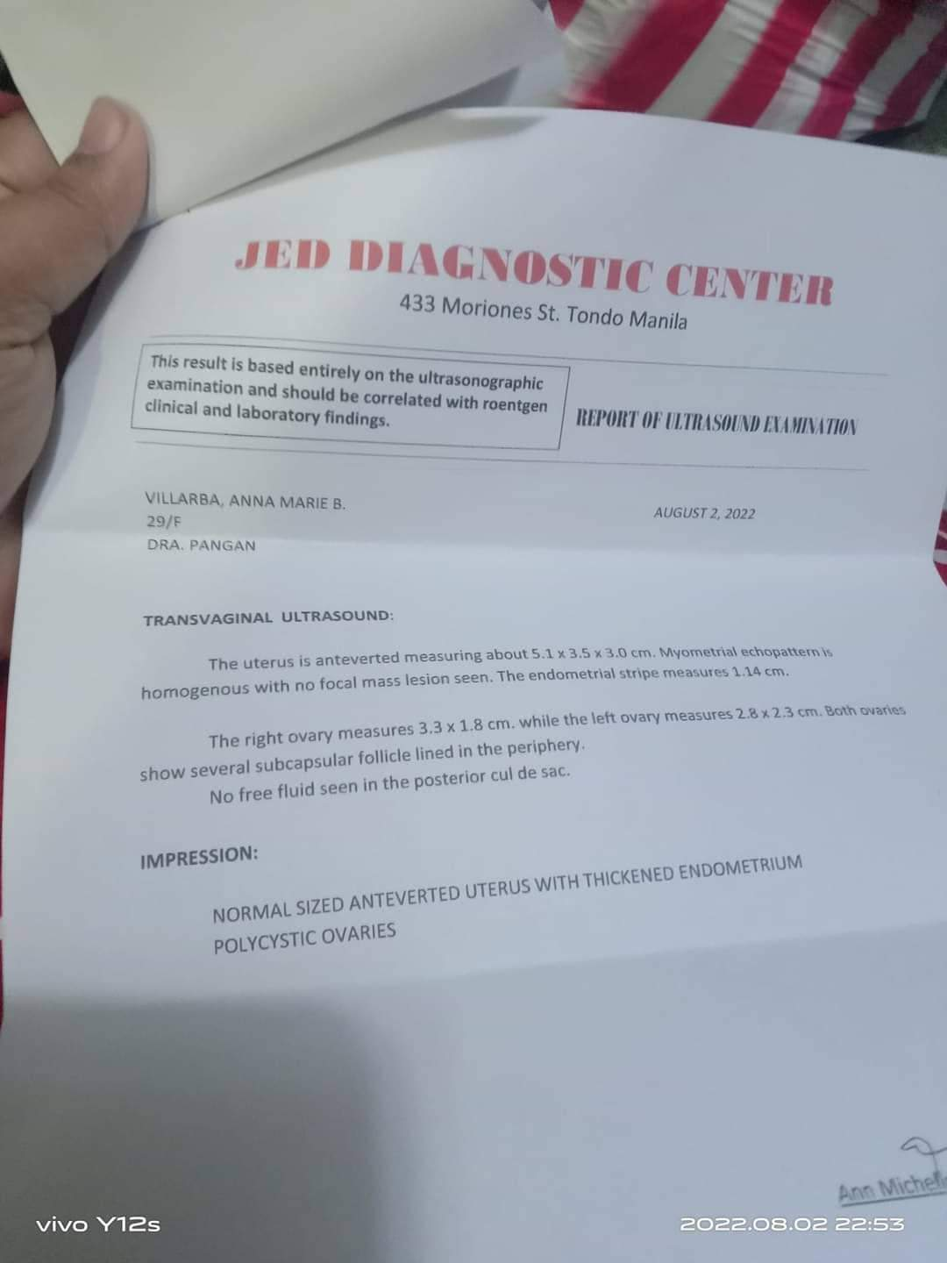

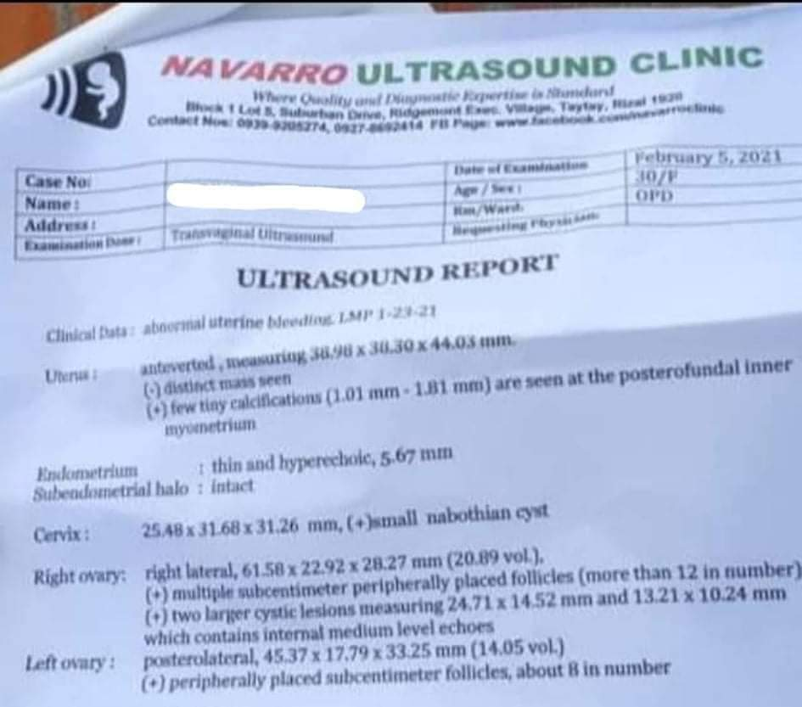
Respondent 2
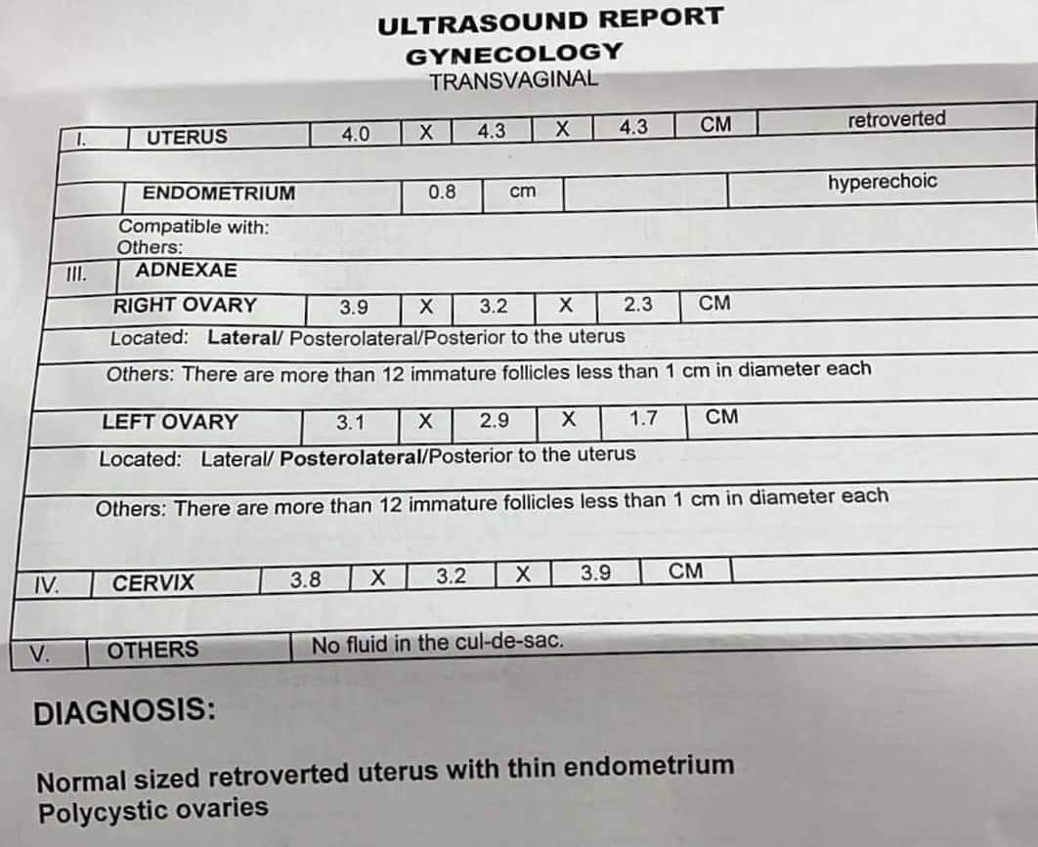
Respondent 3

Respondent 4
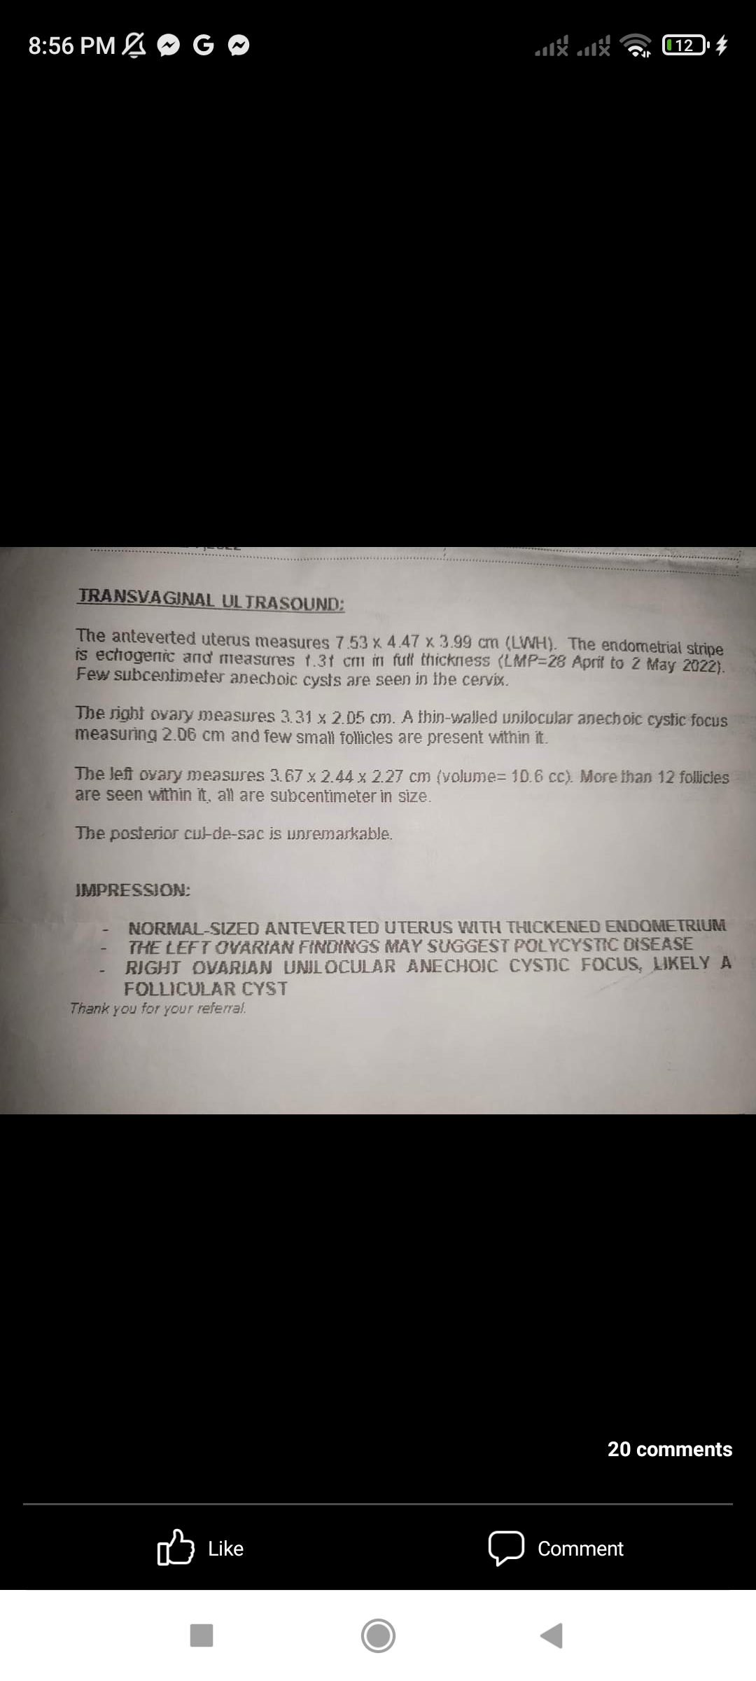
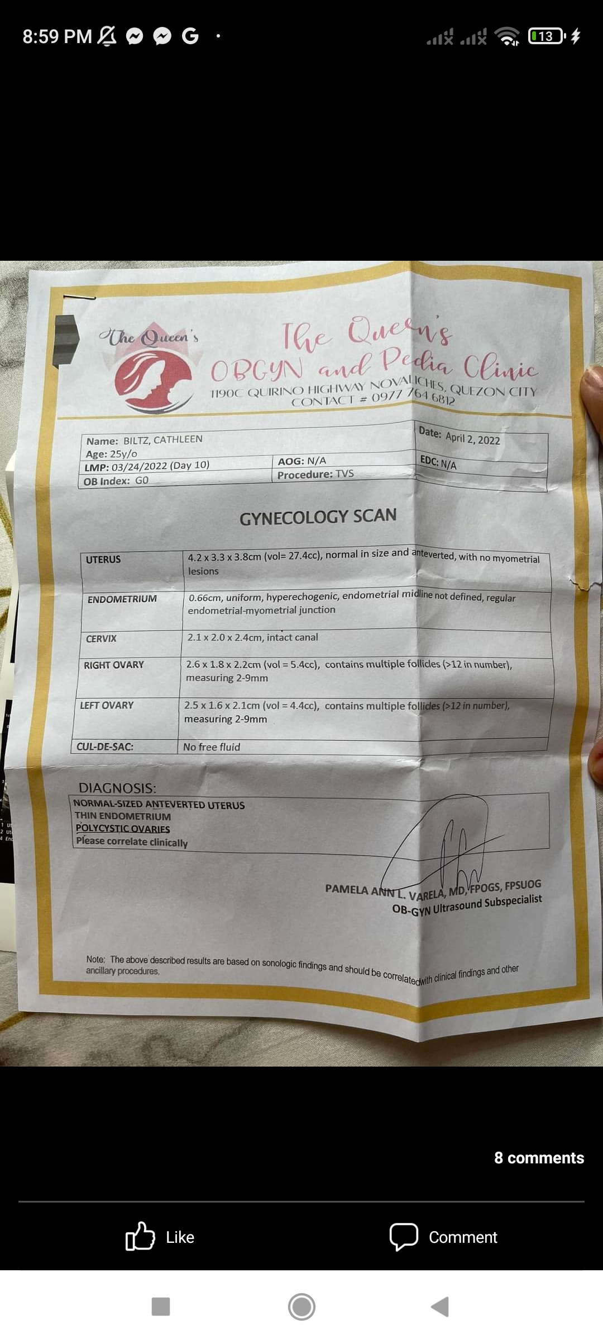
Respondent 5
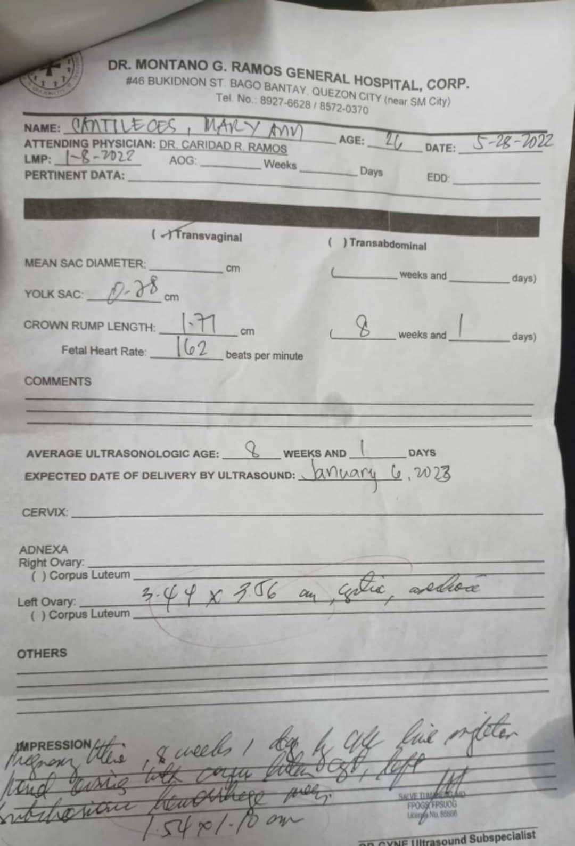
Respondent 6
Respondent 7
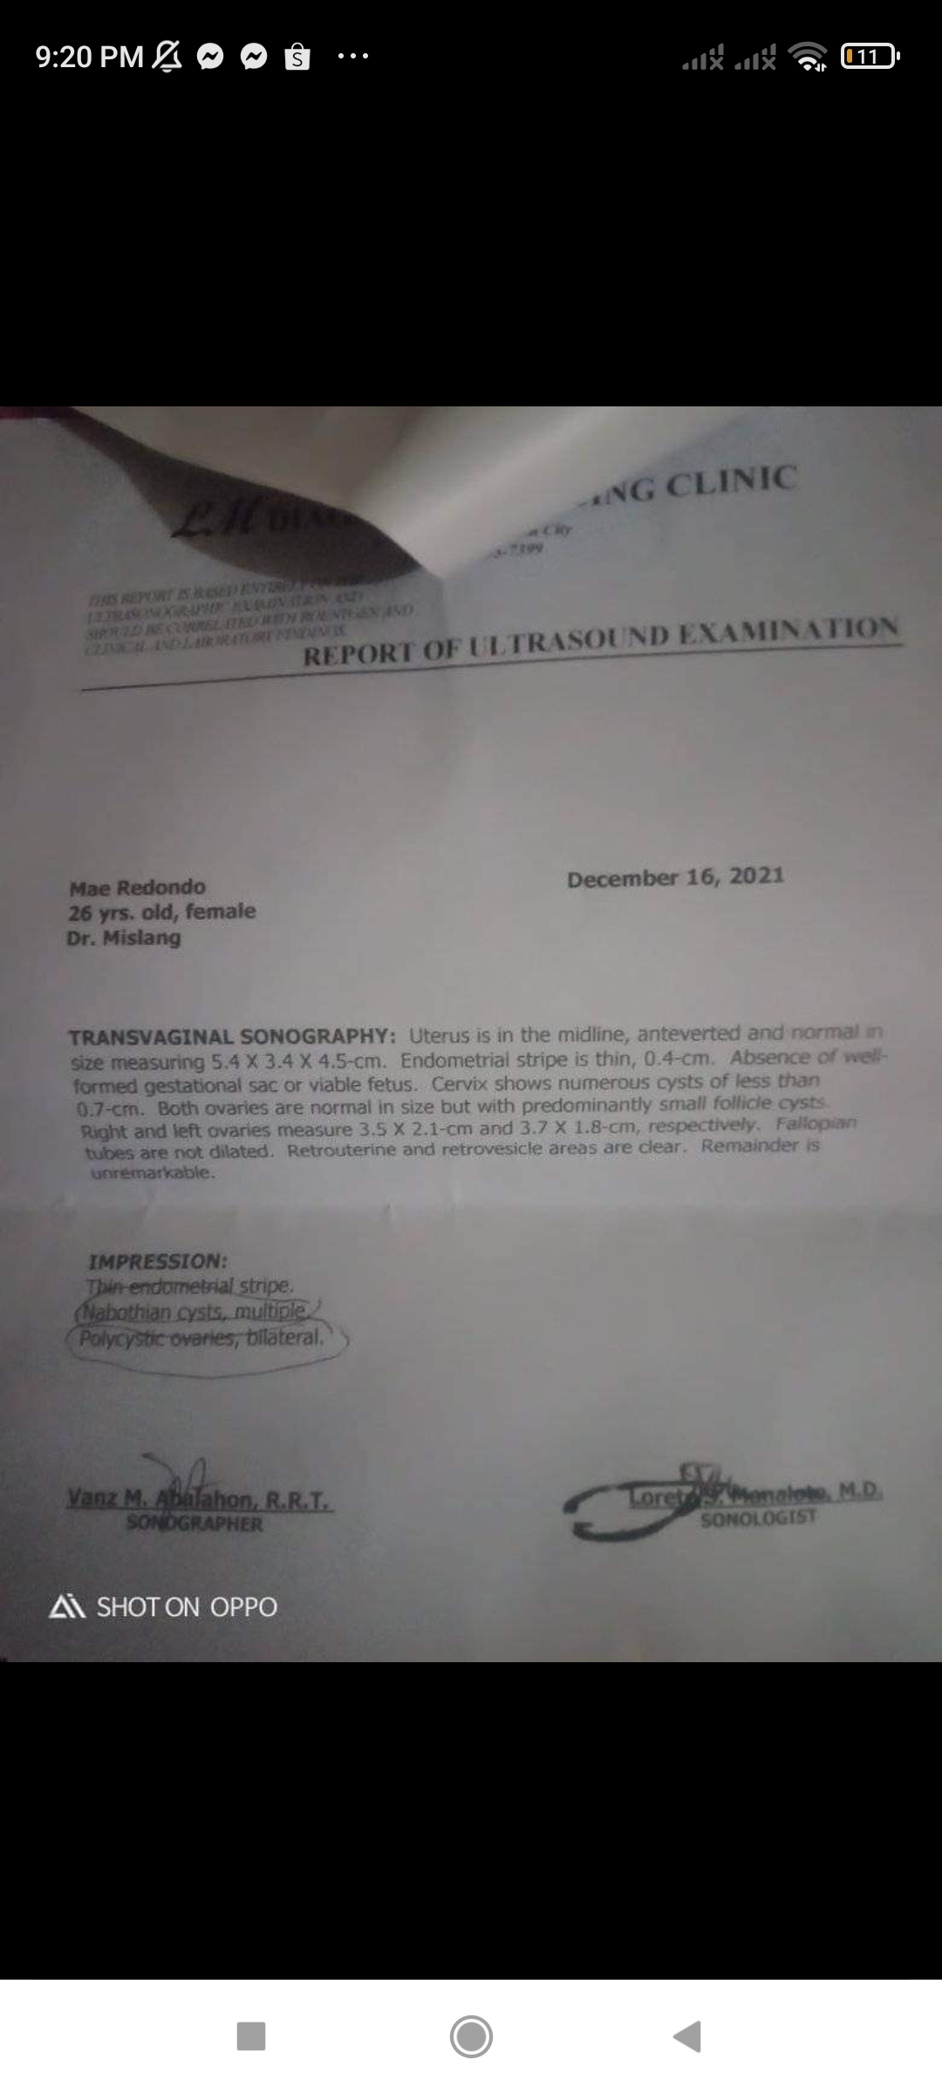
Respondent 8
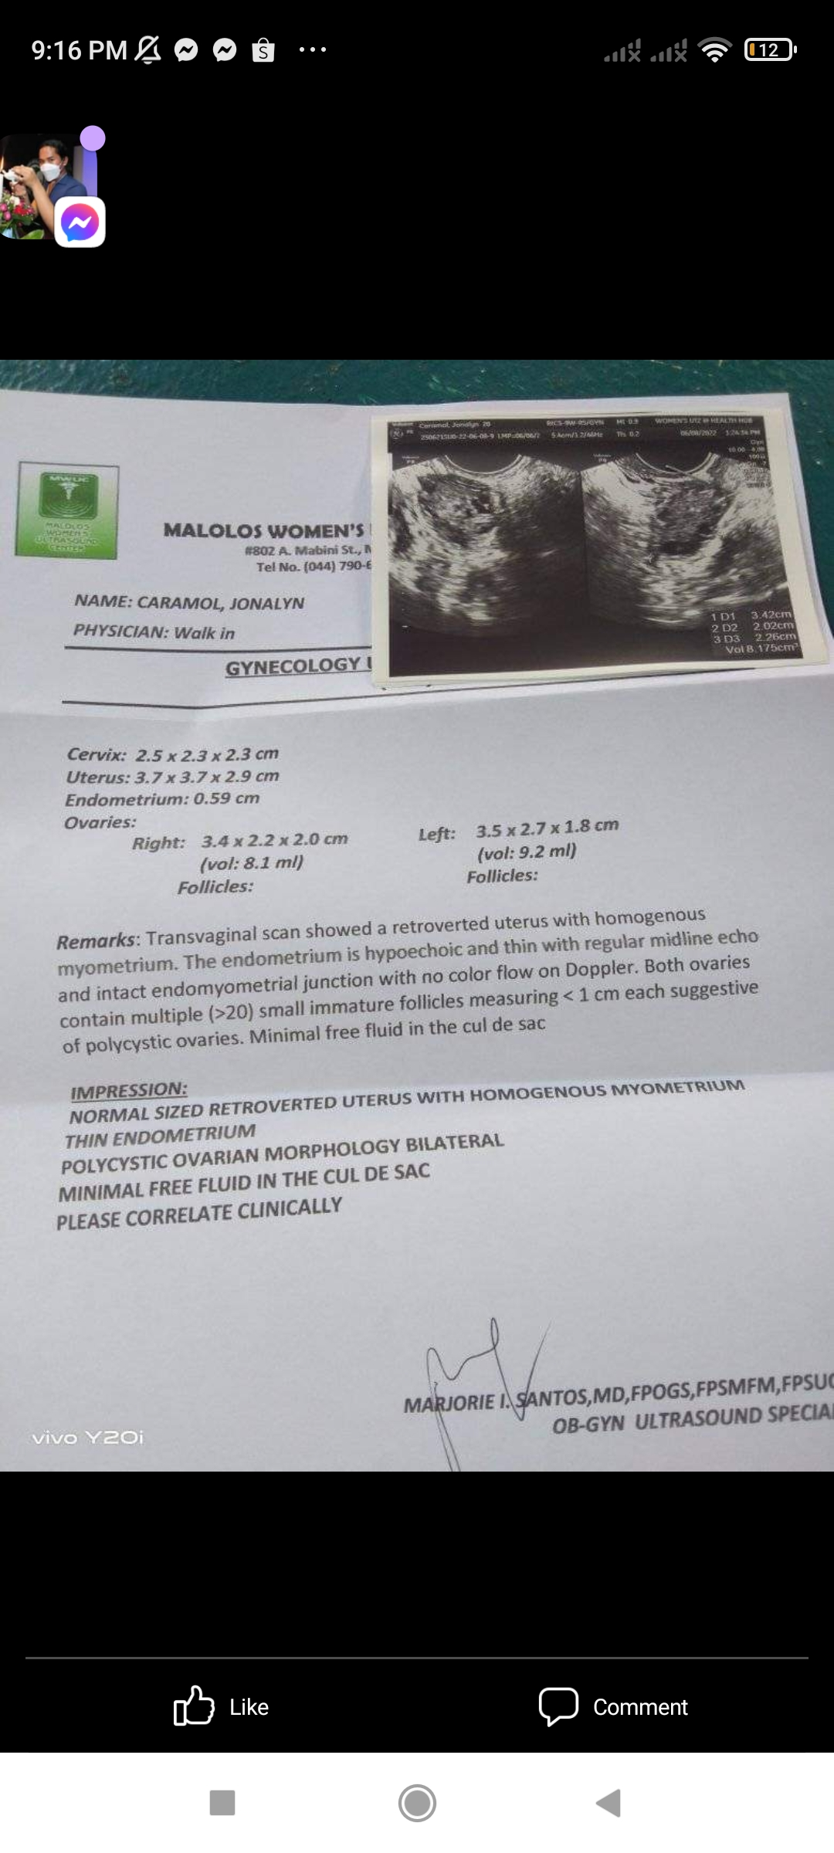

Respondent 9
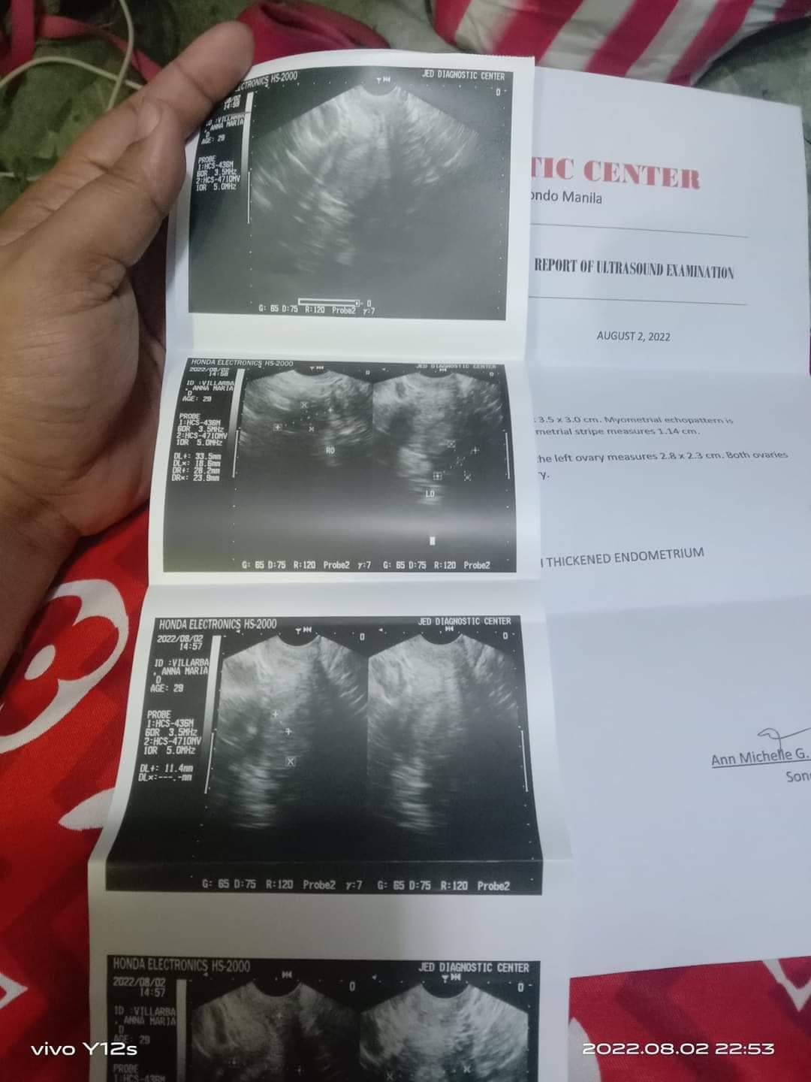

Respondent 10
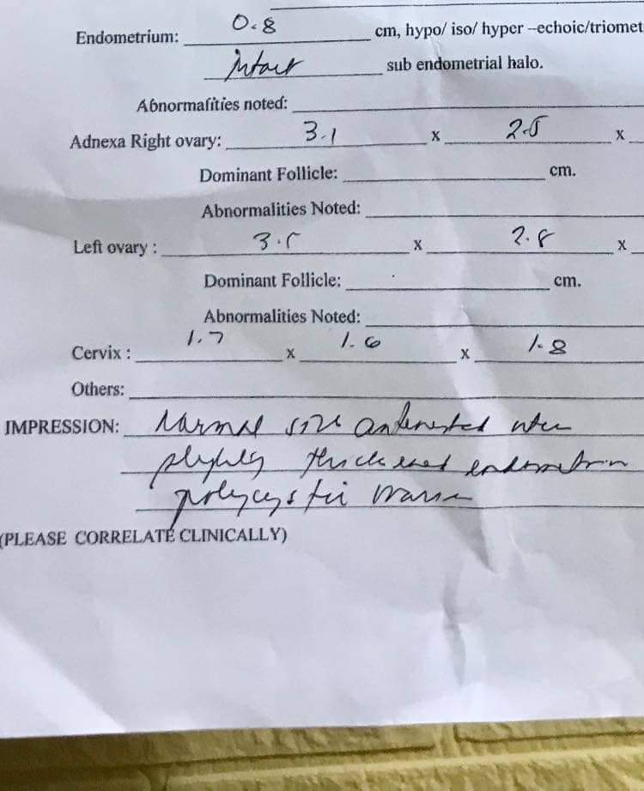

Respondent 11
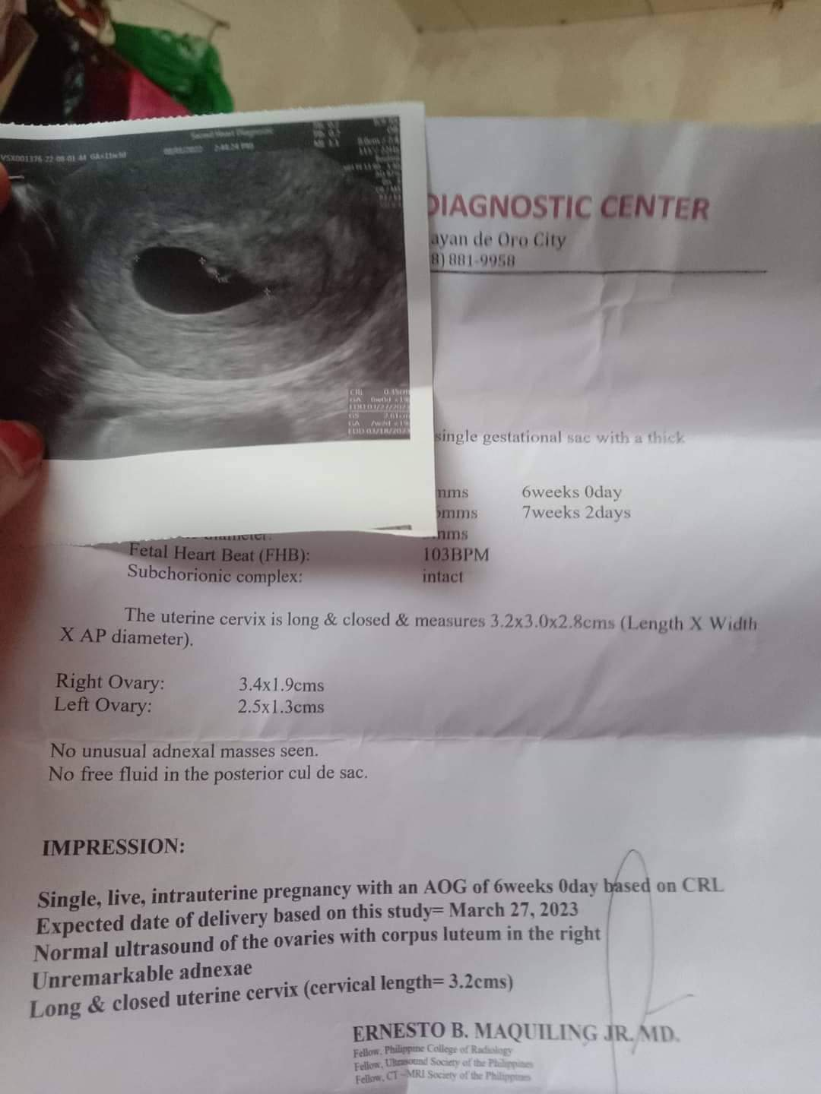

Respondent 12
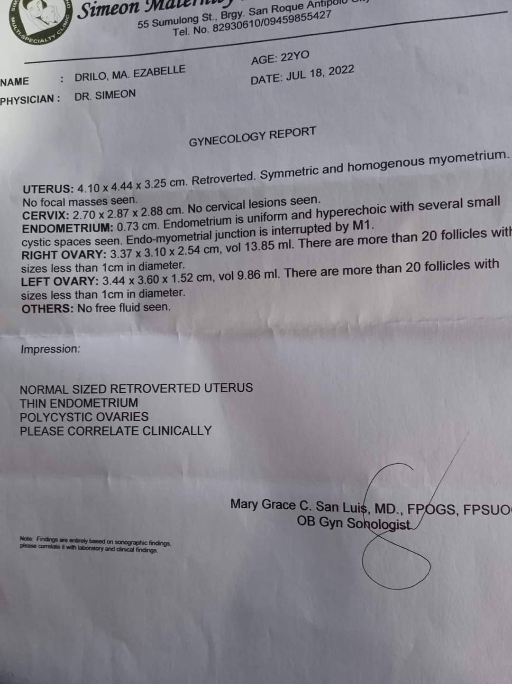

Respondent 13
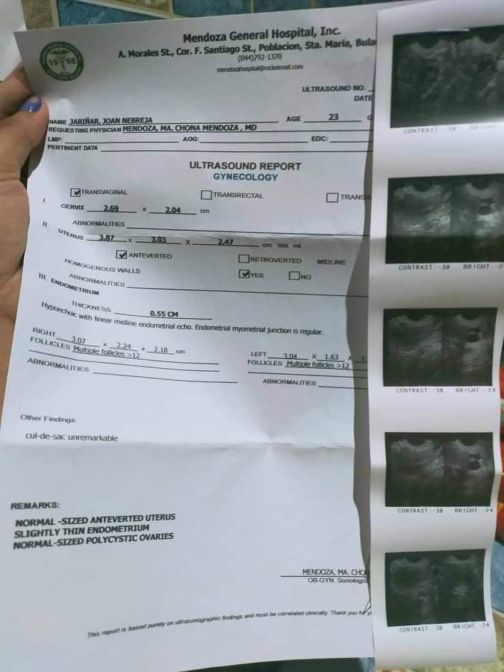

Respondent 14
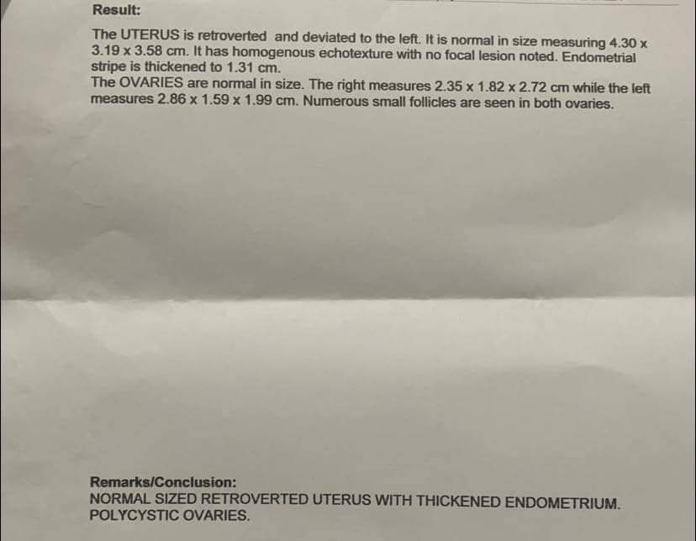

Respondent 15

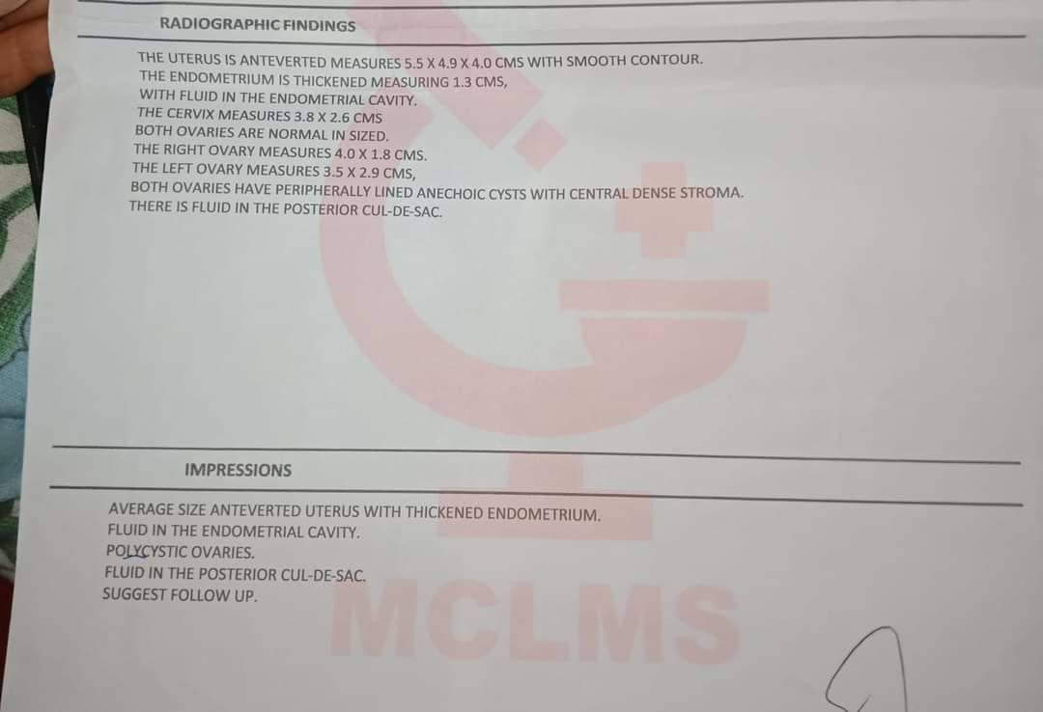

Respondent 16
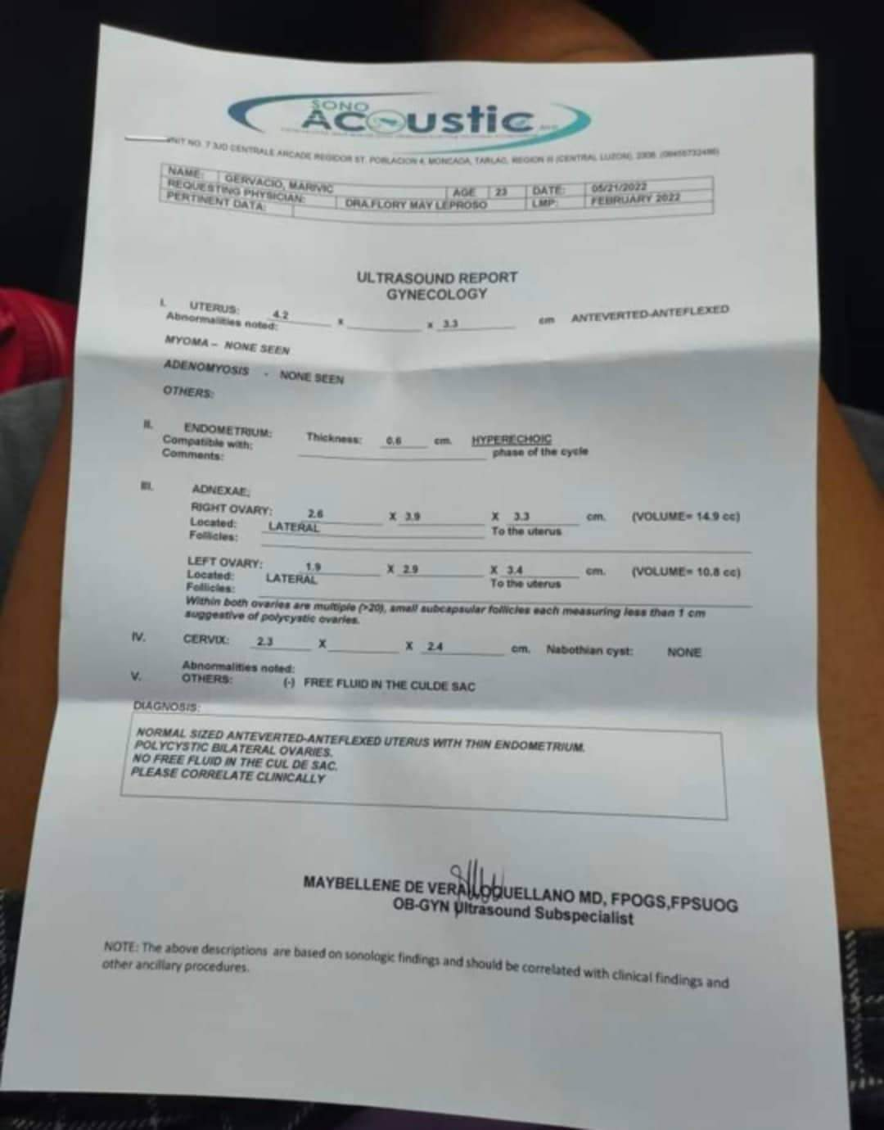

Respondent 17
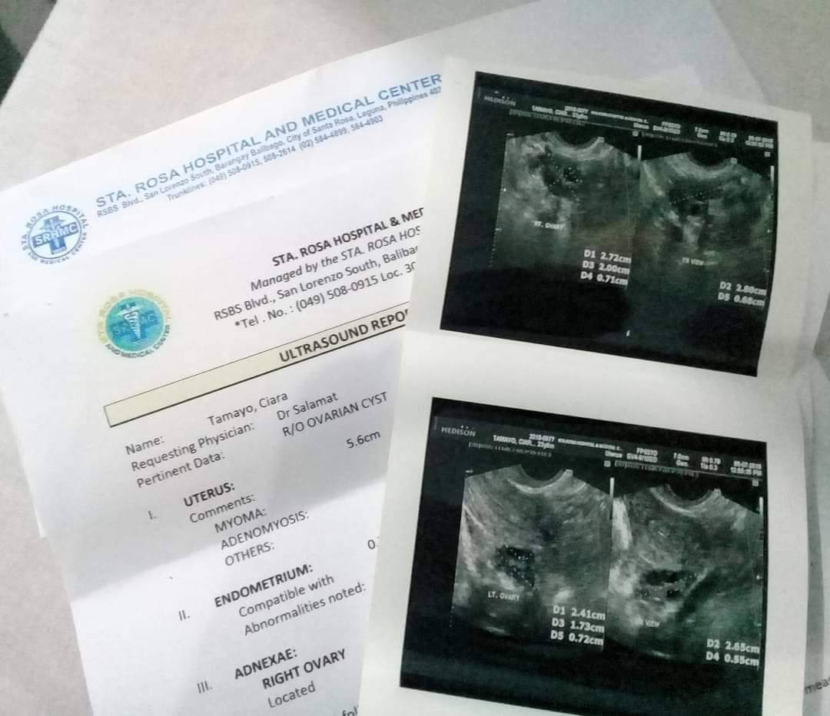

Respondent 18
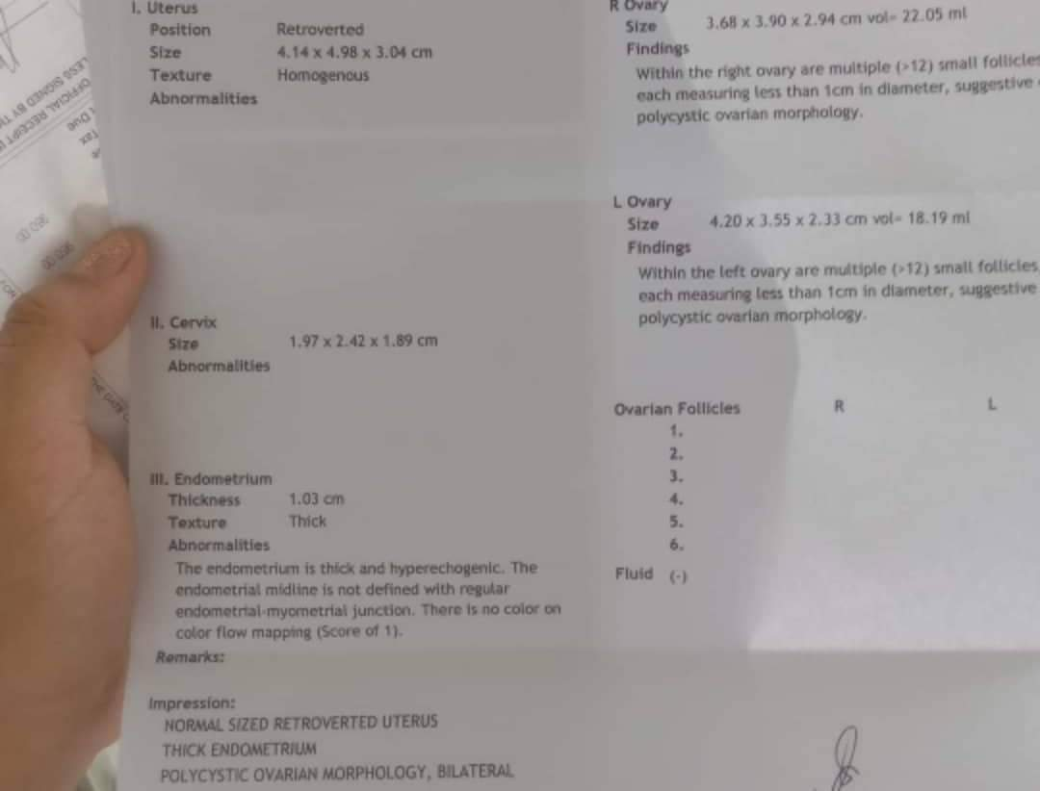

Respondent 19
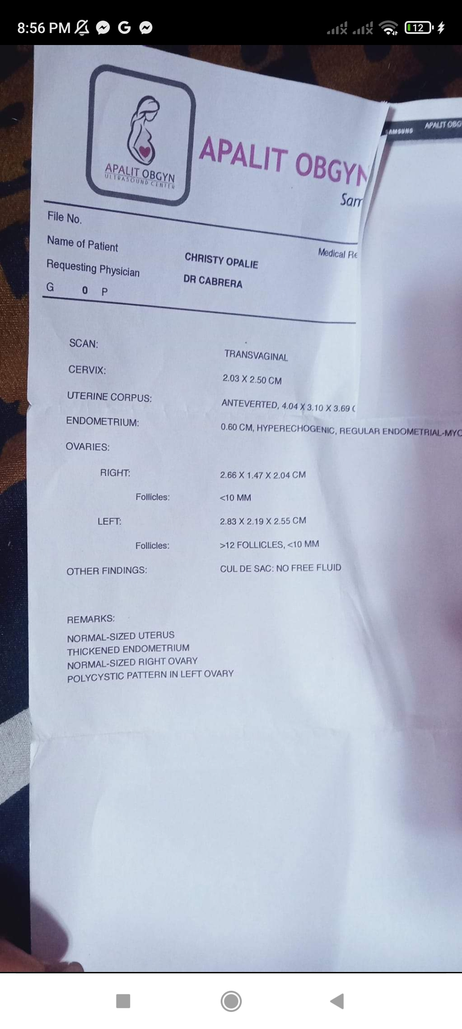

Respondent 20
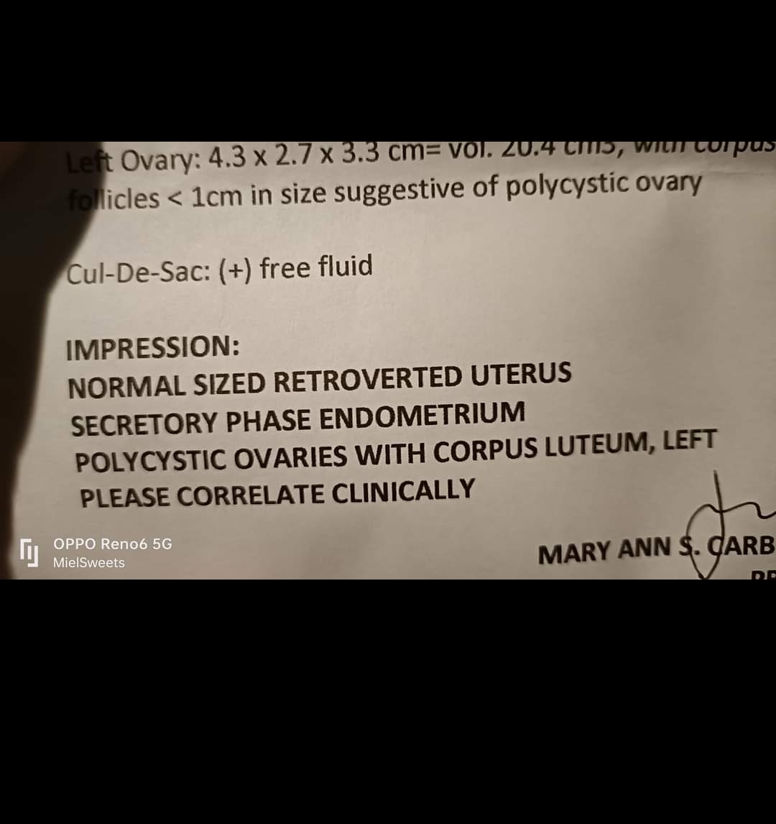

Respondent 21
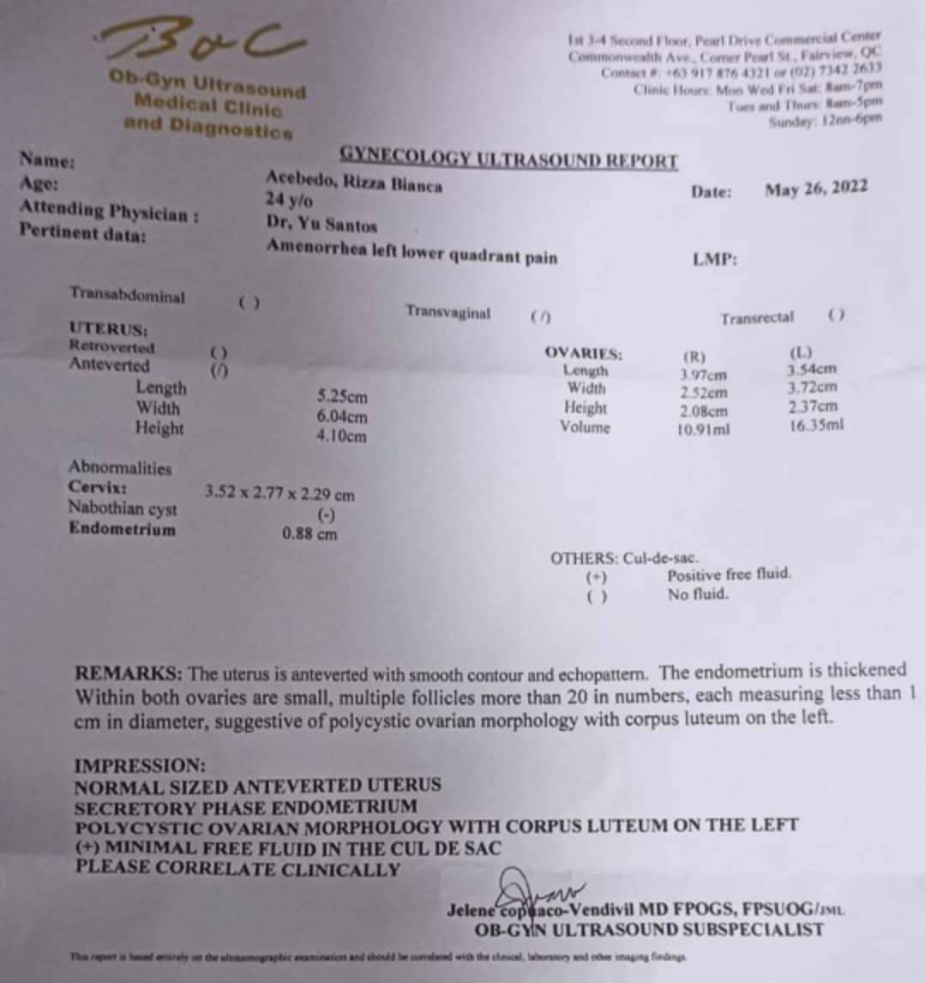

Respondent 22
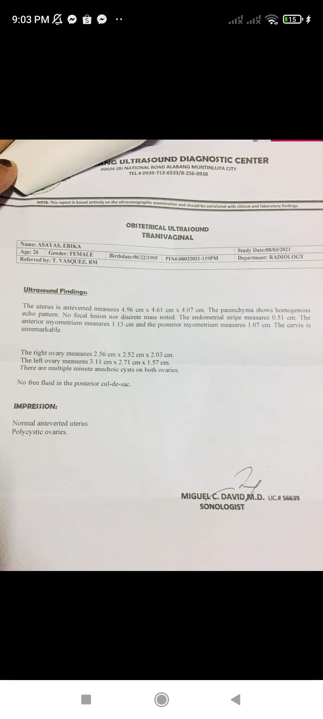

Respondent 23
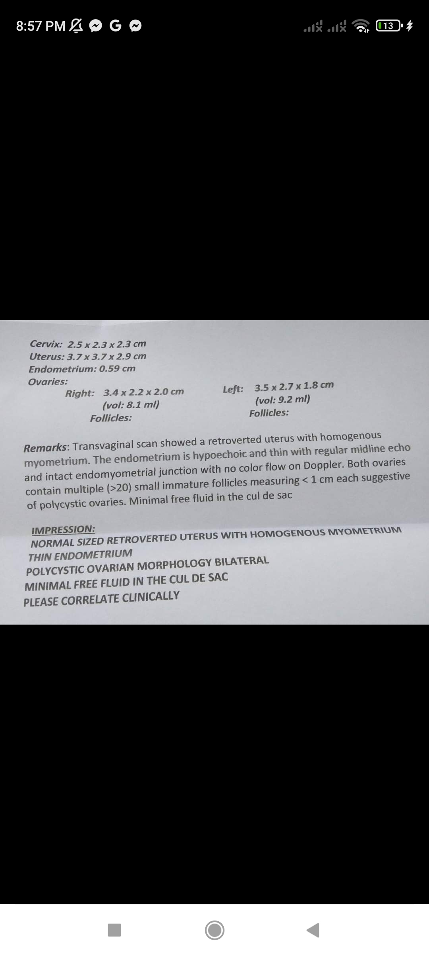

Respondent 24
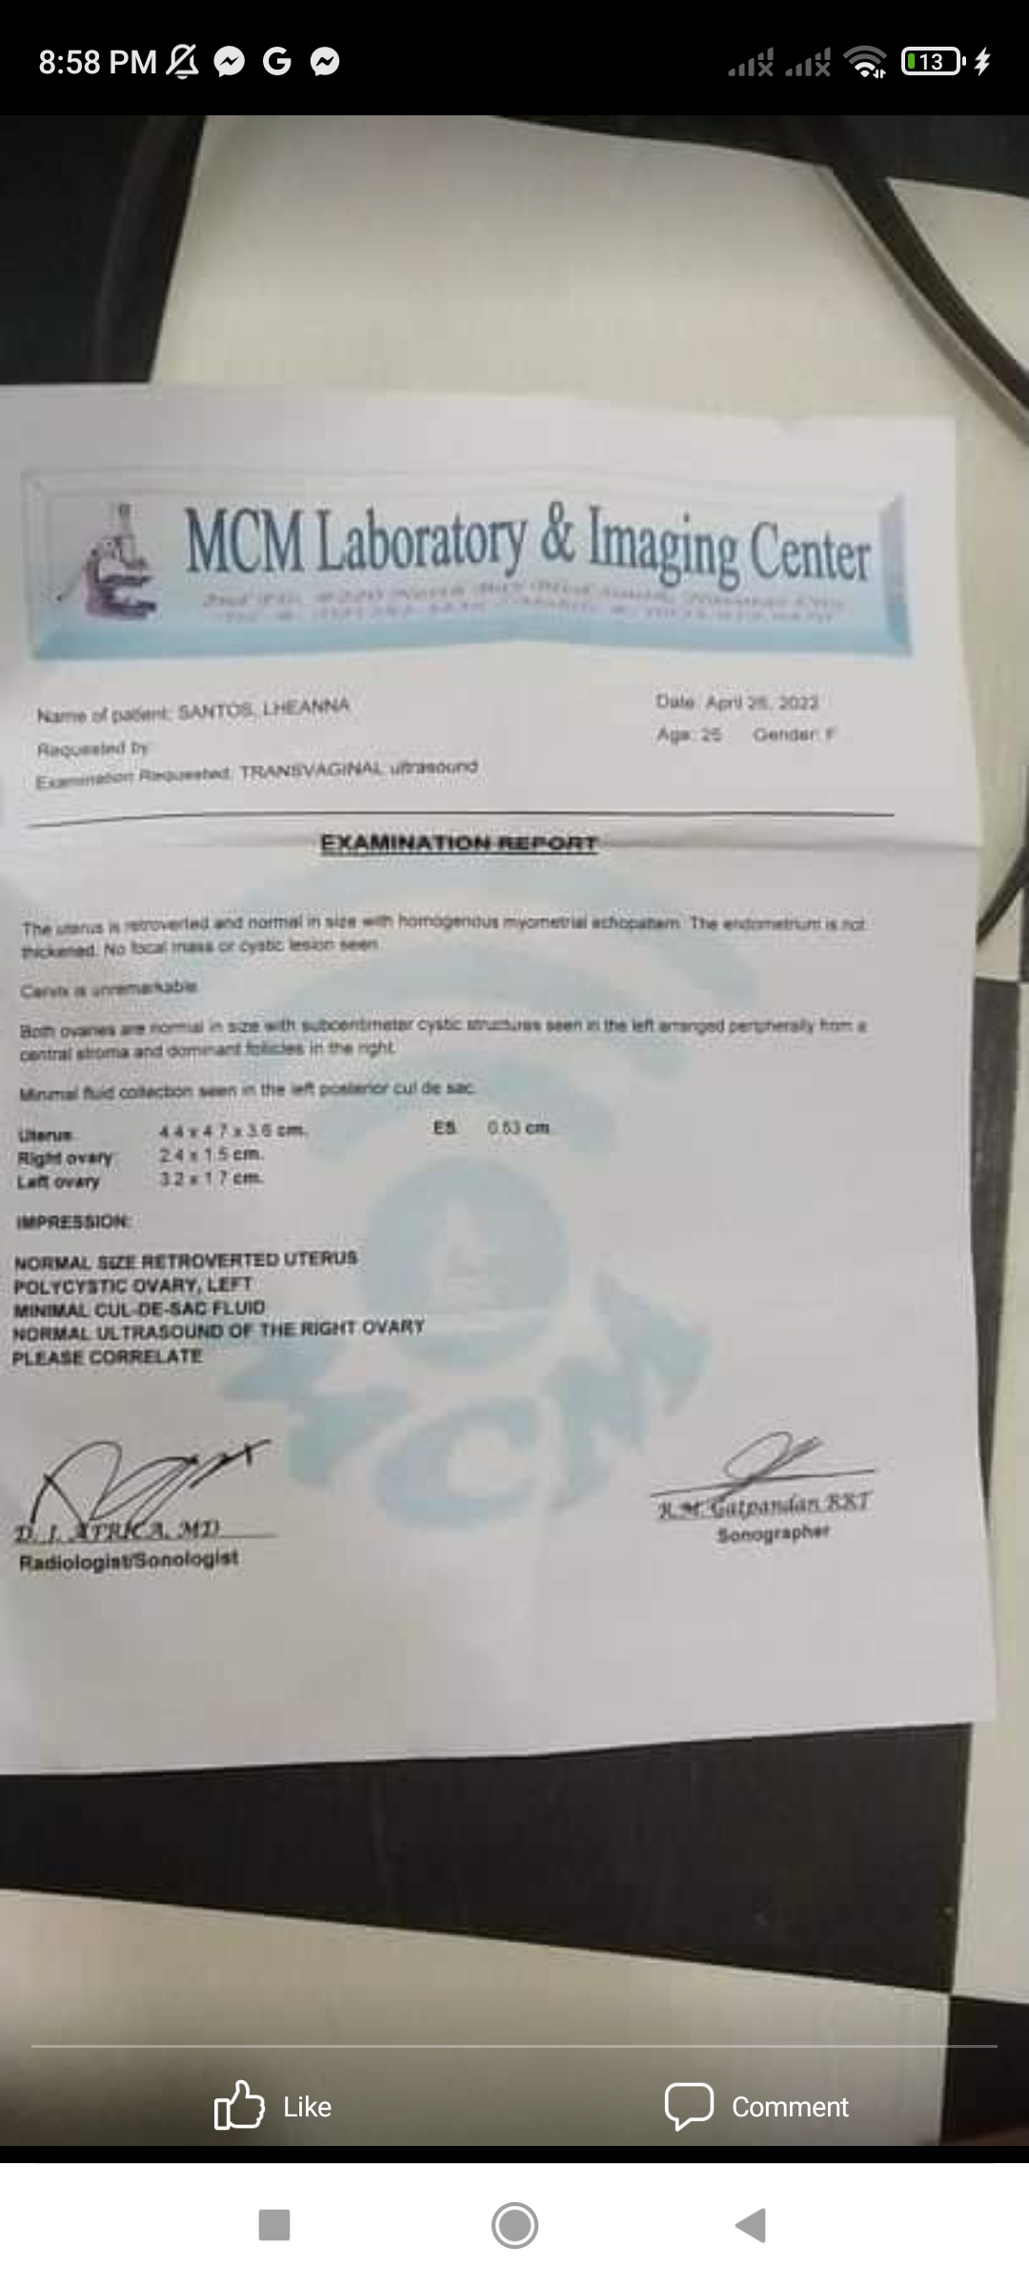

Respondent 25
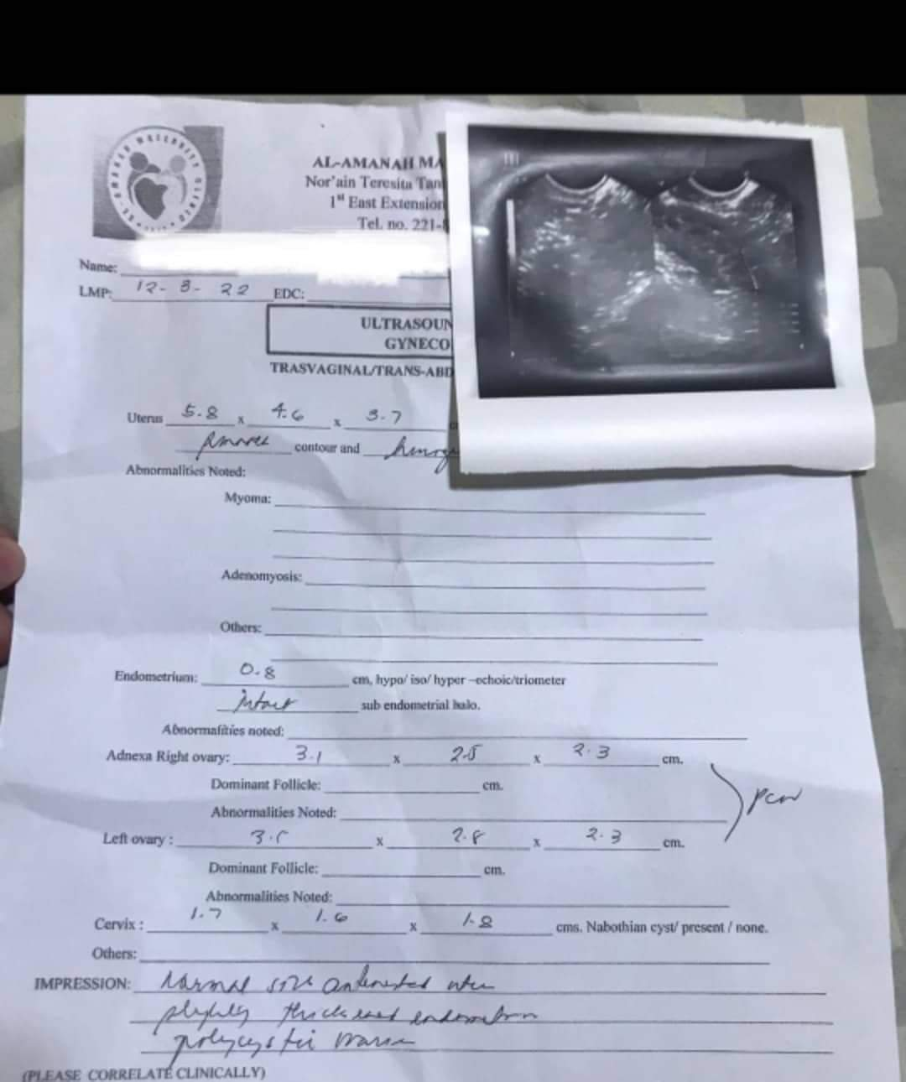

Respondent 26
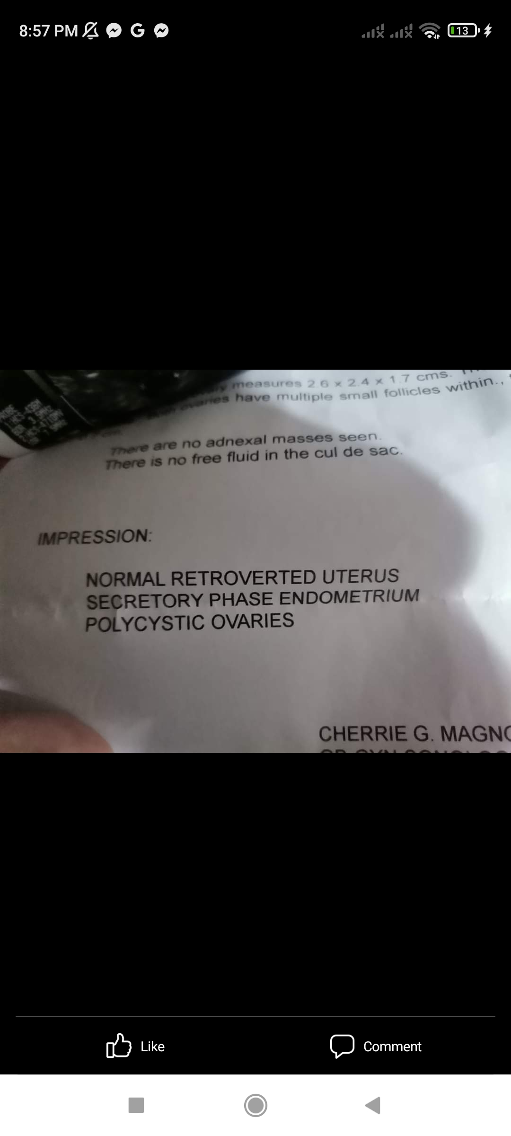

Respondent 27
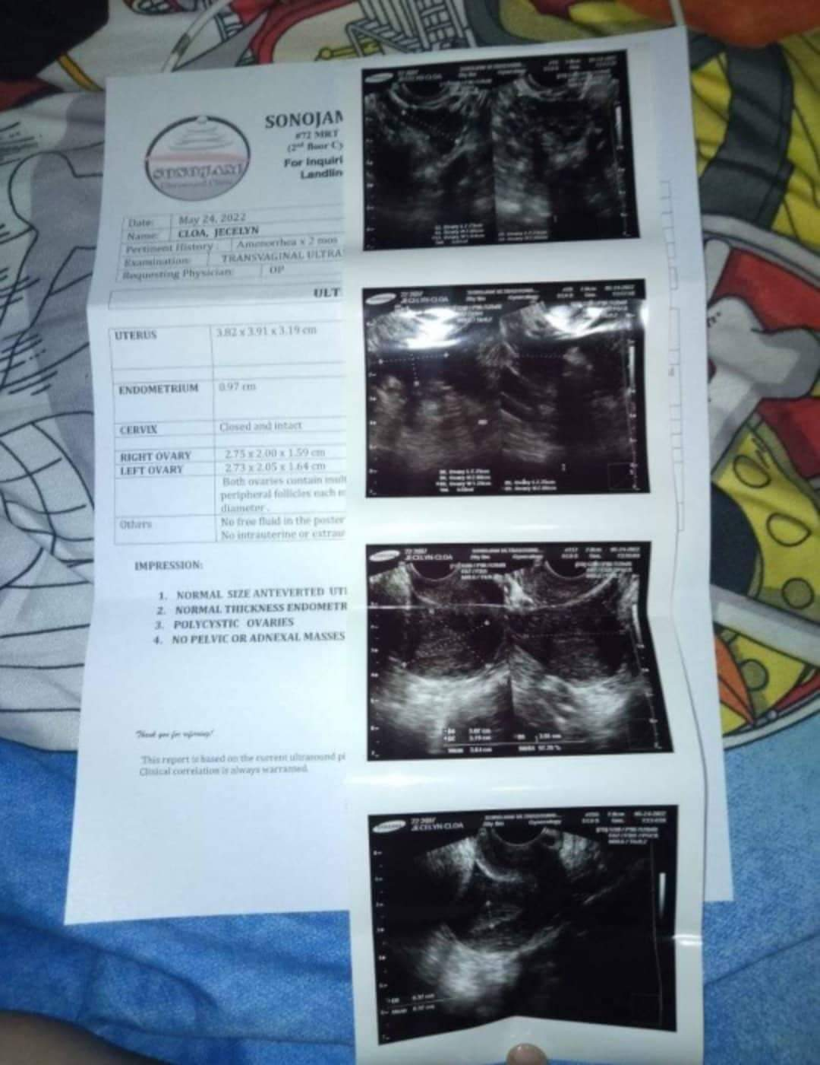

Respondent 28
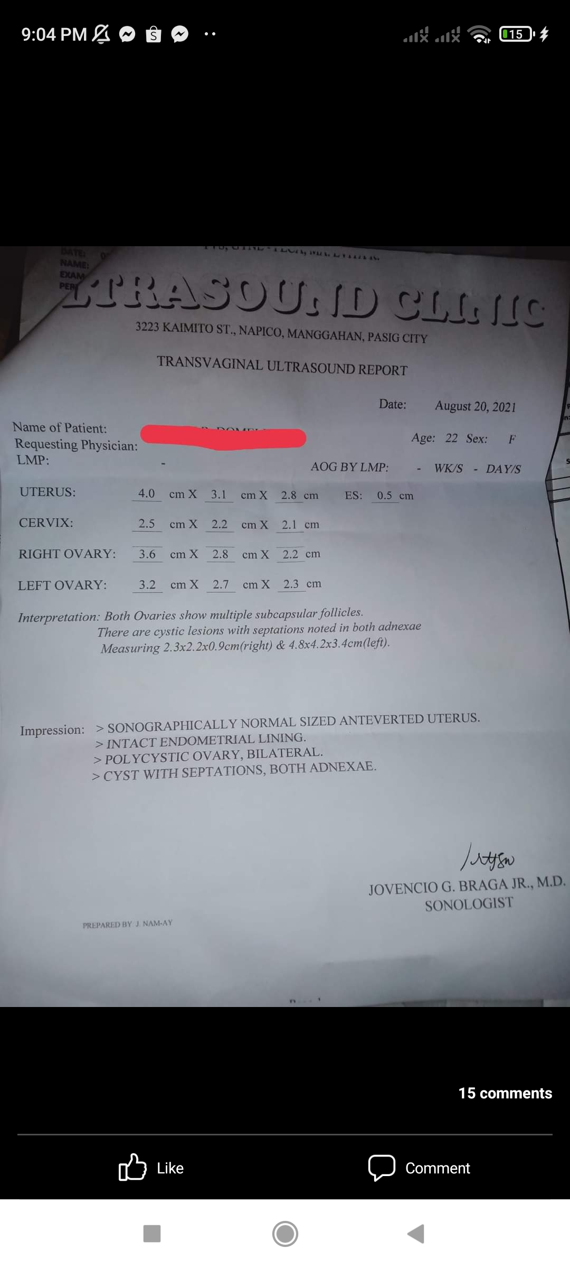

Respondent 29
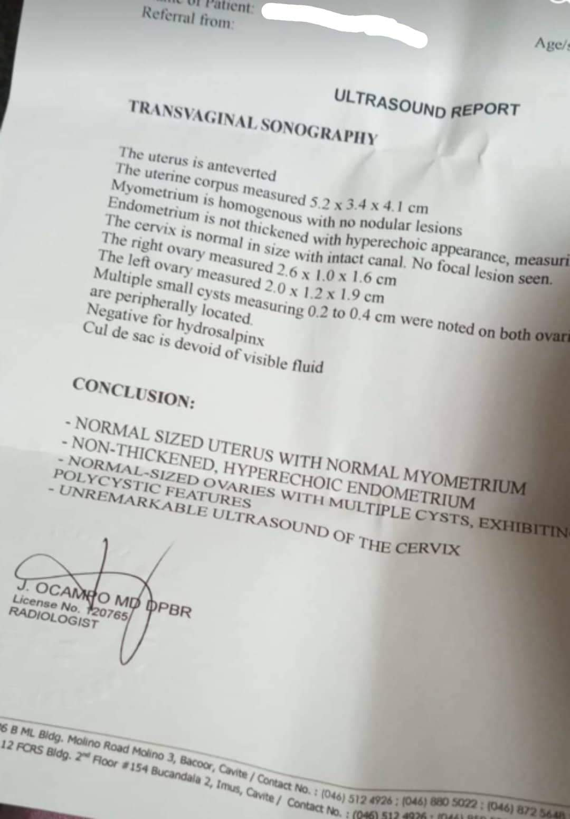

Respondent 30
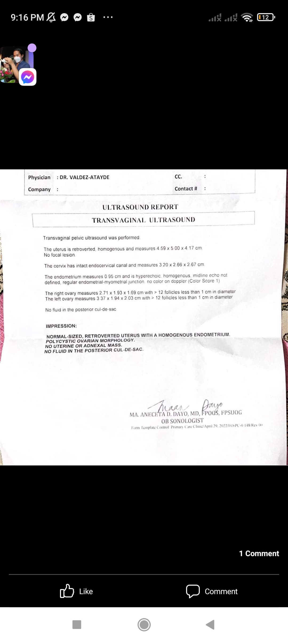

Respondent 31
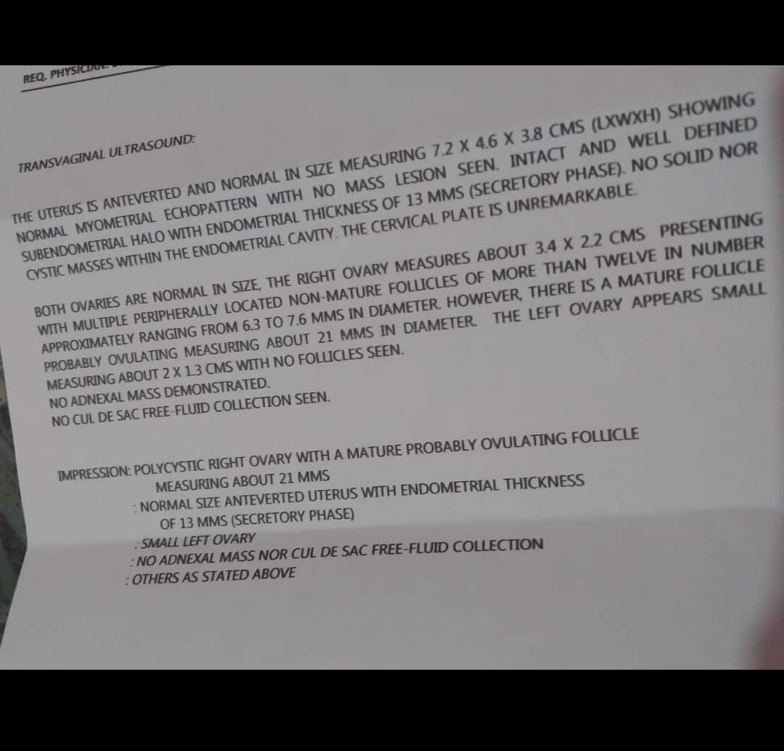

Respondent 32
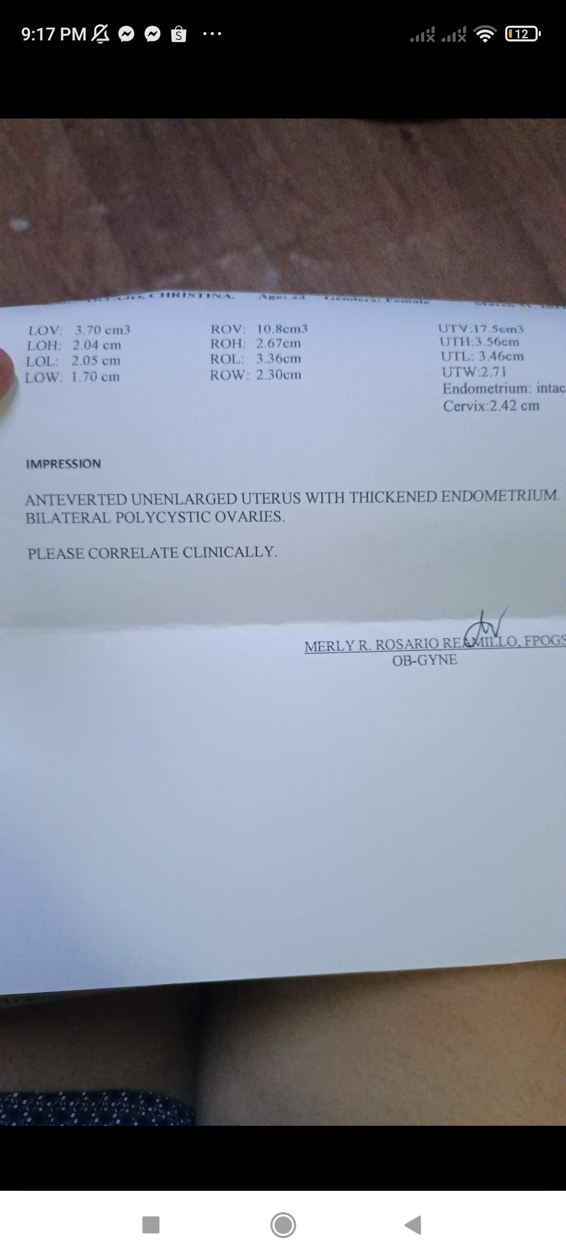

Appendix G
LETTER TO THE RESEARCH ETHICS COMMITTEE
Registration No. 62Q17082
Republic of the Philippines
JOSE RIZAL MEMORIAL STATE UNIVERSITY
The Premier University in Zamboanga del Norte
Gov. Guading Adaza St., Sta. Cruz, Dapitan City, Zamboanga del Norte
College of Nursing and Allied Health Sciences

JOSE RIZAL MEMORIAL STATE UNIVERSITY
The Premier University in ZamboangadelNorte
Gov. Guading Adaza St., Sta. Cruz, Dapitan City, Zamboanga del Norte
College of Nursing and Allied Health Sciences

Date:______________

ARNEL M. CUIVILLAS, PhD
JRMSU-Research Ethics Committee
Dipolog City

Sir:

We would like to request ethical review and certification from your office to allow us to administer the research instrument of our study titled “QUALITY OF LIFE OF MILLENNIAL WITH POLYCYSTIC OVARIAN SYNDROME” to the Student Nurses of the College of Nursing and Allied Health Sciences.

Attached herewith is our questionnaire and consent form for your perusal.
We fervently hope for your full support and kind approval on this matter.

Very truly yours,

FROILAND B. MEÑOSA
KATHERINE ANN E. BONDACO
ROWELA V. DELASAN
REGIELYN M. JOSOL
MARICAR E. REBUCAS

Researchers

Appendix I
MINUTES OF THE ORAL DEFENSE PROPOSAL
Registration No. 62Q17082
Republic of the Philippines
JOSE RIZAL MEMORIAL STATE UNIVERSITY
The Premier University in Zamboanga del Norte
Gov. Guading Adaza St., Sta. Cruz, Dapitan City, Zamboanga del Norte
College of Nursing and Allied Health Sciences

JOSE RIZAL MEMORIAL STATE UNIVERSITY
The Premier University in ZamboangadelNorte
Gov. Guading Adaza St., Sta. Cruz, Dapitan City, Zamboanga del Norte
College of Nursing and Allied Health Sciences

MINUTES OF THE ONLINE RESEARCH PROPOSAL DEFENSE

Date of Proposal: August 10, 2022
Via Google meet at 1:30pm______

Panel of Evaluators:
Prof. Patrick G. Galleto
Prof. Grace R. Abad
Prof. Naomie B. Daguinotas
Research Study Adviser
GLENN P. SABACAHAN
Course Professor:
Joanna Jauculan-Albaño

Research Title: QUALITY OF LIFE OF MILLENNIAL WITH POLYCYSTIC OVARIAN SYNDROME
Researchers:
FROILAND B. MEÑOSA
KATHERINE ANN E. BONDACO
ROWELA V. DELASAN
REGIELYN M. JOSOL
MARICAR E. REBUCAS

Comments/Suggestions:
The Panel of examiner, Prof. Daguinotas recommended to narrow and begin the introduction by providing information about Polycystic Ovarian Syndrome. She suggested narrowing the significance of the study and discusses what the researchers want to accomplish in the conduct of the study. Prof. Daguinotas added that the researchers should discuss in the significance and delimitation that there were no data available from DOH or Government Hospitals of the number of PCOS cases in the area, that the researchers only assessed the number by those who responded in the study. Moreover, Prof. Daguinotas suggested to fused the synthesis and gap of the study and continue right after the review of related of studies.
Prof. Galleto suggested that the researchers must use the Quota sampling which is more fitting to the study as the researchers only waited for the respondents respond in the study using the different online platforms. Prof. Galleto together with Prof. Abad suggested rechecking and reconstructing the Scoring Procedure and include another column explaining the Verbal description answer. They require as well to include and explain the general finding of the study which is the assessment of the Quality of life which is not being seen in the paper. The panellists recommended attaching the online form survey in the Manuscript. Prof. Daguinotas suggested explaining the content of the questionnaire and putting the Cronbach’s alpha result of the adopted research instrument, she added to state the reason why the researchers have used the quantitative research design and cite who said it that it was appropriate for the study
Prof. Galleto recommended to include the finding of the study of question number three in chapter 5.
Prof. Daguinotas recommended to observe authorial and proper citation. She added to provide documentary evidences for the diagnosis of Polycystic Ovarian Syndrome of the respondents. She added to include in the ethical consideration where the researchers have store the data.

Prepared by:
Froiland B. Menosa
Documenter

Conformed by:
NAOMIE B. DAGUINOTAS
Panel Member
GRACE R. ABAD
Panel Member
PATRICK G. GALLETO
Panel Member

Noted by:
JOANNA J. ALBAÑO, RN, LPT, MAN
CNAHS Research Chairperson

Approved/Disapproved:
JOANNA J. ALBAÑO, RN, LPT, MAN
Course Professor

GRACE R. ABAD, RN, LPT, MAN, Ed.D.
Dean, College of Nursing and Allied Health Sciences
Main Campus, Dapitan City

Research Study Adviser: GLENN P. SABACAHAN
Course Professor: JOANNA JAUCULAN-ALBAÑO, RN, LPT, MAN

Registration No. 62Q17082
Republic of the Philippines
JOSE RIZAL MEMORIAL STATE UNIVERSITY
The Premier University in Zamboanga del Norte
Gov. Guading Adaza St., Sta. Cruz, Dapitan City, Zamboanga del Norte
College of Nursing and Allied Health Sciences

JOSE RIZAL MEMORIAL STATE UNIVERSITY
The Premier University in ZamboangadelNorte
Gov. Guading Adaza St., Sta. Cruz, Dapitan City, Zamboanga del Norte
College of Nursing and Allied Health Sciences

Matrix of Comments/Suggestions/Recommendations
Comments/Suggestions/Recommendations | Action Taken
CHAPTER I  Revise the Introduction  Revise the Significance of the Study | -The Researchers narrowed the Introduction of the study into two and half pages and started with issues and concerns about PCOS.  -The Researchers have narrowed the significance of the study and discussed what the researchers would like to accomplish in the study.  -Stated that there were no data from government hospitals and Community Health office about PCOS clients.
CHAPTER 2  Fuse Synthesis and Gap | The Researchers had fuse the synthesis and gap and put right after the review of related studies.
Chapter 3  Explain the Research Methodology and Cite Sources  Use Quota for the Research Sampling and discuss  Recheck and Reconstruct the scoring procedure  Attach the Online Survey Questionnaire in the Manuscript  Attach the Result of the Crohnbach’s alpha of the Adopted Questionnaire  Add some key points to the Ethical Consideration | The researchers have used Quantitative research design with descriptive cross-sectional analysis and discuss in the study and have cited sources.  The researchers have used Qouta sampling which is more fitting for the study and have discuss how the data were gathered.  The researchers have reconstructed the scoring table and have added another column to explain the outcome.  The researchers have screenshot the online survey questionnaire and have attached to the manuscript.  The crohnbach alpha result of the research questionnaire was showed to the manuscript in each subscale and to the overall result.  The researchers have ensure that the data will be store in a safe place and shall be encrypted and abolished after six months from the presentation.
Chapter 4  Explanation of the Table presented | The researchers have provided explanation to every end of the table and discuss the analysis and interpretation of the study.
Chapter 5  Revise Findings, Conclusion and Reccomendations | The researchers concisely revise the chapter 5 by making three columns and rows for the findings, conclusion and recommendation of the study to properly connect and avoid inconsistencies of the study.


CURRICULUM VITAE
Insert picture here preferably in your uniform with white background
NAME OF THE STUDENT: FROILAND B. MEÑOSA
ADDRESS: DIPOLOG CITY
CONTACT NO/EMAIL ADD: lan886163@gmail.com

PERSONAL DATA
Age : 20
Birth date : SEPTEMBER 09, 2001
Birth place : TUNGAWAN ZAMBOANGA SIBUGAY
Civil status : SINGLE
Citizenship : FILIPINO
Name of Parents : DANILO MENOSA

EDUCATIONAL BACKGROUND
Elementary : TIMAN ELEMENTARY SCHOOL

High School : AVE MARIA COLLEGE

College :JOSE RIZAL MEMORIAL STATE UNIVERSITY


CURRICULUM VITAE
NAME OF THE STUDENT: KATHERINE ANN E. BONDACO
ADDRESS: DIPOLOG CITY
CONTACT NO/EMAIL ADD: bondacokatherine@gmail

PERSONAL DATA
Age : 21
Birth date : DECEMBER 20, 2000
Birth place : OZAMIS CITY
Civil status : SINGLE
Citizenship : FILIPINO
Name of Parents : MARIFE BONDACO

EDUCATIONAL BACKGROUND
Elementary : MIPUTAK EAST CENTRAL SCHOOL

High School : ANDRES BONIFACIO COLLEGE

College :JOSE RIZAL MEMORIAL STATE UNIVERSITY


CURRICULUM VITAE
Insert picture here preferably in your uniform with white background
NAME OF THE STUDENT: MARICAR E. REBUCAS
ADDRESS: DIPOLOG CITY
CONTACT NO/EMAIL ADD:

PERSONAL DATA
Age : 21
Birth date : NOVEMBER 29, 2000
Birth place : POBLACION MARIBOJOC BOHOL
Civil status : SINGLE
Citizenship : FILIPINO
Name of Parents : CARMEN E REBUCAS

EDUCATIONAL BACKGROUND
Elementary : STA. CRUZ ELEMENTARY SCHOOL

High School : SAINT VINCENT COLLEGE INSTITUTE

College :JOSE RIZAL MEMORIAL STATE UNIVERSITY


CURRICULUM VITAE
Insert picture here preferably in your uniform with white background
NAME OF THE STUDENT: REGIELYN M. JOSOL
ADDRESS: DIPOLOG CITY
CONTACT NO/EMAIL ADD:

PERSONAL DATA
Age : 21
Birth date : JULY 21, 2000
Birth place : DIPOLOG CITY
Civil status : SINGLE
Citizenship : FILIPINO
Name of Parents : REGINALDO JOSOL

EDUCATIONAL BACKGROUND
Elementary : RIZAL CENTRAL SCHOOL

High School : COLLEGIO DE SAN FRANCISCO JAVIER

College :JOSE RIZAL MEMORIAL STATE UNIVERSITY


CURRICULUM VITAE
NAME OF THE STUDENT: ROWELA V. DELASAN
ADDRESS: DIPOLOG CITY
CONTACT NO/EMAIL ADD:

PERSONAL DATA
Age : 21
Birth date : MARCH 19, 2001
Birth place : DIPOLOG CITY
Civil status : SINGLE
Citizenship : FILIPINO
Name of Parents : CANDELARIO S. DELASAN

EDUCATIONAL BACKGROUND
Elementary : DIPOLOG PILOT DEMONSTRATION SCHOOL

High School : ANDRES BONIFACIO COLLEGE

College :JOSE RIZAL MEMORIAL STATE UNIVERSITY

