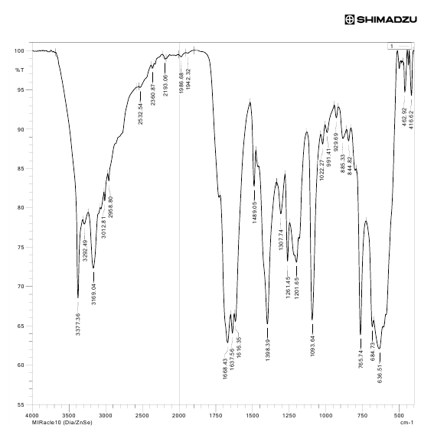
Figure S1. IR spectra for 1-(2-(isopentyloxy)-2-oxoethyl)pyridin-1-ium chloride.
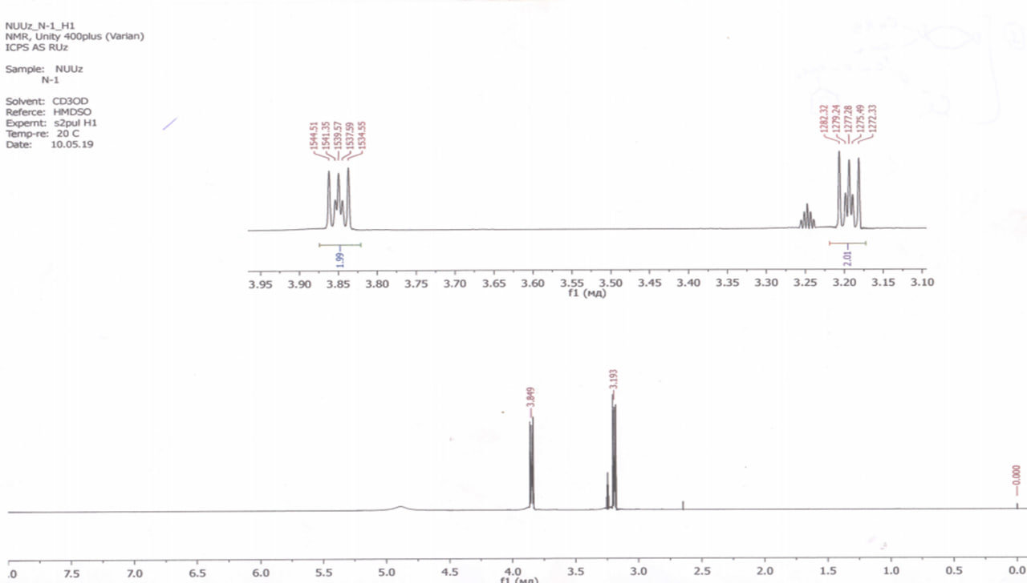

Figure 2S. ¹H NMR spectra for 1-(2-(isopentyloxy)-2-oxoethyl)pyridin-1-ium chloride.

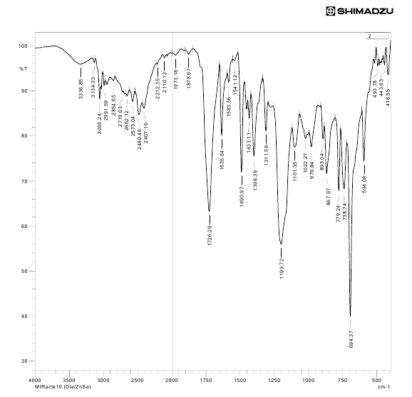
Figure 3S. IR spectra for 1-(2-(hexyloxy)-2-oxoethyl)pyridin-1-ium chloride
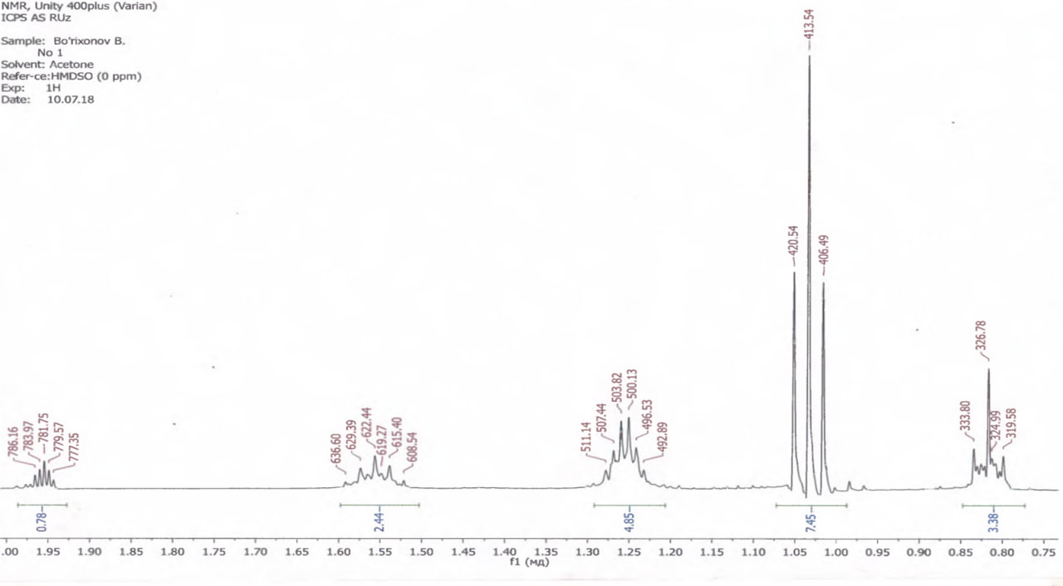
Figure 4S. ¹H NMR spectra for 1-(2-(hexyloxy)-2-oxoethyl)pyridin-1-ium chloride

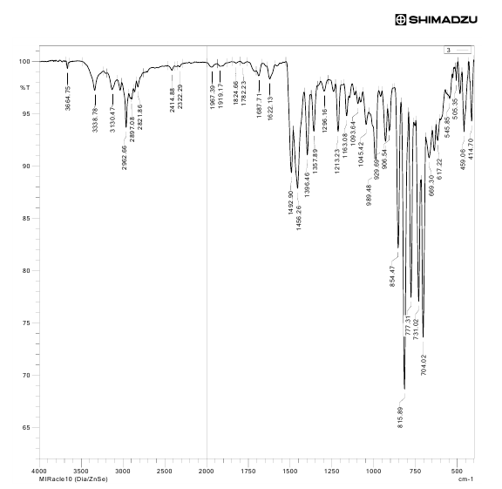
Figure 5S. IR spectra for 1-(2-(benzyloxy)-2-oxoethyl)pyridin-1-ium chloride
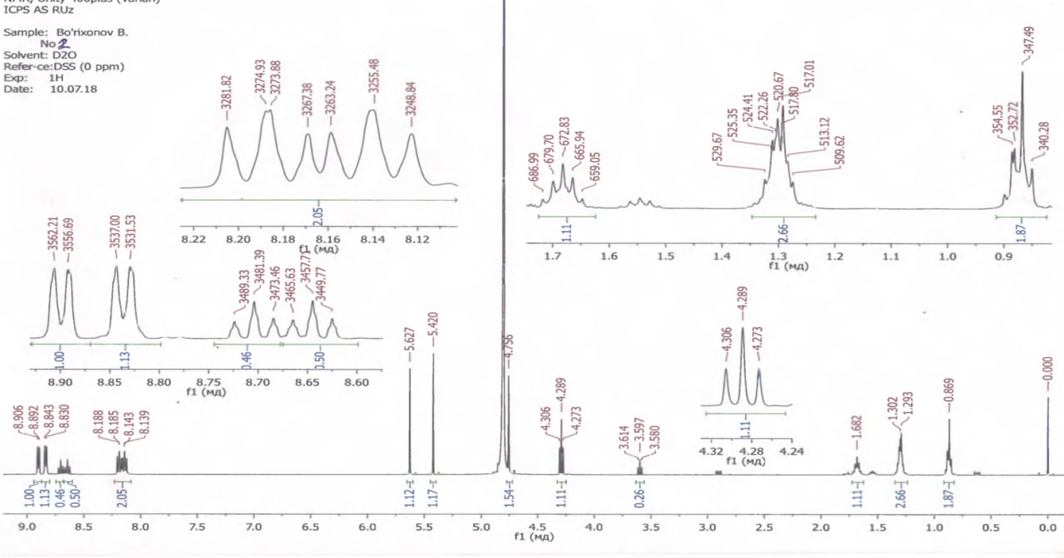
Figure 6S. ¹H NMR spectra for 1-(2-(benzyloxy)-2-oxoethyl)pyridin-1-ium chloride

