Extended Data
Transovarial transmission of Yersinia pestis in fleas
Pauling, CD, et al.

Extended Data Table 1. Primers used to target Yersinia pestis specific genes.
Name | Forward | Reverse | bp
caf1 | 5’-ACTCTTGTTGAACCAGCCCG-3' | 5’-GGTTACGGTTACAGCATCAGTG-3' | 402
pla | 5’-CGGGATGCTGAGTGGAAAGT-3' | 5’-TATCATGTGCCCGAACCCAG-3' | 554

Extended Data Figure 1.
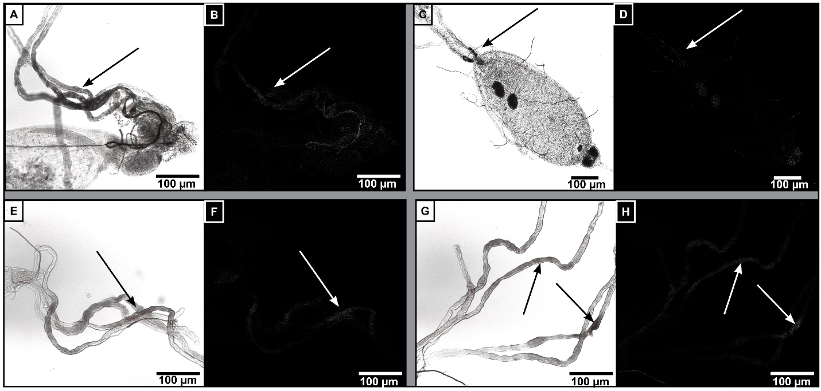
Extended Data Figure 1. Yersinia pestis colonizes Malpighian tubules of X. cheopis. Adult fleas were infected with Y. pestis in rat (A-D) or mouse (E-H) blood, then dissected on day 5 (mouse) or 10 (rat) post-infection. Representative images of Malpighian tubules: RGB images (A, C, E, G) with associated conversion to HSB; Saturation channel (B, D, F, H) are shown. Arrows point to red-fluorescing bacteria.

Extended Data Figure 2.

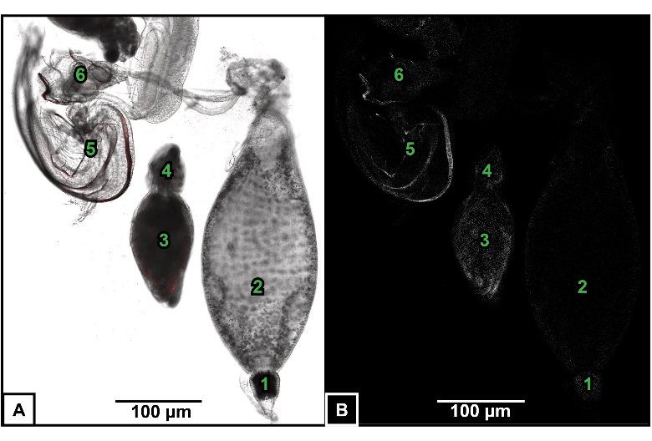
Extended Data Figure 2. Long-term bacterial presence of Y. pestis in reproductive tissues of X. cheopis. Representative images taken from tissues dissected from Y. pestis-infected X. cheopis, 15 weeks following infection in mouse blood: (A) RGB image and the converted HSB image (B) Saturation channel. Anatomy is labeled as follows: 1. Proventriculus, 2. Midgut, 3. Testes, 4. Epididymis, 5. Aedeagus, and 6. Rectal papillae.

Extended Data Figure 3.
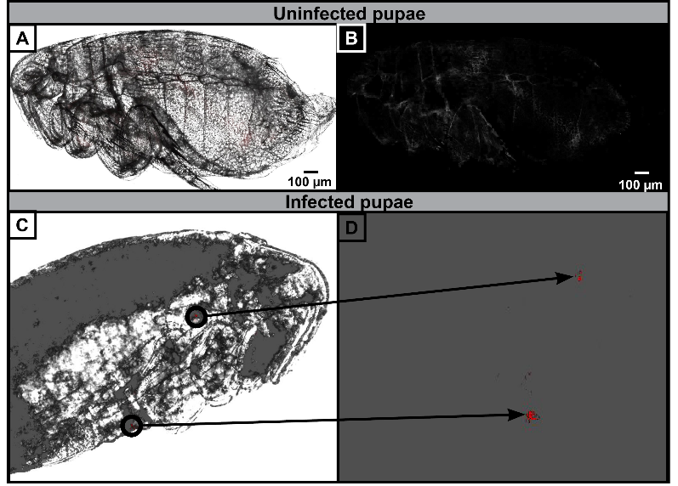
Extended Data Figure 3. Pupae from Y. pestis-infected adult X. cheopis fleas remain infected indicating transstadial transmission. Representative confocal images of pupae from uninfected (A-B) or Y. pestis-infected (C-D) adult X. cheopis fleas that were removed from cocoons: (A, C) RGB image converted to HSB; (B, D) Associated saturation channel. A z-stack on an infected pupa provides internal viewing separate from the external chitin. The overlay from the z-stack (C) indicates two internal areas with brightly-fluorescing bacteria represented in the saturation channel without the overlay (D). Arrows connect the bacteria to the coordinating region in the pupa.

Extended Data Figure 4.
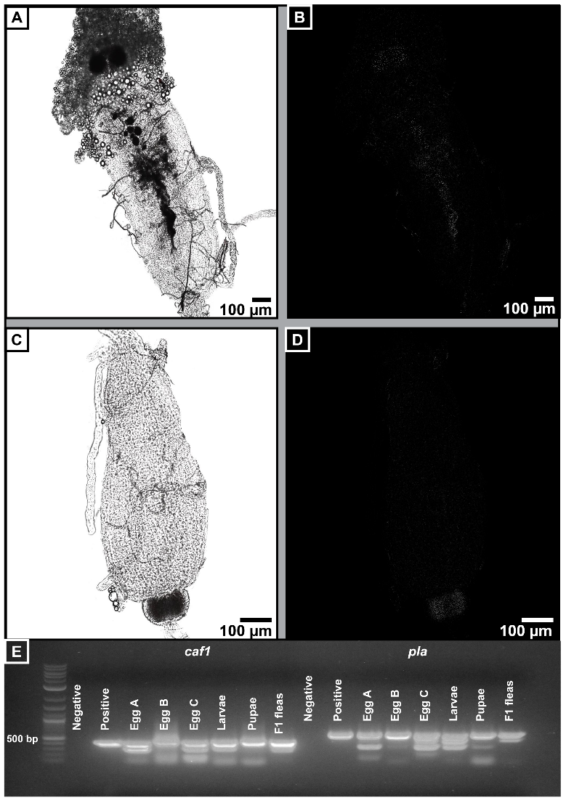
Extended Data Figure 4. Y. pestis is maintained through all developmental stages of X. cheopis. Adult F1 fleas that had developed from eggs collected from Y. pestis-infected fleas were imaged by confocal microscopy (A-D). (A, C) RGB images converted to HSB; (B, D) associated saturation channels from one female (A, B) and one male (C, D); (E) Conventional PCR for strain-specific Y. pestis plasmids pMT1 (caf) and pPCP1 (pla) by PCR; positive control DNA was prepared from Y. pestis KIM6+, negative control had no template DNA; 1kb molecular weight (MW) is shown in lane 1; representative samples are shown.

